Machine Learning & Data Mining

T3 2019

COMP9417 – Homework-2

Chirag Panikkasseril Unni – z5241855
1/11/2019

Question 1

Part A
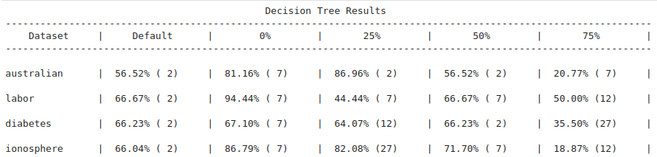

Part B

--- (4) increase overfitting by increasing max_depth of the decision tree

Part C

--- (5) yes, for 4/4 of the datasets

Question 2

Part A

model A Train set
Train set accuracy: 0.8969404186795491

model A Test set
Test set accuracy: 0.7681159420289855

Part B

The optimal k : 19 with score 0.8121693121693122

Part C

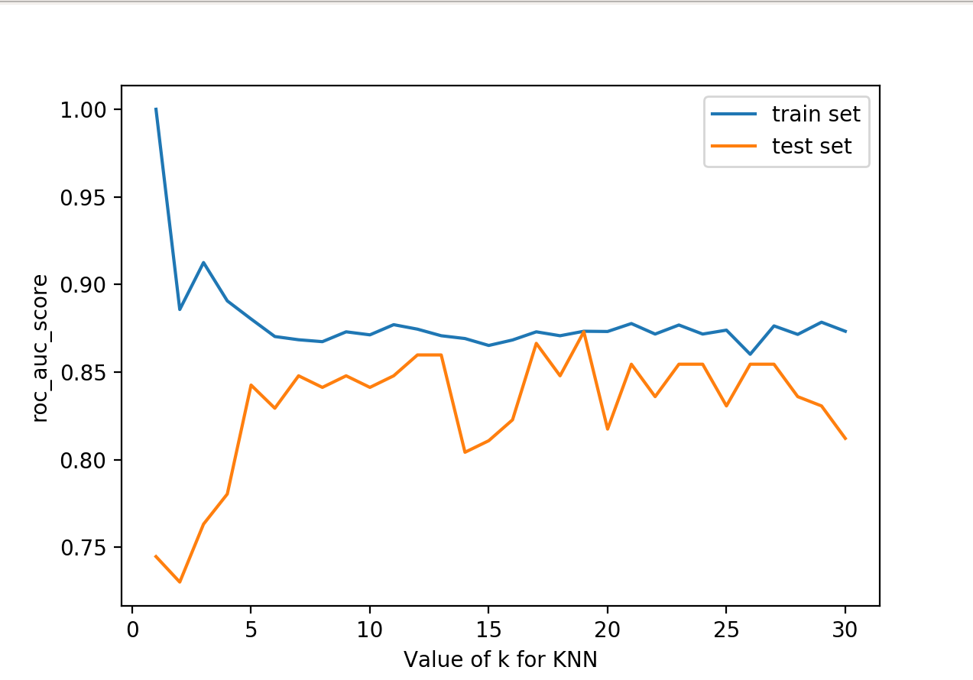

Part D

Scores for Model with best k:19
Recall score: 0.8888888888888888
Precision score: 0.8

Part D

Scores for Model with best k:19
Recall score: 0.8888888888888888
Precision score: 0.8

Scores for Model A with k:2
Recall score: 0.5555555555555556
Precision score: 0.7894736842105263

Code

# Code for question 2
import numpy as np
import pandas as pd
from sklearn import preprocessing
from sklearn.neighbors import KNeighborsClassifier
from sklearn.metrics import accuracy_score, precision_score, roc_auc_score, recall_score
import matplotlib.pyplot as plt
from sklearn.preprocessing import MinMaxScaler
###########################################################
# Code for Question 2
# Load Data
df = pd.read_csv('/home/chirag/anaconda3/envs/Homework2/CreditCards.csv')
data = np.array(df)
# Pre Processing
normalizer = preprocessing.MinMaxScaler()
data[:, :14] = normalizer.fit_transform(data[:, :14])
X = data[:, :14]
y = data[:, -1:]
# Split Train and Test Set
train_set = 621
Xtrain, Xtest = X[:train_set, :], X[train_set:, :]
ytrain, ytest = y[:train_set, 0], y[train_set:, 0]
# PART A
# Model A
modelA = KNeighborsClassifier(n_neighbors=2)
# train the model
modelA.fit(Xtrain, ytrain)
# get the predict value from Xtrain
yprediction = modelA.predict(Xtrain)
# print the accuracy
print("\nmodel A Train set")
print(f'Train set accuracy: {accuracy_score(ytrain, yprediction)}')
# get the predict value from Xtest
print("\nmodel A Test set")
yprediction = modelA.predict(Xtest)
# print the scores
print(f'Test set accuracy: {accuracy_score(ytest, yprediction)}')
print("\nScores for Model A with k:2")
print(f'Recall score: {recall_score(ytest, yprediction)}')
print(f'Precision score: {precision_score(ytest, yprediction)}')
print()
# PART B
List_K = []
AUCscoreTrain = []
AUCscoreTest = []
optimal_score = 0
optimal_k = 0
diff = []
for k in range(1, 31):
# Model with k neighbour
List_K.append(k)
model = KNeighborsClassifier(n_neighbors=k)
# train the model
model.fit(Xtrain, ytrain)
# get the predict value from Xtrain
yprediction = model.predict(Xtrain)
scoreTrain = roc_auc_score(ytrain, yprediction)
AUCscoreTrain.append(scoreTrain)
# get the predict value from Xtest
yprediction = model.predict(Xtest)
scoreTest = roc_auc_score(ytest, yprediction)
AUCscoreTest.append(scoreTest)
diff.append(abs(scoreTrain - scoreTest))
# get the optimal k and score
optimal_k = List_K[diff.index(min(diff))]
optimal_score = scoreTest
print(f'The optimal k : {optimal_k} with score {optimal_score}\n')
#PART C
# plot
plt.plot(List_K, AUCscoreTrain, label='training set')
plt.plot(List_K, AUCscoreTest, label='testing set')
plt.xlabel('k value of the model')
plt.ylabel('roc_auc_score')
plt.legend()
plt.show()
#PART D
# Model with optimal k
model = KNeighborsClassifier(n_neighbors=optimal_k)
# train the model
model.fit(Xtrain, ytrain)
# get the predict value from Xtest
print(f"Scores for Model with best k:{optimal_k}")
yprediction = model.predict(Xtest)
print(f'Recall score: {recall_score(ytest, yprediction)}')
print(f'Precision score: {precision_score(ytest, yprediction)}')

Code Output

model A Train set
Train set accuracy: 0.8969404186795491

model A Test set
Test set accuracy: 0.7681159420289855

Scores for Model A
Recall score: 0.5555555555555556
Precision score: 0.7894736842105263

The optimal k : 19 with score 0.8121693121693122

Scores for Model with best k:19
Recall score: 0.8888888888888888
Precision score: 0.8

Process finished with exit code 0

