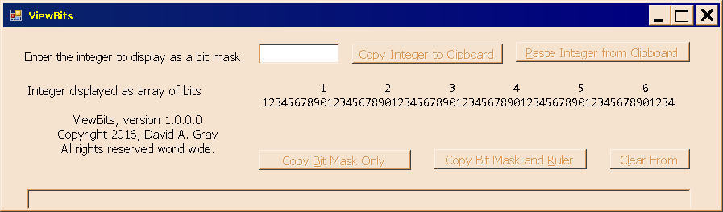
Figure 1 is the revised form, demonstrating that the 64 bit ruler displays correctly.

