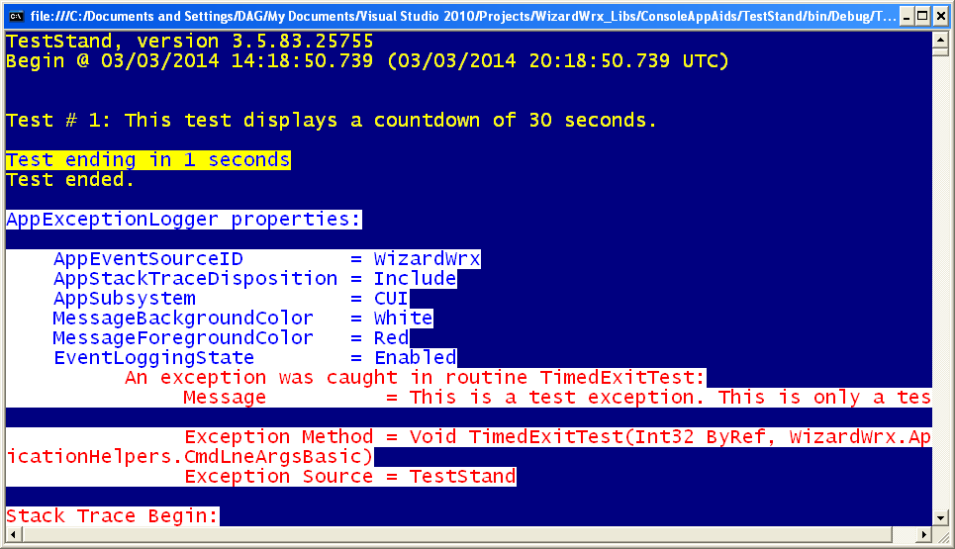
Figure 1 demonstrates use of the ErrorMessageColors property of an ApplicationInstance object to make error message displays that stand out.
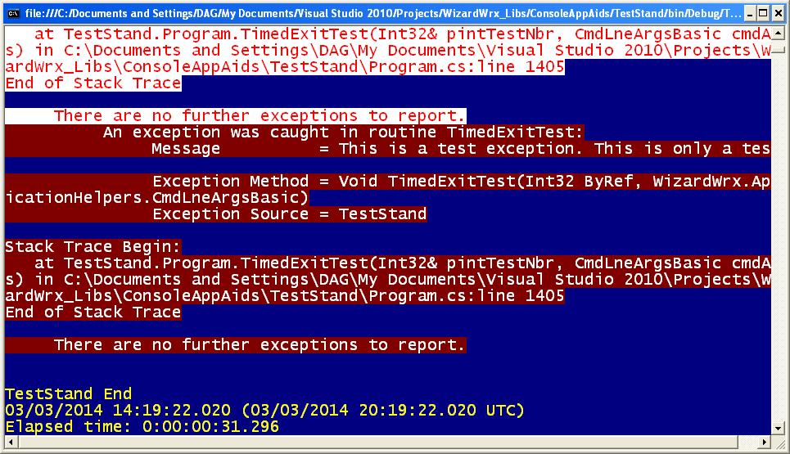
Figure 2 demonstrates use of the MessageInColor class on its own to display error messages.
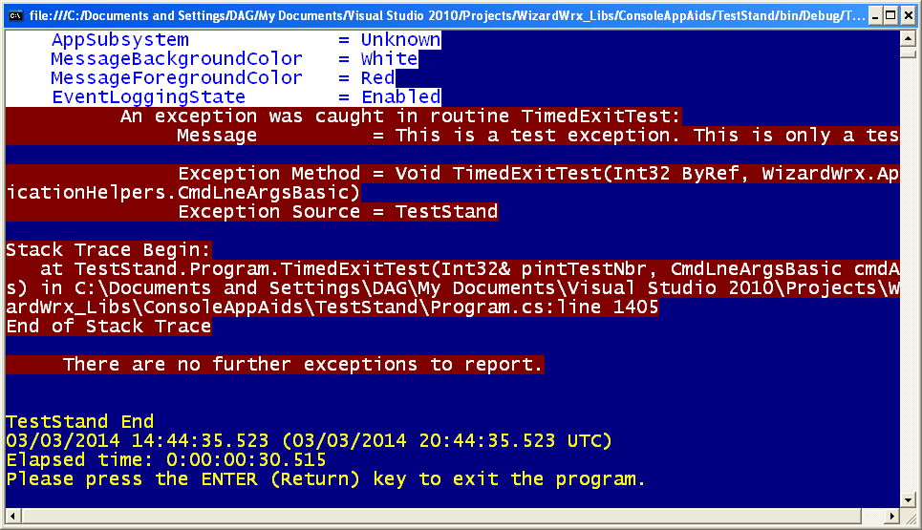
Figure 3 shows the effect of leaving the AppSubsystem property uninitialized and the ErrorMessageColors property set to yield White text on a Red background.
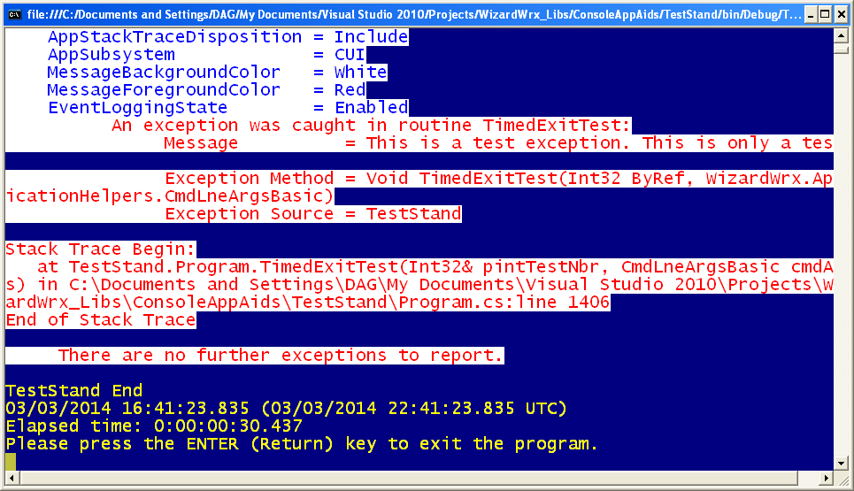
Figure 4 shows what happens when the AppSubsystem property is set to CUI and the ErrorMessageColors property set to yield DarkRed text on a White background.
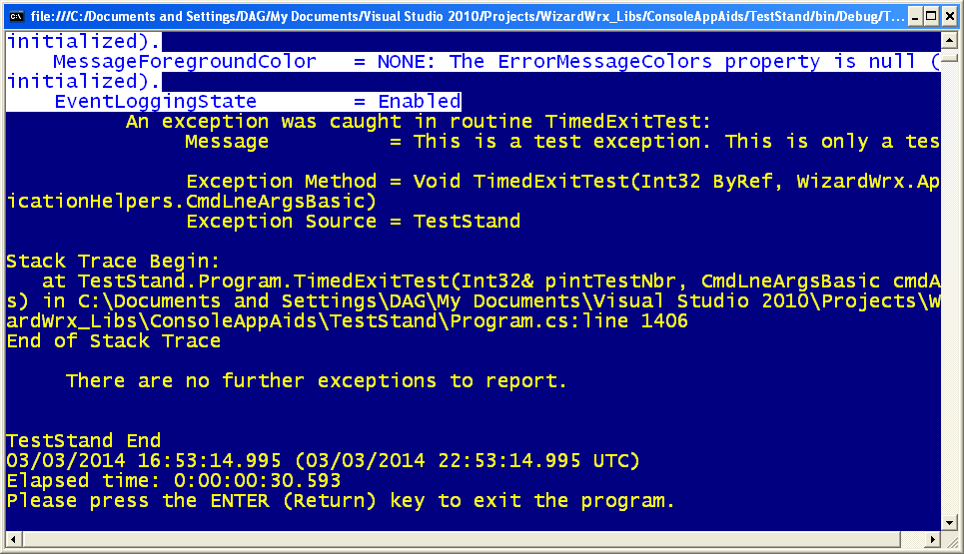
Figure 5 shows what happens when the AppSubsystem property is set to CUI and the ErrorMessageColors property is uninitialized.
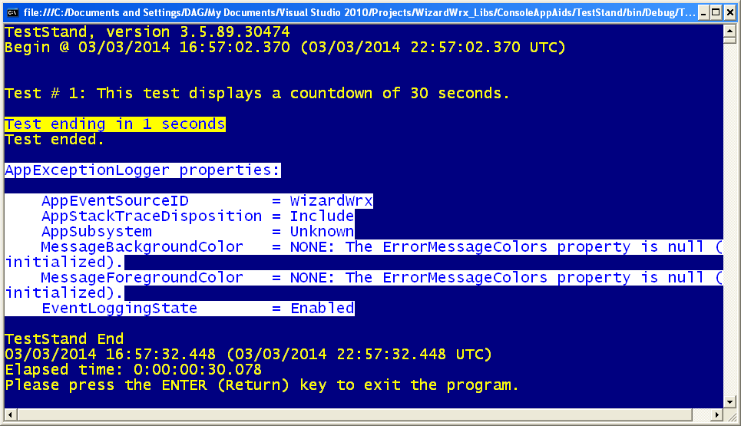
Figure 6 shows what happens when the AppSubsystem property is uninitialized and the application expends no effort to print a message.

