Exercise the Regular MessageInColor Methods
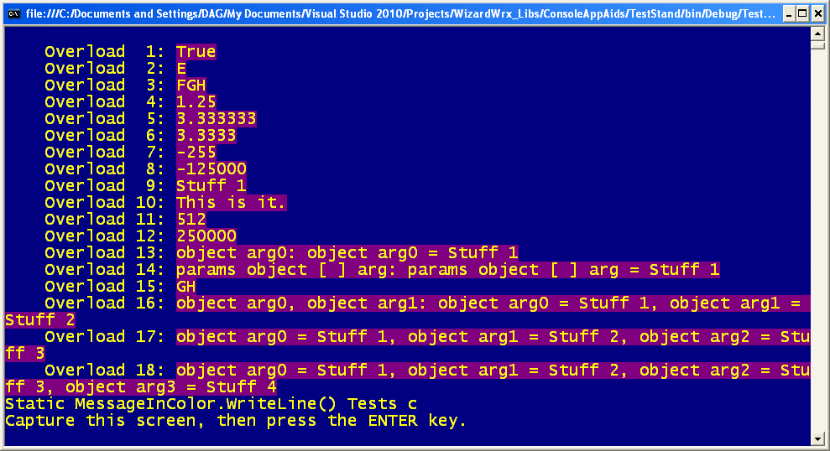
Figure 1 is the 1st of a series of tests of the new exception logging routine, which writes to STDERR.
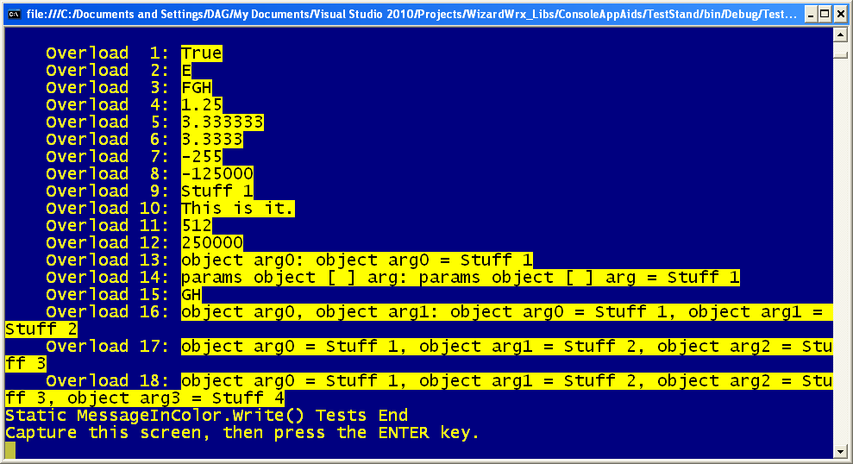
Figure 2 is the 2nd test of the regular message output, writing black text on a yellow background.
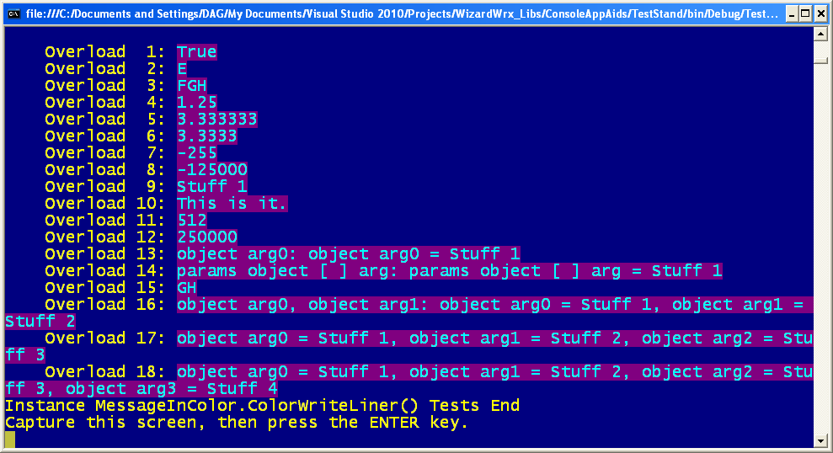
Figure 3 is the 3rd test, writing cyan text on a dark magenta background.
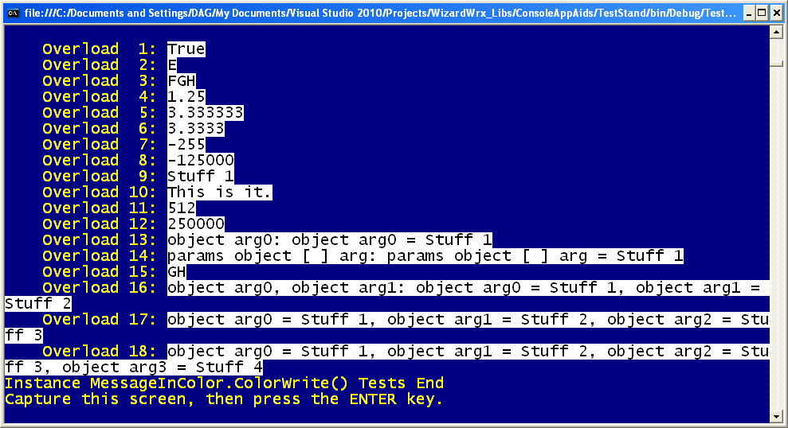
Figure 4 is the 4th test, writing black text on a white background.

Exercise the Exception Reporting Engine
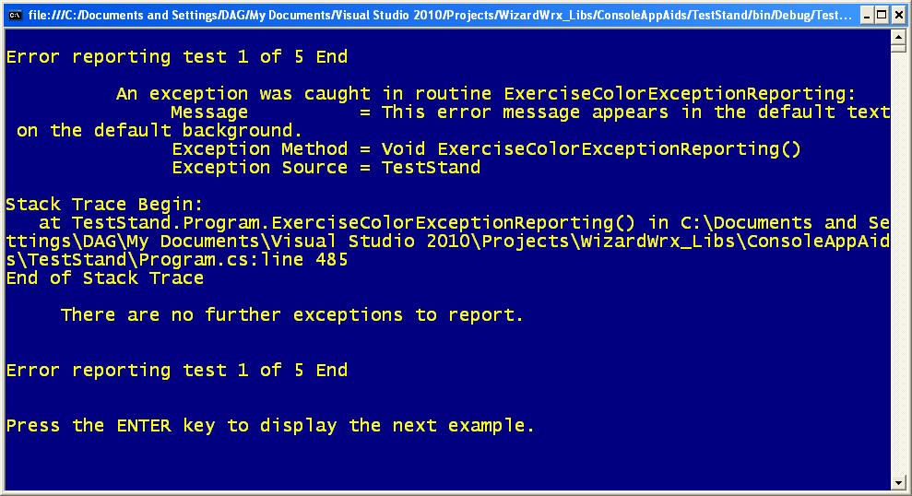
Figure 5 is the 1st exception report, using the default screen colors.
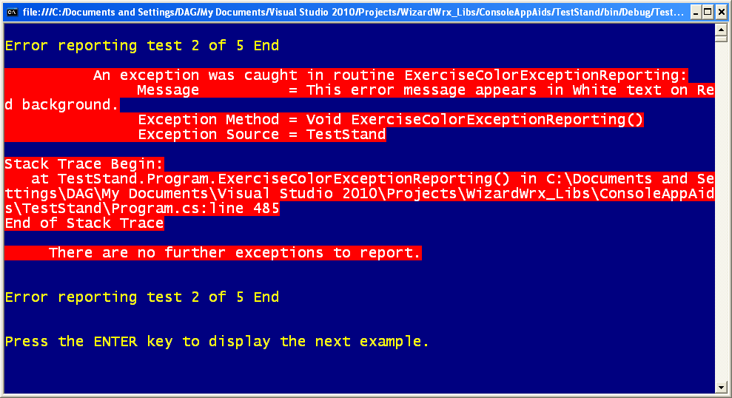
Figure 6 is the 2nd test, which grabs your attention, big time, with its bright red background. Unfortunately, the text is harder to read than I initially expected.
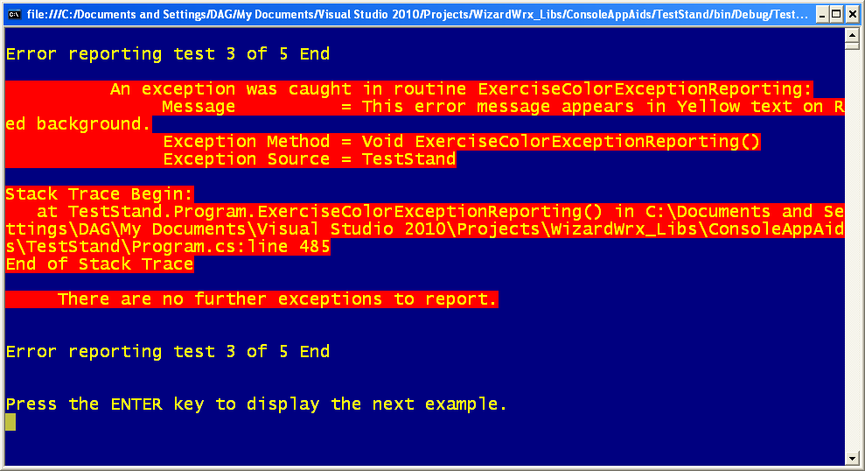
Figure 7 is the same text in yellow, on the same bright red background. This shade of red is just too bright to be useful.
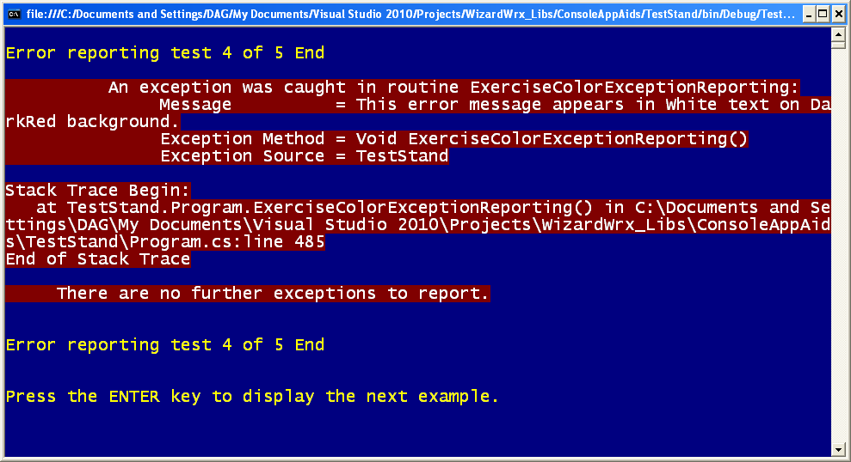
Figure 8 shows how much difference the background color makes. The same text on bright red is very hard to read; this text is much easier to read, yet the background color is equally effective.
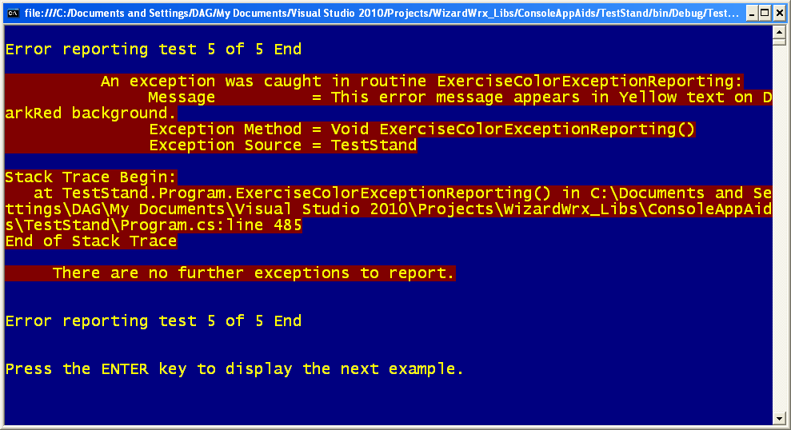
Figure 9 shows that yellow text also works better on the dark background, although I think white has a slight edge.

Repeat with One-Line Messages
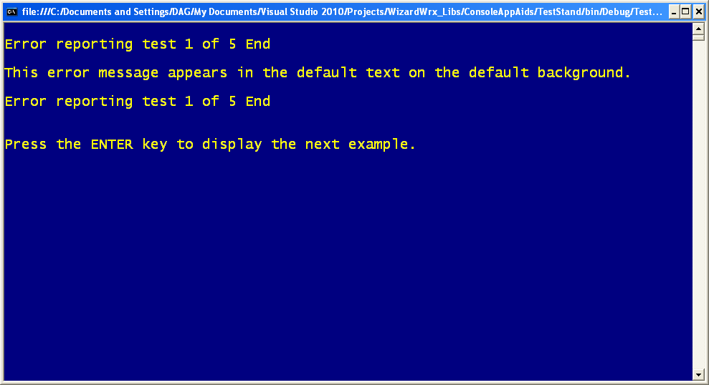
Figure 10 is the basic one-line message, shown in the default screen colors.
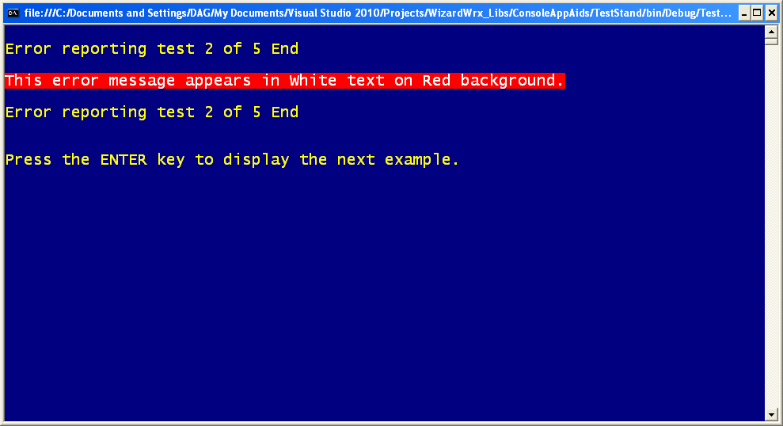
Figure 11 is the same message displayed in white text on the bright red background that was so annoying when applied to the whole message. It is much more effective for these one-liners, but I still think it’s a poor color combination.
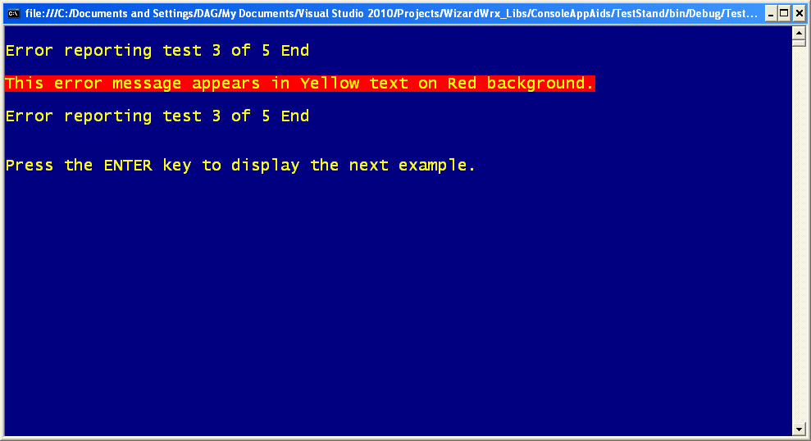
Figure 12 is the one-line message in yellow on red. My verdict is the same as it was for the longer report.
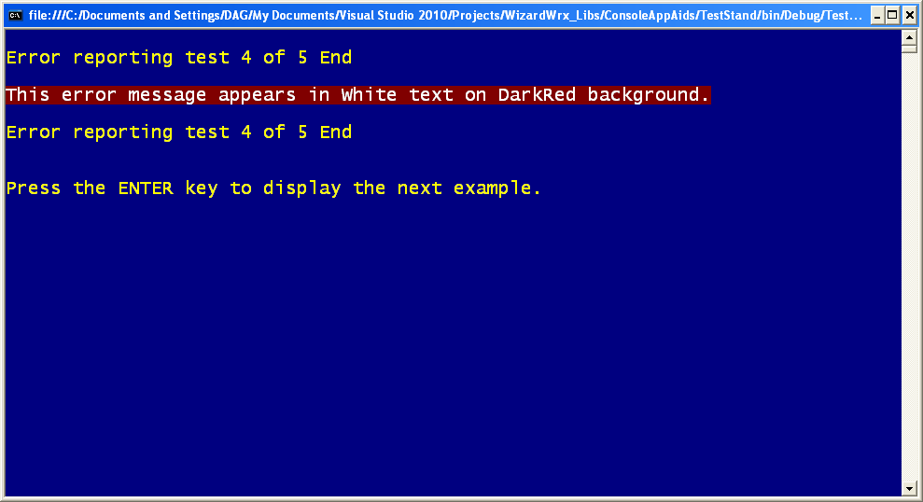
Figure 13 is the white text on the dark red background, which is as effective for this one line as it was for the longer message.
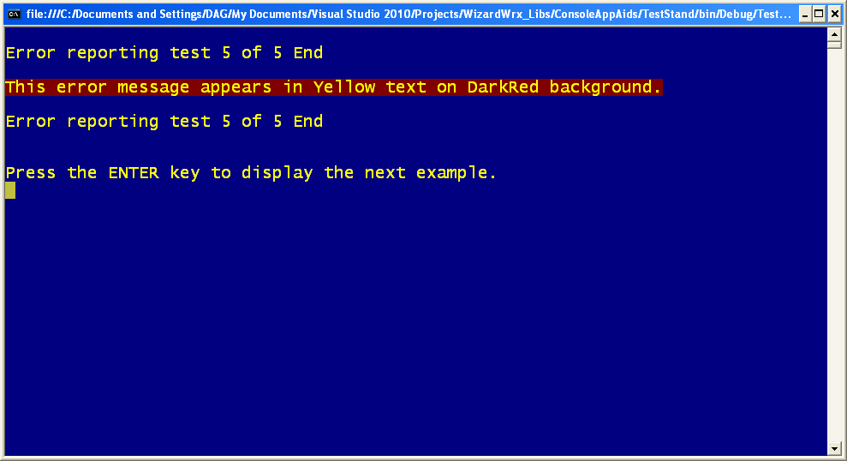
Figure 14 is the yellow on red message, which is effective, but I still think white on dark red has an edge.

Countdown Tests
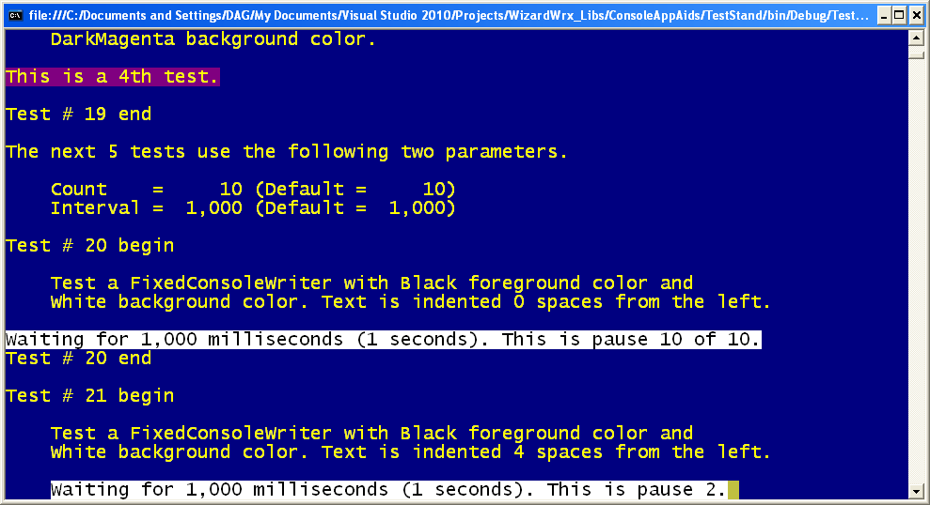
Figure 15 is the 1st and 2nd of a long series of countdown tests.
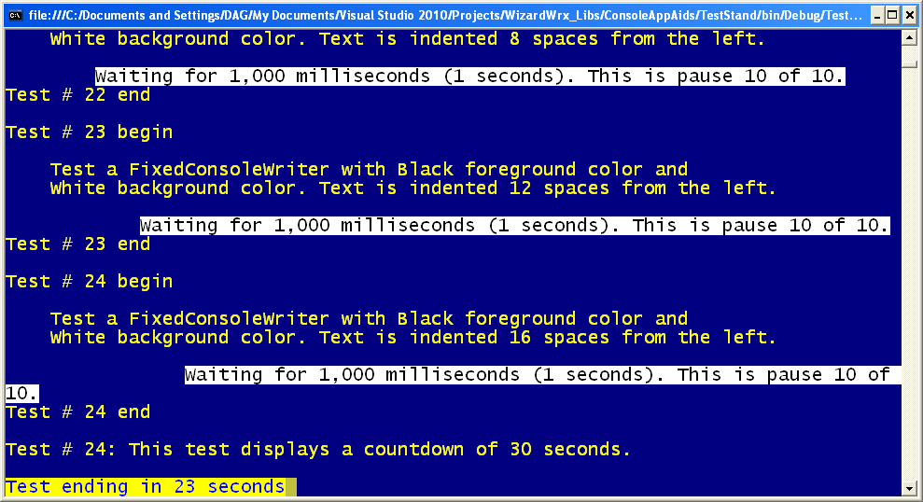
Figure 16 is the 3rd through 5th of the countdown tests.
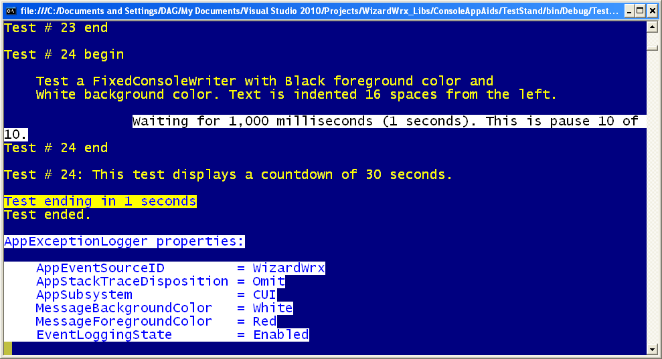
Figure 17 is the 1st of a series of reports covering the exception logger. The code for these tests predates adoption of the 1-byte bit mask.
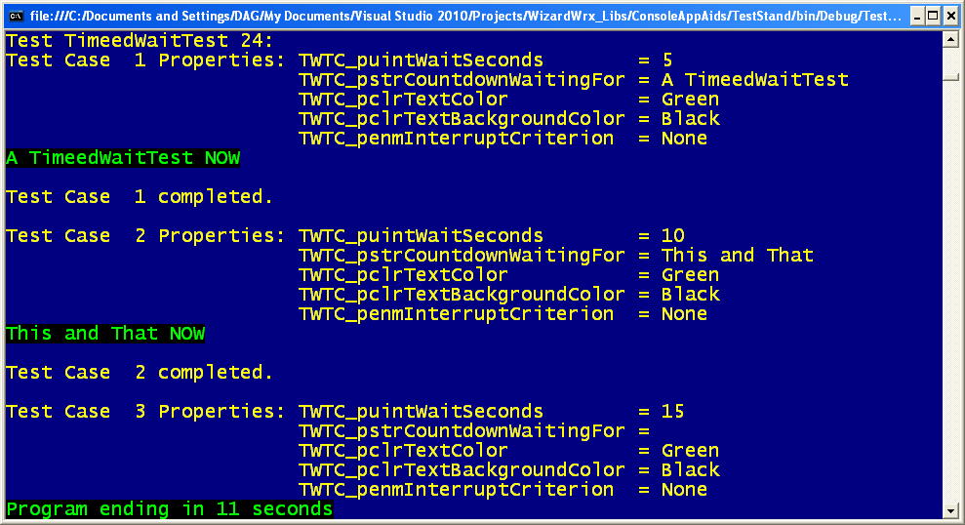
Figure 18 is the 1st three countdown demonstrations.
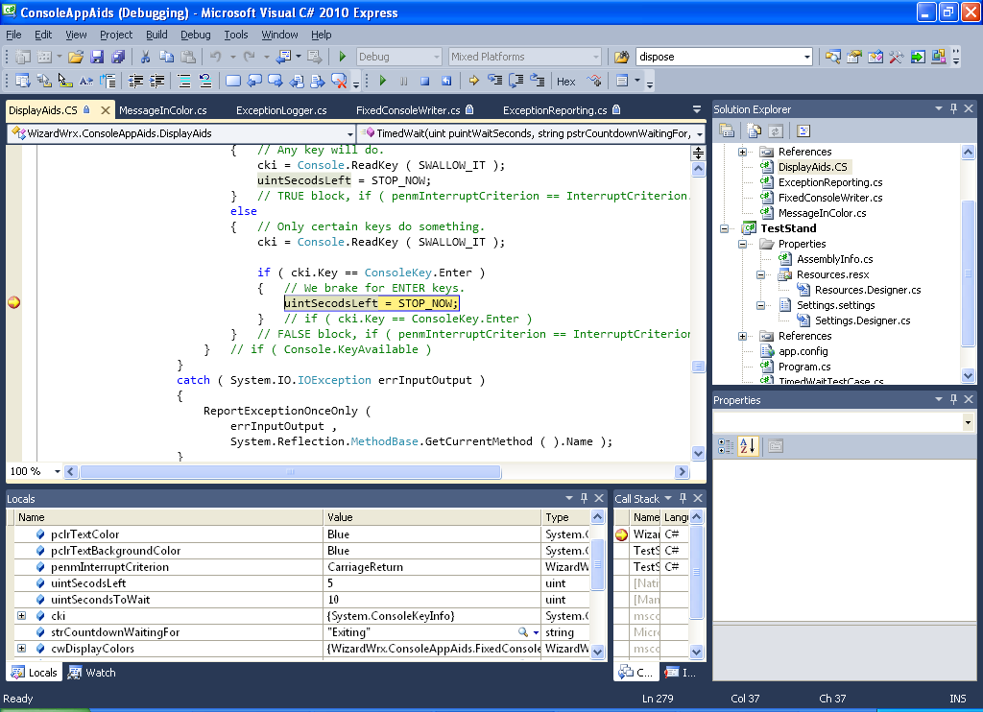
Figure 19 is the Visual Studio debugger, stopped in the middle of the countdown loop. This picture was made while the screen shown in Figure 20 was displayed.
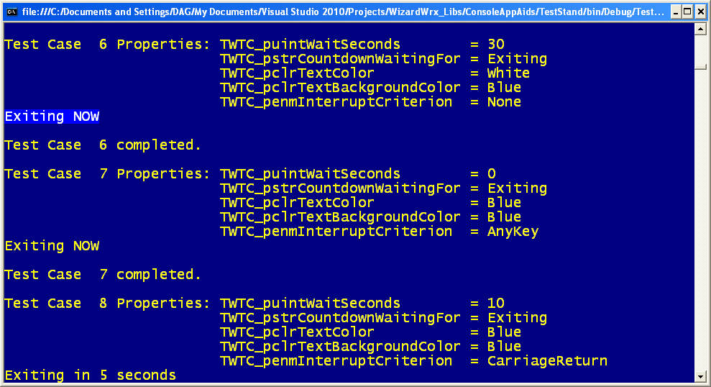
Figure 20 is the screen as it appeared when the screen shown in Figure 19 was captured.

Writing on a Console in Living Color
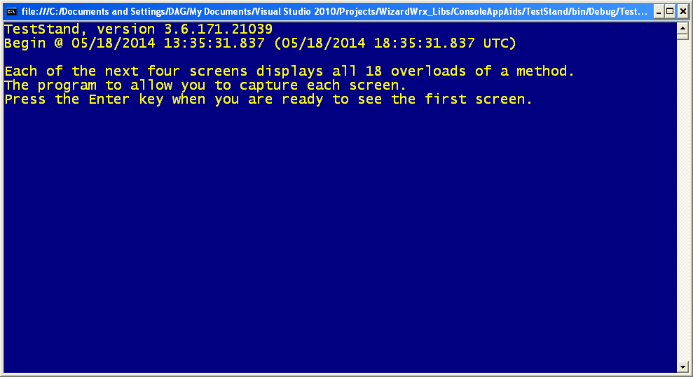
Figure 21 announces the beginning of a series of demonstrations of the various color console writers.
Figure 22 is the 1st of the color writing tests.
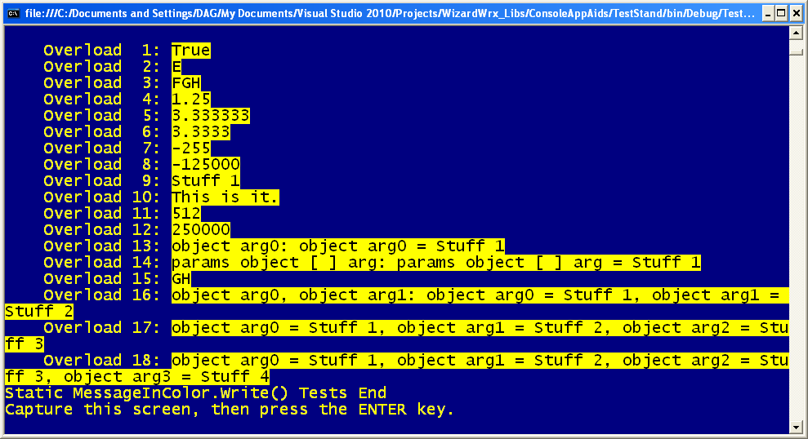
Figure 23 is the same set of tests, using black text on a yellow background.
Figure 24 returns to calmer colors.
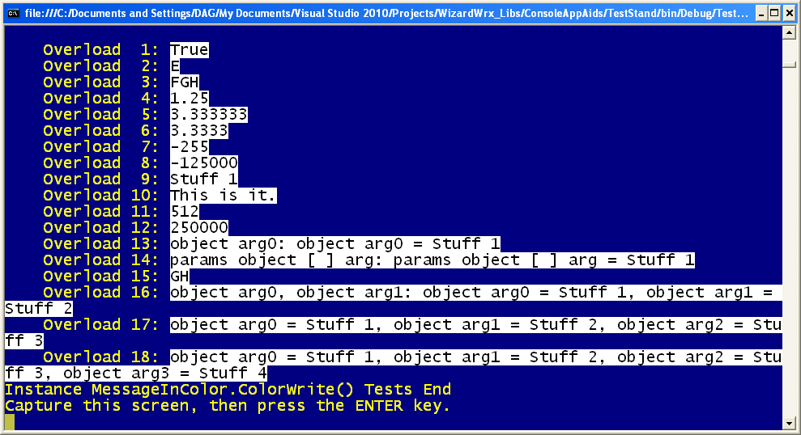
Figure 25 is black text on a white background, which looks much more stark than I might have expected, had I not played around a lot with the high contrast colors in Microsoft Windows that are supposed to help people with low vision. They may help some people, but I was underwhelmed.
Figure 26 is the 1st of a series of complete message displays, using various colors.

Test in a Real Console
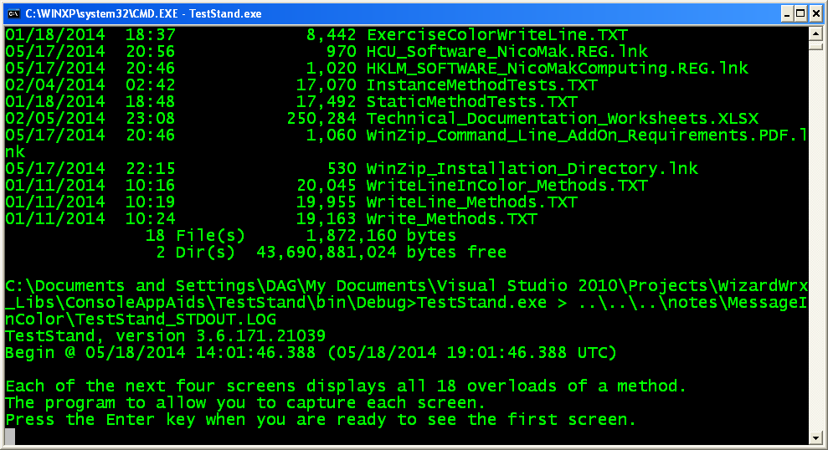
Figure 27 is my first hint that it might be behaving correctly. Maybe!
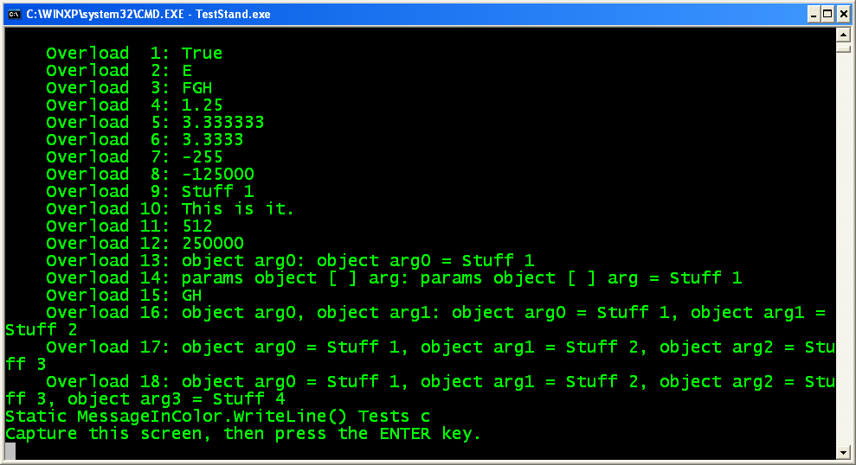
Figure 28 is a full set of console write tests, using the default screen colors.
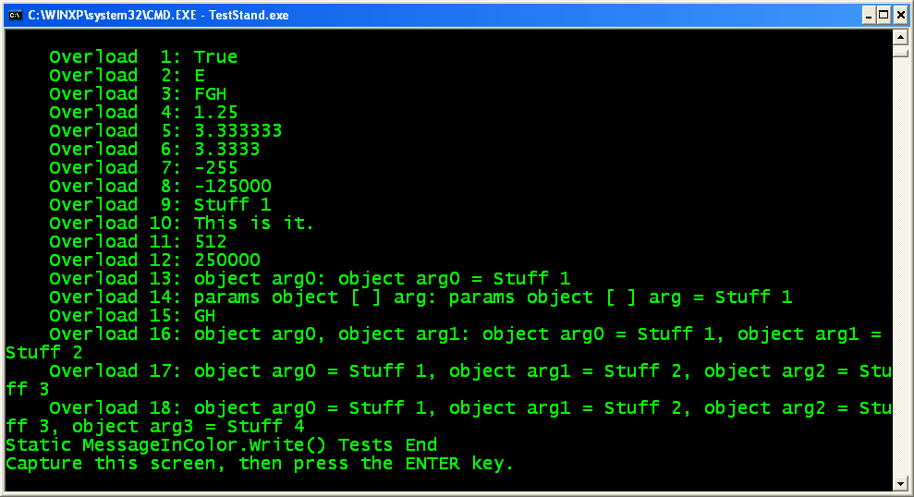
Figure 29 is the second set of console write tests.
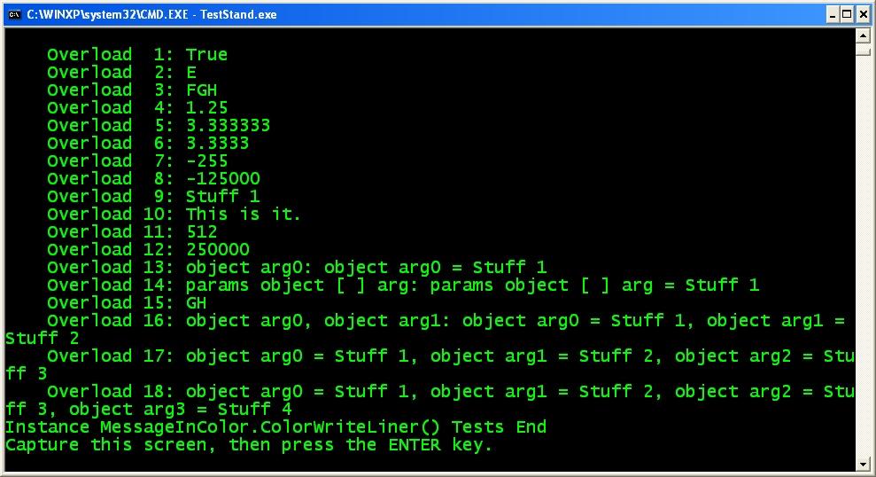
Figure 30 makes me wonder whether I lost my colors.
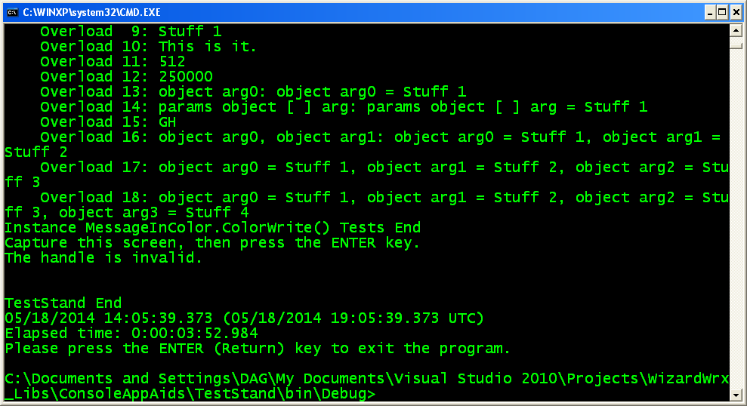
Figure 31 makes clear that my handle trick didn’t work, either.

