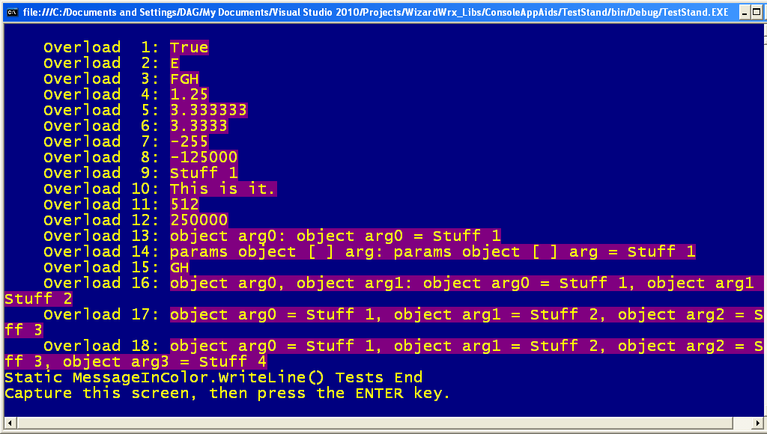
Figure 1 is the 1st of 4 screens, which displays the static WriteLine methods of the MessageInColor class, using Yellow text on a DarkMagenta background.
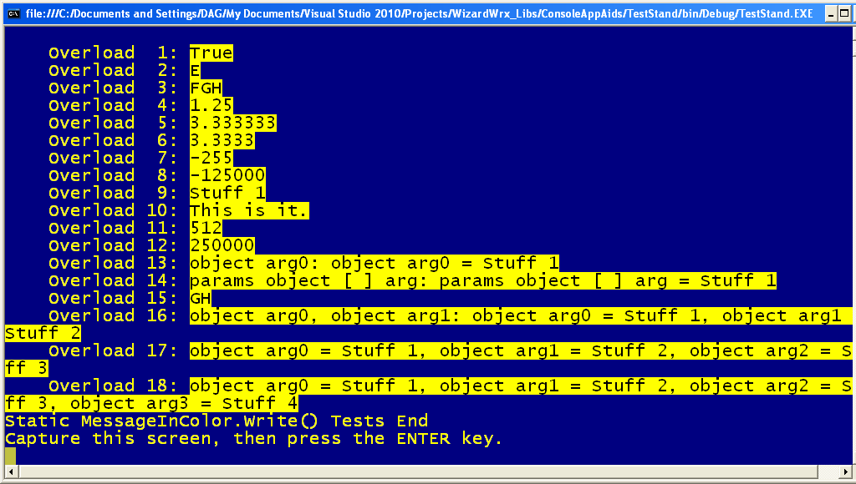
Figure 2 is the 2nd of 4 screens, which displays the static Write methods of the MessageInColor class, using Black text on a Yellow background.
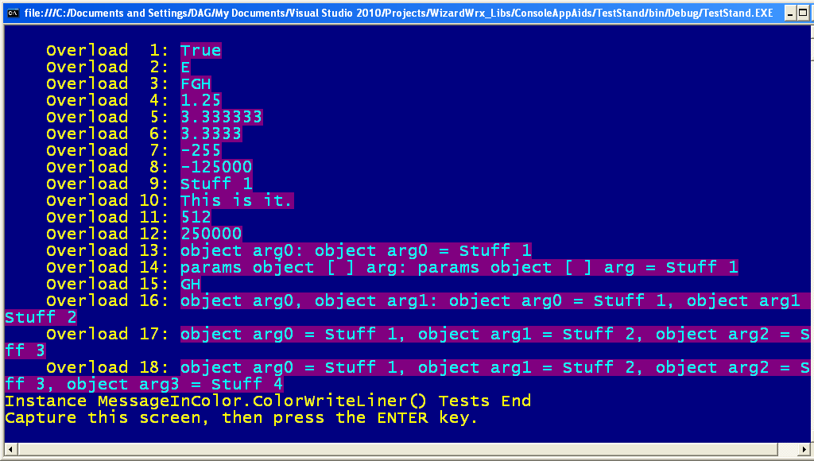
Figure 3 is the 3rd of 4 screens, which displays the instance ColorWriteLine methods of an instance of the MessageInColor class, using Cyan text on a DarkMagenta background.
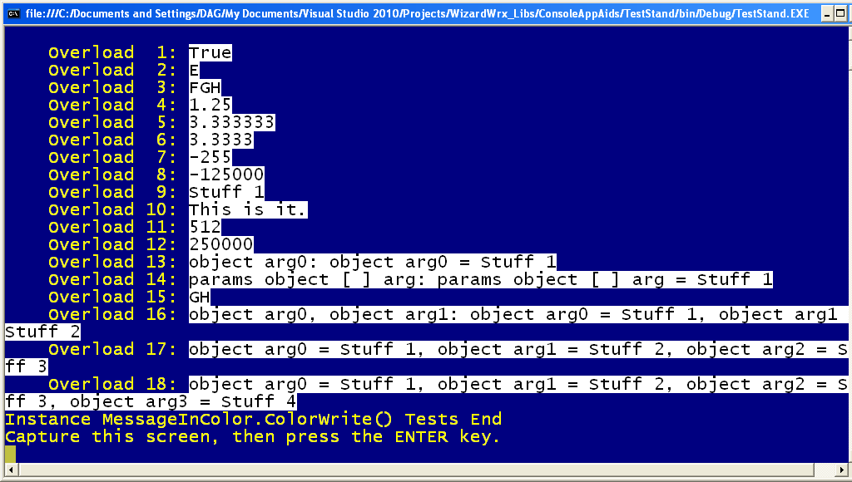
Figure 4 is the 4th of 4 screens, which displays the instance ColorWrite methods of an instance of the MessageInColor class, using Black text on a White background.
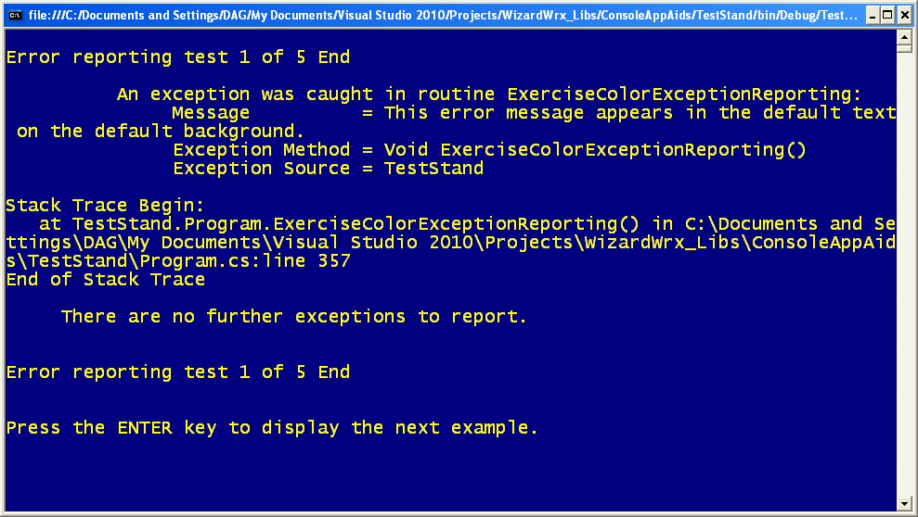
Figure 5 is the original, plain Jane error message display, which renders in the default screen colors.
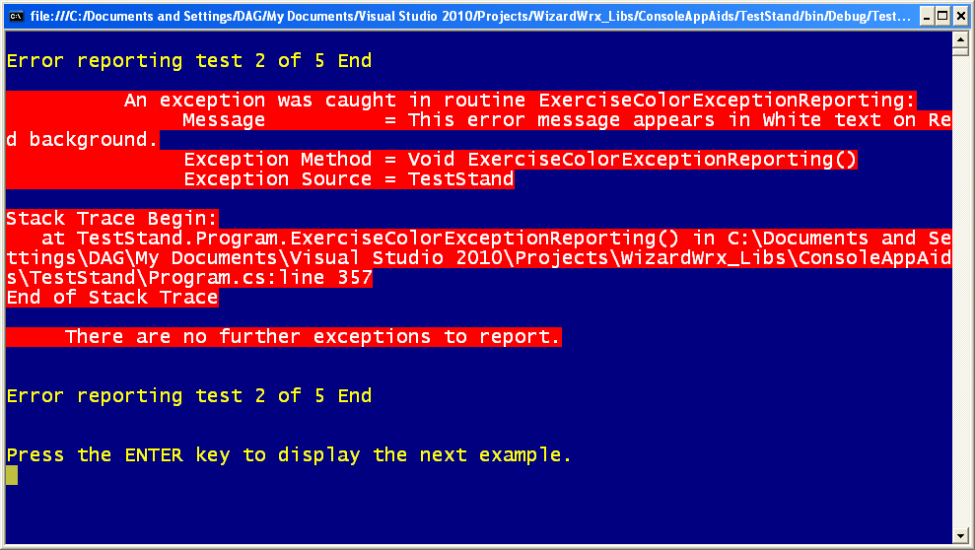
Figure 6 is essentially the same exception report, rendered in white text on a red background. It’s pretty intimidating.
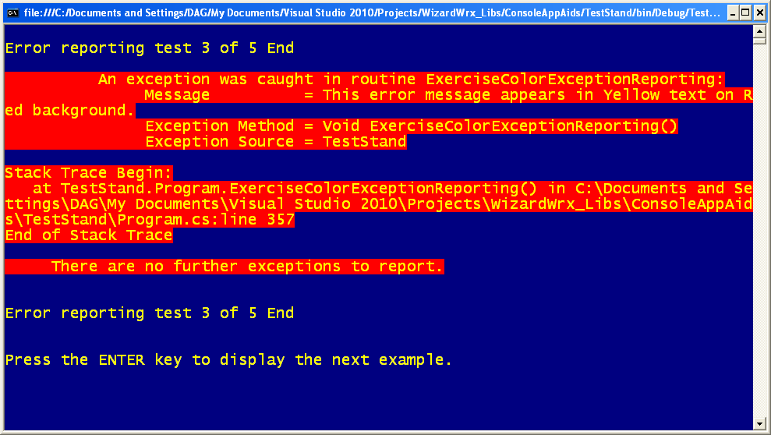
Figure 7 is essentially the same exception report, rendered in yellow text on the same red background as was shown in Figure 6, and it is equally intimidating.
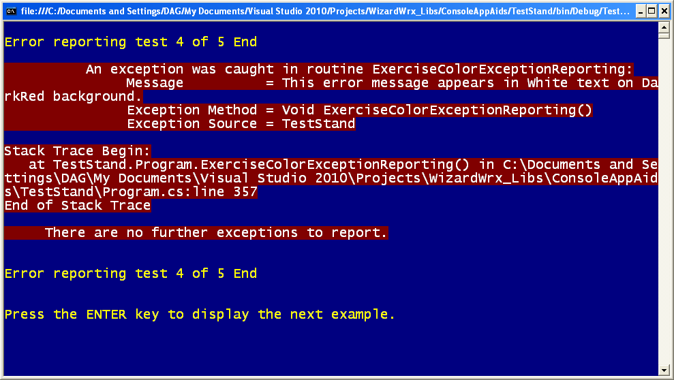
Figure 8 is essentially the same exception report, rendered in white text on a dark red background. This gets attention, without being as overwhelming as the examples shown in Figure 6 and Figure 7.
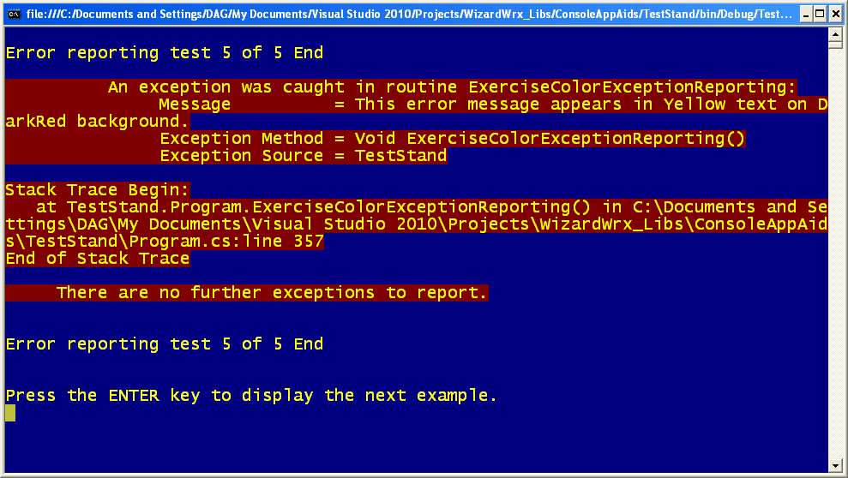
Figure 9 is essentially the same exception report, rendered in the yellow text first mentioned in Figure 7 and the darker red background shown in Figure 8.
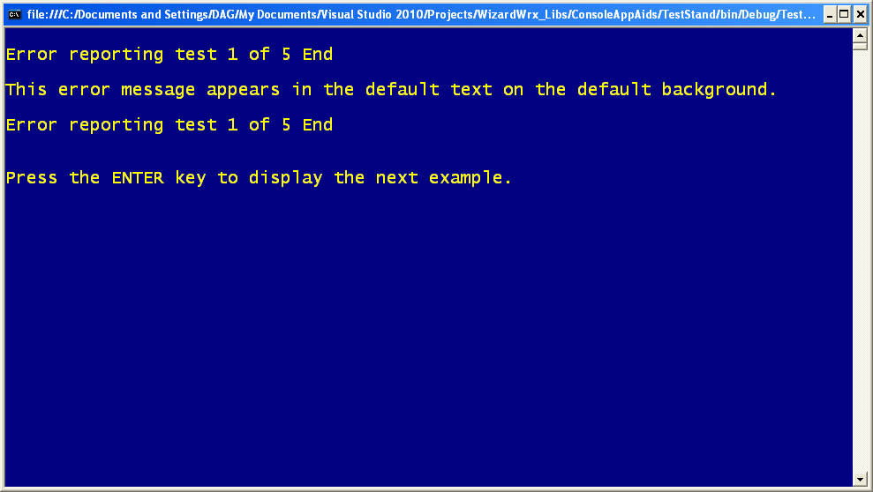
Figure 10 is the abbreviated exception report, showing only the message. This brief message, easily overlooked, motivated me to develop this class.
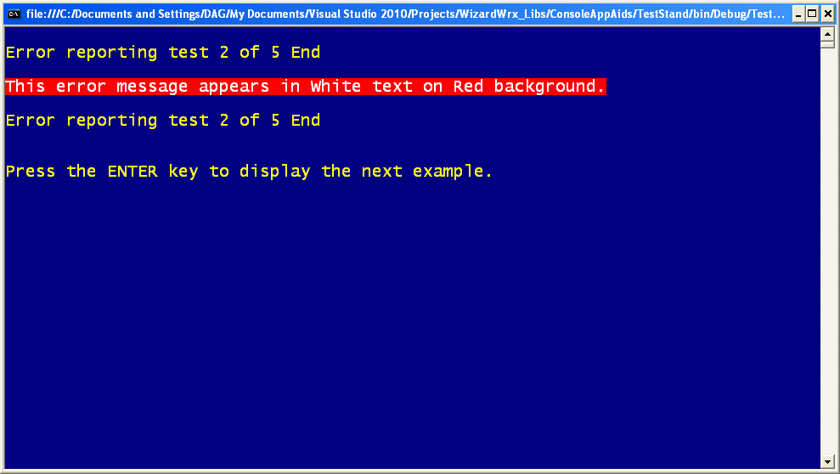
Figure 11 uses the same colors as Figure 6. This limited use is much less intimidating.
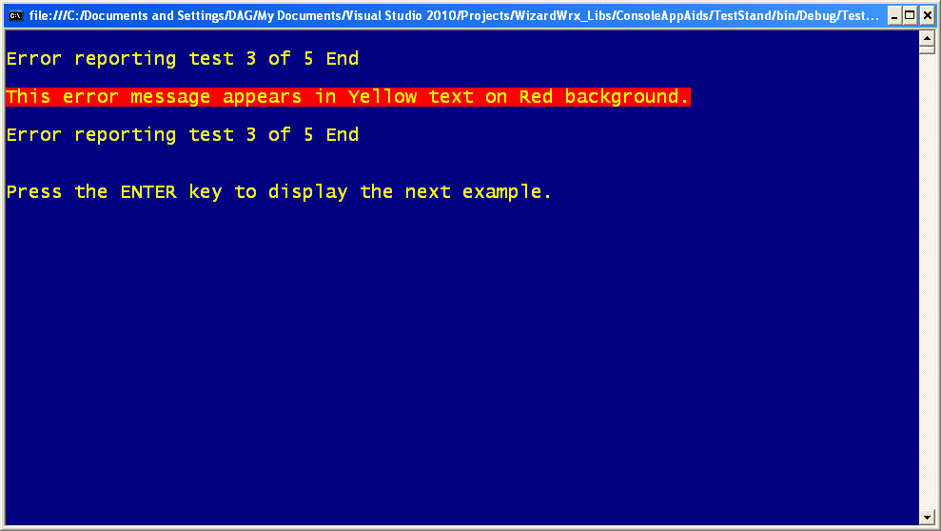
Figure 12 uses the same colors as Figure 7, and, as is the case with the colors shown in Figure 11, gets attention without being overwhelming.
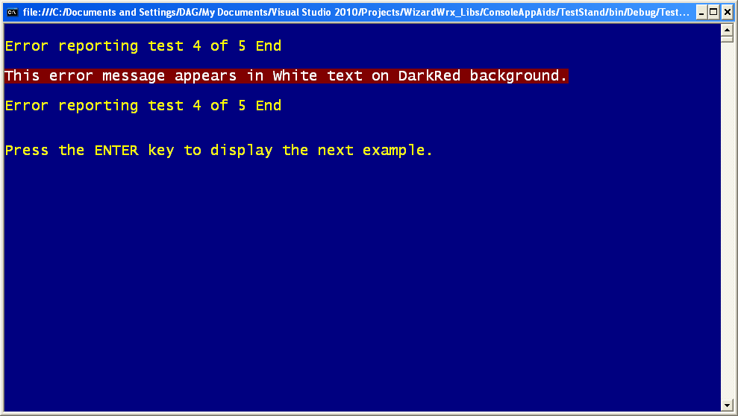
Figure 13 uses the white text and dark background first shown in Figure 8. Though it is a bit more muted than the messages shown in Figure 11 and Figure 12, this color scheme gets the job done.
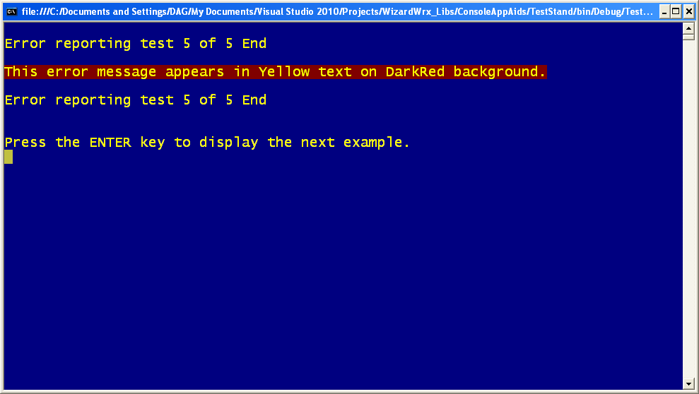
Figure 14 uses yellow text on a dark red background to make a stronger statement than does the message shown in Figure 13.

