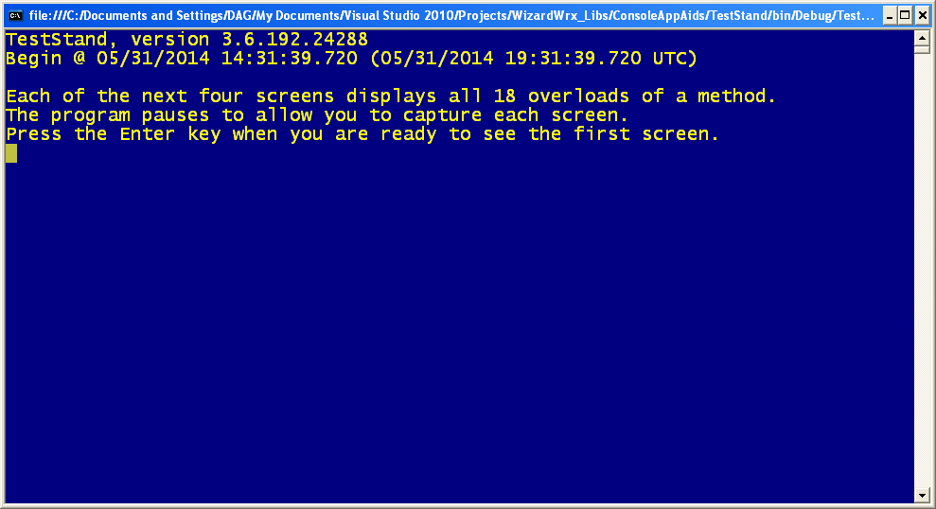
Figure 1 is the first page displayed by build 3.6.192.24288 of the test program.
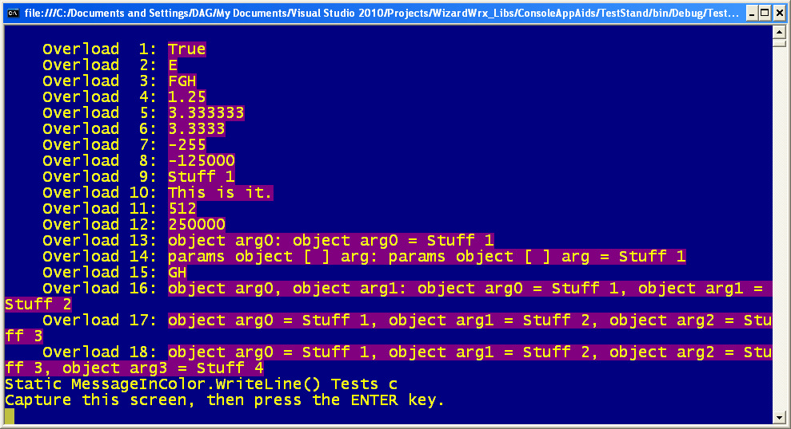
Figure 2 is the first set of actual messages, and I see a possible issue in the penultimate line.
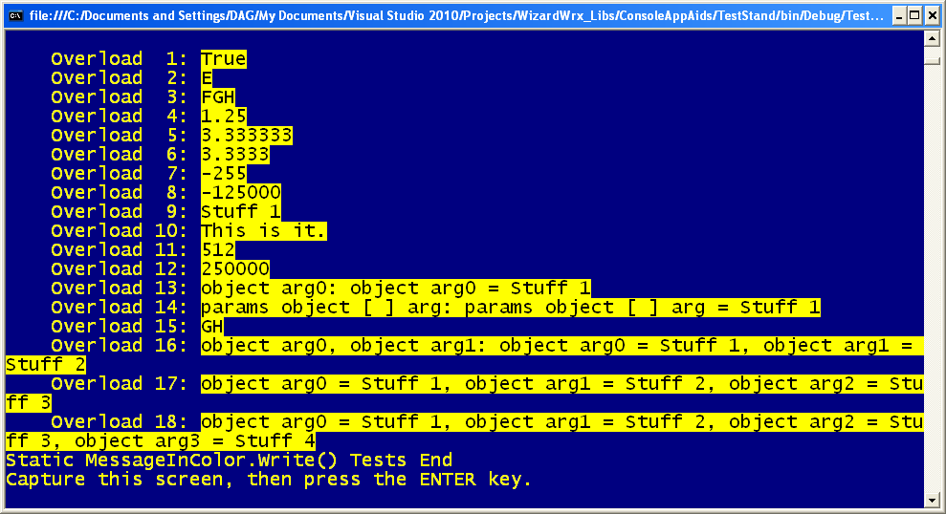
Figure 3 is the second set of messages, which doesn’t demonstrate the stray character visible at the bottom of Figure 2.
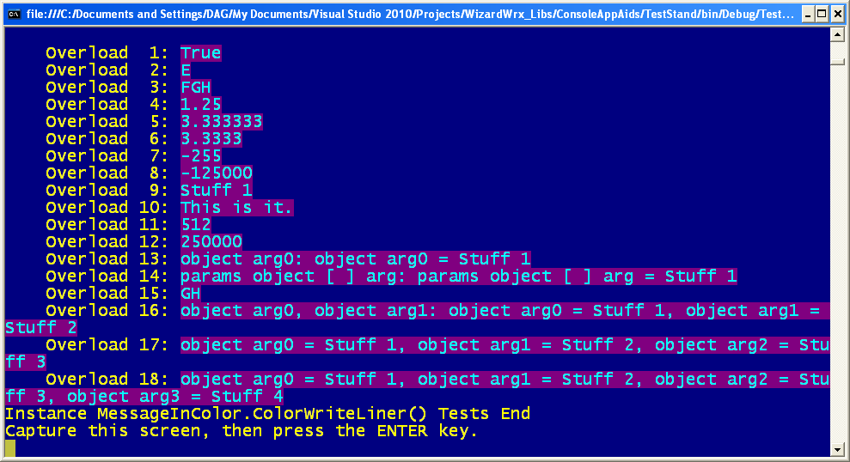
Figure 4 is the 3rd set of messages, which is also free of the stray character visible at the bottom of Figure 2. Since it is also absent from the screen shown in Figure 3, it may be a keyboard artifact.
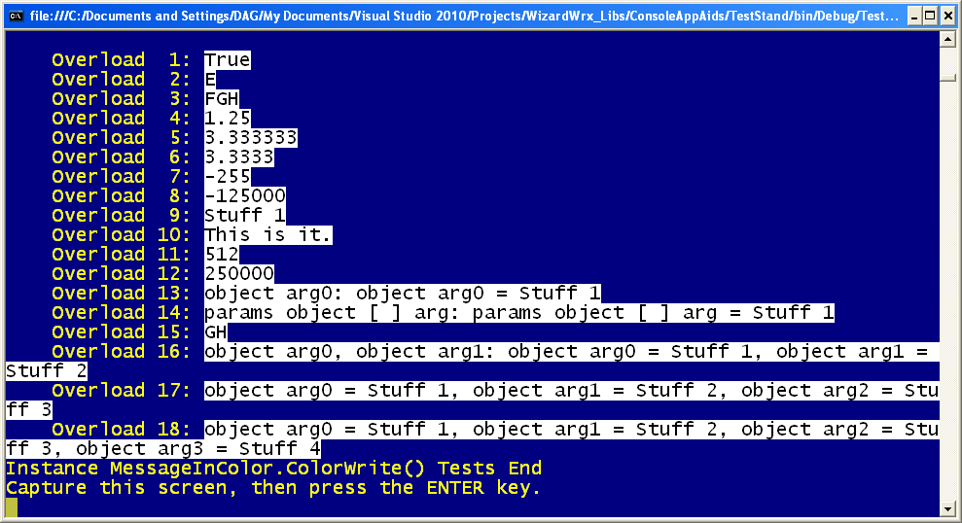
Figure 5 is the 4th set of messages, and the artifact seen in the 1st set has not resurfaced.
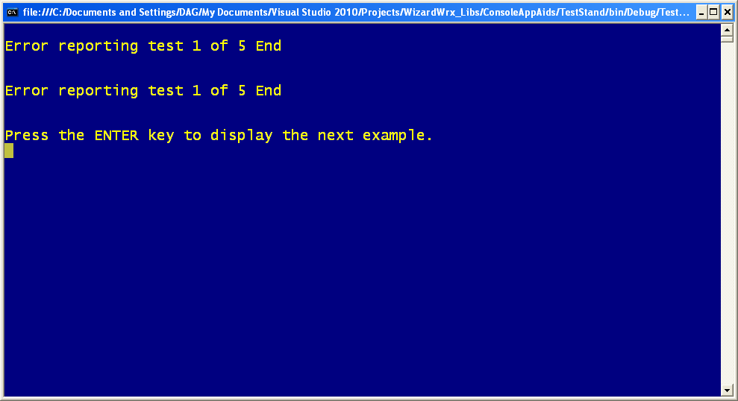
Figure 6 announces the 1st of a new batch of tests. The absence of a message between the 1st and 3rd lines bothers me.
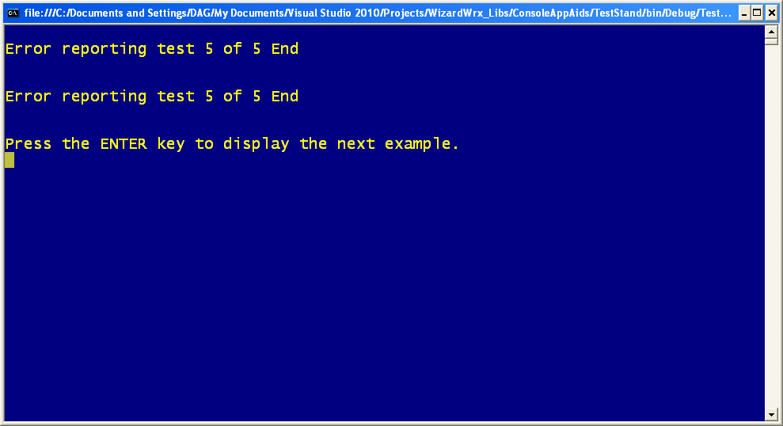
Figure 7 is the 5th of 5 tests; it had no message. Neither did the 2nd, 3rd, and 4th messages, all of which I skipped. This may indicate a bug in the test program, caused by internal changes in the way the ExceptionLogger class handles the flags that govern its behavior and output.
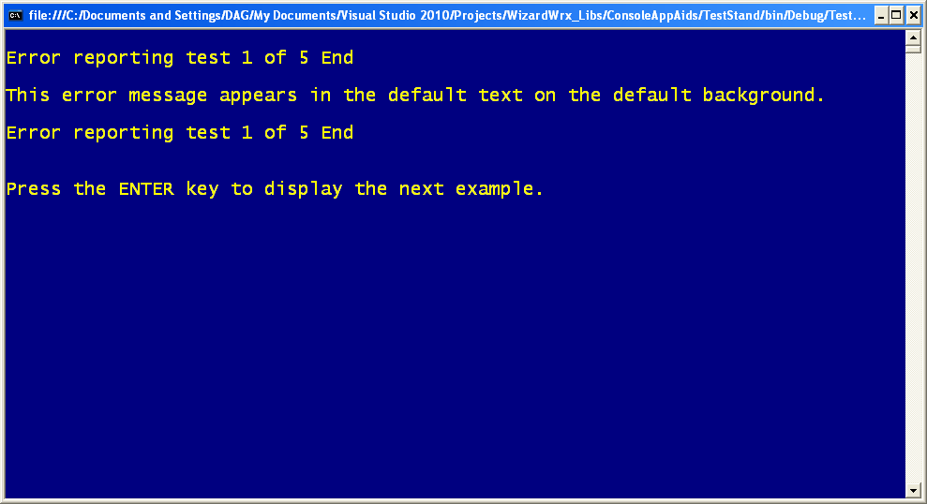
Figure 8 is the 1st of a new quintet of tests, which looks OK.
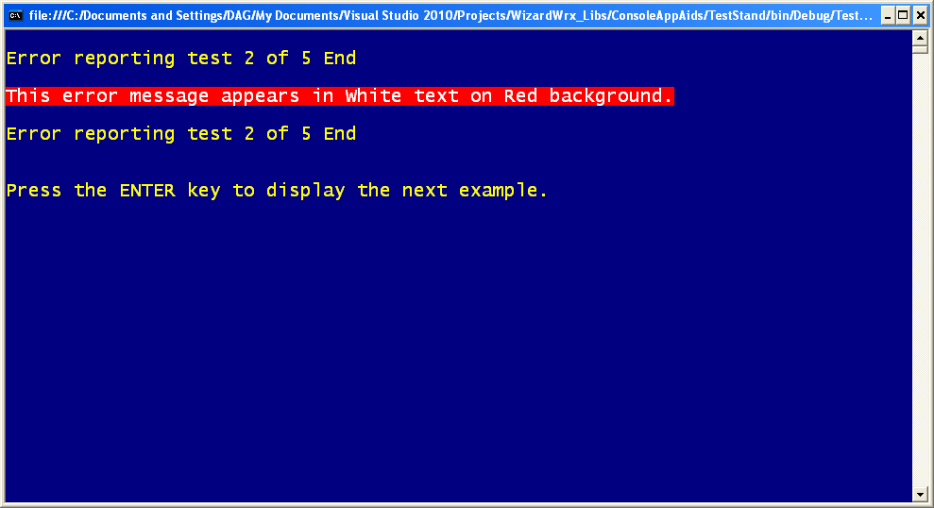
Figure 9 is the 2nd of the new test quintet, and it appears according to plan, too.
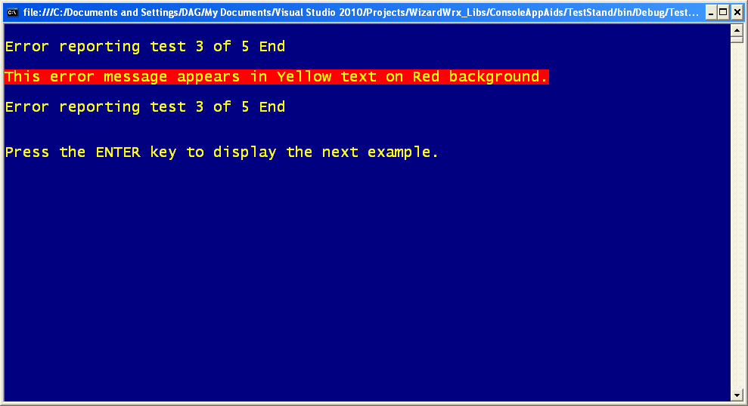
Figure 10 is the 3rd of this quintet of tests, which is also following plan.
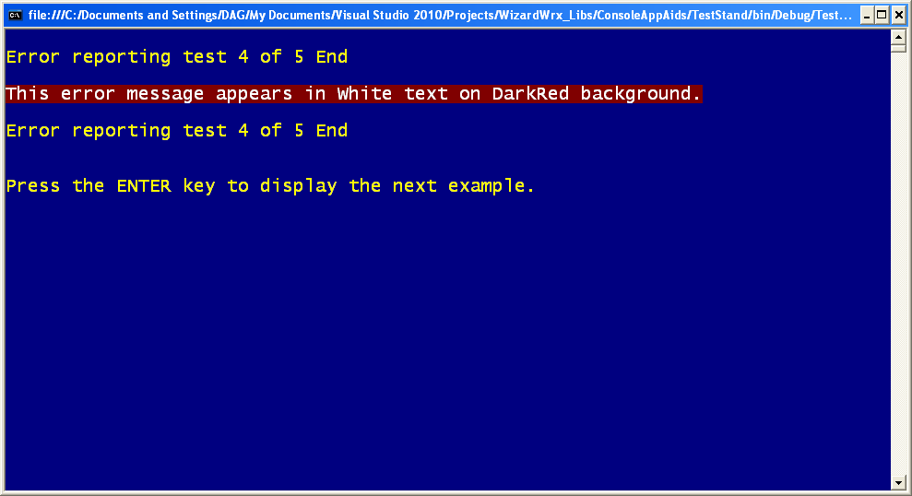
Figure 11 is the 4th of the 5 tests in this set, which is also as expected.
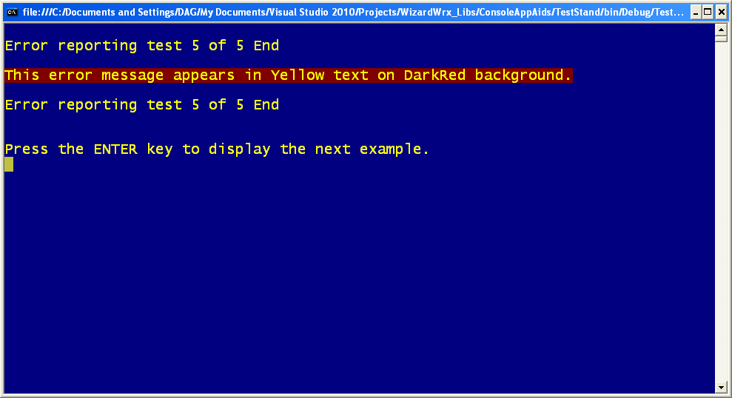
Figure 12 is the 5th of the 5 tests in the 3rd group, which is also nominal.
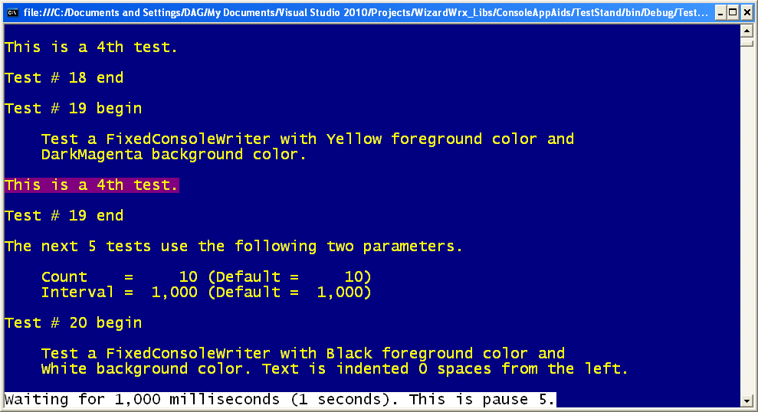
Figure 13 begins a series of tests on the fixed color text writer.
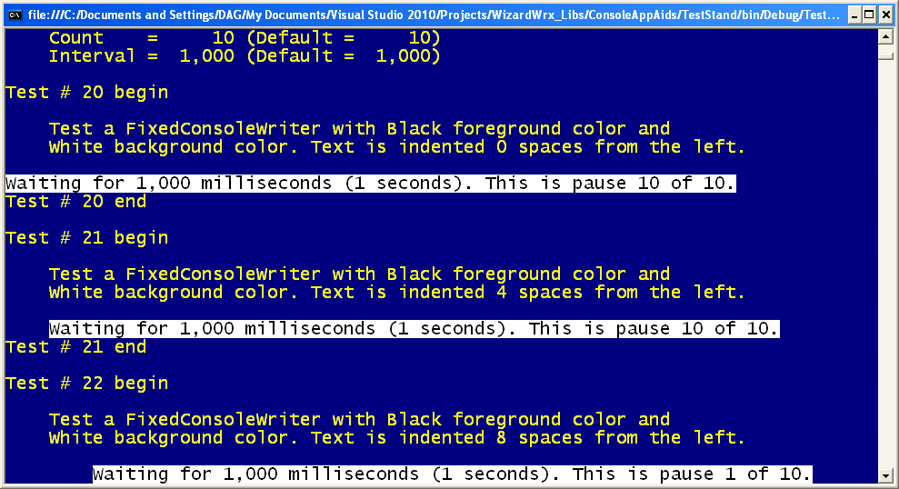
Figure 14 is further along in the fixed color writer tests.
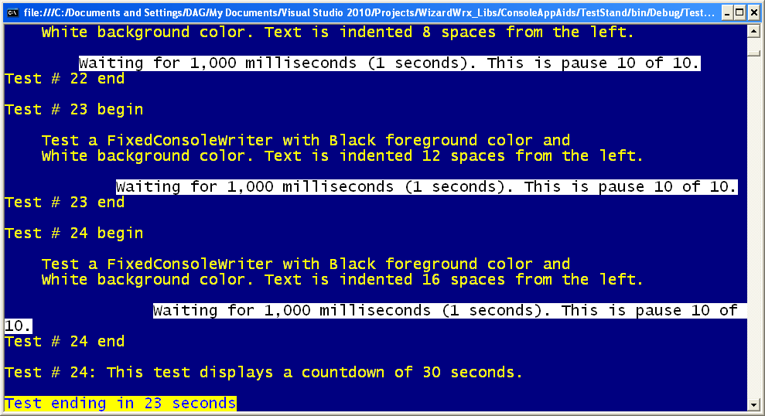
Figure 15 is the beginning of the timed pause tests.
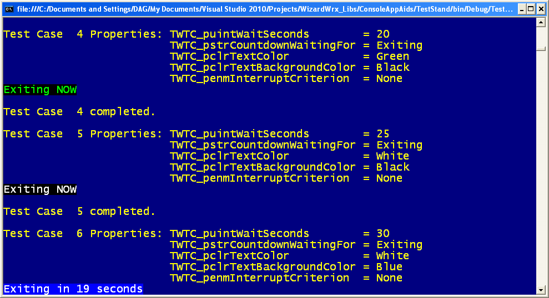
Figure 16 is several steps further into the timed pause tests; several new color schemes appear in this screen.
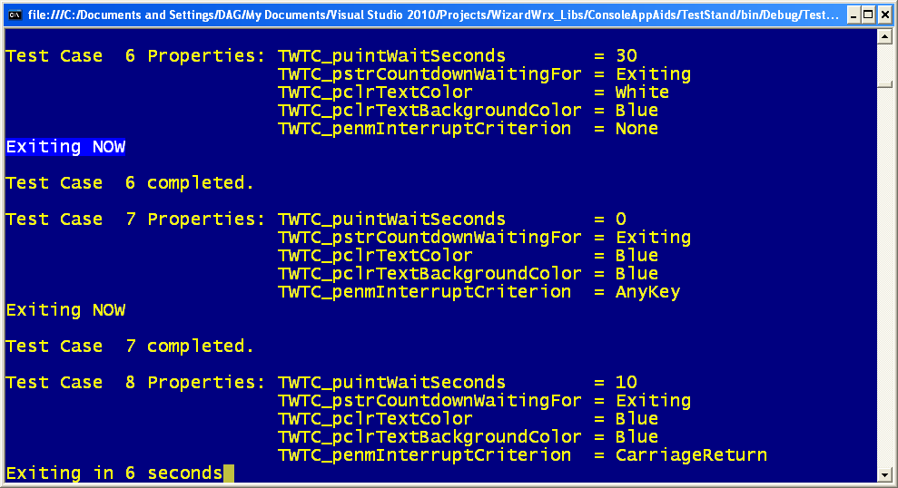
Figure 17 is further along, where we are testing different termination scenarios.
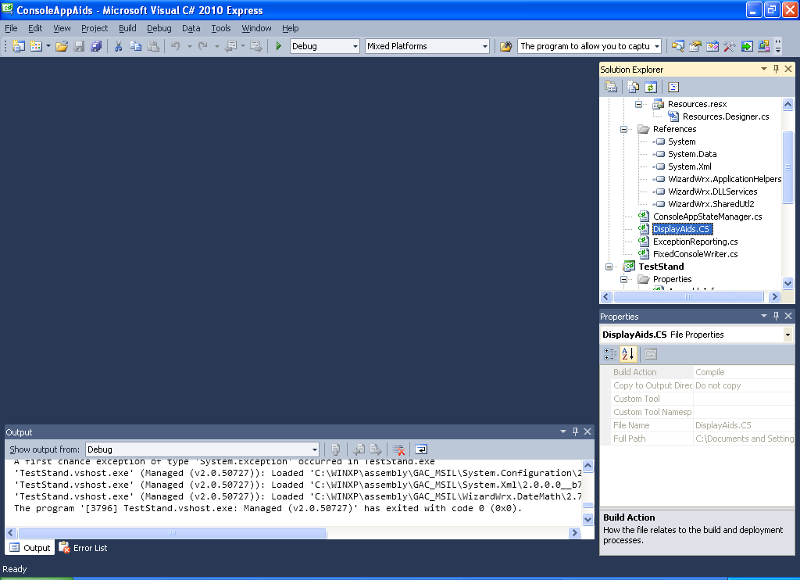
Figure 18 is the Visual Studio debugger, showing the CodeView output log, which confirms that the program ended on its own.
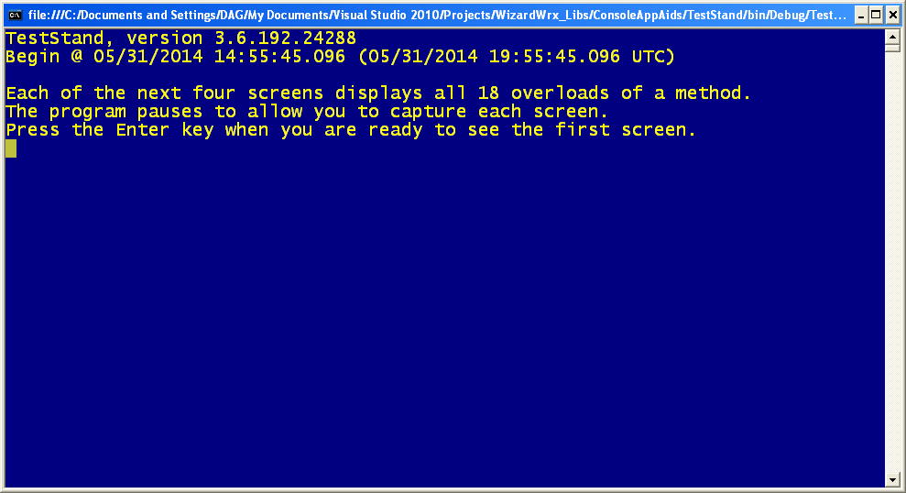
Figure 19 documents the program restarting, to repeat the test reported in Figure 2.
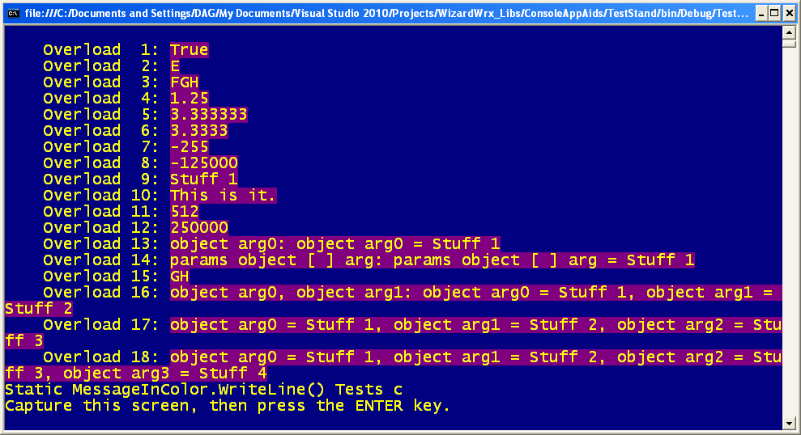
Figure 20 confirms that the display in Figure 2 is due to a real formatting error, not a screen or keyboard artifact.
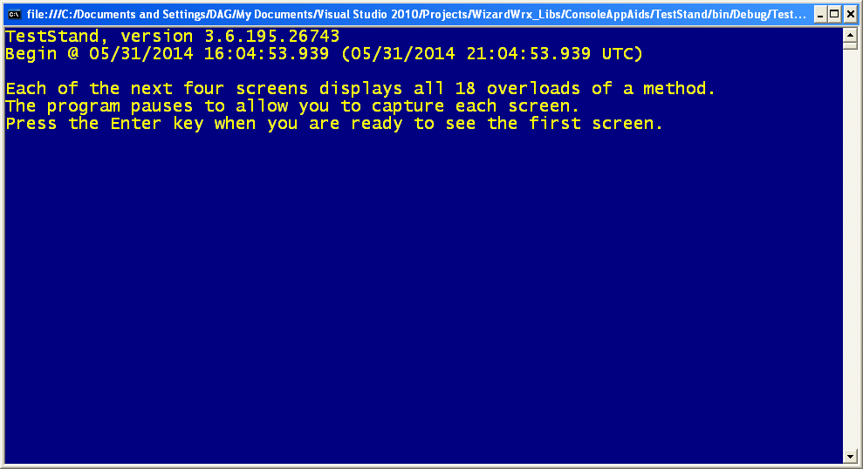
Figure 21 establishes that the following pages are generated by a new build, 3.6.195.26743; the build that produced the screen shown in Figure 2 was build 3.6.192.24288. See Figure 1, which displays the build number.
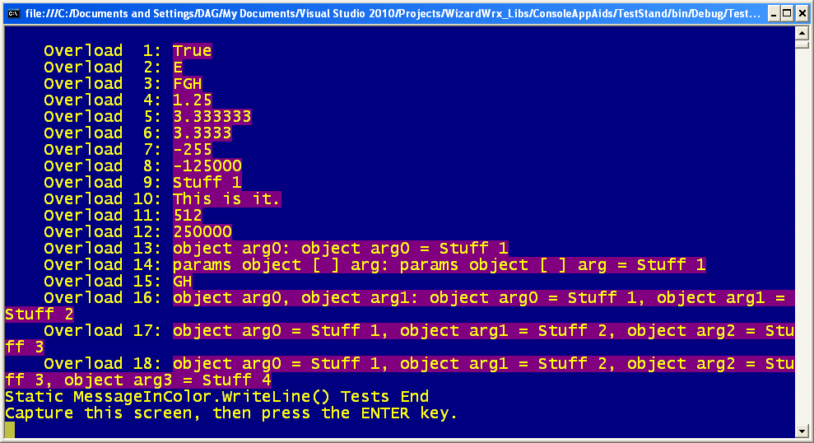
Figure 22 is a screen capture of the static MessageInColor.WriteLine test first shown in Figure 2 was captured, and the artifact is gone.
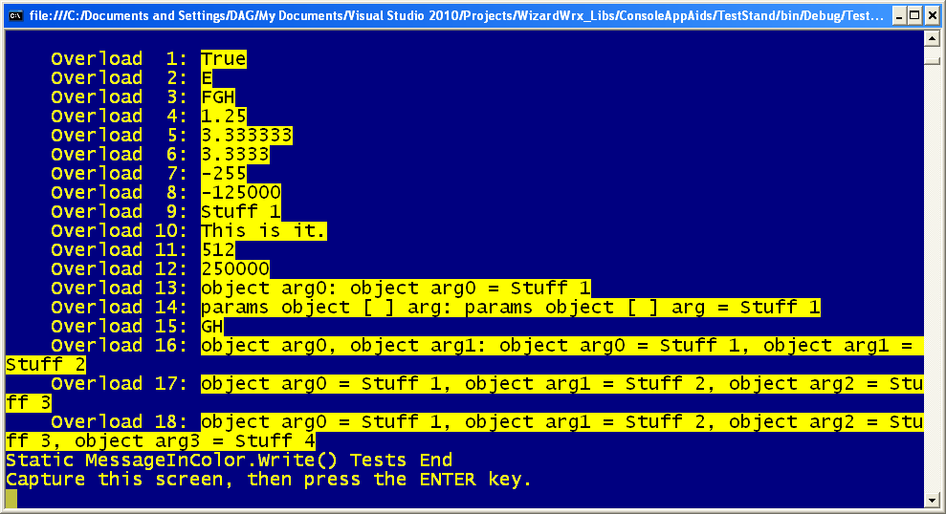
Figure 23 is the 2nd of 4 full page tests. This test covers the static MessageInColor.Write method exercises.
Figure 24 is the 3rd of four full-page tests; this test covers all overloads of the instance MessageInColor.ColorWriteLine tests, and I see another typographical error in the fixed message text.
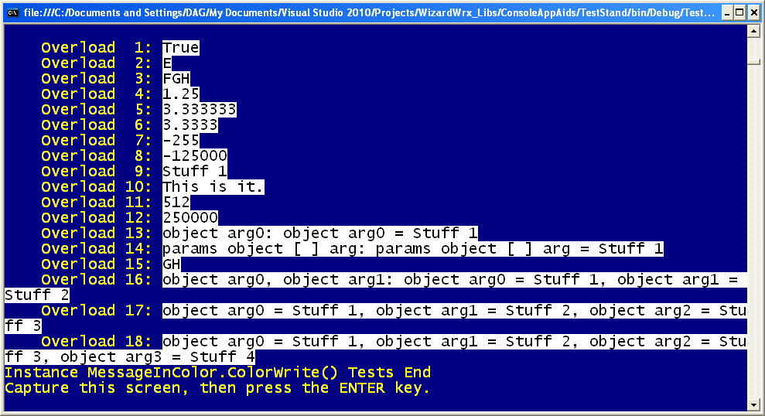
Figure 25 is the 4th of the 4 full-page exercises. This page demonstrates all overloads of the instance MessageInColor.ColorWrite method.
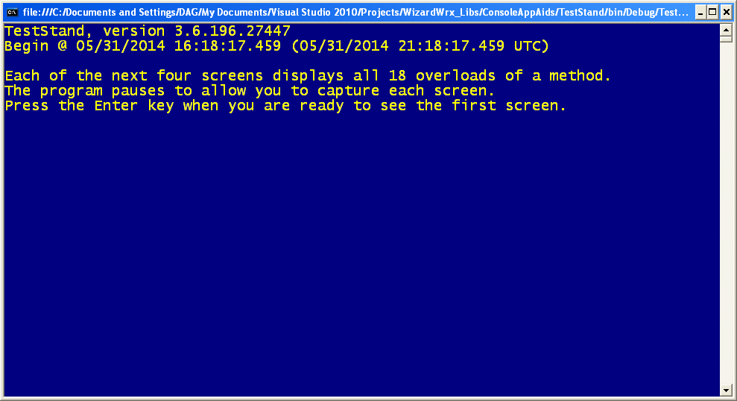
Figure 26 establishes that the following screens are generated by a new build, version 3.6.196.27447, of the test program.
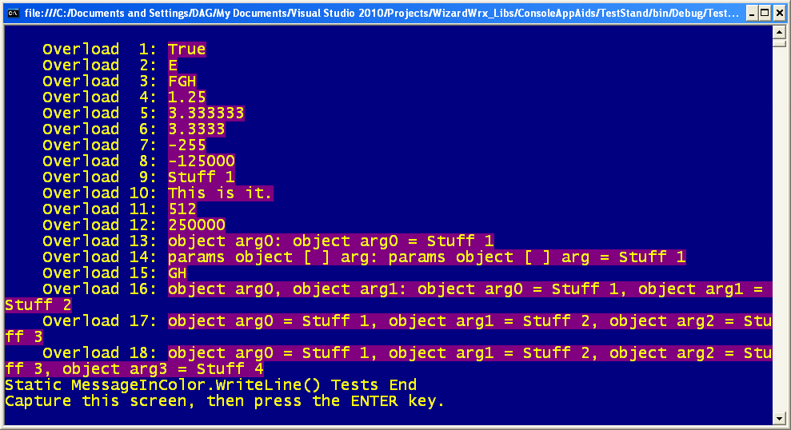
Figure 27 confirms that the Static MessageInColor.WriteLine test page is correct.
Figure 28 confirms that the Static MessageInColor.Write test page is correct.
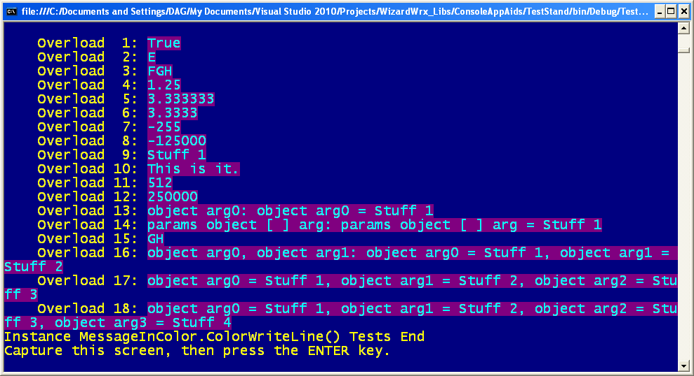
Figure 29 establishes that the Instance MessageInColor.ColorWriteLine test page is correct.
Figure 30 establishes that the Instance MessageInColor.ColorWrite test page is correct.

