Degenerate Case – All Three Standard Handles Attached
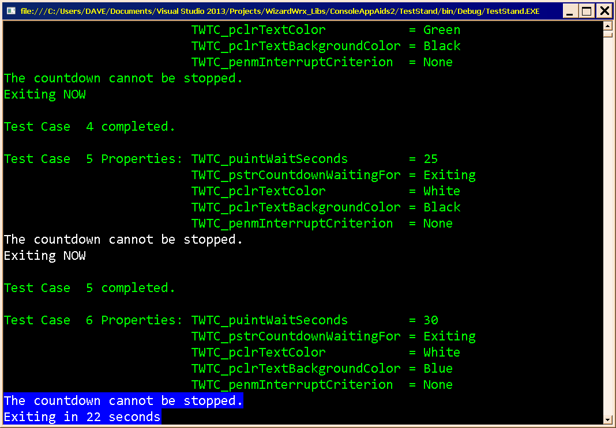
Figure 1 documents that the color coded messages are working, and that the prompt color matches that of its countdown messages. The final message is shown in Figure 2
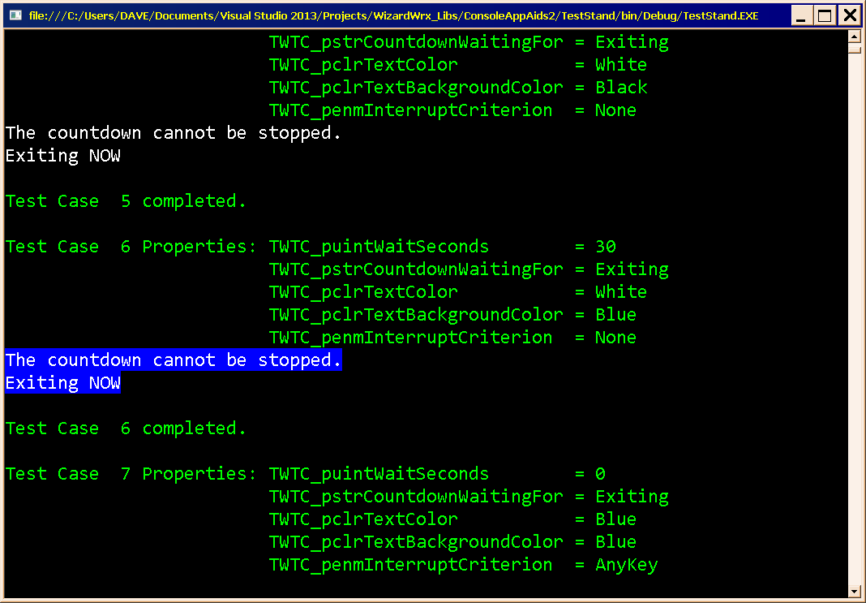
Figure 2 documents that the color of the final message displayed by the second test matches that of the countdown messages shown in Figure 1.
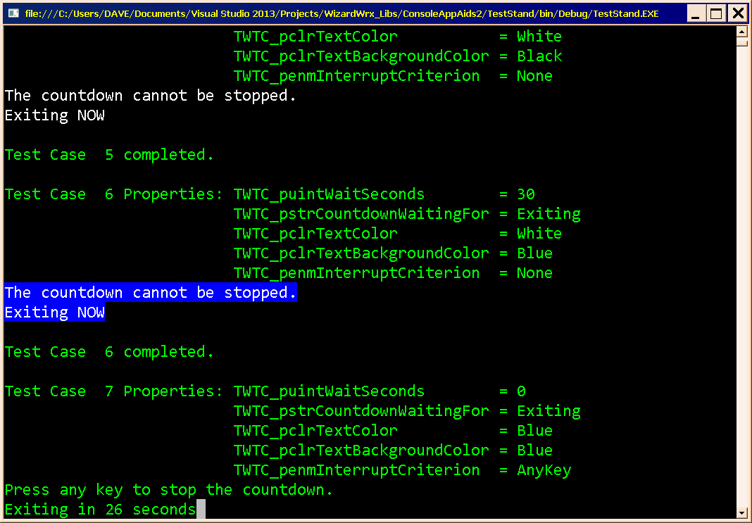
Figure 3 documents the correct behavior of a timed wait that has its foreground and background colors set to the same value, which the method interprets as “use the current console colors.” As always, the prompt appears in the same colors. Figure 4 shows the termination message.
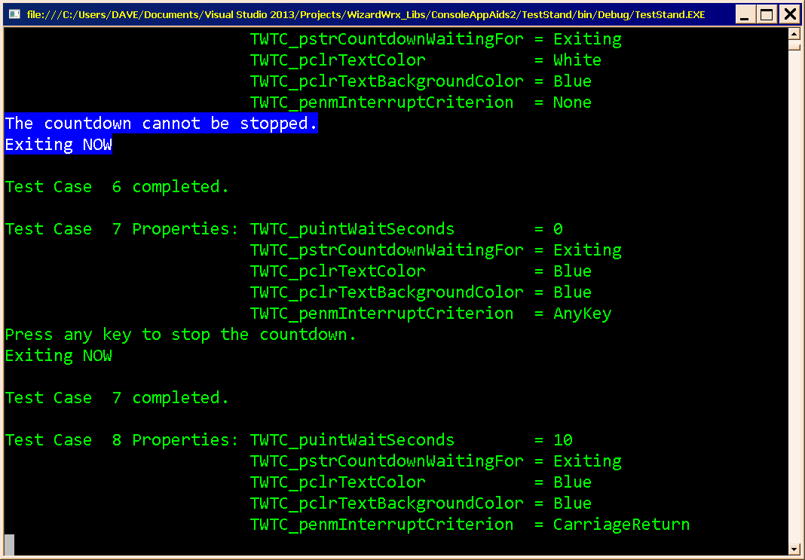
Figure 4 is the countdown shown in Figure 3, which was terminated early by pressing any key. However, there is nothing in the output to document the early termination. Contrast this with the improvement shown in Figure 6.
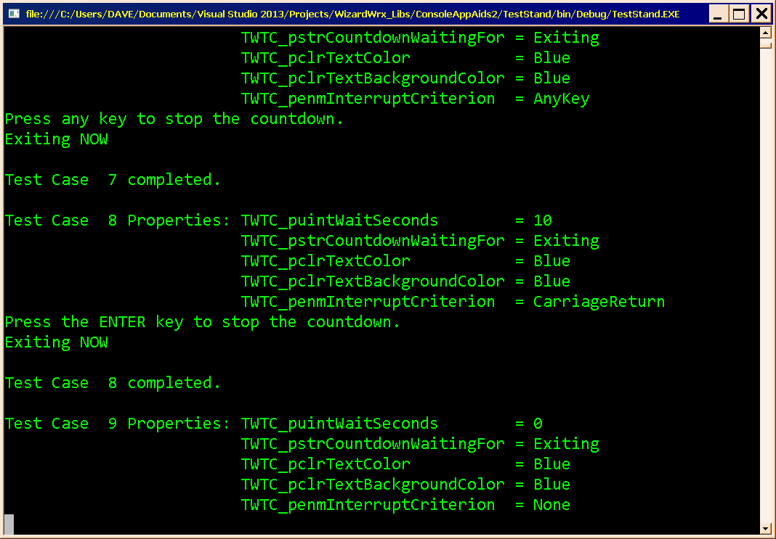
Figure 5 is a countdown that could be stopped by pressing the Enter key (and only the enter key!), and its early termination. As is so in the previous case, shown in Figure 4, there is no outward sign of the early exit.
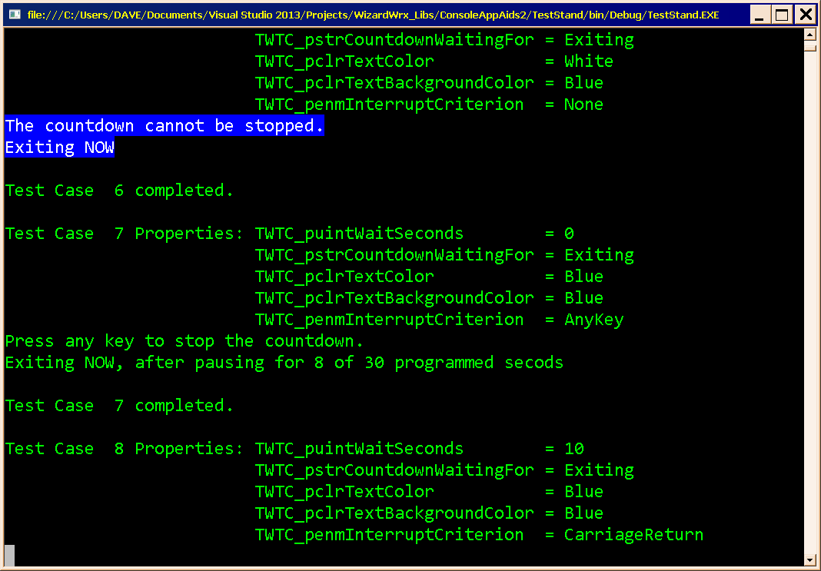
Figure 6 is the improved timed wait routine, which now indicates both how long it waited, and the maximum time that was allotted, if the wait terminates early. Contrast this with Figure 4.
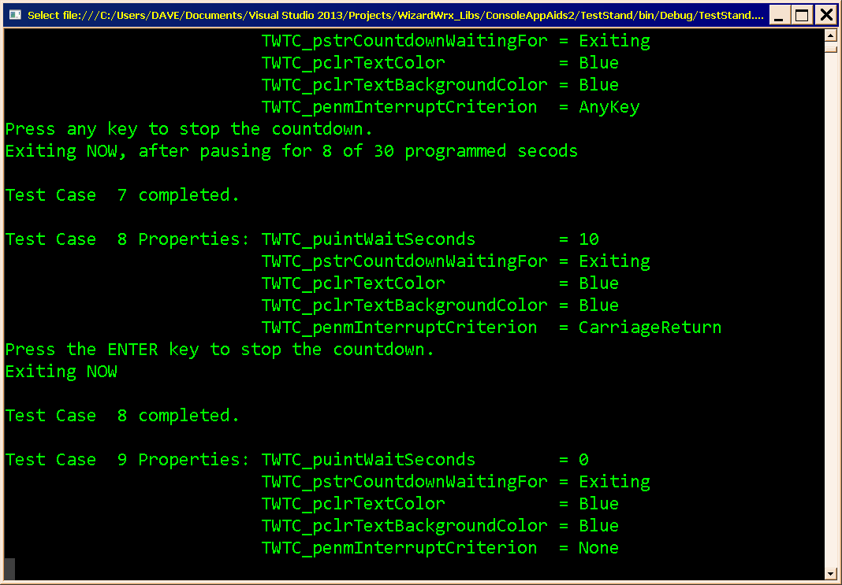
Figure 7 is the second interruptible test, which I allowed to run its course. As above, nothing is mentioned about early termination, or even the duration of the pause.
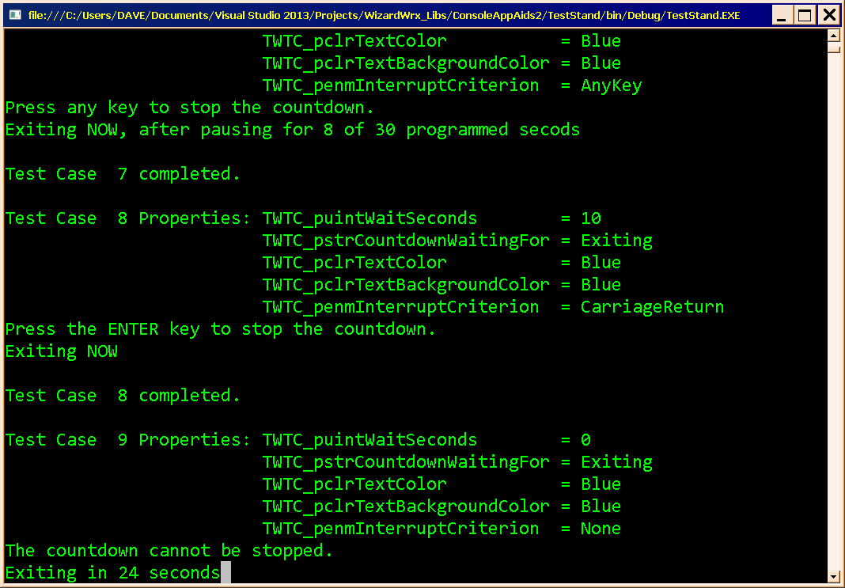
Figure 8 is the next test, which specified an invalid wait time of zero. It should be fairly evident that it is applying the default wait time of 30 seconds.
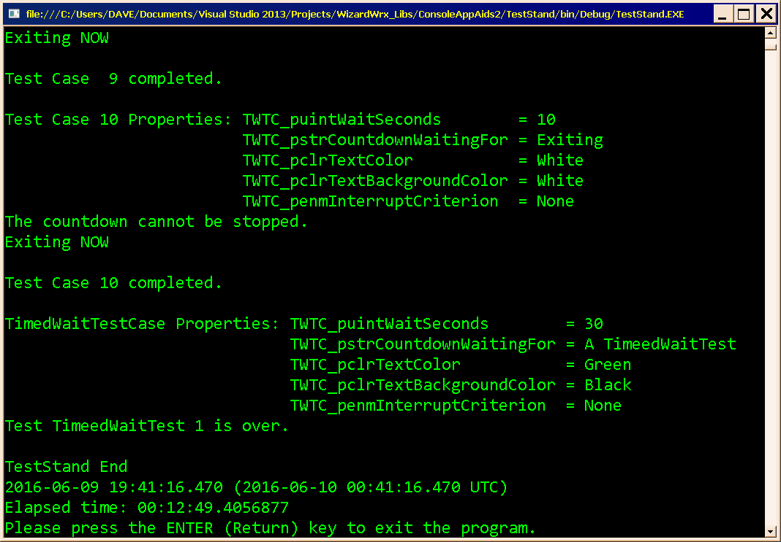
Figure 9 is the final message displayed by the program, which ran for quite a long time, doe to the combination of the lengths of the pauses and the extra time required to create these images.

Alternative Scenario – Standard Output Redirected
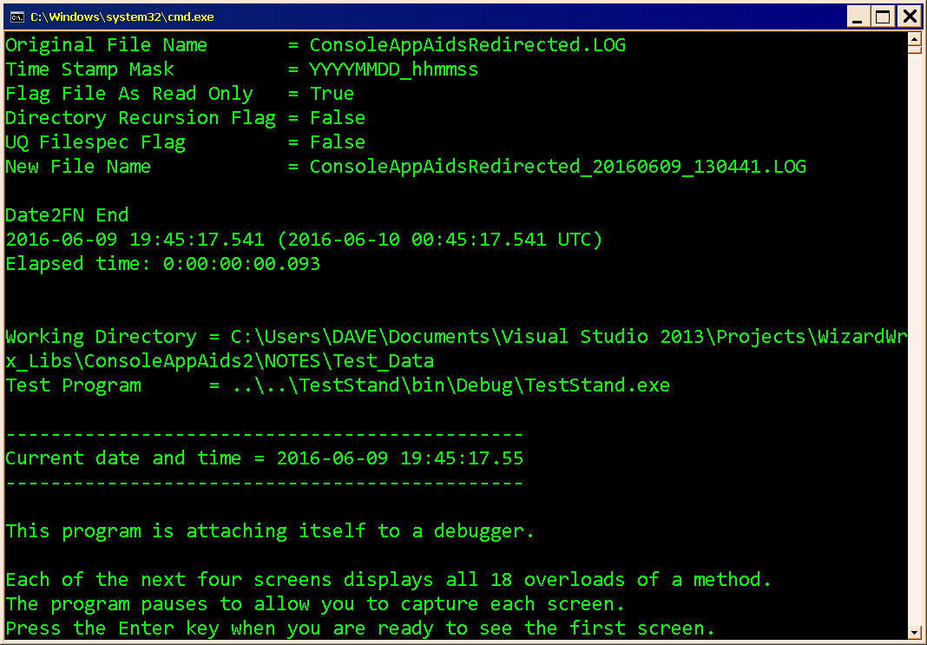
Figure 10 is the initial display, before anything happens. This is a debug build that has instructions to attach itself to a debugger when it starts without one.
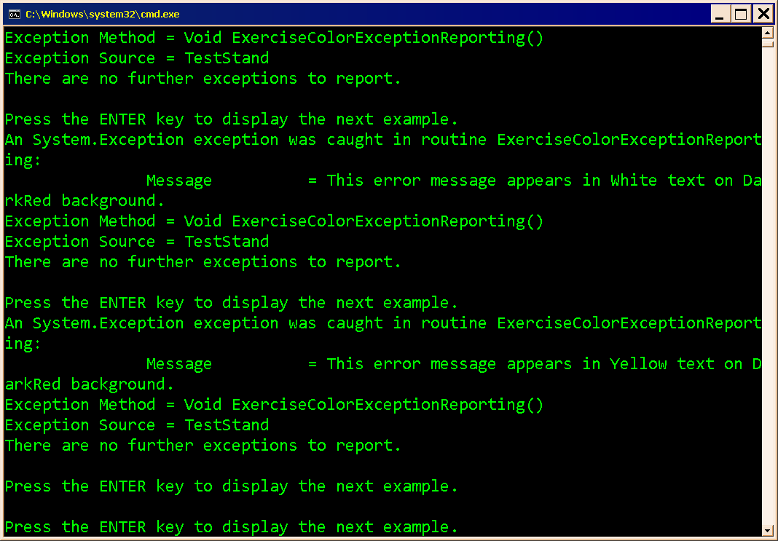
Figure 11 is further along into the same test. A single blank like separates some of the prompts where everything else went to standard output.
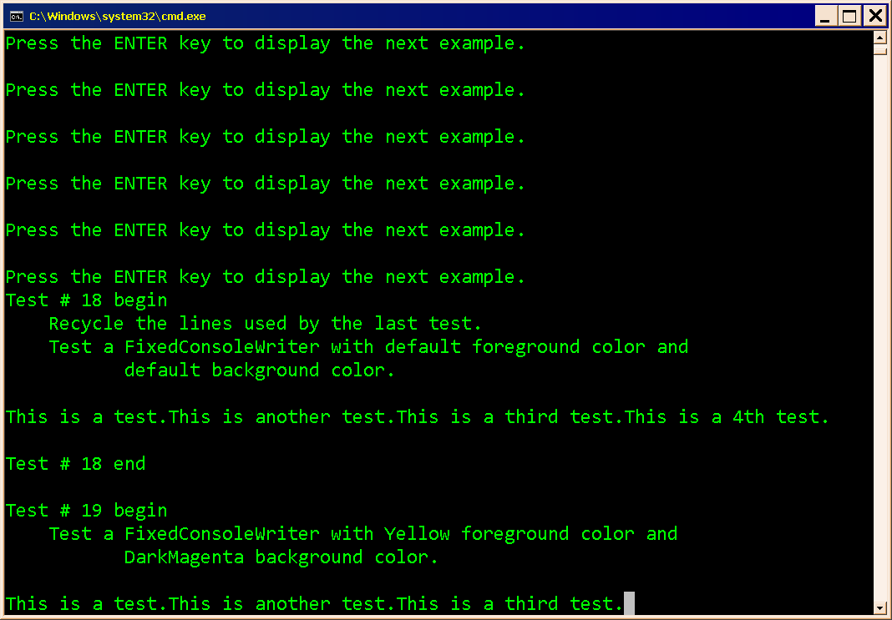
Figure 12 demonstrates the current behavior of the fixed console writer, which is not ideal. Fixing it must wait, however, since it involves major work on the FixedConsoleWriter class.
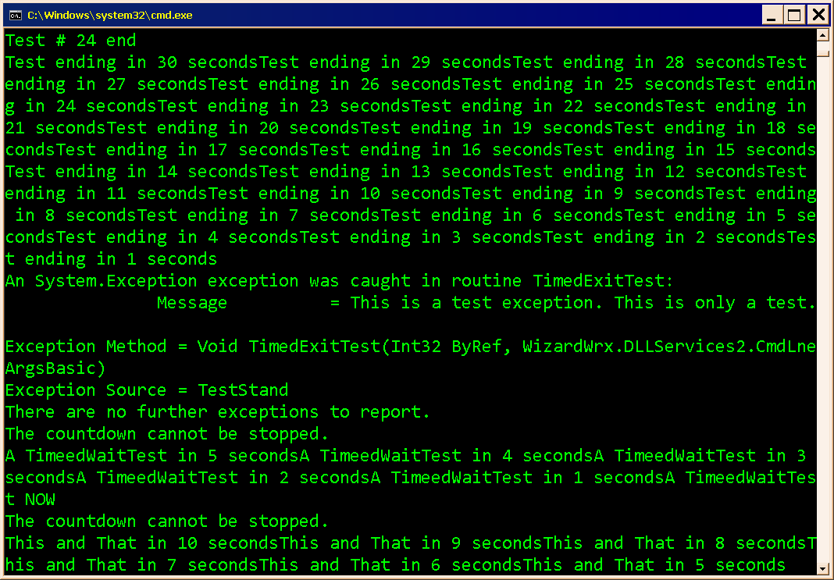
Figure 13 is the timed wait tests, which suffer from the same shortcoming, but may be easier to fix.
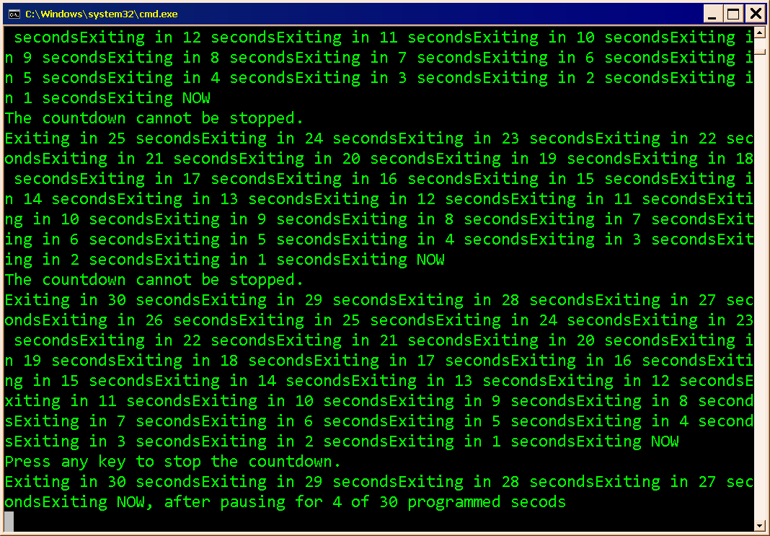
Figure 14 demonstrates that the interruption message displays correctly, even with standard output redirected.
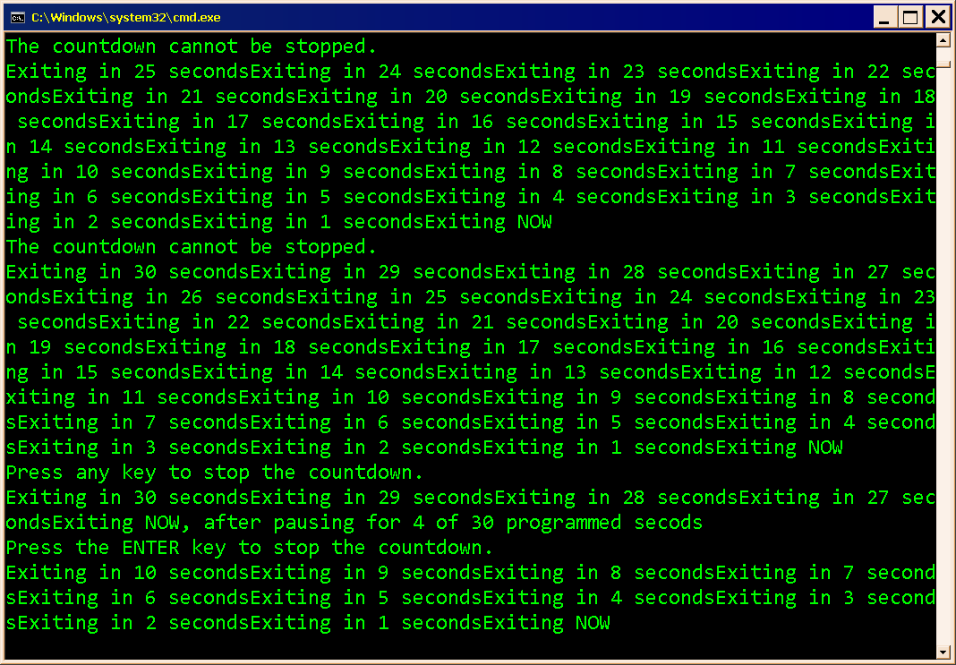
Figure 15 is the second interruptible test, which ran its course.
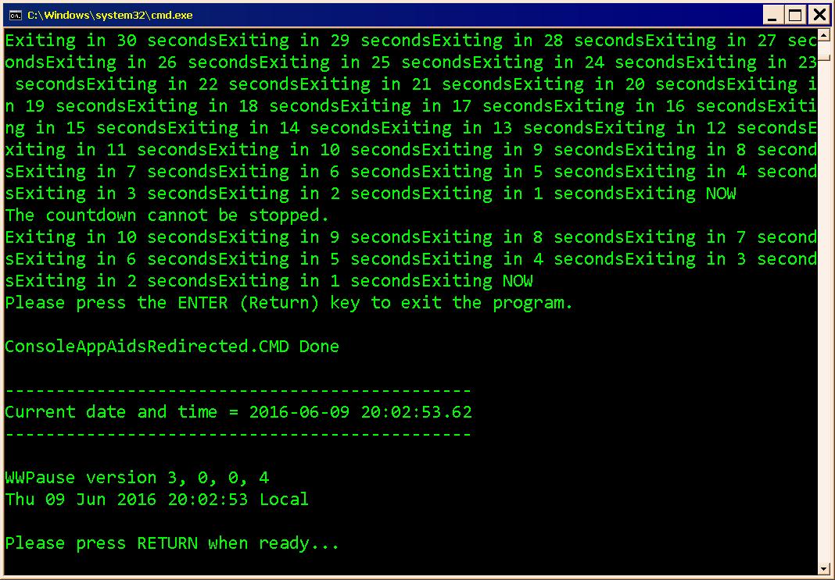
Figure 16 is the final messages displayed by the test program.

