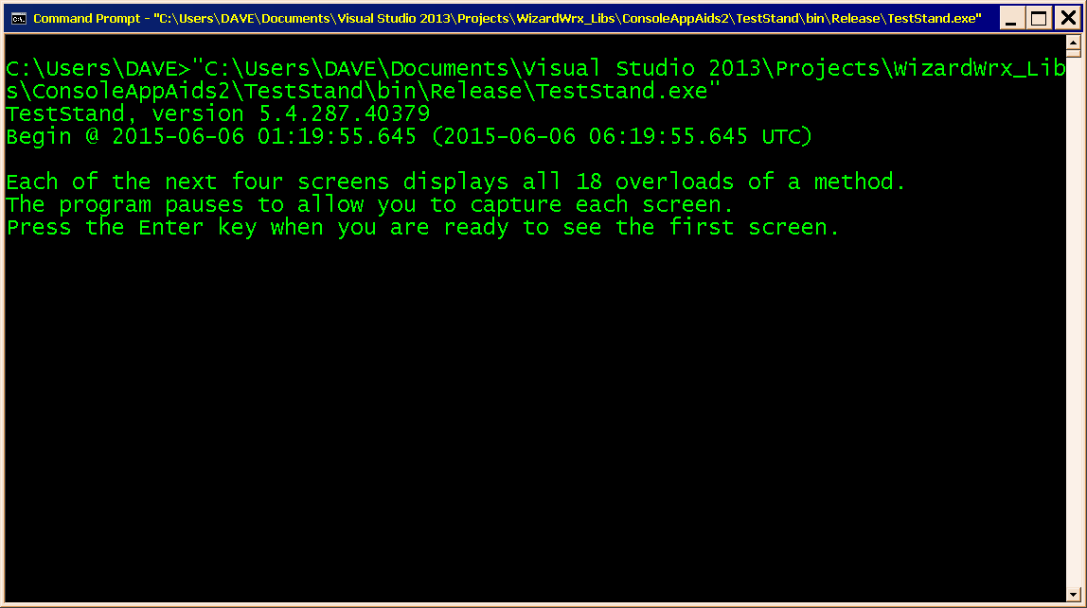
Figure 1 is the initial display of TestStand.exe when started from CMD.EXE without command line arguments.
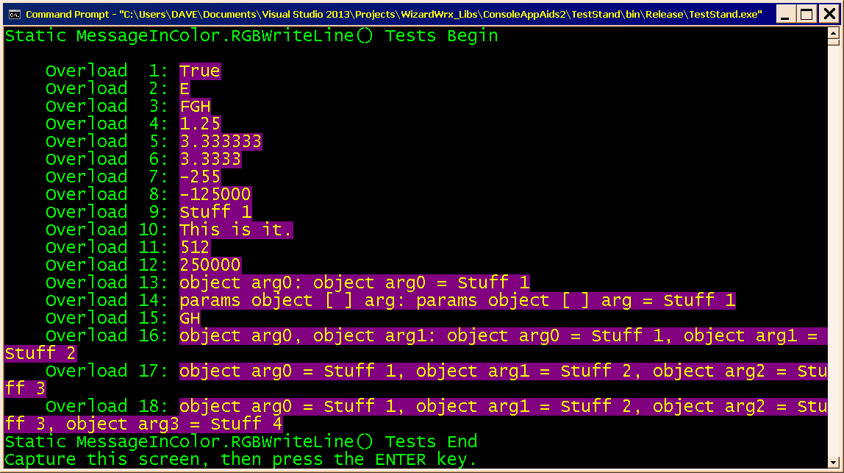
Figure 2 demonstrates all overloads of static MessageInColor.RGBWriteLine(). This test uses a color scheme of Yellow text on a DarkMagenta background.
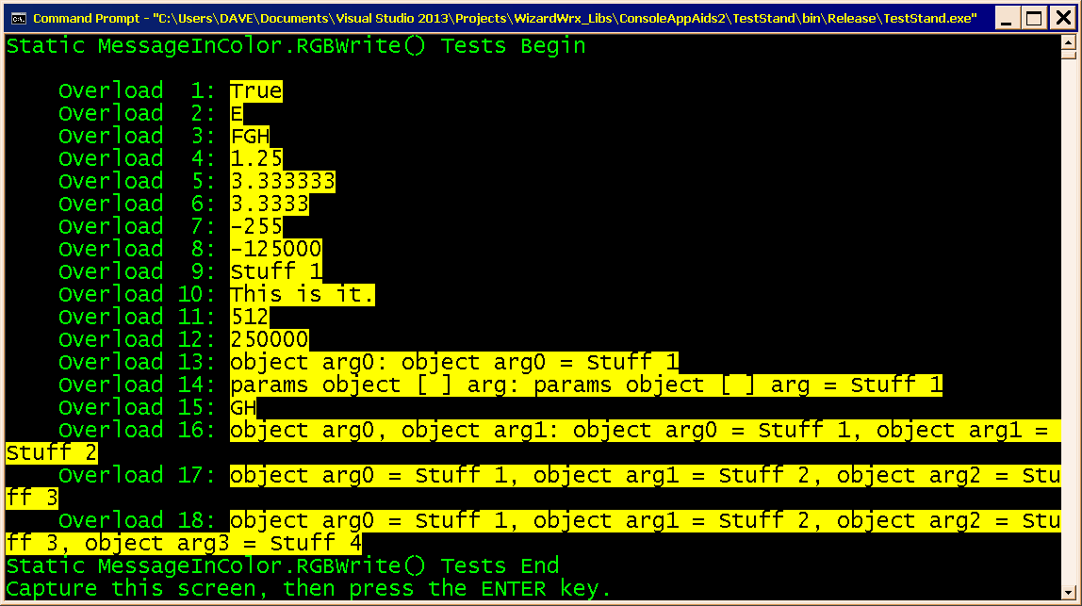
Figure 3 demonstrates all overloads of static MessageInColor.RGBWrite(), using a new color scheme, Black text on a Yellow background.
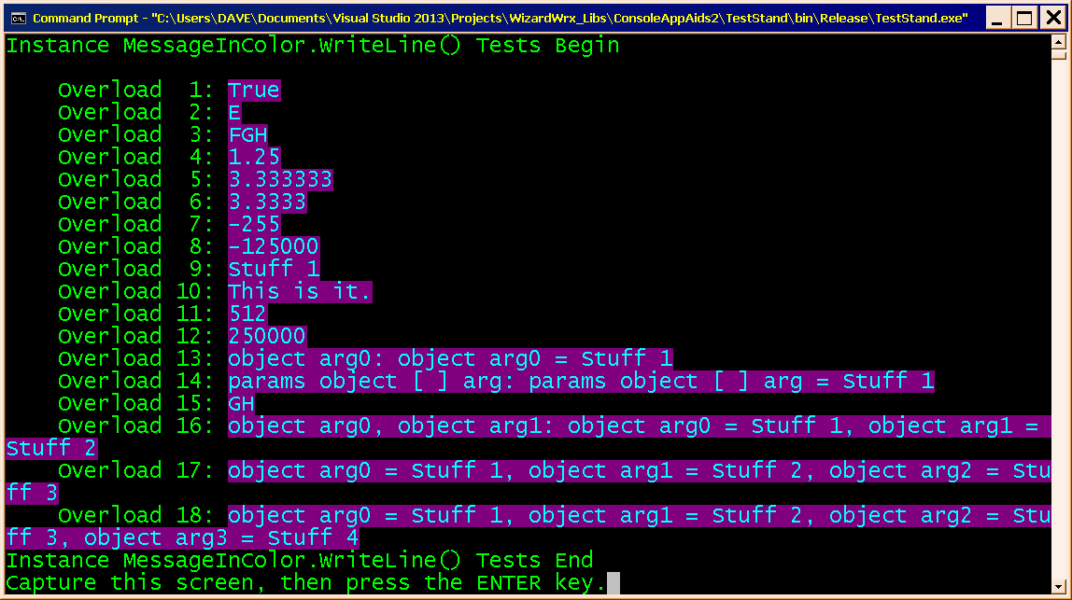
Figure 4 demonstrates all overloads of instance MessageInColor.WriteLine(), using a new color scheme of Cyan text on a DarkMagenta background.
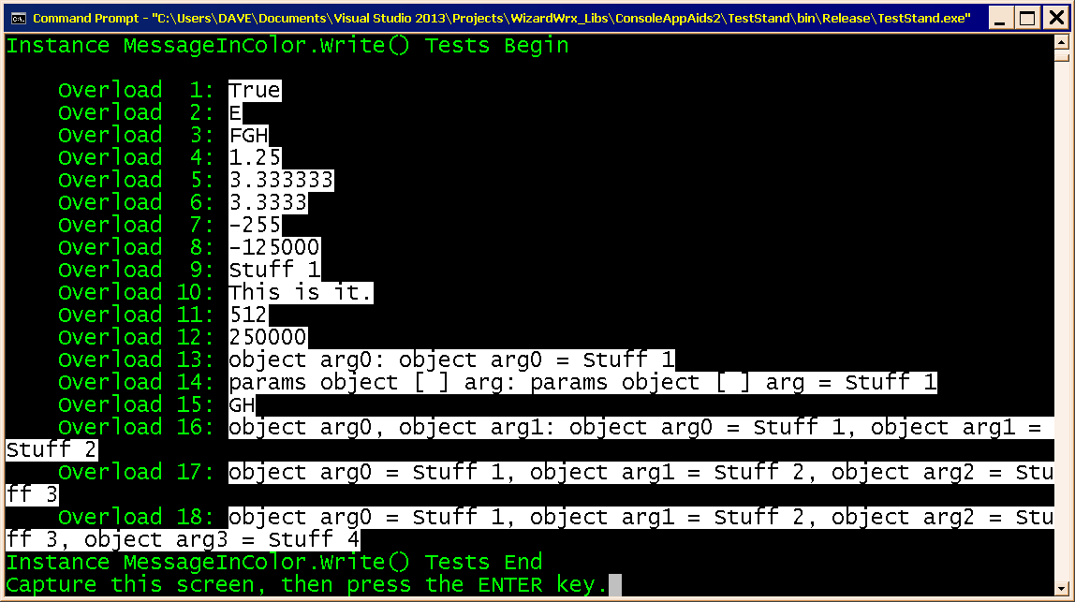
Figure 5 demonstrates all overloads of instance MessageInColor.Write(), using a new color scheme of Black text on a White background.
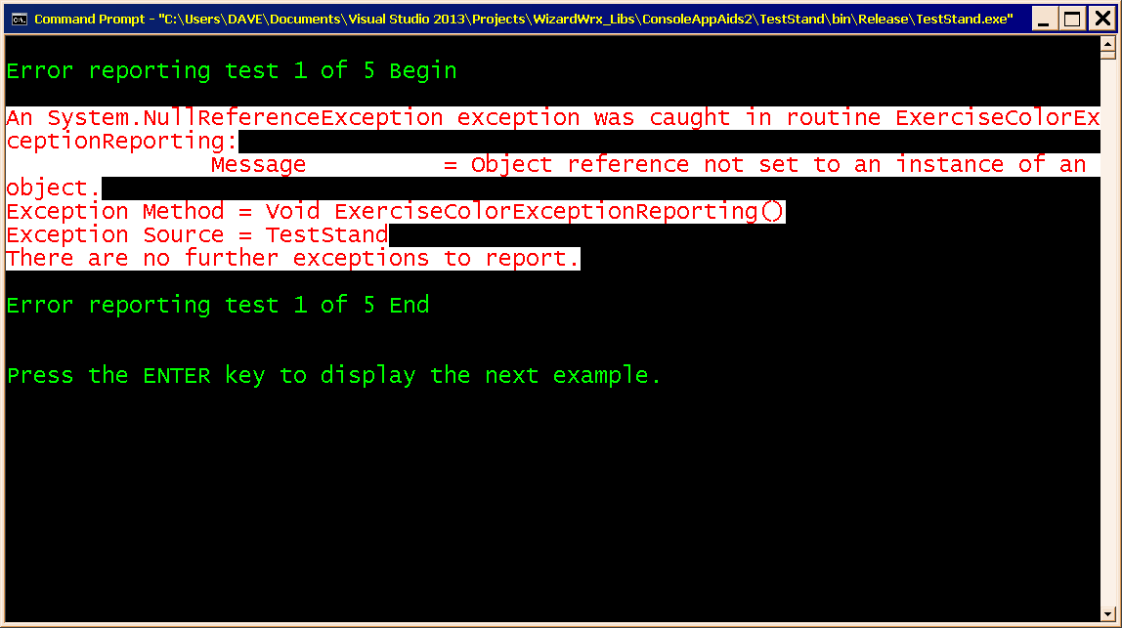
Figure 6 is the first of 5 error reporting tests. This test and the next four use exceptions that are intentionally thrown, caught, and reported through the AppExceptionLogger class, and setting its ErrorMessageColors property to one of 5 carefully selected color pairs.
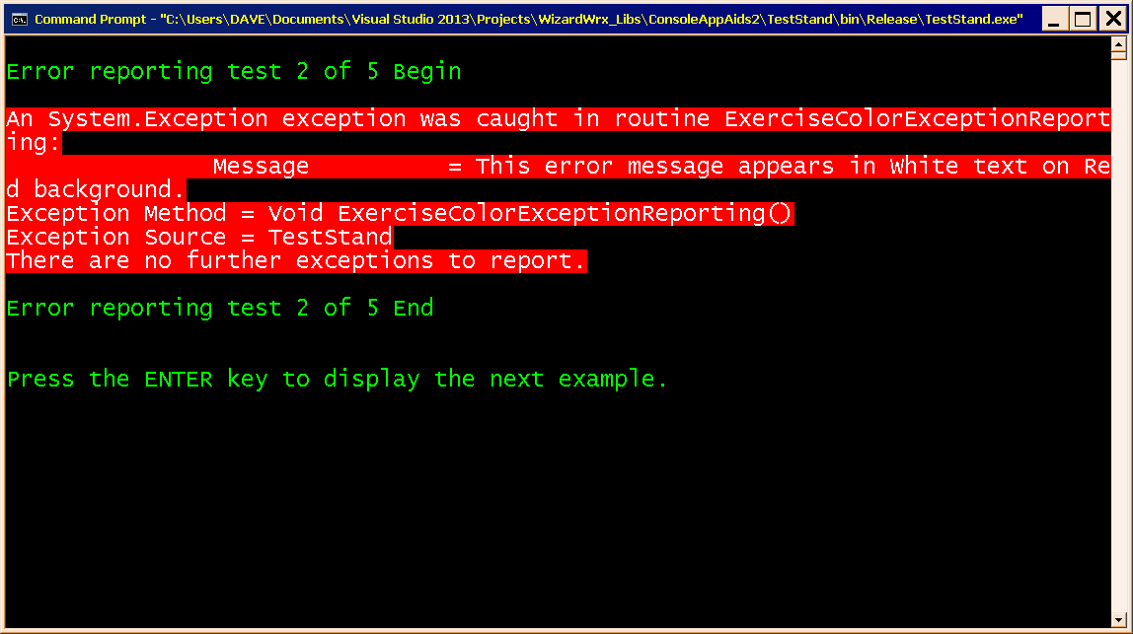
Figure 7 is the second of the 5 error message tests. The bright red background in this test is pretty intense, especially in contrast to the red text on a white background shown in Figure 6.
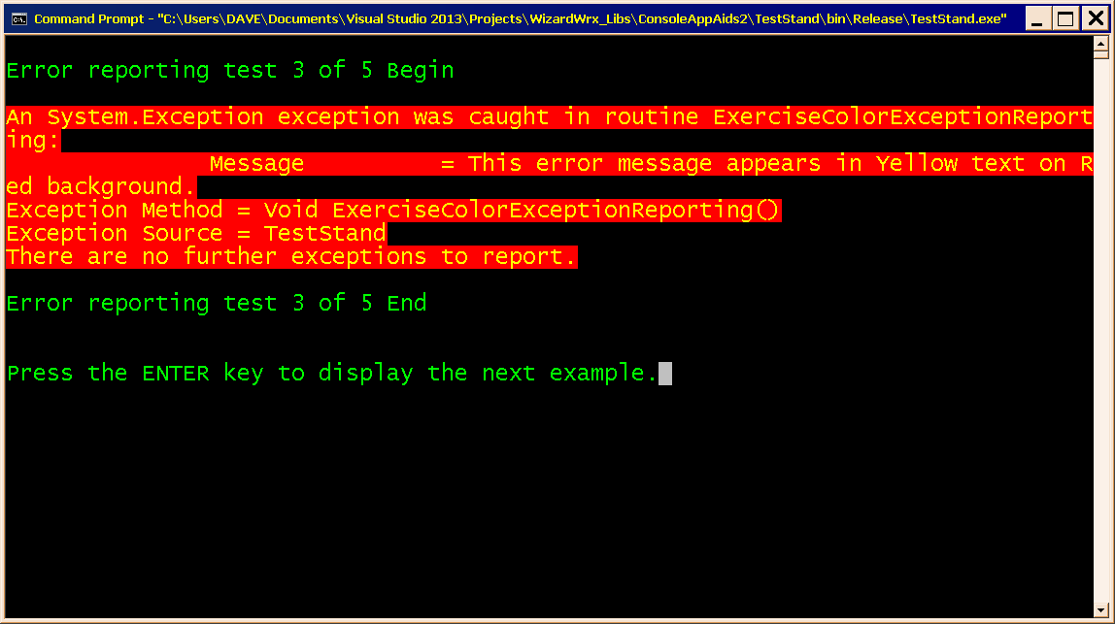
Figure 8 is the third of 5 error message tests, rendered in Yellow text on a bright Red background. This color scheme is almost as intense as the one shown in Figure 7.
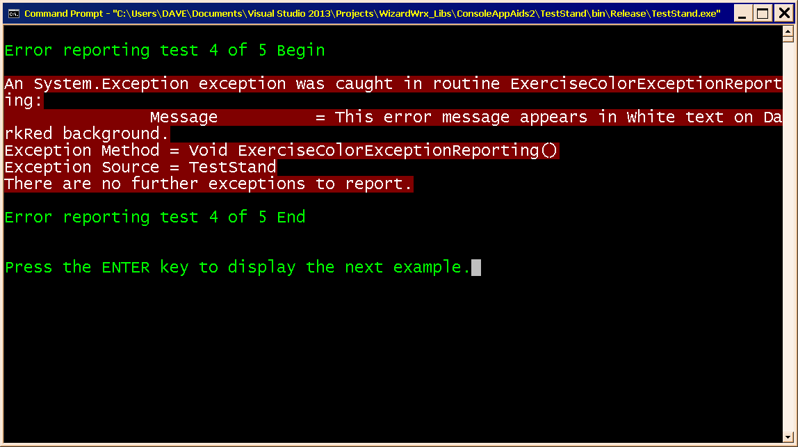
Figure 9 is the fourth of the 5 error message displays. The DarkRed background gets your attention without being nearly as overwhelming as the regular red used in the three previous examples. By a small margin, this color scheme is my favorite.
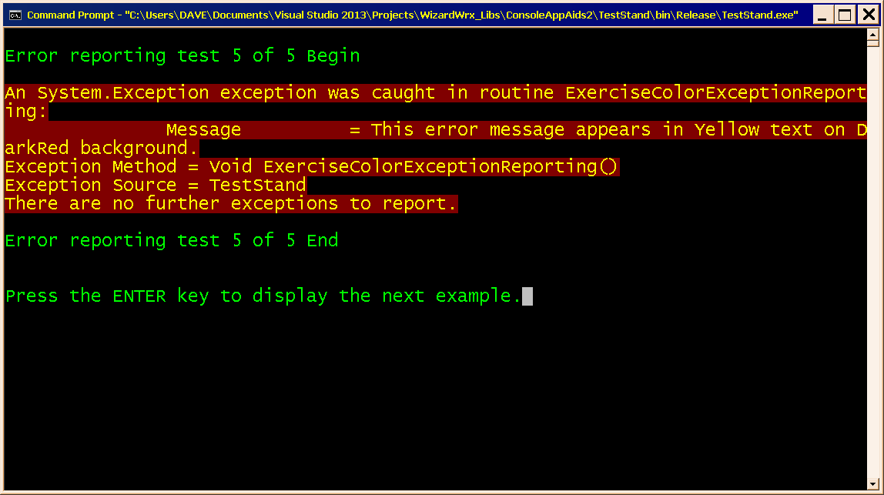
Figure 10 is the fifth of the 5 color scheme demonstrations. This is my second preference, mostly because I think the yellow text sends a somewhat mixed signal; it is Stop or Caution?
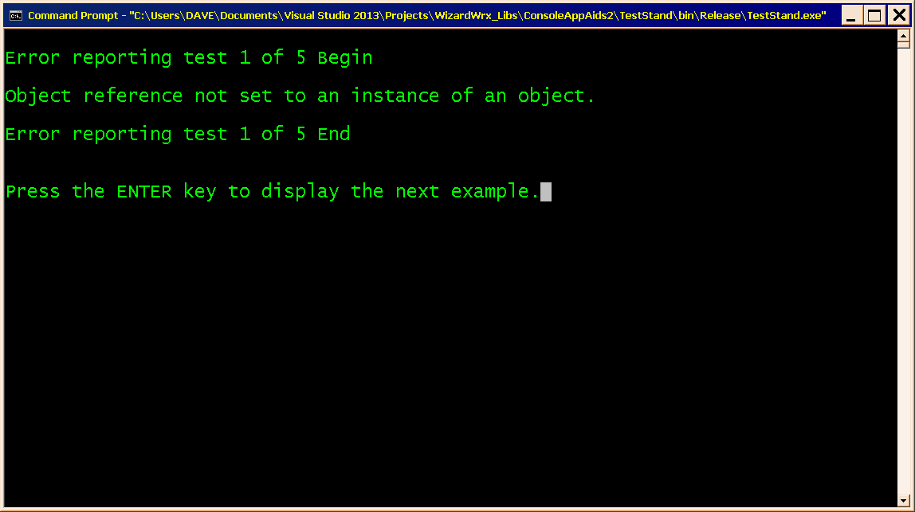
Figure 11 is the first of 5 terse error message demonstrations. This baseline demonstration uses the default color scheme of my console window, which is Green text on a Black background. Your results will vary, depending on the colors set for your CMD.EXE window.
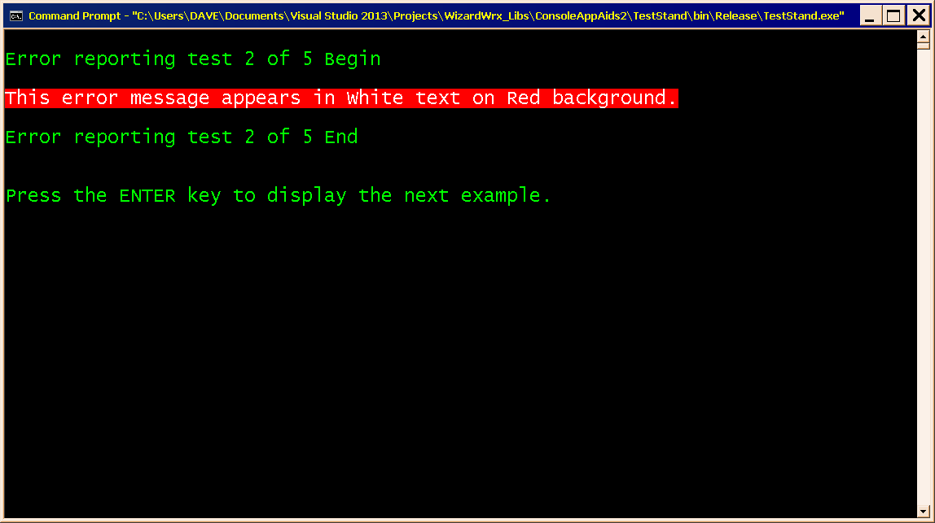
Figure 12 demonstrates the color scheme first shown in Figure 7with a terse message.
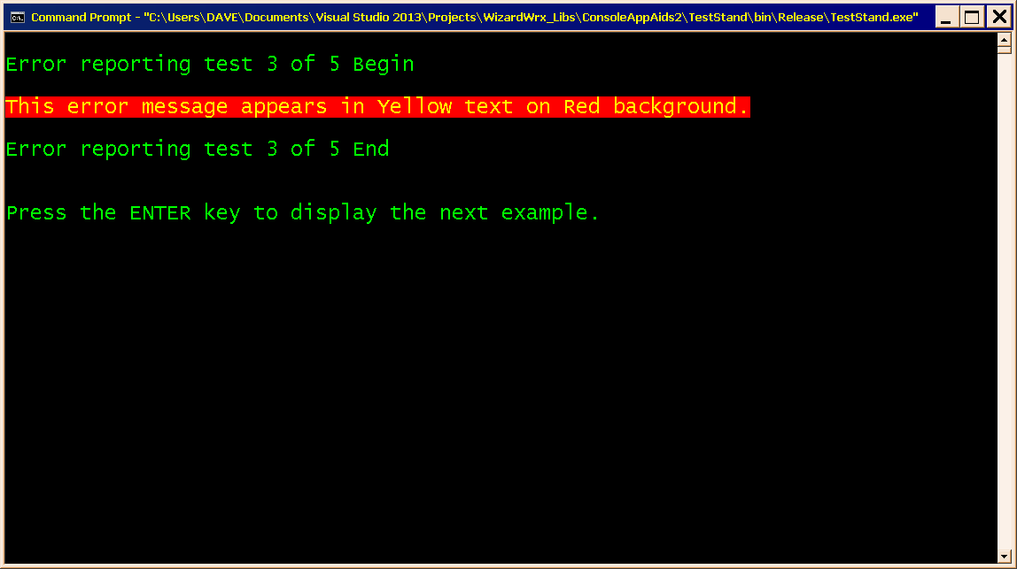
Figure 13 demonstrates the color scheme first shown in Figure 8 with a terse message.
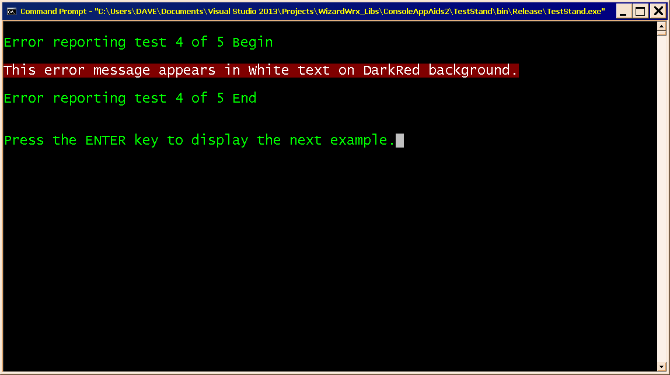
Figure 14 demonstrates the color scheme first shown in Figure 9 with a terse message.
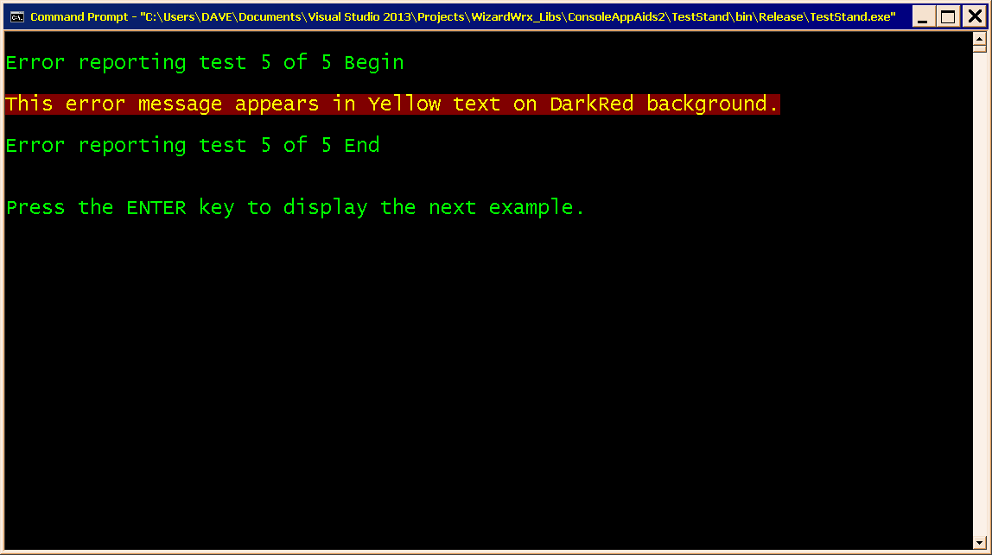
Figure 15 demonstrates the color scheme first shown in Figure 10 with a terse message.
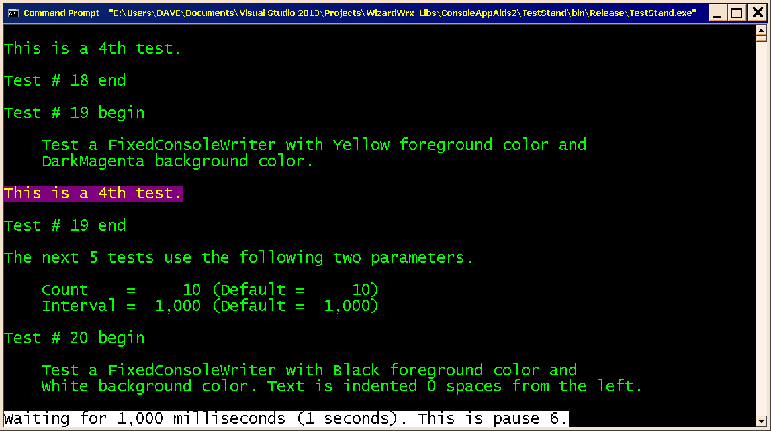
Figure 16 is the first of 3 demonstrations of the FixedConsoleWriter class. This is its most basic application, where the text starts at the left edge of the window.
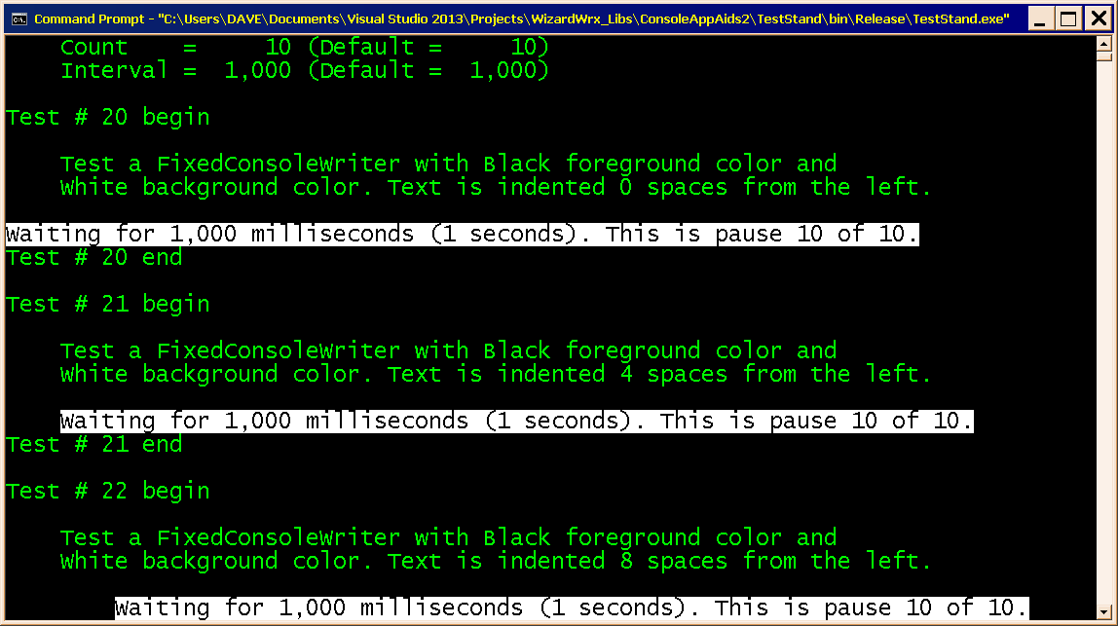
Figure 17 is the second of 3 demonstrations of the FixedConsoleWriter class, showing resumption after the first test completed, followed by a demonstration in which the message is displayed at an indent of 4 spaces, then another set displayed at an indent of 8 spaces.
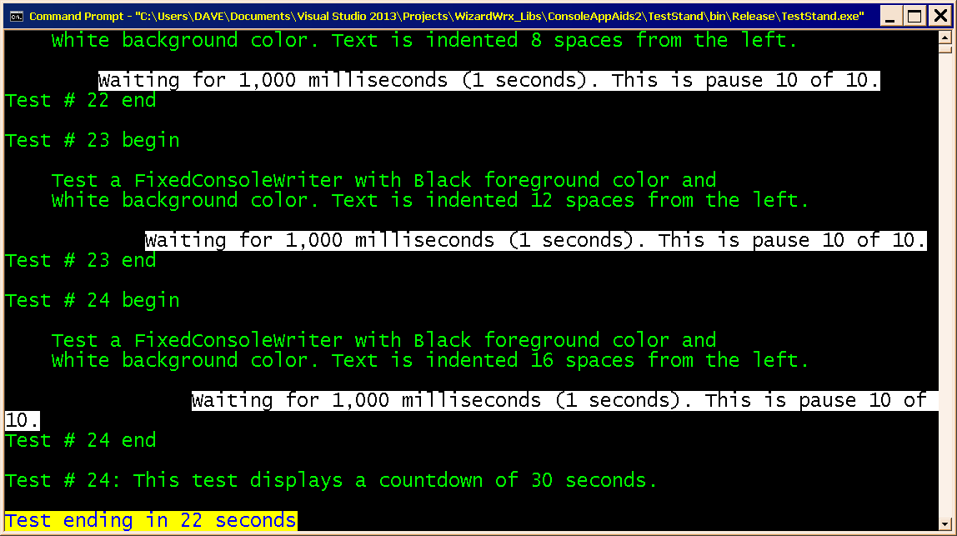
Figure 18 is the third demonstration, in which the text wraps around, followed by another countdown displayed in blue text on a yellow background.
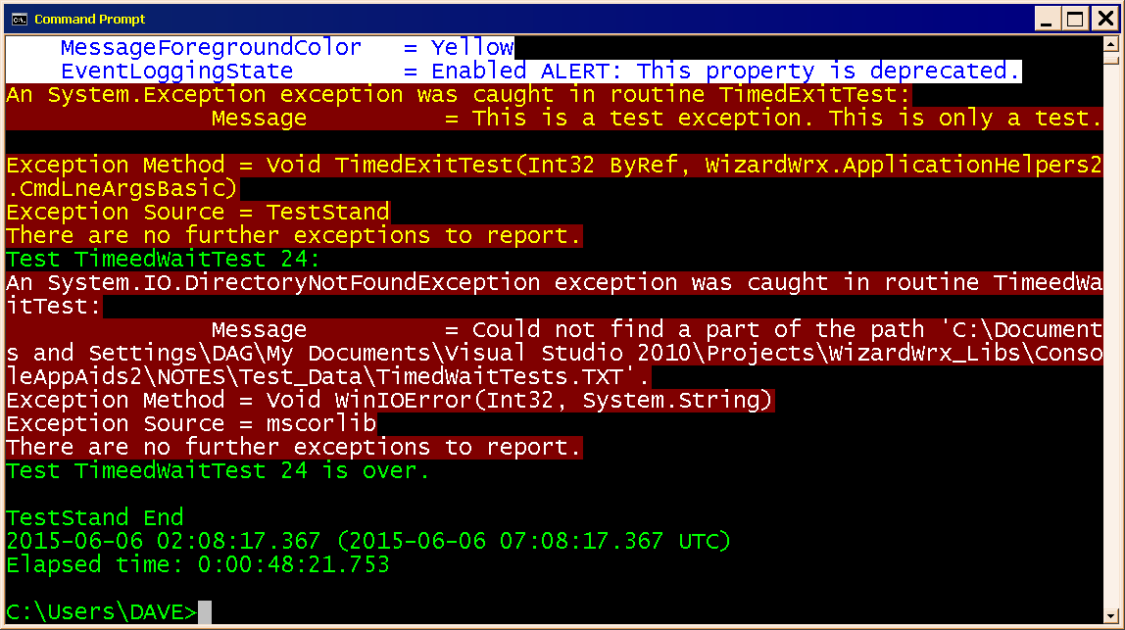
Figure 19 repeats the demonstration of my two preferred color schemes, coupled with interruptible timed waits, both of which were interrupted by keyboard inputs.

