In the presence of a debugger, there is no timed halt.
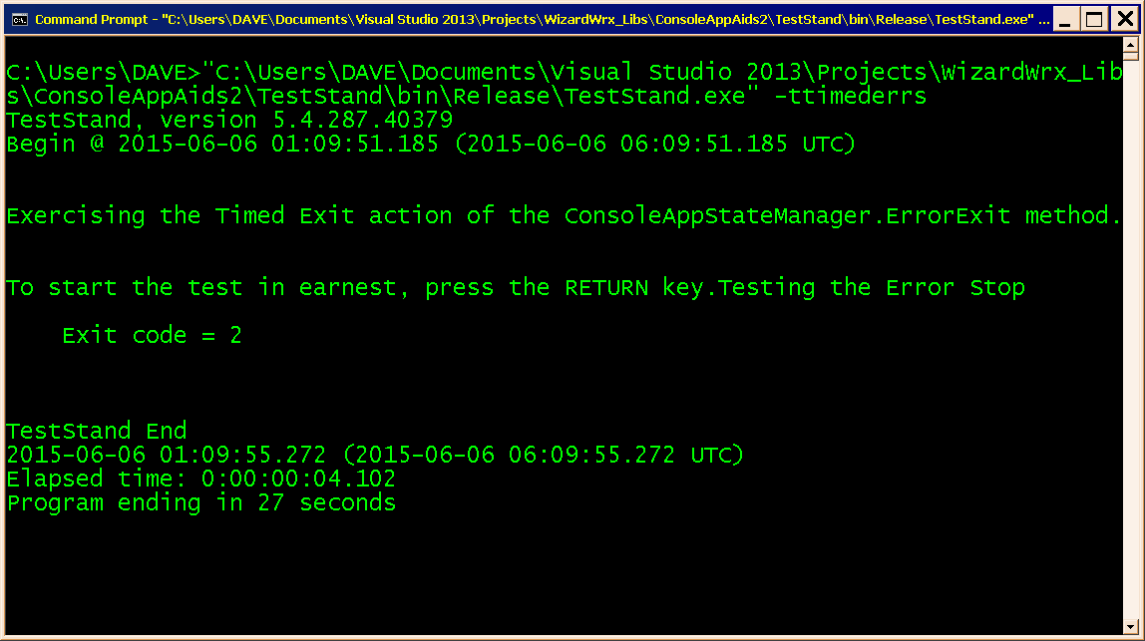
Figure 1 is the test stand window as it appeared 3 seconds after the error was reported when the debug build runs from CMD.EXE, outside the debugger.
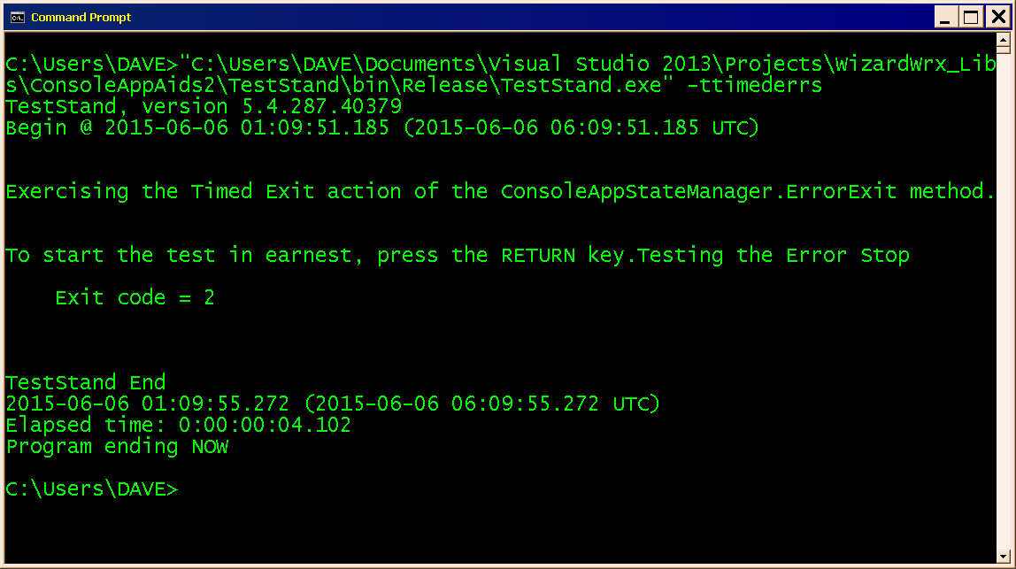
Figure 2 is the final display of the test stand program. At this point, a script would resume.

