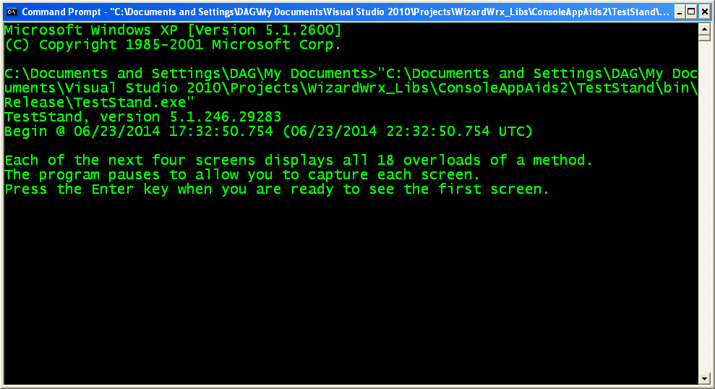
Figure 1 is the 1st screen of output, as it appears when the release build of TestStand.exe starts from an instance of cmd.exe, which was launched from one of my Green Screen desktop shortcuts.

Exercise the MessageInColor Class
This class is intended to be used as a more or less drop-in replacement for the System.Console.Write and System.Console.WriteLine methods, with convenience features to simplify displaying messages in something other than the default screen colors. It is intended for adding “spot color,” such as when you need to call attention to something important, such as an error message. Everything this class does can be achieved using built-in properties and methods of the System.Console class, but it’s a tad more work.
If you don’t want your program to be hostage to the colors stored in the shortcut that launches the instance of cmd.exe that you happen to inherit, there are simpler means to achieve that. If that is your goal, you can easily do that by setting the Console.BackgroundColor and Console.ForegroundColor properties.
There are two ways to use the WizaardWrx.DLLServices2.MessageInColor class.
- Static Methods require you to specify the colors to use each time, but you don’t have another object to manage.
- Instance Methods let you set the colors and forget about them, which means that the signatures exactly match those of the corresponding Console.Write and Console.WriteLine methods.
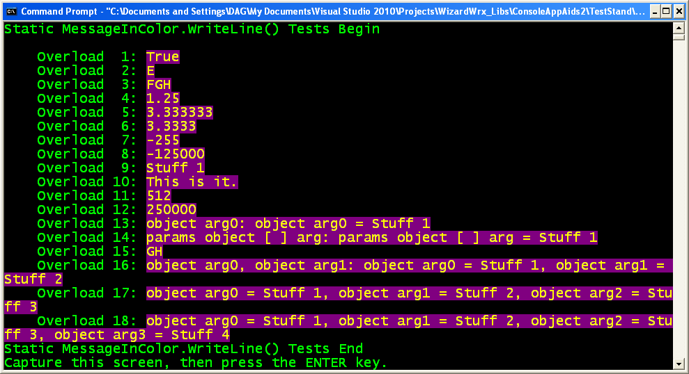
Figure 2 is the 1st of 4 screens that use four similar sets of methods to write in color. This first screen demonstrates the color version of Console.WriteLine, which I called MessageInColor.WriteLine, which is static, but requires two extra arguments.
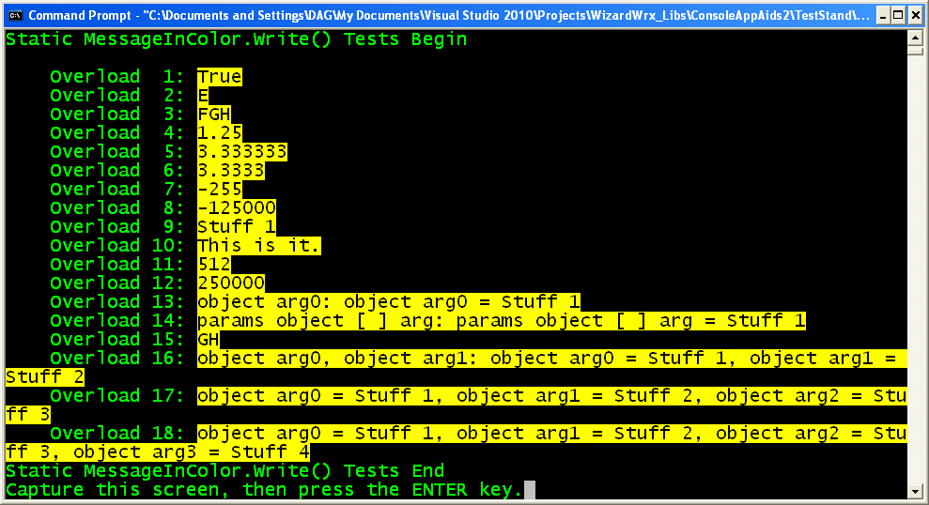
Figure 3 is the 2nd of 4 screens that use four similar sets of methods to write in color. This first screen demonstrates the color version of Console.Write, which I called MessageInColor.Write, which is static, but requires two extra arguments.
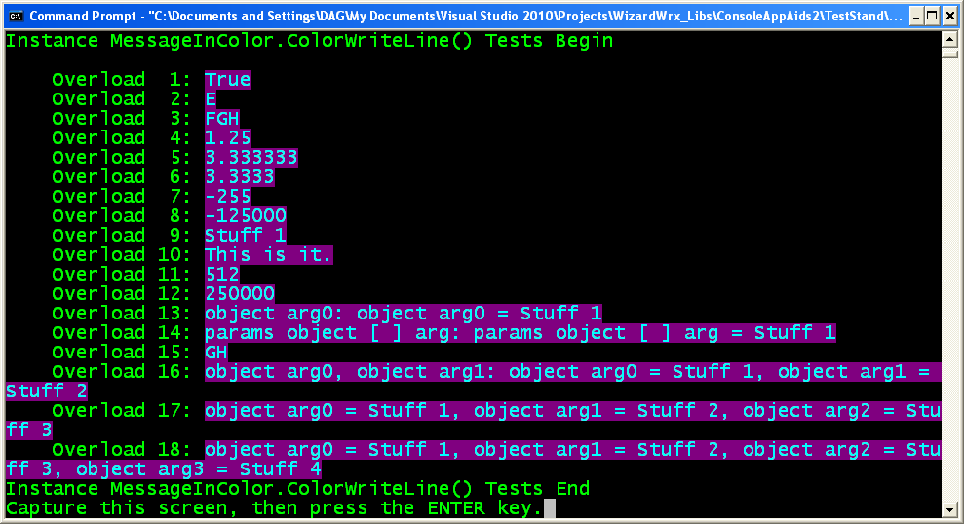
Figure 4 is the 3rd of the 4 screens of the color writing demonstration. This screen shows another color version of Console.WriteLine, which I called MessageInColor. ColorWriteLine, and gave the same signature as Consosle.WriteLine.
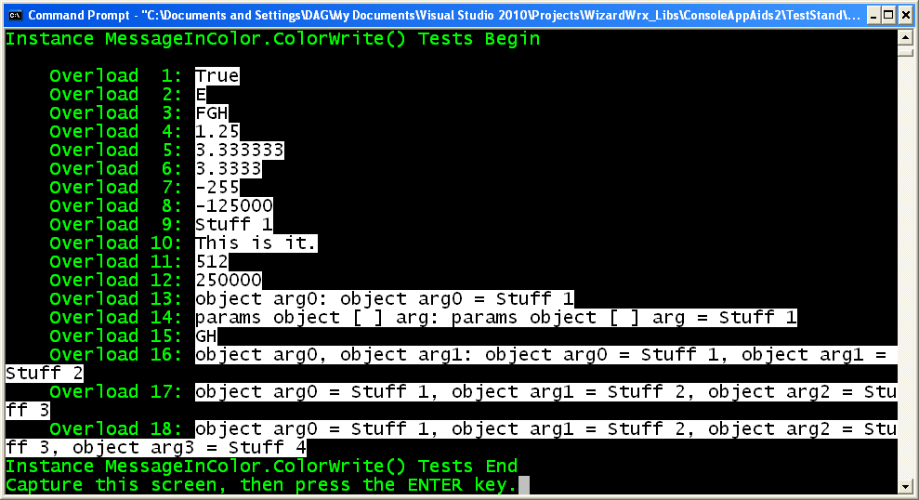
Figure 5 is the 4th of the 4 screens of the color writing demonstration. This screen shows another color version of Console.Write, which I called MessageInColor. ColorWrite, and gave the same signature as Consosle.Write.

Exercise the Renamed Writer Methods, 20 July 2014
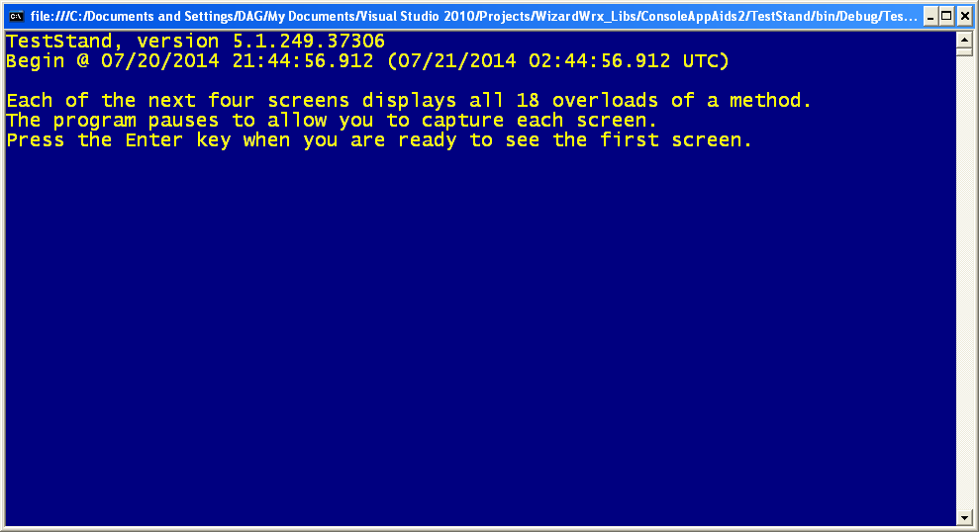
Figure 6 is the first screen displayed by the program. The position of the cursor is significant; WaitForCarbonUnit uses a Console.Write() to display its message. The line feed is held until the message is acknowledged, so that nothing is lost.
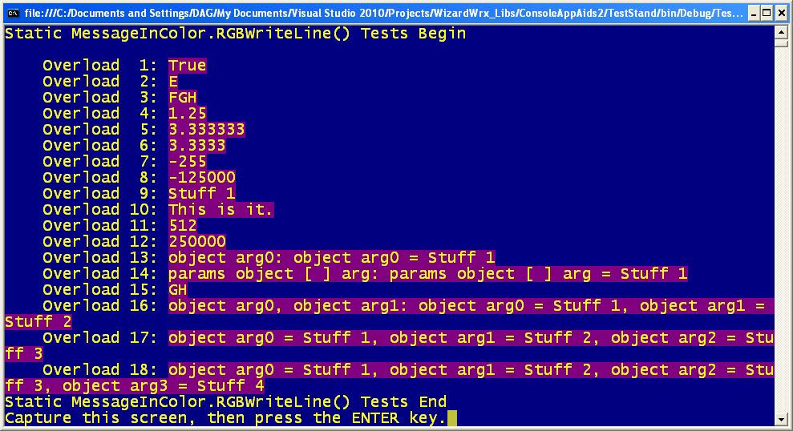
Figure 7 is the MessageInColor.WriteLine() methods, now called RGBWriteLine().
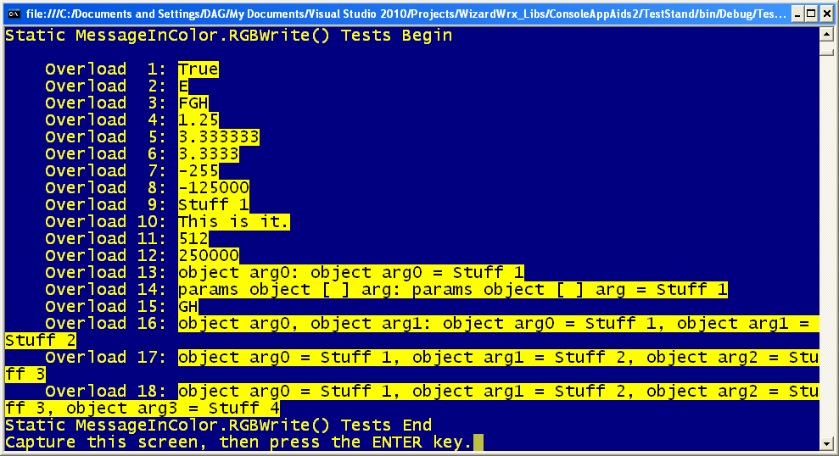
Figure 8 is MessageInColor .RGBWrite(), which writes black text on a yellow background.
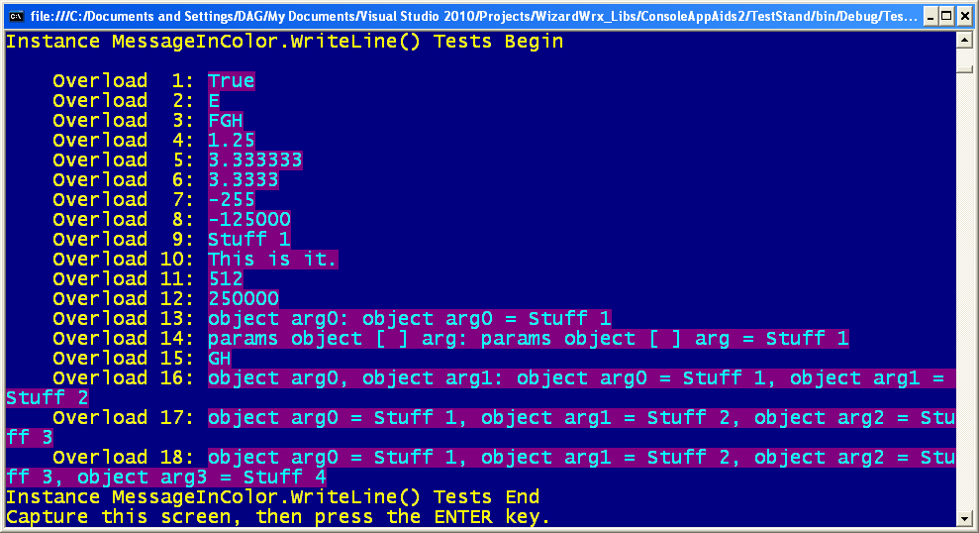
Figure 9 is the instance MessageInColor.WriteLine(), which changes colors again, to light cyan text on a dark magenta background.
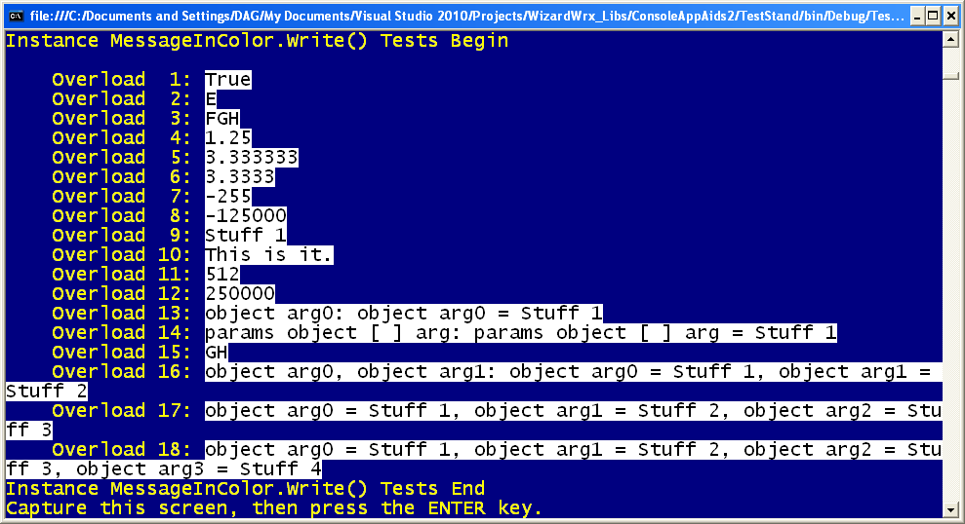
Figure 10 is the fourth (and last) of the standard console writers, another instance method, MessageInColor.WriteLine(), which changes colors yet again, to black text on a white background.
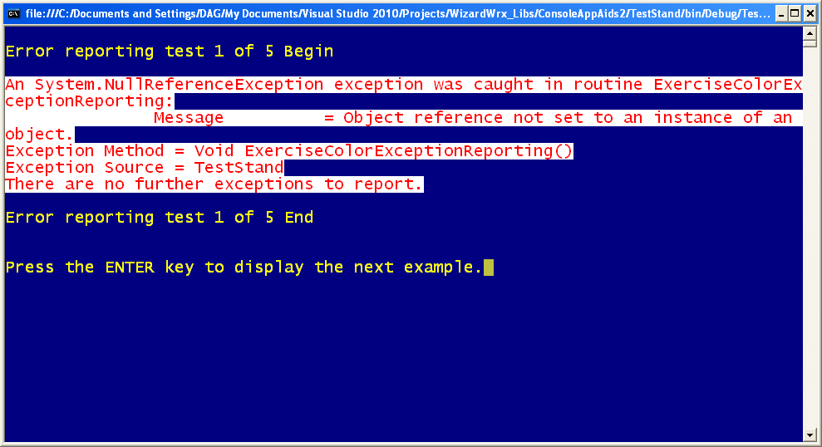
Figure 11 is the 1st of 5 error reporting exercises, using red text on a white background, both selected at run time.
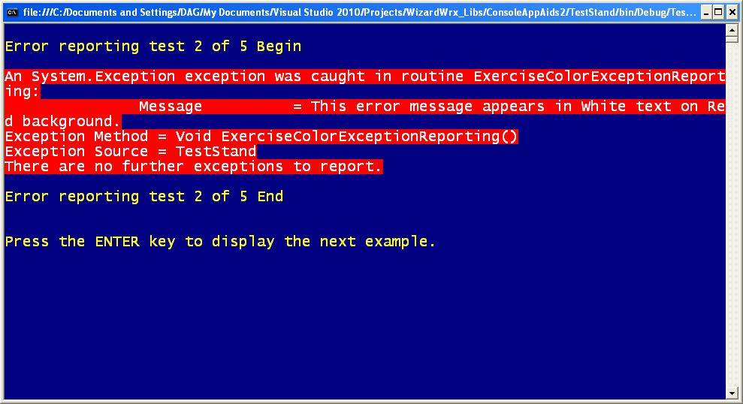
Figure 12 is the 2nd of the 5 error message tests, which proves that bright red is a poor choice for a background color.
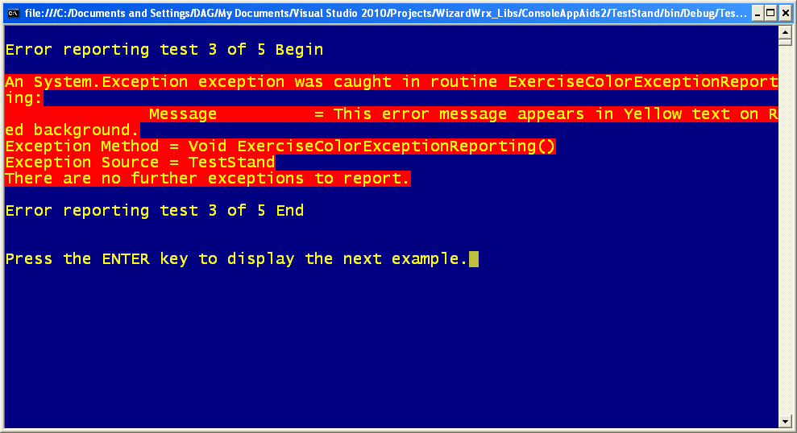
Figure 13 is the 3rd of the 5 tests, which demonstrates that yellow is easier to read on the bright red background, but it’s still too much.
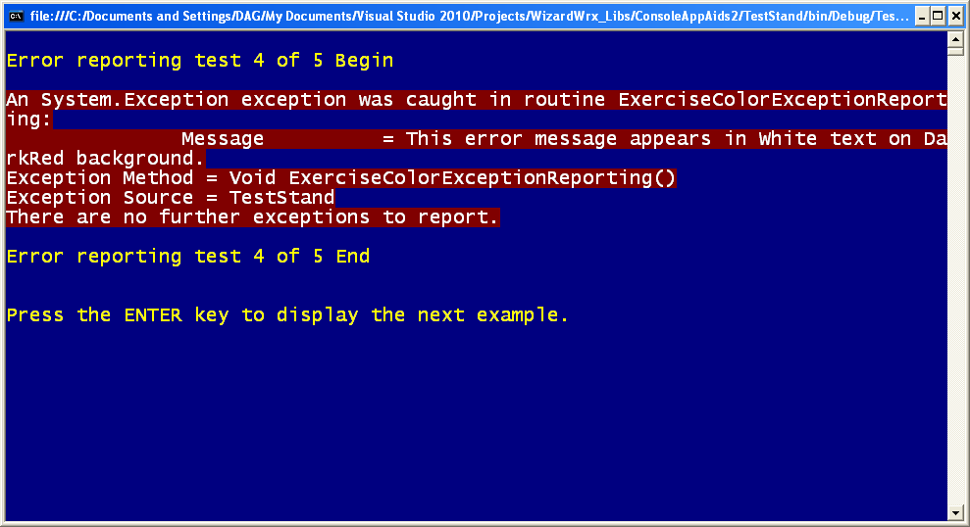
Figure 14, the 4th of the 5 tests, demonstrates white text on a dark red background, which works well by getting your attention, while remaining easy to read.
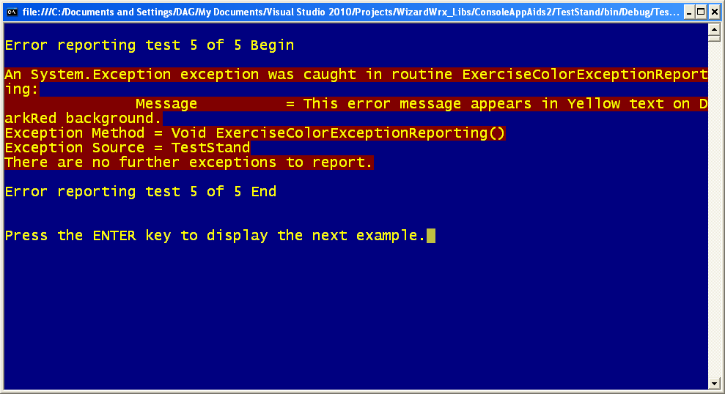
Figure 15, the 5th of the 5 tests, is yellow text on the dark red background, where it is much better than it is on bright red, and is my second choice. I still think white text on red trumps it.
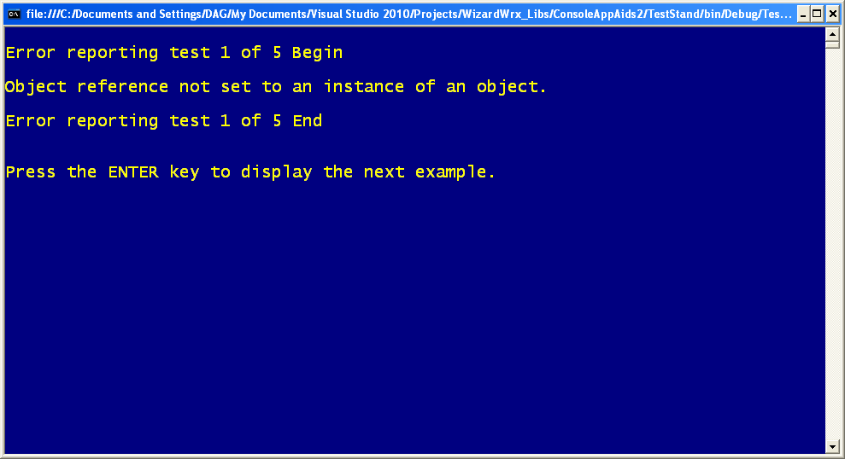
Figure 16 is the 1st of a series of 5 one-line messages displayed in a variety of color combinations.
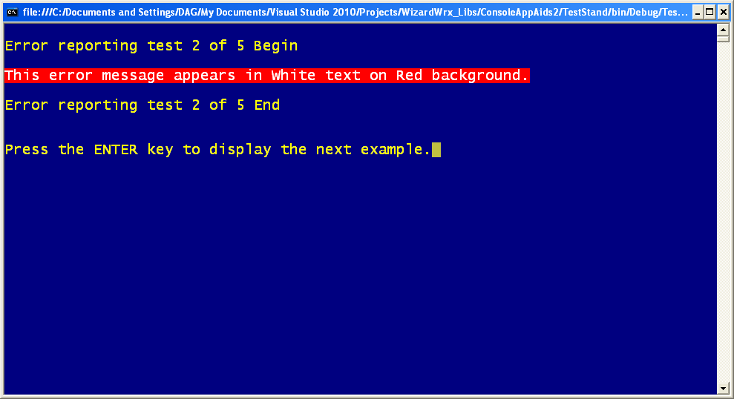
Figure 17 is the 2nd of the 5 messages. Even this single line of white text on the bright red background is hard on the eyes.
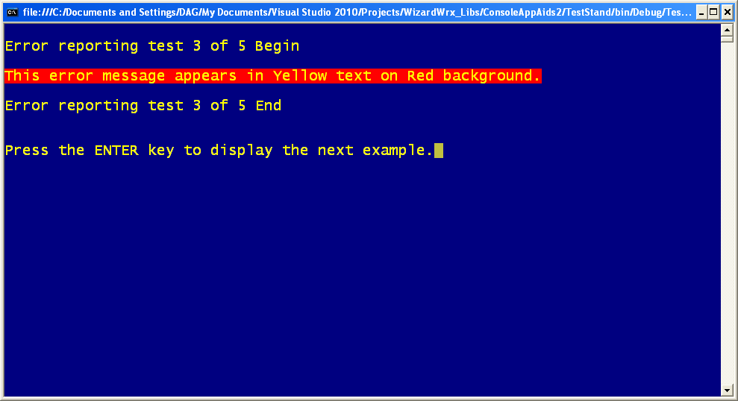
Figure 18 is the 3rd of the 5 tests, in which even a single line of yellow text fares equally poorly on the bright red background.
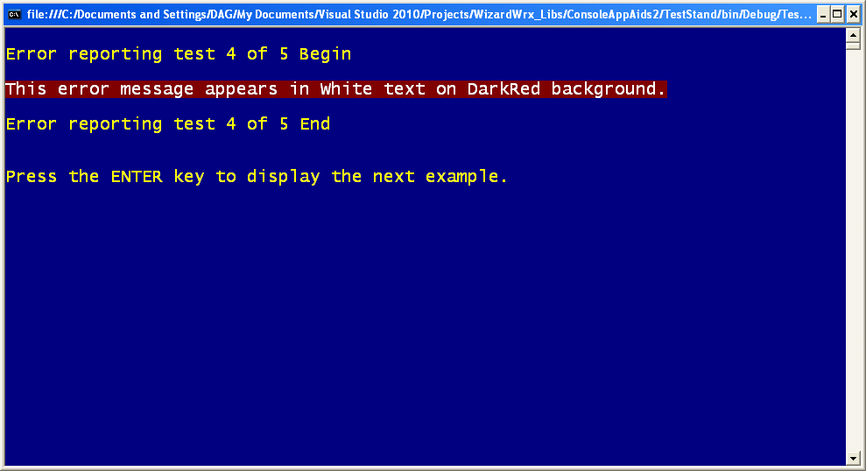
Figure 19 is the 4th of the 5 demonstrations, which confirms that white text on a dark red background is quite effective for calling one’s attention to a one-line message. Of course, it doesn’t hurt a bit that the program stops to give you all the time you need to read it.
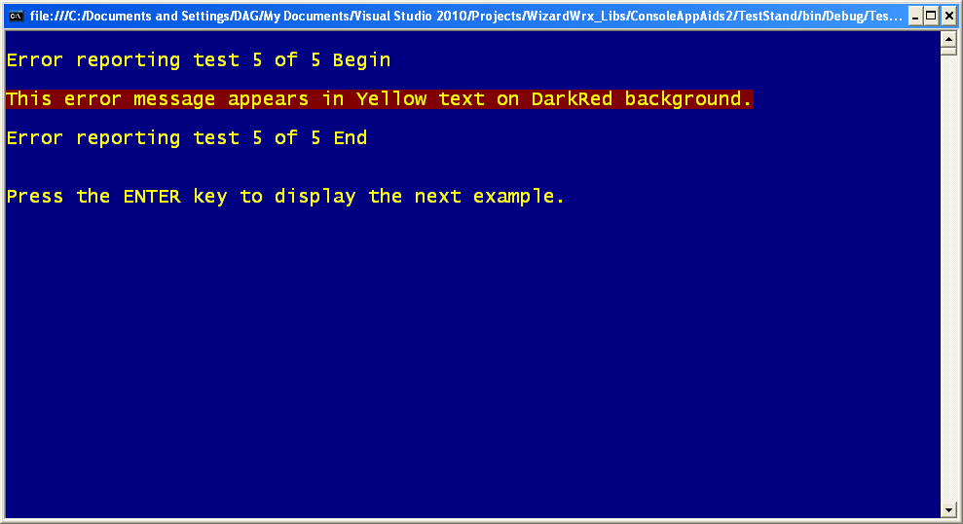
Figure 20 is the 5th of 5 demonstrations, showing that yellow text on the dark red background is quite effective for this one-line message. I think it’s a close call; compare this to Figure 19, and decide for yourself.
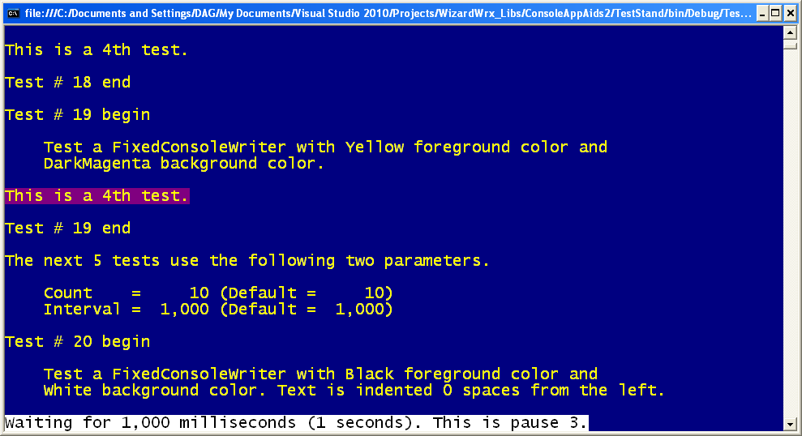
Figure 21 is the first of a series of tests that demonstrate the features of the FixedConsoleWriter class. The message starts at the left, and is intended as a reference for the remaining tests.
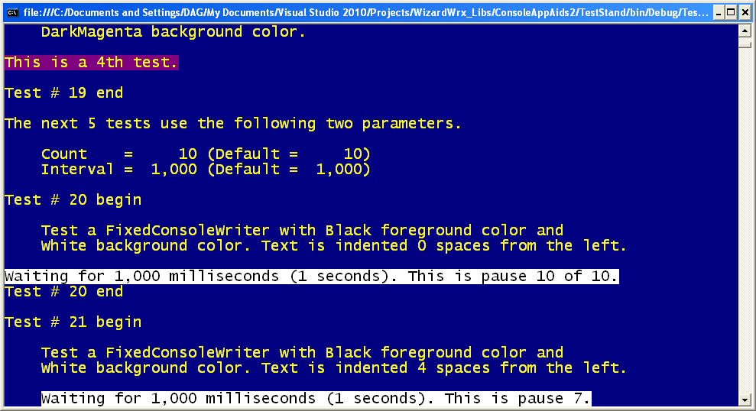
Figure 22 is the first to showcase the idea behind the FixedConsoleWriter.
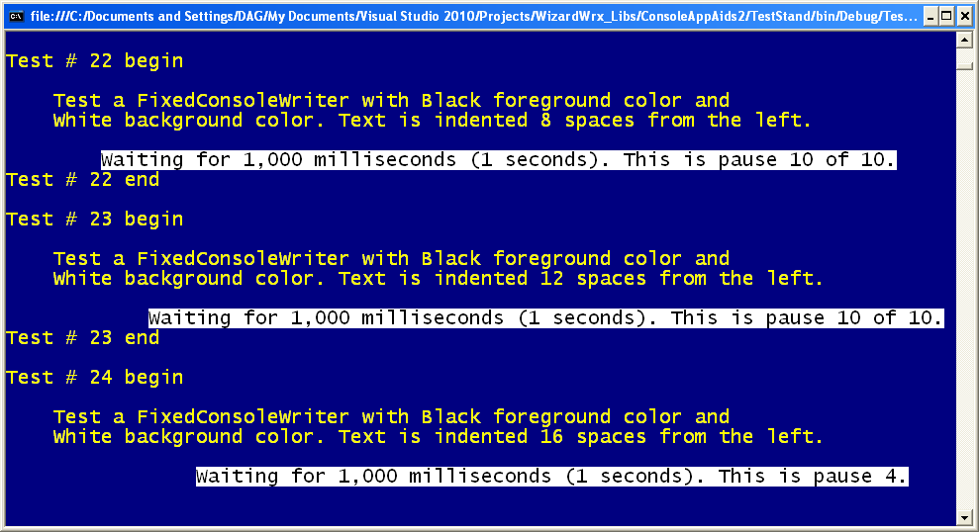
Figure 23 demonstrates what happens when the message wraps to a new line, and is subsequently overwritten by a shorter message.
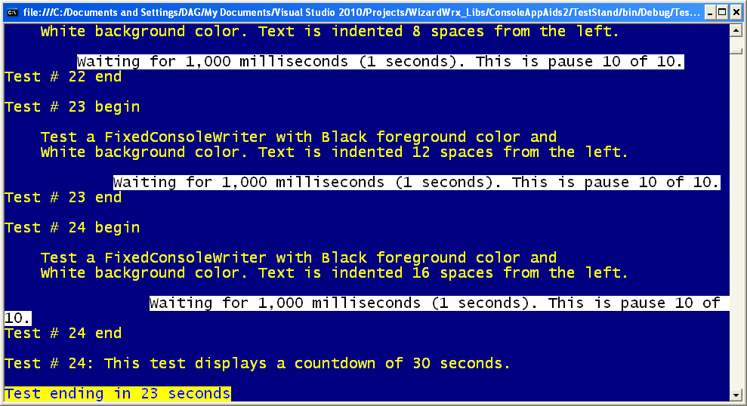
Figure 24 shows what happens when you revert to the regular console writer, in test 24, and shows the first of a series of countdown messages that leverage the FixedConsoleWriter, and motivated its creation.
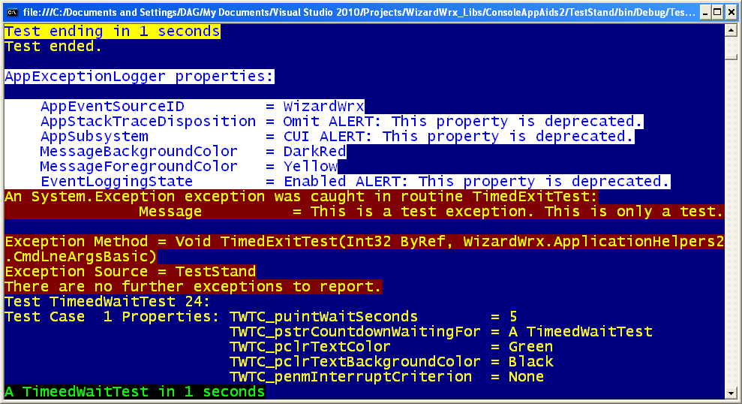
Figure 25 demonstrates the results achieved by combining a report formatter capable of generating perfectly aligned rows of labels and values, followed by the first of a series of interruptible countdowns.
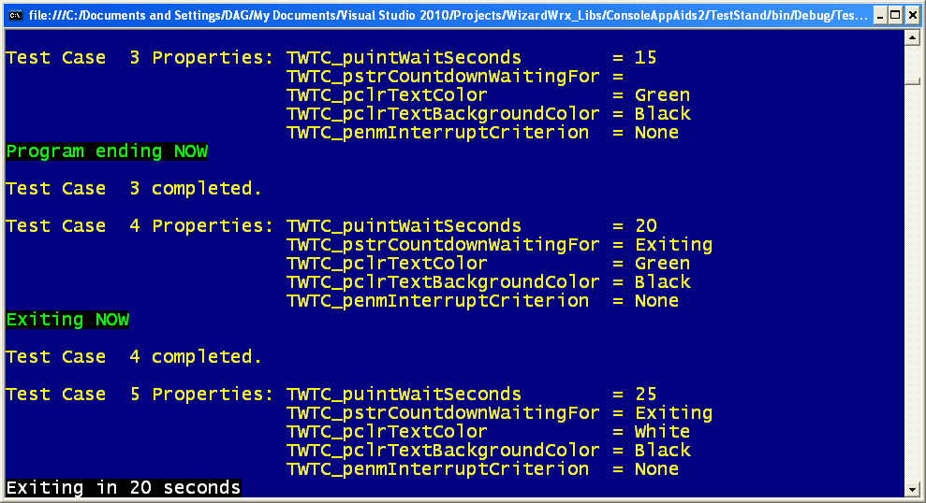
Figure 26 demonstrates additional features of the interruptible countdown routine for console programs.
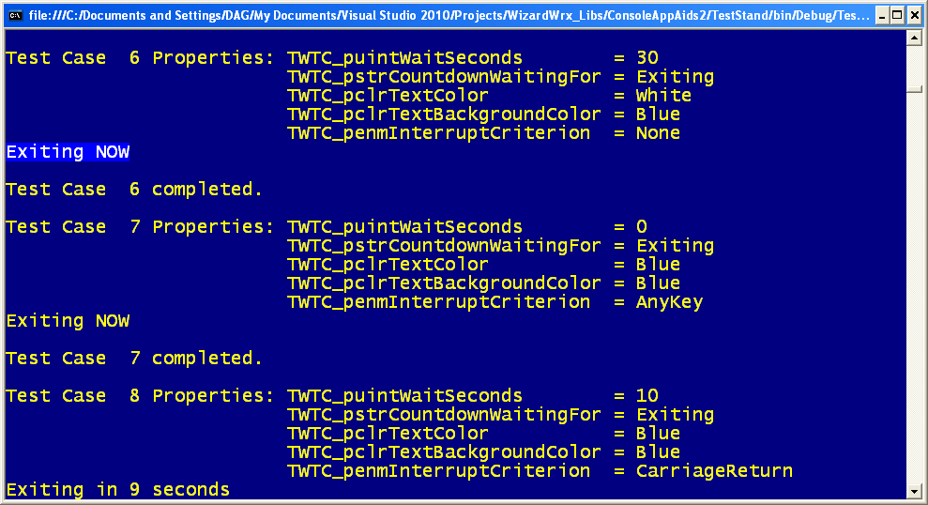
Figure 27 demonstrates my least favorite feature of the interruptible countdown, the AnyKey option. The PAUSE batch command that it emulates is so lame that it provoked me to write my first 8086 Assembler program.
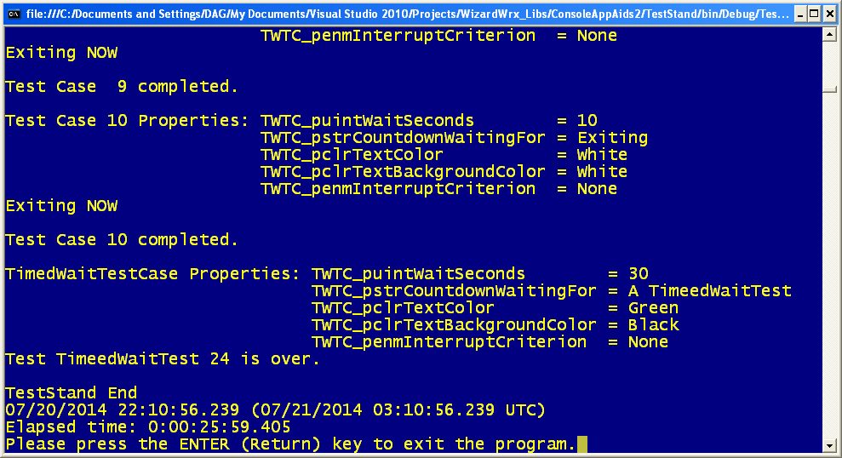
Figure 28 is the final screen rendered by the interruptible countdown tests. There is nothing special here; it’s just a recital of the remaining options.

