The images stored in this document are taken from several executions of TestStand.exe, the program that I created to put the classes exposed by WizardWrx.ConsoleAppAids2.dll through their paces. The classes in question comprise the WizardWrx.ConsoleAppAids2 namespace.
The first 19 pictures were captured during a single run of a Debug build of TestStand.exe that was started directly from the file explorer of a 64 bit Windows 7 installation. The remaining pictures are from several sessions, most running under a Visual Studio debugger, that took place over the past 11 months.

Why Is There Green Text on a Black Background?
The text and background colors seen in Figure 1, hereafter referred to as the default color scheme, are the colors designated in the properties of my default shortcut for CMD.EXE. If you are of a certain age, you recognize them as the Green Screen colors of the monitor that came with the original IBM PC, and most of the terminals used with mainframe and midrange computers of the day.
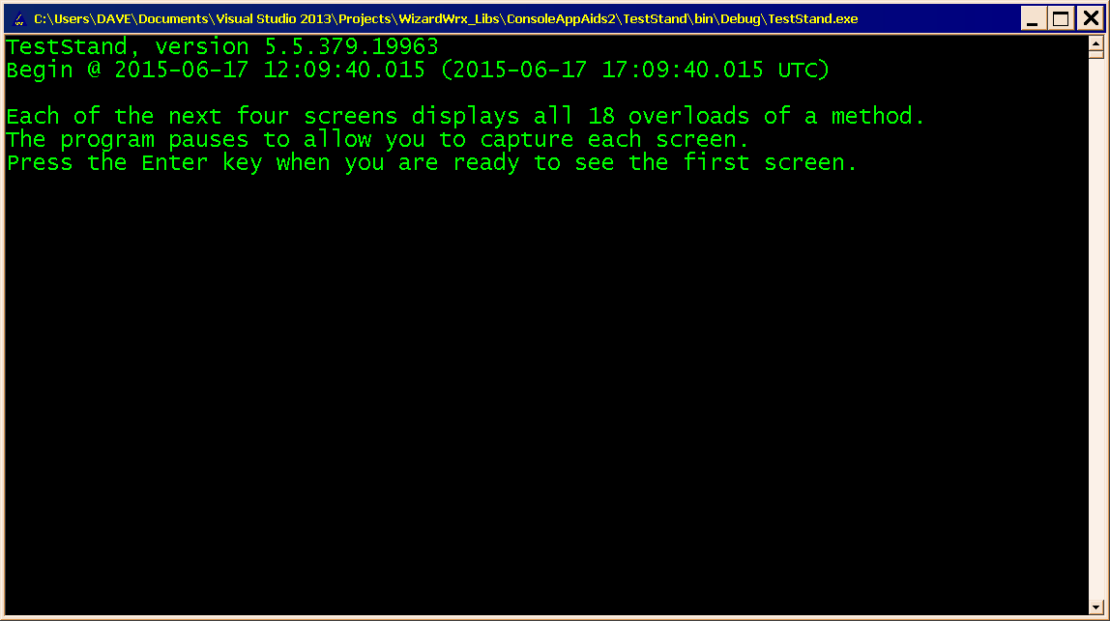
Figure 1 is the 1st screen of output, as it appears when the release build of TestStand.exe starts from an instance of cmd.exe, which was launched from one of my Green Screen desktop shortcuts.

Exercise the MessageInColor Class
This class is intended to be used as a more or less drop-in replacement for the System.Console.Write and System.Console.WriteLine methods, with convenience features to simplify displaying messages in something other than the default screen colors. It is intended for adding “spot color,” such as when you need to call attention to something important, such as an error message. Everything this class does can be achieved using built-in properties and methods of the System.Console class, but it’s a tad more work.
If you don’t want your program to be hostage to the colors stored in the shortcut that launches the instance of cmd.exe that you happen to inherit, there are simpler means to achieve that. If that is your goal, you can easily do that by setting the Console.BackgroundColor and Console.ForegroundColor properties.
There are two ways to use the WizaardWrx.DLLServices2.MessageInColor class.
- Static Methods require you to specify the colors to use each time, but you don’t have another object to manage.
- Instance Methods let you set the colors and forget about them, which means that the signatures exactly match those of the corresponding Console.Write and Console.WriteLine methods.
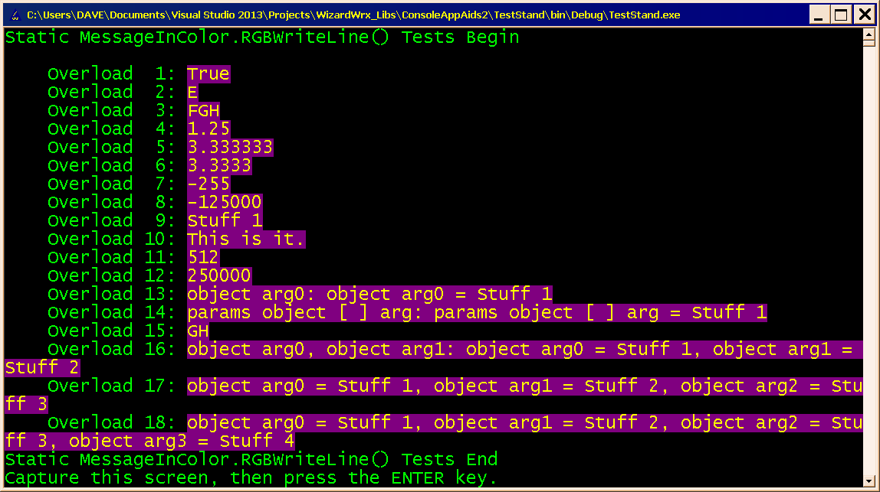
Figure 2 is the 1st of 4 screens that use four similar sets of methods to write in color. This first screen demonstrates the color version of Console.WriteLine, which I called MessageInColor.RGBWriteLine, which is static, and requires two extra arguments to specify the foreground (text) and background colors.
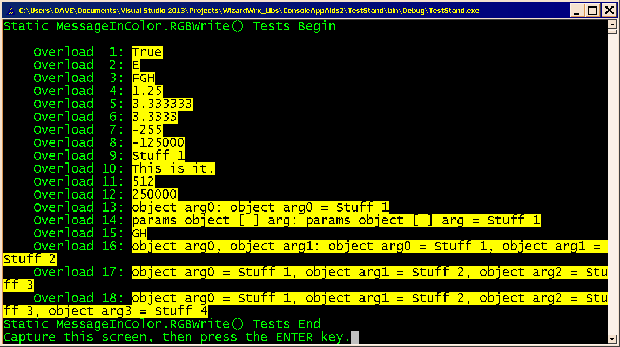
Figure 3 demonstrates MessageInColor.RGBWrite, which is static, requires two extra arguments to specify the color, and is equivalent to Console.Write.
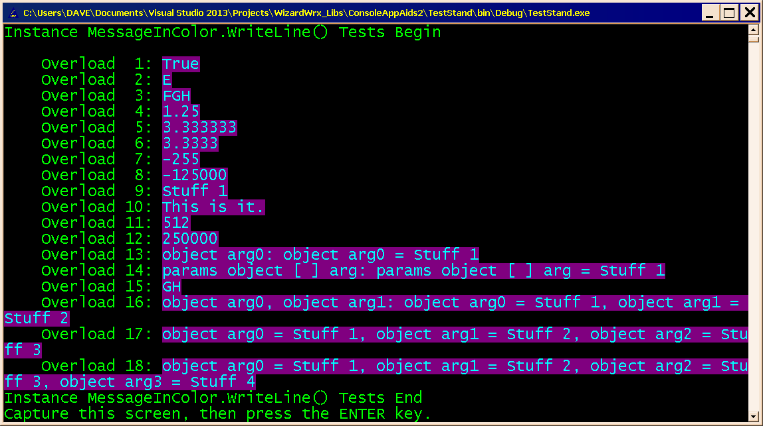
Figure 4 is the 3rd of the 4 screens of the color writing demonstration. This screen shows the instance version of Console.WriteLine, which I called MessageInColor. WriteLine, and gave the same signature as Consosle.WriteLine.
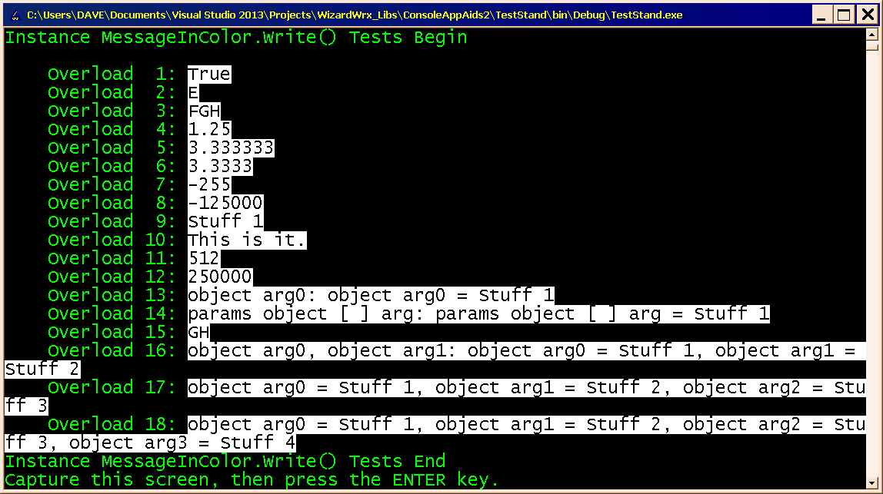
Figure 5 is the 4th of the 4 screens of the color writing demonstration. This screen shows the instance version of Console.Write, which I called MessageInColor.Write, and gave the same signature as Consosle.Write.

The Color Error Message Writers
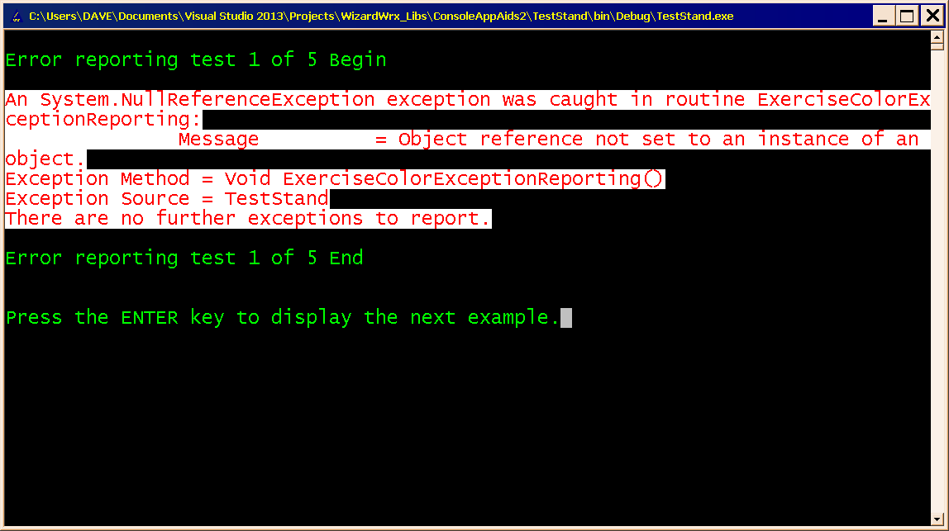
Figure 6 demonstrates my NullReferenceException reporting routine, using an alternative color scheme that was set at run time. If logging in a Windows event log is enabled, additional details, such as the stack trace, go into the message written into the Windows Event Log record.
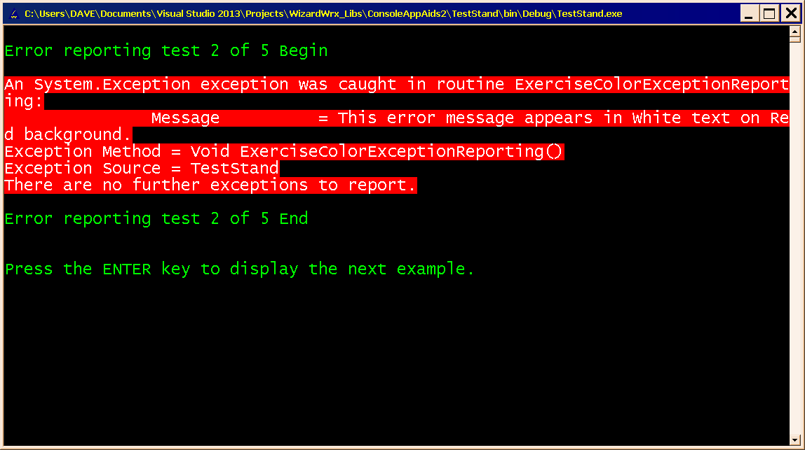
Figure 7 demonstrates the report writer output of a generic System.Exception exception.
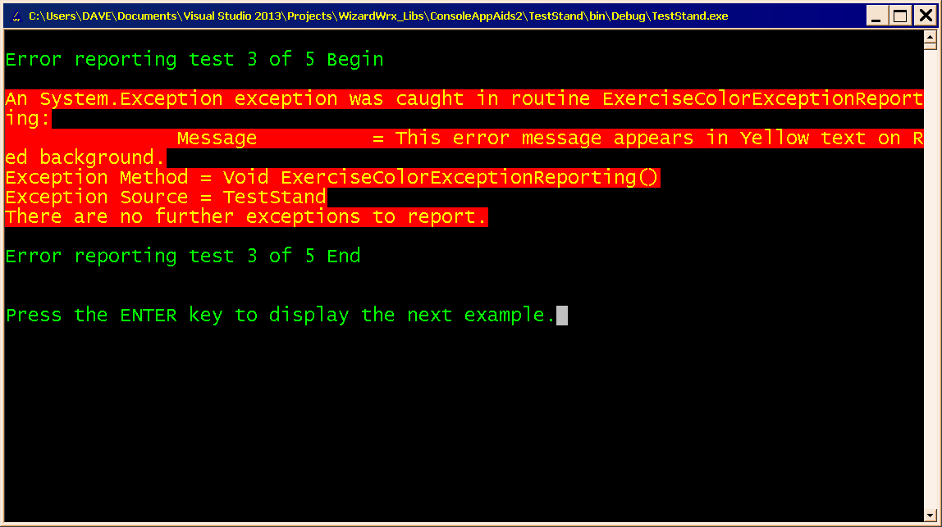
Figure 8 uses a different color scheme to present the same generic System.Exception exception report. I think the colors shown in this figure and in Figure 7 are too intense, but you can’t say you didn’t notice it!
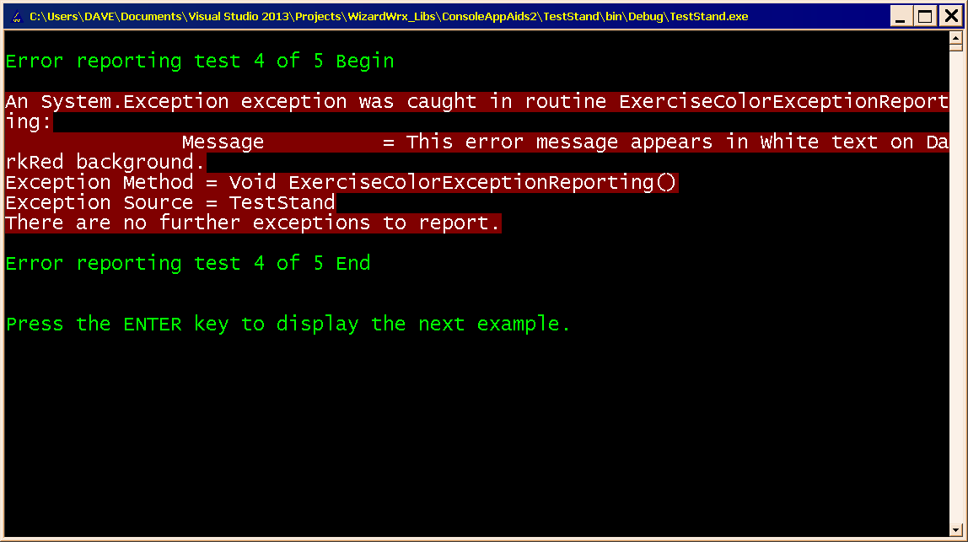
Figure 9 is the 4th example of the System.Exception exception report, which is sufficiently bright to get your attention without blinding you. Of the five color schemes shown, I think this is the best.
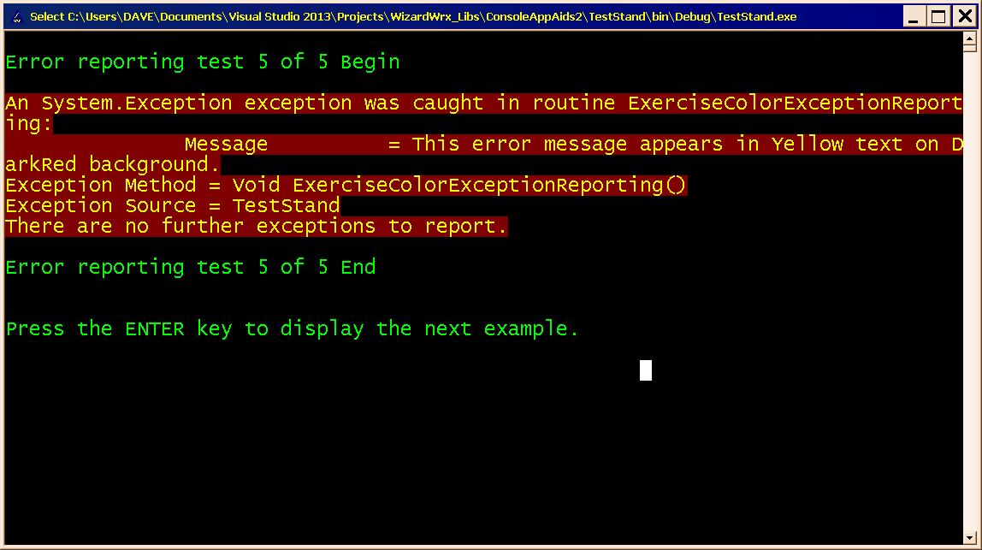
Figure 10 is the 5th version of the same exception report. I think this is the 2nd best of the 5 color combinations shown, though it’s a close second to the colors shown in Figure 9.
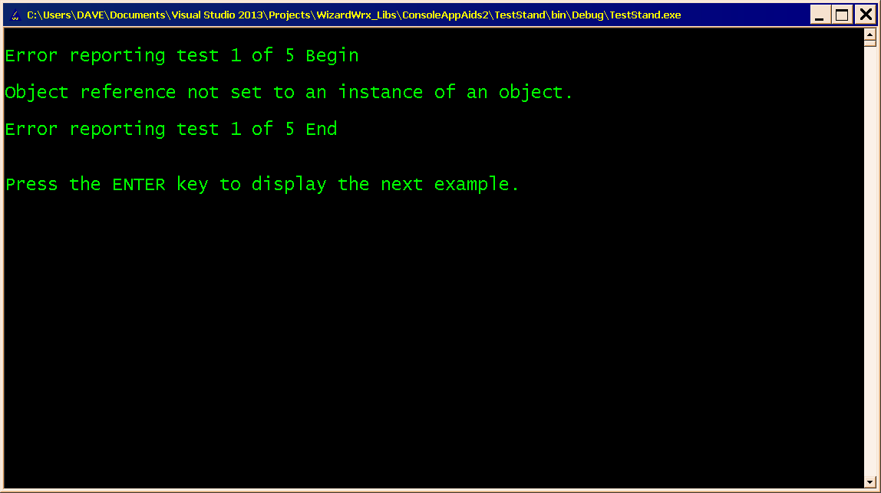
Figure 11 is the kind of terse error message that is easily overlooked, unless something is done to make it stand out. A standard character mode display offers few options other than limited special formatting and contrasting colors. Of the two, I think colors trump formatting for getting your attention.
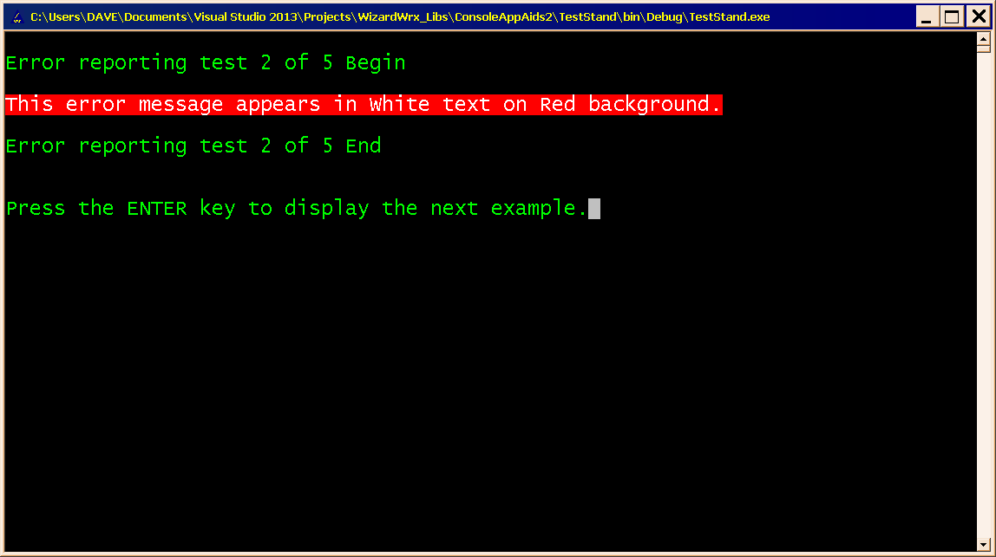
Figure 12 is an equally terse message displayed in white text on a very bright red background. These colors definitely get your attention, at least sufficiently to prove my point.
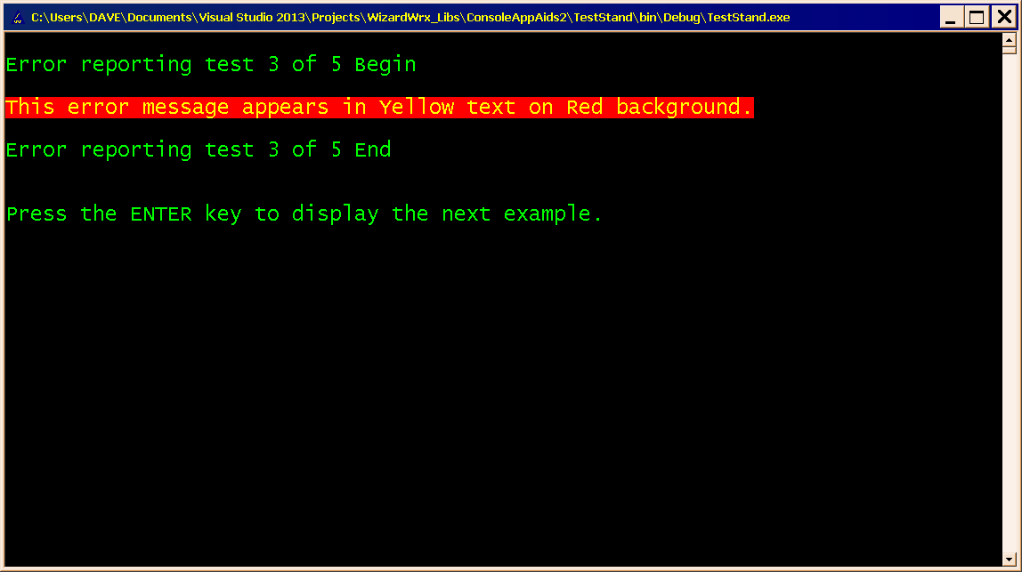
Figure 13 is a message similar to the one shown in Figure 11 and Figure 12, but using the second color combination that I tried.
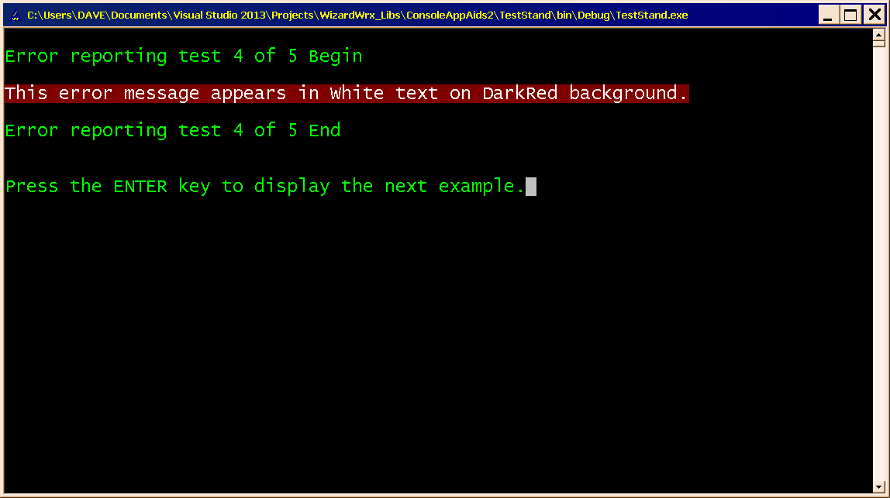
Figure 14 is the 4th of 5 terse messages, using the color scheme shown in Figure 9. The fact that it is equally effective for this terse message strengthens my confidence in adopting it as my standard color scheme for reporting fatal (unrecoverable) errors.
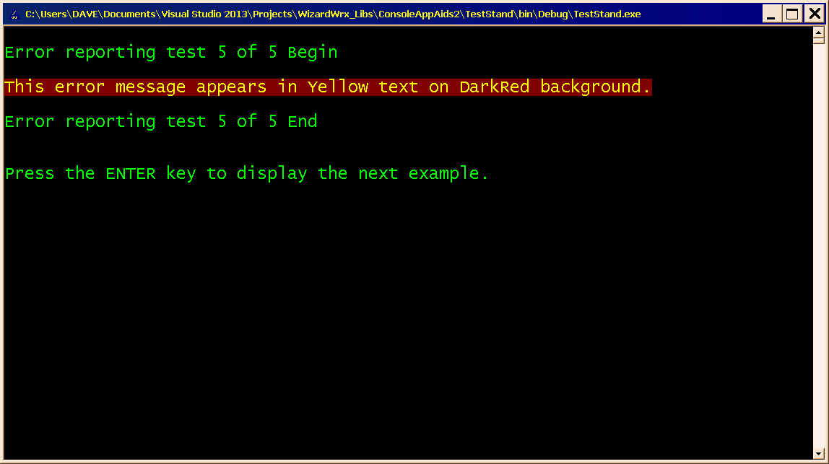
Figure 15 applies the color scheme shown in Figure 10 to a terse message, for which it is equally effective.

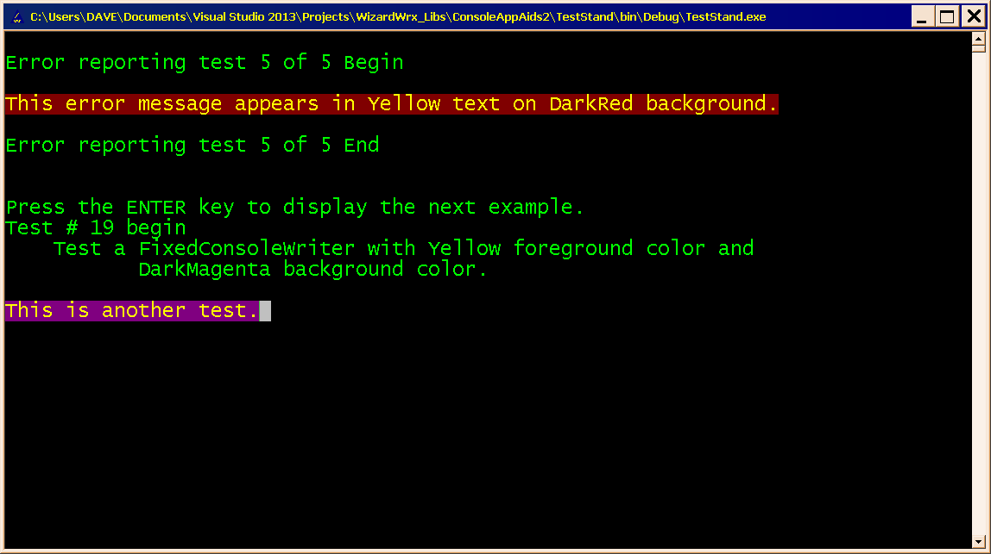
Figure 16 is the first of a series of demonstrations of my FixedConsoleWriter class. This is the simplest case, in which the text is written from the left edge of the window.
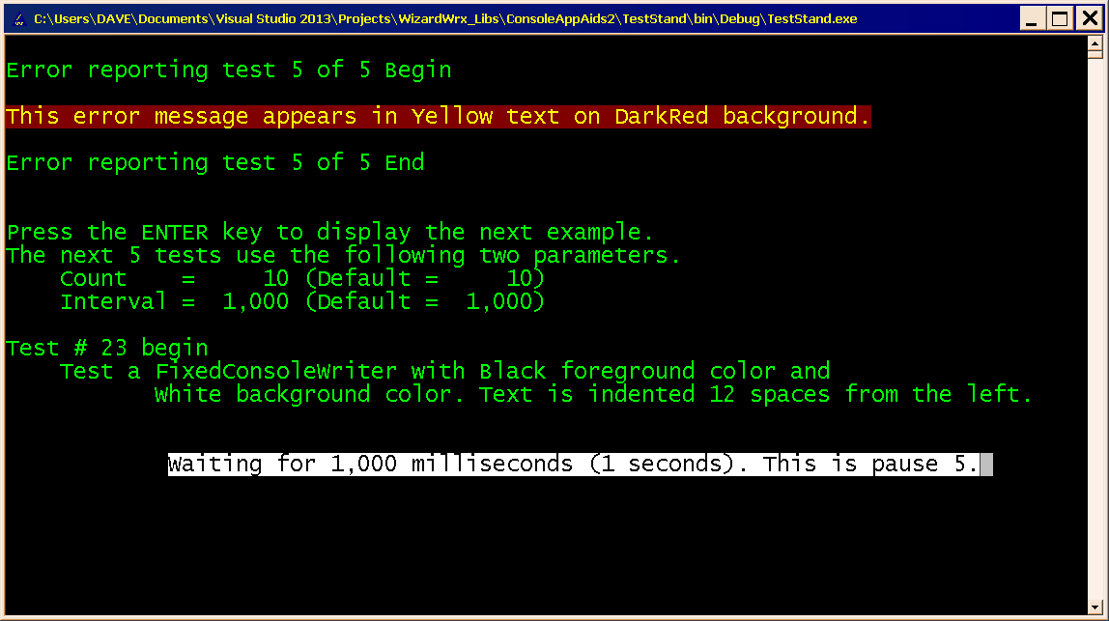
Figure 17 demonstrates two additional features of the FixedConsoleWriter class. First, the bottom message is indented 12 spaces. Second and third instances allow this and subsequent tests to reuse the same screen real estate, while keeping the text above them visible.
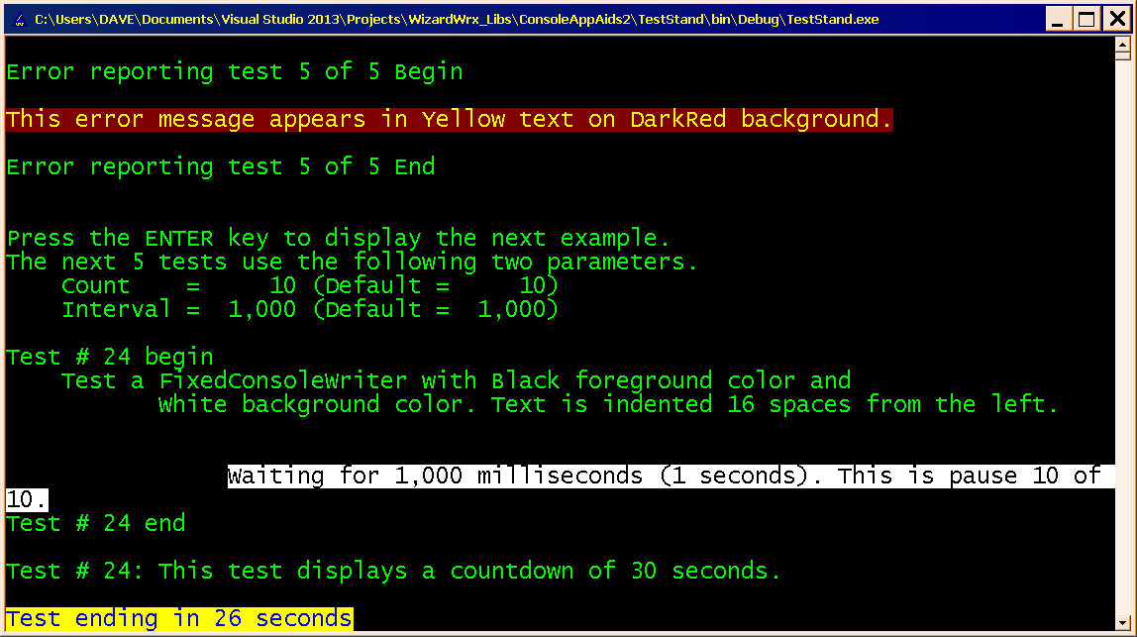
Figure 18 demonstrates how the FixedConsoleWriter class handles text that wraps around the end of a line, followed by a countdown clock, shown at the bottom of the screen, which follows a brief resumption of normal scrolling.
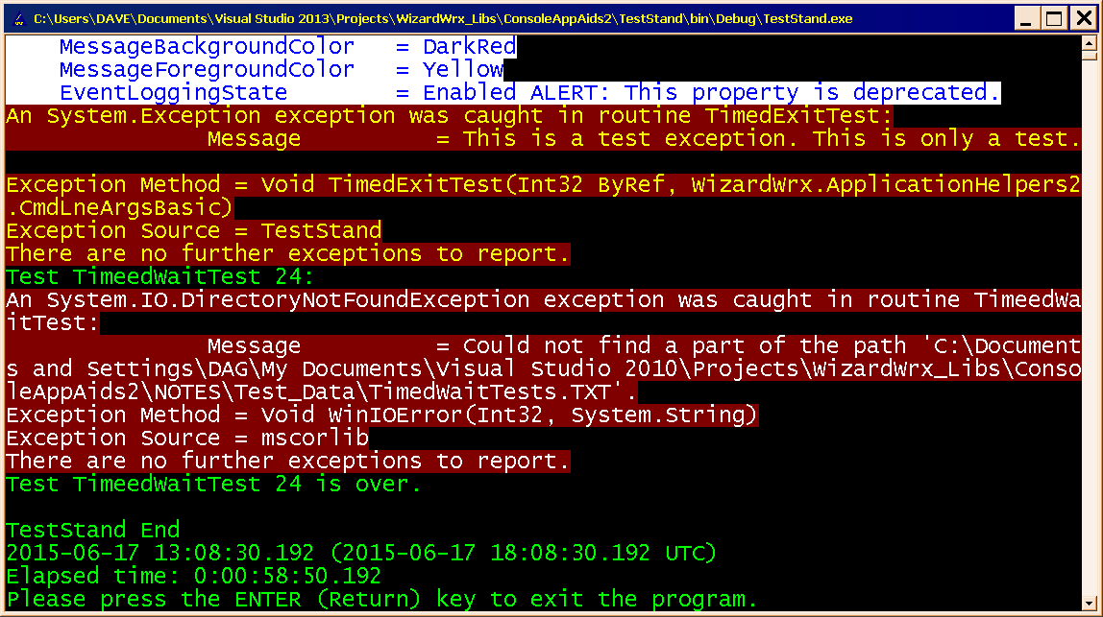
Figure 19 demonstrates a couple of other overloads of the ReportException method of the AppExceptionLogger singleton class. Though a production application should usually confine such details as invalid path strings to the messages that go into the Windows Event Log, but I wanted to make a point about the frequent absence of such actionable information.

The FixedConsoleWriter Class
FixedConsoleWriter is a class that builds on the ErrorMessagesInColor class illustrated in the last section to deliver status reports without scrolling the text above them out of the visible window. Demonstration program TestStand.exe uses three FixedConsoleWriter instances to deliver the results shown in the pictures that follow. Two of the three are created at once, at the top of the routine that generates the text shown in these pictures, and the third is created with different initial values fed into its constructor for each phase of the test series.

Why Do We Need Three Objects, when One Console Singleton Will Do?
Although the colors and left margin are established when a new FixedConsoleWriter is created, the screen row that marks the top of a zone of rows that it reuses is determined the first time one of its Write methods is called.
In Figure 1, the line that reads, “Test # 1 begin,” is the first line written through a FixedConsoleWriter instance method, and the last FixedConsoleWriter instance created is responsible for “This is a test.” This test and the next use only two of the three FixedConsoleWriter instances.
In Figure 21, the last line of Figure 20 is replaced by “This is another test.” The new message contains 21 characters, versus 15 for the first message. This has ramifications when it comes time to display the fourth message. To reuse the same lint to display it, this message and the next two are written by the same FixedConsoleWriter instance that wrote the last line shown in Figure 20, which always starts at the left edge of that line on the screen.
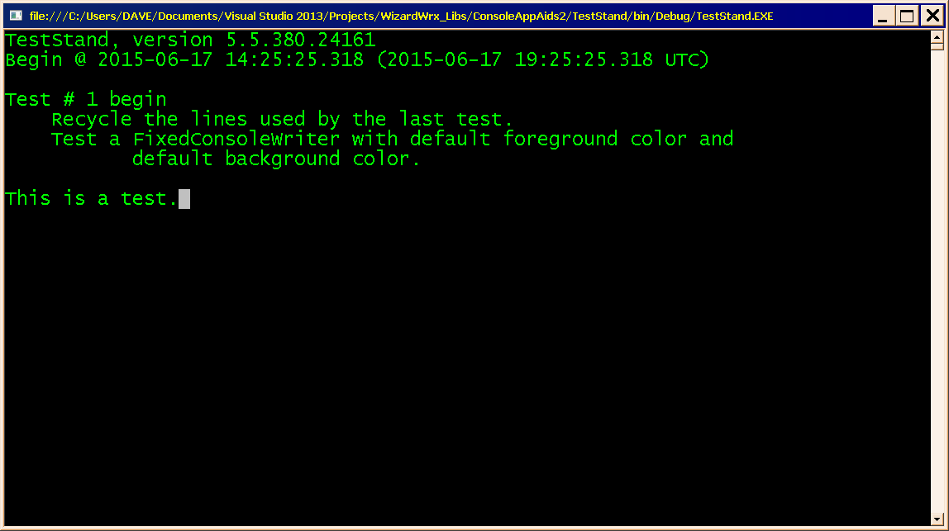
Figure 20 is the first of four messages displayed by a very basic test of the FixedConsoleWriter class.
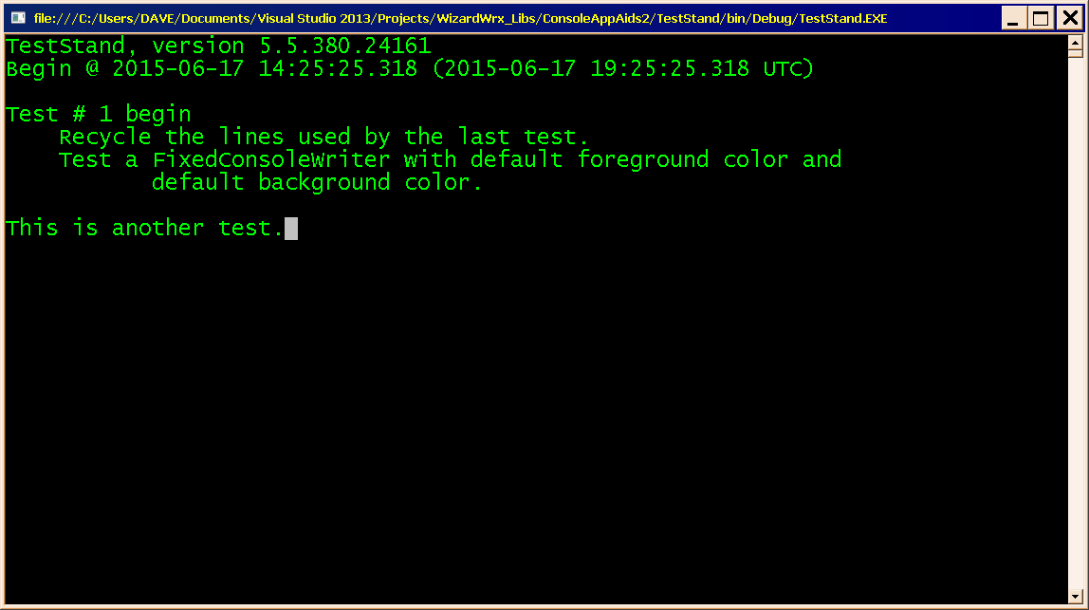
Figure 21 is the output of the 2nd of 4 iterations of a loop that updates a status display that stays in a fixed position on the screen, while keeping the text that preceded it visible.
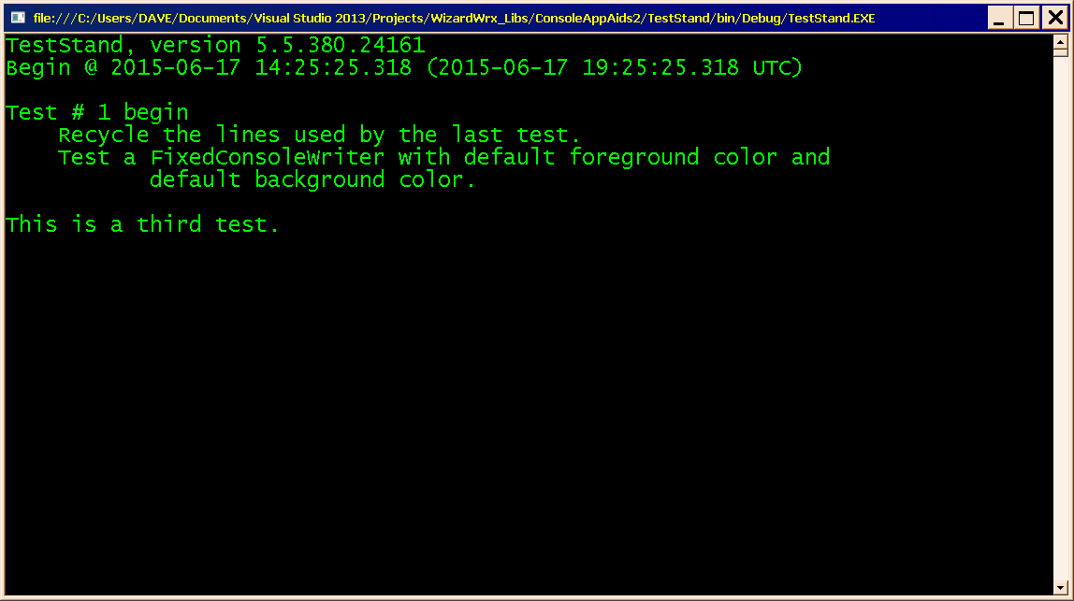
Figure 22 is the 3rd of 4 iterations of this test. The length of this message is 21 characters, as was the last message.
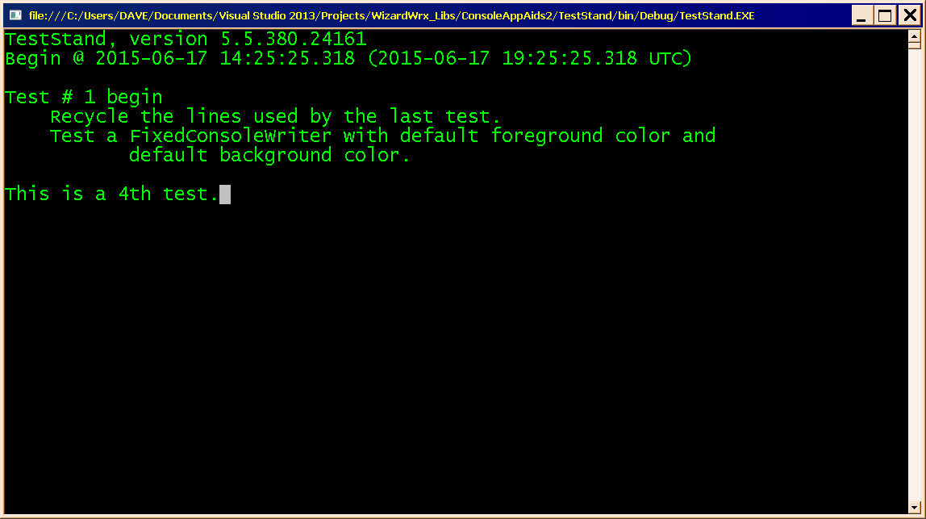
Figure 23 is the output at the end of the 4th of 4 iterations. At 19 characters, the new message, “This is a 4th test,” is two characters shorter than the last message. The previous text was cleared away by overwriting it with spaces.
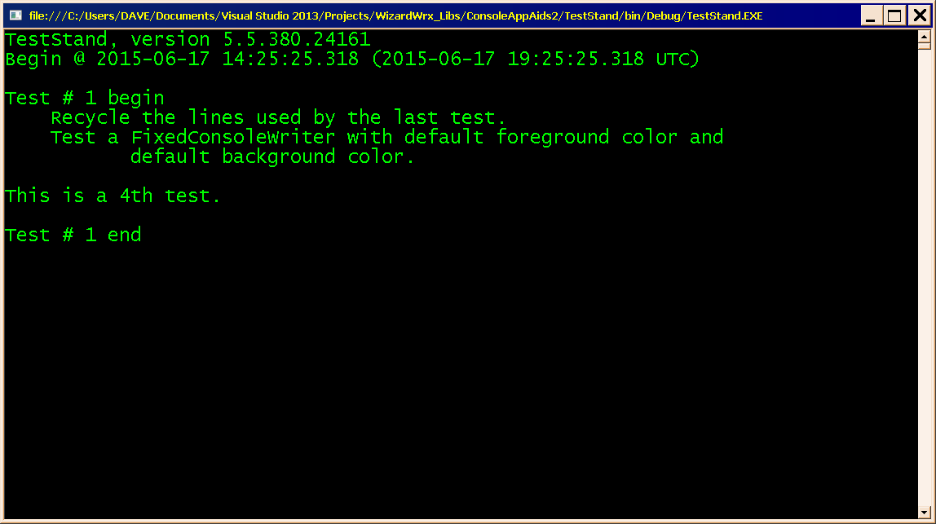
Figure 24 is the final report on this test, which was rendered by calling the ScrollUp method on the FixedConsoleWriter instance that put the four messages onto the screen, followed by a conventional Console.Error.WriteLine method call.
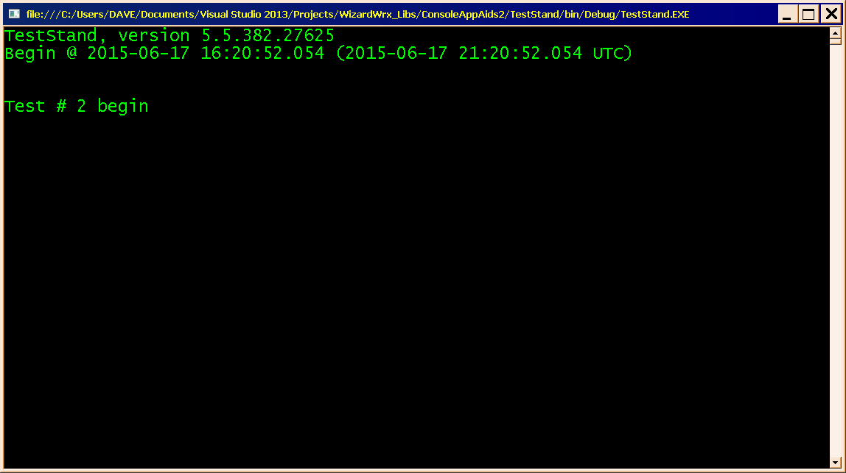
Figure 25 is the result of calling the first of the three (the “outermost” FixedConsoleWriter instance, which last saw action when it was called upon to write “Test # 1 begin,” onto the screen (Figure 20). Calls to any Write method on a FixedConsoleWriter instance call Reset(), a private method, to reposition the cursor to the point where it first wrote something, and to clear all lines below that position.
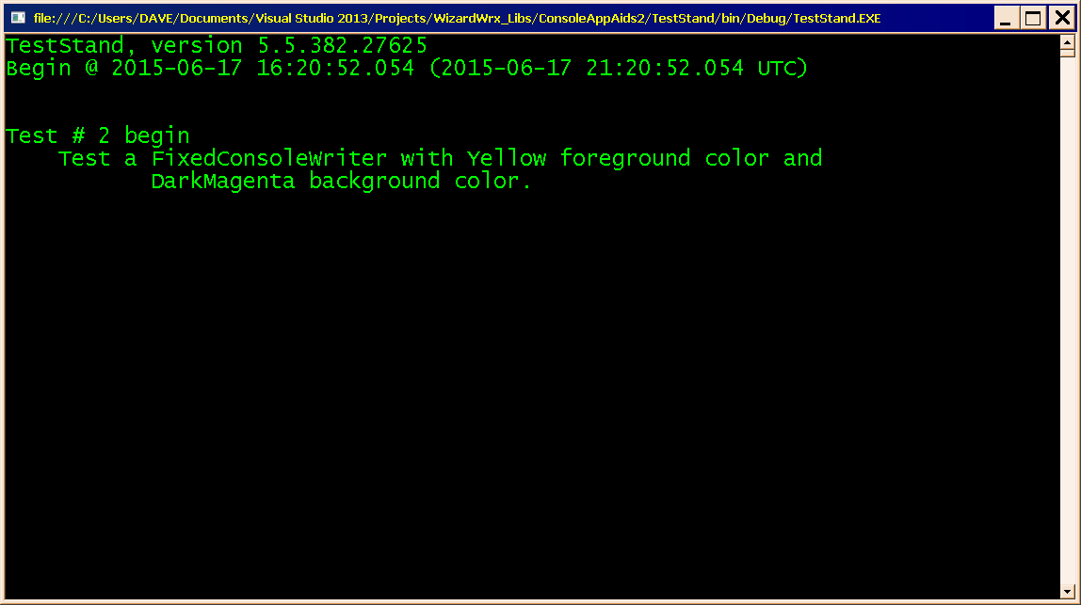
Figure 26 is the output of a call to Console.Error.WriteLine, which puts two lines onto the screen just below the line written by the last call to FixedConsoleWriter (Figure 25).
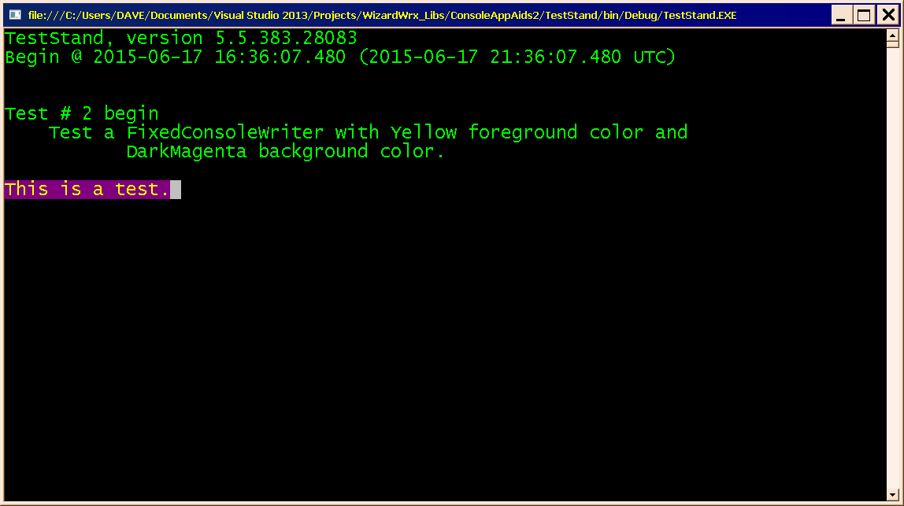
Figure 27 is the outcome of the first of four slightly more advanced FixedConsoleWriter test outputs. Everything is the same as it was when I created Figure 20, except the colors, which are specified as two arguments to an overloaded FixedConsoleWriter constructor. Since this test starts at the same place on the screen as test 1, the yellow on magenta test message occupies the same line, (Line 9, at offset 8 from the origin).
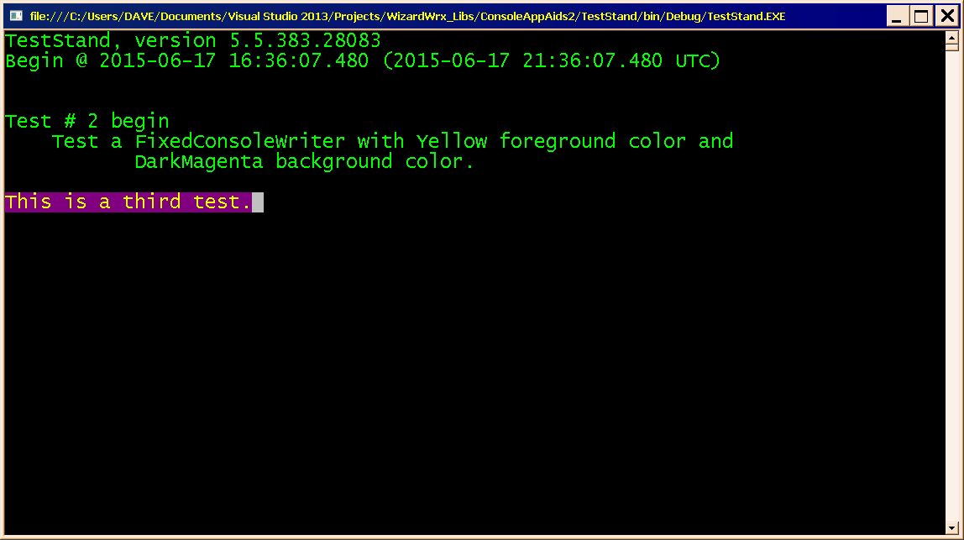
Figure 28 is the outcome of the 3rd of the 4 iterations of test # 2. The 2nd test (not shown) is unremarkable.
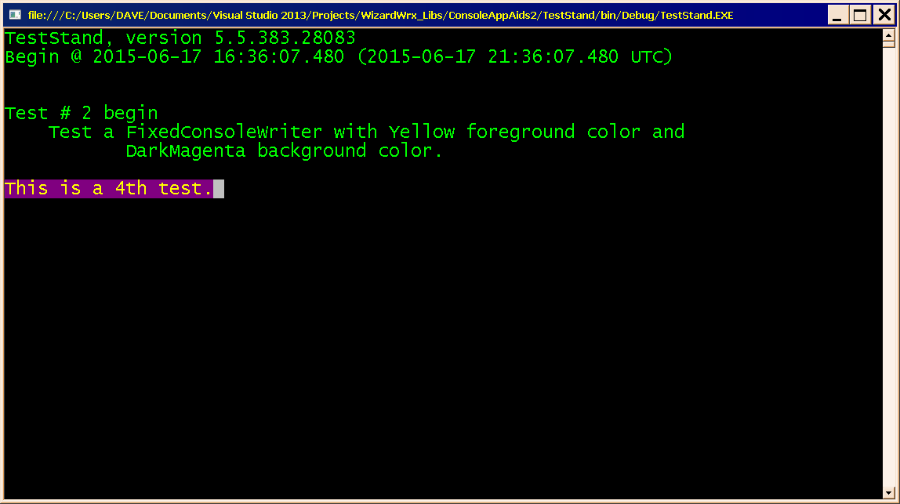
Figure 29 is the outcome of the 4th iteration of test # 2. As was the case in test # 1, shown in Figure 24, there is no trace of the longer string from the 3rd iteration (Figure 28); even the background has reverted to its default color. This is the result of the blanks being written with the console colors set to their default values.
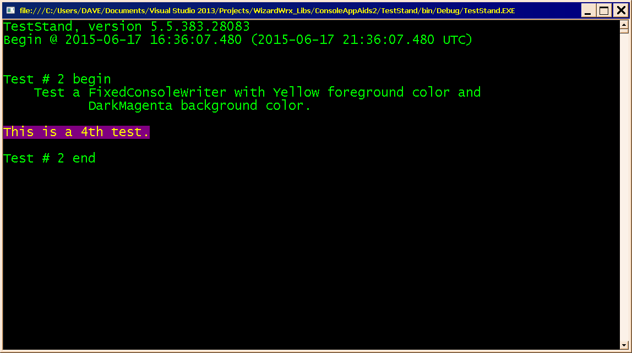
Figure 30 is the final output of test # 2, which was achieved in exactly the same way as it was in test #1 (Figure 24).
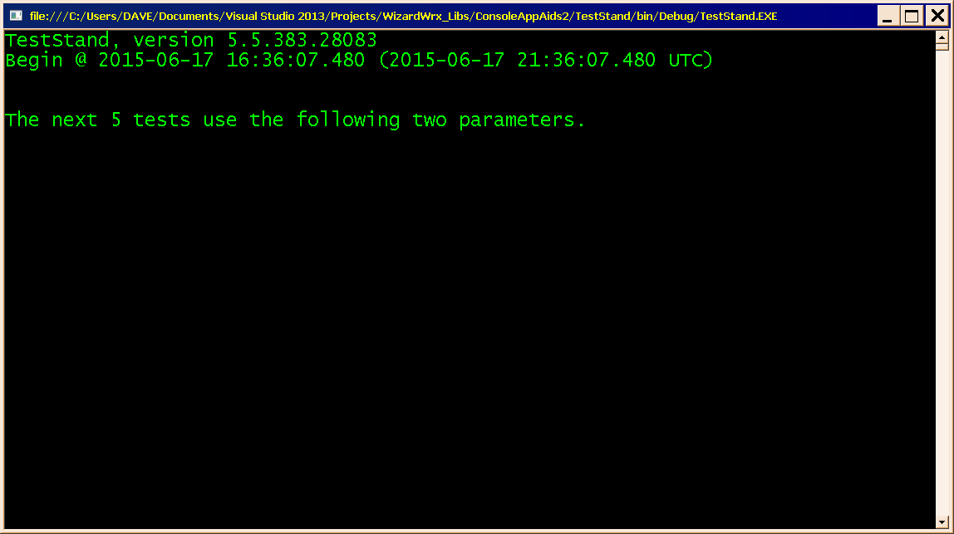
Figure 31 marks the beginning of 5 tests that fully exercise a FixedConsoleWriter instance, and marks the first use of all three FixedConsoleWriter objects. To partially clear the screen and restore the cursor to its starting position, the FixedConsoleWriter instance that wrote the messages shown in Figure 20 and Figure 25 is once more called upon to write.
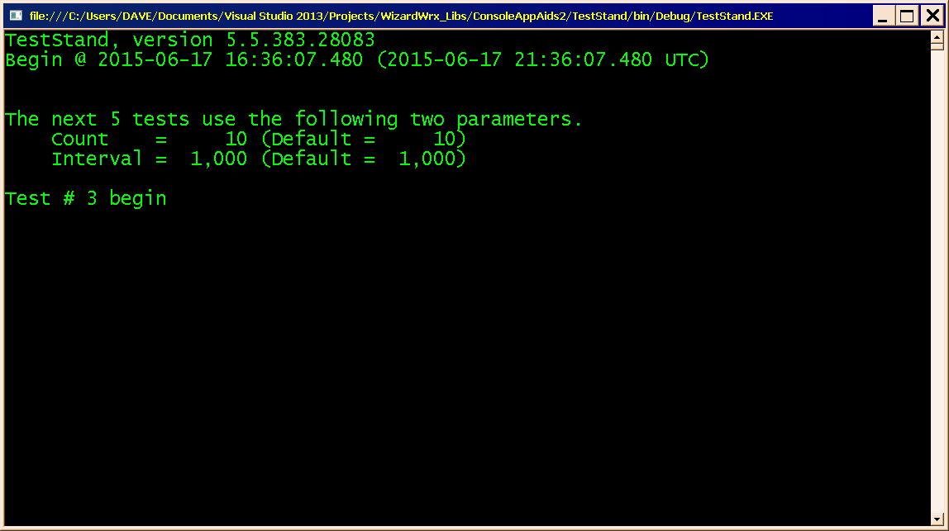
Figure 32 brings the 3rd of the 3 FixedConsoleWriter instances into play for the first time, marking off an area that will be reused for tests 3 through 7.
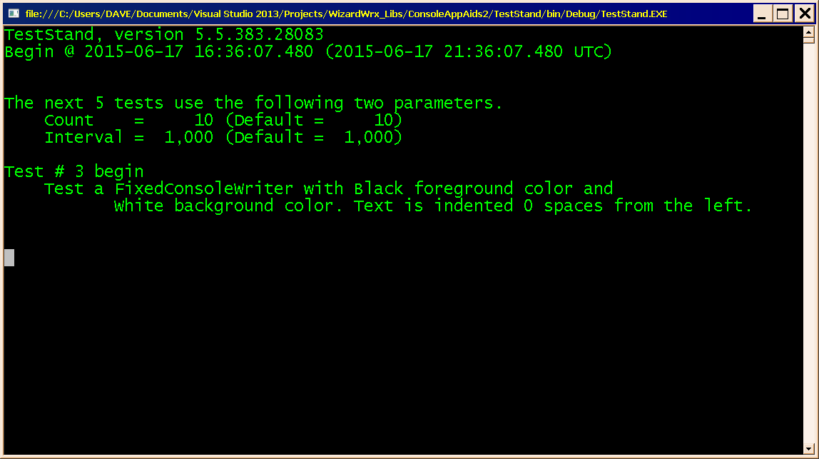
Figure 33 is the output of a garden variety Console.Error.WriteLine call that lists the parameters of test # 3. Since it follows the text first shown in Figure 32, and precedes that shown in Figure 34, the FixedConsoleWriter object that wrote the message shown in Figure 34 protects it until the FixedConsoleWriter object that wrote the message shown in Figure 32 erases it.
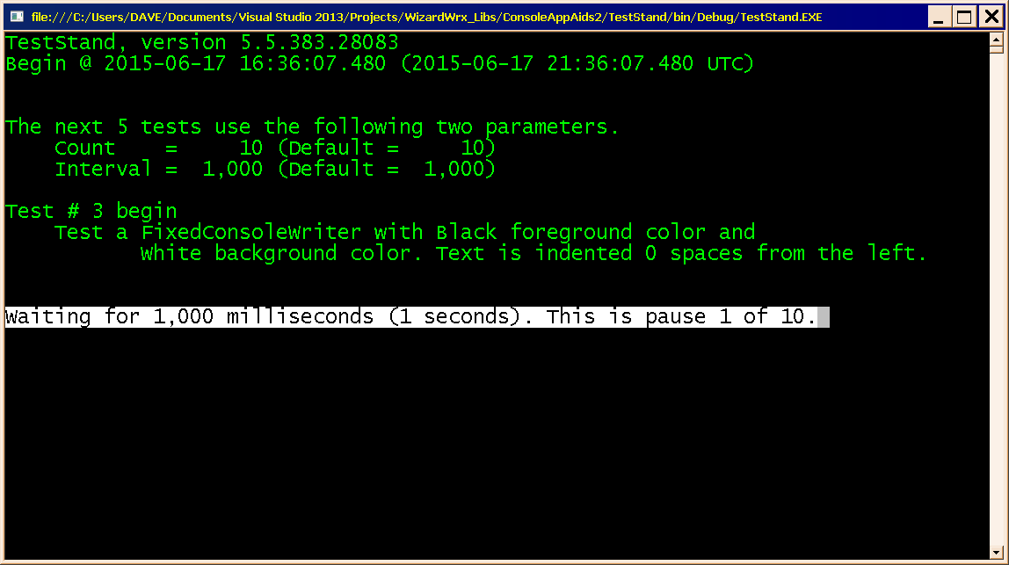
Figure 34 is the first of 10 messages displayed by the FixedConsoleWriter object that writes the messages that comprise the output of test # 3.
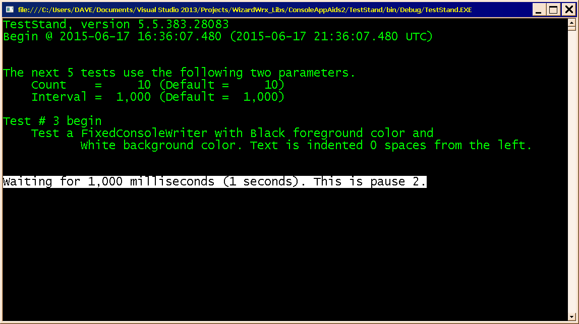
Figure 35 is the second of the ten messages that comprise the output of test # 3. Since this message is slightly shorter, so is the area covered by the white background.
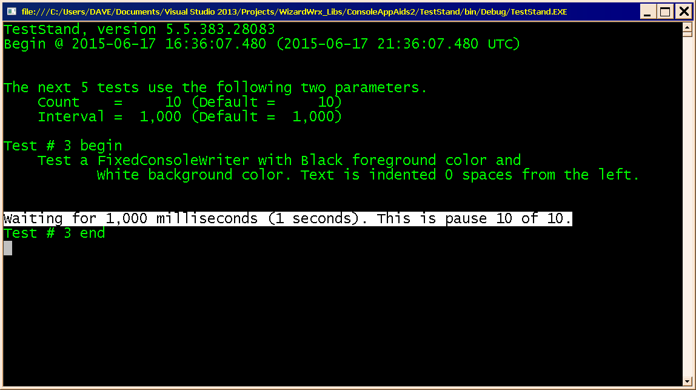
Figure 36 is the conclusion of test # 3. I omitted messages 3 through 9, all of which are unremarkable.
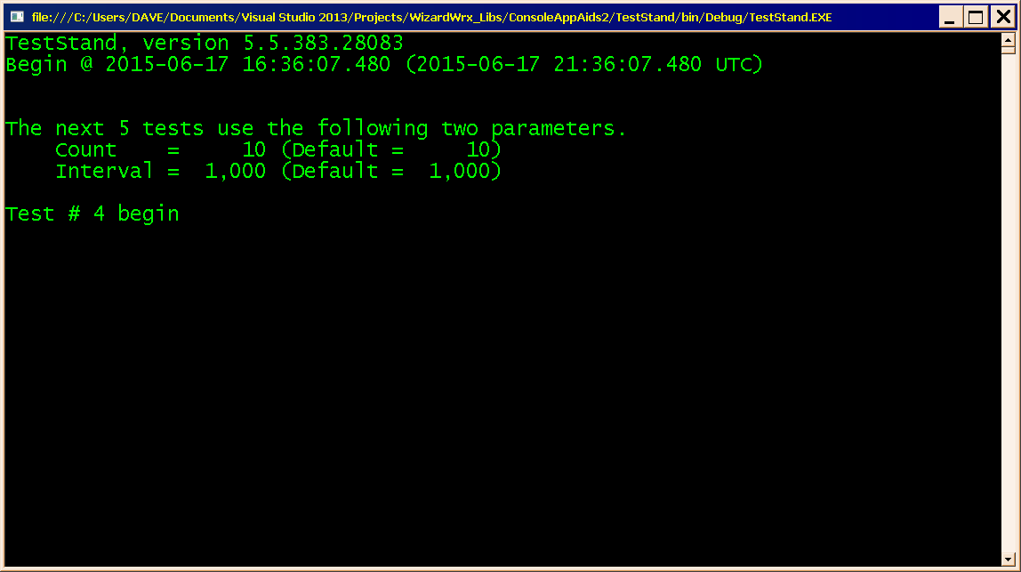
Figure 37 is the screen as it appears after the FixedConsoleWriter instance that wrote the last line shown in Figure 32 erases the output of test # 3 before it writes the heading message of test # 4 in place of the heading of test # 3.
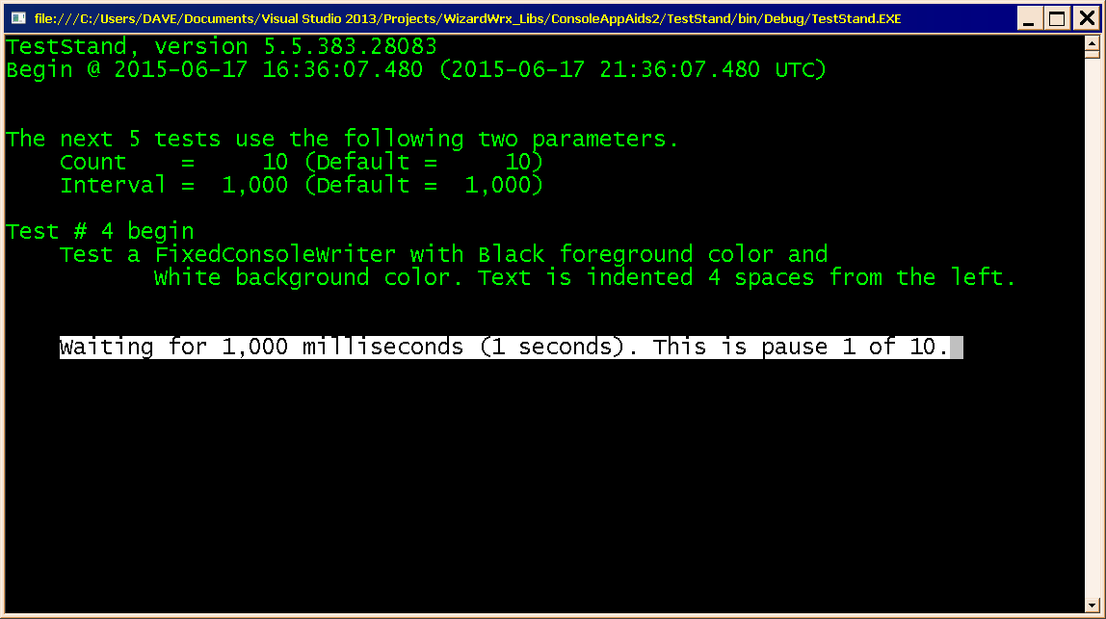
Figure 38 is the remaining specifications for test # 4, followed by the first of its ten messages. Everything about this test is the same as it was for test # 3, except that the messages are indented four spaces.
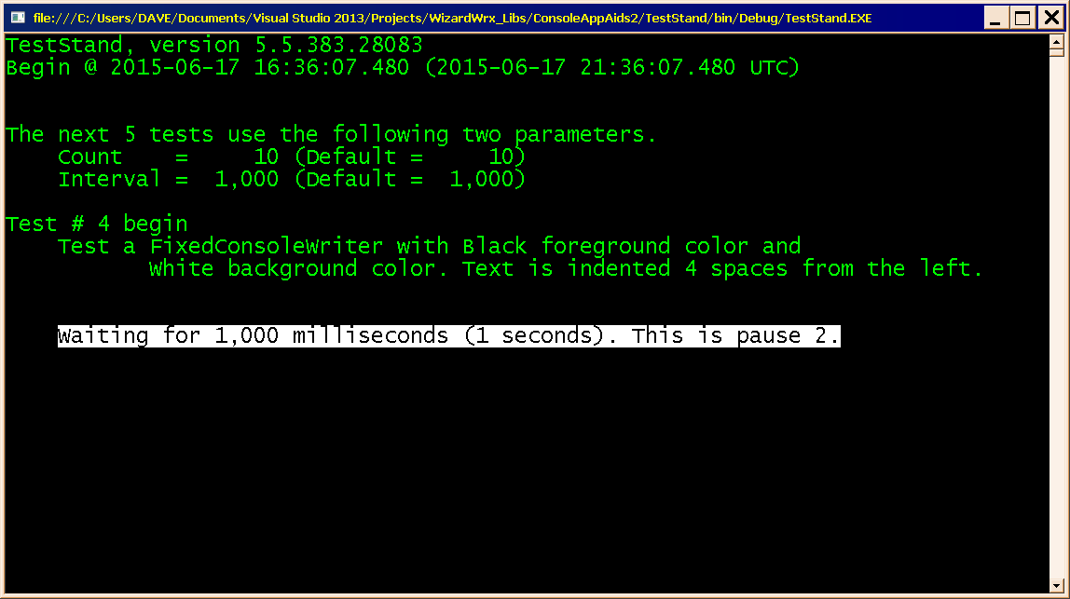
Figure 39 looks almost like Figure 35, except that the message is indented 4 spaces.
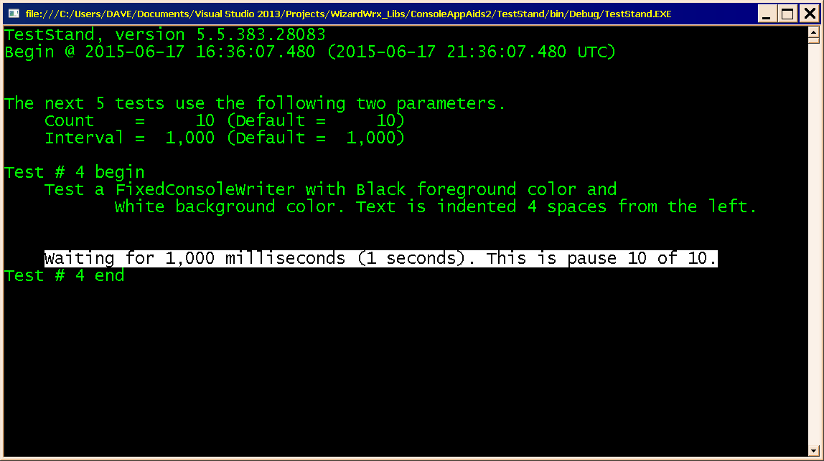
Figure 40 is the conclusion of test # 4.
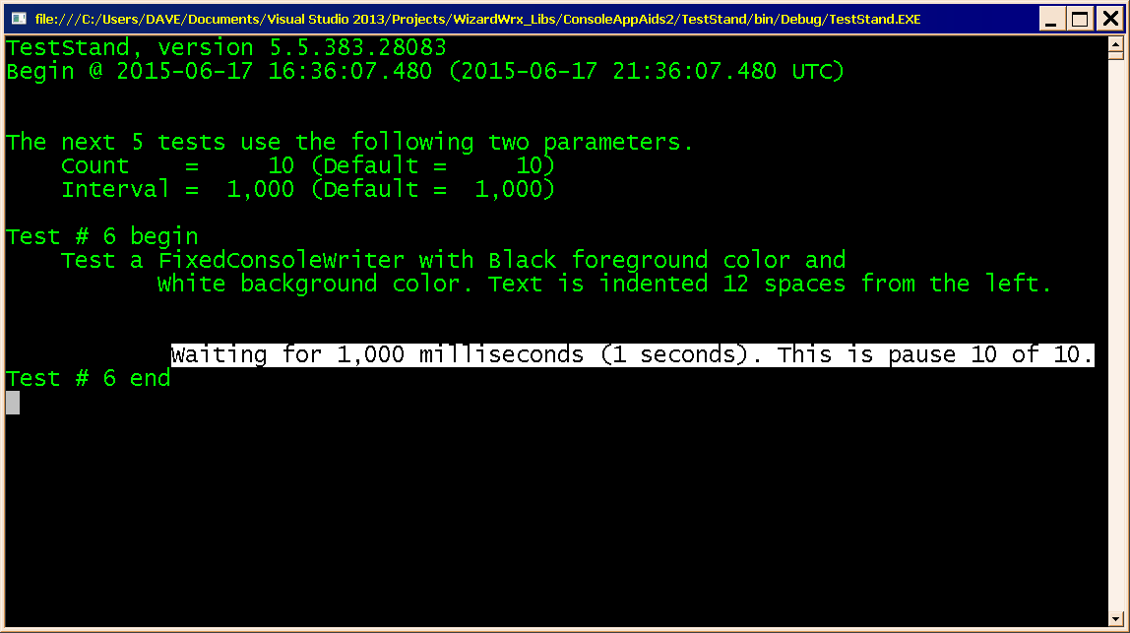
Figure 41 is the final display of test # 6, which writes just short of the right edge of the screen.
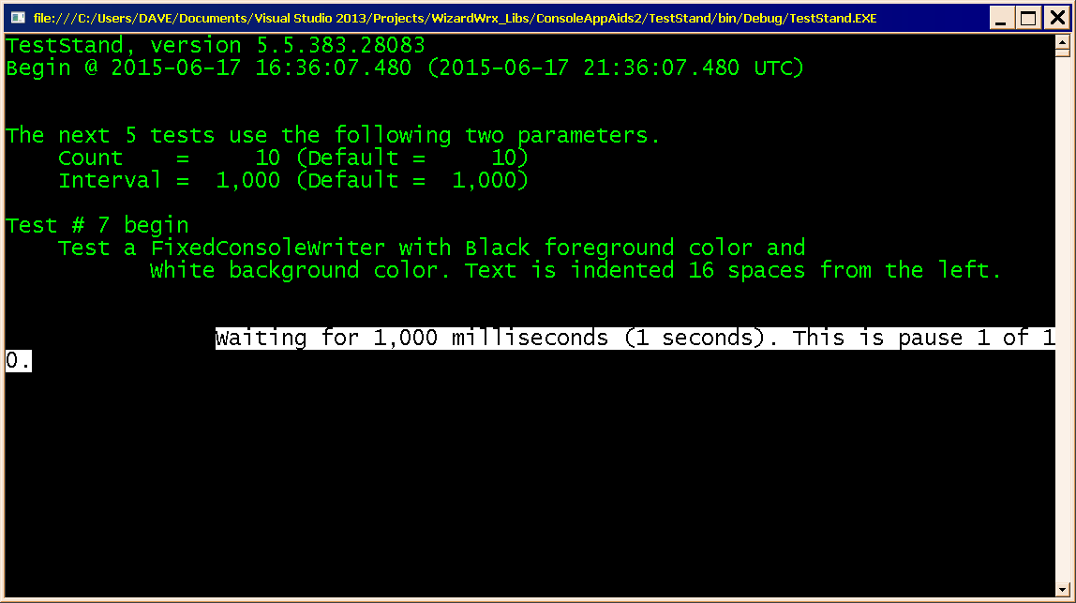
Figure 42 is the first message displayed by test # 7, which indents 16 spaces, as opposed to 12 on test 6, causing the first message to wrap around.
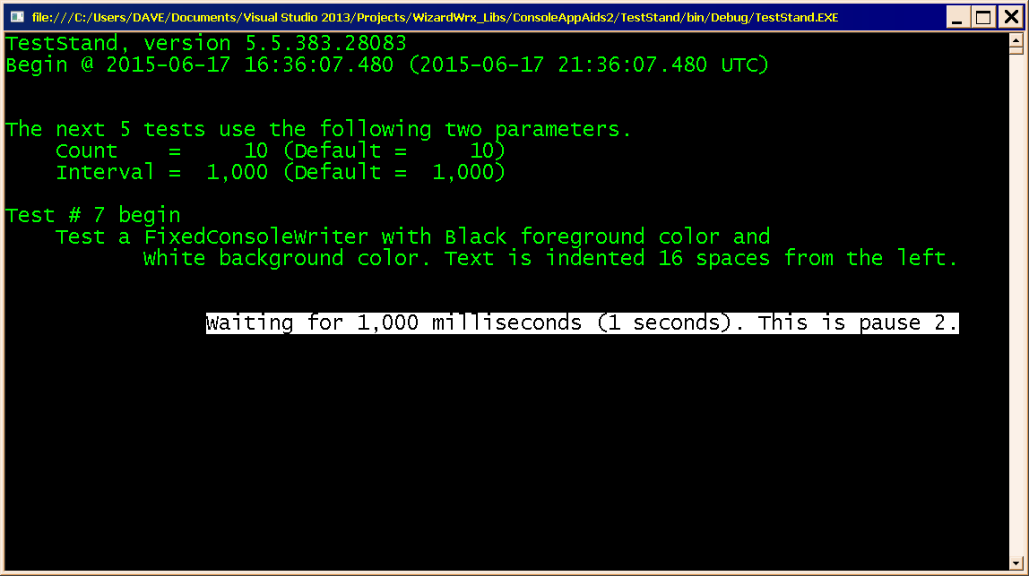
Figure 43 is the second of the ten messages generated by test # 7. The text selection rectangle generated by the Select All option on the control menu makes it clear that the wrapped line is gone, so far as Windows is concerned.
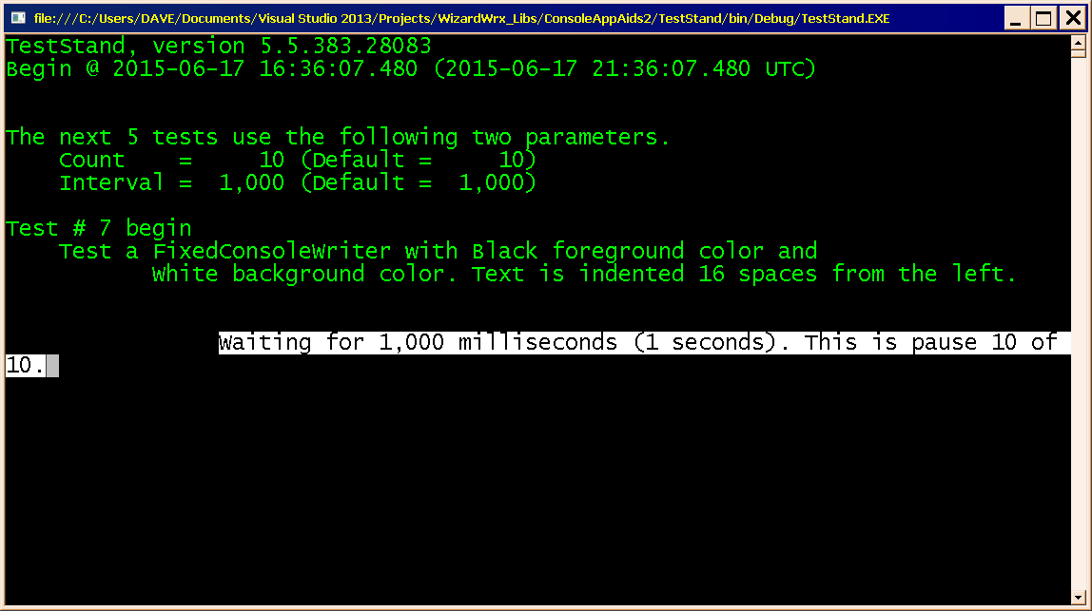
Figure 44 is the tenth message written by test # 7, which wraps a tad further (1 extra character) than the first message (Figure 42).
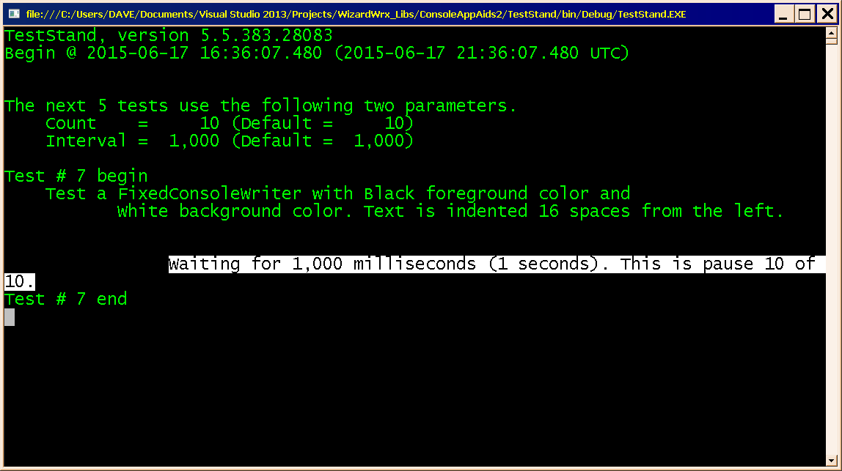
Figure 45 is the final message displayed by test # 7, which demonstrates that the line wrap doesn’t confuse the FixedConsoleWriter object
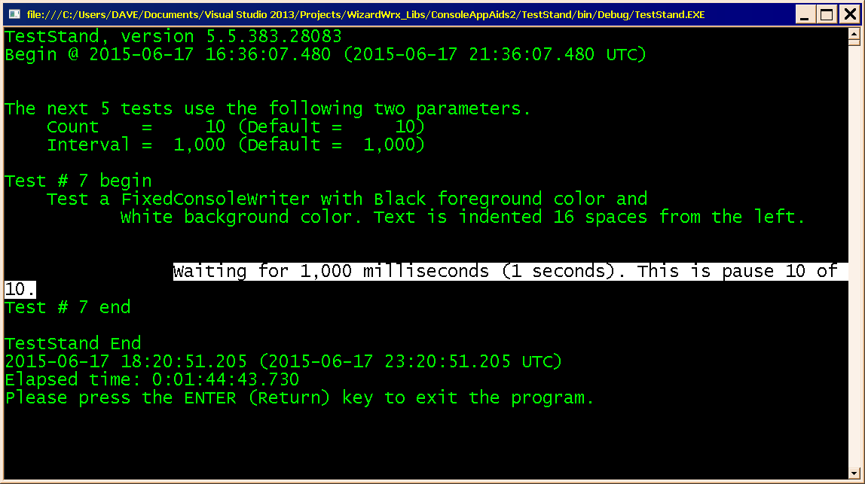
Figure 46 is the conclusion of the whole test set. All three FixedConsoleWriter objects went out of scope, and the last three lines are the work of garden variety Console.WriteLine calls.
.

Exercise the Renamed Writer Methods, 20 July 2014
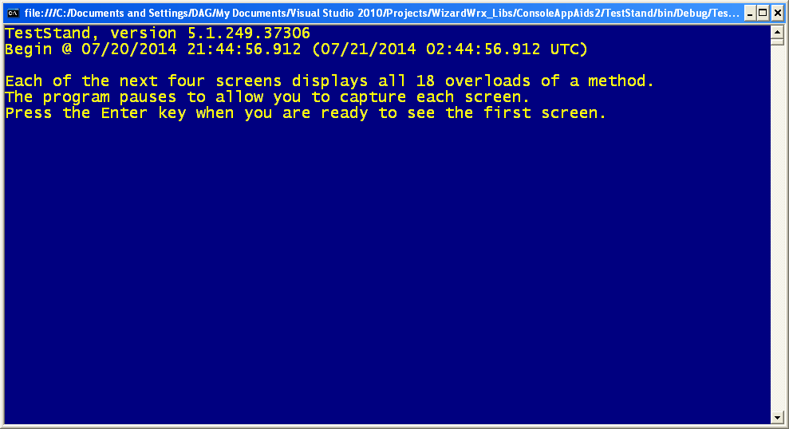
Figure 47 is the first screen displayed by the program. The position of the cursor is significant; WaitForCarbonUnit uses a Console.Write() to display its message. The line feed is held until the message is acknowledged, so that nothing is lost.
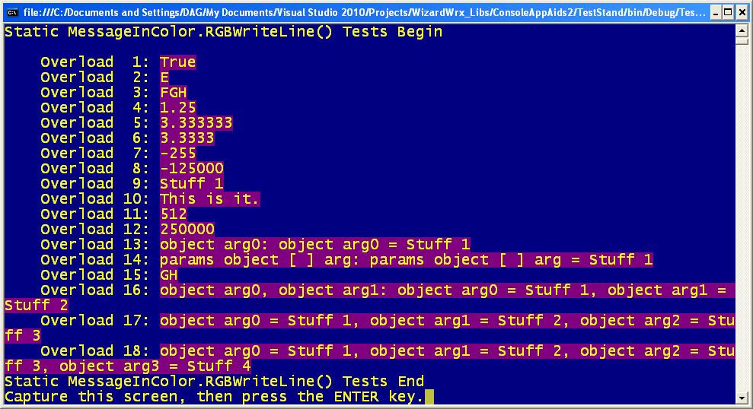
Figure 48 is the MessageInColor.WriteLine() methods, now called RGBWriteLine().
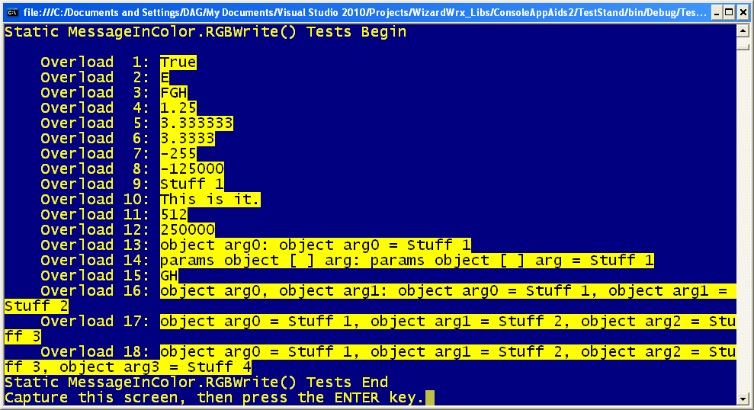
Figure 49 is MessageInColor .RGBWrite(), which writes black text on a yellow background.
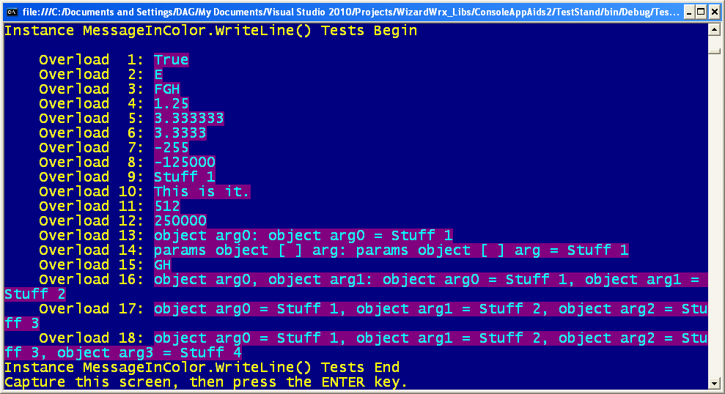
Figure 50 is the instance MessageInColor.WriteLine(), which changes colors again, to light cyan text on a dark magenta background.
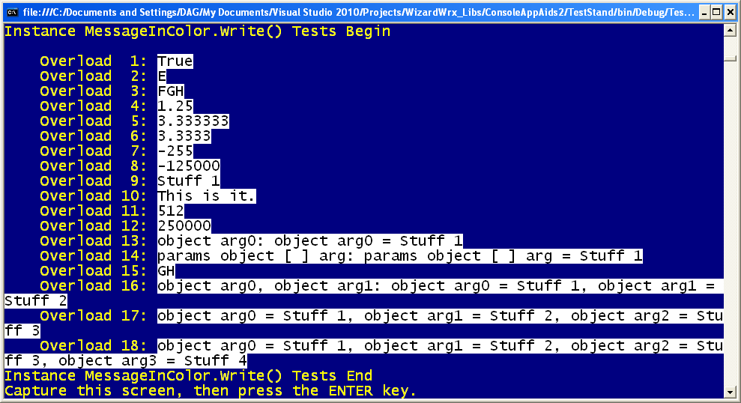
Figure 51 is the fourth (and last) of the standard console writers, another instance method, MessageInColor.WriteLine(), which changes colors yet again, to black text on a white background.
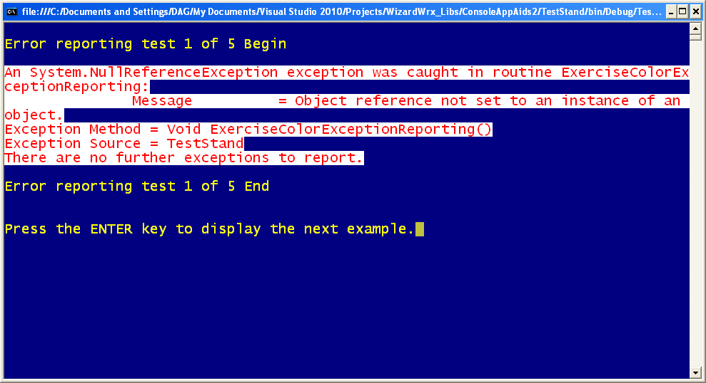
Figure 52 is the 1st of 5 error reporting exercises, using red text on a white background, both selected at run time.
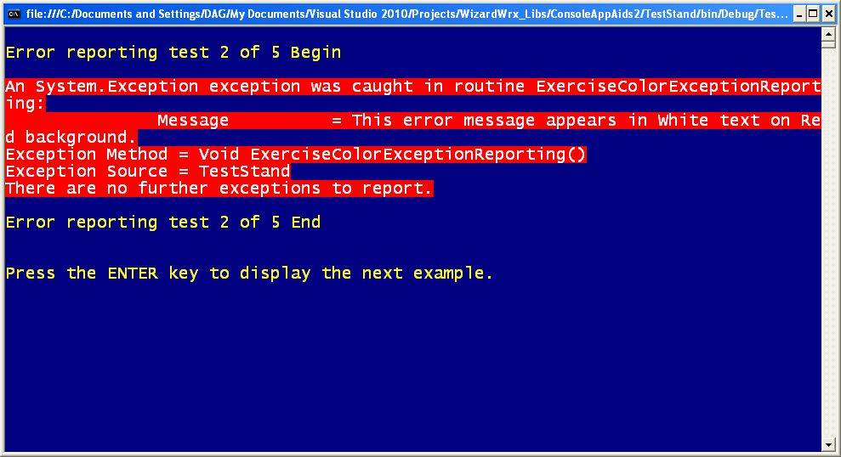
Figure 53 is the 2nd of the 5 error message tests, which proves that bright red is a poor choice for a background color.
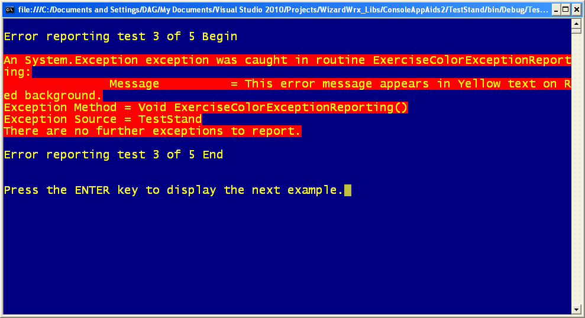
Figure 54 is the 3rd of the 5 tests, which demonstrates that yellow is easier to read on the bright red background, but it’s still too much.
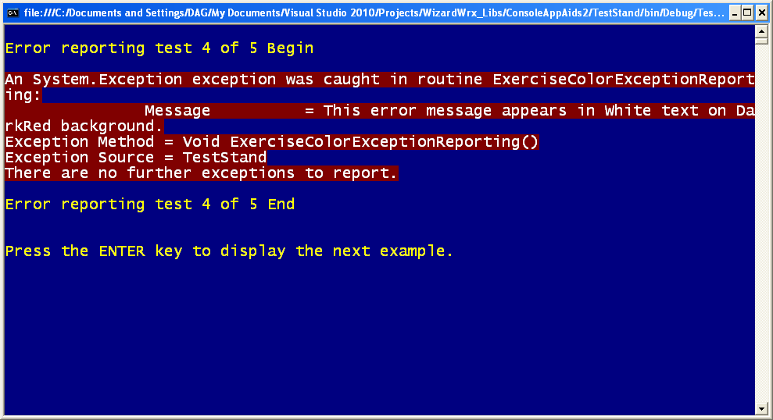
Figure 55, the 4th of the 5 tests, demonstrates white text on a dark red background, which works well by getting your attention, while remaining easy to read.
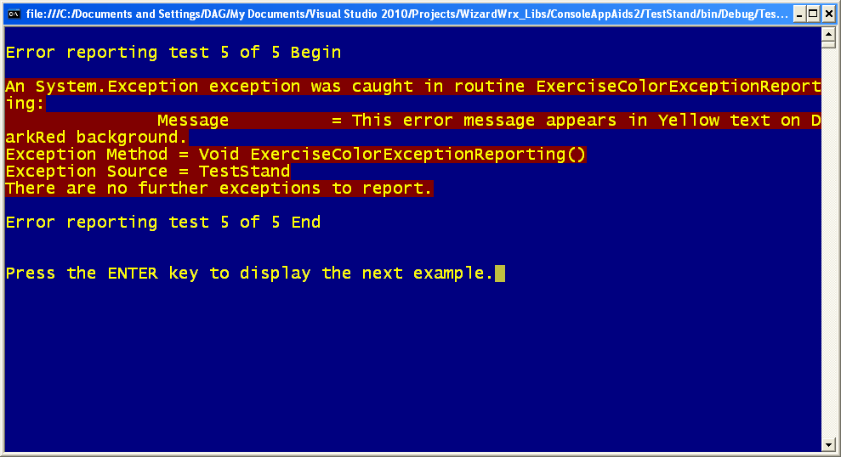
Figure 56, the 5th of the 5 tests, is yellow text on the dark red background, where it is much better than it is on bright red, and is my second choice. I still think white text on red trumps it.
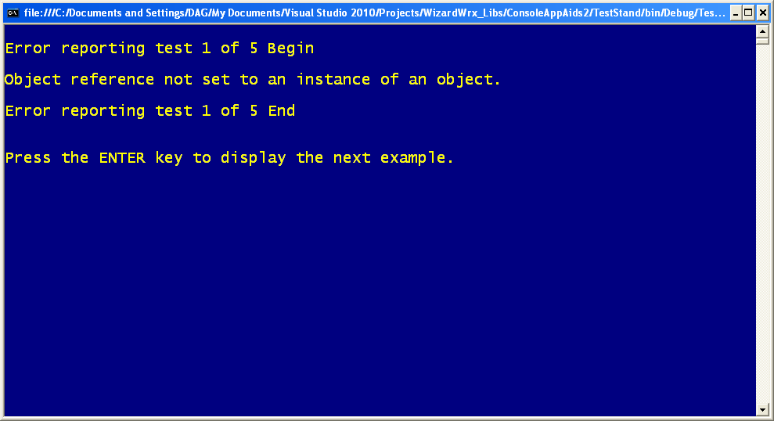
Figure 57 is the 1st of a series of 5 one-line messages displayed in a variety of color combinations.
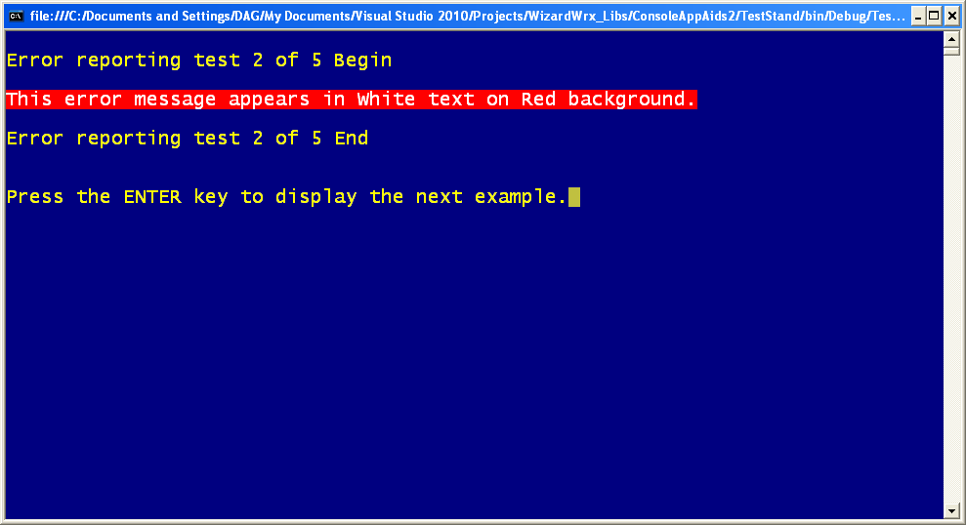
Figure 58 is the 2nd of the 5 messages. Even this single line of white text on the bright red background is hard on the eyes.
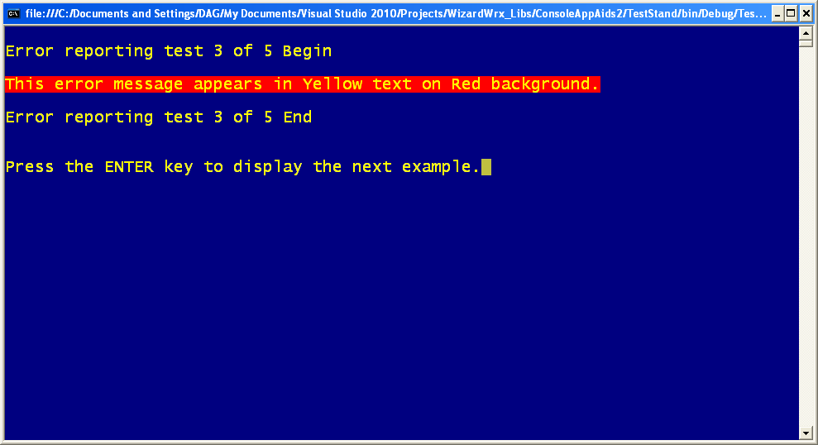
Figure 59 is the 3rd of the 5 tests, in which even a single line of yellow text fares equally poorly on the bright red background.
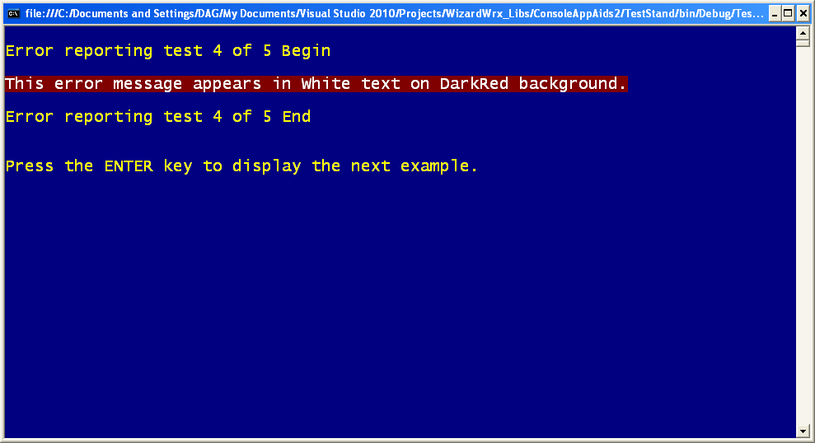
Figure 60 is the 4th of the 5 demonstrations, which confirms that white text on a dark red background is quite effective for calling one’s attention to a one-line message. Of course, it doesn’t hurt a bit that the program stops to give you all the time you need to read it.
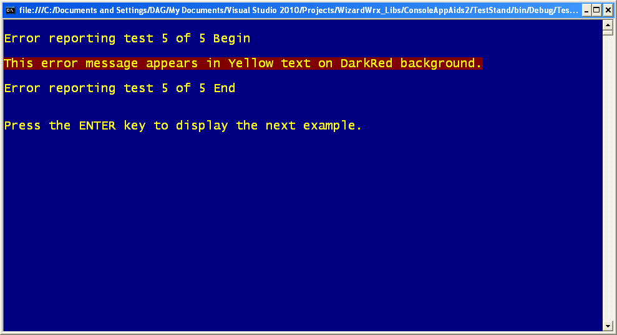
Figure 61 is the 5th of 5 demonstrations, showing that yellow text on the dark red background is quite effective for this one-line message. I think it’s a close call; compare this to Figure 19, and decide for yourself.
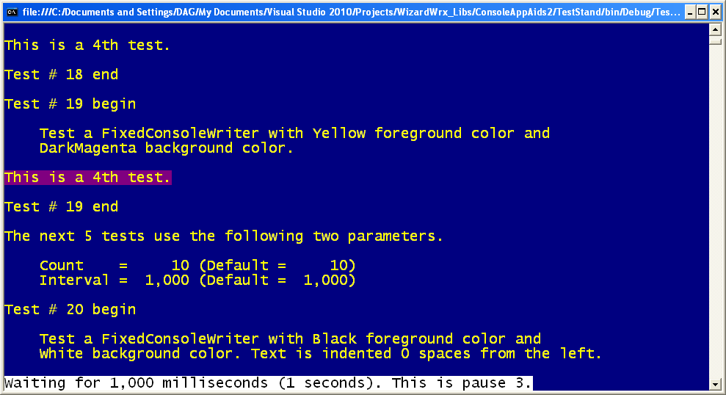
Figure 62 is the first of a series of tests that demonstrate the features of the FixedConsoleWriter class. The message starts at the left, and is intended as a reference for the remaining tests.
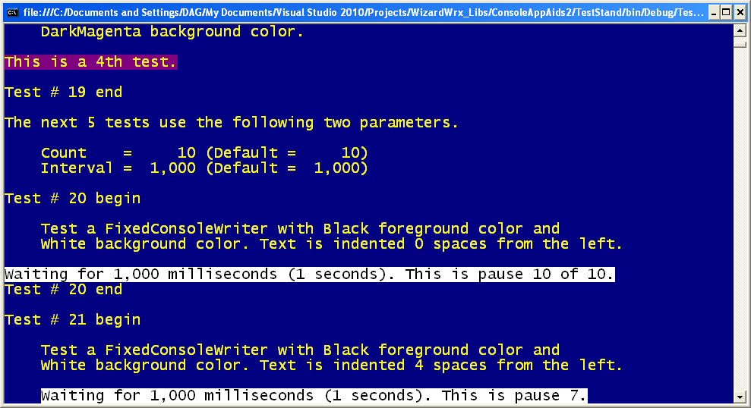
Figure 63 is the first to showcase the idea behind the FixedConsoleWriter.
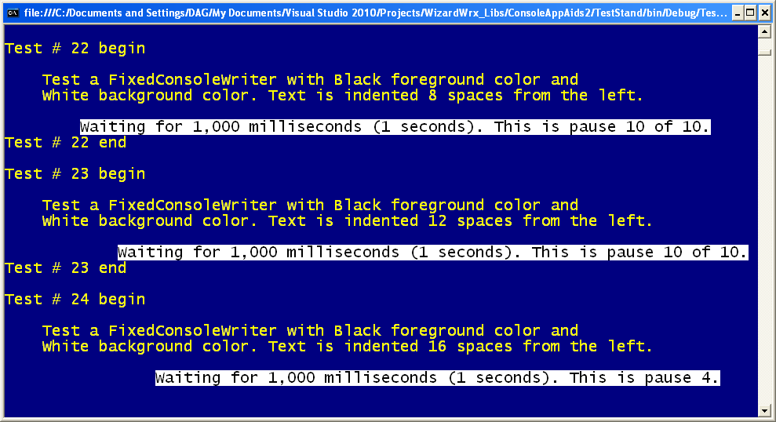
Figure 64 demonstrates what happens when the message wraps to a new line, and is subsequently overwritten by a shorter message.
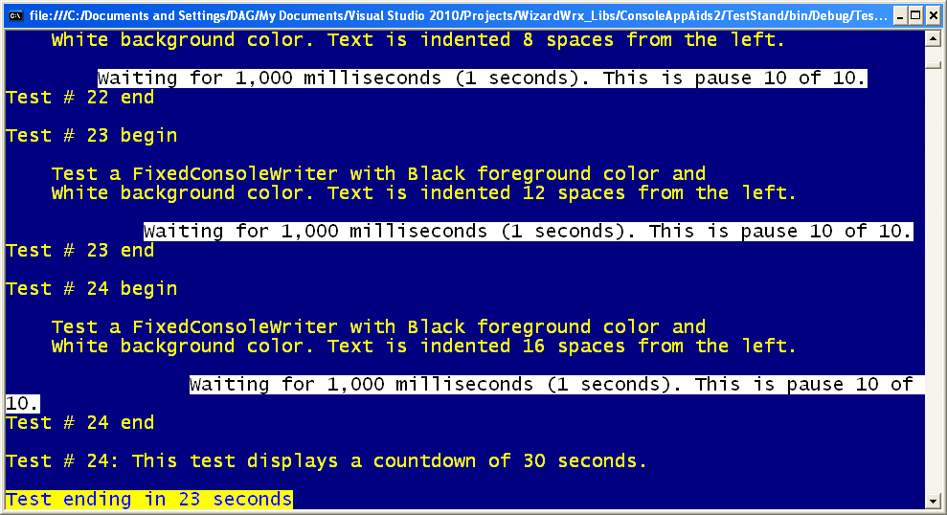
Figure 65 shows what happens when you revert to the regular console writer, in test 24, and shows the first of a series of countdown messages that leverage the FixedConsoleWriter, and motivated its creation.
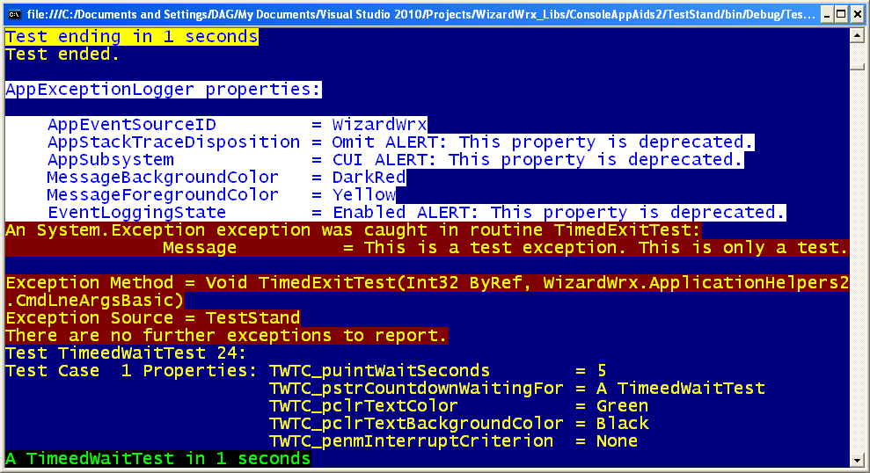
Figure 66 demonstrates the results achieved by combining a report formatter capable of generating perfectly aligned rows of labels and values, followed by the first of a series of interruptible countdowns.
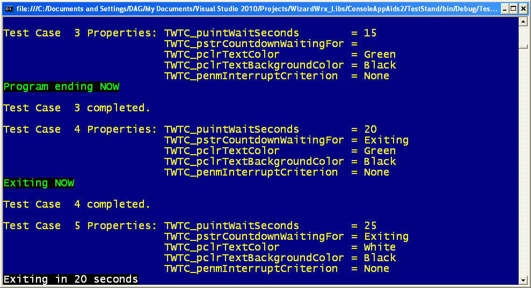
Figure 67 demonstrates additional features of the interruptible countdown routine for console programs.
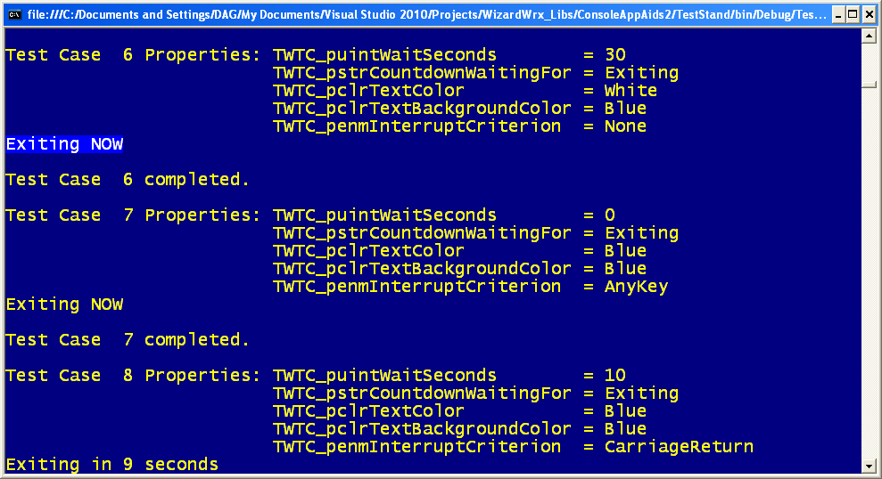
Figure 68 demonstrates my least favorite feature of the interruptible countdown, the AnyKey option. The PAUSE batch command that it emulates is so lame that it provoked me to write my first 8086 Assembler program.
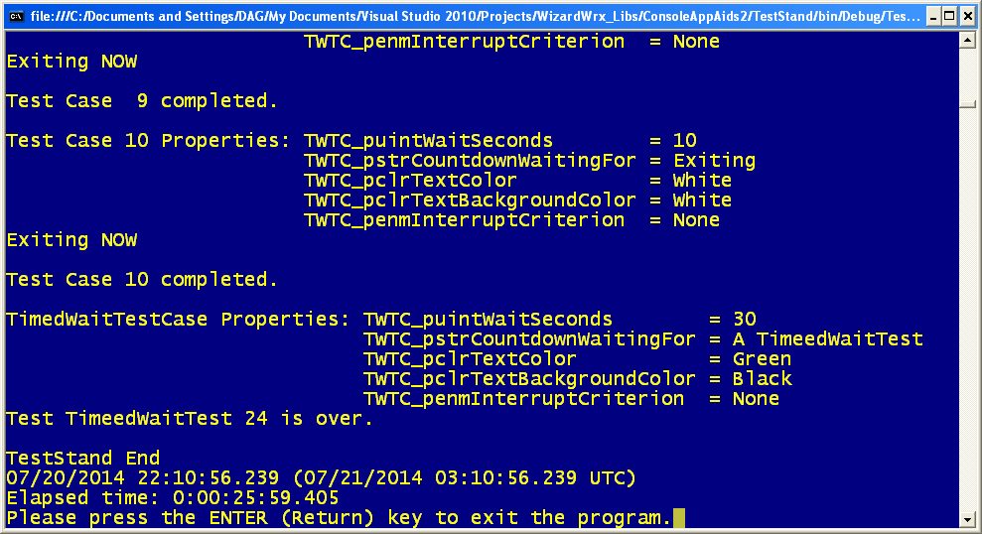
Figure 69 is the final screen rendered by the interruptible countdown tests. There is nothing special here; it’s just a recital of the remaining options.

