Problem Statement
The intent behind the design of my Windows Event Log recording routine was to create output that would always be treated as a single logical line of output, so that event log records can safely be imported into Microsoft Excel. On that point, it succeeded brilliantly; in the eight or so years I implemented it (2010/03/24, according to its revision history), I have yet to encounter a record that exceeded one logical line.
Figure 1 shows the contents of the worksheet cell that contains the message, while Figure 2 shows how Excel renders the record.
Reviewing the same record as it appears in the export created by PsLogList.exe, DLLServices2TestStand_7_0_Debug_ApplicationEvents_20170829_010730.TXT, confirmed that Excel faithfully copied what it received; that record is preserved as EventSequence_332255_per_PSLogList.TXT.
This presents a problem when you want or need to reproduce the report as it was rendered by the exception logger, complete with its original line breaks. To guarantee that the record was preserved as a single line in the event log exports generated by PsLogList.exe and other programs, the current implementation of the ExceptionLogger class discards all newlines.
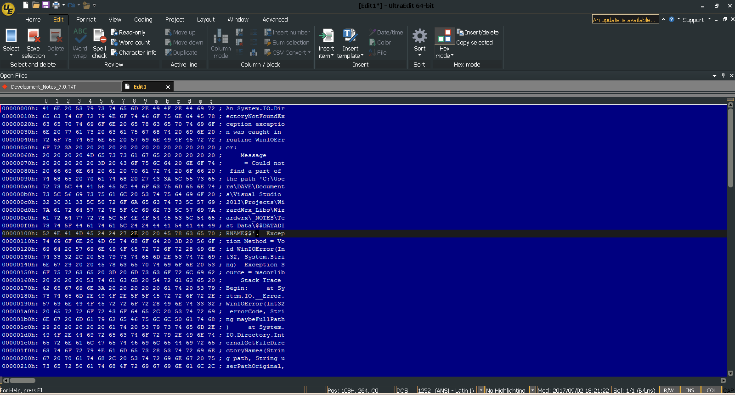
Figure 1 is the hexadecimal view of the exception report logged by the ExceptionLogger class defined in the WizardWrx.DLLConfigurationManager namespace. Figure 2 shows how my Microsoft Excel template renders it. I saved this edit buffer as EventSequence_332255_per_Excel_Cell_I2.TXT.
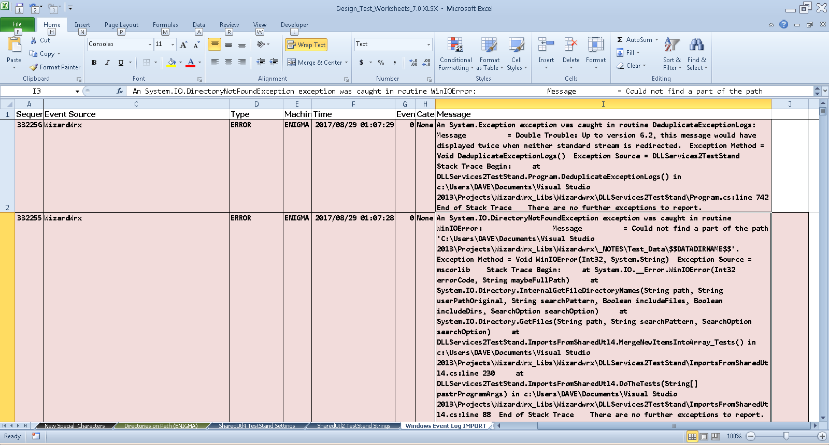
Figure 2 shows the exception record displayed in Figure 1 as it is rendered in my Windows_Event_Log.XLTX template.

Discussion
Discarding the newlines when the exception report is sent to the Windows Event Log service completely solves the problem of event records spanning two or more lines in a text file generated from a Windows Event Log by discarding a great deal of intentionally generated formatting. Unfortunately, most of it cannot be faithfully reproduced from the plain text, although it is possible to make educated guesses, provided that you have a reliable way to identify the messages to which it should be applied.
Alternatives exist, but the depend on identifying a character or sequence that meets the following criteria.
- The character or sequence cannot occur naturally in the text. This requirement eliminates all alphanumeric and punctuation characters, single and double quotation marks, and the natural space character (represented by ASCII code 0x20), as individual characters, though specific sequences are permissible.
- The character or sequence cannot be mistaken for naturally occurring newlines. This requirement eliminates ASCII characters 0x0a (carriage return) and 0x0d (line feed), alone and in pairs.
- The character or sequence cannot be the delimiter character employed by the export program (e. g., PsLogList.exe). This requirement eliminates ASCII character 0x09 (horizontal tab).
- The character or sequence cannot be a printer control character. This requirement eliminates ASCII characters 0x07 (bell, or alarm), 0x08 (destructive backspace), 0x0c (form feed), 0x1a (DOS end of file), 0x1b (escape)
- The character or sequence must be permitted in a standard C string. This requirement eliminates ASCII character 0x00 (NUL or NULL).
- Most important, it cannot reading. This restricts the character or sequence to the so-called “non-printing” ASCII characters.

ASCII Code 160 (0xa0), the Non-Breaking Space
The first candidate that comes to mind is the non-breaking space, ASCII character code 160 (0xa0).,
This character has in its favor the following properties.
- Compactness: It occupies one byte in the ASCII character stream (two in a UTF-16 Unicode stream), the same amount of space required by any other single character, including either of the usual single newline characters (CR and LF).
- Unobtrusiveness: Since most display fonts render it as if it were a normal space, its presence is not visually disruptive.
- Uniqueness: A search of a 3 megabyte archive (28 files) of Windows event logs that I’ve accumulated since the last purge three months ago found not a single occurrence of that character in the exports generated by PsLogList.exe, nor in the 11 megabytes in an additional 32 files of permanent archives that I’ve accumulated over a little over two years.
Of particular interest is the following statement in Wikipedia: “Apart from this, applications and environments often have methods of entering unicode entities directly via their code point, e.g. via the Alt Numpad input method. (Non-breaking space has codepoint 255 decimal (FF hex) in codepage 437 and codepage 850, and codepoint 160 decimal (A0 hex) in codepage 1252.)
The following comment in an issues thread in the peg-markdown project on GitHub bears serious consideration.
I don't agree that the nonbreaking space should be counted as a space character in peg-markdown. It is very handy to be able to insert spaces that should be treated just as normal spaces. For example, if you want a paragraph to start with four spaces, you can start with four 160's, and the paragraph won't be treated as a code block. Furthermore, spaces are treated as word boundaries in the writers, and lines may break on them.
To this thread, I added the following comment on Sunday, 03 September 2017.
In the course of investigating how others interpret the ASCII code that is its subject, I came across this 5 year old discussion about an issue that remains Open, in spite of being inactive for almost 5 years.
The motivation behind my research is that I am revisiting a design decision that I made seven years ago, when I created my ExceptionLogger class, implemented in ExceptionLogger.cs, which is part of a Microsoft .NET class library that I published here, at txwizard/DLLServices2. Early in its development, I implemented optional logging in a Windows Event log, against a registered event source string. To prevent log records being split into two or more lines when event records are subsequently exported by a tool, such as PsLogList.exe, rendering them unsuitable for processing by a tool, such as the import engine in Microsoft Excel, SSRS, or MySQL, the method that implements event logging strips away all newline characters (CR/LF pairs in a Windows environment.
A consequence of this decision is that reconstructing the message as it was originally generated by the System.Exception class is a nontrivial undertaking, since one must first identify in some way that the message in question is an exception that contains a stack trace. Although my design is such that it would be fairly easy to do so, it occurs to me that it would be preferable to preserve those line breaks, and others that might occur in other types of messages that might be fed into the same parser, which brings me to my interest in ASCII code 160, an otherwise unobtrusive single byte character (in the context of the 8-bit data stream generated by PsLogList.exe, or by any text writer that implements the US-ASCII encoding.
Further investigation revealed something about which I forgot long ago, which is that the Windows Event Logging service faithfully records the messages sent to it, newlines and all. Rather, it is PsLogList.exe that is discarding them, as directed by none other than me, with the following command line.
psloglist.exe -accepteula -d 1 -s -t \t %1 > "%~2"
The above command specifies switch –s, which is described as follows.
This switch has PsLogList print Event Log records one-per-line, with comma delimited fields.
This format is convenient for text searches.
This doesn’t negate the case for replacing the embedded newlines, although it suggests that such replacement should be optional, and perhaps governed by a configuration setting that travels with the DLL, as do the event source and console color settings.

Side Expeditions
Such expeditions as these inevitably lead me to explore subject that came to my attention months, or even years, ago, but never got the investigation they so richly deserved. Such is the case with kerning, a subject that first arose in conversation with Jim Nisbet, when he was a client at Caltex Petroleum Corporation, beginning in 1988. Today, I had the opportunity to pursue it a bit, by reading “Beginner’s Guide to Kerning,” by Janie Kliever, at https://designschool.canva.com/blog/kerning.
This excursion actually began with an article published in the Journal of Electronic Publishing, “Justify Just or Just Justify,” by Mohamed Elyaakoubi and Azzeddine Lazrek, in its Winter 2010 edition, and available online, naturally, at https://quod.lib.umich.edu/j/jep/3336451.0013.105?view=text;rgn=main. As I finished reading this paper, I noted with great interest the sixth note, “Since the 10th century, hyphenation in Arabic writing has been strictly prohibited.”

“Appendix F. ASCII Table,” http://lwp.interglacial.com/appf_01.htm is substantially identical to the table stored in my ASCIIInfo class library, and was created as part of “Perl & LWP: Fetching web pages, Parsing HTML, Writing Spiders, & More,” by Sean M. Burke, at http://lwp.interglacial.com/index.html.
“ASCII Table / Extended ASCII Codes,” Jeffrey Hunter, http://www.idevelopment.info/data/Programming/programming_resources/PROGRAMMING_ascii_table.shtml, is generally the same as the previously cited work, but its presentation differs from it significantly.
“Non-breaking space,” https://en.wikipedia.org/wiki/Non-breaking_space
“ASCII 160 (non-breaking space) is not Recognised as a Space Character,” https://github.com/jgm/peg-markdown/issues/16.
“PsLogList v2.8,” https://docs.microsoft.com/en-us/sysinternals/downloads/psloglist.

