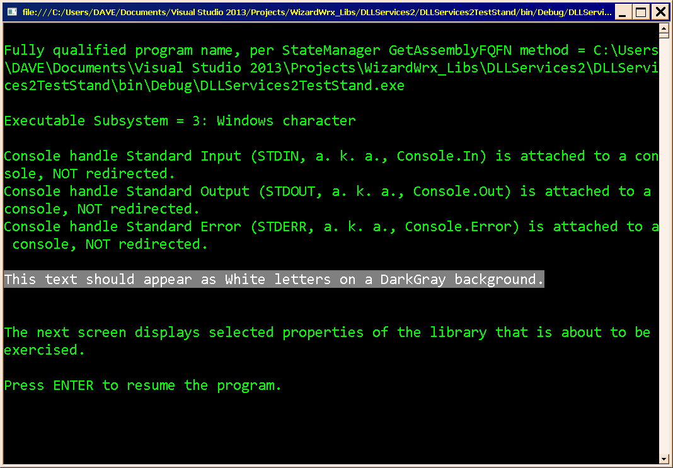
Figure 1 is the first screen that displays anything in color, which I forgot to capture yesterday.
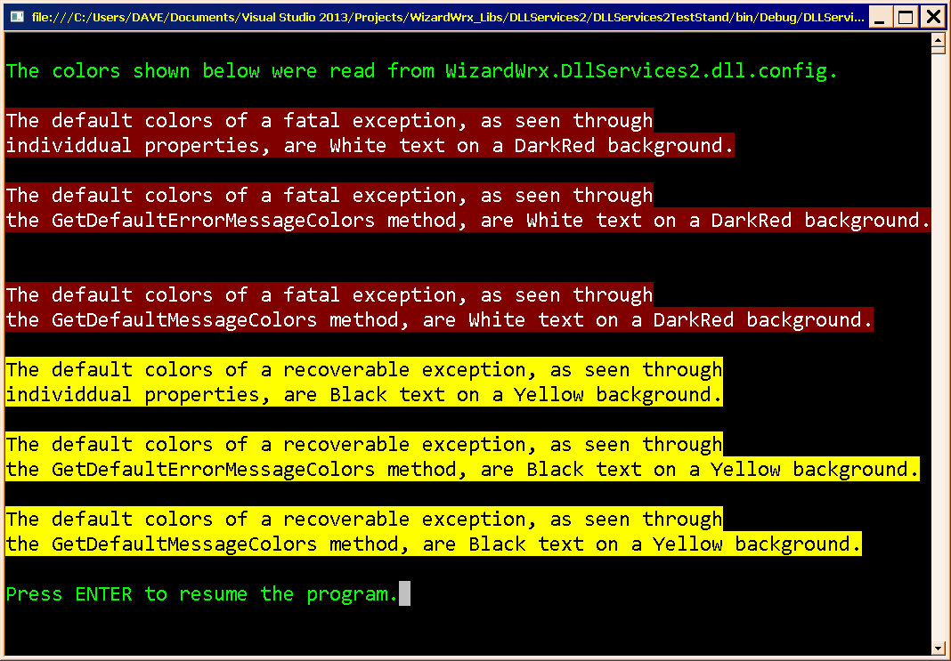
Figure 2 is the first of the full color exception reports, captured in living black and white text at time index 2017/02/20 01:47:49 in “Development Notes for WizardWrx.DLLServices2.dll, version 7.0.”
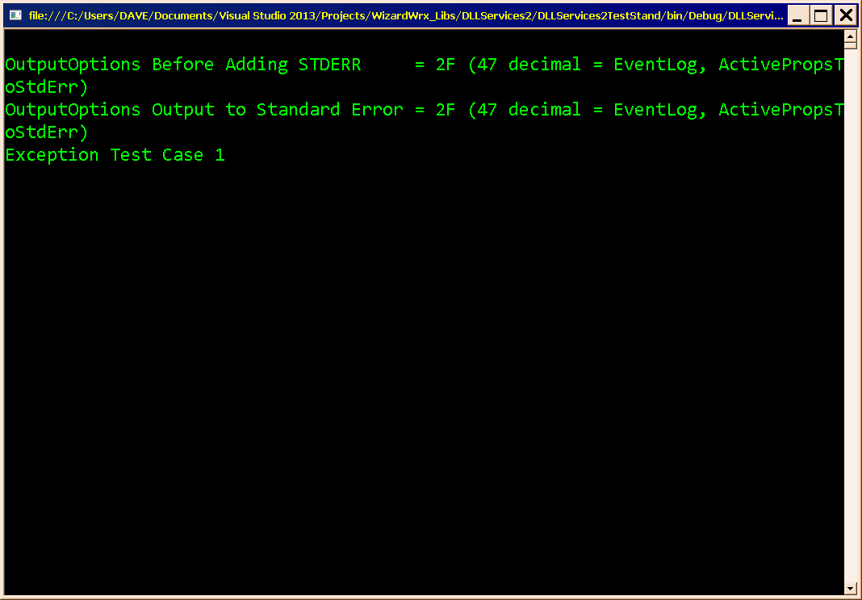
Figure 3 is the output captured at time index 2017/02/20 01:50:58, when the test program hit the breakpoint shown in Figure 4.
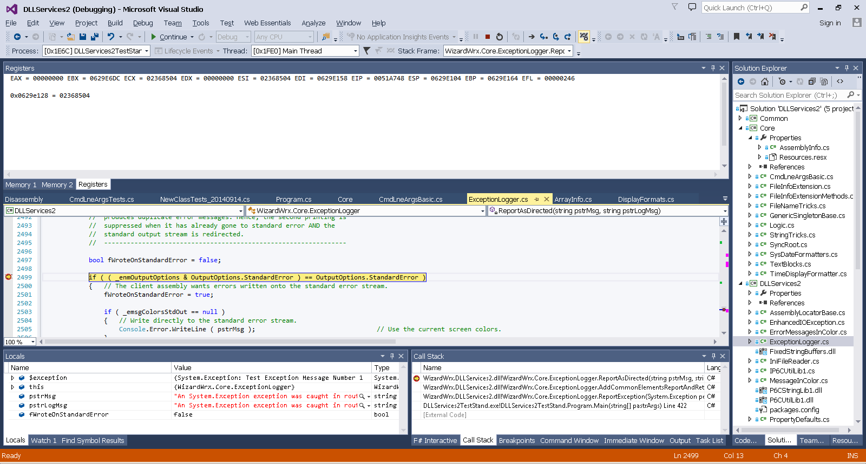
Figure 4 is the Visual Studio display at the breakpoint where the screen shown in Figure 3 was captured.
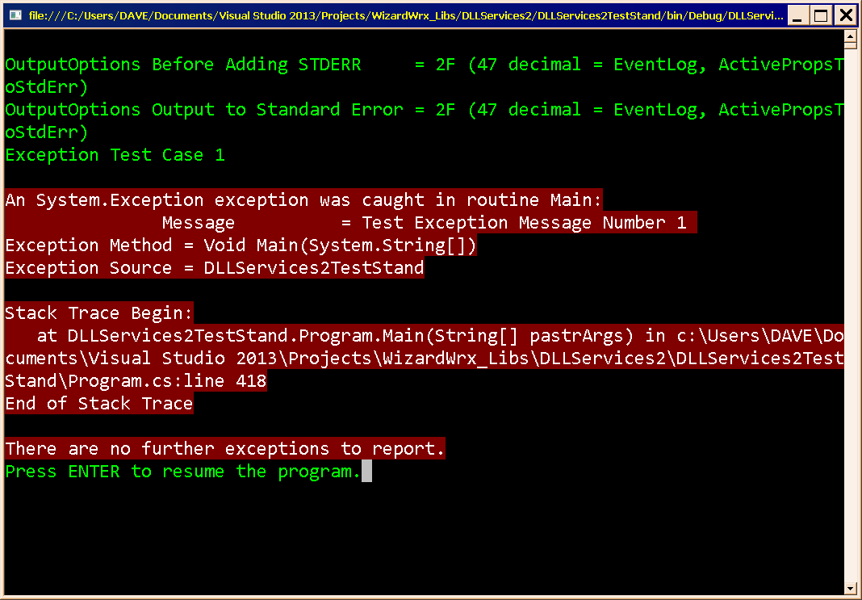
Figure 5 is the window that I captured at time index 2017/02/20 01:55:28.
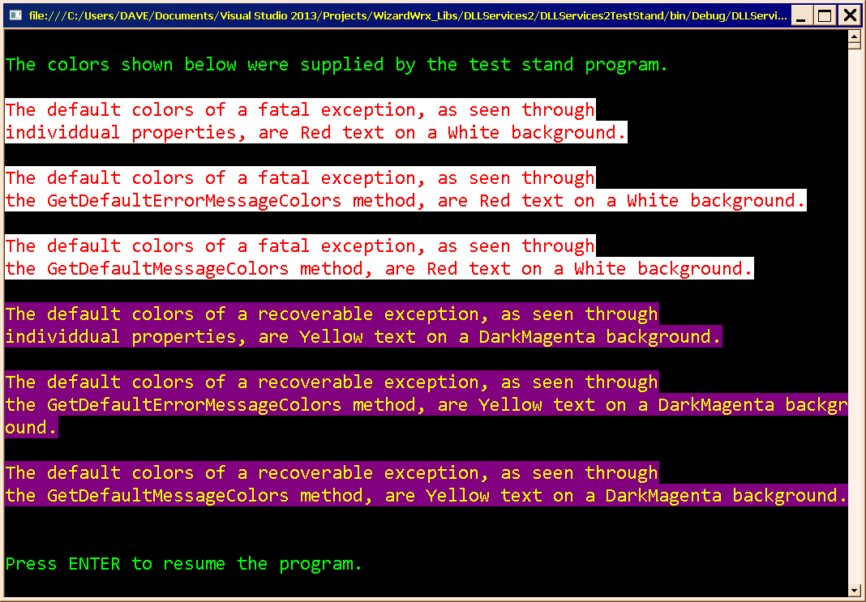
Figure 6 is the screen that was captured at time index 2017/02/20 01:56:39.
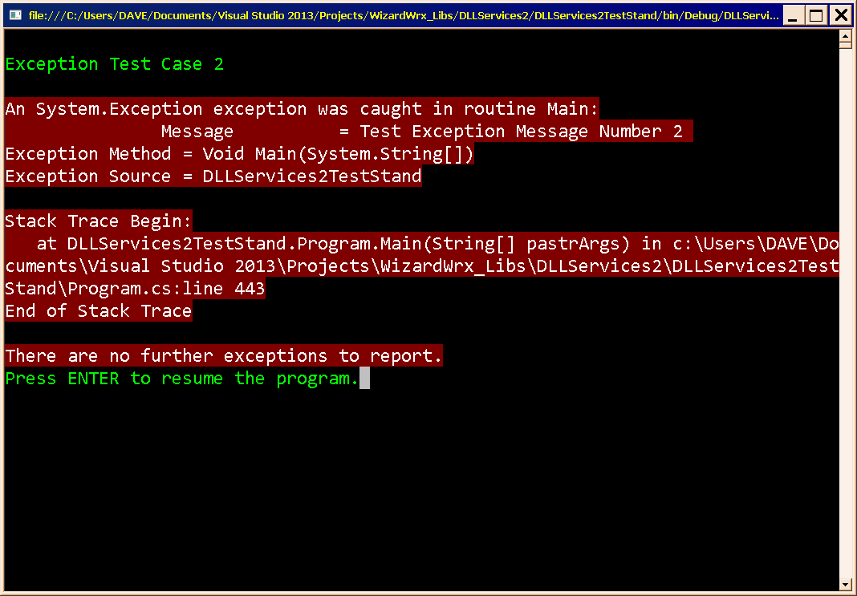
Figure 7 is the screen that was captured at time index 2017/02/20 01:59:53.

Message Color Anomaly
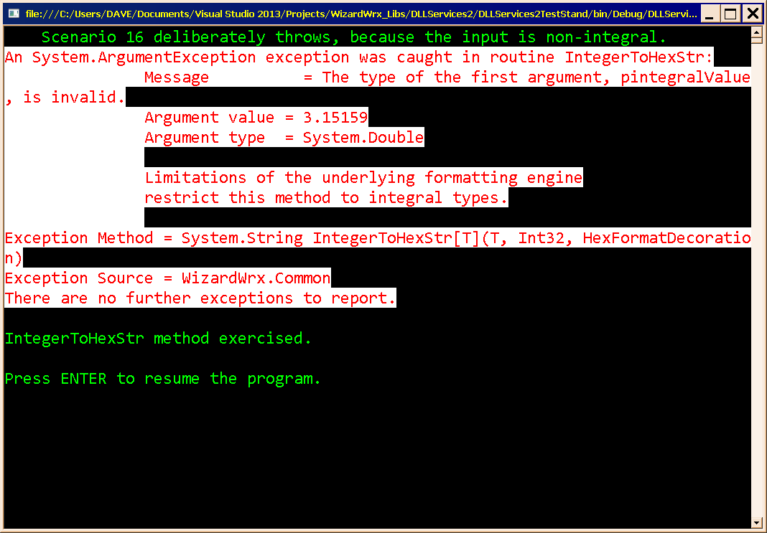
Figure 8 is the message displayed by the first test of the subdivided library. However, since I don’t have any other pictures from this point, the status is inconclusive. See Figure 9, though.
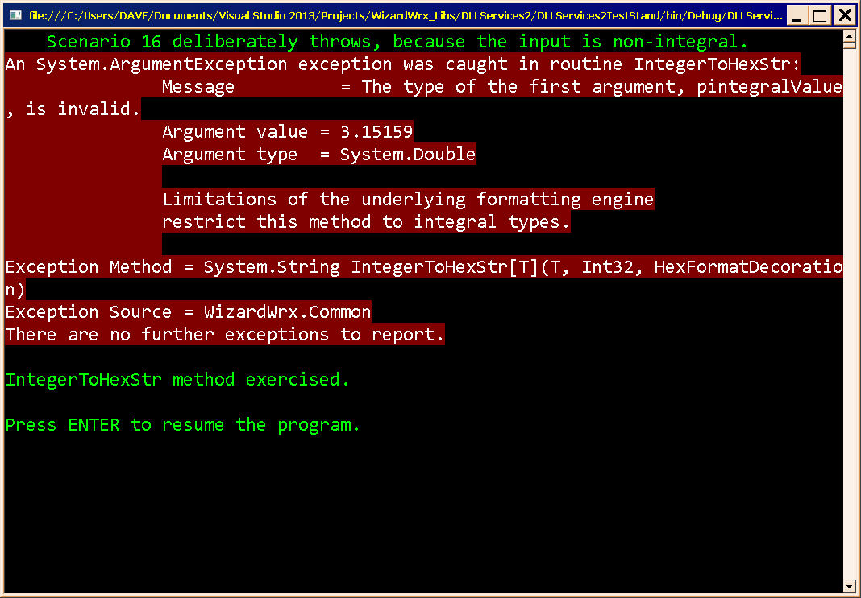
Figure 9 is the same message, rendered in the colors read from the configuration file, which confirms my suspicion that the colors shown in Figure 8 are incorrect.

Show That the New Configuration Mapper Works
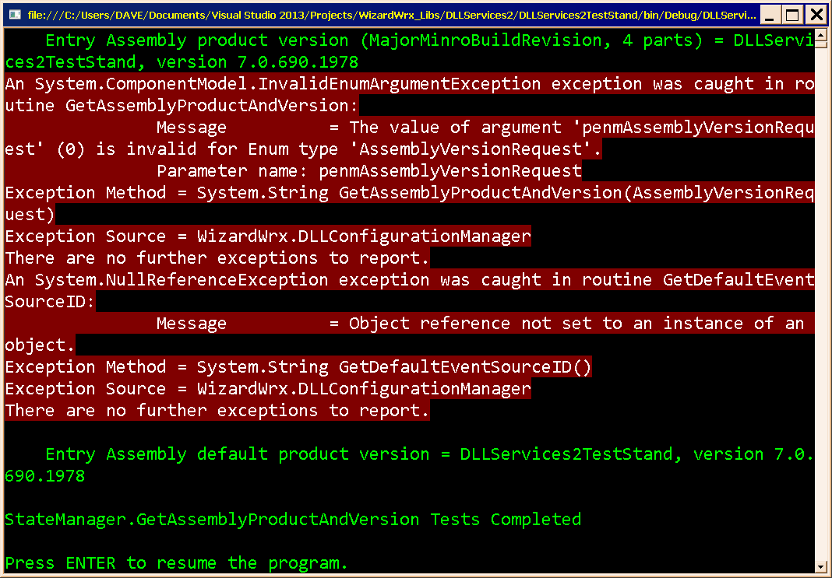
Figure 10 is two reports; the first indicates that the configuration keys were successfully read into static properties on ExrrorMessagesInColor attached to ExceptionLogger. The second shows that the exception raised by attempting to read the event source ID bubbled up.
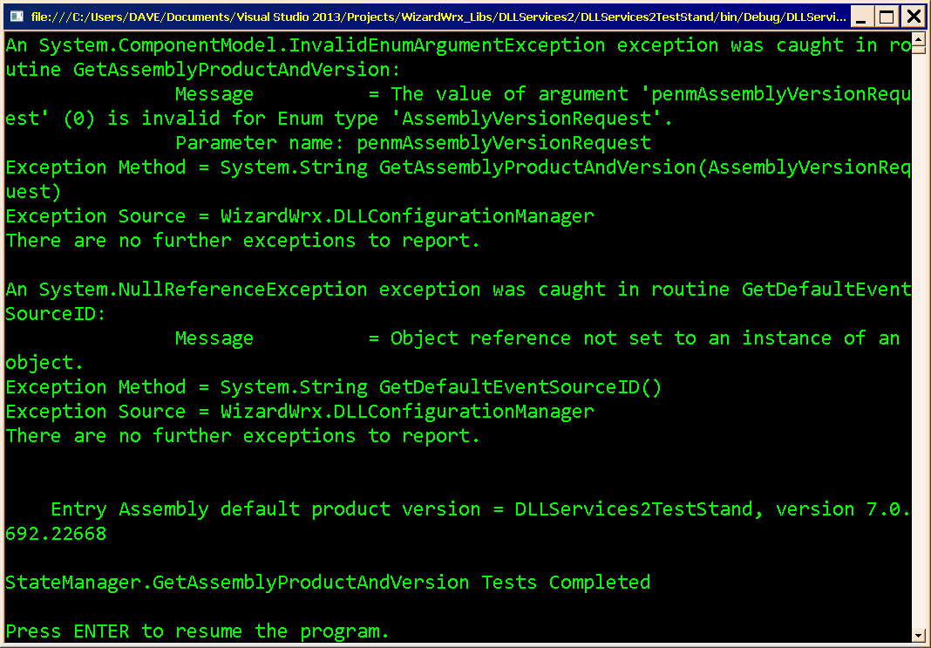
Figure 11 shows what happens when the configuration file is missing; reports in default colors.
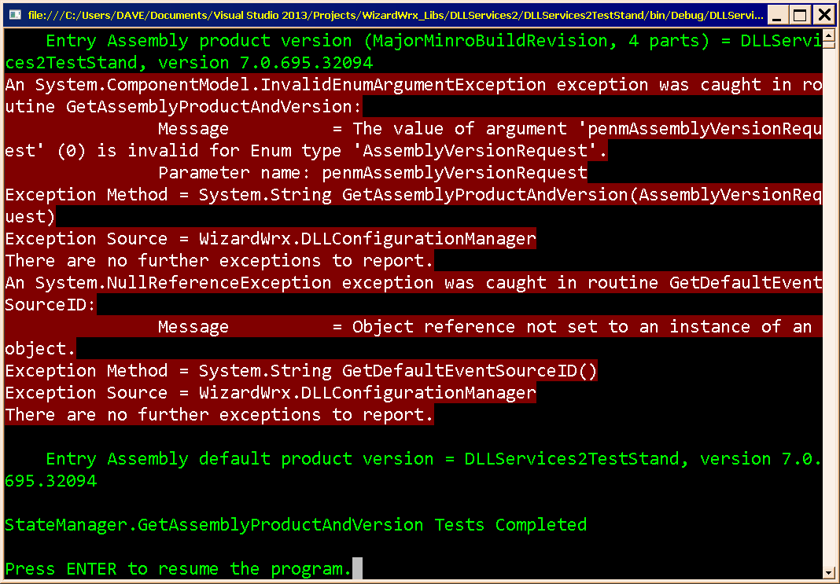
Figure 12 is the resurrected full color exception report.
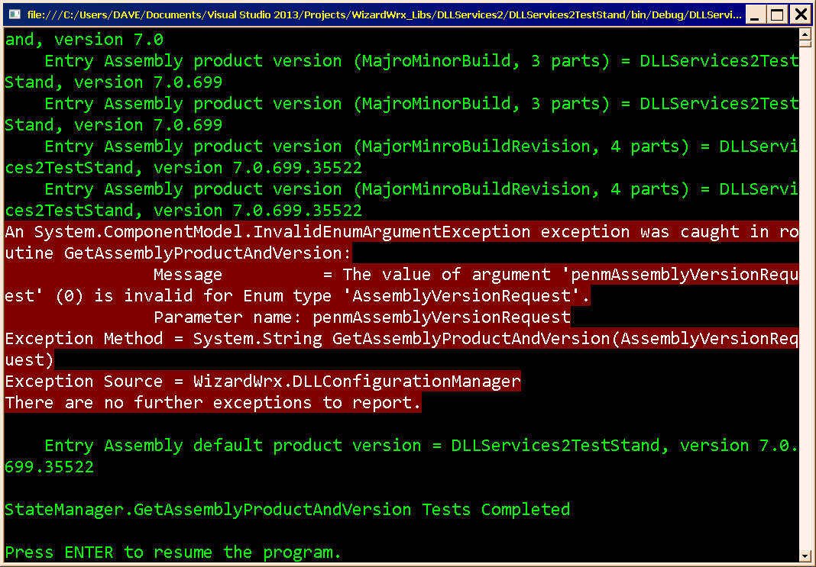
Figure 13 shows that the event source ID is again being read from the configuration file, eliminating the second exception report shown in Figure 12.
Figure 14 shows that the exception logging continues to work as designed.
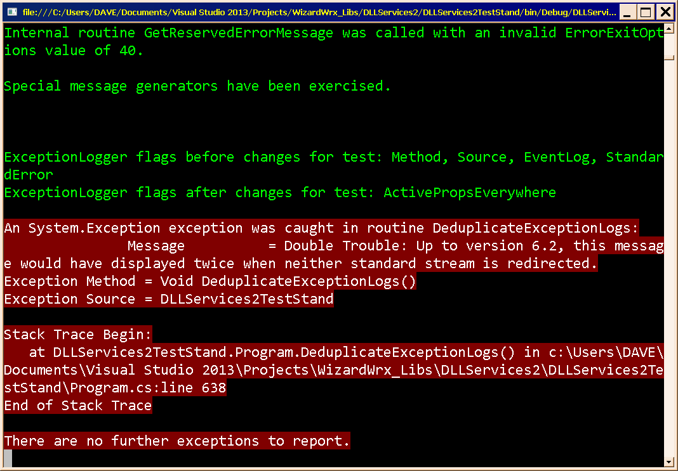
Figure 15 is the final message, which shows that the exception deduplication routine still works as designed.
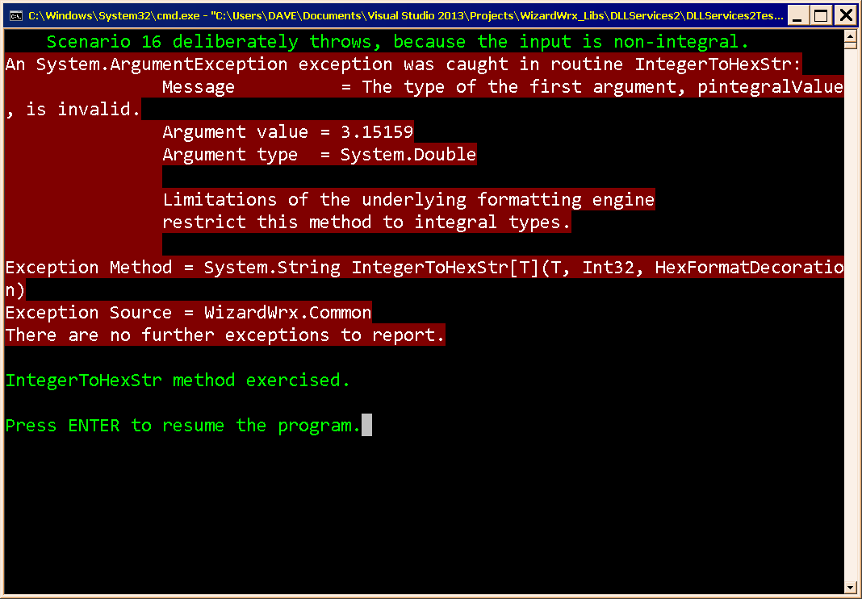
Figure 16 is an example of the kind of error message that I think a program should deliver, which also showcases my colored messages.

Recoverable Exception Colors in the Real World
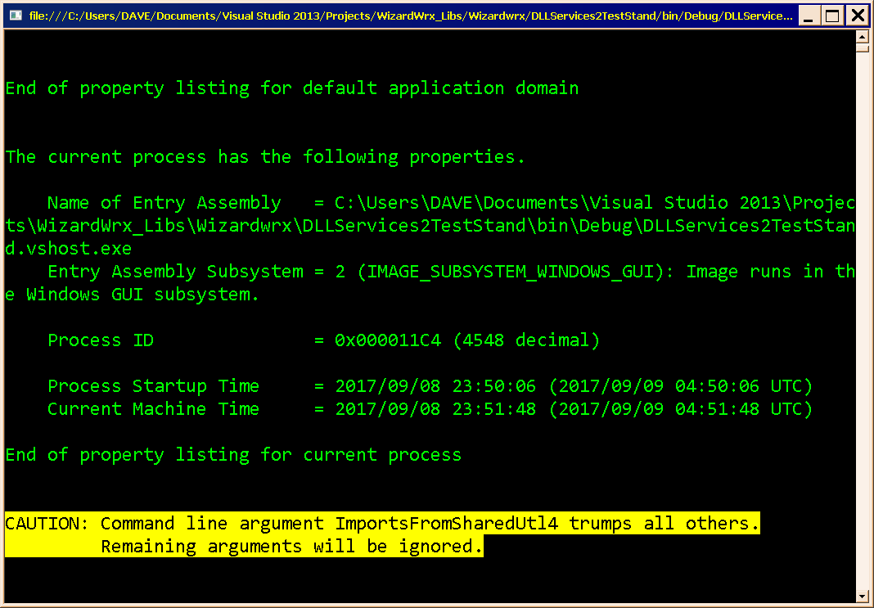
Figure 17 is the first actual use of the nonfatal exception message colors, which was generated by the code shown in Listing 1, which is a bit tedious, but it works as expected.
if ( s_fSkipRemainingTests )
{ // Selecting the whole group trumps all other selections in the list, since the other selectors expect a single selection.
WizardWrx.ConsoleStreams.MessageInColor.RGBWriteLine (
WizardWrx.ConsoleStreams.ErrorMessagesInColor.RecoverableExceptionTextColor ,
WizardWrx.ConsoleStreams.ErrorMessagesInColor.RecoverableExceptionBackgroundColor ,
Properties.Resources.MSG_WARNING_SUPERFLUOUS_ARGS_DISCARDED ,
TEST_SHAREDUTL4_ALL ,
Environment.NewLine );
} // if ( s_fSkipRemainingTests )
Listing 1 is the code that generated the message shown in Figure 17.

C:\Users\DAVE\Documents\Visual Studio 2013\Projects\WizardWrx_Libs\DLLServices2\_NOTES\Development_Notes_7.0.TXT.

