Problem Statement
Determine the feasibility of importing the resource strings stored in a Microsoft .NET assembly from its .resx source file, using one or both of two starting points.
- "C:\Users\DAVE\Documents\Visual Studio 2013\Projects\WizardWrx_Libs\Wizardwrx\DLLServices2TestStand\Properties\Resources.resx" is the name of a source file as it appears in the source code tree.
- "C:\Users\DAVE\Documents\Visual Studio 2013\Projects\WizardWrx_Libs\Wizardwrx\_NOTES\SharedUtl2_TestStand_Strings.XML" is a copy of the above file, which is assigned a new name that makes its format more evident.
Both scenarios assume that Microsoft Excel is already open, but whether or not an existing document happens also to be open is irrelevant.

Scenario 1: Load the .RESX File Directly into Excel
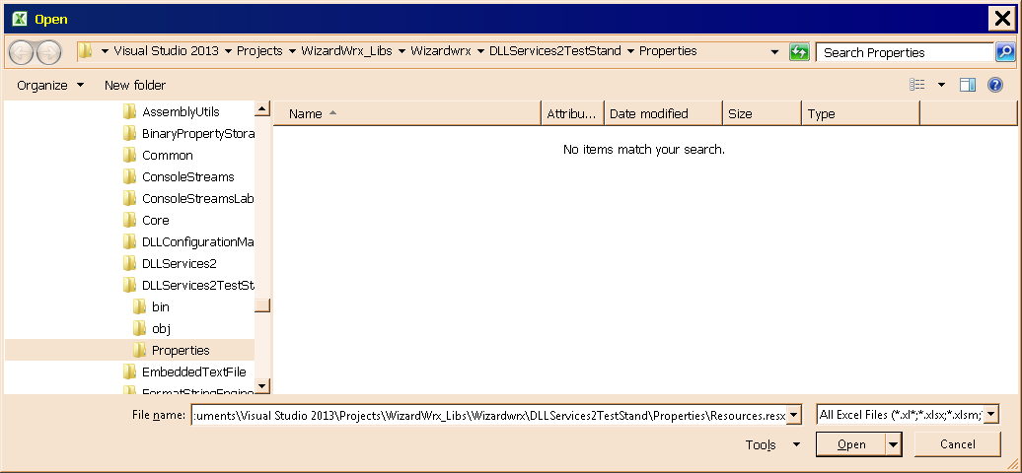
Figure 1 is the standard File Open dialog box, called forth by way of the C-O accelerator key, specifying C:\Users\DAVE\Documents\Visual Studio 2013\Projects\WizardWrx_Libs\Wizardwrx\DLLServices2TestStand\Properties\Resources.resx as the file to open.
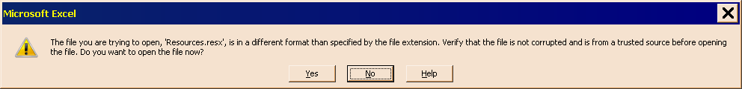
Figure 2 is the warning raised by Excel, which doesn’t recognize the .resx extension.
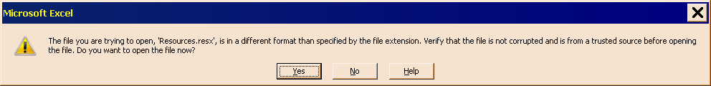
Figure 3 is the warning box shown in Figure 2, corrected to grant permission for Excel to open the file.
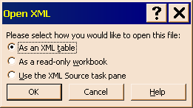
Figure 4 is the dialog box that appears when the dialog box shown in Figure 3 is processed with its Yes button having the focus. This dialog box can be accepted as is.
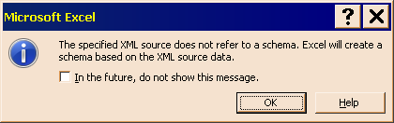
Figure 5 is the dialog box that appears when the dialog box shown in Figure 4 is processed. Selecting (activating) the check box is entirely up to you; I prefer to be warned that Excel is on its own to generate a schema from the data in the XML file.
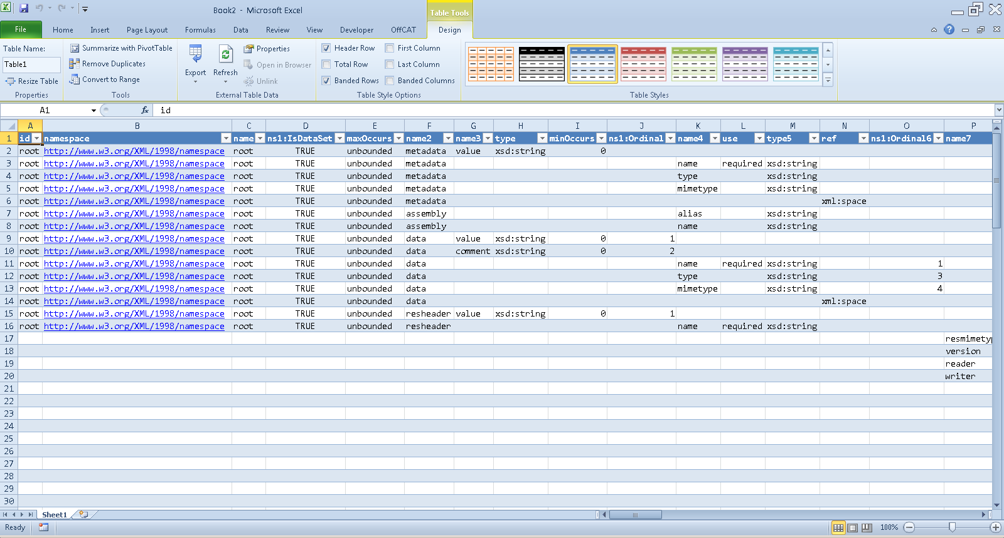
Figure 6 shows the worksheet that Excel creates when the dialog box shown in Figure 5 is processed.
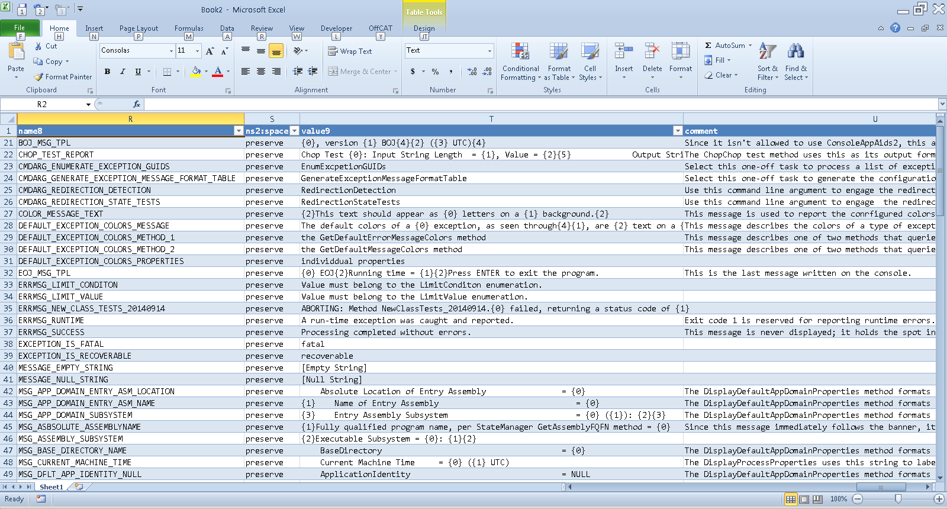
Figure 7 is the worksheet shown in Figure 6 with columns A through Q, and rows 2 through 19 hidden, since there isn’t anything of practical use in those rows and columns. Even if another workbook is open, the XML document opens as a stand-alone document, in the same way that a CSV or text file does. It can be easily moved into any open workbook.

Scenario 2: Load the Renamed Resource File into Excel
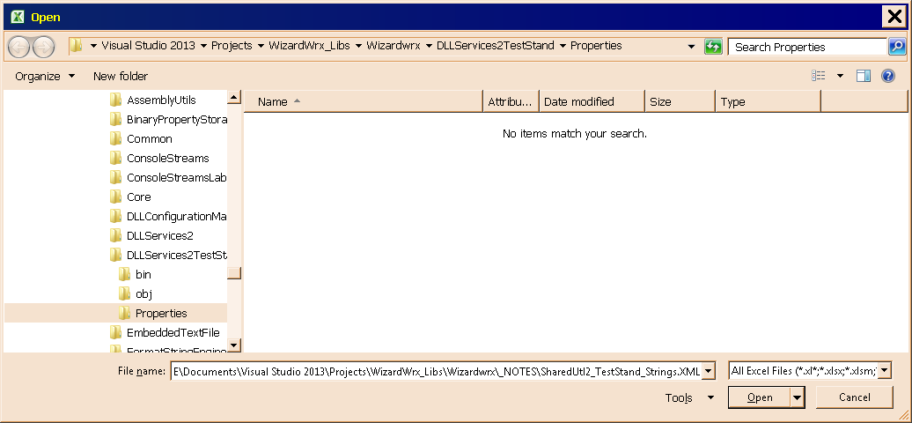
Figure 8 is the standard File Open dialog box, specifying that C:\Users\DAVE\Documents\Visual Studio 2013\Projects\WizardWrx_Libs\Wizardwrx\_NOTES\SharedUtl2_TestStand_Strings.XML is to be opened.
Figure 9 is the same Open XML dialog box first shown in Figure 4. Since the file extension is xml, the dialog box shown in Figure 2 is redundant, and is suppressed.
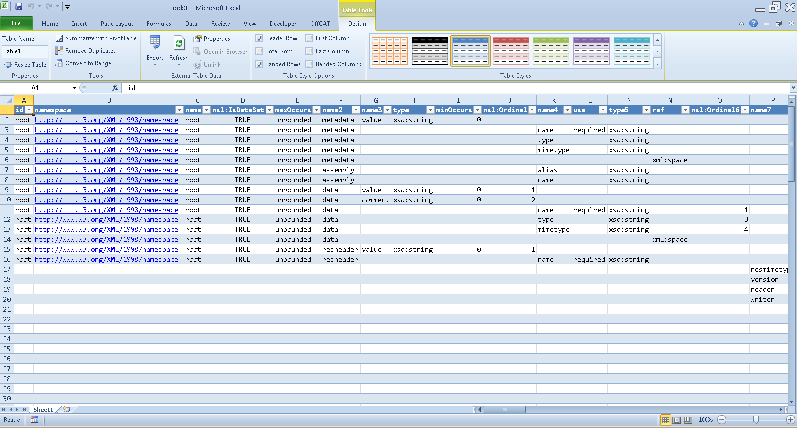
Figure 10 shows the worksheet created from the XML document, which is identical in all respects to the worksheet shown in Figure 6, since it was created from a copy of the same file that is identical in every respect except that its extension is .xml.

Conclusion
If you don’t mind answering the prompt shown in Figure 2, including the adjustment shown in Figure 3, you can import a .resx file directly into excel. Once columns A though Q and the rows in which column R is blank, you have a neat table that displays the names, values, and comments of the string resources defined therein. Once they are in a workbook, there is no end of additional processing that can be performed on the names and values.

