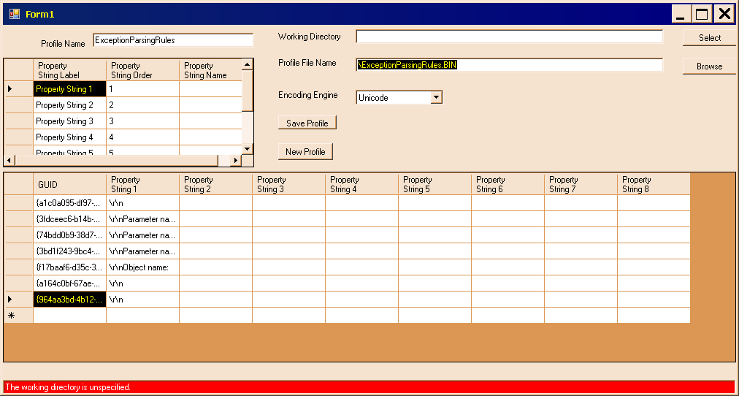
Figure 1 is the main form, populated with data for a first attempt. Although the working directory is unspecified, saving is enabled. This must be corrected.
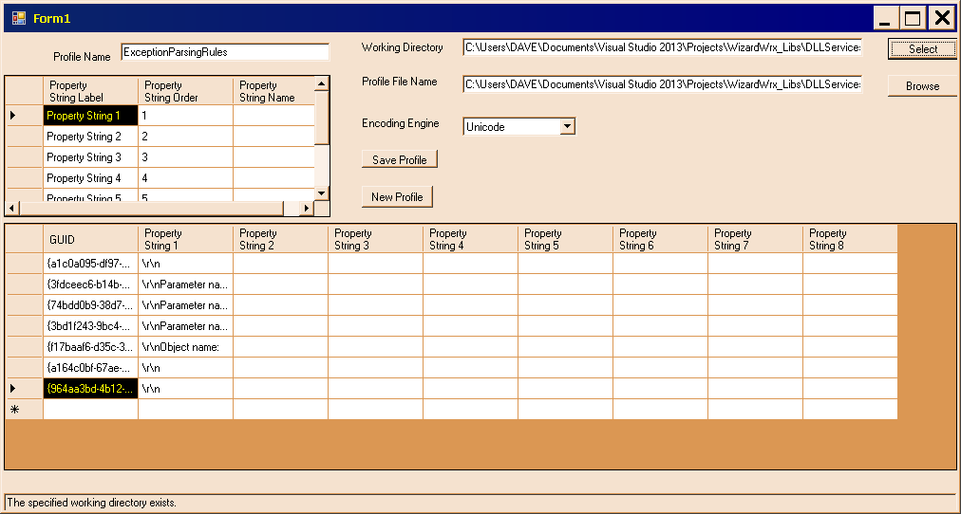
Figure 2 is the same form, with the working directory specified.
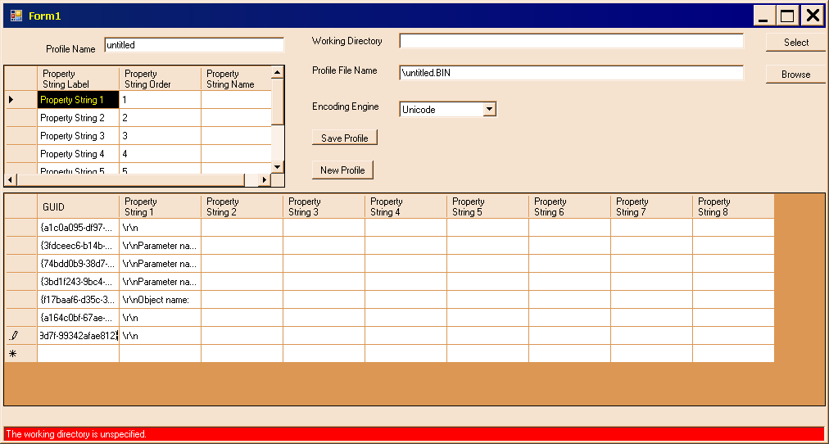
Figure 3 demonstrates that the profile save button remains enabled when neither the working directory, nor the profile name, is set.
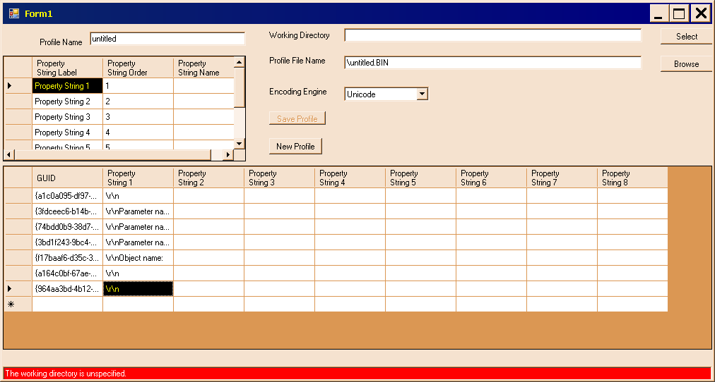
Figure 4 shows the form fully populated, while the working directory and profile name remain uninitialized. The Save Profile button is disabled, as it should be.
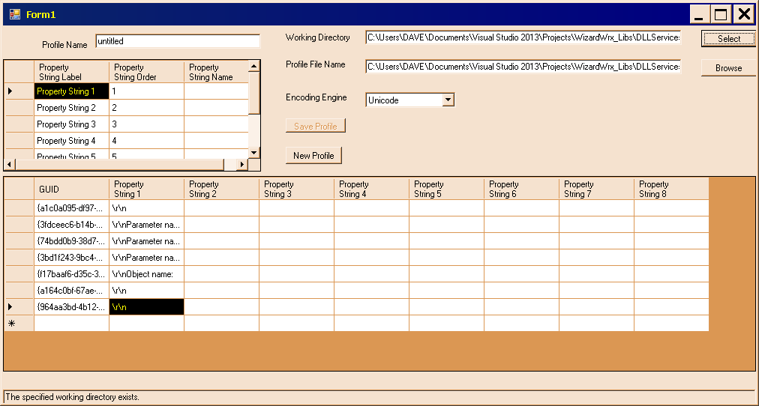
Figure 5 is the revised form, with the working directory specified. The prompt message indicates that the specified directory exists. Since the profile remains unnamed, the Save Profile button remains disabled. The fully qualified profile filename text box contains C:\Users\DAVE\Documents\Visual Studio 2013\Projects\WizardWrx_Libs\DLLServices2\untitled.BIN.
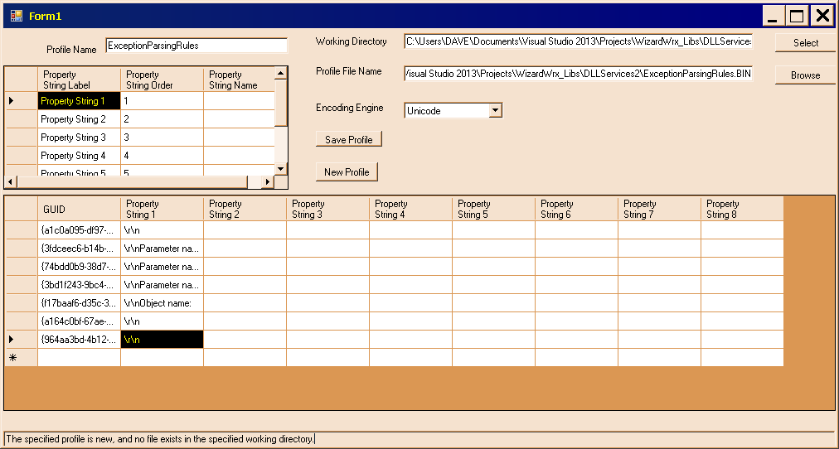
Figure 6 is the revised form, following input of a profile name, ExceptionParsingRules. The output filename is now C:\Users\DAVE\Documents\Visual Studio 2013\Projects\WizardWrx_Libs\DLLServices2\ExceptionParsingRules.BIN, the message is “The specified profile is new, and no file exists in the specified working directory,” and the Save Profile button is enabled.
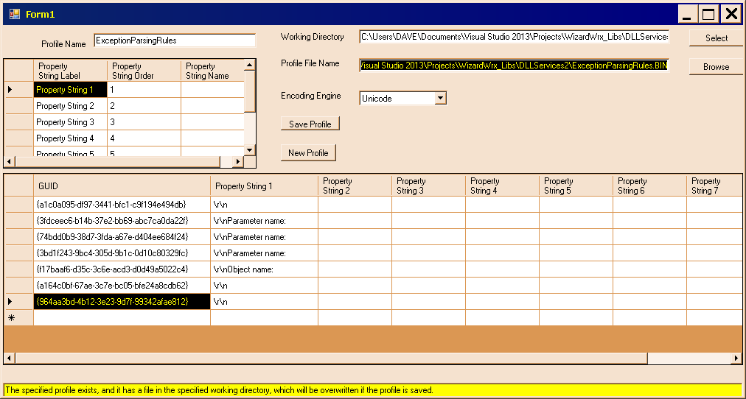
Figure 7 indicates that the last test left a file in the file system, which will be overwritten when I save this one. This was probably the result of execution passing out of the Using block when the exception was thrown.
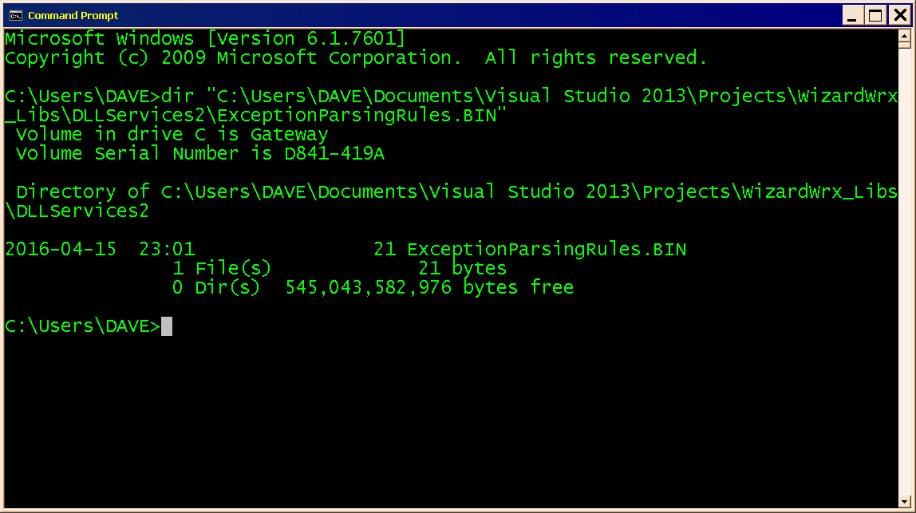
Figure 8 is the directory listing, indicating that there is, indeed, a file, as indicated by the message displayed at the bottom of Figure 7.
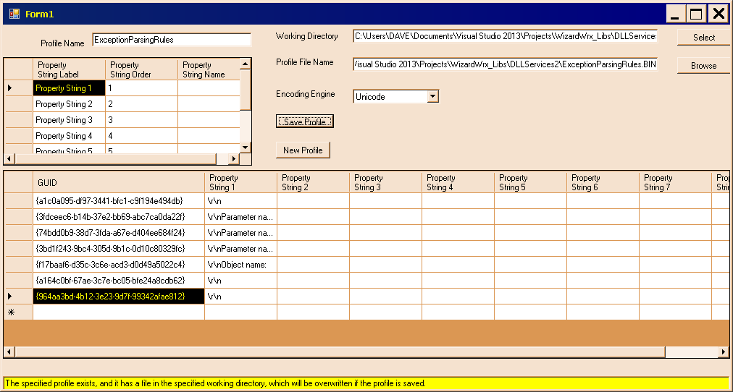
Figure 9 is the form as it appears upon return. The save button remains activated, and the warning message should be replaced.
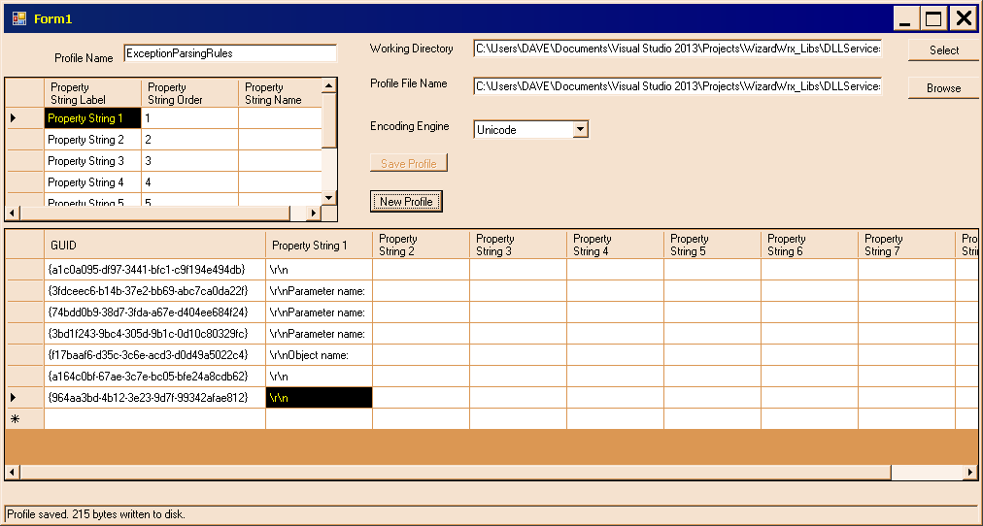
Figure 10 is the clean save, which happens also to be the first execution of a retail build.
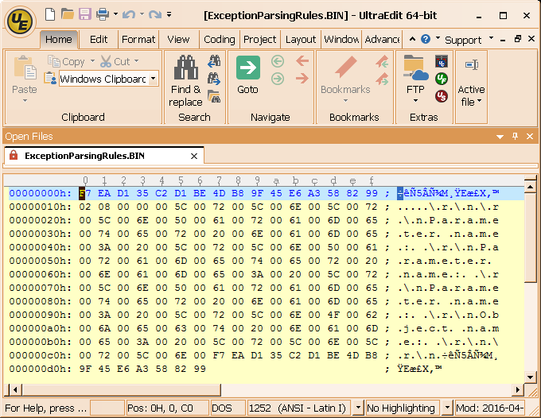
Figure 11 is the new file, as seen in UltraEdit.
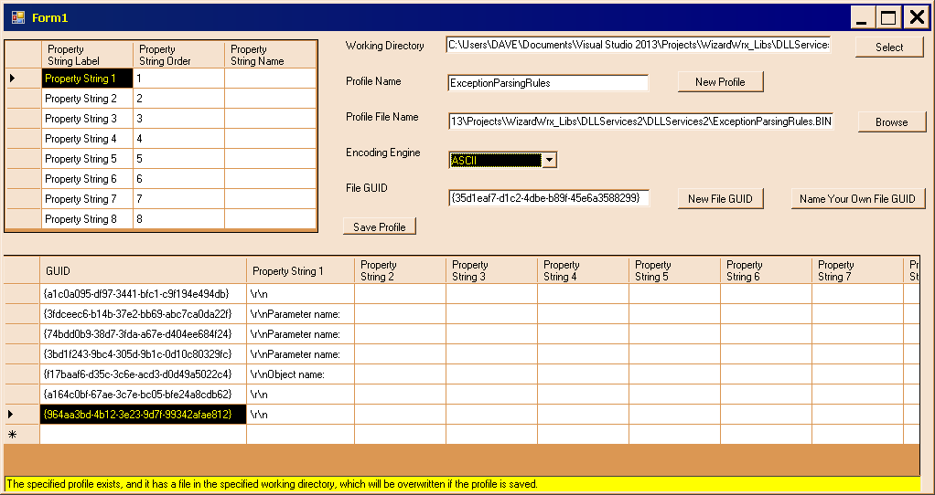
Figure 12 is the main window of a fully populated form, ready to save with ASCII strings.
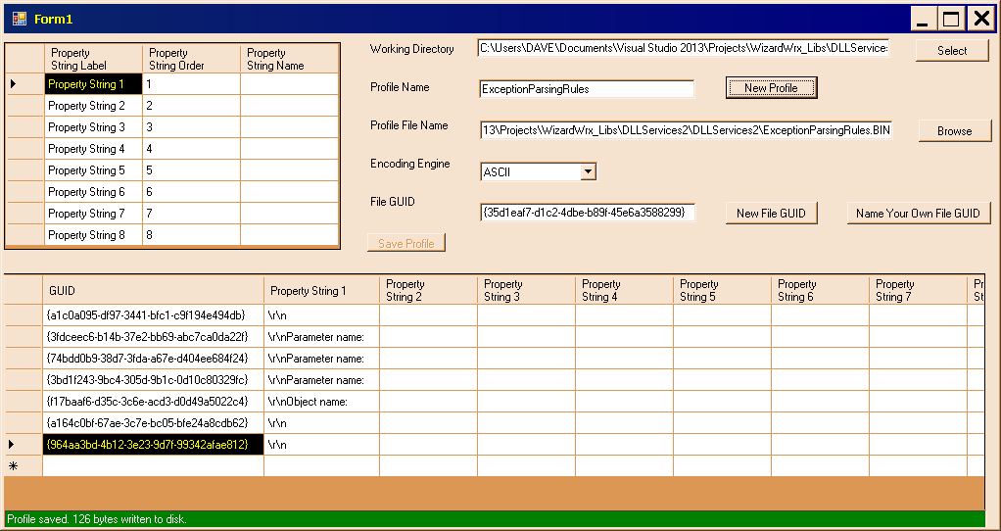
Figure 13 is the improved message display, rendered with the green background suggested by Janet.
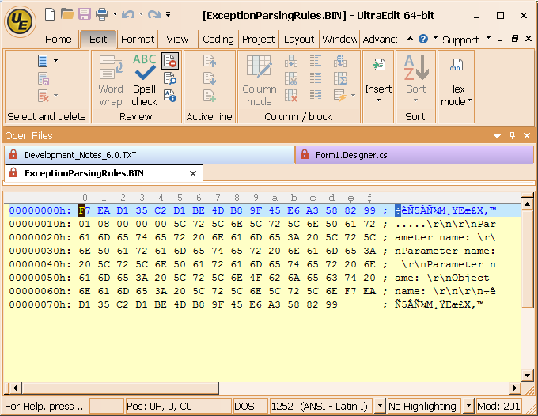
Figure 14 is the way the file displays when the program encodes the strings as ASCII.
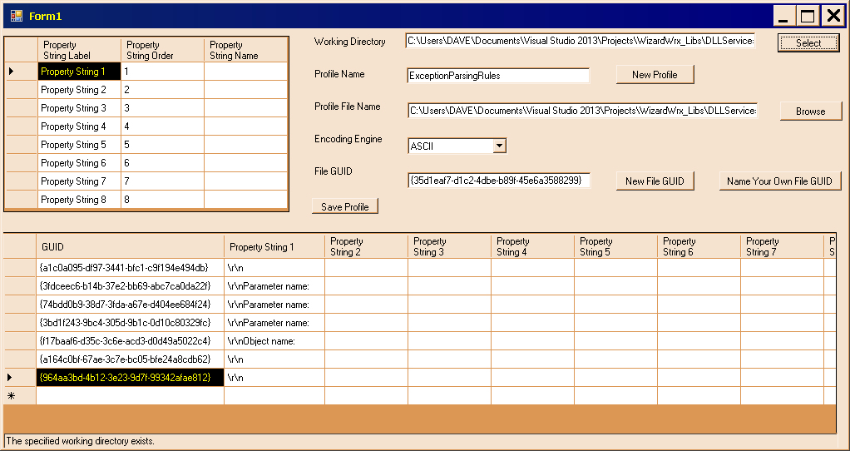
Figure 15 is a reminder of what happens when the filename is set before the directory name.
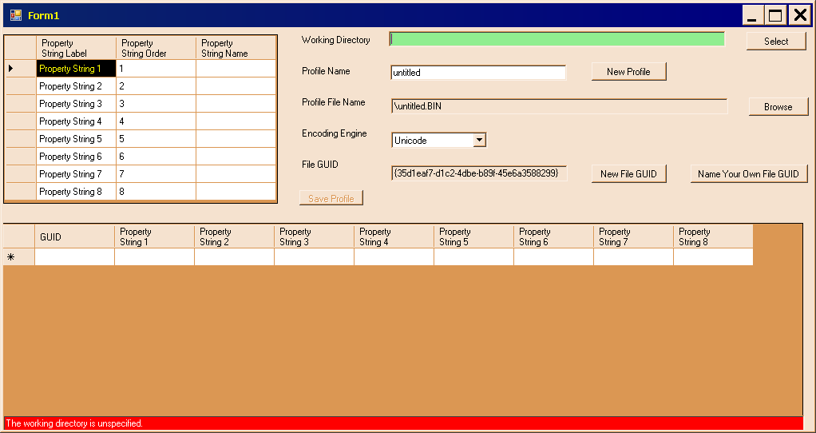
Figure 16 is the amended form, which changes the background color of the active cell when it is empty to draw attention to the cell that has the focus.
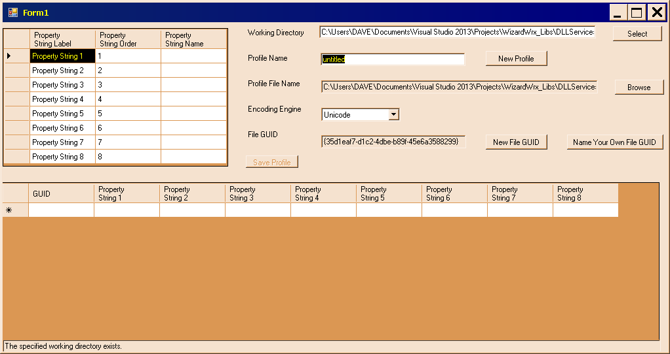
Figure 17 is the same form, after the text box shown in Figure 16 is populated, and the focus shifts to the next text box, which has an initial value that draws adequate attention to it.
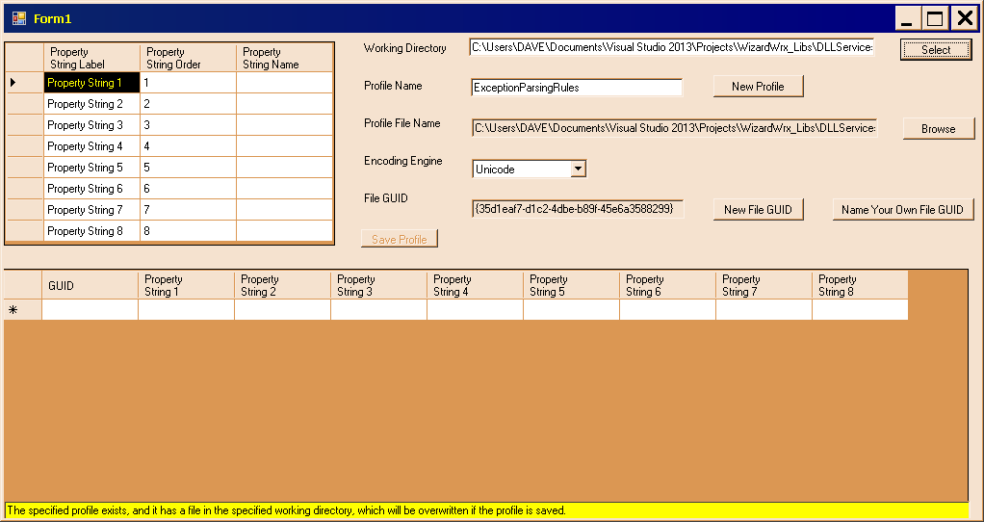
Figure 18 documents that the warning about an existing file appears when the profile gets its name before the directory is designated.
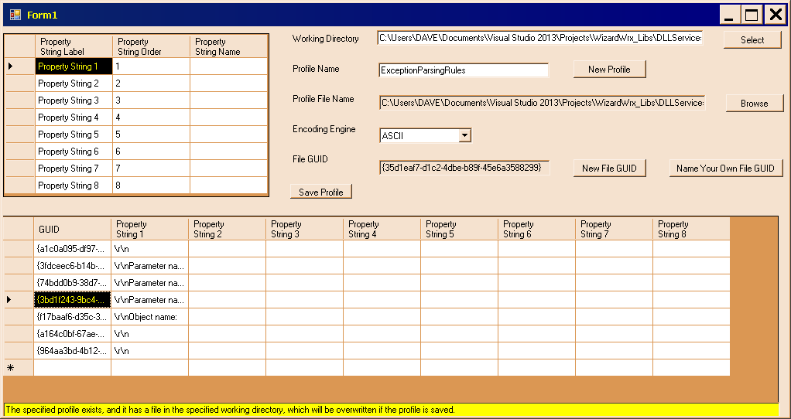
Figure 19 is the fully populated form, ready to save.
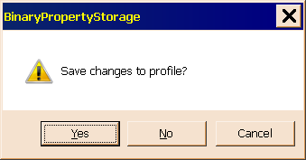
Figure 20 demonstrates that the prompt to save happens as expected when I click the Big Red X (although it quit being red with Windows Vista).
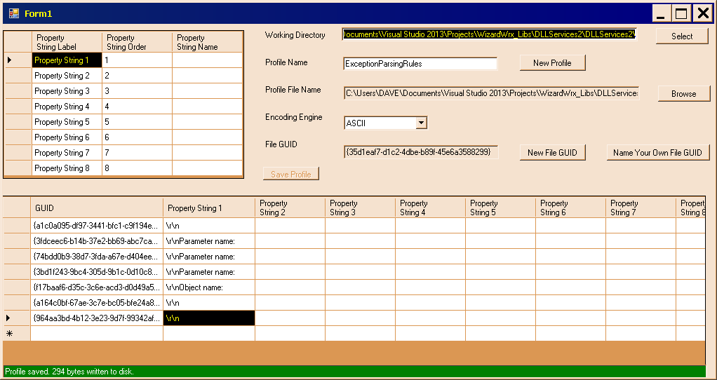
Figure 21 may be the first technically correct output. At any rate, the math checks out.
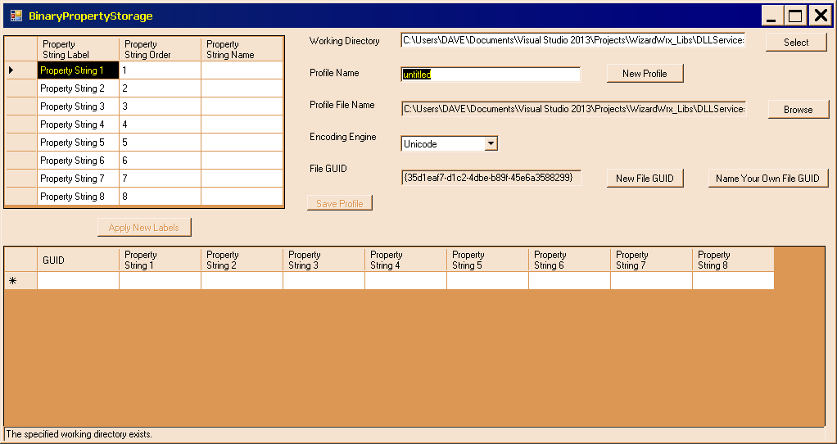
Figure 22 is the form after the working directory was populated and the new events magically moved the focus to the next text box.
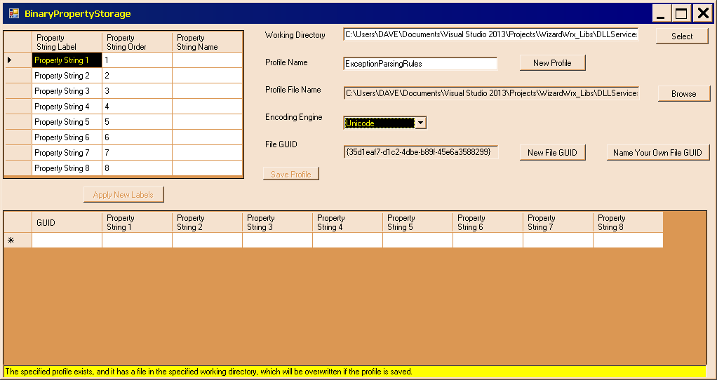
Figure 23 is the next stop, where the focus advanced to the Encoding Engine combo box.
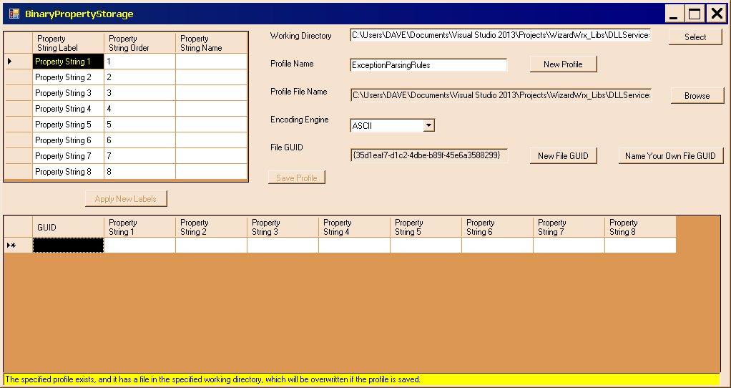
Figure 24 is the next stop in the tab order, which is the origin cell of the property grid control near the bottom of the form. The Encoding Engine combo box doesn’t fire the special code.
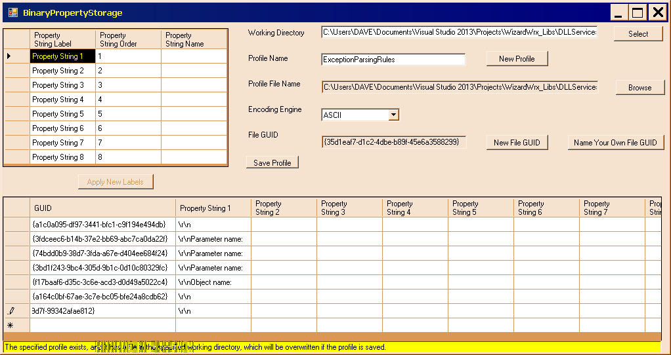
Figure 25 is the completed form, with a fully populated property grid, which retains the focus.
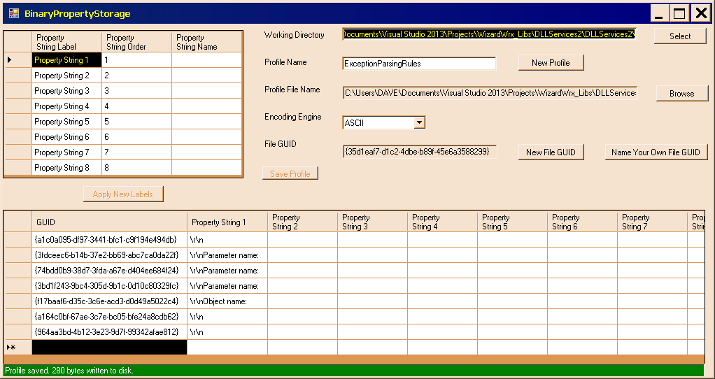
Figure 26 is the completed form, following a successful save operation.

