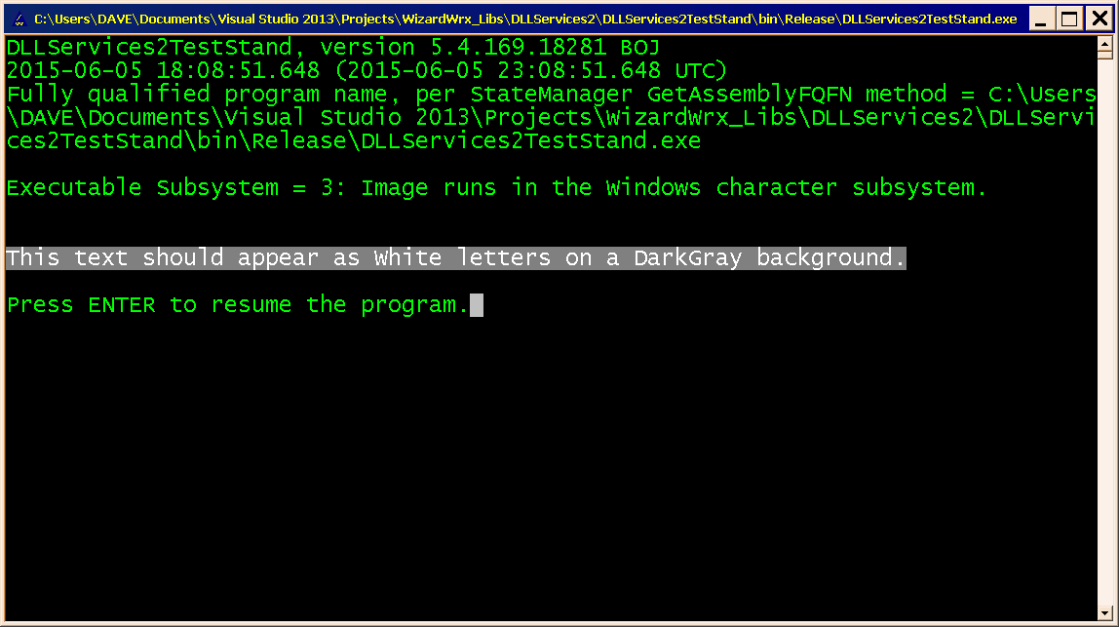
Figure 1 is the 1st of 5 screens of output that put the colored text generators through their paces.
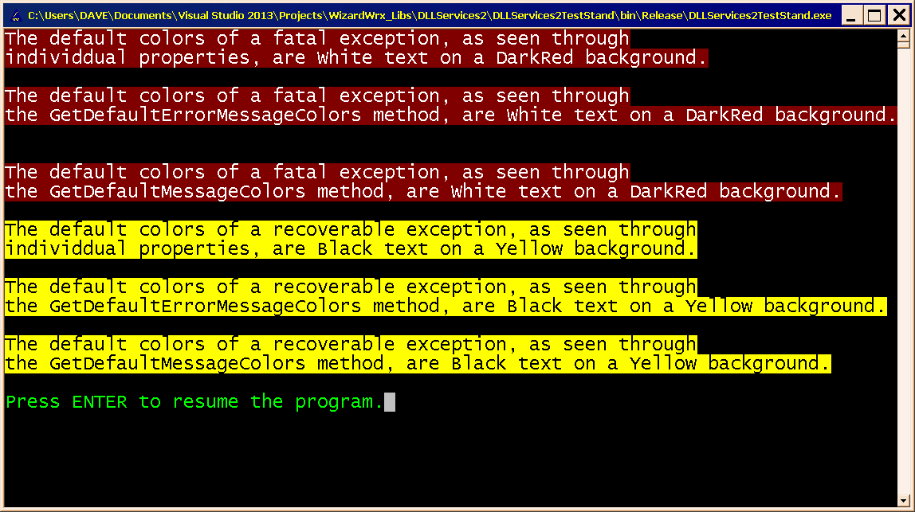
Figure 2 displays the default colors for reports about fatal and recoverable errors, using the colors defined in WizardWrx.DLLServices2.dll.config.
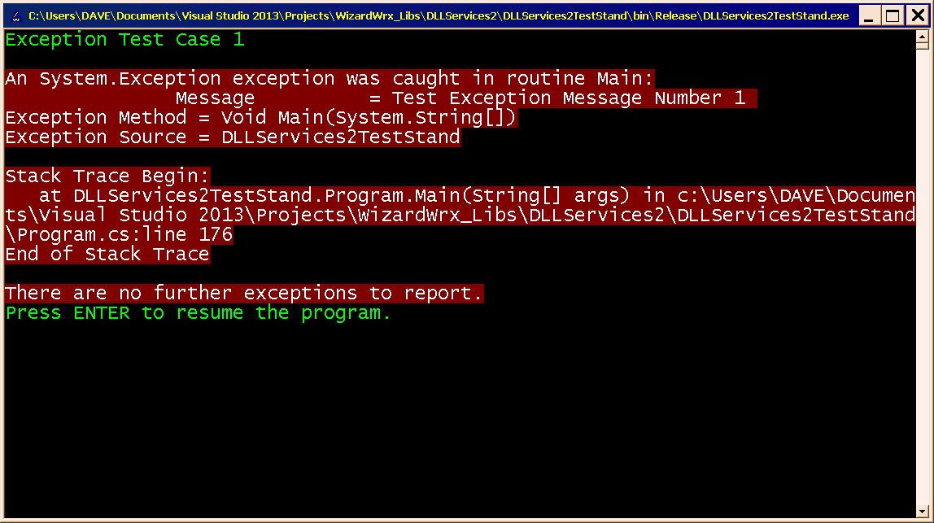
Figure 3 is an actual exception report, rendered in the default colors for a fatal error, as defined in WizardWrx.DLLServices2.dll.config, and first shown in Figure 2.
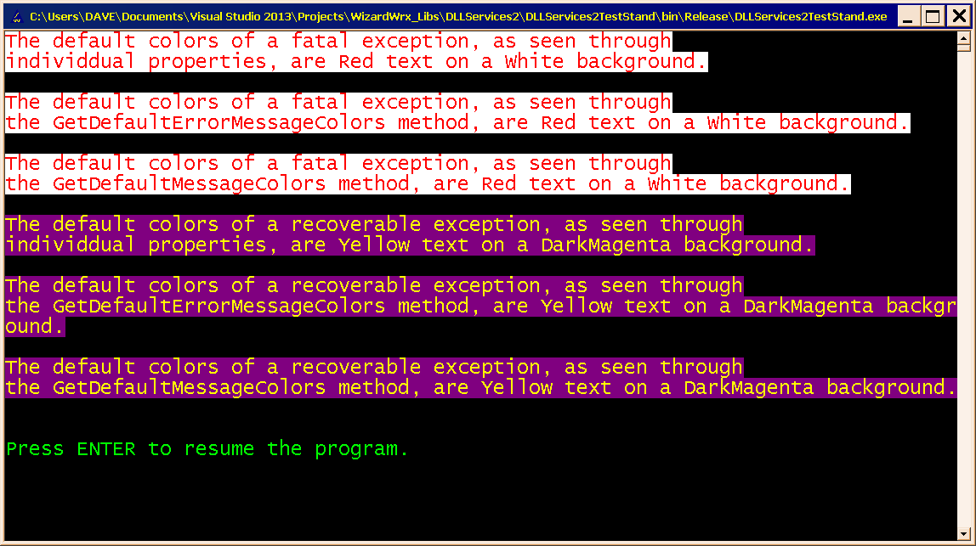
Figure 4 demonstrates programmatically overriding the colors stored in WizardWrx.DLLServices2.dll.config.
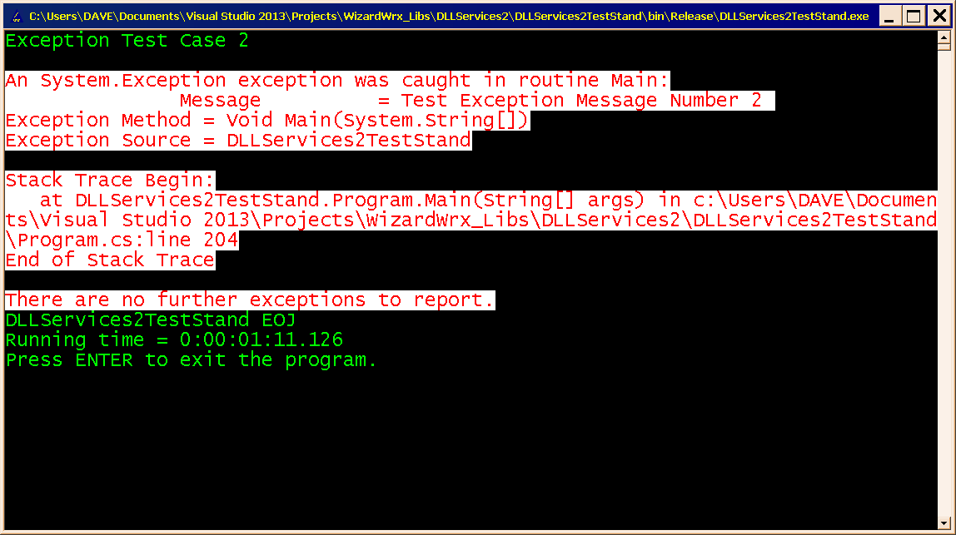
Figure 5 is a real exception report, using the color scheme shown in Figure 4

