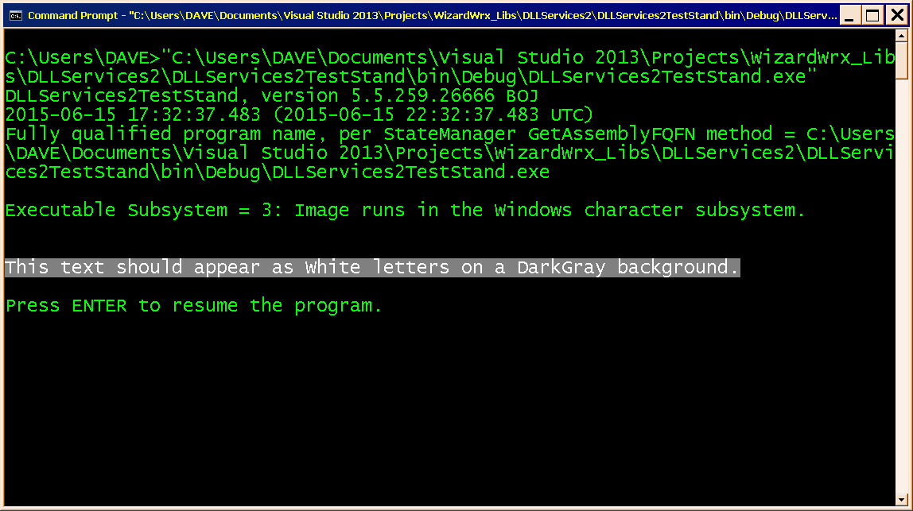
Figure 1 displays the image subsystem type of the application, folloed by a very basic demonstration of the MessageInColors object.
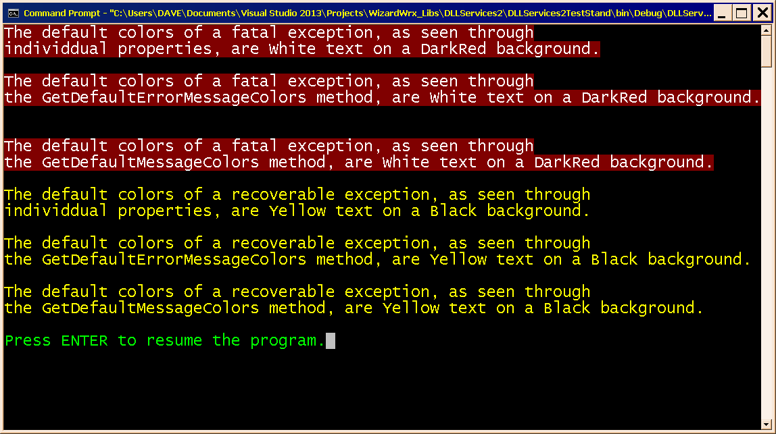
Figure 2 displays the derfault colors, per WizardWrx.DLLServices2.dll.config. On further consideration, I reveresed the foreground and background colors of a nonfatal exception report.
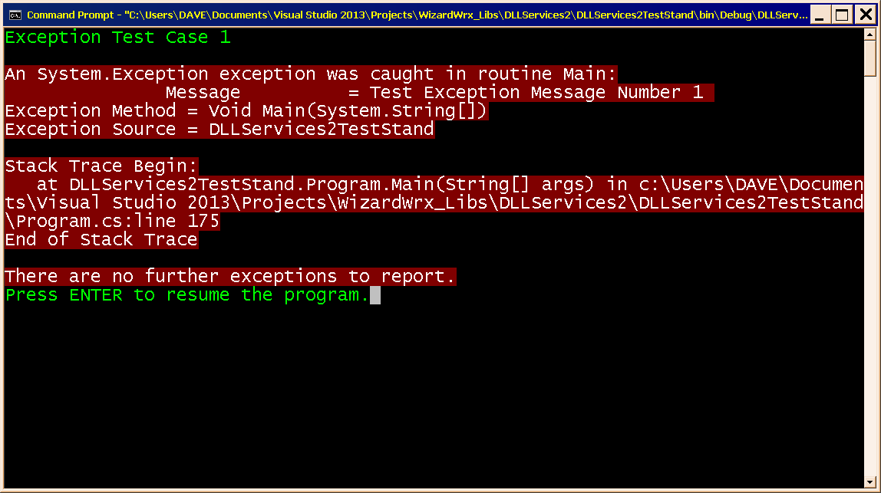
Figure 3 is a real exception report, which I created by intentionally causing the program to throw an exception.
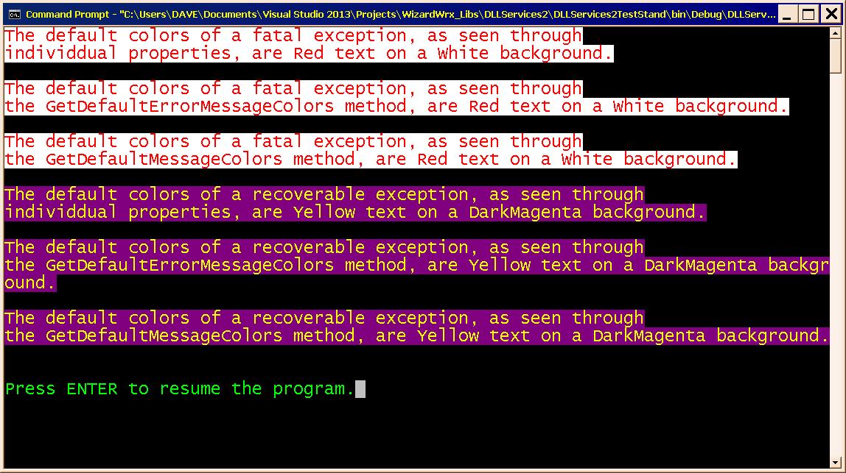
Figure 4 demonstrates overriding the default message colors in code.
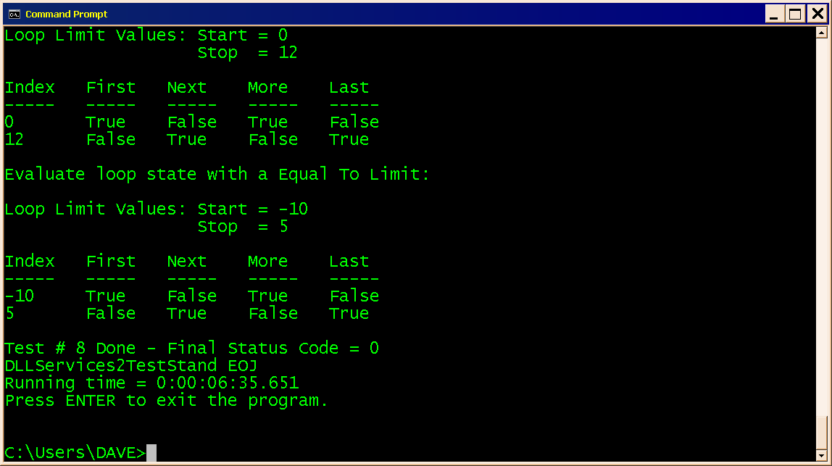
Figure 5 is the final display generated by the debug build of the test program. A retail build omits the last line, Press ENTER to exit the program.”

