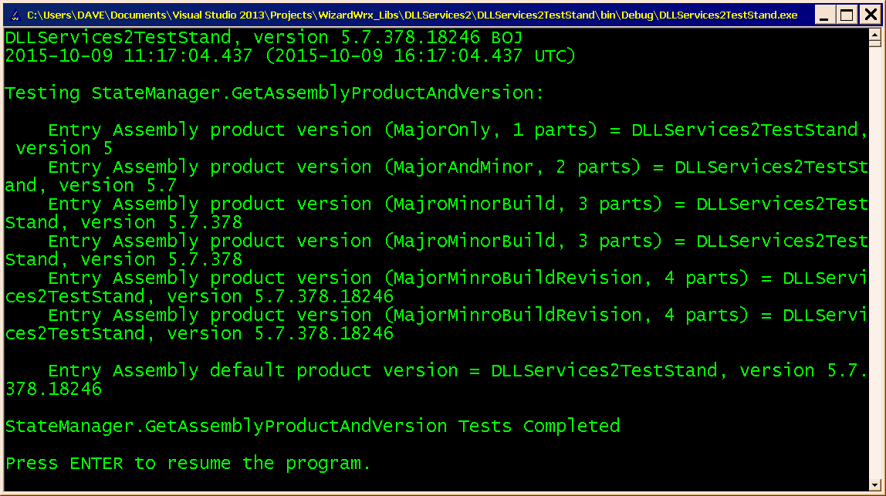
Figure 1 displays the output of the GetAssemblyProductAndVersion method for all members of the AssemblyVersionRequest enumeration as inputs.
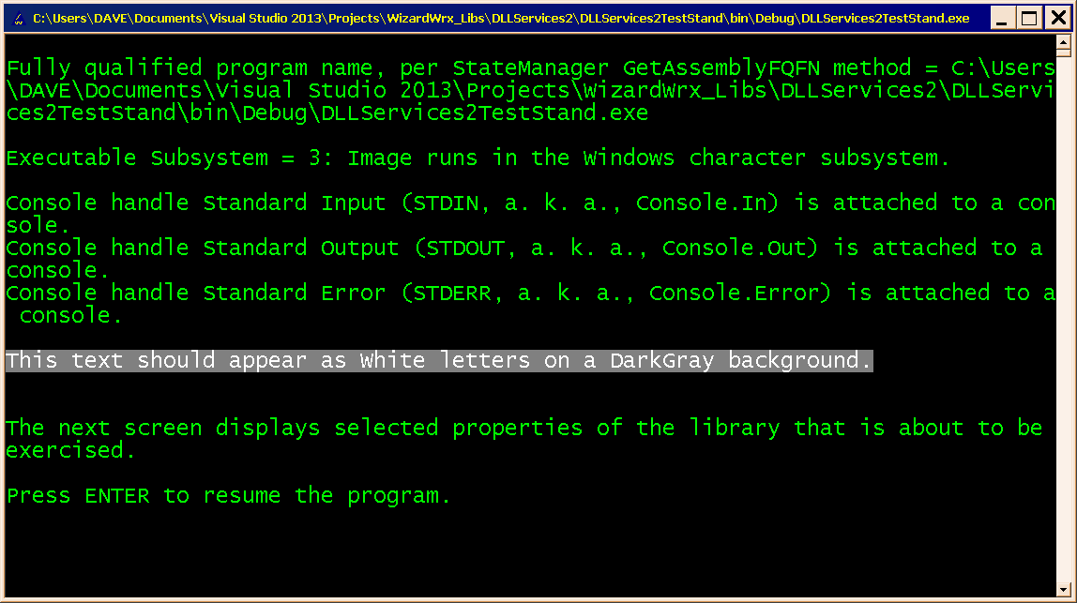
Figure 2 displays the image subsystem type of the application, followed by a listing of the state of the three console stream handles and a very basic demonstration of the MessageInColors object.
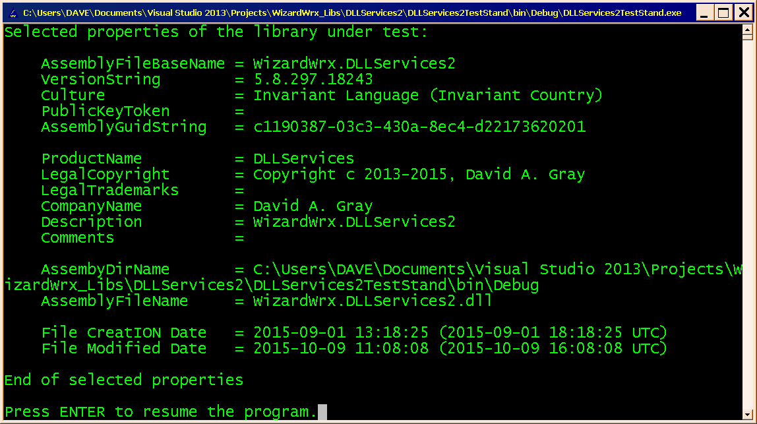
Figure 3 displays key properties of the assembly that exports the WizardWrx.DllServices2 namespace.
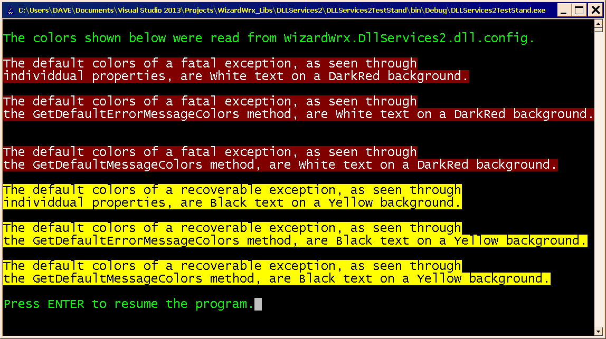
Figure 4 displays the current derfault colors, per WizardWrx.DLLServices2.dll.config, of exception reports. Cointrast the recoverable exception with Figure 5
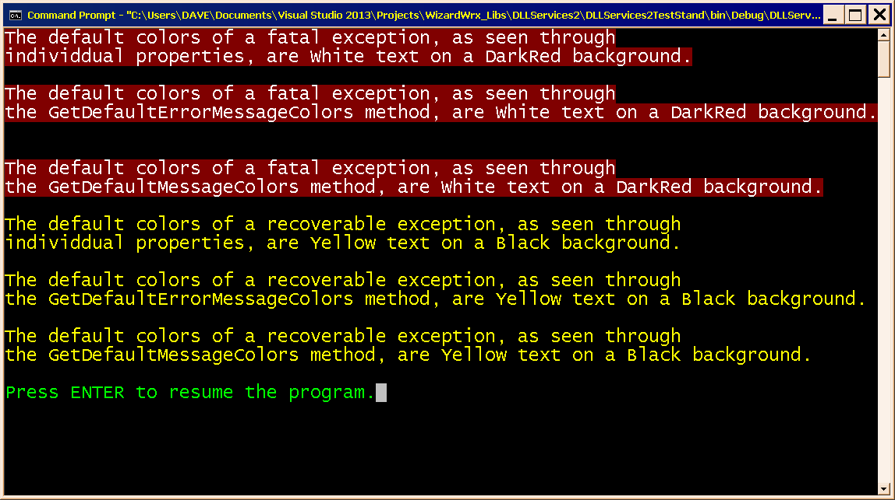
Figure 5 displays the original derfault colors, per WizardWrx.DLLServices2.dll.config, of exception reports. Contrast this with the revised colors displayed in Figure 4.
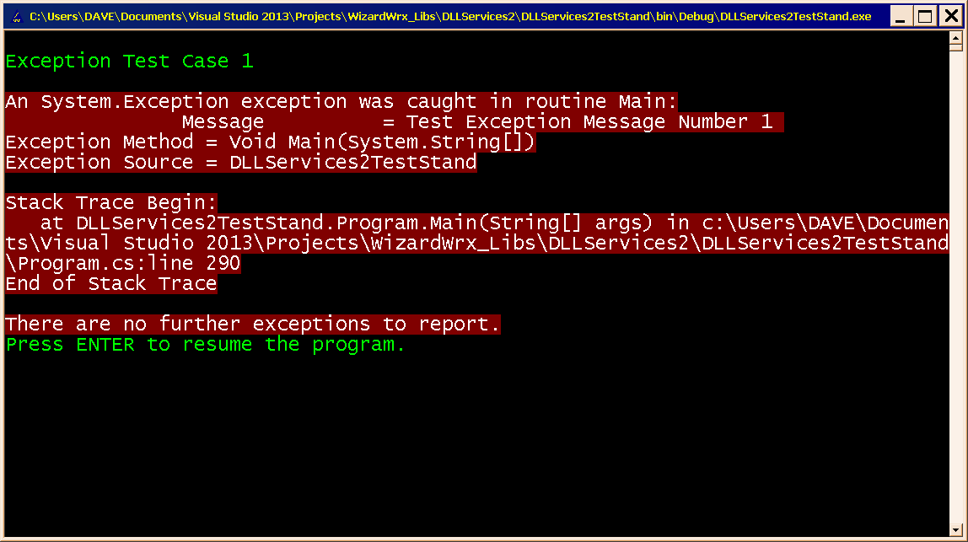
Figure 6 is a real exception report, which I created by intentionally causing the program to throw an exception. Nothing changed in this part of the program between version 5.5 and 5.8.
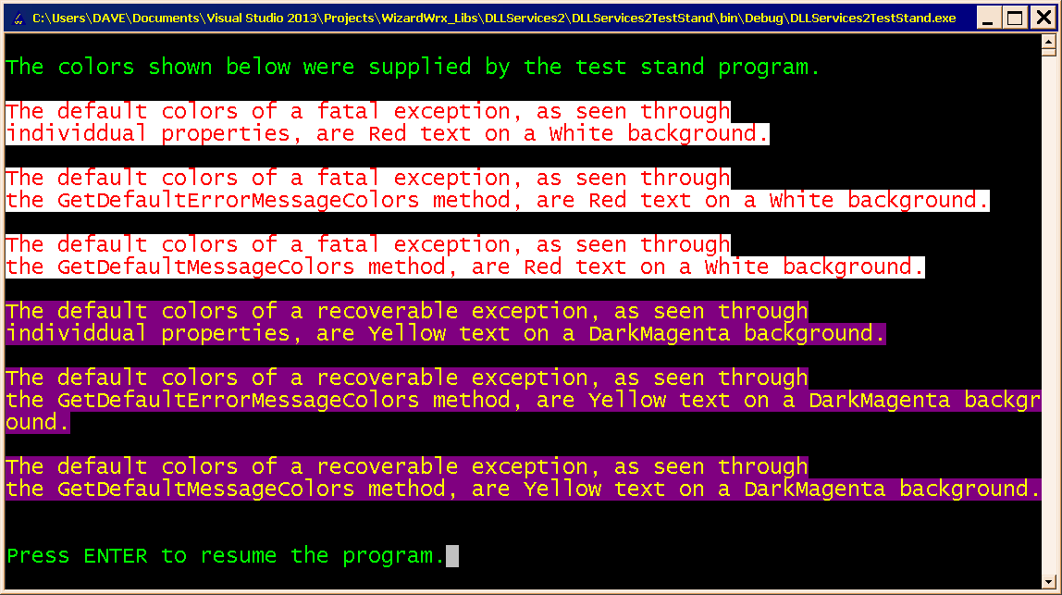
Figure 7 demonstrates overriding the default message colors in code. These are unchanged from version 5.5.
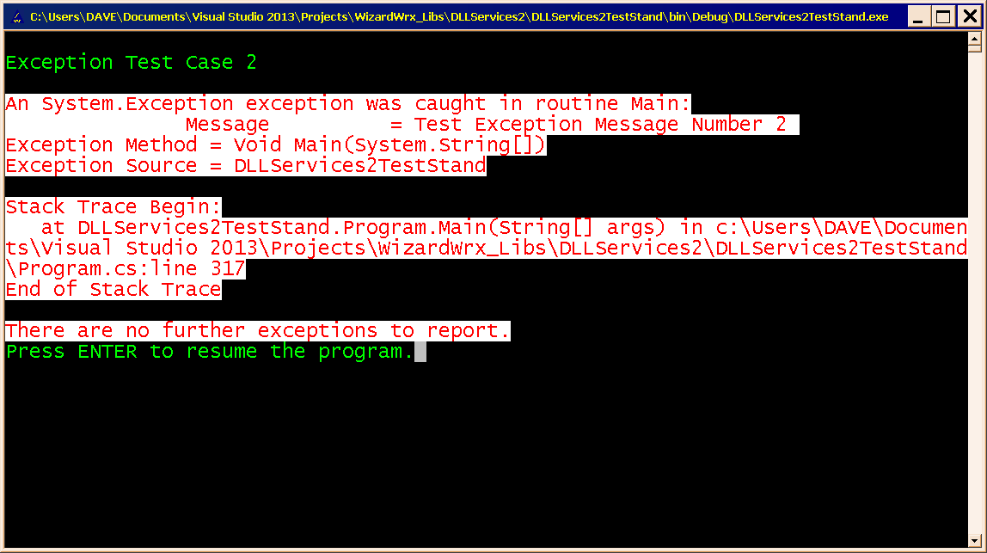
Figure 8 is a second test case, which displays an exception report in the programmatically overridden colors for a fatal exception report.
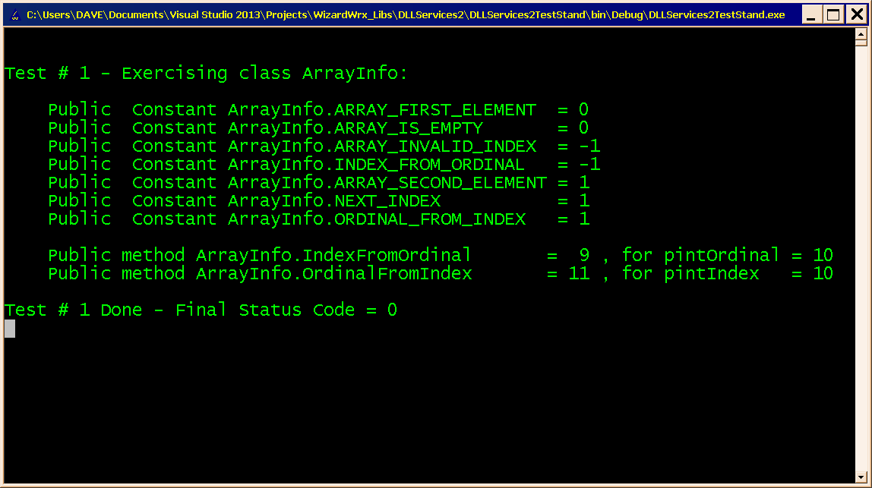
Figure 9 is the first of a series of reports covering the utility classes. I won’t bother with pictures of the rest, since they are all monochrome. This page demonstrates that displaying a message leaves the default screen colors unchanged.
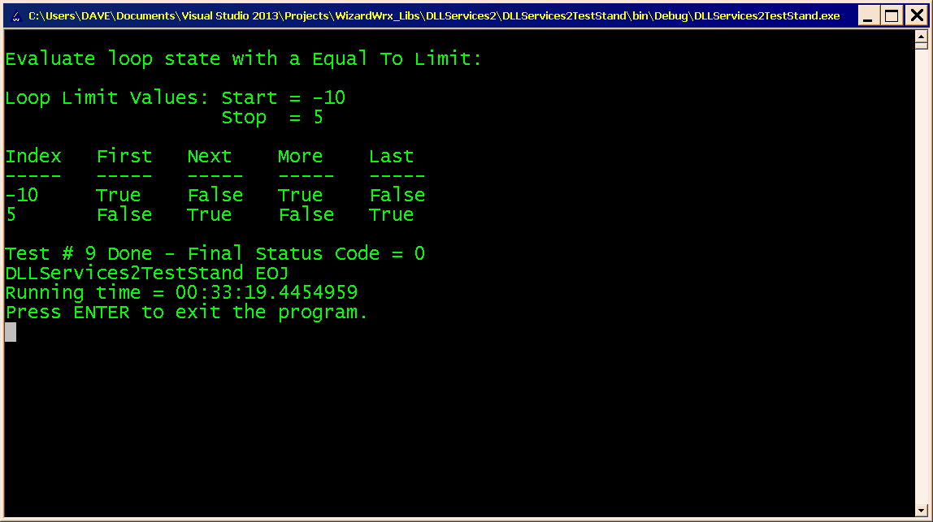
Figure 10 is the final display generated by the debug build of the test program. A retail build omits the last line, Press ENTER to exit the program.”

