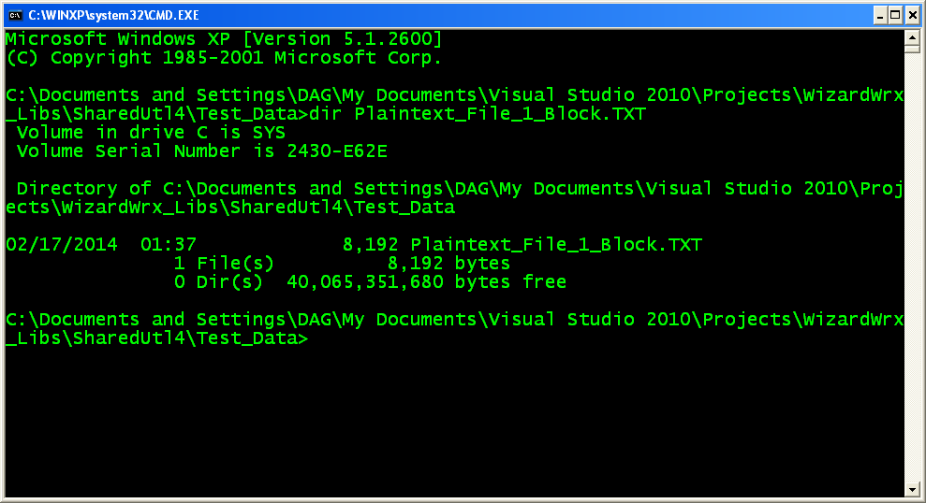
Figure 1 is the directory listing of the 1st test file, Plaintext_File_1_Block.TXT, which occupies exactly 1 buffer. The digests, per MD5WIN.EXE and the DigestFile class, are shown in Figure 2.
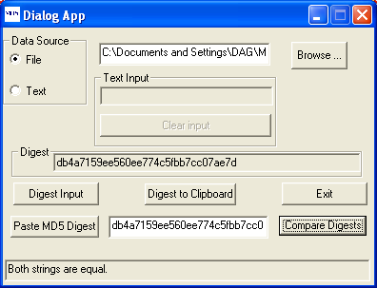
Figure 2 is the confirmation that the 1st test, which is a file of exactly one block yields the same result as my benchmark program, MD5WIN.EXE, which uses the C code published by Dr. Ronald L. Rivest. The directory listing for this file is shown in Figure 1.
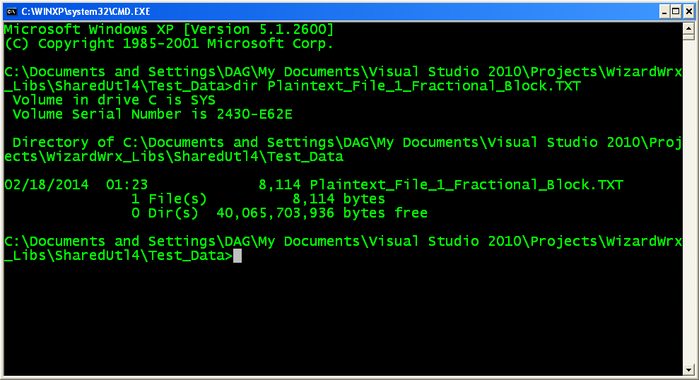
Figure 3 is the directory listing for the 2nd test file, Plaintext_File_1_Fractional_Block.TXT, which occupies most, but not all, of a single buffer.
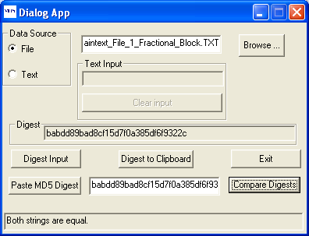
Figure 4 is the digest of Plaintext_File_1_Fractional_Block.TXT, per MD5WIN.EXE and the DigestFile class.

