犯的错误以及解决办法
1. 无法解析插件 org.springframework.boot:spring-boot-maven-plugin:2.6.10
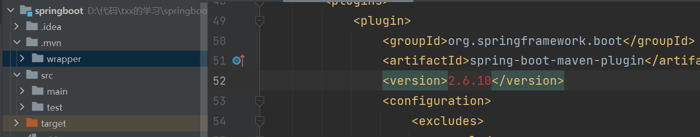
\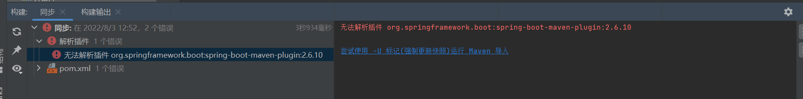

解决办法：
https://blog.csdn.net/dlz_yhn/article/details/125133085?spm=1001.2101.3001.6650.6&utm_medium=distribute.pc_relevant.none-task-blog-2%7Edefault%7EBlogCommendFromBaidu%7Edefault-6-125133085-blog-123707111.pc_relevant_multi_platform_whitelistv1_exp2&depth_1-utm_source=distribute.pc_relevant.none-task-blog-2%7Edefault%7EBlogCommendFromBaidu%7Edefault-6-125133085-blog-123707111.pc_relevant_multi_platform_whitelistv1_exp2&utm_relevant_index=12
去用户目录找到.m文件夹下的reporstory，搜索spring-boot-maven-plugin，找一个能用的版本号就行
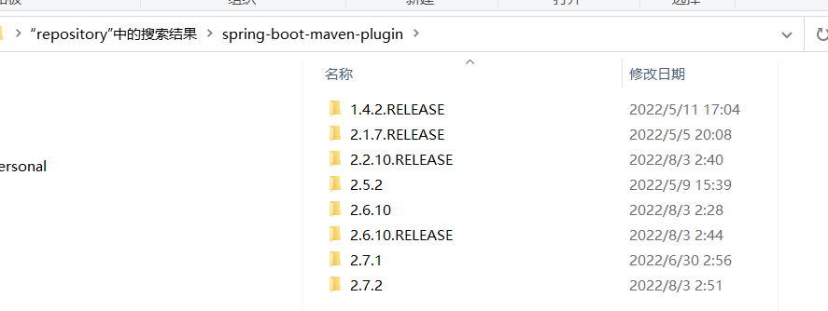
我的2.6.10的文件夹不完整，这里我用的是2.5.2版本，修改之后就不报错了
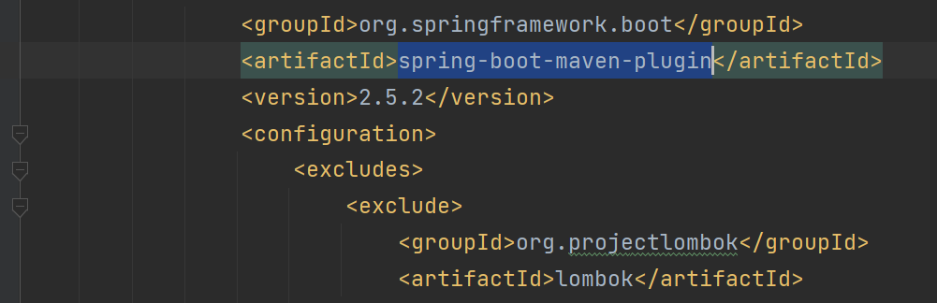

Git上出现的问题，分支发生了冲突，提交到gitee上的vue文件夹有@符号，解决办法

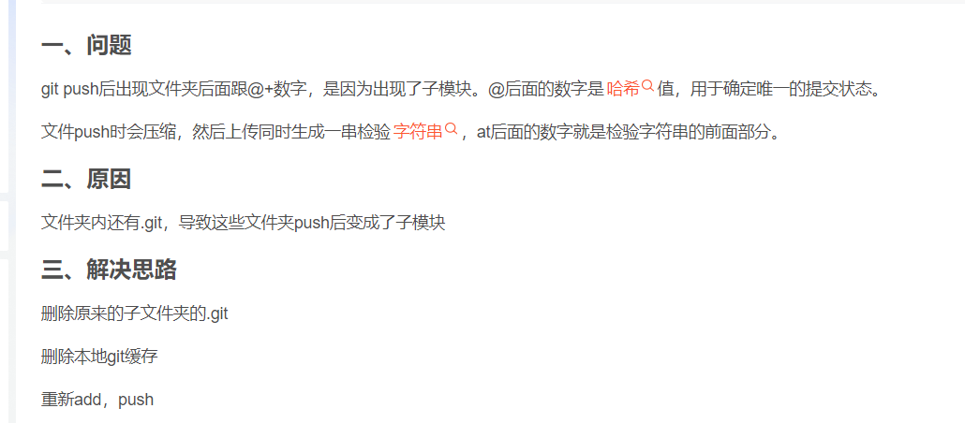
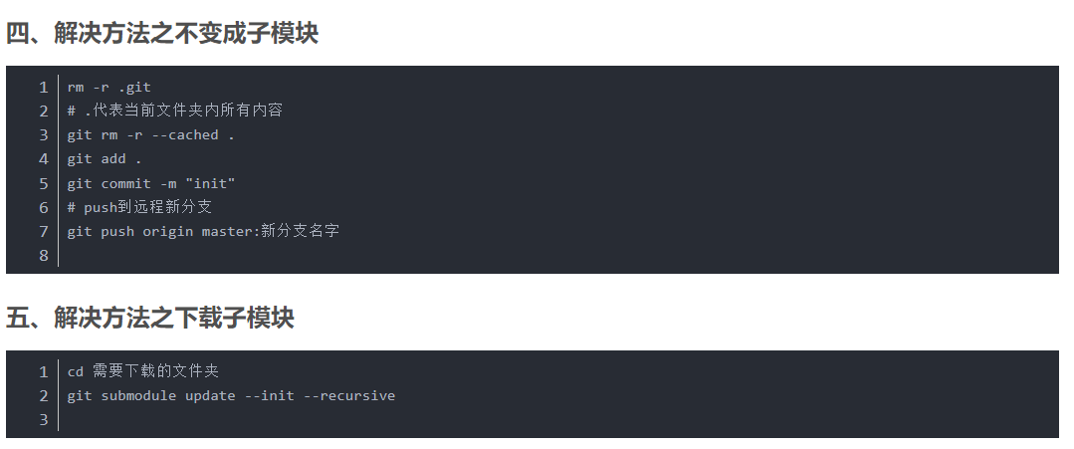
https://blog.csdn.net/qq_23590921/article/details/108087020
幸好有git的版本回退，让我不断的回溯之前的版本。

项目结构的问题，找不到package.json的path,更改了npm的配置也不行，只有放在主文件夹才可以，移出来就会报错

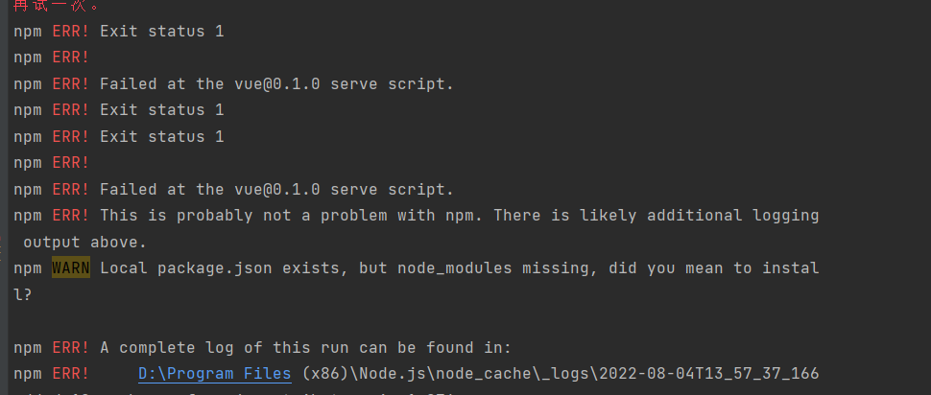解决办法 删除node_modules文件夹重新安装(估计是之前push到git上合并项目出现了问题，导致node_modules文件位置的索引出现了问题)，解决办法如下
https://blog.csdn.net/tulihetulihe/article/details/123199136

在pom.xml文件里面配置阿里云仓库
<repositories>
<repository>
<id>nexus-aliyun</id>
<name>nexus-aliyun</name>
<url>http://maven.aliyun.com/nexus/content/groups/public/</url>
<releases>
<enabled>true</enabled>
</releases>
<snapshots>
<enabled>false</enabled>
</snapshots>
</repository>
</repositories>

<pluginRepositories>
<pluginRepository>
<id>public</id>
<name>aliyun nexus</name>
<url>http://maven.aliyun.com/nexus/content/groups/public/</url>
<releases>
<enabled>true</enabled>
</releases>
<snapshots>
<enabled>false</enabled>
</snapshots>
</pluginRepository>
</pluginRepositories>

Application.properties
server.port=9090
spring.datasource.driver-class-name=com.mysql.cj.jdbc.Driver
spring.datasource.url=jdbc.mysql://localhost:3306/txx?serverTimezone=GMT%2b8
spring.datasource.username=root
spring.datasource.password=root

SpringbootApplication.java
package com.txx.springboot;
import org.springframework.boot.SpringApplication;
import org.springframework.boot.autoconfigure.SpringBootApplication;
import org.springframework.web.bind.annotation.GetMapping;
import org.springframework.web.bind.annotation.RestController;
@RestController
@SpringBootApplication
public class SpringbootApplication {
public static void main(String[] args) {
SpringApplication.run(SpringbootApplication.class, args);
}
@GetMapping("/")
public String index(){
return "ok";
}
}

pom.xml
<?xml version="1.0" encoding="UTF-8"?>
<project xmlns="http://maven.apache.org/POM/4.0.0" xmlns:xsi="http://www.w3.org/2001/XMLSchema-instance"
xsi:schemaLocation="http://maven.apache.org/POM/4.0.0 https://maven.apache.org/xsd/maven-4.0.0.xsd">
<modelVersion>4.0.0</modelVersion>
<parent>
<groupId>org.springframework.boot</groupId>
<artifactId>spring-boot-starter-parent</artifactId>
<version>2.5.2</version>
<relativePath/> <!-- lookup parent from repository -->
</parent>
<groupId>com.txx</groupId>
<artifactId>springboot</artifactId>
<version>0.0.1-SNAPSHOT</version>
<name>springboot</name>
<description>这是我的第一个springboot项目</description>
<properties>
<java.version>1.8</java.version>
</properties>
<dependencies>
<dependency>
<groupId>org.springframework.boot</groupId>
<artifactId>spring-boot-starter-web</artifactId>
</dependency>
<dependency>
<groupId>org.mybatis.spring.boot</groupId>
<artifactId>mybatis-spring-boot-starter</artifactId>
<version>2.2.2</version>
</dependency>
<dependency>
<groupId>mysql</groupId>
<artifactId>mysql-connector-java</artifactId>
<scope>runtime</scope>
</dependency>
<dependency>
<groupId>org.projectlombok</groupId>
<artifactId>lombok</artifactId>
<optional>true</optional>
</dependency>
<dependency>
<groupId>org.springframework.boot</groupId>
<artifactId>spring-boot-starter-test</artifactId>
<scope>test</scope>
</dependency>
</dependencies>
<build>
<plugins>
<plugin>
<groupId>org.springframework.boot</groupId>
<artifactId>spring-boot-maven-plugin</artifactId>
<version>2.5.2</version>
<configuration>
<excludes>
<exclude>
<groupId>org.projectlombok</groupId>
<artifactId>lombok</artifactId>
</exclude>
</excludes>
</configuration>
</plugin>
</plugins>
</build>
<repositories>
<repository>
<id>nexus-aliyun</id>
<name>nexus-aliyun</name>
<url>http://maven.aliyun.com/nexus/content/groups/public/</url>
<releases>
<enabled>true</enabled>
</releases>
<snapshots>
<enabled>false</enabled>
</snapshots>
</repository>
</repositories>
<pluginRepositories>
<pluginRepository>
<id>public</id>
<name>aliyun nexus</name>
<url>http://maven.aliyun.com/nexus/content/groups/public/</url>
<releases>
<enabled>true</enabled>
</releases>
<snapshots>
<enabled>false</enabled>
</snapshots>
</pluginRepository>
</pluginRepositories>
</project>

