学到的知识点
1.@requestBody、@requestParam的详解
https://blog.csdn.net/justry_deng/article/details/80972817
2.@PathVariable
https://blog.csdn.net/weixin_45393094/article/details/108814901

遇到的问题及其解决方案
- 前端输入正确的用户名及密码但是跳转不了报400
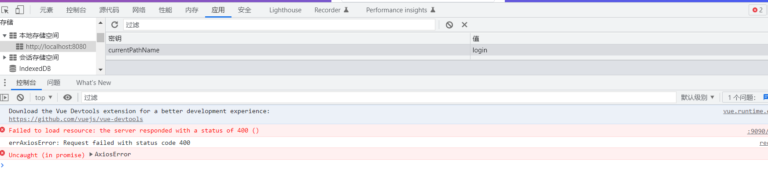
原因：前端的数据和后端的对不上，前端是this.request传过去，默认是以get方式，传不了json对象，而且后台写的login参数使用的是@PostMapping("/login")的方式，所以前端得改改。
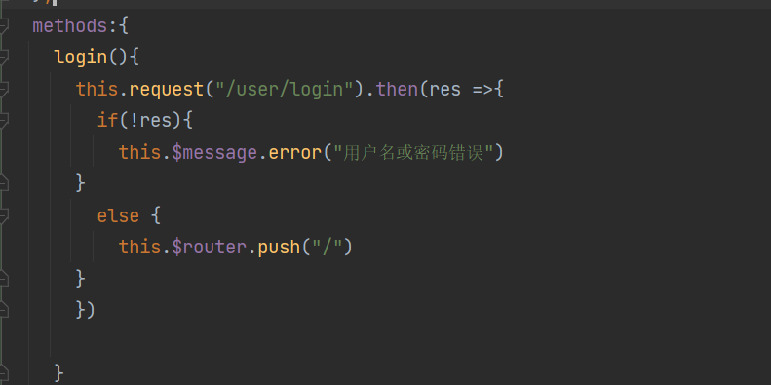
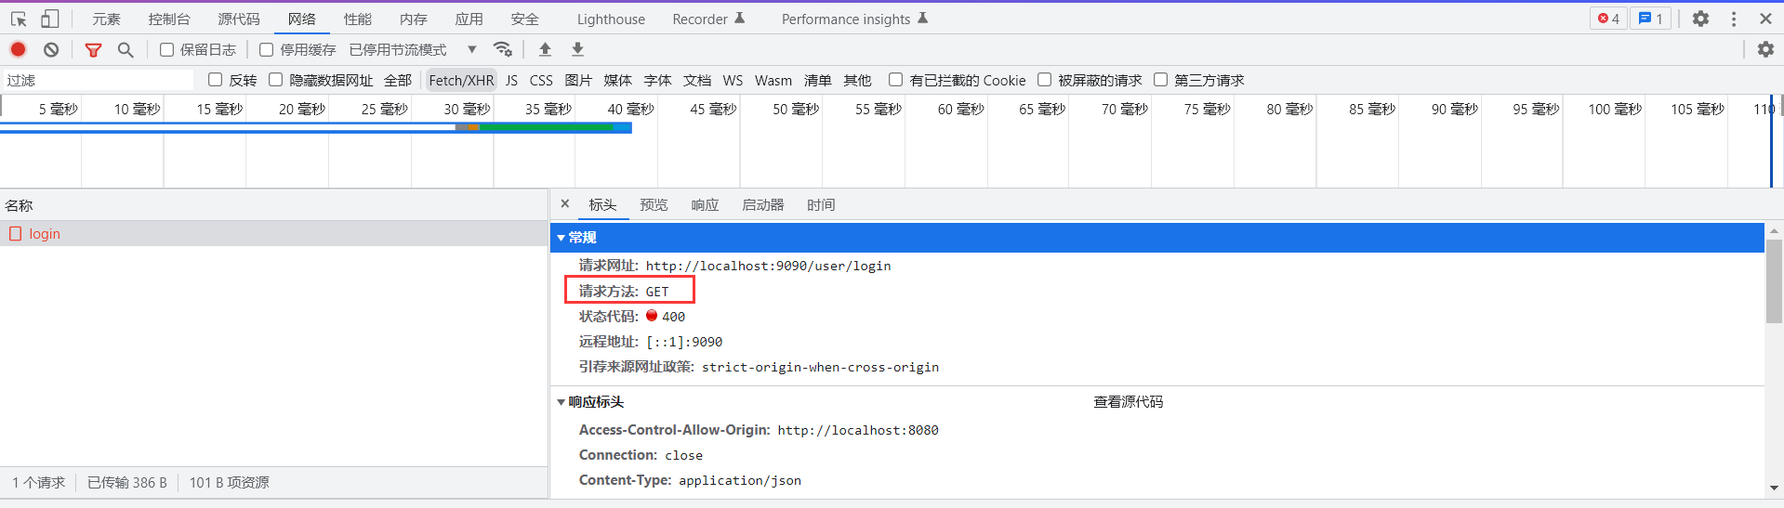

解决办法：以post方式提交，并且把参数传进去
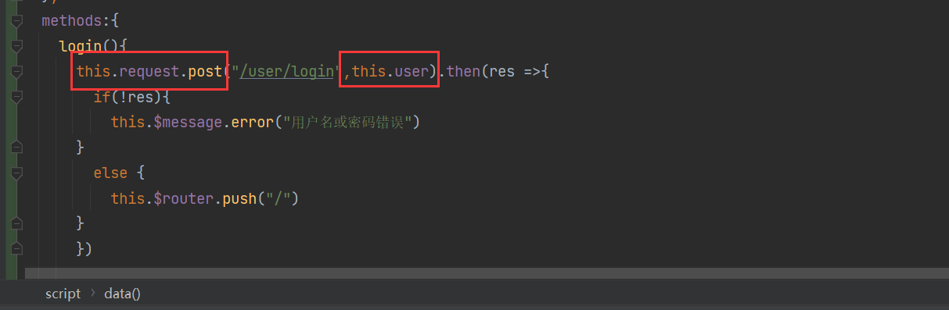

- 设置好表单校验之后，我们还需加一个判断，即当表单校验不合法的时候，不要往后台发送数据。利用vue使用dom对象，ref="userForm"，在请求之前校验一下是否合法。
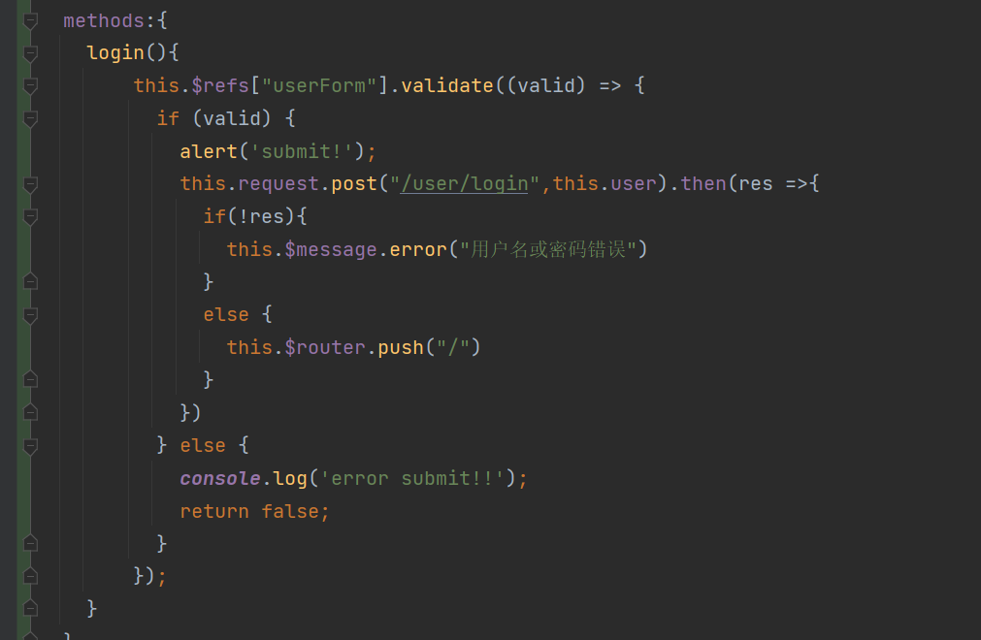

- 当数据库中出现同名同密码的脏数据，如图
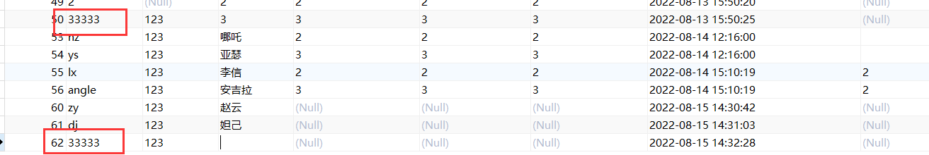
则查不出来数据，报错信息
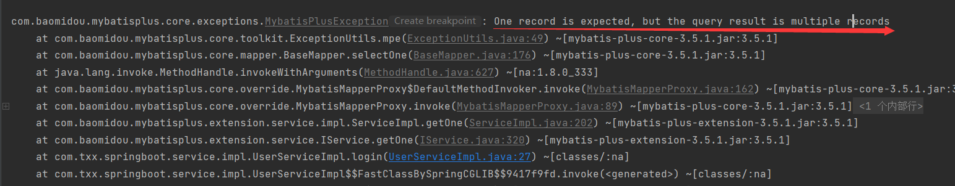
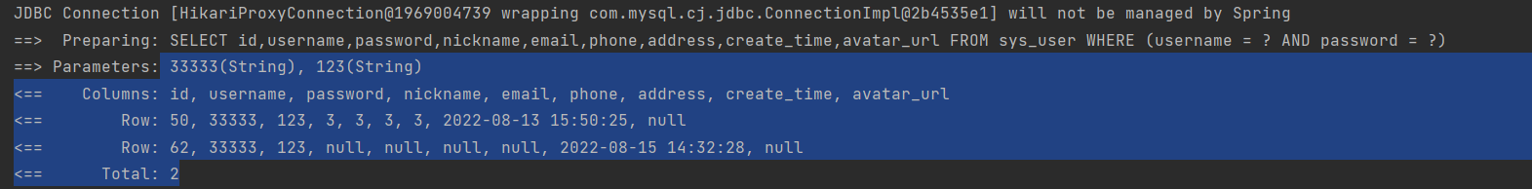
原因：我们后台用的getOne(queryWrapper);方法
解决办法：加 try catch()，当后台返回多条数据时，也返回false
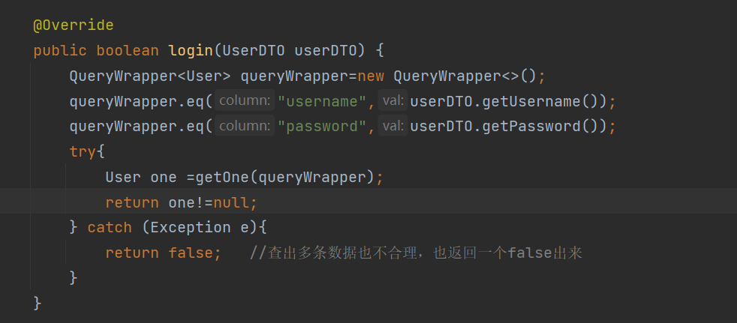

代码
Login.vue
<template>
<div class="wrapper">
<div style="margin:200px auto; background-color: #ffffff;width: 350px ;height:300px ; padding: 20px;border: 20px;border-radius: 10px">
<div style="margin: 20px 0;text-align: center;font-size: 24px"><b>登 录</b></div>
<el-form :model="user" :rules="rules" ref="userForm">
<el-form-item prop="username">
<el-input size="medium" style="margin: 10px 0" prefix-icon="el-icon-user" v-model="user.username"></el-input>
</el-form-item>
<el-form-item prop="password">
<el-input size="medium" style="margin: 10px 0" prefix-icon="el-icon-lock" show-password v-model="user.password"></el-input>
</el-form-item>
<div style="margin: 10px 0;text-align: right">
<el-form-item>
<el-button type="primary" size="small" autocomplete="off" @click="login">登录</el-button>
<el-button type="warning" size="small" autocomplete="off">注册</el-button>
</el-form-item>
</div>
</el-form>
</div>
</div>
</template>
<script>
export default {
name:"Login",
data(){
return{
user:{},
rules: {
username: [
{required: true, message: '请输入用户名', trigger: 'blur'},
{min: 3, max: 10, message: '长度在 3 到 5 个字符', trigger: 'blur'}
],
password:[
{required: true, message: '请输入密码', trigger: 'blur'},
{min: 1, max: 20, message: '长度在 1 到 20 个字符', trigger: 'blur'}
],
}
}
},
methods:{
login(){
this.$refs["userForm"].validate((valid) => {
if (valid) {
this.request.post("/user/login",this.user).then(res =>{
if(!res){
this.$message.error("用户名或密码错误")
}
else {
this.$router.push("/")
}
})
} else {
console.log('error submit!!');
return false;
}
});
}
}
}
</script>
<style>
.wrapper{
height: 100vh;
background-image:linear-gradient(to bottom right,#FC466B,#3F5EF8) ;
overflow: hidden;
}
</style>

Header.vue
<template>
<div style="line-height: 60px;display: flex">
<div style="flex: 1;">
<span :class="collapseBtnClass" style="cursor: pointer; font-size: 18px" @click="collapse"></span>
<el-breadcrumb separator="/" style="display: inline-block;margin-left: 10px">
<el-breadcrumb-item :to="'/'">首页</el-breadcrumb-item>
<el-breadcrumb-item>{{ currentPathName }}</el-breadcrumb-item>
</el-breadcrumb>
</div>
<el-dropdown style="width: 100px;cursor: pointer">
<div style="display: inline-block">
<img src="../img/admin.jpg" alt="" style="width: 30px;border-radius: 50%;position: relative;top:10px;right: 5px">
<span>糖香香</span><i class="el-icon-arrow-down" style="margin-left: 5px"></i>
</div>
<el-dropdown-menu slot="dropdown" style="width: 100px;text-align: center">
<el-dropdown-item style="font-size: 14px; padding: 5px 0">个人信息</el-dropdown-item>
<el-dropdown-item style="font-size: 14px; padding: 5px 0">
<router-link to="/login" style="text-decoration: none">退出</router-link>
</el-dropdown-item>
</el-dropdown-menu>
</el-dropdown>
</div>
</template>
<script>
export default {
name: "Header",
props:{
collapseBtnClass:String,
collapse:'',
},
computed: {
currentPathName () {
return this.$store.state.currentPathName; //需要监听的数据
}
},
watch: {
currentPathName (newVal, oldVal) {
console.log(newVal)
}
},
}
</script>
<style scoped>
</style>

UserController.java
package com.txx.springboot.controller;
import cn.hutool.core.collection.CollUtil;
import cn.hutool.core.util.StrUtil;
import cn.hutool.poi.excel.ExcelReader;
import cn.hutool.poi.excel.ExcelUtil;
import cn.hutool.poi.excel.ExcelWriter;
import com.baomidou.mybatisplus.extension.plugins.pagination.Page;
import com.txx.springboot.config.dto.UserDTO;
import org.springframework.beans.factory.annotation.Value;
import org.springframework.web.bind.annotation.*;
import javax.annotation.Resource;
import javax.servlet.ServletOutputStream;
import javax.servlet.http.HttpServletResponse;
import java.io.InputStream;
import java.net.URLEncoder;
import java.util.List;
import com.baomidou.mybatisplus.core.conditions.query.QueryWrapper;
import com.txx.springboot.service.IUserService;
import com.txx.springboot.entity.User;
import org.springframework.web.bind.annotation.RestController;
import org.springframework.web.multipart.MultipartFile;
/**
* <p>
* 前端控制器
* </p>
*
* @author txx
* @since 2022-08-12
*/
@RestController
@RequestMapping("/user")
public class UserController {
// @Value("${files.upload.path}")
// private String fileUploadPath;
@Resource
private IUserService userService;
@PostMapping("/login")
public boolean login(@RequestBody UserDTO userDTO) {
String username = userDTO.getUsername();
String password = userDTO.getPassword();
if(StrUtil.isBlank(username) || StrUtil.isBlank(password)){
return false;
}
return userService.login(userDTO);
}
// 新增或者更新
@PostMapping
public boolean save(@RequestBody User user) {
return userService.saveOrUpdate(user);
}
@DeleteMapping("/{id}")
public Boolean delete(@PathVariable Integer id) {
return userService.removeById(id);
}
@PostMapping("/del/batch")
public boolean deleteBatch(@RequestBody List<Integer> ids) {
return userService.removeByIds(ids);
}
@GetMapping
public List<User> findAll() {
return userService.list();
}
@GetMapping("/{id}")
public User findOne(@PathVariable Integer id) {
return userService.getById(id);
}
@GetMapping("/page")
public Page<User> findPage(@RequestParam Integer pageNum,
@RequestParam Integer pageSize,
@RequestParam(defaultValue = "") String username,
@RequestParam(defaultValue = "") String nickname,
@RequestParam(defaultValue = "")String address) {
QueryWrapper<User> queryWrapper = new QueryWrapper<>();
if(!"".equals(username)){
queryWrapper.like("username",username);
}
if (!"".equals(nickname)){
queryWrapper.like("nickname",nickname);
}
if (!"".equals(address)){
queryWrapper.like("address",address);
}
queryWrapper.orderByDesc("id");
return userService.page(new Page<>(pageNum, pageSize), queryWrapper);
}
/**
* 导出接口
*/
@GetMapping("/export")
public void export(HttpServletResponse response) throws Exception {
// 从数据库查询出所有的数据
List<User> list = userService.list();
// 通过工具类创建writer 写出到磁盘路径
// ExcelWriter writer = ExcelUtil.getWriter(filesUploadPath + "/用户信息.xlsx");
// 在内存操作，写出到浏览器
ExcelWriter writer = ExcelUtil.getWriter(true);
//自定义标题别名
writer.addHeaderAlias("username", "用户名");
writer.addHeaderAlias("password", "密码");
writer.addHeaderAlias("nickname", "昵称");
writer.addHeaderAlias("email", "邮箱");
writer.addHeaderAlias("phone", "电话");
writer.addHeaderAlias("address", "地址");
writer.addHeaderAlias("createTime", "创建时间");
writer.addHeaderAlias("avatarUrl", "头像");
// 一次性写出list内的对象到excel，使用默认样式，强制输出标题
writer.write(list, true);
// 设置浏览器响应的格式
response.setContentType("application/vnd.openxmlformats-officedocument.spreadsheetml.sheet;charset=utf-8");
String fileName = URLEncoder.encode("用户信息", "UTF-8");
response.setHeader("Content-Disposition", "attachment;filename=" + fileName + ".xlsx");
ServletOutputStream out = response.getOutputStream();
writer.flush(out, true);
out.close();
writer.close();
}
/**
* excel 导入
* @param file
* @throws Exception
*/
@PostMapping("/import")
public Boolean imp(MultipartFile file) throws Exception {
InputStream inputStream = file.getInputStream();
ExcelReader reader = ExcelUtil.getReader(inputStream);
// 方式1：(推荐) 通过 javabean的方式读取Excel内的对象，但是要求表头必须是英文，跟javabean的属性要对应起来
// List<User> users = reader.readAll(User.class);
// 方式2：忽略表头的中文，直接读取表的内容
List<List<Object>> list = reader.read(1);
List<User> users = CollUtil.newArrayList();
for (List<Object> row : list) {
User user = new User();
user.setUsername(row.get(0).toString());
user.setPassword(row.get(1).toString());
user.setNickname(row.get(2).toString());
user.setEmail(row.get(3).toString());
user.setPhone(row.get(4).toString());
user.setAddress(row.get(5).toString());
user.setAvatarUrl(row.get(6).toString());
users.add(user);
}
userService.saveBatch(users);
return true;
}
}

IUserService.java
package com.txx.springboot.service;
import com.txx.springboot.config.dto.UserDTO;
import com.txx.springboot.entity.User;
import com.baomidou.mybatisplus.extension.service.IService;
/**
* <p>
* 服务类
* </p>
*
* @author txx
* @since 2022-08-12
*/
public interface IUserService extends IService<User> {
boolean login(UserDTO userDTO);
}

UserServiceImpl.java
package com.txx.springboot.service.impl;
import cn.hutool.log.Log;
import com.baomidou.mybatisplus.core.conditions.query.QueryWrapper;
import com.txx.springboot.config.dto.UserDTO;
import com.txx.springboot.entity.User;
import com.txx.springboot.mapper.UserMapper;
import com.txx.springboot.service.IUserService;
import com.baomidou.mybatisplus.extension.service.impl.ServiceImpl;
import org.springframework.stereotype.Service;
/**
* <p>
* 服务实现类
* </p>
*
* @author txx
* @since 2022-08-12
*/
@Service
public class UserServiceImpl extends ServiceImpl<UserMapper, User> implements IUserService {
private static final Log LOG= Log.get();
@Override
public boolean login(UserDTO userDTO) {
QueryWrapper<User> queryWrapper=new QueryWrapper<>();
queryWrapper.eq("username",userDTO.getUsername());
queryWrapper.eq("password",userDTO.getPassword());
try{
User one =getOne(queryWrapper);
return one!=null;
} catch (Exception e){
LOG.error(e);
return false; //查出多条数据也不合理，也返回一个false出来
}
}
}

