学到的知识点
- 本节课的内容就是改进登录，我们要在头部右上角显示登录的个人信息，要在后台不是返回true或者false，而是返回一个带有数据的对象，将对象返回前台。but…光是返回数据还不够，只返回数据那么前端不清楚是否登录成功，所以需要返回一个封装的对象，这个对象里既要有返回的用户数据，又要有是否登录成功的信息。
- 自定义业务逻辑异常，比如下面这种情况就需要我们自定义异常
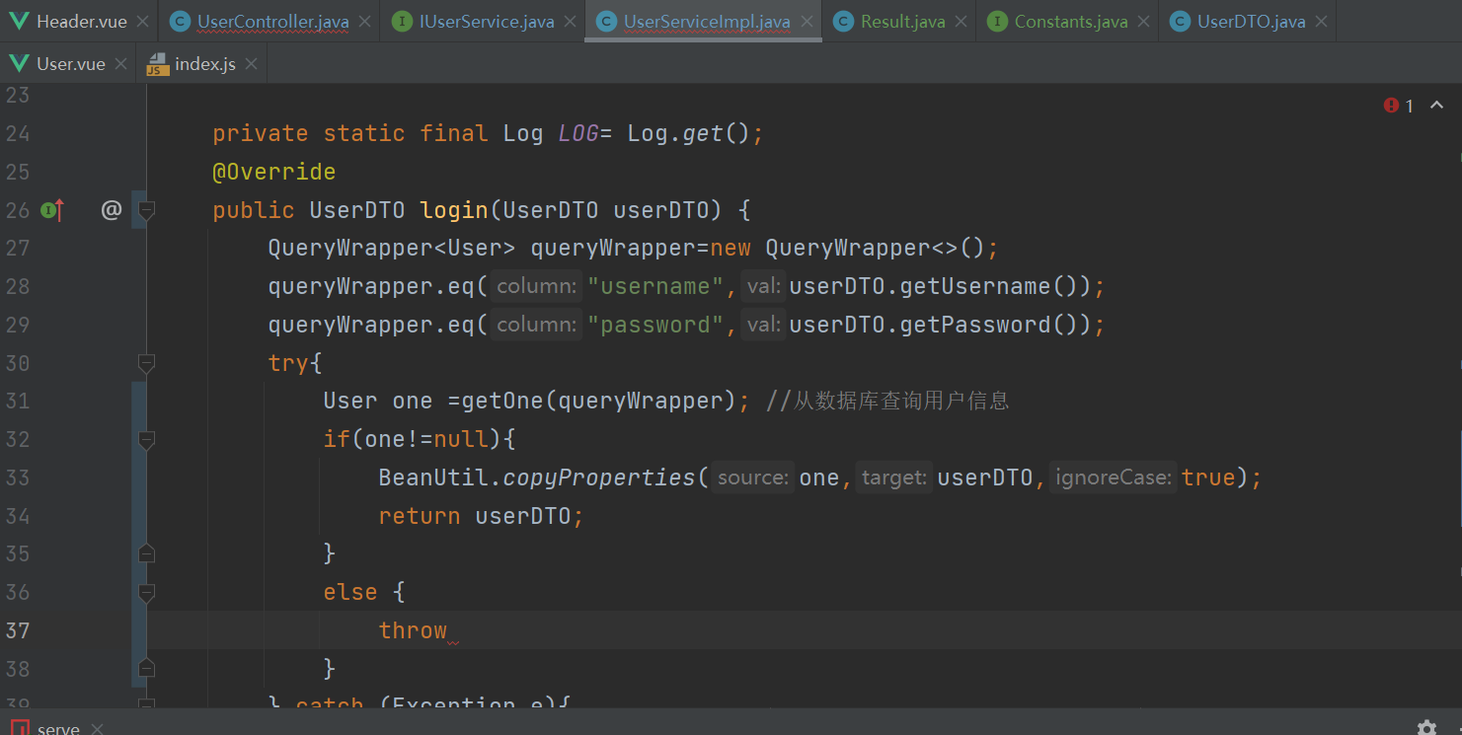
解决：https://www.cnblogs.com/menmenz/p/11649613.html
1.定义一个全局的异常处理器
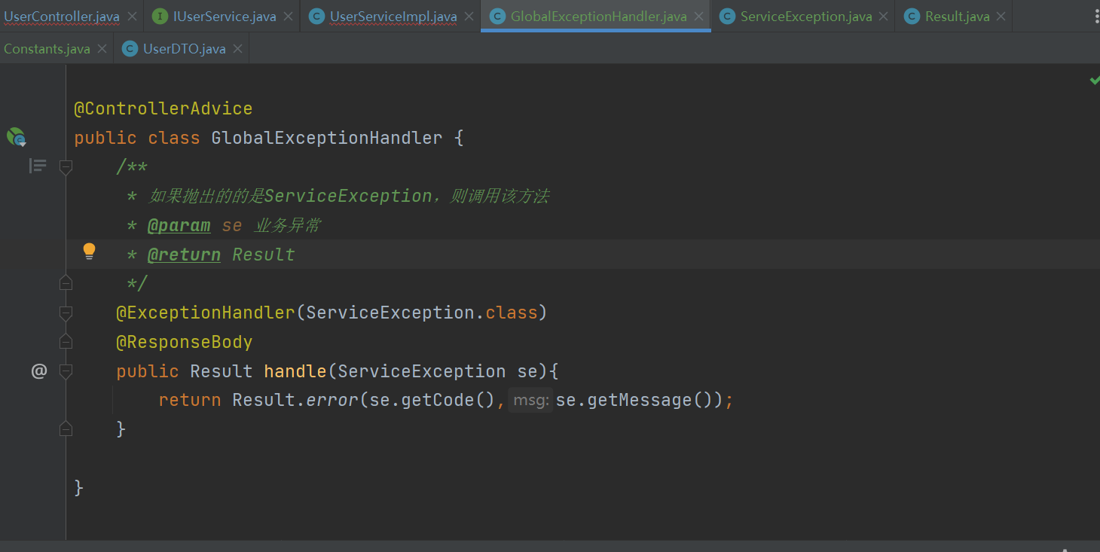
2．编写这个处理器要求的类
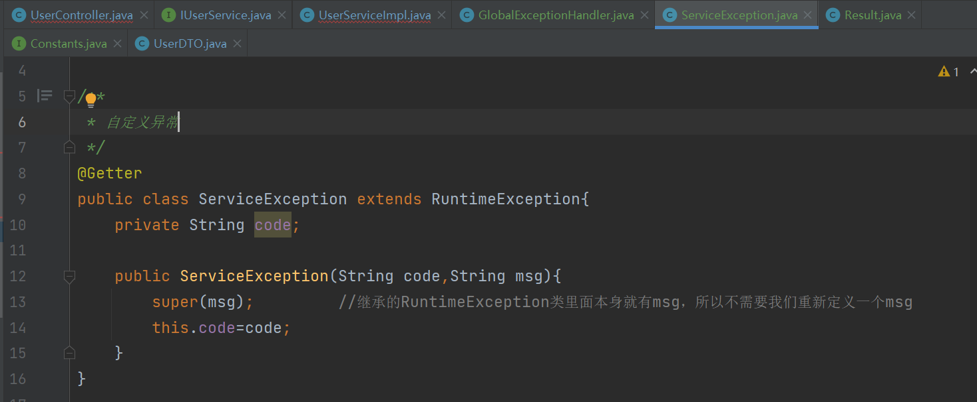
理清了一下思路：1.我们的目标是返回一个result对象，该对象有数据必须携带数据+msg，没有数据也必须返回msg告诉前台错误信息。2.所以我们必须得改造Controller的方法和service的方法，以及添加类uesrDTO和和results。
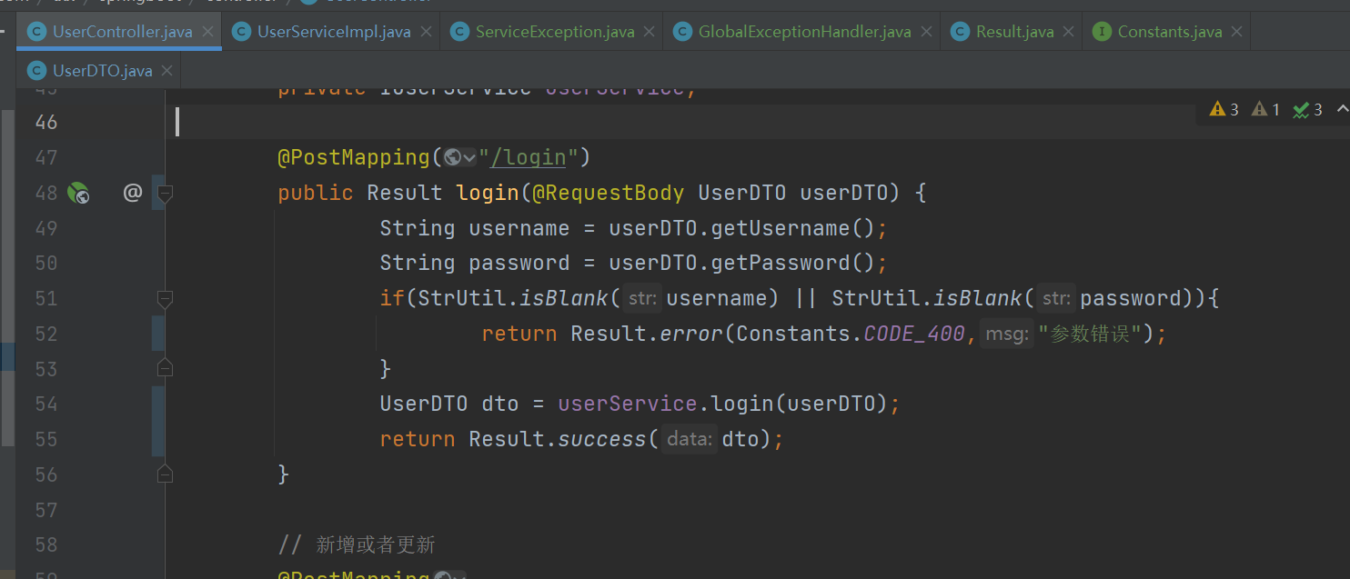
先判断uesrname和password是否合法（输入是否为null或者空格），不合法返回参数错误；合法则执行login方法。
- 在login方法里，使用getOne()函数查找，若查找成功则返回一个UserDTO对象，这个对象在controller里面会被封装成Result对象返回。若在login方法里查找出多个数据（例如脏数据），则会被try-cache捕获，被ServiceException.java分装成Result对象，由GlobalExceptionHandler.java返回给前端。下图为返回前端的数据模式。
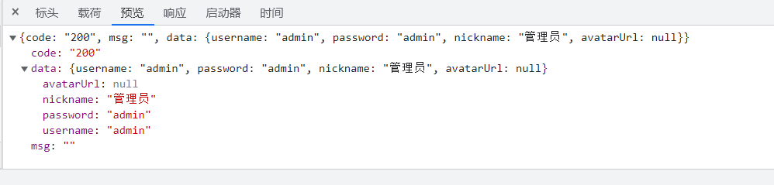
- 修改前端的login方法，一开始我们是要获取true或者false，现在我们要获取的是后端传来的数据和传来的正确或错误信息。这算是把路由的掌控权给了后端，增加了安全性。
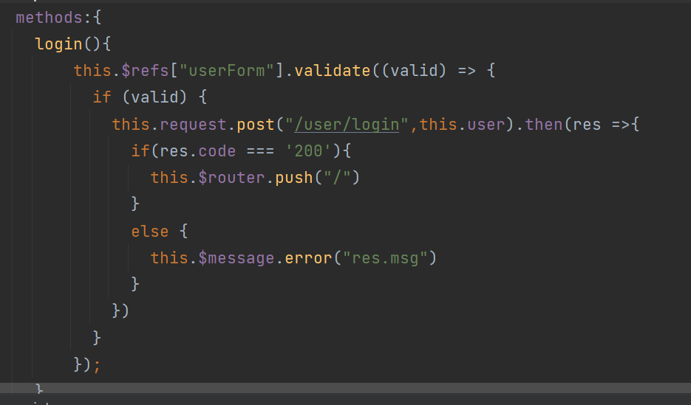

遇到的问题及解决方案
- 当输入错误的用户名和密码时弹“系统错误”而不是“用户名或密码错误”
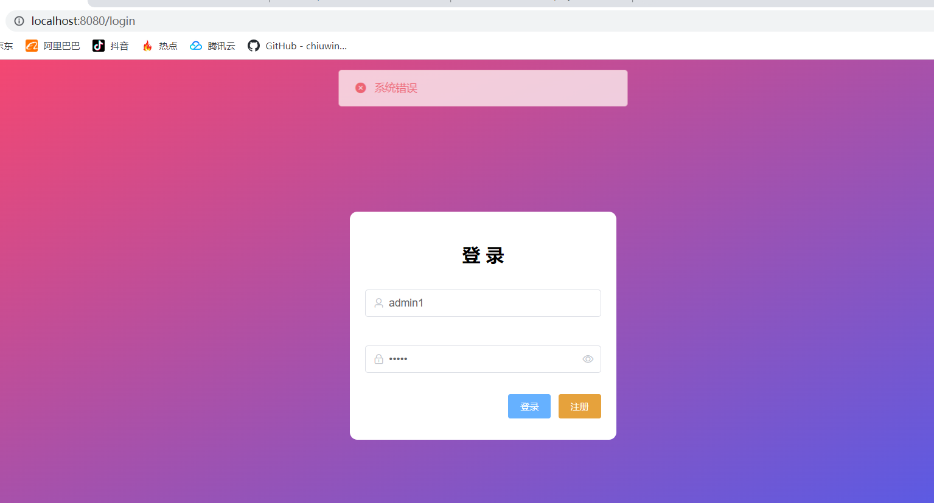
检查UserServiceImpl.java和控制台
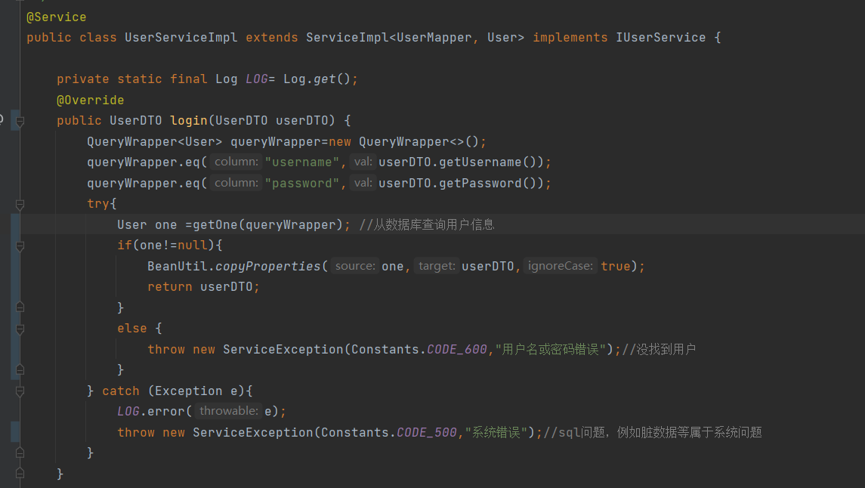
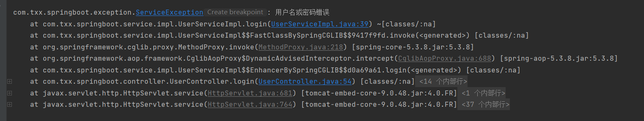
为什么在控制台的报错是正常的，在前端的报错是有问题的呢？
原因：报的异常throw new ServiceException(Constants.CODE_600,"用户名或密码错误");后面又被Exception e catch住了，所以throw了 ServiceException(Constants.CODE_500,"系统错误");被全局捕获到了。
解决办法：像下面这样写就没有逻辑错误了
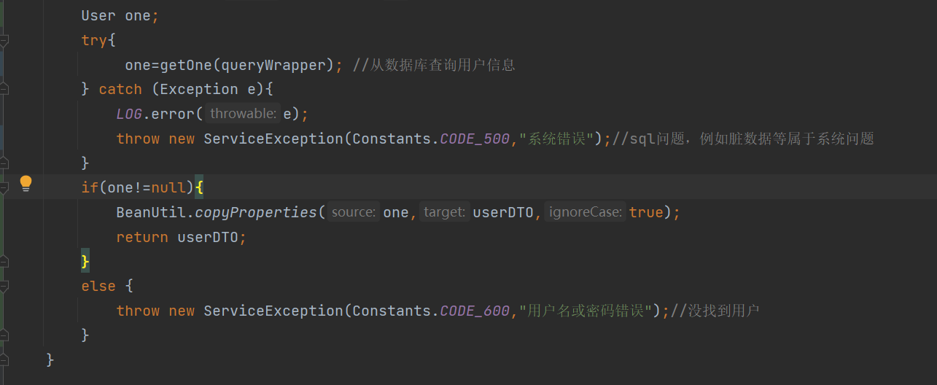
- 在实现用户个人信息回显的时候，在前台有获取到用户信息，但是页面上却有显示
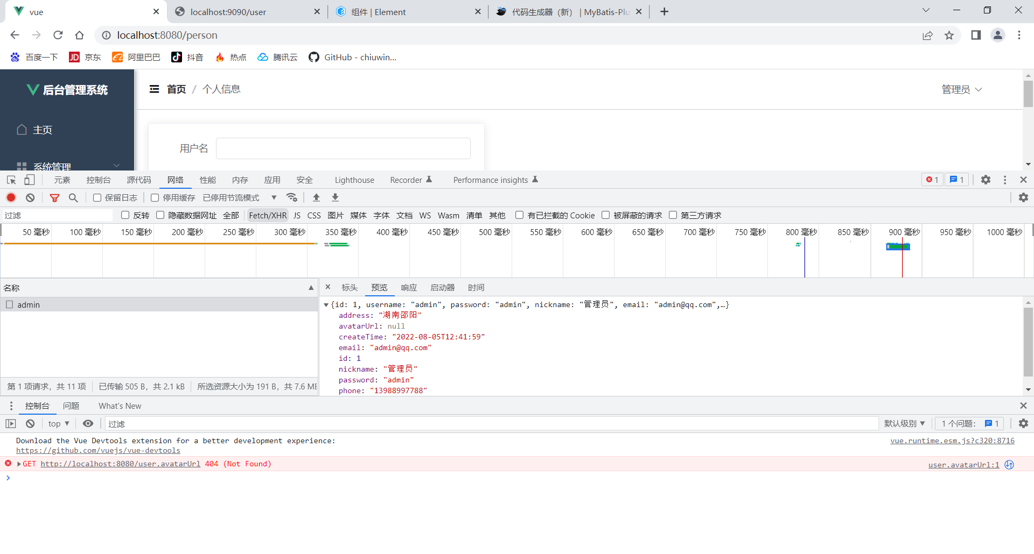
原因:返回的是Result类型的对象，所以我们必须改造接口，改造增删改查等等contoller里面的每一个接口以及前端每一个需要后端数据的接口。
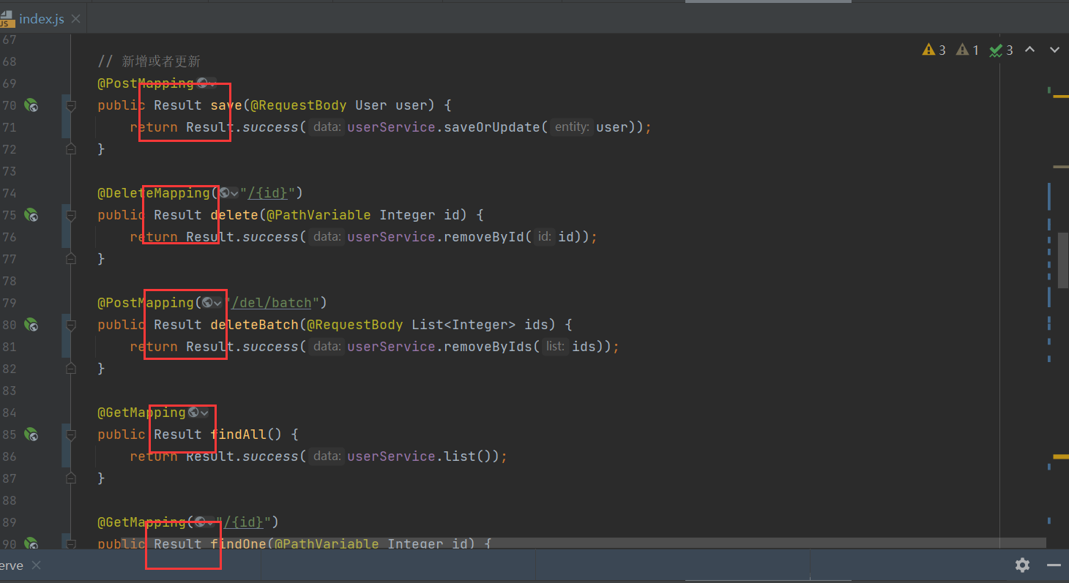

代码
Constants.java
package com.txx.springboot.common;
public interface Constants {
String CODE_200 = "200";//成功
String CODE_401 = "401";//权限不足
String CODE_400 = "400";//参数不足
String CODE_500 = "500";//系统错误
String CODE_600 = "600";//其他业务异常
}

Result.java
package com.txx.springboot.common;
import lombok.AllArgsConstructor;
import lombok.Data;
import lombok.NoArgsConstructor;
/**
*
* 接口统一返回包装类
*/
@Data
@NoArgsConstructor
@AllArgsConstructor
public class Result {
private String code;
private String msg;
private Object data;
public static Result success(){//返回成功信息
return new Result(Constants.CODE_200,"",null);
}
public static Result success(Object data){
return new Result(Constants.CODE_200,"",data);
}
public static Result error(String code,String msg){
return new Result(code,msg,null);
}
public static Result error(){
return new Result(Constants.CODE_500,"系统错误",null);
}
}

UserDTO.java
package com.txx.springboot.config.dto;
import lombok.Data;
/**
* 接受前端登录请求的参数
*/
@Data
public class UserDTO {
private String username;
private String password;
private String nickname;
private String avatarUrl;
}

UserController.java
package com.txx.springboot.controller;
import cn.hutool.core.collection.CollUtil;
import cn.hutool.core.util.StrUtil;
import cn.hutool.poi.excel.ExcelReader;
import cn.hutool.poi.excel.ExcelUtil;
import cn.hutool.poi.excel.ExcelWriter;
import com.baomidou.mybatisplus.extension.plugins.pagination.Page;
import com.txx.springboot.common.Constants;
import com.txx.springboot.common.Result;
import com.txx.springboot.config.dto.UserDTO;
import org.springframework.beans.factory.annotation.Value;
import org.springframework.web.bind.annotation.*;
import javax.annotation.Resource;
import javax.servlet.ServletOutputStream;
import javax.servlet.http.HttpServletResponse;
import java.io.InputStream;
import java.net.URLEncoder;
import java.util.List;
import com.baomidou.mybatisplus.core.conditions.query.QueryWrapper;
import com.txx.springboot.service.IUserService;
import com.txx.springboot.entity.User;
import org.springframework.web.bind.annotation.RestController;
import org.springframework.web.multipart.MultipartFile;
/**
* <p>
* 前端控制器
* </p>
*
* @author txx
* @since 2022-08-12
*/
@RestController
@RequestMapping("/user")
public class UserController {
// @Value("${files.upload.path}")
// private String fileUploadPath;
@Resource
private IUserService userService;
@PostMapping("/login")
public Result login(@RequestBody UserDTO userDTO) {
String username = userDTO.getUsername();
String password = userDTO.getPassword();
if(StrUtil.isBlank(username) || StrUtil.isBlank(password)){
return Result.error(Constants.CODE_400,"参数错误");
}
UserDTO dto = userService.login(userDTO);
return Result.success(dto);
}
@PostMapping("/register")
public Result register(@RequestBody UserDTO userDTO) {
String username = userDTO.getUsername();
String password = userDTO.getPassword();
if(StrUtil.isBlank(username) || StrUtil.isBlank(password)){
return Result.error(Constants.CODE_400,"参数错误");
}
return Result.success(userService.register(userDTO));
}
// 新增或者更新
@PostMapping
public Result save(@RequestBody User user) {
return Result.success(userService.saveOrUpdate(user));
}
@DeleteMapping("/{id}")
public Result delete(@PathVariable Integer id) {
return Result.success(userService.removeById(id));
}
@PostMapping("/del/batch")
public Result deleteBatch(@RequestBody List<Integer> ids) {
return Result.success(userService.removeByIds(ids));
}
@GetMapping
public Result findAll() {
return Result.success(userService.list());
}
@GetMapping("/{id}")
public Result findOne(@PathVariable Integer id) {
return Result.success(userService.getById(id));
}
@GetMapping("/username/{username}")
public Result findOne(@PathVariable String username) {
QueryWrapper<User> queryWrapper = new QueryWrapper<>();
queryWrapper.eq("username",username);
return Result.success(userService.getOne(queryWrapper));
}
@GetMapping("/page")
public Result findPage(@RequestParam Integer pageNum,
@RequestParam Integer pageSize,
@RequestParam(defaultValue = "") String username,
@RequestParam(defaultValue = "") String email,
@RequestParam(defaultValue = "")String address) {
QueryWrapper<User> queryWrapper = new QueryWrapper<>();
if(!"".equals(username)){
queryWrapper.like("username",username);
}
if (!"".equals(email)){
queryWrapper.like("email",email);
}
if (!"".equals(address)){
queryWrapper.like("address",address);
}
queryWrapper.orderByDesc("id");
return Result.success(userService.page(new Page<>(pageNum, pageSize), queryWrapper));
}
/**
* 导出接口
*/
@GetMapping("/export")
public void export(HttpServletResponse response) throws Exception {
// 从数据库查询出所有的数据
List<User> list = userService.list();
// 通过工具类创建writer 写出到磁盘路径
// ExcelWriter writer = ExcelUtil.getWriter(filesUploadPath + "/用户信息.xlsx");
// 在内存操作，写出到浏览器
ExcelWriter writer = ExcelUtil.getWriter(true);
//自定义标题别名
writer.addHeaderAlias("username", "用户名");
writer.addHeaderAlias("password", "密码");
writer.addHeaderAlias("nickname", "昵称");
writer.addHeaderAlias("email", "邮箱");
writer.addHeaderAlias("phone", "电话");
writer.addHeaderAlias("address", "地址");
writer.addHeaderAlias("createTime", "创建时间");
writer.addHeaderAlias("avatarUrl", "头像");
// 一次性写出list内的对象到excel，使用默认样式，强制输出标题
writer.write(list, true);
// 设置浏览器响应的格式
response.setContentType("application/vnd.openxmlformats-officedocument.spreadsheetml.sheet;charset=utf-8");
String fileName = URLEncoder.encode("用户信息", "UTF-8");
response.setHeader("Content-Disposition", "attachment;filename=" + fileName + ".xlsx");
ServletOutputStream out = response.getOutputStream();
writer.flush(out, true);
out.close();
writer.close();
}
/**
* excel 导入
* @param file
* @throws Exception
*/
@PostMapping("/import")
public Result imp(MultipartFile file) throws Exception {
InputStream inputStream = file.getInputStream();
ExcelReader reader = ExcelUtil.getReader(inputStream);
// 方式1：(推荐) 通过 javabean的方式读取Excel内的对象，但是要求表头必须是英文，跟javabean的属性要对应起来
// List<User> users = reader.readAll(User.class);
// 方式2：忽略表头的中文，直接读取表的内容
List<List<Object>> list = reader.read(1);
List<User> users = CollUtil.newArrayList();
for (List<Object> row : list) {
User user = new User();
user.setUsername(row.get(0).toString());
user.setPassword(row.get(1).toString());
user.setNickname(row.get(2).toString());
user.setEmail(row.get(3).toString());
user.setPhone(row.get(4).toString());
user.setAddress(row.get(5).toString());
user.setAvatarUrl(row.get(6).toString());
users.add(user);
}
userService.saveBatch(users);
return Result.success(true);
}
}

GlobalExceptionHandler.java
package com.txx.springboot.exception;
import com.txx.springboot.common.Result;
import org.springframework.web.bind.annotation.ControllerAdvice;
import org.springframework.web.bind.annotation.ExceptionHandler;
import org.springframework.web.bind.annotation.ResponseBody;
@ControllerAdvice
public class GlobalExceptionHandler {
/**
* 如果抛出的的是ServiceException，则调用该方法
* @param se 业务异常
* @return Result
*/
@ExceptionHandler(ServiceException.class)
@ResponseBody
public Result handle(ServiceException se){
return Result.error(se.getCode(),se.getMessage());
}
}

ServiceException.java
package com.txx.springboot.exception;
import lombok.Getter;
/**
* 自定义异常
*/
@Getter
public class ServiceException extends RuntimeException{
private String code;
public ServiceException(String code,String msg){
super(msg); //继承的RuntimeException类里面本身就有msg，所以不需要我们重新定义一个msg
this.code=code;
}
}

UserServiceImpl.java
package com.txx.springboot.service.impl;
import cn.hutool.core.bean.BeanUtil;
import cn.hutool.log.Log;
import com.baomidou.mybatisplus.core.conditions.query.QueryWrapper;
import com.txx.springboot.common.Constants;
import com.txx.springboot.config.dto.UserDTO;
import com.txx.springboot.entity.User;
import com.txx.springboot.exception.ServiceException;
import com.txx.springboot.mapper.UserMapper;
import com.txx.springboot.service.IUserService;
import com.baomidou.mybatisplus.extension.service.impl.ServiceImpl;
import org.springframework.stereotype.Service;
/**
* <p>
* 服务实现类
* </p>
*
* @author txx
* @since 2022-08-12
*/
@Service
public class UserServiceImpl extends ServiceImpl<UserMapper, User> implements IUserService {
private static final Log LOG= Log.get();
@Override
public UserDTO login(UserDTO userDTO) {
User one = getUserInfo(userDTO);
//业务异常
if(one!=null){
BeanUtil.copyProperties(one,userDTO,true);
return userDTO;
}
else {
throw new ServiceException(Constants.CODE_600,"用户名或密码错误");//没找到用户
}
}
@Override
public User register(UserDTO userDTO) {
User one = getUserInfo(userDTO);
if(one ==null){
one =new User();
BeanUtil.copyProperties(userDTO,one,true);
save(one); //把copy完之后的用户
}else {
throw new ServiceException(Constants.CODE_600,"用户已存在");
}
return one;
}
private User getUserInfo(UserDTO userDTO){
QueryWrapper<User> queryWrapper=new QueryWrapper<>();
queryWrapper.eq("username",userDTO.getUsername());
queryWrapper.eq("password",userDTO.getPassword());
User one;
//系统异常
try{
one=getOne(queryWrapper); //从数据库查询用户信息
} catch (Exception e){
LOG.error(e);
throw new ServiceException(Constants.CODE_500,"系统错误");//sql查询问题，例如脏数据等属于系统问题
}
return one;
}
}
IUserService.java
package com.txx.springboot.service;
import com.txx.springboot.config.dto.UserDTO;
import com.txx.springboot.entity.User;
import com.baomidou.mybatisplus.extension.service.IService;
/**
* <p>
* 服务类
* </p>
*
* @author txx
* @since 2022-08-12
*/
public interface IUserService extends IService<User> {
UserDTO login(UserDTO userDTO);
User register(UserDTO userDTO);
}

Header.vue
<template>
<div style="line-height: 60px;display: flex">
<div style="flex: 1;">
<span :class="collapseBtnClass" style="cursor: pointer; font-size: 18px" @click="collapse"></span>
<el-breadcrumb separator="/" style="display: inline-block;margin-left: 10px">
<el-breadcrumb-item :to="'/'">首页</el-breadcrumb-item>
<el-breadcrumb-item>{{ currentPathName }}</el-breadcrumb-item>
</el-breadcrumb>
</div>
<el-dropdown style="width: 100px;cursor: pointer">
<div style="display: inline-block">
<img src="user.avatarUrl" alt=""
style="width: 30px;border-radius: 50%;position: relative;top:10px;right: 5px">
<span>{{ user.nickname}}</span><i class="el-icon-arrow-down" style="margin-left: 5px"></i>
</div>
<el-dropdown-menu slot="dropdown" style="width: 100px;text-align: center">
<el-dropdown-item style="font-size: 14px; padding: 5px 0">
<router-link to="/person">个人信息</router-link>
</el-dropdown-item>
<el-dropdown-item style="font-size: 14px; padding: 5px 0">
<span style="text-decoration: none" @click="lockout">退出</span>
</el-dropdown-item>
</el-dropdown-menu>
</el-dropdown>
</div>
</template>
<script>
export default {
name: "Header",
props:{
collapseBtnClass:String,
collapse:'',
},
computed: {
currentPathName () {
return this.$store.state.currentPathName; //需要监听的数据
}
},
data(){
return{
user:localStorage.getItem("user") ? JSON.parse(localStorage.getItem("user")) : null
}
},
methods:{
lockout(){
this.$router.push("/login")
localStorage.removeItem("user")
this.$message.success("退出成功")
}
},
watch: {
currentPathName (newVal, oldVal) {
console.log(newVal)
}
},
}
</script>
<style scoped>
</style>

router/index.js
import Vue from 'vue'
import VueRouter from 'vue-router'
import store from '@/store'
Vue.use(VueRouter)
const routes = [
{
path: '/',
component: () => import('../views/Manage.vue'),
redirect:"/home",
children:[
{path: 'home', name: '首页', component: () => import('../views/Home.vue')},
{path: 'user', name: '用户管理', component: () => import('../views/User.vue')},
{path: 'person', name: '个人信息', component: () => import('../views/Person.vue')},
]
},
{
path: '/about',
name: 'About',
component: () => import('../views/About.vue')
},
{
path: '/login',
name: 'login',
component: () => import('../views/Login.vue')
},
{
path: '/register',
name: 'Register',
component: () => import('../views/Register.vue')
}
]
const router = new VueRouter({
mode: 'history',
base: process.env.BASE_URL,
routes
})
//路由守卫
router.beforeEach((to, from, next) =>{
localStorage.setItem("currentPathName",to.name) //设置当前的路由,为了在Header组件中使用
store.commit("setPath") //触发store的数据更新
next() //放行路由
})
export default router

Login.vue
<template>
<div class="wrapper">
<div style="margin:200px auto; background-color: #ffffff;width: 350px ;height:300px ; padding: 20px;border: 20px;border-radius: 10px">
<div style="margin: 20px 0;text-align: center;font-size: 24px"><b>登 录</b></div>
<el-form :model="user" :rules="rules" ref="userForm">
<el-form-item prop="username">
<el-input size="medium" style="margin: 10px 0" prefix-icon="el-icon-user" v-model="user.username"></el-input>
</el-form-item>
<el-form-item prop="password">
<el-input size="medium" style="margin: 10px 0" prefix-icon="el-icon-lock" show-password v-model="user.password"></el-input>
</el-form-item>
<div style="margin: 10px 0;text-align: right">
<el-form-item>
<el-button type="primary" size="small" autocomplete="off" @click="login">登录</el-button>
<el-button type="warning" size="small" autocomplete="off" @click="$router.push('/register')">注册</el-button>
</el-form-item>
</div>
</el-form>
</div>
</div>
</template>

<script>
export default {
name:"Login",
data(){
return{
user:{},
rules: {
username: [
{required: true, message: '请输入用户名', trigger: 'blur'},
{min: 3, max: 10, message: '长度在 3 到 5 个字符', trigger: 'blur'}
],
password:[
{required: true, message: '请输入密码', trigger: 'blur'},
{min: 1, max: 20, message: '长度在 1 到 20 个字符', trigger: 'blur'}
],
}
}
},
methods:{
login() {
this.$refs['userForm'].validate((valid) => {
if (valid) { // 表单校验合法
this.request.post("/user/login", this.user).then(res => {
if(res.code === '200') {
localStorage.setItem("user", JSON.stringify(res.data)) // 存储用户信息到浏览器
this.$router.push("/")
this.$message.success("登录成功")
} else {
this.$message.error(res.msg)
}
})
}
});
}
}
}
</script>

<style>
.wrapper{
height: 100vh;
background-image:linear-gradient(to bottom right,#FC466B,#3F5EF8) ;
overflow: hidden;
}

</style>
Person.vue
<template>
<el-card style="width:500px;">
<el-form label-width="80px" size="small">
<el-form-item label="用户名">
<el-input v-model="form.username" autocomplete="off"></el-input>
</el-form-item>
<el-form-item label="昵称">
<el-input v-model="form.nickname" autocomplete="off"></el-input>
</el-form-item>
<el-form-item label="邮箱">
<el-input v-model="form.email" autocomplete="off"></el-input>
</el-form-item>
<el-form-item label="电话">
<el-input v-model="form.phone" autocomplete="off"></el-input>
</el-form-item>
<el-form-item label="地址">
<el-input v-model="form.address" autocomplete="off"></el-input>
</el-form-item>
<el-form-item>
<el-button type="primary" @click="save">确 定</el-button>
</el-form-item>
</el-form>
</el-card>
</template>
<script>
export default {
name: "Person",
data(){
return{
form:{},
user:localStorage.getItem("user") ? JSON.parse(localStorage.getItem("user")) : null
}
},
created() {
this.request.get("/user/username/"+this.user.username).then(res => {
if(res.code ==='200'){
this.form = res.data
}
})
},
methods:{
save(){
this.request.post("/user",this.form).then(res =>{
if(res.data){
this.$message.success("保存成功")
}
else {
this.$message.error("保存失败")
}
})
}
}
}
</script>
<style scoped>
</style>

Register.vue
<template>
<div class="wrapper">
<div style="margin:100px auto; background-color: #ffffff;width: 350px ;height:400px ; padding: 20px;border: 20px;border-radius: 10px">
<div style="margin: 20px 0;text-align: center;font-size: 24px"><b>注 册</b></div>
<el-form :model="user" :rules="rules" ref="userForm">
<el-form-item prop="username">
<el-input placeholder="请输入账号" size="medium" style="margin: 5px 0" prefix-icon="el-icon-user" v-model="user.username"></el-input>
</el-form-item>
<el-form-item prop="password">
<el-input placeholder="请输入密码" size="medium" style="margin: 5px 0" prefix-icon="el-icon-lock" show-password v-model="user.password"></el-input>
</el-form-item>
<el-form-item prop="comfirmpassword">
<el-input placeholder="请确认密码" size="medium" style="margin: 5px 0" prefix-icon="el-icon-lock" show-password v-model="user.comfirmpassword"></el-input>
</el-form-item>
<div style="margin: 5px 0;text-align: right">
<el-form-item>
<el-button type="primary" size="small" autocomplete="off" @click="login">注册</el-button>
<el-button type="warning" size="small" autocomplete="off" @click="$router.push('/login')">返回登录</el-button>
</el-form-item>
</div>
</el-form>
</div>
</div>
</template>
<script>
export default {
name:"Login",
data(){
return{
user:{},
rules: {
username: [
{required: true, message: '请输入用户名', trigger: 'blur'},
{min: 3, max: 10, message: '长度在 3 到 5 个字符', trigger: 'blur'}
],
password:[
{required: true, message: '请输入密码', trigger: 'blur'},
{min: 1, max: 20, message: '长度在 1 到 20 个字符', trigger: 'blur'}
],
confirmPassword:[
{required: true, message: '请输入密码', trigger: 'blur'},
{min: 1, max: 20, message: '长度在 1 到 20 个字符', trigger: 'blur'}
],
}
}
},
methods:{
login() {
this.$refs['userForm'].validate((valid) => {
if (valid) { // 表单校验合法
if(this.user.padding !== this.user.confirmPassword){
this.$message.success("两次输入的密码不一致")
return false
}
this.request.post("/user/register", this.user).then(res => {
if(res.code === '200') {
this.$message.success("注册成功")
} else {
this.$message.error(res.msg)
}
})
}
});
}
}
}
</script>
<style>
.wrapper{
height: 100vh;
background-image:linear-gradient(to bottom right,#FC466B,#3F5EF8) ;
overflow: hidden;
}
</style>
User.vue
<template>
<div>
<div style="padding: 10px 0">
<el-input style="width: 200px" placeholder="请输入名称" suffix-icon="el-icon-search" v-model="username"></el-input>
<el-input style="width: 200px" placeholder="请输入邮箱" suffix-icon="el-icon-message" class="ml-5" v-model="email"></el-input>
<el-input style="width: 200px" placeholder="请输入地址" suffix-icon="el-icon-position" class="ml-5" v-model="address"></el-input>
<el-button class="ml-5" type="primary" @click="load">搜索</el-button>
<el-button type="warning" @click="reset">重置</el-button>
</div>
<div style="margin: 10px 0">
<el-button type="primary" @click="handleAdd">新增 <i class="el-icon-circle-plus-outline"></i></el-button>
<el-popconfirm
class="ml-5"
confirm-button-text='确定'
cancel-button-text='我再想想'
icon="el-icon-info"
icon-color="red"
title="您确定批量删除这些数据吗？"
@confirm="delBatch"
>
<el-button type="danger" slot="reference">批量删除 <i class="el-icon-remove-outline"></i></el-button>
</el-popconfirm>
<el-upload action="http://localhost:9090/user/import" :show-file-list="false" accept="xlsx" :on-success="handleExcelImportSuccess" style="display:inline-block">
<el-button type="primary" class="ml-5">导入 <i class="el-icon-bottom"></i></el-button>
</el-upload>
<el-button type="primary" @click="exp" class="ml-5">导出 <i class="el-icon-top"></i></el-button>
</div>
<el-table :data="tableData" border stripe :header-cell-class-name="'headerBg'" @selection-change="handleSelectionChange">
<el-table-column type="selection" width="55"></el-table-column>
<el-table-column prop="id" label="ID" width="80"></el-table-column>
<el-table-column prop="username" label="用户名" width="140"></el-table-column>
<el-table-column prop="nickname" label="昵称" width="120"></el-table-column>
<el-table-column prop="email" label="邮箱"></el-table-column>
<el-table-column prop="phone" label="电话"></el-table-column>
<el-table-column prop="address" label="地址"></el-table-column>
<el-table-column label="操作" width="200" align="center">
<template slot-scope="scope">
<el-button type="success" @click="handleEdit(scope.row)">编辑 <i class="el-icon-edit"></i></el-button>
<el-popconfirm
class="ml-5"
confirm-button-text='确定'
cancel-button-text='我再想想'
icon="el-icon-info"
icon-color="red"
title="您确定删除吗？"
@confirm="del(scope.row.id)"
>
<el-button type="danger" slot="reference">删除 <i class="el-icon-remove-outline"></i></el-button>
</el-popconfirm>
</template>
</el-table-column>
</el-table>
<div style="padding: 10px 0">
<el-pagination
@size-change="handleSizeChange"
@current-change="handleCurrentChange"
:current-page="pageNum"
:page-sizes="[2, 5, 10, 20]"
:page-size="pageSize"
layout="total, sizes, prev, pager, next, jumper"
:total="total">
</el-pagination>
</div>
<el-dialog title="用户信息" :visible.sync="dialogFormVisible" width="30%">
<el-form label-width="80px" size="small">
<el-form-item label="用户名">
<el-input v-model="form.username" autocomplete="off"></el-input>
</el-form-item>
<el-form-item label="昵称">
<el-input v-model="form.nickname" autocomplete="off"></el-input>
</el-form-item>
<el-form-item label="邮箱">
<el-input v-model="form.email" autocomplete="off"></el-input>
</el-form-item>
<el-form-item label="电话">
<el-input v-model="form.phone" autocomplete="off"></el-input>
</el-form-item>
<el-form-item label="地址">
<el-input v-model="form.address" autocomplete="off"></el-input>
</el-form-item>
</el-form>
<div slot="footer" class="dialog-footer">
<el-button @click="dialogFormVisible = false">取 消</el-button>
<el-button type="primary" @click="save">确 定</el-button>
</div>
</el-dialog>
</div>
</template>
<script>
export default {
name: "User",
data(){
return {
tableData: [],
total: 0,
pageNum:1,
pageSize:10,
username:"",
email:"",
address:"",
form:{},
dialogFormVisible:false,
multipleSelection:[],
}
},
created() {
this.load()
},
methods:{
load(){
//与下面注释的代码对比，我改动的是api的替换和赋值方式的替换
this.request.get("/user/page",{
params:{
pageNum:this.pageNum,
pageSize:this.pageSize,
username:this.username,
email:this.email,
address:this.address
}
}).then(res =>{
this.tableData=res.data.records
this.total=res.data.total
})
// fetch("http://localhost:9090/user/page?pageNum="+this.pageNum+"&pageSize="+this.pageSize+"&username="+this.username)
// .then(res => res.json()).then(res =>{
// console.log(res)
// //数据绑定
// this.tableData = res.data
// this.total=res.total
// })
},
save(){
this.request.post("/user",this.form).then(res =>{
if(res.data){
this.$message.success("保存成功")
this.dialogFormVisible=false
this.load()
}
else {
this.$message.error("保存失败")
}
})
},
handleAdd(){
this.dialogFormVisible=true
this.form={}
},
handleEdit(row){
//this.form=row //赋予表单数据,这样有个bug就是，在点击取消的时候表单上仍然有值，不过数据库里面的值没有变化,
this.form=JSON.parse(JSON.stringify(row)); //这是解决办法
this.dialogFormVisible=true //打开对话框
},
del(id){
this.request.delete("/user/"+id).then(res =>{
if(res.data){
this.$message.success("删除成功")
this.load()
}
else {
this.$message.error("删除失败")
}
})
},
handleSelectionChange(val){
console.log(val)
this.multipleSelection=val //获取到的是个对象 不是我们后台需要的ids
},
delBatch(){
let ids = this.multipleSelection.map(v =>v.id) //[{},{},{}]=>[1,2,3]
this.request.post("/user/del/batch",ids).then(res =>{
if(res.data){
this.$message.success("批量删除成功")
this.load()
}
else {
this.$message.error("批量删除失败")
}
})
},
reset(){
this.username=""
this.email=""
this.address=""
this.load()
},
handleSizeChange(pageSize){
console.log(pageSize)
this.pageSize=pageSize
this.load()
},
handleCurrentChange(pageNum){
console.log(pageNum)
this.pageNum=pageNum
this.load()
},
exp(){
window.open("http://localhost:9090/user/export")
},
handleExcelImportSuccess(){
this.$message.success("导入成功")
this.load()
}
}
}
</script>
<style>
.headerBg {
background: #eee!important;
}
</style>

