学到的知识点
这一节学的是权限菜单的菜单管理。
思路：
前端：在用户登录时获取用户的角色信息存储到浏览器，再在Aside组件里面从浏览器中获取用户的菜单信息。
后端：根据用户的登录信息获取到用户的角色以及角色对应的菜单及其子菜单，再返回给前台。

遇到的问题及其解决办法
1.
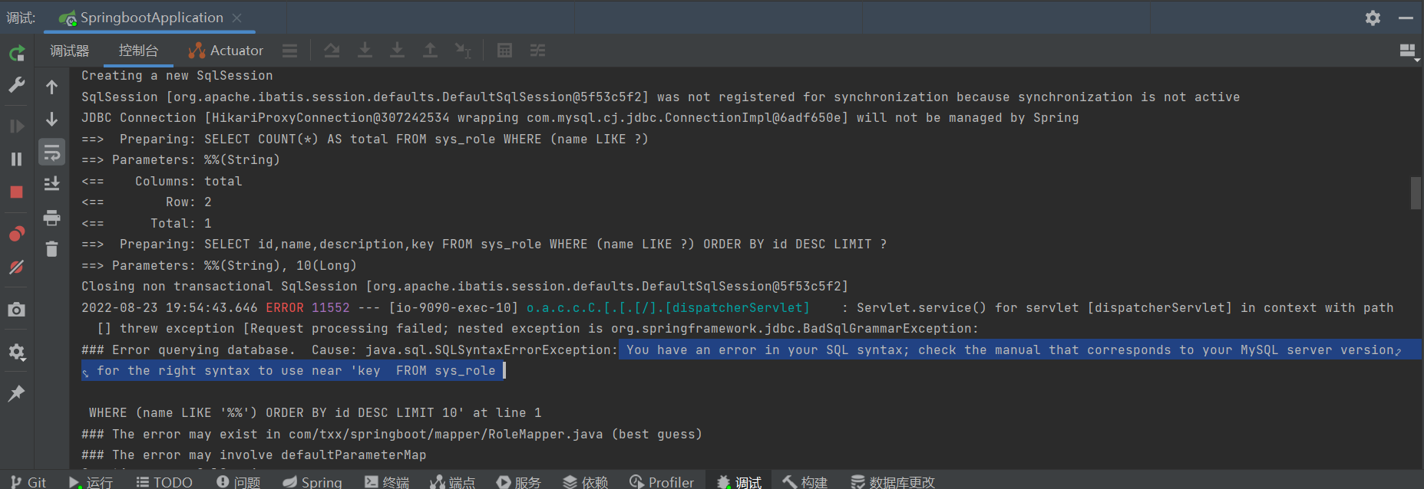
原因: key是MySQL的关键词
解决办法：将key改成flag

2.在给用户角色分配的时候，选择系统管理菜单下的子菜单就会失效，只有全选才会有效
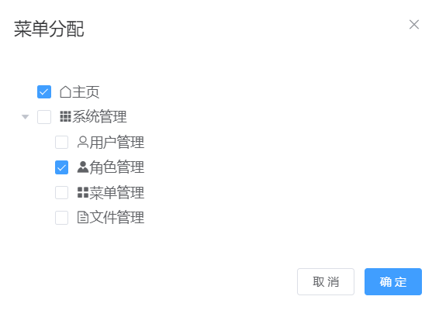
解决办法：
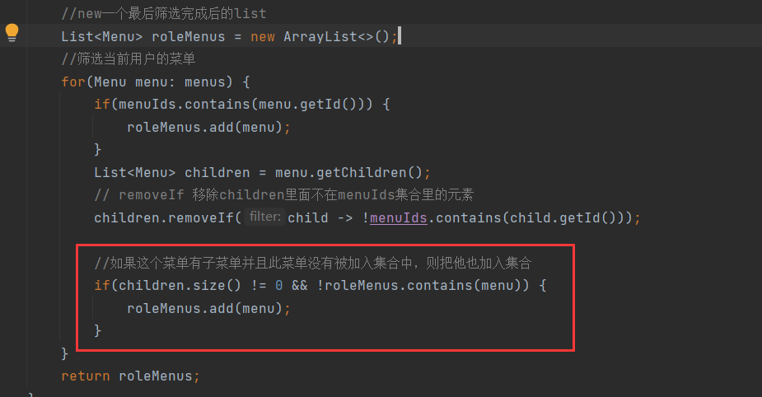

代码

UserServiceImpl.java
package com.txx.springboot.service.impl;
import cn.hutool.core.bean.BeanUtil;
import cn.hutool.log.Log;
import com.baomidou.mybatisplus.core.conditions.query.QueryWrapper;
import com.txx.springboot.common.Constants;
import com.txx.springboot.controller.dto.UserDTO;
import com.txx.springboot.entity.Menu;
import com.txx.springboot.entity.User;
import com.txx.springboot.exception.ServiceException;
import com.txx.springboot.mapper.RoleMapper;
import com.txx.springboot.mapper.RoleMenuMapper;
import com.txx.springboot.mapper.UserMapper;
import com.txx.springboot.service.IMenuService;
import com.txx.springboot.service.IUserService;
import com.baomidou.mybatisplus.extension.service.impl.ServiceImpl;
import com.txx.springboot.utils.TokenUtils;
import org.springframework.beans.factory.annotation.Autowired;
import org.springframework.stereotype.Service;
import javax.annotation.Resource;
import java.util.ArrayList;
import java.util.List;
/**
* <p>
* 服务实现类
* </p>
*
* @author txx
* @since 2022-08-12
*/
@Service
public class UserServiceImpl extends ServiceImpl<UserMapper, User> implements IUserService {
private static final Log LOG= Log.get();
@Resource
private RoleMapper roleMapper;
@Resource
private RoleMenuMapper roleMenuMapper;
@Resource
private IMenuService menuService;
@Override
public UserDTO login(UserDTO userDTO) {
User one = getUserInfo(userDTO);
//判断业务异常
if(one!=null){
BeanUtil.copyProperties(one,userDTO,true);
//设置token
String token = TokenUtils.genToken(one.getId().toString(), one.getPassword());
userDTO.setToken(token);
//设置用户的菜单列表
String role = one.getRole(); //ROLE＿ADMIN
List<Menu> roleMenus = getRoleMenu(role);
userDTO.setMenus(roleMenus);
return userDTO;
}
else {
throw new ServiceException(Constants.CODE_600,"用户名或密码错误");//没找到用户
}
}
@Override
public User register(UserDTO userDTO) {
User one = getUserInfo(userDTO);
if(one ==null){
one =new User();
BeanUtil.copyProperties(userDTO,one,true);
save(one); //把copy完之后的用户
}else {
throw new ServiceException(Constants.CODE_600,"用户已存在");
}
return one;
}
private User getUserInfo(UserDTO userDTO){
QueryWrapper<User> queryWrapper=new QueryWrapper<>();
queryWrapper.eq("username",userDTO.getUsername());
queryWrapper.eq("password",userDTO.getPassword());
User one;
//系统异常
try{
one=getOne(queryWrapper); //从数据库查询用户信息
} catch (Exception e){
LOG.error(e);
throw new ServiceException(Constants.CODE_500,"系统错误");//sql查询问题，例如脏数据等属于系统问题
}
return one;
}
/**
* 获取当前角色的菜单列表
* @param roleFlag
* @return
*/
private List<Menu> getRoleMenu(String roleFlag){
Integer roleId = roleMapper.selectByFlag(roleFlag);
//当前用户的所有菜单id集合
List<Integer> menuIds = roleMenuMapper.selectByRoleId(roleId);
//查出系统所有的菜单
List<Menu> menus = menuService.findMenus("");
//new一个最后筛选完成后的list
List<Menu> roleMenus = new ArrayList<>();
//筛选当前用户的菜单
for(Menu menu: menus) {
if(menuIds.contains(menu.getId())) {
roleMenus.add(menu);
}
List<Menu> children = menu.getChildren();
// removeIf 移除children里面不在menuIds集合里的元素
children.removeIf(child -> !menuIds.contains(child.getId()));
//如果这个菜单有子菜单并且此菜单没有被加入集合中，则把他也加入集合
if(children.size() != 0 && !roleMenus.contains(menu)) {
roleMenus.add(menu);
}
}
return roleMenus;
}
}

MenuController.java
package com.txx.springboot.controller;
import com.baomidou.mybatisplus.extension.plugins.pagination.Page;
import com.txx.springboot.common.Constants;
import com.txx.springboot.entity.Dict;
import com.txx.springboot.mapper.DictMapper;
import org.springframework.web.bind.annotation.*;
import javax.annotation.Resource;
import java.util.List;
import java.util.stream.Collectors;
import com.baomidou.mybatisplus.core.conditions.query.QueryWrapper;
import com.txx.springboot.common.Result;
import com.txx.springboot.service.IMenuService;
import com.txx.springboot.entity.Menu;
import org.springframework.web.bind.annotation.RestController;
/**
* <p>
* 前端控制器
* </p>
*
* @author txx
* @since 2022-08-22
*/
@RestController
@RequestMapping("/menu")
public class MenuController {
@Resource
private IMenuService menuService;
@Resource
private DictMapper dictMapper;
// 新增或者更新
@PostMapping
public Result save(@RequestBody Menu menu) {
menuService.saveOrUpdate(menu);
return Result.success();
}
@DeleteMapping("/{id}")
public Result delete(@PathVariable Integer id) {
menuService.removeById(id);
return Result.success();
}
@PostMapping("/del/batch")
public Result deleteBatch(@RequestBody List<Integer> ids) {
menuService.removeByIds(ids);
return Result.success();
}
@GetMapping
public Result findAll(@RequestParam(defaultValue = "") String name) {
return Result.success(menuService.findMenus(name));
}
@GetMapping("/{id}")
public Result findOne(@PathVariable Integer id) {
return Result.success(menuService.getById(id));
}
@GetMapping("/page")
public Result findPage(@RequestParam String name,
@RequestParam Integer pageNum,
@RequestParam Integer pageSize) {
QueryWrapper<Menu> queryWrapper = new QueryWrapper<>();
queryWrapper.like("name",name);
queryWrapper.orderByDesc("id");
return Result.success(menuService.page(new Page<>(pageNum, pageSize), queryWrapper));
}
@GetMapping("/icons")
public Result getIcons(){
QueryWrapper<Dict> queryWrapper = new QueryWrapper<>();
queryWrapper.eq("type", Constants.DICT_TYPE_ICON);
return Result.success(dictMapper.selectList(null));
}
}

IMenuService.java
package com.txx.springboot.service;
import com.txx.springboot.entity.Menu;
import com.baomidou.mybatisplus.extension.service.IService;
import java.util.List;
/**
* <p>
* 服务类
* </p>
*
* @author txx
* @since 2022-08-22
*/
public interface IMenuService extends IService<Menu> {
List<Menu> findMenus(String name);
}

MenuServiceImpl.java
package com.txx.springboot.service.impl;
import cn.hutool.core.util.StrUtil;
import com.baomidou.mybatisplus.core.conditions.query.QueryWrapper;
import com.txx.springboot.entity.Menu;
import com.txx.springboot.mapper.MenuMapper;
import com.txx.springboot.service.IMenuService;
import com.baomidou.mybatisplus.extension.service.impl.ServiceImpl;
import org.springframework.stereotype.Service;
import java.util.List;
import java.util.stream.Collectors;
/**
* <p>
* 服务实现类
* </p>
*
* @author txx
* @since 2022-08-22
*/
@Service
public class MenuServiceImpl extends ServiceImpl<MenuMapper, Menu> implements IMenuService {
@Override
public List<Menu> findMenus(String name) {
QueryWrapper<Menu> queryWrapper = new QueryWrapper<>();
if(StrUtil.isNotBlank(name)){
queryWrapper.like("name",name);
}
//查询所有数据
List<Menu> list = list(queryWrapper);
//找出pid为null的一级菜单
List<Menu> parentNodes = list.stream().filter(menu -> menu.getPid() == null).collect(Collectors.toList());
for(Menu menu : parentNodes){
//筛选所有数据中pid=父级id的数据就是二级菜单
menu.setChildren(list.stream().filter(m -> menu.getId().equals(m.getPid())).collect(Collectors.toList()));
}
return parentNodes;
}
}

RoleMapper.java
package com.txx.springboot.mapper;
import com.txx.springboot.entity.Role;
import com.baomidou.mybatisplus.core.mapper.BaseMapper;
import org.apache.ibatis.annotations.Param;
import org.apache.ibatis.annotations.Select;
/**
* <p>
* Mapper 接口
* </p>
*
* @author txx
* @since 2022-08-22
*/
public interface RoleMapper extends BaseMapper<Role> {
@Select("select id from sys_role where flag = #{flag}")
Integer selectByFlag(@Param("flag") String flag);
}

Role.vue
<template>
<div>
<div style="padding: 10px 0">
<el-input style="width: 200px" placeholder="请输入名称" suffix-icon="el-icon-search" v-model="name"></el-input>
<!-- <el-input style="width: 200px" placeholder="请输入邮箱" suffix-icon="el-icon-message" class="ml-5" v-model="email"></el-input>-->
<!-- <el-input style="width: 200px" placeholder="请输入地址" suffix-icon="el-icon-position" class="ml-5" v-model="address"></el-input>-->
<el-button class="ml-5" type="primary" @click="load">搜索</el-button>
<el-button type="warning" @click="reset">重置</el-button>
</div>
<div style="margin: 10px 0">
<el-button type="primary" @click="handleAdd">新增 <i class="el-icon-circle-plus-outline"></i></el-button>
<el-popconfirm
class="ml-5"
confirm-button-text='确定'
cancel-button-text='我再想想'
icon="el-icon-info"
icon-color="red"
title="您确定批量删除这些数据吗？"
@confirm="delBatch"
>
<el-button type="danger" slot="reference">批量删除 <i class="el-icon-remove-outline"></i></el-button>
</el-popconfirm>
<!-- <el-upload action="http://localhost:9090/user/import" :show-file-list="false" accept="xlsx" :on-success="handleExcelImportSuccess" style="display:inline-block">-->
<!-- <el-button type="primary" class="ml-5">导入 <i class="el-icon-bottom"></i></el-button>-->
<!-- </el-upload>-->
<!-- <el-button type="primary" @click="exp" class="ml-5">导出 <i class="el-icon-top"></i></el-button>-->
</div>
<el-table :data="tableData" border stripe :header-cell-class-name="'headerBg'">
<el-table-column type="selection" width="55"></el-table-column>
<el-table-column prop="id" label="ID" width="80px"></el-table-column>
<el-table-column prop="name" label="名称"></el-table-column>
<el-table-column prop="flag" label="唯一标识"></el-table-column>
<el-table-column prop="description" label="描述"></el-table-column>
<el-table-column label="操作" width="280" align="center">
<template slot-scope="scope">
<el-button type="info" @click="selectMenu(scope.row.id)">分配菜单 <i class="el-icon-menu"></i></el-button>
<el-button type="success" @click="handleEdit(scope.row)">编辑 <i class="el-icon-edit"></i></el-button>
<el-popconfirm
class="ml-5"
confirm-button-text='确定'
cancel-button-text='我再想想'
icon="el-icon-info"
icon-color="red"
title="您确定删除吗？"
@confirm="del(scope.row.id)"
>
<el-button type="danger" slot="reference">删除 <i class="el-icon-remove-outline"></i></el-button>
</el-popconfirm>
</template>
</el-table-column>
</el-table>
<div style="padding: 10px 0">
<el-pagination
@size-change="handleSizeChange"
@current-change="handleCurrentChange"
:current-page="pageNum"
:page-sizes="[2, 5, 10, 20]"
:page-size="pageSize"
layout="total, sizes, prev, pager, next, jumper"
:total="total">
</el-pagination>
</div>
<el-dialog title="角色信息" :visible.sync="dialogFormVisible" width="30%">
<el-form label-width="80px" size="small">
<el-form-item label="名称">
<el-input v-model="form.name" autocomplete="off"></el-input>
</el-form-item>
<el-form-item label="唯一标识">
<el-input v-model="form.flag" autocomplete="off"></el-input>
</el-form-item>
<el-form-item label="描述">
<el-input v-model="form.description" autocomplete="off"></el-input>
</el-form-item>
</el-form>
<div slot="footer" class="dialog-footer">
<el-button @click="dialogFormVisible = false">取 消</el-button>
<el-button type="primary" @click="save">确 定</el-button>
</div>
</el-dialog>
<el-dialog title="菜单分配" :visible.sync="menuDialogVis" width="30%">
<el-tree
:props="props"
:data="menuData"
show-checkbox
node-key="id"
ref="tree"
:default-expanded-keys="expends"
:default-checked-keys="checks"
:check-strictly="true"
>
<span class="custom-tree-node" slot-scope="{ node, data }">
<span><i :class="data.icon"/>{{ data.name }}</span>
</span>
</el-tree>
<div slot="footer" class="dialog-footer">
<el-button @click="menuDialogVis = false">取 消</el-button>
<el-button type="primary" @click="saveRoleMenu">确 定</el-button>
</div>
</el-dialog>
</div>
</template>
<script>
export default {
name: "User",
data(){
return {
tableData: [],
total: 0,
pageNum:1,
pageSize:10,
name:"",
form:{},
dialogFormVisible:false,
menuDialogVis:false,
multipleSelection:[],
menuData:[],
props: {
label: 'name',
},
expends:[],
checks:[],
roleId:0
}
},
created() {
this.load()
},
methods:{
load(){
//与下面注释的代码对比，我改动的是api的替换和赋值方式的替换
this.request.get("/role/page",{
params:{
pageNum:this.pageNum,
pageSize:this.pageSize,
name:this.name,
}
}).then(res =>{
this.tableData=res.data.records
this.total=res.data.total
})
// fetch("http://localhost:9090/user/page?pageNum="+this.pageNum+"&pageSize="+this.pageSize+"&username="+this.username)
// .then(res => res.json()).then(res =>{
// console.log(res)
// //数据绑定
// this.tableData = res.data
// this.total=res.total
// })
//请求菜单数据
},
save(){
this.request.post("/role",this.form).then(res =>{
if(res.code ==='200'){
this.$message.success("保存成功")
this.dialogFormVisible=false
this.load()
}
else {
this.$message.error("保存失败")
}
})
},
saveRoleMenu(){
this.request.post("/role/roleMenu/" + this.roleId, this.$refs.tree.getCheckedKeys()).then(res =>{
if(res.code ==='200'){
this.$message.success("绑定成功")
this.menuDialogVis=false
}else {
this.$message.error(res.msg)
}
})
},
handleAdd(){
this.dialogFormVisible=true
this.form={}
},
handleEdit(row){
//this.form=row //赋予表单数据,这样有个bug就是，在点击取消的时候表单上仍然有值，不过数据库里面的值没有变化,
this.form=JSON.parse(JSON.stringify(row)); //这是解决办法
this.dialogFormVisible=true //打开对话框
},
del(id){
this.request.delete("/role/"+id).then(res =>{
if(res.code ==='200'){
this.$message.success("删除成功")
this.load()
}
else {
this.$message.error("删除失败")
}
})
},
delBatch(){
let ids = this.multipleSelection.map(v =>v.id) //[{},{},{}]=>[1,2,3]
this.request.post("/role/del/batch",ids).then(res =>{
if(res.code ==='200'){
this.$message.success("批量删除成功")
this.load()
}
else {
this.$message.error("批量删除失败")
}
})
},
reset(){
this.name=""
this.load()
},
handleSizeChange(pageSize){
console.log(pageSize)
this.pageSize=pageSize
this.load()
},
handleCurrentChange(pageNum){
console.log(pageNum)
this.pageNum=pageNum
this.load()
},
selectMenu(roleId){
this.menuDialogVis = true
this.roleId = roleId
//请求菜单数据
this.request.get("/menu").then(res =>{
this.menuData = res.data
//把后台返回的菜单数据处理成id数组
this.expends = this.menuData.map(v =>v.id)
})
this.request.get("/role/roleMenu/"+roleId).then(res =>{
this.checks = res.data
})
},
handleCheckChange(data, checked, indeterminate) {
console.log(data, checked, indeterminate);
},
}
}
</script>
<style>
.headerBg {
background: #eee!important;
}
</style>

Aside.vue
<template>
<el-menu :default-openeds="opens" style="min-height: 100%;overflow-x: hidden"
background-color="rgb(48, 65, 86)"
text-color="#fff"
active-text-color="#ffd04b"
:collapse-transition="false"
:collapse="isCollapse"
router
>
<div style="height:60px;text-align: center;line-height: 60px">
<img src="../assets/logo.png" alt="" style="width: 20px;position: relative;top:5px;margin-right: 5px">
<b style="color: white" v-show="logoTextShow">后台管理系统</b>
</div>
<div v-for="item in menus" :key="item.id">
<div v-if="item.path">
<el-menu-item :index="item.path">
<i :class="item.icon"></i>
<span slot="title">{{ item.name }}</span>
</el-menu-item>
</div>
<div v-else>
<el-submenu :index="item.id + ''">
<template slot="title">
<i :class="item.icon"></i>
<span slot="title">{{ item.name }}</span>
</template>
<div v-for="subItem in item.children" :key="subItem.id">
<el-menu-item :index="subItem.path">
<i :class="subItem.icon"></i>
<span slot="title">{{ subItem.name }}</span>
</el-menu-item>
</div>
</el-submenu>
</div>
</div>
</el-menu>
</template>
<script>
export default {
name: "Aside",
props:{
isCollapse : Boolean,
logoTextShow : Boolean,
},
data(){
return{
menus:localStorage.getItem("menus") ? JSON.parse(localStorage.getItem("menus")): [],
opens:localStorage.getItem("menus") ? JSON.parse(localStorage.getItem("menus")).map(v =>v.id + ''): []
}
},
}
</script>
<style>
.el-menu-item.is-active {
background-color: rgb(38, 52, 69) !important;
}
.el-menu-item:hover {
background-color: rgb(38, 52, 69) !important;
}
.el-submenu__title:hover {
background-color: rgb(38, 52, 69) !important;
}
/*解决收缩菜单文字不消失问题*/
.el-menu--collapse span {
visibility: hidden;
}
</style>

Manage.vue
<template>
<el-container style="min-height: 100vh">
<el-aside :width="sideWidth+'px'" style="background-color: rgb(238, 241, 246);box-shadow: 2px 0 6px rgb(0 21 41 / 35%);">
<Aside :isCollapse="isCollapse" :logoTextShow="logoTextShow" />
</el-aside>
<el-container>
<el-header style="border-bottom: 1px solid #ccc;">
<Header :collapseBtnClass="collapseBtnClass" :collapse="collapse" :user="user"/>
</el-header>
<el-main>
<!-- 表示当前页面的子路由会在router-view里面展示-->
<router-view @refreshUser="getUser"/>
</el-main>
</el-container>
</el-container>
</template>
<script>
import Aside from "@/components/Aside";
import Header from "@/components/Header";
export default {
name: 'Home',
data() {
return {
collapseBtnClass:'el-icon-s-fold',
isCollapse:false,
sideWidth:200,
logoTextShow:true,
user: {}
}
},
components:{
Aside,
Header
},
created() {
//从后台获取最新的User数据
this.getUser()
},
methods:{
collapse(){ //点击收缩按钮触发
this.isCollapse=!this.isCollapse
if(this.isCollapse){ //收缩
this.sideWidth=64
this.collapseBtnClass='el-icon-s-unfold'
this.logoTextShow=false
}
else { //展开
this.sideWidth=200
this.collapseBtnClass='el-icon-s-fold'
this.logoTextShow=true
}
},
getUser(){
let username = localStorage.getItem("user") ? JSON.parse(localStorage.getItem("user")).username : ""
//从后台获取User数据
this.request.get("/user/username/" + username).then(res =>{
//重新赋值后台最新User数据
this.user = res.data
})
}
}
}
</script>
<style>
.headerBg{
background-color: #eee !important;
}
</style>

Login.vue
<template>
<div class="wrapper">
<div style="margin:200px auto; background-color: #ffffff;width: 350px ;height:300px ; padding: 20px;border: 20px;border-radius: 10px">
<div style="margin: 20px 0;text-align: center;font-size: 24px"><b>登 录</b></div>
<el-form :model="user" :rules="rules" ref="userForm">
<el-form-item prop="username">
<el-input size="medium" style="margin: 10px 0" prefix-icon="el-icon-user" v-model="user.username"></el-input>
</el-form-item>
<el-form-item prop="password">
<el-input size="medium" style="margin: 10px 0" prefix-icon="el-icon-lock" show-password v-model="user.password"></el-input>
</el-form-item>
<div style="margin: 10px 0;text-align: right">
<el-form-item>
<el-button type="primary" size="small" autocomplete="off" @click="login">登录</el-button>
<el-button type="warning" size="small" autocomplete="off" @click="$router.push('/register')">注册</el-button>
</el-form-item>
</div>
</el-form>
</div>
</div>
</template>
<script>
export default {
name:"Login",
data(){
return{
user:{},
rules: {
username: [
{required: true, message: '请输入用户名', trigger: 'blur'},
{min: 3, max: 10, message: '长度在 3 到 5 个字符', trigger: 'blur'}
],
password:[
{required: true, message: '请输入密码', trigger: 'blur'},
{min: 1, max: 20, message: '长度在 1 到 20 个字符', trigger: 'blur'}
],
}
}
},
methods:{
login() {
this.$refs['userForm'].validate((valid) => {
if (valid) { // 表单校验合法
this.request.post("/user/login", this.user).then(res => {
if(res.code === '200') {
localStorage.setItem("user", JSON.stringify(res.data)) // 存储用户信息到浏览器
localStorage.setItem("menus", JSON.stringify(res.data.menus)) // 存储用户信息到浏览器
this.$router.push("/")
this.$message.success("登录成功")
} else {
this.$message.error(res.msg)
}
})
}
});
}
}
}
</script>
<style>
.wrapper{
height: 100vh;
background-image:linear-gradient(to bottom right,#FC466B,#3F5EF8) ;
overflow: hidden;
}
</style>

