遇到的问题及其解决
1.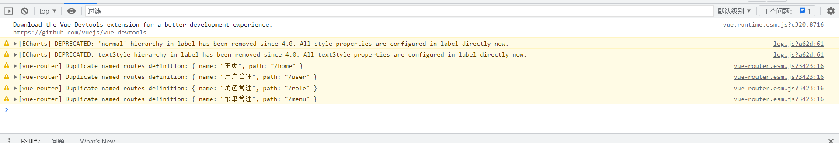
原因：路由重复了，因为调用了两次，在登录的时候路由设置了一次，在登录完成之后刷新页面的时候又设置了一次。
解决办法：
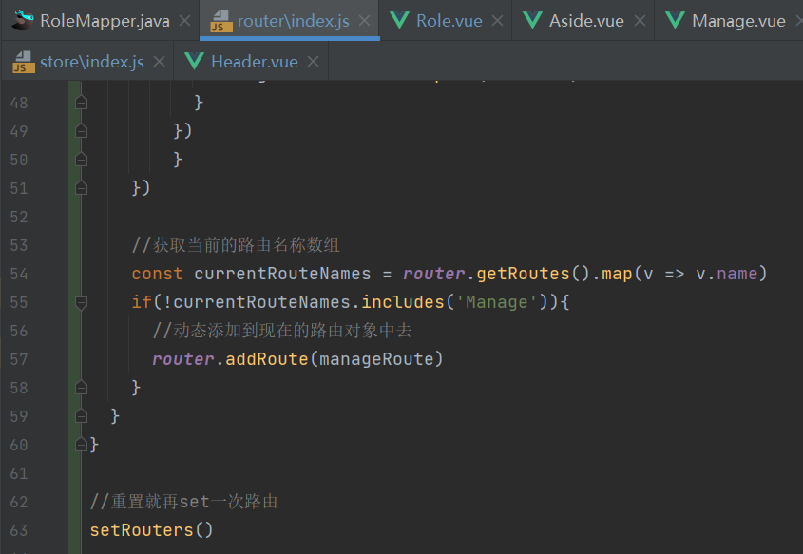

代码

router/index.js
import Vue from 'vue'
import VueRouter from 'vue-router'
import store from '@/store'
Vue.use(VueRouter)
const routes = [
{
path: '/login',
name: 'login',
component: () => import('../views/Login.vue')
},
{
path: '/register',
name: 'Register',
component: () => import('../views/Register.vue')
},
{
path: '*',
name: '404',
component: () => import('../views/404.vue')
}
]
const router = new VueRouter({
mode: 'history',
base: process.env.BASE_URL,
routes
})
export const setRouters = () =>{
const storeMenus=localStorage.getItem("menus");
if(storeMenus) {
//拼装动态路由
const manageRoute = {path: '/', name:'Manage',component: () => import('../views/Manage.vue'), redirect:"/home", children:[]}
const menus = JSON.parse(storeMenus)
menus.forEach(item =>{
if(item.path){ //当且仅当path不为空的时候才去设置路由
let itemMenu = {path:item.path.replace("/",""),name: item.name,component:() => import('../views/' + item.pagePath + '.vue')}
manageRoute.children.push(itemMenu)
} else if(item.children.length) {
item.children.forEach(item =>{
if(item.path){
let itemMenu = {path:item.path.replace("/",""),name: item.name,component:() => import('../views/' + item.pagePath + '.vue')}
manageRoute.children.push(itemMenu)
}
})
}
})
//获取当前的路由名称数组
const currentRouteNames = router.getRoutes().map(v => v.name)
if(!currentRouteNames.includes('Manage')){
//动态添加到现在的路由对象中去
router.addRoute(manageRoute)
}
}
}
//重置就再set一次路由
setRouters()
//路由守卫
router.beforeEach((to, from, next) =>{
localStorage.setItem("currentPathName",to.name) //设置当前的路由,为了在Header组件中使用
store.commit("setPath") //触发store的数据更新
next() //放行路由
})
export default router

Role.vue
<template>
<div>
<div style="padding: 10px 0">
<el-input style="width: 200px" placeholder="请输入名称" suffix-icon="el-icon-search" v-model="name"></el-input>
<!-- <el-input style="width: 200px" placeholder="请输入邮箱" suffix-icon="el-icon-message" class="ml-5" v-model="email"></el-input>-->
<!-- <el-input style="width: 200px" placeholder="请输入地址" suffix-icon="el-icon-position" class="ml-5" v-model="address"></el-input>-->
<el-button class="ml-5" type="primary" @click="load">搜索</el-button>
<el-button type="warning" @click="reset">重置</el-button>
</div>
<div style="margin: 10px 0">
<el-button type="primary" @click="handleAdd">新增 <i class="el-icon-circle-plus-outline"></i></el-button>
<el-popconfirm
class="ml-5"
confirm-button-text='确定'
cancel-button-text='我再想想'
icon="el-icon-info"
icon-color="red"
title="您确定批量删除这些数据吗？"
@confirm="delBatch"
>
<el-button type="danger" slot="reference">批量删除 <i class="el-icon-remove-outline"></i></el-button>
</el-popconfirm>
<!-- <el-upload action="http://localhost:9090/user/import" :show-file-list="false" accept="xlsx" :on-success="handleExcelImportSuccess" style="display:inline-block">-->
<!-- <el-button type="primary" class="ml-5">导入 <i class="el-icon-bottom"></i></el-button>-->
<!-- </el-upload>-->
<!-- <el-button type="primary" @click="exp" class="ml-5">导出 <i class="el-icon-top"></i></el-button>-->
</div>
<el-table :data="tableData" border stripe :header-cell-class-name="'headerBg'">
<el-table-column type="selection" width="55"></el-table-column>
<el-table-column prop="id" label="ID" width="80px"></el-table-column>
<el-table-column prop="name" label="名称"></el-table-column>
<el-table-column prop="flag" label="唯一标识"></el-table-column>
<el-table-column prop="description" label="描述"></el-table-column>
<el-table-column label="操作" width="280" align="center">
<template slot-scope="scope">
<el-button type="info" @click="selectMenu(scope.row)">分配菜单 <i class="el-icon-menu"></i></el-button>
<el-button type="success" @click="handleEdit(scope.row)">编辑 <i class="el-icon-edit"></i></el-button>
<el-popconfirm
class="ml-5"
confirm-button-text='确定'
cancel-button-text='我再想想'
icon="el-icon-info"
icon-color="red"
title="您确定删除吗？"
@confirm="del(scope.row.id)"
>
<el-button type="danger" slot="reference">删除 <i class="el-icon-remove-outline"></i></el-button>
</el-popconfirm>
</template>
</el-table-column>
</el-table>
<div style="padding: 10px 0">
<el-pagination
@size-change="handleSizeChange"
@current-change="handleCurrentChange"
:current-page="pageNum"
:page-sizes="[2, 5, 10, 20]"
:page-size="pageSize"
layout="total, sizes, prev, pager, next, jumper"
:total="total">
</el-pagination>
</div>
<el-dialog title="角色信息" :visible.sync="dialogFormVisible" width="30%">
<el-form label-width="80px" size="small">
<el-form-item label="名称">
<el-input v-model="form.name" autocomplete="off"></el-input>
</el-form-item>
<el-form-item label="唯一标识">
<el-input v-model="form.flag" autocomplete="off"></el-input>
</el-form-item>
<el-form-item label="描述">
<el-input v-model="form.description" autocomplete="off"></el-input>
</el-form-item>
</el-form>
<div slot="footer" class="dialog-footer">
<el-button @click="dialogFormVisible = false">取 消</el-button>
<el-button type="primary" @click="save">确 定</el-button>
</div>
</el-dialog>
<el-dialog title="菜单分配" :visible.sync="menuDialogVis" width="30%">
<el-tree
:props="props"
:data="menuData"
show-checkbox
node-key="id"
ref="tree"
:default-expanded-keys="expends"
:default-checked-keys="checks"
>
<span class="custom-tree-node" slot-scope="{ node, data }">
<span><i :class="data.icon"/>{{ data.name }}</span>
</span>
</el-tree>
<div slot="footer" class="dialog-footer">
<el-button @click="menuDialogVis = false">取 消</el-button>
<el-button type="primary" @click="saveRoleMenu">确 定</el-button>
</div>
</el-dialog>
</div>
</template>
<script>
export default {
name: "User",
data(){
return {
tableData: [],
total: 0,
pageNum:1,
pageSize:10,
name:"",
form:{},
dialogFormVisible:false,
menuDialogVis:false,
multipleSelection:[],
menuData:[],
props: {
label: 'name',
},
expends:[],
checks:[],
roleId:0,
roleFlag:''
}
},
created() {
this.load()
},
methods:{
load(){
//与下面注释的代码对比，我改动的是api的替换和赋值方式的替换
this.request.get("/role/page",{
params:{
pageNum:this.pageNum,
pageSize:this.pageSize,
name:this.name,
}
}).then(res =>{
this.tableData=res.data.records
this.total=res.data.total
})
// fetch("http://localhost:9090/user/page?pageNum="+this.pageNum+"&pageSize="+this.pageSize+"&username="+this.username)
// .then(res => res.json()).then(res =>{
// console.log(res)
// //数据绑定
// this.tableData = res.data
// this.total=res.total
// })
//请求菜单数据
},
save(){
this.request.post("/role",this.form).then(res =>{
if(res.code ==='200'){
this.$message.success("保存成功")
this.dialogFormVisible=false
this.load()
//操作管理员角色的时候需要重新登录
if(this.roleFlag === 'ROLE_ADMIN'){
this.$store.commit("logout")
}
}
else {
this.$message.error("保存失败")
}
})
},
saveRoleMenu(){
this.request.post("/role/roleMenu/" + this.roleId, this.$refs.tree.getCheckedKeys()).then(res =>{
if(res.code ==='200'){
this.$message.success("绑定成功")
this.menuDialogVis=false
//操作管理员角色的时候需要重新登录
if(this.roleFlag === 'ROLE_ADMIN'){
this.$store.commit("logout")
}
}else {
this.$message.error(res.msg)
}
})
},
handleAdd(){
this.dialogFormVisible=true
this.form={}
},
handleEdit(row){
//this.form=row //赋予表单数据,这样有个bug就是，在点击取消的时候表单上仍然有值，不过数据库里面的值没有变化,
this.form=JSON.parse(JSON.stringify(row)); //这是解决办法
this.dialogFormVisible=true //打开对话框
},
del(id){
this.request.delete("/role/"+id).then(res =>{
if(res.code ==='200'){
this.$message.success("删除成功")
this.load()
}
else {
this.$message.error("删除失败")
}
})
},
delBatch(){
let ids = this.multipleSelection.map(v =>v.id) //[{},{},{}]=>[1,2,3]
this.request.post("/role/del/batch",ids).then(res =>{
if(res.code ==='200'){
this.$message.success("批量删除成功")
this.load()
}
else {
this.$message.error("批量删除失败")
}
})
},
reset(){
this.name=""
this.load()
},
handleSizeChange(pageSize){
console.log(pageSize)
this.pageSize=pageSize
this.load()
},
handleCurrentChange(pageNum){
console.log(pageNum)
this.pageNum=pageNum
this.load()
},
selectMenu(role){
this.menuDialogVis = true
this.roleId = role.id
this.roleFlag = role.flag
//请求菜单数据
this.request.get("/menu").then(res =>{
this.menuData = res.data
//把后台返回的菜单数据处理成id数组
this.expends = this.menuData.map(v =>v.id)
})
this.request.get("/role/roleMenu/"+this.roleId).then(res =>{
this.checks = res.data
})
},
handleCheckChange(data, checked, indeterminate) {
console.log(data, checked, indeterminate);
},
}
}
</script>
<style>
.headerBg {
background: #eee!important;
}
</style>

Login.vue
<template>
<div class="wrapper">
<div style="margin:200px auto; background-color: #ffffff;width: 350px ;height:300px ; padding: 20px;border: 20px;border-radius: 10px">
<div style="margin: 20px 0;text-align: center;font-size: 24px"><b>登 录</b></div>
<el-form :model="user" :rules="rules" ref="userForm">
<el-form-item prop="username">
<el-input size="medium" style="margin: 10px 0" prefix-icon="el-icon-user" v-model="user.username"></el-input>
</el-form-item>
<el-form-item prop="password">
<el-input size="medium" style="margin: 10px 0" prefix-icon="el-icon-lock" show-password v-model="user.password"></el-input>
</el-form-item>
<div style="margin: 10px 0;text-align: right">
<el-form-item>
<el-button type="warning" size="small" autocomplete="off" @click="$router.push('/register')">注册</el-button>
<el-button type="primary" size="small" autocomplete="off" @click="login">登录</el-button>
</el-form-item>
</div>
</el-form>
</div>
</div>
</template>
<script>
import {setRouters} from "@/router";
export default {
name:"Login",
data(){
return{
user:{},
rules: {
username: [
{required: true, message: '请输入用户名', trigger: 'blur'},
{min: 3, max: 10, message: '长度在 3 到 5 个字符', trigger: 'blur'}
],
password:[
{required: true, message: '请输入密码', trigger: 'blur'},
{min: 1, max: 20, message: '长度在 1 到 20 个字符', trigger: 'blur'}
],
}
}
},
methods:{
login() {
this.$refs['userForm'].validate((valid) => {
if (valid) { // 表单校验合法
this.request.post("/user/login", this.user).then(res => {
if(res.code === '200') {
localStorage.setItem("user", JSON.stringify(res.data)) // 存储用户信息到浏览器
localStorage.setItem("menus", JSON.stringify(res.data.menus)) // 存储用户信息到浏览器
//动态设置当前用户的路由
setRouters()
this.$router.push("/")
this.$message.success("登录成功")
} else {
this.$message.error(res.msg)
}
})
}
});
}
}
}
</script>
<style>
.wrapper{
height: 100vh;
background-image:linear-gradient(to bottom right,#FC466B,#3F5EF8) ;
overflow: hidden;
}
</style>

store/index.js
import Vue from 'vue'
import Vuex from 'vuex'
import router from "@/router";
Vue.use(Vuex)
const store = new Vuex.Store({
state: {
currentPathName: ''
},
mutations: {
setPath (state) {
state.currentPathName = localStorage.getItem("currentPathName")
},
logout(){
//清空缓存
localStorage.removeItem("user")
localStorage.removeItem("menus")
router.push("/login")
}
}
})
export default store

Header.vue
<template>
<div style="line-height: 60px;display: flex">
<div style="flex: 1;">
<span :class="collapseBtnClass" style="cursor: pointer; font-size: 18px" @click="collapse"></span>
<el-breadcrumb separator="/" style="display: inline-block;margin-left: 10px">
<el-breadcrumb-item :to="'/'">首页</el-breadcrumb-item>
<el-breadcrumb-item>{{ currentPathName }}</el-breadcrumb-item>
</el-breadcrumb>
</div>
<el-dropdown style="width: 150px;cursor: pointer;text-align:right">
<div style="display: inline-block">
<img :src="user.avatarUrl" alt=""
style="width: 30px; border-radius: 50%; position: relative; top: 10px; right: 5px">
<span>{{user.nickname}}</span><i class="el-icon-arrow-down" style="margin-left: 5px"></i>
</div>
<el-dropdown-menu slot="dropdown" style="width: 100px;text-align: center">
<el-dropdown-item style="font-size: 14px; padding: 5px 0">
<router-link to="/person">个人信息</router-link>
</el-dropdown-item>
<el-dropdown-item style="font-size: 14px; padding: 5px 0">
<span style="text-decoration: none" @click="logout">退出</span>
</el-dropdown-item>
</el-dropdown-menu>
</el-dropdown>
</div>
</template>
<script>
export default {
name: "Header",
props:{
collapseBtnClass:String,
collapse:'',
user:Object
},
computed: {
currentPathName () {
return this.$store.state.currentPathName; //需要监听的数据
}
},
data(){
return{
}
},
methods:{
logout() {
this.$store.commit("logout")
this.$message.success("退出成功")
}
},
}
</script>
<style scoped>
</style>

404.vue
<template>
<div style="overflow: hidden; height: 100vh">
<img src="../assets/404.png" alt="" style="width: 100%; height: 100%">
</div>
</template>
<script>
export default {
name: "NotFound"
}
</script>
<style scoped>
</style>

