8＿SpringBoot实现分页查询

运行界面截图
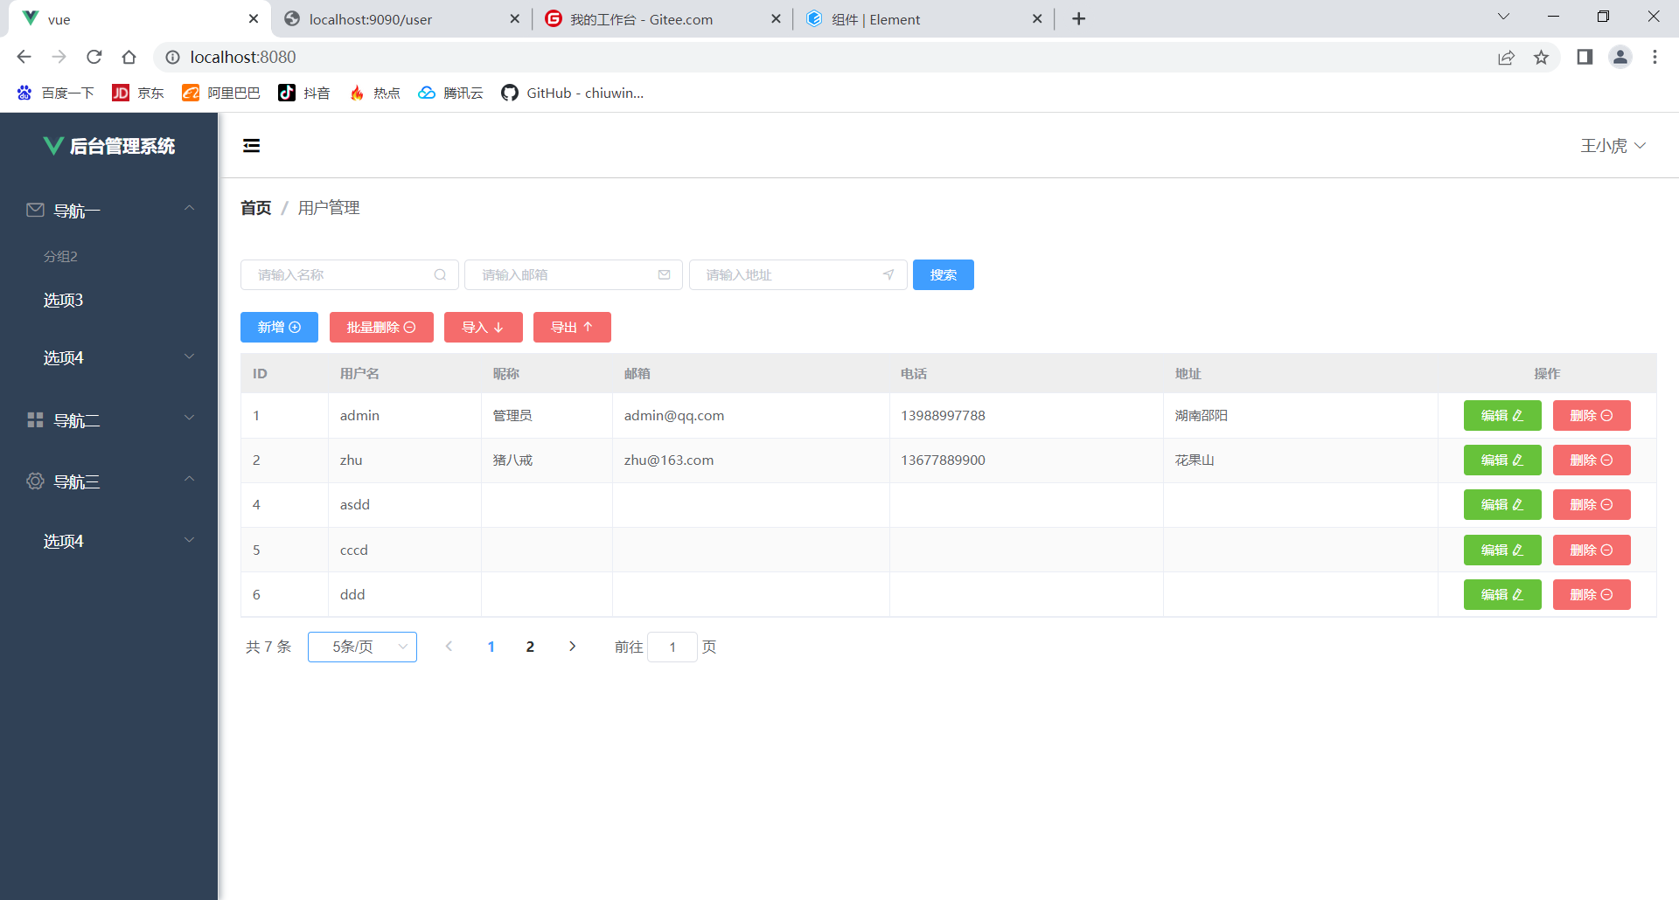
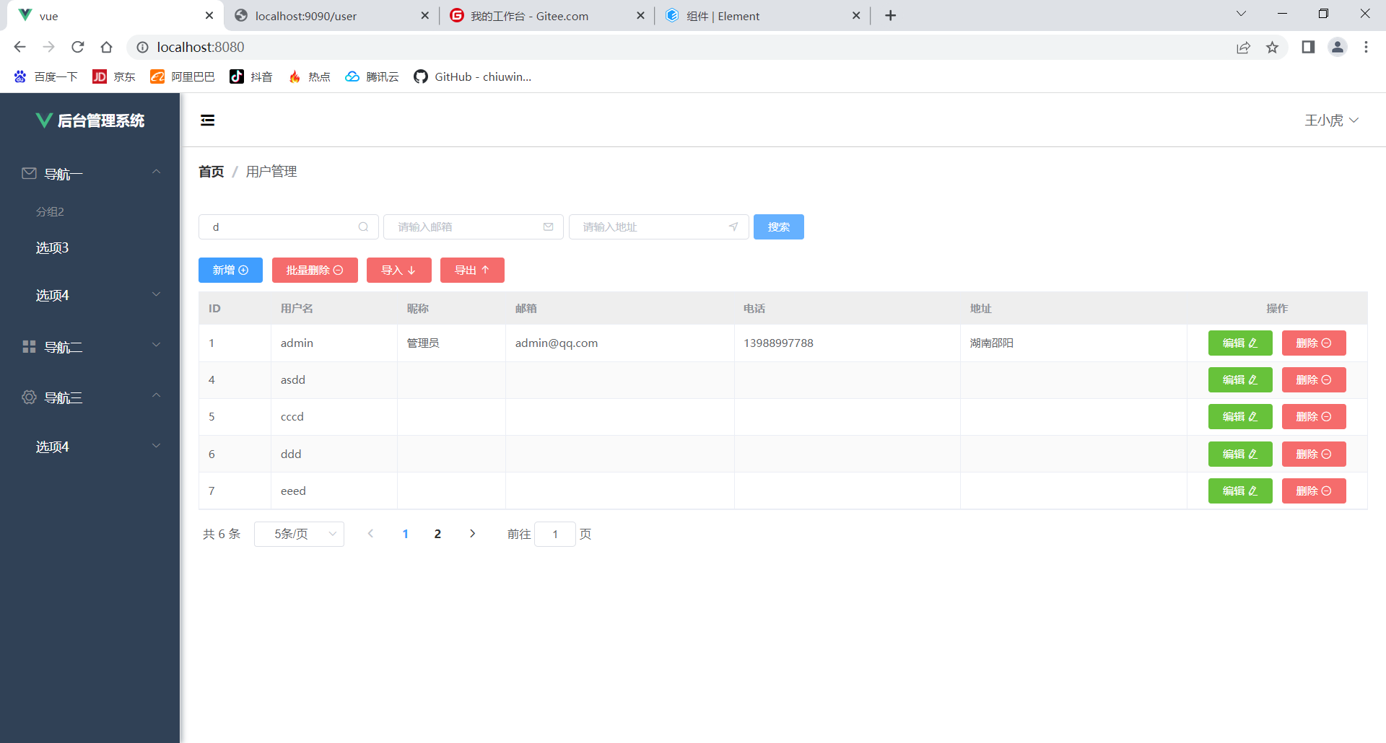

学到的知识点
- 分页查询的公式
Select * from sys_user limit 参数1,参数2
结论：第一个参数==(pageNum-1)*pageSize
第二个参数是pageSize

- 学习了java的hashmap
https://www.runoob.com/java/java-hashmap.html

- Vue中利用v-model实现数据绑定
https://blog.csdn.net/yun_hou/article/details/86313212#:~:text=%E4%B8%80%EF%BC%8C%20v-model%20%E6%98%AF%E4%BB%80%E4%B9%88%20v-model%20%E5%B0%B1%E6%98%AF%20vue,%E7%9A%84%E5%8F%8C%E5%90%91%E7%BB%91%E5%AE%9A%E7%9A%84%E6%8C%87%E4%BB%A4%EF%BC%8C%E8%83%BD%E5%B0%86%E9%A1%B5%E9%9D%A2%E4%B8%8A%E6%8E%A7%E4%BB%B6%E8%BE%93%E5%85%A5%E7%9A%84%E5%80%BC%E5%90%8C%E6%AD%A5%E6%9B%B4%E6%96%B0%E5%88%B0%E7%9B%B8%E5%85%B3%E7%BB%91%E5%AE%9A%E7%9A%84data%E5%B1%9E%E6%80%A7%EF%BC%8C%E4%B9%9F%E4%BC%9A%E5%9C%A8%E6%9B%B4%E6%96%B0data%E7%BB%91%E5%AE%9A%E5%B1%9E%E6%80%A7%E6%97%B6%E5%80%99%EF%BC%8C%E6%9B%B4%E6%96%B0%E9%A1%B5%E9%9D%A2%E4%B8%8A%E8%BE%93%E5%85%A5%E6%8E%A7%E4%BB%B6%E7%9A%84%E5%80%BC%E3%80%82%20%E4%BA%8C%EF%BC%8C%E4%B8%BA%E4%BB%80%E4%B9%88%E4%BD%BF%E7%94%A8%20v-model%20v-model%20%E4%BD%9C%E4%B8%BA%E5%8F%8C%E5%90%91%E7%BB%91%E5%AE%9A%E6%8C%87%E4%BB%A4%E4%B9%9F%E6%98%AF%20vue%20%E4%B8%A4%E5%A4%A7%E6%A0%B8%E5%BF%83%E5%8A%9F%E8%83%BD%E4%B9%8B%E4%B8%80%EF%BC%8C%E4%BD%BF%E7%94%A8%E9%9D%9E%E5%B8%B8%E6%96%B9%E4%BE%BF%EF%BC%8C%E6%8F%90%E9%AB%98%E5%89%8D%E7%AB%AF%E5%BC%80%E5%8F%91%E6%95%88%E7%8E%87%E3%80%82

https://blog.csdn.net/qq_43742385/article/details/114572773?spm=1001.2101.3001.6650.6&utm_medium=distribute.pc_relevant.none-task-blog-2%7Edefault%7EBlogCommendFromBaidu%7Edefault-6-114572773-blog-86313212.pc_relevant_multi_platform_whitelistv3&depth_1-utm_source=distribute.pc_relevant.none-task-blog-2%7Edefault%7EBlogCommendFromBaidu%7Edefault-6-114572773-blog-86313212.pc_relevant_multi_platform_whitelistv3&utm_relevant_index=12

- 解决跨域问题(前端跨域问题)
不同端口请求是肯定会跨域
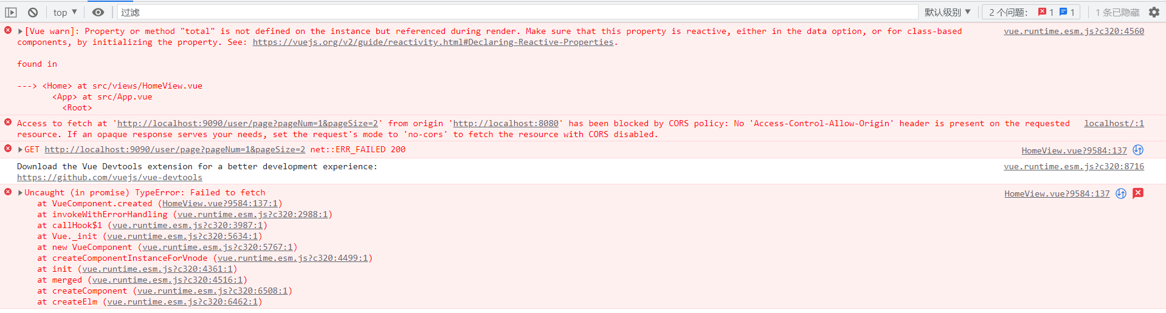
https://blog.csdn.net/xqnode/article/details/120947462?spm=1001.2014.3001.5502
CorsConfig.java
package com.txx.springboot.config;
import org.springframework.context.annotation.Bean;
import org.springframework.context.annotation.Configuration;
import org.springframework.web.cors.CorsConfiguration;
import org.springframework.web.cors.UrlBasedCorsConfigurationSource;
import org.springframework.web.filter.CorsFilter;
@Configuration
public class CorsConfig {
// 当前跨域请求最大有效时长。这里默认1天
private static final long MAX_AGE = 24 * 60 * 60;
@Bean
public CorsFilter corsFilter() {
UrlBasedCorsConfigurationSource source = new UrlBasedCorsConfigurationSource();
CorsConfiguration corsConfiguration = new CorsConfiguration();
corsConfiguration.addAllowedOrigin("*"); // 1 设置访问源地址
corsConfiguration.addAllowedHeader("*"); // 2 设置访问源请求头
corsConfiguration.addAllowedMethod("*"); // 3 设置访问源请求方法
corsConfiguration.setMaxAge(MAX_AGE);
source.registerCorsConfiguration("/**", corsConfiguration); // 4 对接口配置跨域设置
return new CorsFilter(source);
}
}
- 忽略某个字段，不展示给前端
xxxxxx@JsonIgnore
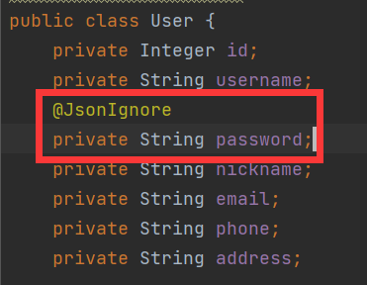
- 字符串拼接做迷糊查询
- 前端数据绑定
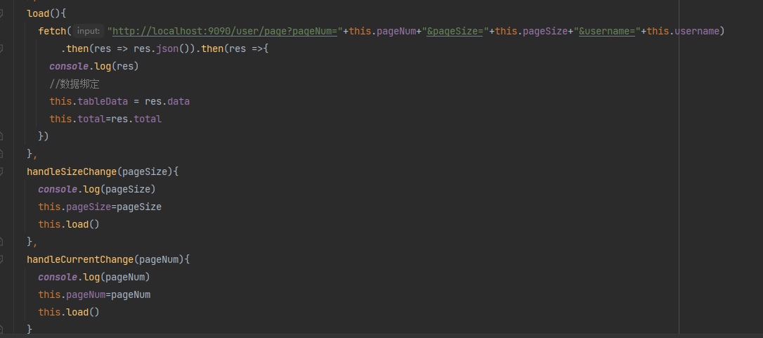

UserController.java
package com.txx.springboot.controller;
import com.txx.springboot.entity.User;
import com.txx.springboot.mapper.UserMapper;
import com.txx.springboot.service.UserService;
import org.springframework.beans.factory.annotation.Autowired;
import org.springframework.web.bind.annotation.*;
import java.util.HashMap;
import java.util.List;
import java.util.Map;
@RestController
@RequestMapping("/user")
public class UserController {
@Autowired
private UserMapper userMapper;
@Autowired
private UserService userService;
@PostMapping
//新增和修改都是post接口
public Integer save(@RequestBody User user){//前端传过来的json对象转化成为java类型的User对象
//新增和更新都在这个userService.save()方法里面
return userService.save(user);
}
@GetMapping
//查询所有数据
public List<User> findall(){
List<User> all = userMapper.findAll();
return all;
}
@DeleteMapping("/{id}")
public Integer delete(@PathVariable Integer id){ //pathVariable表示从url获得id
return userMapper.deleteById(id);
}
//分页查询
//接口路径：/user/page
//@RequestParam接受来自url里面的pageNum=?和pageSize=?
//limit的第一个参数=(pageNum-1)*pageSize
@GetMapping("/page")
public Map<String,Object> findPage(@RequestParam Integer pageNum,
@RequestParam Integer pageSize,
@RequestParam String username
){
pageNum=(pageNum-1)*pageSize;
username="%"+username+"%";
List<User> data=userMapper.selectPage(pageNum,pageSize,username);
Integer total = userMapper.selectTotal(username);
Map<String,Object> res=new HashMap<>();
res.put("total",total);
res.put("data",data);
return res;
}
}

User.java
package com.txx.springboot.entity;
import com.fasterxml.jackson.annotation.JsonIgnore;
import lombok.AllArgsConstructor;
import lombok.Data;
import lombok.NoArgsConstructor;
@Data
//可以不添加get和set方法（lombok插件）
@NoArgsConstructor
//可以帮助创建无参构造方法
@AllArgsConstructor
//可以帮助创建有参构造方法
public class User {
private Integer id;
private String username;
@JsonIgnore
private String password;
private String nickname;
private String email;
private String phone;
private String address;
}

UserMapper.java
package com.txx.springboot.mapper;
import com.txx.springboot.entity.User;
import org.apache.ibatis.annotations.*;
import java.util.List;
//数据库查询的接口，专门用来和数据库交互用的
@Mapper
public interface UserMapper {
@Select("SELECT * FROM sys_user")
List<User> findAll();
@Insert("INSERT INTO sys_user(username,`password`,nickname,email,phone,address) " +
"VALUES (#{username},#{password},#{nickname},#{email},#{phone},#{address})")
int insert(User user);
int update(User user);
@Delete("delete from sys_user where id=#{id}")
Integer deleteById(@Param("id") Integer id); //@Param("id")里面的id和id=#{id}里面的必须一致
@Select("select * from sys_user where username like #{username} limit #{pageNum},#{pageSize}")//从第pageNum条数据起，查找pageSize条。
List<User> selectPage(Integer pageNum, Integer pageSize, String username);
@Select("select count(*) from sys_user where username like concat('%',#{username},'%')")//查询出sys_user里面符合username总条数
Integer selectTotal(String username);
}

HomeView.vue
<template>
<el-container style="min-height: 100vh">
<el-aside :width="sideWidth+'px'" style="background-color: rgb(238, 241, 246);box-shadow: 2px 0 6px rgb(0 21 41 / 35%);">
<el-menu :default-openeds="['1', '3']" style="min-height: 100%;overflow-x: hidden"
background-color="rgb(48, 65, 86)"
text-color="#fff"
active-text-color="#ffd04b"
:collapse-transition="false"
:collapse="isCollapse"
>
<div style="height:60px;text-align: center;line-height: 60px">
<img src="../assets/logo.png" alt="" style="width: 20px;position: relative;top:5px;margin-right: 5px">
<b style="color: white" v-show="logoTextShow">后台管理系统</b>
</div>
<el-submenu index="1">
<template slot="title"><i class="el-icon-message"></i>
<span slot="title">导航一</span>
</template>
<el-menu-item-group title="分组2">
<el-menu-item index="1-3">选项3</el-menu-item>
</el-menu-item-group>
<el-submenu index="1-4">
<template slot="title">选项4</template>
<el-menu-item index="1-4-1">选项4-1</el-menu-item>
</el-submenu>
</el-submenu>
<el-submenu index="2">
<template slot="title"><i class="el-icon-menu"></i>
<span slot="title">导航二</span>
</template>
<el-submenu index="2-4">
<template slot="title">选项4</template>
<el-menu-item index="2-4-1">选项4-1</el-menu-item>
</el-submenu>
</el-submenu>
<el-submenu index="3">
<template slot="title"><i class="el-icon-setting"></i>
<span slot="title">导航三</span>
</template>
<el-submenu index="3-4">
<template slot="title">选项4</template>
<el-menu-item index="3-4-1">选项4-1</el-menu-item>
</el-submenu>
</el-submenu>
</el-menu>
</el-aside>
<el-container>
<el-header style="font-size: 12px; border-bottom: 1px solid #ccc; line-height: 60px;display: flex">
<div style="flex: 1; font-size: 20px">
<span :class="collapseBtnClass" style="cursor: pointer" @click="collapse"></span>
</div>
<el-dropdown style="width: 70px">
<span style="cursor: pointer">王小虎</span><i class="el-icon-arrow-down" style="margin-left: 5px"></i>
<el-dropdown-menu slot="dropdown">
<el-dropdown-item>个人信息</el-dropdown-item>
<el-dropdown-item>退出</el-dropdown-item>
</el-dropdown-menu>
</el-dropdown>
</el-header>
<el-main>
<div style="margin-bottom: 30px">
<el-breadcrumb separator="/">
<el-breadcrumb-item :to="{ path: '/' }">首页</el-breadcrumb-item>
<el-breadcrumb-item>用户管理</el-breadcrumb-item>
</el-breadcrumb>
</div>
<div style="padding: 10px 0">
<el-input style="width: 200px" placeholder="请输入名称" suffix-icon="el-icon-search" v-model="username"></el-input>
<el-input style="width: 200px" placeholder="请输入邮箱" suffix-icon="el-icon-message" class="ml-5"></el-input>
<el-input style="width: 200px" placeholder="请输入地址" suffix-icon="el-icon-position" class="ml-5"></el-input>
<el-button class="ml-5" type="primary" @click="load">搜索</el-button>
</div>
<div style="margin: 10px 0">
<el-button type="primary">新增 <i class="el-icon-circle-plus-outline"></i></el-button>
<el-button type="danger">批量删除 <i class="el-icon-remove-outline"></i></el-button>
<el-button type="danger">导入 <i class="el-icon-bottom"></i></el-button>
<el-button type="danger">导出 <i class="el-icon-top"></i></el-button>
</div>
<el-table :data="tableData" border stripe header-cell-class-name="headerBg">
<el-table-column prop="id" label="ID" width="80"></el-table-column>
<el-table-column prop="username" label="用户名" width="140"></el-table-column>
<el-table-column prop="nickname" label="昵称" width="120"></el-table-column>
<el-table-column prop="email" label="邮箱"></el-table-column>
<el-table-column prop="phone" label="电话"></el-table-column>
<el-table-column prop="address" label="地址"></el-table-column>
<el-table-column label="操作" width="200" align="center">
<template slot-scope="scope">
<el-button type="success">编辑 <i class="el-icon-edit"></i></el-button>
<el-button type="danger">删除 <i class="el-icon-remove-outline"></i></el-button>
</template>
</el-table-column>
</el-table>
<div style="padding: 10px 0">
<el-pagination
@size-change="handleSizeChange"
@current-change="handleCurrentChange"
:current-page="pageNum"
:page-sizes="[2, 5, 10, 20]"
:page-size="pageSize"
layout="total, sizes, prev, pager, next, jumper"
:total="total">
</el-pagination>
</div>
</el-main>
</el-container>
</el-container>
</template>
<script>
export default {
name: 'Home',
data() {
return {
tableData: [],
total: 0,
pageNum:1,
pageSize:2,
username:"",
msg: "hello 唐湘",
collapseBtnClass:'el-icon-s-fold',
isCollapse:false,
sideWidth:200,
logoTextShow:true,
headerBg:'headerBg'
}
},
created() {
//请求分页查询数据
this.load()
},
methods:{
collapse(){ //点击收缩按钮触发
this.isCollapse=!this.isCollapse
if(this.isCollapse){ //收缩
this.sideWidth=64
this.collapseBtnClass='el-icon-s-unfold'
this.logoTextShow=false
}
else { //展开
this.sideWidth=200
this.collapseBtnClass='el-icon-s-fold'
this.logoTextShow=true
}
},
load(){
fetch("http://localhost:9090/user/page?pageNum="+this.pageNum+"&pageSize="+this.pageSize+"&username="+this.username)
.then(res => res.json()).then(res =>{
console.log(res)
//数据绑定
this.tableData = res.data
this.total=res.total
})
},
handleSizeChange(pageSize){
console.log(pageSize)
this.pageSize=pageSize
this.load()
},
handleCurrentChange(pageNum){
console.log(pageNum)
this.pageNum=pageNum
this.load()
}
}
}
</script>
<style>
.headerBg{
background-color: #eee !important;
}
</style>

