学到的知识点
- SpringBoot集成JWT实现token验证
https://blog.csdn.net/gjtao1130/article/details/111658060
加密信息，把用户的信息加密在字符串token（json web token）里面去，通过字符串来验证这个用户合不合法，他能不能访问我们系统里面的资源，就是通过这一串字符串来确定。所以在每次请求接口的时候都要把这一长串发给后台，后台拿到这个字符串之后就进行验证。验证成功就返回用户需要的数据，如果验证不通过就不返回数据，给他提示一个权限不足这样的错误，微服务里面比较流行的这样一种方式。
不需要在服务端保存会话信息（SSM的session就是在服务端保留会话，当服务器关闭了，session就消失了），这是我们前后端分离最重要的特点，而token的有效期是可以我们开发他人员人为去设置的。
缺点：1.无法作废
2.不易应对数据过期
2.使用拦截器进行拦截，可以保证程序的安全性，使得在地址栏上输入url需要验证token后才能进入主页面。
每次登录的时候都会获取一个token。放在这个请求头上，带给后台，然后后台再对这个toke进行验证。如下图。
后端要做的就是从请求头中获取token，认证token，解析token中的userId。

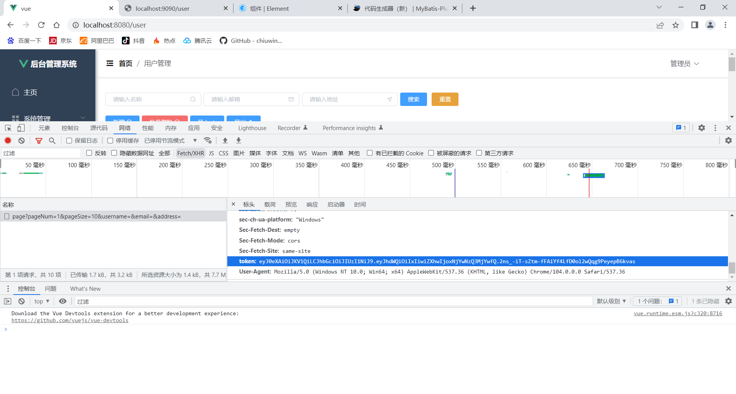
- 让后台获取到当前页面用户信息（通过tokenUtils获取），不是每个时候前端都会携带用户参数，有时候后台需要获取用户信息id，后台获取当前用户的信息，才方便权限管理，第一是前端个人信息展示，二是判断用户角色是什么。
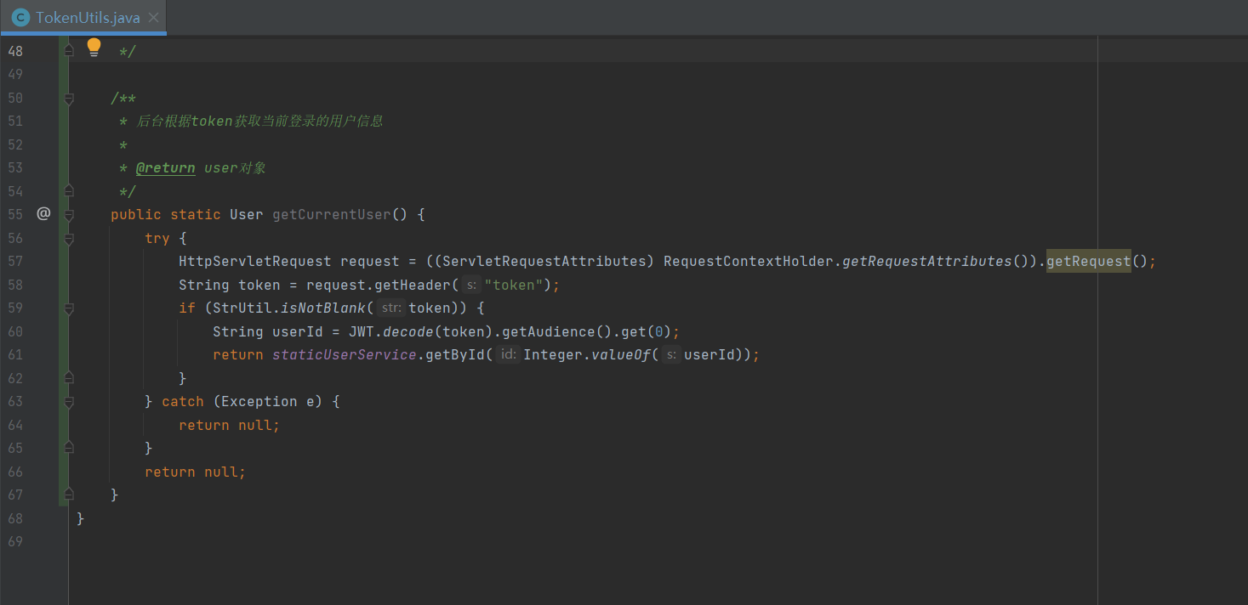
使用如下
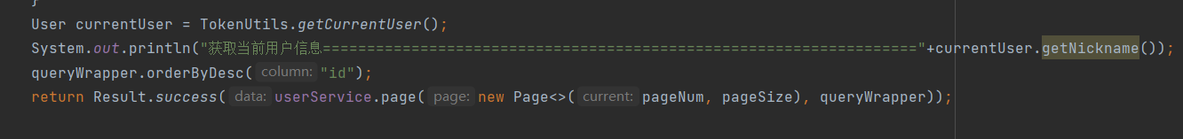

遇到的问题及解决
- 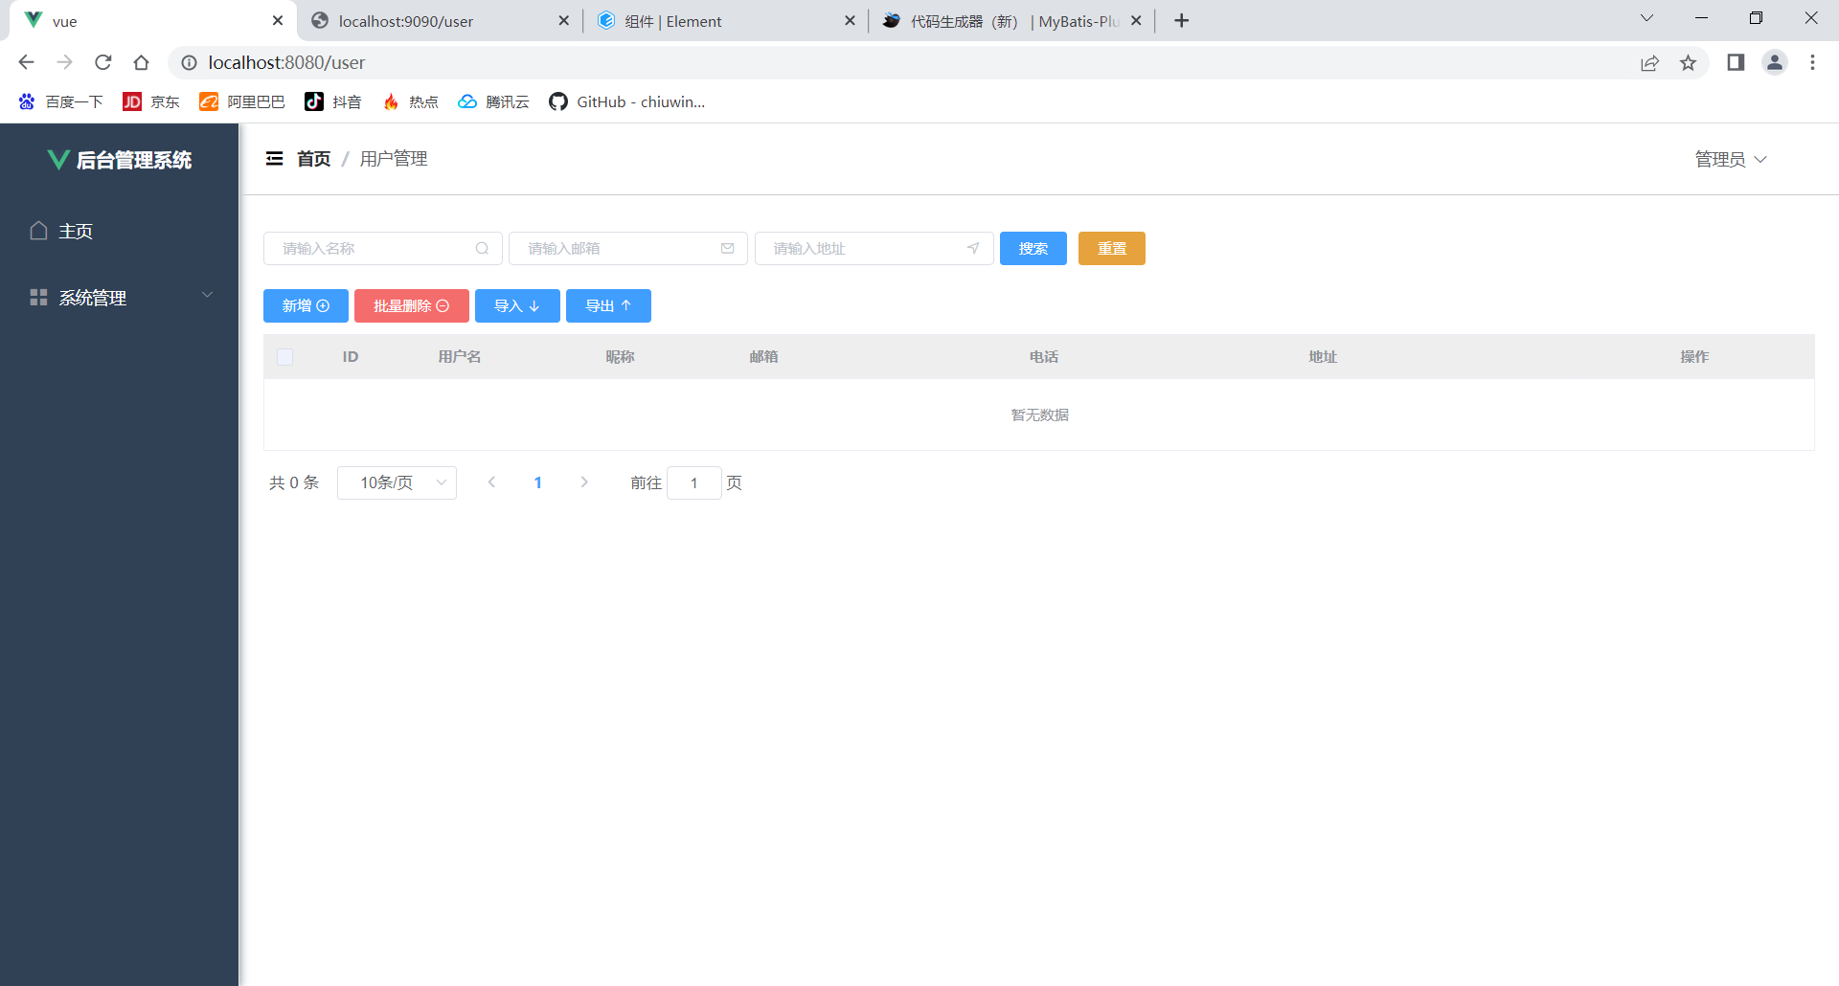
刷新之后没有数据，debug模式下userService为null
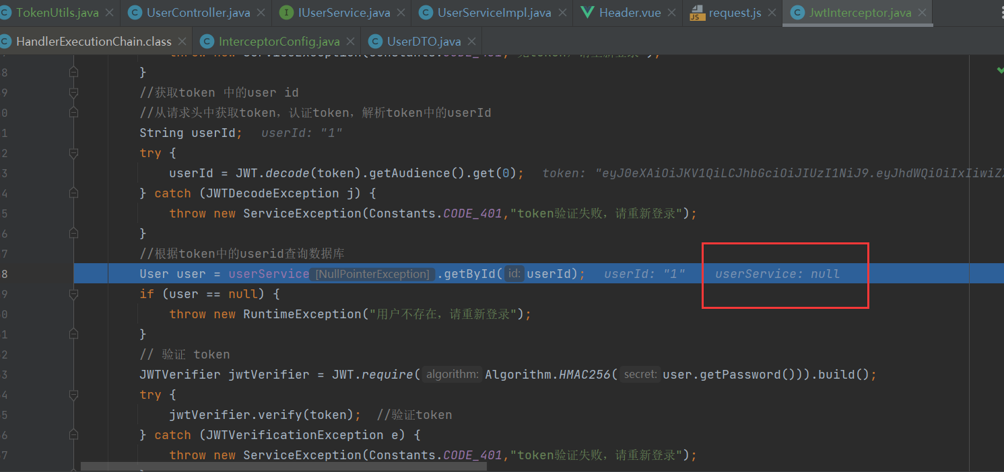
原因：这里是用new的方式，没有注入到spring容器里面去。不太合理。
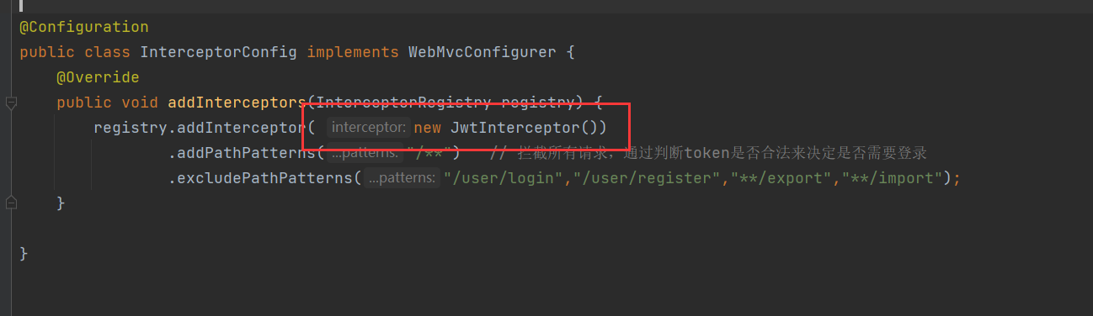
解决办法：再JwtInterceptor.java里面去掉@component,再在InterceptorConfig.java里面定义一个bean
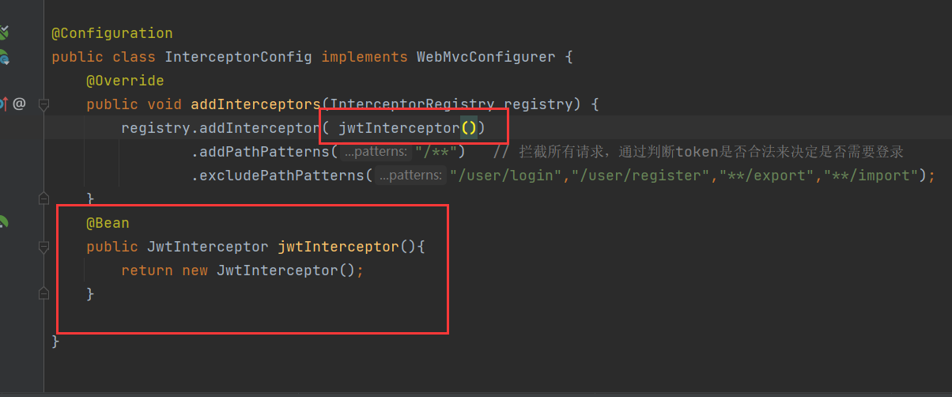

代码
pom.xml依赖
<!-- JWT-->
<dependency>
<groupId>com.auth0</groupId>
<artifactId>java-jwt</artifactId>
<version>3.10.3</version>
</dependency>

JwtInterceptor.java
package com.txx.springboot.config.Intercepter;
import cn.hutool.core.util.StrUtil;
import com.auth0.jwt.JWT;
import com.auth0.jwt.JWTVerifier;
import com.auth0.jwt.algorithms.Algorithm;
import com.auth0.jwt.exceptions.JWTDecodeException;
import com.auth0.jwt.exceptions.JWTVerificationException;
import com.txx.springboot.common.Constants;
import com.txx.springboot.entity.User;
import com.txx.springboot.exception.ServiceException;
import com.txx.springboot.service.IUserService;
import org.springframework.beans.factory.annotation.Autowired;
import org.springframework.web.method.HandlerMethod;
import org.springframework.web.servlet.HandlerInterceptor;
import javax.servlet.http.HttpServletRequest;
import javax.servlet.http.HttpServletResponse;
public class JwtInterceptor implements HandlerInterceptor {
@Autowired
private IUserService userService;
@Override
public boolean preHandle(HttpServletRequest request, HttpServletResponse response, Object handler) {
String token = request.getHeader("token");
// 如果不是映射到方法直接通过
if(!(handler instanceof HandlerMethod)){
return true;
}
//执行认证
if(StrUtil.isBlank(token)){
throw new ServiceException(Constants.CODE_401,"无token，请重新登录");
}
//获取token 中的user id
//从请求头中获取token，认证token，解析token中的userId
String userId;
try {
userId = JWT.decode(token).getAudience().get(0);
} catch (JWTDecodeException j) {
throw new ServiceException(Constants.CODE_401,"token验证失败，请重新登录");
}
//根据token中的userid查询数据库
User user = userService.getById(userId);
if (user == null) {
throw new RuntimeException("用户不存在，请重新登录");
}
// 验证 token
JWTVerifier jwtVerifier = JWT.require(Algorithm.HMAC256(user.getPassword())).build();
try {
jwtVerifier.verify(token); //验证token
} catch (JWTVerificationException e) {
throw new ServiceException(Constants.CODE_401,"token验证失败，请重新登录");
}
return true;
}
}

InterceptorConfig.java
package com.txx.springboot.config;
import com.sun.javafx.logging.PulseLogger;
import com.txx.springboot.config.Intercepter.JwtInterceptor;
import org.springframework.context.annotation.Bean;
import org.springframework.context.annotation.Configuration;
import org.springframework.web.servlet.config.annotation.InterceptorRegistry;
import org.springframework.web.servlet.config.annotation.WebMvcConfigurer;
@Configuration
public class InterceptorConfig implements WebMvcConfigurer {
@Override
public void addInterceptors(InterceptorRegistry registry) {
registry.addInterceptor( jwtInterceptor())
.addPathPatterns("/**") // 拦截所有请求，通过判断token是否合法来决定是否需要登录
.excludePathPatterns("/user/login","/user/register","/**/export","/**/import");
}
@Bean
public JwtInterceptor jwtInterceptor(){
return new JwtInterceptor();
}
}

UserDTO.java
package com.txx.springboot.controller.dto;
import lombok.Data;
/**
* 接受前端登录请求的参数
*/
@Data
public class UserDTO {
private String username;
private String password;
private String nickname;
private String avatarUrl;
private String token;
}

UserController.java
package com.txx.springboot.controller;
import cn.hutool.core.collection.CollUtil;
import cn.hutool.core.util.StrUtil;
import cn.hutool.poi.excel.ExcelReader;
import cn.hutool.poi.excel.ExcelUtil;
import cn.hutool.poi.excel.ExcelWriter;
import com.baomidou.mybatisplus.extension.plugins.pagination.Page;
import com.txx.springboot.common.Constants;
import com.txx.springboot.common.Result;
import com.txx.springboot.controller.dto.UserDTO;
import com.txx.springboot.config.Intercepter.utils.TokenUtils;
import org.springframework.web.bind.annotation.*;
import javax.annotation.Resource;
import javax.servlet.ServletOutputStream;
import javax.servlet.http.HttpServletResponse;
import java.io.InputStream;
import java.net.URLEncoder;
import java.util.List;
import com.baomidou.mybatisplus.core.conditions.query.QueryWrapper;
import com.txx.springboot.service.IUserService;
import com.txx.springboot.entity.User;
import org.springframework.web.bind.annotation.RestController;
import org.springframework.web.multipart.MultipartFile;
/**
* <p>
* 前端控制器
* </p>
*
* @author txx
* @since 2022-08-12
*/
@RestController
@RequestMapping("/user")
public class UserController {
// @Value("${files.upload.path}")
// private String fileUploadPath;
@Resource
private IUserService userService;
@PostMapping("/login")
public Result login(@RequestBody UserDTO userDTO) {
String username = userDTO.getUsername();
String password = userDTO.getPassword();
if(StrUtil.isBlank(username) || StrUtil.isBlank(password)){
return Result.error(Constants.CODE_400,"参数错误");
}
UserDTO dto = userService.login(userDTO);
return Result.success(dto);
}
@PostMapping("/register")
public Result register(@RequestBody UserDTO userDTO) {
String username = userDTO.getUsername();
String password = userDTO.getPassword();
if(StrUtil.isBlank(username) || StrUtil.isBlank(password)){
return Result.error(Constants.CODE_400,"参数错误");
}
return Result.success(userService.register(userDTO));
}
// 新增或者更新
@PostMapping
public Result save(@RequestBody User user) {
return Result.success(userService.saveOrUpdate(user));
}
@DeleteMapping("/{id}")
public Result delete(@PathVariable Integer id) {
return Result.success(userService.removeById(id));
}
@PostMapping("/del/batch")
public Result deleteBatch(@RequestBody List<Integer> ids) {
return Result.success(userService.removeByIds(ids));
}
@GetMapping
public Result findAll() {
return Result.success(userService.list());
}
@GetMapping("/{id}")
public Result findOne(@PathVariable Integer id) {
return Result.success(userService.getById(id));
}
@GetMapping("/username/{username}")
public Result findOne(@PathVariable String username) {
QueryWrapper<User> queryWrapper = new QueryWrapper<>();
queryWrapper.eq("username",username);
return Result.success(userService.getOne(queryWrapper));
}
@GetMapping("/page")
public Result findPage(@RequestParam Integer pageNum,
@RequestParam Integer pageSize,
@RequestParam(defaultValue = "") String username,
@RequestParam(defaultValue = "") String email,
@RequestParam(defaultValue = "")String address) {
QueryWrapper<User> queryWrapper = new QueryWrapper<>();
if(!"".equals(username)){
queryWrapper.like("username",username);
}
if (!"".equals(email)){
queryWrapper.like("email",email);
}
if (!"".equals(address)){
queryWrapper.like("address",address);
}
User currentUser = TokenUtils.getCurrentUser();
System.out.println("获取当前用户信息==================================================================="+currentUser.getNickname());
queryWrapper.orderByDesc("id");
return Result.success(userService.page(new Page<>(pageNum, pageSize), queryWrapper));
}
/**
* 导出接口
*/
@GetMapping("/export")
public void export(HttpServletResponse response) throws Exception {
// 从数据库查询出所有的数据
List<User> list = userService.list();
// 通过工具类创建writer 写出到磁盘路径
// ExcelWriter writer = ExcelUtil.getWriter(filesUploadPath + "/用户信息.xlsx");
// 在内存操作，写出到浏览器
ExcelWriter writer = ExcelUtil.getWriter(true);
//自定义标题别名
writer.addHeaderAlias("username", "用户名");
writer.addHeaderAlias("password", "密码");
writer.addHeaderAlias("nickname", "昵称");
writer.addHeaderAlias("email", "邮箱");
writer.addHeaderAlias("phone", "电话");
writer.addHeaderAlias("address", "地址");
writer.addHeaderAlias("createTime", "创建时间");
writer.addHeaderAlias("avatarUrl", "头像");
// 一次性写出list内的对象到excel，使用默认样式，强制输出标题
writer.write(list, true);
// 设置浏览器响应的格式
response.setContentType("application/vnd.openxmlformats-officedocument.spreadsheetml.sheet;charset=utf-8");
String fileName = URLEncoder.encode("用户信息", "UTF-8");
response.setHeader("Content-Disposition", "attachment;filename=" + fileName + ".xlsx");
ServletOutputStream out = response.getOutputStream();
writer.flush(out, true);
out.close();
writer.close();
}
/**
* excel 导入
* @param file
* @throws Exception
*/
@PostMapping("/import")
public Result imp(MultipartFile file) throws Exception {
InputStream inputStream = file.getInputStream();
ExcelReader reader = ExcelUtil.getReader(inputStream);
// 方式1：(推荐) 通过 javabean的方式读取Excel内的对象，但是要求表头必须是英文，跟javabean的属性要对应起来
// List<User> users = reader.readAll(User.class);
// 方式2：忽略表头的中文，直接读取表的内容
List<List<Object>> list = reader.read(1);
List<User> users = CollUtil.newArrayList();
for (List<Object> row : list) {
User user = new User();
user.setUsername(row.get(0).toString());
user.setPassword(row.get(1).toString());
user.setNickname(row.get(2).toString());
user.setEmail(row.get(3).toString());
user.setPhone(row.get(4).toString());
user.setAddress(row.get(5).toString());
user.setAvatarUrl(row.get(6).toString());
users.add(user);
}
userService.saveBatch(users);
return Result.success(true);
}
}

UserServiceImpl.java
package com.txx.springboot.service.impl;
import cn.hutool.core.bean.BeanUtil;
import cn.hutool.log.Log;
import com.baomidou.mybatisplus.core.conditions.query.QueryWrapper;
import com.txx.springboot.common.Constants;
import com.txx.springboot.controller.dto.UserDTO;
import com.txx.springboot.entity.User;
import com.txx.springboot.exception.ServiceException;
import com.txx.springboot.mapper.UserMapper;
import com.txx.springboot.service.IUserService;
import com.baomidou.mybatisplus.extension.service.impl.ServiceImpl;
import com.txx.springboot.config.Intercepter.utils.TokenUtils;
import org.springframework.stereotype.Service;
/**
* <p>
* 服务实现类
* </p>
*
* @author txx
* @since 2022-08-12
*/
@Service
public class UserServiceImpl extends ServiceImpl<UserMapper, User> implements IUserService {
private static final Log LOG= Log.get();
@Override
public UserDTO login(UserDTO userDTO) {
User one = getUserInfo(userDTO);
//判断业务异常
if(one!=null){
BeanUtil.copyProperties(one,userDTO,true);
//设置token
String token = TokenUtils.genToken(one.getId().toString(), one.getPassword());
userDTO.setToken(token);
return userDTO;
}
else {
throw new ServiceException(Constants.CODE_600,"用户名或密码错误");//没找到用户
}
}
@Override
public User register(UserDTO userDTO) {
User one = getUserInfo(userDTO);
if(one ==null){
one =new User();
BeanUtil.copyProperties(userDTO,one,true);
save(one); //把copy完之后的用户
}else {
throw new ServiceException(Constants.CODE_600,"用户已存在");
}
return one;
}
private User getUserInfo(UserDTO userDTO){
QueryWrapper<User> queryWrapper=new QueryWrapper<>();
queryWrapper.eq("username",userDTO.getUsername());
queryWrapper.eq("password",userDTO.getPassword());
User one;
//系统异常
try{
one=getOne(queryWrapper); //从数据库查询用户信息
} catch (Exception e){
LOG.error(e);
throw new ServiceException(Constants.CODE_500,"系统错误");//sql查询问题，例如脏数据等属于系统问题
}
return one;
}
}

IUserService.java
package com.txx.springboot.service;
import com.txx.springboot.controller.dto.UserDTO;
import com.txx.springboot.entity.User;
import com.baomidou.mybatisplus.extension.service.IService;
/**
* <p>
* 服务类
* </p>
*
* @author txx
* @since 2022-08-12
*/
public interface IUserService extends IService<User> {
UserDTO login(UserDTO userDTO);
User register(UserDTO userDTO);
}

TokenUtils.java
package com.txx.springboot.config.Intercepter.utils;
import cn.hutool.core.date.DateUtil;
import cn.hutool.core.util.StrUtil;
import com.auth0.jwt.JWT;
import com.auth0.jwt.algorithms.Algorithm;
import com.txx.springboot.entity.User;
import com.txx.springboot.service.IUserService;
import org.springframework.beans.factory.annotation.Autowired;
import org.springframework.stereotype.Component;
import org.springframework.web.context.request.RequestContextHolder;
import org.springframework.web.context.request.ServletRequestAttributes;
import javax.annotation.PostConstruct;
import javax.annotation.Resource;
import javax.servlet.http.HttpServletRequest;
import javax.servlet.http.HttpServletResponse;
import javax.xml.crypto.Data;
import java.util.Date;
@Component
public class TokenUtils {
private static IUserService staticUserService;
@Resource
private IUserService userService;
@PostConstruct
public void setUserService(){
staticUserService = userService;
}
/**
* 生成token
* @return
*/
public static String genToken(String userId,String sign){
return JWT.create().withAudience(userId) // 将 user id 保存到 token 里面，作为载荷
.withExpiresAt(DateUtil.offsetHour(new Date(),2)) //五分钟后token过期
.sign(Algorithm.HMAC256(sign)); // 以 password 作为 token 的密钥
}
/**
* 获取当前登录的用户信息
* @return user
*/
/**
* 后台根据token获取当前登录的用户信息
*
* @return user对象
*/
public static User getCurrentUser() {
try {
HttpServletRequest request = ((ServletRequestAttributes) RequestContextHolder.getRequestAttributes()).getRequest();
String token = request.getHeader("token");
if (StrUtil.isNotBlank(token)) {
String userId = JWT.decode(token).getAudience().get(0);
return staticUserService.getById(Integer.valueOf(userId));
}
} catch (Exception e) {
return null;
}
return null;
}
}

