学到的知识点
- 在做文件上传时，好几个相同但文件名不同的文件成列，这样极大的占用和浪费了磁盘或服务器的资源，我们可以想办法让重复的图片共用，比如只存一张图，其他的图就和它共用一个url就行了。
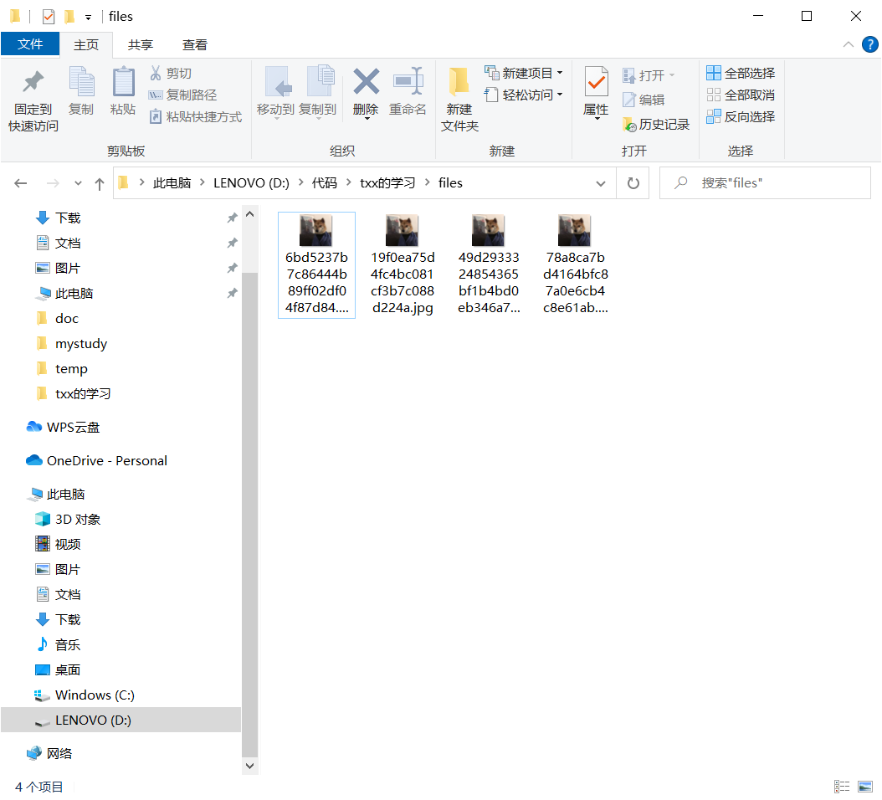
处理办法：给上传文件加一个md5,md5作为文件的唯一标识，比较这个唯一标识，看看它在这个磁盘里有没有，如果这个在磁盘里存在了，就不上传了，就把之前文件的链接拿过来用，把链接存到数据库里就行了，逻辑如下。可以实现秒传。
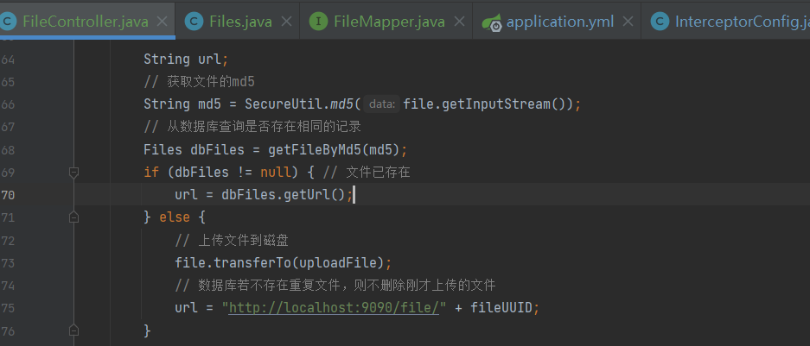
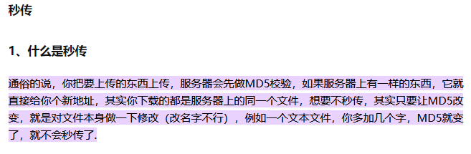
2.假删除，设置逻辑值isDelete，删除不是将数据库中的某一条记录删除，而是将数据的isDelete的这个字段修改，这样有利于上面的文件上传功能（假删除仍然保留删除字段的md5和url，在文件上传时可以实共用），也可以实现回收站功能。

遇到的问题及解决办法
1.上传头像，修改用户信息点击保存之后，右上角的头像和用户名没办法实时更新，如图。
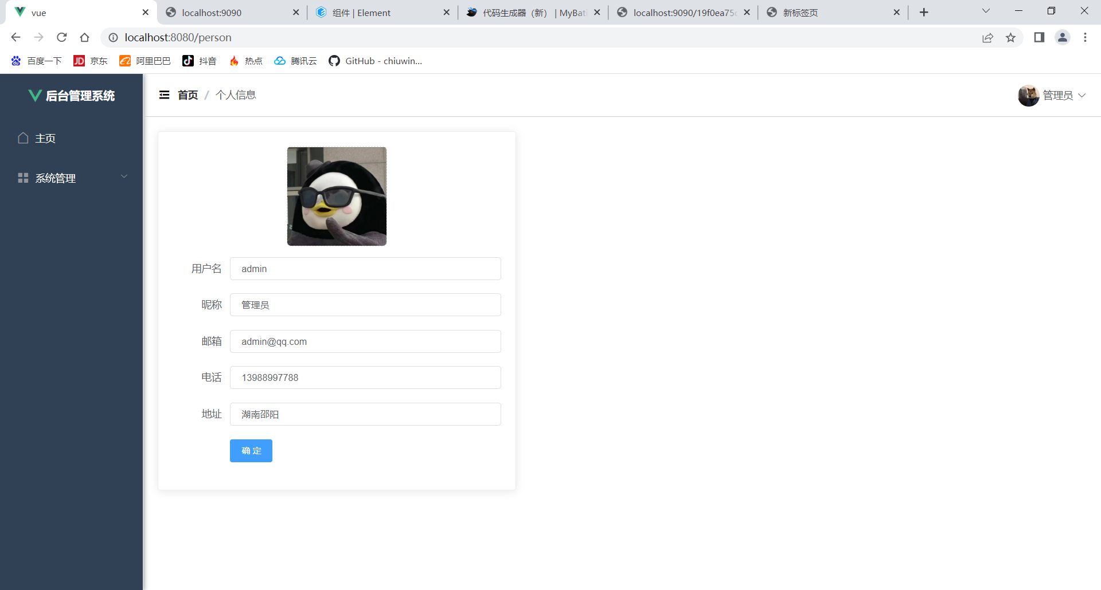
解决办法：
1.将获取用户的信息抽取成方法，放到Manage公共组件中
2. Manage将user=>父传子给header组件
3. Person，更新用户信息时，=>通过子传父触发Manage的获取用户的方法
总结: 子(方法)=>父(公共组件)=>子(数据)
person.vue
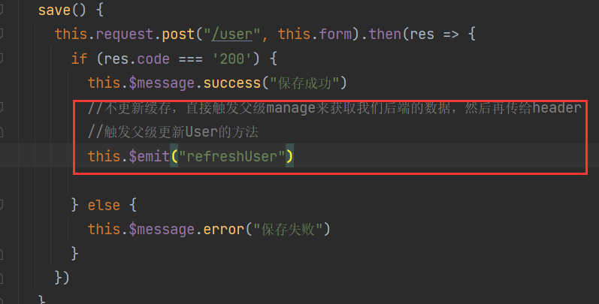
manage.vue
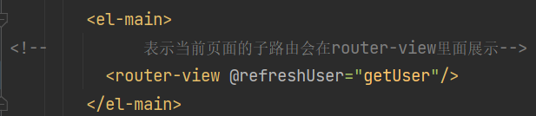
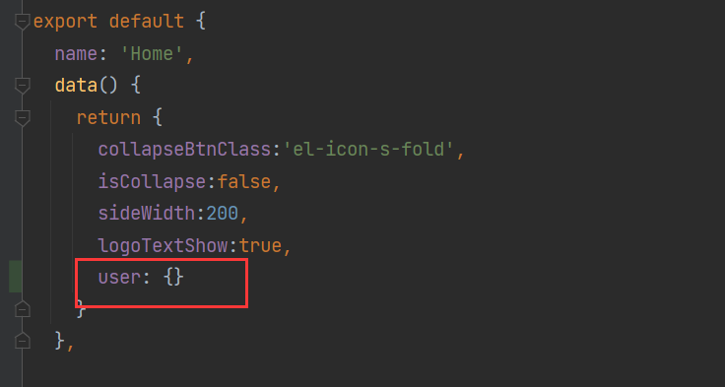
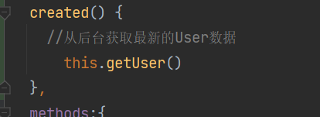
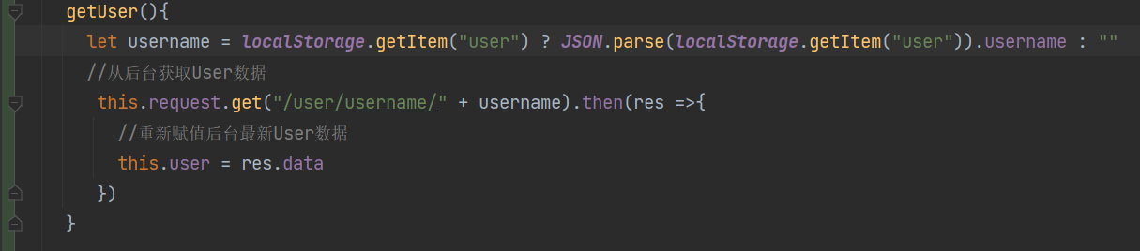
Header.vue
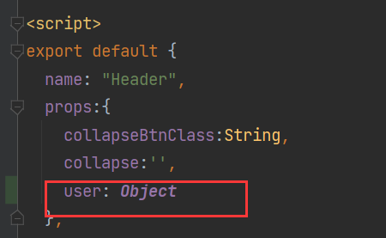

代码

InterceptorConfig.java
public void addInterceptors(InterceptorRegistry registry) {
registry.addInterceptor( jwtInterceptor())
.addPathPatterns("/**") // 拦截所有请求，通过判断token是否合法来决定是否需要登录
.excludePathPatterns("/user/login","/user/register","/**/export","/**/import","/file/**");
}

FileController.java
package com.txx.springboot.controller;
import cn.hutool.core.io.FileUtil;
import cn.hutool.core.util.IdUtil;
import cn.hutool.core.util.StrUtil;
import cn.hutool.crypto.SecureUtil;
import com.baomidou.mybatisplus.core.conditions.query.QueryWrapper;
import com.baomidou.mybatisplus.core.metadata.IPage;
import com.baomidou.mybatisplus.extension.plugins.pagination.Page;
import com.txx.springboot.common.Result;
import com.txx.springboot.entity.Files;
import com.txx.springboot.entity.User;
import com.txx.springboot.mapper.FileMapper;
import com.txx.springboot.common.Result;
import com.txx.springboot.entity.Files;
import com.txx.springboot.mapper.FileMapper;
import org.springframework.beans.factory.annotation.Value;
import org.springframework.web.bind.annotation.*;
import org.springframework.web.multipart.MultipartFile;
import javax.annotation.Resource;
import javax.servlet.ServletOutputStream;
import javax.servlet.http.HttpServletResponse;
import java.io.File;
import java.io.IOException;
import java.net.URLEncoder;
import java.util.List;
/**
* 文件上传相关接口
*/
@RestController
@RequestMapping("/file")
public class FileController {
@Value("${files.upload.path}")
private String fileUploadPath;
@Resource
private FileMapper fileMapper;
/**
* 文件上传接口
* @param file 前端传递过来的文件
* @return
* @throws IOException
*/
@PostMapping("/upload")
public String upload(@RequestParam MultipartFile file) throws IOException {
String originalFilename = file.getOriginalFilename();
String type = FileUtil.extName(originalFilename);
long size = file.getSize();
// 定义一个文件唯一的标识码
String uuid = IdUtil.fastSimpleUUID();
String fileUUID = uuid + StrUtil.DOT + type;
File uploadFile = new File(fileUploadPath + fileUUID);
// 判断配置的文件目录是否存在，若不存在则创建一个新的文件目录
File parentFile = uploadFile.getParentFile();
if(!parentFile.exists()) {
parentFile.mkdirs();
}
String url;
// 获取文件的md5
String md5 = SecureUtil.md5(file.getInputStream());
// 从数据库查询是否存在相同的记录
Files dbFiles = getFileByMd5(md5);
if (dbFiles != null) { // 文件已存在
url = dbFiles.getUrl();
} else {
// 上传文件到磁盘
file.transferTo(uploadFile);
// 数据库若不存在重复文件，则不删除刚才上传的文件
url = "http://localhost:9090/file/" + fileUUID;
}
// 存储数据库
Files saveFile = new Files();
saveFile.setName(originalFilename);
saveFile.setType(type);
saveFile.setSize(size/1024);
saveFile.setUrl(url);
saveFile.setMd5(md5);
fileMapper.insert(saveFile);
return url;
}
/**
* 文件下载接口 http://localhost:9090/file/{fileUUID}
* @param fileUUID
* @param response
* @throws IOException
*/
@GetMapping("/{fileUUID}")
public void download(@PathVariable String fileUUID, HttpServletResponse response) throws IOException {
// 根据文件的唯一标识码获取文件
File uploadFile = new File(fileUploadPath + fileUUID);
// 设置输出流的格式
ServletOutputStream os = response.getOutputStream();
response.addHeader("Content-Disposition", "attachment;filename=" + URLEncoder.encode(fileUUID, "UTF-8"));
response.setContentType("application/octet-stream");
// 读取文件的字节流
os.write(FileUtil.readBytes(uploadFile));
os.flush();
os.close();
}
/**
* 通过文件的md5查询文件
* @param md5
* @return
*/
private Files getFileByMd5(String md5) {
// 查询文件的md5是否存在
QueryWrapper<Files> queryWrapper = new QueryWrapper<>();
queryWrapper.eq("md5", md5);
List<Files> filesList = fileMapper.selectList(queryWrapper);
return filesList.size() == 0 ? null : filesList.get(0);
}
@PostMapping("/update")
public Result update(@RequestBody Files files) {
return Result.success(fileMapper.updateById(files));
}
@DeleteMapping("/{id}")
public Result delete(@PathVariable Integer id) {
Files files = fileMapper.selectById(id);
files.setIsDelete(true);
fileMapper.updateById(files);
return Result.success();
}
@PostMapping("/del/batch")
public Result deleteBatch(@RequestBody List<Integer> ids) {
// select * from sys_file where id in (id,id,id...)
QueryWrapper<Files> queryWrapper = new QueryWrapper<>();
queryWrapper.in("id", ids);
List<Files> files = fileMapper.selectList(queryWrapper);
for (Files file : files) {
file.setIsDelete(true);
fileMapper.updateById(file);
}
return Result.success();
}
/**
* 分页查询接口
* @param pageNum
* @param pageSize
* @param name
* @return
*/
@GetMapping("/page")
public Result findPage(@RequestParam Integer pageNum,
@RequestParam Integer pageSize,
@RequestParam(defaultValue = "") String name) {
QueryWrapper<Files> queryWrapper = new QueryWrapper<>();
// 查询未删除的记录
queryWrapper.eq("is_delete", false);
queryWrapper.orderByDesc("id");
if (!"".equals(name)) {
queryWrapper.like("name", name);
}
return Result.success(fileMapper.selectPage(new Page<>(pageNum, pageSize), queryWrapper));
}
}

Files.java
package com.txx.springboot.entity;
import com.baomidou.mybatisplus.annotation.IdType;
import com.baomidou.mybatisplus.annotation.TableId;
import com.baomidou.mybatisplus.annotation.TableName;
import lombok.Data;
@Data
@TableName("sys_file")
public class Files {
@TableId(type = IdType.AUTO)
private Integer id;
private String name;
private String type;
private Long size;
private String url;
private String md5;
private Boolean isDelete;
private Boolean enable;
}

FileMapper.java
package com.txx.springboot.mapper;
import com.baomidou.mybatisplus.core.mapper.BaseMapper;
import com.txx.springboot.entity.Files;
public interface FileMapper extends BaseMapper<Files> {
}

application.yml
server:
port: 9090
spring.datasource:
driver-class-name: com.mysql.cj.jdbc.Driver
url: jdbc:mysql://localhost:3306/txx?serverTimezone=GMT%2b8
username: root
password: root
mybatis:
mapper-locations: classpath:mapper/*.xml #扫描所有mybaits的xml文件，实现mapper接口和mapper接口配置文件之间的绑定
# configuration:
# log-impl: org.apache.ibatis.logging.stdout.StdOutImpl
#将mybaits优化成为mybaits-plus，所以之前mybaits打log的配置要优化成mybaits-plus打log的配置
mybatis-plus:
configuration:
log-impl: org.apache.ibatis.logging.stdout.StdOutImpl
files:
upload:
path: D:/代码/txx的学习/files/

Aside.vue
<template>
<el-menu :default-openeds="['1', '3']" style="min-height: 100%;overflow-x: hidden"
background-color="rgb(48, 65, 86)"
text-color="#fff"
active-text-color="#ffd04b"
:collapse-transition="false"
:collapse="isCollapse"
router
@select="handleSelect"
>
<div style="height:60px;text-align: center;line-height: 60px">
<img src="../assets/logo.png" alt="" style="width: 20px;position: relative;top:5px;margin-right: 5px">
<b style="color: white" v-show="logoTextShow">后台管理系统</b>
</div>
<el-menu-item index="/home">
<template ><i class="el-icon-house"></i>
<span slot="title">主页</span>
</template>
</el-menu-item>
<el-submenu index="2">
<template slot="title"><i class="el-icon-menu"></i>
<span slot="title">系统管理</span>
</template>
<el-menu-item index="/user">
<i class="el-icon-s-custom"></i>
<span slot="title">用户管理</span>
</el-menu-item>
<el-menu-item index="/file">
<i class="el-icon-document"></i>
<span slot="title">文件管理</span>
</el-menu-item>
</el-submenu>
</el-menu>
</template>
<script>
export default {
name: "Aside",
props:{
isCollapse : Boolean,
logoTextShow : Boolean
},
methods:{
handleSelect(index){
}
}
}
</script>
<style scoped>
</style>

Header.vue
<template>
<div style="line-height: 60px;display: flex">
<div style="flex: 1;">
<span :class="collapseBtnClass" style="cursor: pointer; font-size: 18px" @click="collapse"></span>
<el-breadcrumb separator="/" style="display: inline-block;margin-left: 10px">
<el-breadcrumb-item :to="'/'">首页</el-breadcrumb-item>
<el-breadcrumb-item>{{ currentPathName }}</el-breadcrumb-item>
</el-breadcrumb>
</div>
<el-dropdown style="width: 150px;cursor: pointer;text-align:right">
<div style="display: inline-block">
<img :src="user.avatarUrl" alt=""
style="width: 30px; border-radius: 50%; position: relative; top: 10px; right: 5px">
<span>{{user.nickname}}</span><i class="el-icon-arrow-down" style="margin-left: 5px"></i>
</div>
<el-dropdown-menu slot="dropdown" style="width: 100px;text-align: center">
<el-dropdown-item style="font-size: 14px; padding: 5px 0">
<router-link to="/person">个人信息</router-link>
</el-dropdown-item>
<el-dropdown-item style="font-size: 14px; padding: 5px 0">
<span style="text-decoration: none" @click="logout">退出</span>
</el-dropdown-item>
</el-dropdown-menu>
</el-dropdown>
</div>
</template>
<script>
export default {
name: "Header",
props:{
collapseBtnClass:String,
collapse:'',
user:Object
},
computed: {
currentPathName () {
return this.$store.state.currentPathName; //需要监听的数据
}
},
data(){
return{
}
},
methods:{
logout() {
this.$router.push("/login")
localStorage.removeItem("user")
this.$message.success("退出成功")
}
},
}
</script>
<style scoped>
</style>

router/index.js
import Vue from 'vue'
import VueRouter from 'vue-router'
import store from '@/store'
Vue.use(VueRouter)
const routes = [
{
path: '/',
component: () => import('../views/Manage.vue'),
redirect:"/home",
children:[
{path: 'home', name: '首页', component: () => import('../views/Home.vue')},
{path: 'user', name: '用户管理', component: () => import('../views/User.vue')},
{path: 'person', name: '个人信息', component: () => import('../views/Person.vue')},
{path: 'file', name: '文件管理', component: () => import('../views/File.vue')},
]
},
{
path: '/about',
name: 'About',
component: () => import('../views/About.vue')
},
{
path: '/login',
name: 'login',
component: () => import('../views/Login.vue')
},
{
path: '/register',
name: 'Register',
component: () => import('../views/Register.vue')
}
]
const router = new VueRouter({
mode: 'history',
base: process.env.BASE_URL,
routes
})
//路由守卫
router.beforeEach((to, from, next) =>{
localStorage.setItem("currentPathName",to.name) //设置当前的路由,为了在Header组件中使用
store.commit("setPath") //触发store的数据更新
next() //放行路由
})
export default router

File.vue
<template>
<div>
<div style="margin: 10px 0">
<el-input style="width: 200px" placeholder="请输入名称" suffix-icon="el-icon-search" v-model="name"></el-input>
<el-button class="ml-5" type="primary" @click="load">搜索</el-button>
<el-button type="warning" @click="reset">重置</el-button>
</div>
<div style="margin: 10px 0">
<el-upload action="http://localhost:9090/file/upload" :show-file-list="false" :on-success="handleFileUploadSuccess" style="display: inline-block">
<el-button type="primary" class="ml-5">上传文件 <i class="el-icon-top"></i></el-button>
</el-upload>
<el-popconfirm
class="ml-5"
confirm-button-text='确定'
cancel-button-text='我再想想'
icon="el-icon-info"
icon-color="red"
title="您确定批量删除这些数据吗？"
@confirm="delBatch"
>
<el-button type="danger" slot="reference">批量删除 <i class="el-icon-remove-outline"></i></el-button>
</el-popconfirm>
</div>
<el-table :data="tableData" border stripe :header-cell-class-name="'headerBg'" @selection-change="handleSelectionChange">
<el-table-column type="selection" width="55"></el-table-column>
<el-table-column prop="id" label="ID" width="80"></el-table-column>
<el-table-column prop="name" label="文件名称"></el-table-column>
<el-table-column prop="type" label="文件类型"></el-table-column>
<el-table-column prop="size" label="文件大小(kb)"></el-table-column>
<el-table-column label="下载">
<template slot-scope="scope">
<el-button type="primary" @click="download(scope.row.url)">下载</el-button>
</template>
</el-table-column>
<el-table-column label="启用">
<template slot-scope="scope">
<el-switch v-model="scope.row.enable" active-color="#13ce66" inactive-color="#ccc" @change="changeEnable(scope.row)"></el-switch>
</template>
</el-table-column>
<el-table-column label="操作" width="200" align="center">
<template slot-scope="scope">
<el-popconfirm
class="ml-5"
confirm-button-text='确定'
cancel-button-text='我再想想'
icon="el-icon-info"
icon-color="red"
title="您确定删除吗？"
@confirm="del(scope.row.id)"
>
<el-button type="danger" slot="reference">删除 <i class="el-icon-remove-outline"></i></el-button>
</el-popconfirm>
</template>
</el-table-column>
</el-table>
<div style="padding: 10px 0">
<el-pagination
@size-change="handleSizeChange"
@current-change="handleCurrentChange"
:current-page="pageNum"
:page-sizes="[2, 5, 10, 20]"
:page-size="pageSize"
layout="total, sizes, prev, pager, next, jumper"
:total="total">
</el-pagination>
</div>
</div>
</template>
<script>
export default {
name: "File",
data() {
return {
tableData: [],
name: '',
multipleSelection: [],
pageNum: 1,
pageSize: 10,
total: 0
}
},
created() {
this.load()
},
methods: {
load() {
this.request.get("/file/page", {
params: {
pageNum: this.pageNum,
pageSize: this.pageSize,
name: this.name,
}
}).then(res => {
this.tableData = res.data.records
this.total = res.data.total
})
},
changeEnable(row) {
this.request.post("/file/update", row).then(res => {
if (res.code === '200') {
this.$message.success("操作成功")
}
})
},
del(id) {
this.request.delete("/file/" + id).then(res => {
if (res.code === '200') {
this.$message.success("删除成功")
this.load()
} else {
this.$message.error("删除失败")
}
})
},
handleSelectionChange(val) {
console.log(val)
this.multipleSelection = val
},
delBatch() {
let ids = this.multipleSelection.map(v => v.id) // [{}, {}, {}] => [1,2,3]
this.request.post("/file/del/batch", ids).then(res => {
if (res.code === '200') {
this.$message.success("批量删除成功")
this.load()
} else {
this.$message.error("批量删除失败")
}
})
},
reset() {
this.name = ""
this.load()
},
handleSizeChange(pageSize) {
console.log(pageSize)
this.pageSize = pageSize
this.load()
},
handleCurrentChange(pageNum) {
console.log(pageNum)
this.pageNum = pageNum
this.load()
},
handleFileUploadSuccess(res) {
console.log(res)
this.load()
},
download(url) {
window.open(url)
}
}
}
</script>
<style scoped>
</style>

Manage.vue
<template>
<el-container style="min-height: 100vh">
<el-aside :width="sideWidth+'px'" style="background-color: rgb(238, 241, 246);box-shadow: 2px 0 6px rgb(0 21 41 / 35%);">
<Aside :isCollapse="isCollapse" :logoTextShow="logoTextShow"/>
</el-aside>
<el-container>
<el-header style="border-bottom: 1px solid #ccc;">
<Header :collapseBtnClass="collapseBtnClass" :collapse="collapse" :user="user"/>
</el-header>
<el-main>
<!-- 表示当前页面的子路由会在router-view里面展示-->
<router-view @refreshUser="getUser"/>
</el-main>
</el-container>
</el-container>
</template>
<script>
import Aside from "@/components/Aside";
import Header from "@/components/Header";
export default {
name: 'Home',
data() {
return {
collapseBtnClass:'el-icon-s-fold',
isCollapse:false,
sideWidth:200,
logoTextShow:true,
user: {}
}
},
components:{
Aside,
Header
},
created() {
//从后台获取最新的User数据
this.getUser()
},
methods:{
collapse(){ //点击收缩按钮触发
this.isCollapse=!this.isCollapse
if(this.isCollapse){ //收缩
this.sideWidth=64
this.collapseBtnClass='el-icon-s-unfold'
this.logoTextShow=false
}
else { //展开
this.sideWidth=200
this.collapseBtnClass='el-icon-s-fold'
this.logoTextShow=true
}
},
getUser(){
let username = localStorage.getItem("user") ? JSON.parse(localStorage.getItem("user")).username : ""
//从后台获取User数据
this.request.get("/user/username/" + username).then(res =>{
//重新赋值后台最新User数据
this.user = res.data
})
}
}
}
</script>
<style>
.headerBg{
background-color: #eee !important;
}
</style>

Person.vue
<template>
<el-card style="width: 500px;">
<el-form label-width="80px" size="small">
<el-upload
class="avatar-uploader"
action="http://localhost:9090/file/upload"
:show-file-list="false"
:on-success="handleAvatarSuccess"
>
<img v-if="form.avatarUrl" :src="form.avatarUrl" class="avatar">
<i v-else class="el-icon-plus avatar-uploader-icon"></i>
</el-upload>
<el-form-item label="用户名">
<el-input v-model="form.username" autocomplete="off"></el-input>
</el-form-item>
<el-form-item label="昵称">
<el-input v-model="form.nickname" autocomplete="off"></el-input>
</el-form-item>
<el-form-item label="邮箱">
<el-input v-model="form.email" autocomplete="off"></el-input>
</el-form-item>
<el-form-item label="电话">
<el-input v-model="form.phone" autocomplete="off"></el-input>
</el-form-item>
<el-form-item label="地址">
<el-input v-model="form.address" autocomplete="off"></el-input>
</el-form-item>
<el-form-item>
<el-button type="primary" @click="save">确 定</el-button>
</el-form-item>
</el-form>
</el-card>
</template>
<script>
export default {
name: "Person",
data() {
return {
form: {},
user: localStorage.getItem("user") ? JSON.parse(localStorage.getItem("user")) : {}
}
},
created() {
this.getUser().then(res => {
console.log(res)
this.form = res
})
},
methods: {
async getUser() {
return (await this.request.get("/user/username/" + this.user.username)).data
},
save() {
this.request.post("/user", this.form).then(res => {
if (res.code === '200') {
this.$message.success("保存成功")
//触发父级更新User的方法
this.$emit("refreshUser")
} else {
this.$message.error("保存失败")
}
})
},
handleAvatarSuccess(res) {
this.form.avatarUrl = res
}
}
}
</script>
<style>
.avatar-uploader {
text-align: center;
padding-bottom: 10px;
}
.avatar-uploader .el-upload {
border: 1px dashed #d9d9d9;
border-radius: 6px;
cursor: pointer;
position: relative;
overflow: hidden;
}
.avatar-uploader .el-upload:hover {
border-color: #409EFF;
}
.avatar-uploader-icon {
font-size: 28px;
color: #8c939d;
width: 138px;
height: 138px;
line-height: 138px;
text-align: center;
}
.avatar {
width: 138px;
height: 138px;
display: block;
}
</style>

