在整体布局上：菜单+头部+主题都发生了修改，菜单收缩+菜单颜色+头部下拉框完善
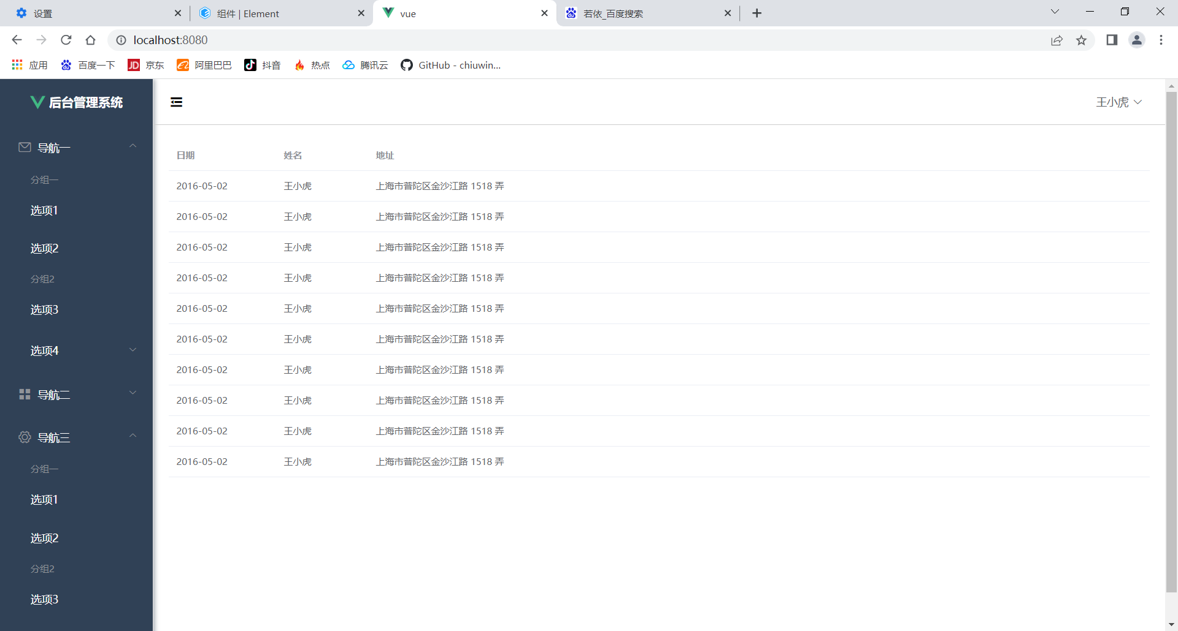
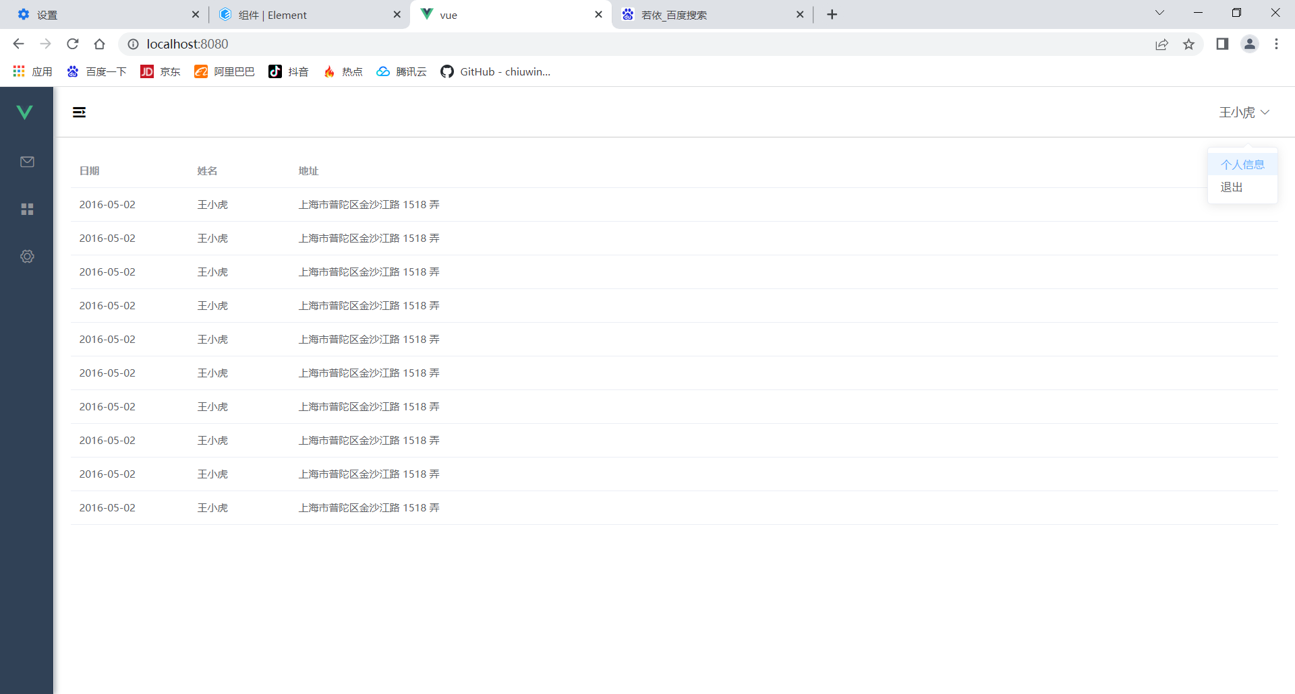
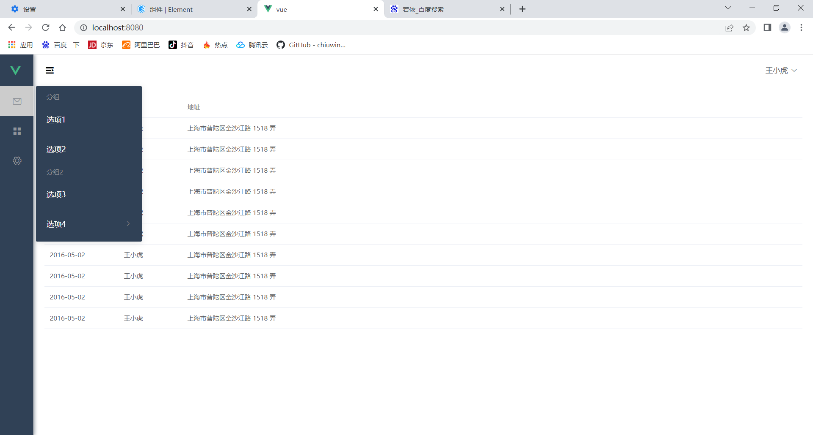
修改的代码如下：

global.css
*{
margin: 0;
padding: 0;
box-sizing: border-box;
}

HomeView.vue
<template>
<el-container style="min-height: 100vh">
<el-aside :width="sideWidth+'px'" style="background-color: rgb(238, 241, 246);box-shadow: 2px 0 6px rgb(0 21 41 / 35%);">
<el-menu :default-openeds="['1', '3']" style="min-height: 100%;overflow-x: hidden"
background-color="rgb(48, 65, 86)"
text-color="#fff"
active-text-color="#ffd04b"
:collapse-transition="false"
:collapse="isCollapse"
>
<div style="height:60px;text-align: center;line-height: 60px">
<img src="../assets/logo.png" alt="" style="width: 20px;position: relative;top:5px;margin-right: 5px">
<b style="color: white" v-show="logoTextShow">后台管理系统</b>
</div>
<el-submenu index="1">
<template slot="title"><i class="el-icon-message"></i>
<span slot="title">导航一</span>
</template>
<el-menu-item-group>
<template slot="title">分组一</template>
<el-menu-item index="1-1">选项1</el-menu-item>
<el-menu-item index="1-2">选项2</el-menu-item>
</el-menu-item-group>
<el-menu-item-group title="分组2">
<el-menu-item index="1-3">选项3</el-menu-item>
</el-menu-item-group>
<el-submenu index="1-4">
<template slot="title">选项4</template>
<el-menu-item index="1-4-1">选项4-1</el-menu-item>
</el-submenu>
</el-submenu>
<el-submenu index="2">
<template slot="title"><i class="el-icon-menu"></i>
<span slot="title">导航二</span>
</template>
<el-menu-item-group>
<template slot="title">分组一</template>
<el-menu-item index="2-1">选项1</el-menu-item>
<el-menu-item index="2-2">选项2</el-menu-item>
</el-menu-item-group>
<el-menu-item-group title="分组2">
<el-menu-item index="2-3">选项3</el-menu-item>
</el-menu-item-group>
<el-submenu index="2-4">
<template slot="title">选项4</template>
<el-menu-item index="2-4-1">选项4-1</el-menu-item>
</el-submenu>
</el-submenu>
<el-submenu index="3">
<template slot="title"><i class="el-icon-setting"></i>
<span slot="title">导航三</span>
</template>
<el-menu-item-group>
<template slot="title">分组一</template>
<el-menu-item index="3-1">选项1</el-menu-item>
<el-menu-item index="3-2">选项2</el-menu-item>
</el-menu-item-group>
<el-menu-item-group title="分组2">
<el-menu-item index="3-3">选项3</el-menu-item>
</el-menu-item-group>
<el-submenu index="3-4">
<template slot="title">选项4</template>
<el-menu-item index="3-4-1">选项4-1</el-menu-item>
</el-submenu>
</el-submenu>
</el-menu>
</el-aside>
<el-container>
<el-header style="font-size: 12px; border-bottom: 1px solid #ccc; line-height: 60px;display: flex">
<div style="flex: 1; font-size: 20px">
<span :class="collapseBtnClass" style="cursor: pointer" @click="collapse"></span>
</div>
<el-dropdown style="width: 70px">
<span style="cursor: pointer">王小虎</span><i class="el-icon-arrow-down" style="margin-left: 5px"></i>
<el-dropdown-menu slot="dropdown">
<el-dropdown-item>个人信息</el-dropdown-item>
<el-dropdown-item>退出</el-dropdown-item>
</el-dropdown-menu>
</el-dropdown>
</el-header>
<el-main>
<el-table :data="tableData">
<el-table-column prop="date" label="日期" width="140">
</el-table-column>
<el-table-column prop="name" label="姓名" width="120">
</el-table-column>
<el-table-column prop="address" label="地址">
</el-table-column>
</el-table>
</el-main>
</el-container>
</el-container>
</template>
<script>
export default {
name: 'Home',
data() {
const item = {
date: '2016-05-02',
name: '王小虎',
address: '上海市普陀区金沙江路 1518 弄'
};
return {
tableData: Array(10).fill(item),
msg: "hello 唐湘",
collapseBtnClass:'el-icon-s-fold',
isCollapse:false,
sideWidth:200,
logoTextShow:true
}
},
methods:{
collapse(){ //点击收缩按钮触发
this.isCollapse=!this.isCollapse
if(this.isCollapse){ //收缩
this.sideWidth=64
this.collapseBtnClass='el-icon-s-unfold'
this.logoTextShow=false
}
else { //展开
this.sideWidth=200
this.collapseBtnClass='el-icon-s-fold'
this.logoTextShow=true
}
}
}
}
</script>
App.vue
<template>
<div id="app">
<router-view/>
</div>
</template>
<style>
</style>

