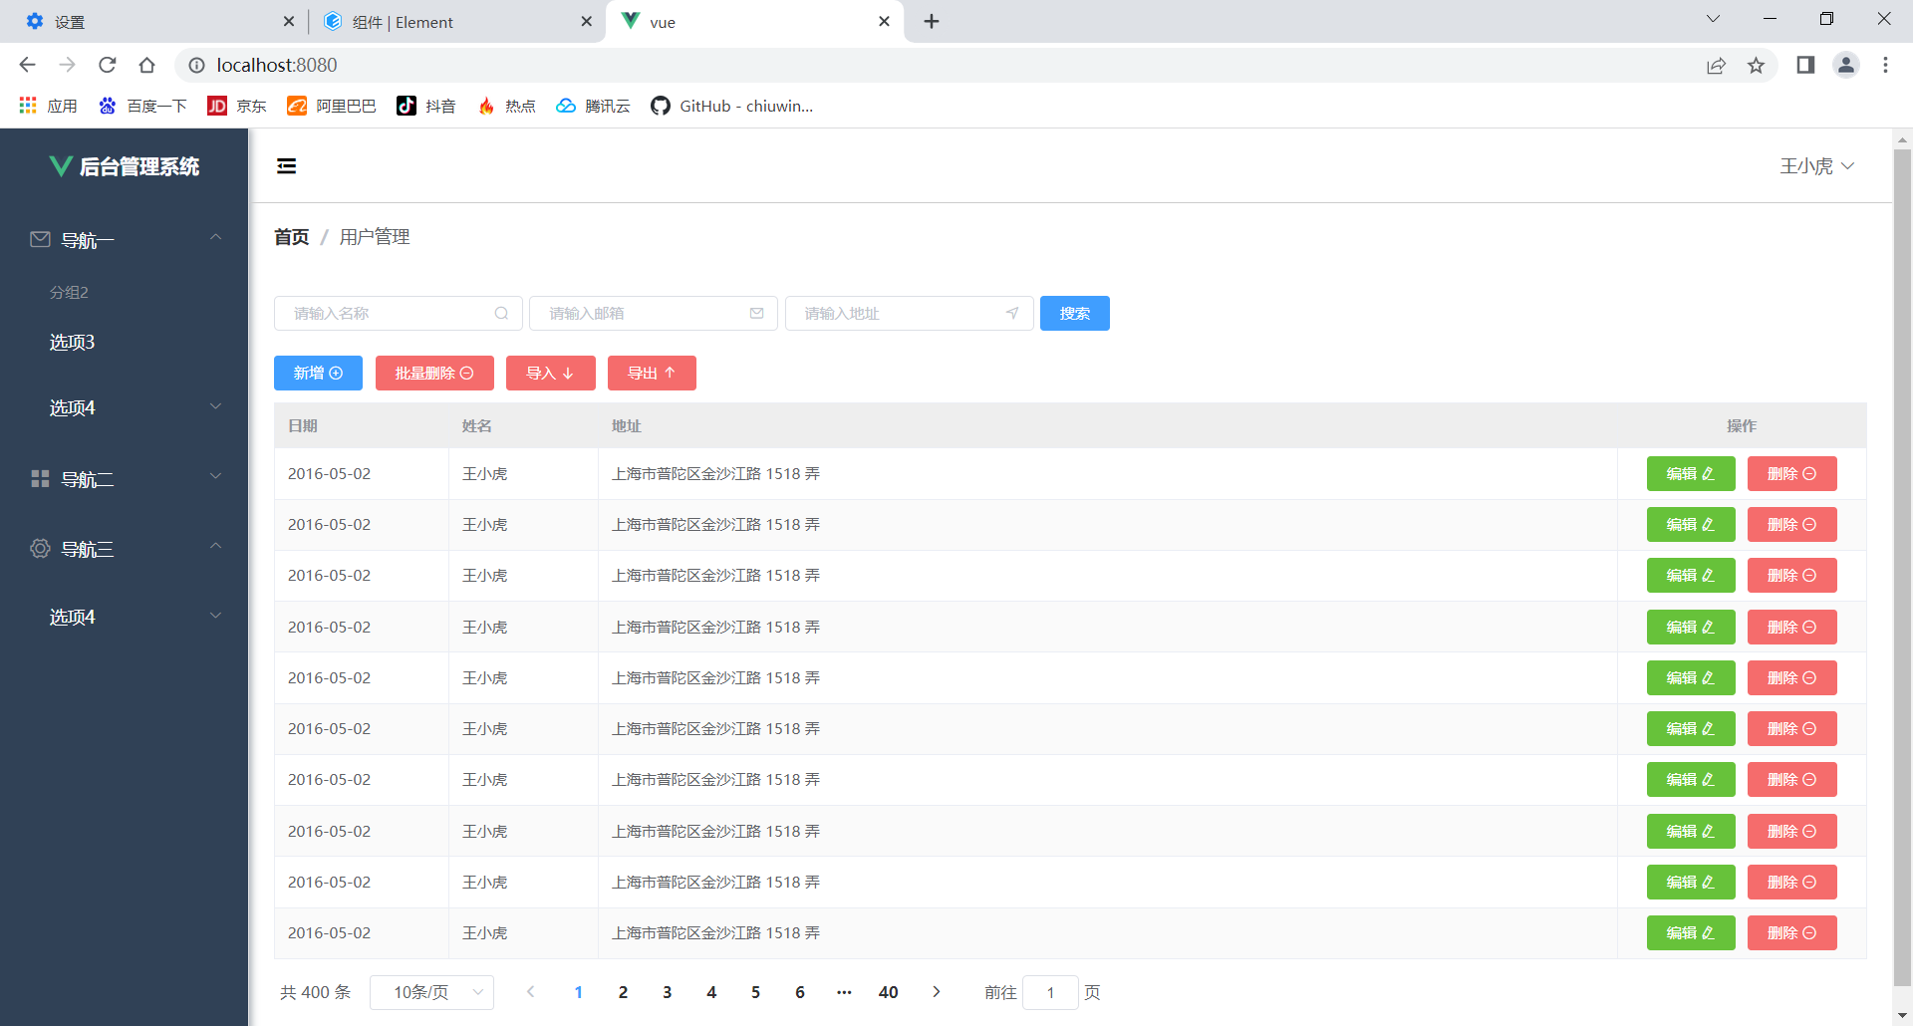
1.整理表格的样式
2.新增按钮(具备基本的增删改查功能)
3.分页功能的前端实现

global.css
*{
margin: 0;
padding: 0;
box-sizing: border-box;
}
.ml-5{
margin-left: 5px;
}
.mr-5{
margin-right: 5px;
}
.pd-10{
padding: 10px 0;
}

HomeView.vue
<template>
<el-container style="min-height: 100vh">
<el-aside :width="sideWidth+'px'" style="background-color: rgb(238, 241, 246);box-shadow: 2px 0 6px rgb(0 21 41 / 35%);">
<el-menu :default-openeds="['1', '3']" style="min-height: 100%;overflow-x: hidden"
background-color="rgb(48, 65, 86)"
text-color="#fff"
active-text-color="#ffd04b"
:collapse-transition="false"
:collapse="isCollapse"
>
<div style="height:60px;text-align: center;line-height: 60px">
<img src="../assets/logo.png" alt="" style="width: 20px;position: relative;top:5px;margin-right: 5px">
<b style="color: white" v-show="logoTextShow">后台管理系统</b>
</div>
<el-submenu index="1">
<template slot="title"><i class="el-icon-message"></i>
<span slot="title">导航一</span>
</template>
<el-menu-item-group title="分组2">
<el-menu-item index="1-3">选项3</el-menu-item>
</el-menu-item-group>
<el-submenu index="1-4">
<template slot="title">选项4</template>
<el-menu-item index="1-4-1">选项4-1</el-menu-item>
</el-submenu>
</el-submenu>
<el-submenu index="2">
<template slot="title"><i class="el-icon-menu"></i>
<span slot="title">导航二</span>
</template>
<el-submenu index="2-4">
<template slot="title">选项4</template>
<el-menu-item index="2-4-1">选项4-1</el-menu-item>
</el-submenu>
</el-submenu>
<el-submenu index="3">
<template slot="title"><i class="el-icon-setting"></i>
<span slot="title">导航三</span>
</template>
<el-submenu index="3-4">
<template slot="title">选项4</template>
<el-menu-item index="3-4-1">选项4-1</el-menu-item>
</el-submenu>
</el-submenu>
</el-menu>
</el-aside>
<el-container>
<el-header style="font-size: 12px; border-bottom: 1px solid #ccc; line-height: 60px;display: flex">
<div style="flex: 1; font-size: 20px">
<span :class="collapseBtnClass" style="cursor: pointer" @click="collapse"></span>
</div>
<el-dropdown style="width: 70px">
<span style="cursor: pointer">王小虎</span><i class="el-icon-arrow-down" style="margin-left: 5px"></i>
<el-dropdown-menu slot="dropdown">
<el-dropdown-item>个人信息</el-dropdown-item>
<el-dropdown-item>退出</el-dropdown-item>
</el-dropdown-menu>
</el-dropdown>
</el-header>
<el-main>
<div style="margin-bottom: 30px">
<el-breadcrumb separator="/">
<el-breadcrumb-item :to="{ path: '/' }">首页</el-breadcrumb-item>
<el-breadcrumb-item>用户管理</el-breadcrumb-item>
</el-breadcrumb>
</div>
<div style="padding: 10px 0">
<el-input style="width: 200px" placeholder="请输入名称" suffix-icon="el-icon-search"></el-input>
<el-input style="width: 200px" placeholder="请输入邮箱" suffix-icon="el-icon-message" class="ml-5"></el-input>
<el-input style="width: 200px" placeholder="请输入地址" suffix-icon="el-icon-position" class="ml-5"></el-input><el-button class="ml-5" type="primary">搜索</el-button>
</div>
<div style="margin: 10px 0">
<el-button type="primary">新增 <i class="el-icon-circle-plus-outline"></i></el-button>
<el-button type="danger">批量删除 <i class="el-icon-remove-outline"></i></el-button>
<el-button type="danger">导入 <i class="el-icon-bottom"></i></el-button>
<el-button type="danger">导出 <i class="el-icon-top"></i></el-button>
</div>
<el-table :data="tableData" border stripe header-cell-class-name="headerBg">
<el-table-column prop="date" label="日期" width="140">
</el-table-column>
<el-table-column prop="name" label="姓名" width="120">
</el-table-column>
<el-table-column prop="address" label="地址">
</el-table-column>
<el-table-column label="操作" width="200" align="center">
<template slot-scope="scope">
<el-button type="success">编辑 <i class="el-icon-edit"></i></el-button>
<el-button type="danger">删除 <i class="el-icon-remove-outline"></i></el-button>
</template>
</el-table-column>
</el-table>
<div style="padding: 10px 0">
<el-pagination
:page-sizes="[5, 10, 15, 20]"
:page-size="10"
layout="total, sizes, prev, pager, next, jumper"
:total="400">
</el-pagination>
</div>
</el-main>
</el-container>
</el-container>
</template>
<script>
export default {
name: 'Home',
data() {
const item = {
date: '2016-05-02',
name: '王小虎',
address: '上海市普陀区金沙江路 1518 弄'
};
return {
tableData: Array(10).fill(item),
msg: "hello 唐湘",
collapseBtnClass:'el-icon-s-fold',
isCollapse:false,
sideWidth:200,
logoTextShow:true,
headerBg:'headerBg'
}
},
methods:{
collapse(){ //点击收缩按钮触发
this.isCollapse=!this.isCollapse
if(this.isCollapse){ //收缩
this.sideWidth=64
this.collapseBtnClass='el-icon-s-unfold'
this.logoTextShow=false
}
else { //展开
this.sideWidth=200
this.collapseBtnClass='el-icon-s-fold'
this.logoTextShow=true
}
}
}
}
</script>
<style>
.headerBg{
background-color: #eee !important;
}
</style>

main.js
import Vue from 'vue'
import App from './App.vue'
import router from './router'
import ElementUI from 'element-ui';
import 'element-ui/lib/theme-chalk/index.css';
import './assets/global.css'
Vue.config.productionTip = false
Vue.use(ElementUI,{size:"mini"});
new Vue({
router,
render: h => h(App)
}).$mount('#app')

