Patient record page:

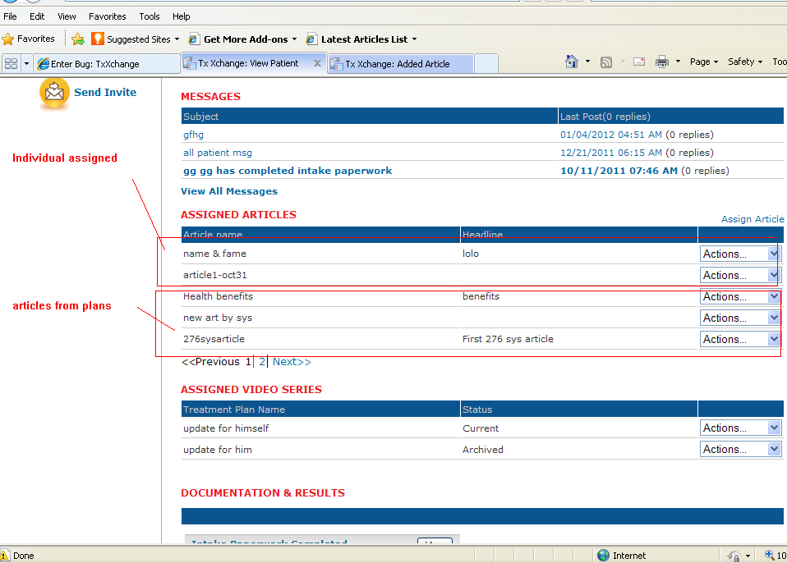

Assign Article Page:

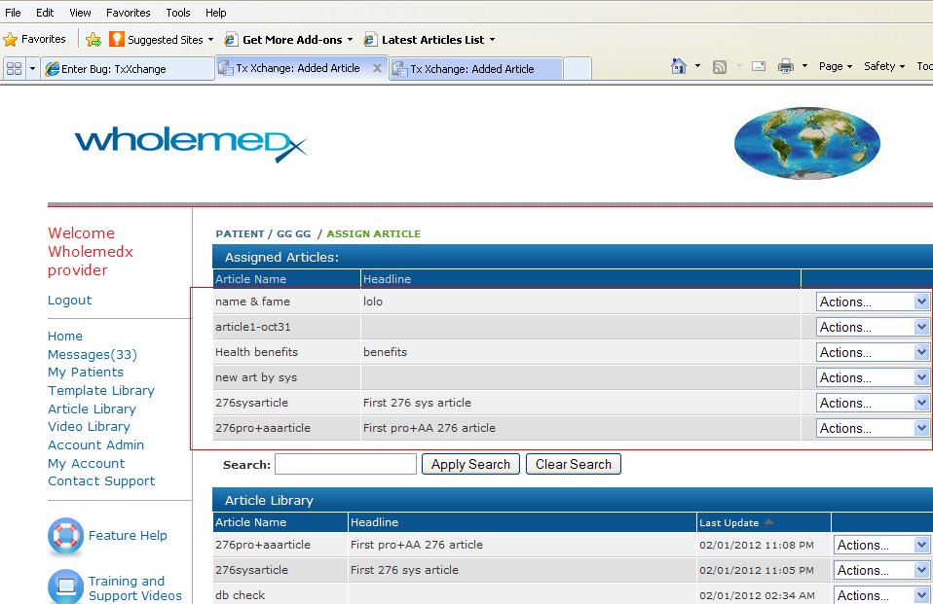

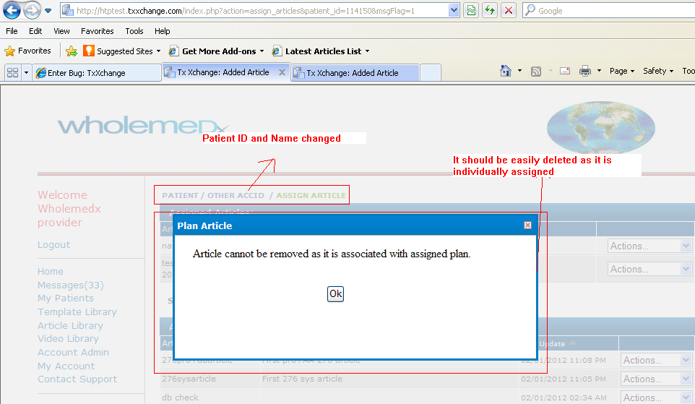

Record Page also changed:

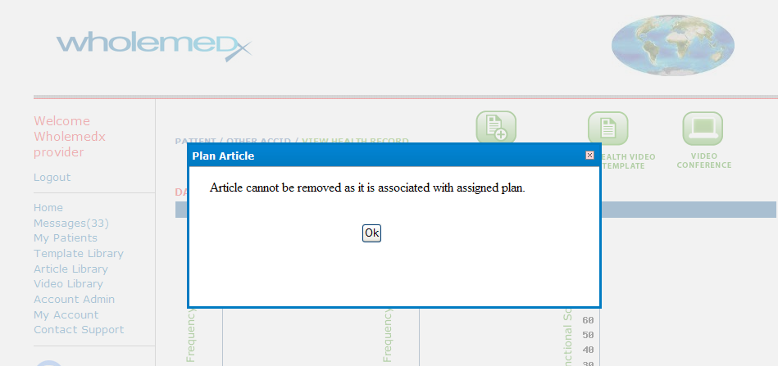

When individually assign an article which is already associated with any plan and assigned to other patient then on removing it creates above scenario.