运行结果：
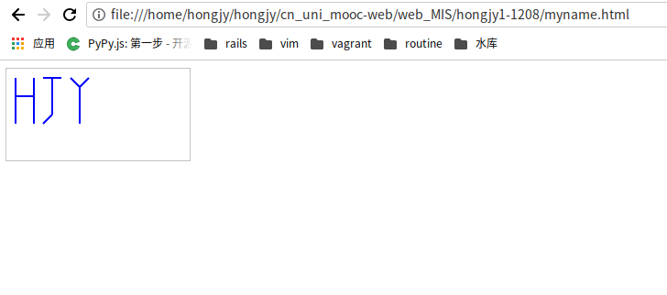

源代码：
<!doctype html>
<html>
<head>
<meta charset="utf-8">
<title>draw name</title>
</head>
<body>
<canvas id="myCanvas" width="200" height="100" style="border:1px solid #c3c3c3;">
</canvas>
<script type="text/javascript">
var c=document.getElementById("myCanvas");
var cxt=c.getContext("2d");
cxt.strokeStyle="#0000ff";
cxt.lineWidth="2";

//draw ‘Ｈ’
cxt.moveTo(10,10);
cxt.lineTo(10,60);
cxt.moveTo(30,10);
cxt.lineTo(30,60);
cxt.moveTo(10,30);
cxt.lineTo(30,30);

//draw ‘J’
cxt.moveTo(40,10);
cxt.lineTo(60,10);
cxt.moveTo(50,10);
cxt.lineTo(50,50);
cxt.moveTo(50,50);
cxt.lineTo(40,60);

//draw ‘Ｙ’
cxt.moveTo(70,10);
cxt.lineTo(80,20);
cxt.moveTo(90,10);
cxt.lineTo(80,20);
cxt.moveTo(80,20);
cxt.lineTo(80,60);

cxt.stroke();
</script>
</body>
</html>

