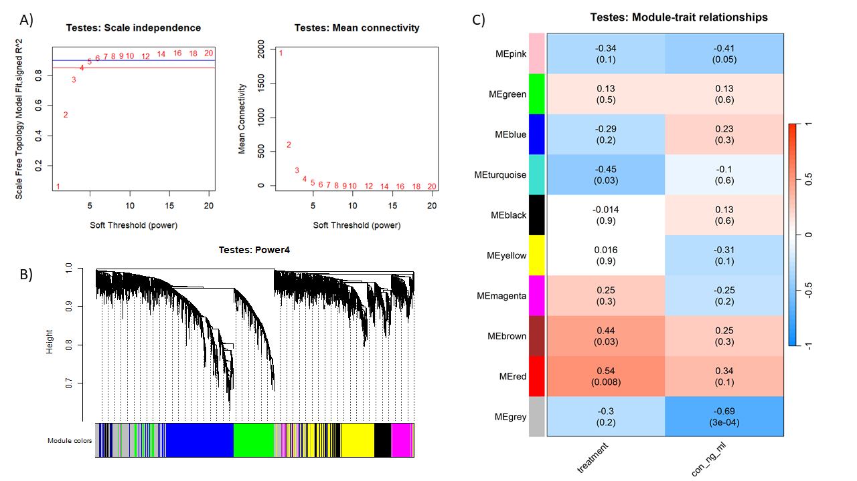

**Supplemental Figure 1:** WGCNA Soft threshold plots (A), Dendrograms (B), and Module correlation heatmaps (C) for all 23 ovary samples.

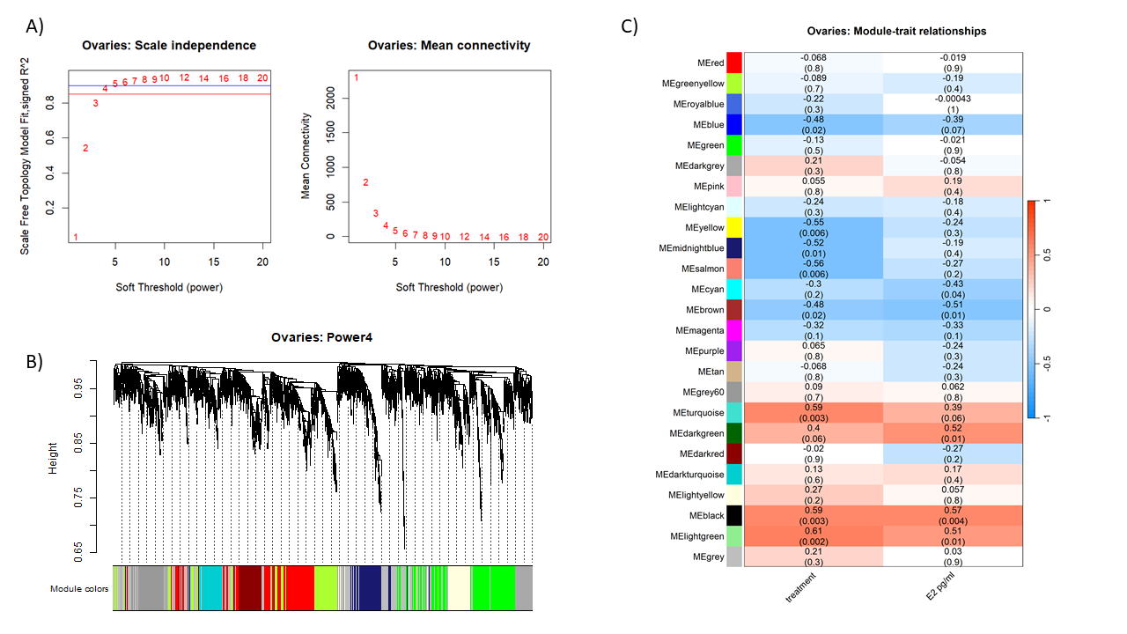**Supplemental Figure 2:** WGCNA Soft threshold plots (A), Dendrograms (B), and Module correlation heatmaps (C) for all 23 testis samples.

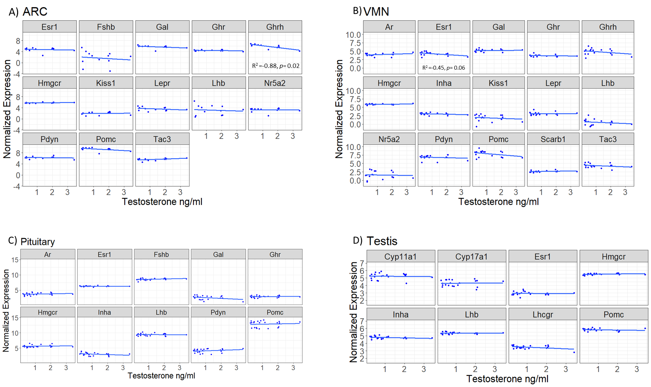

**Supplemental Figure 3:** Log normalized expression levels of a priori selected genes plotted against serum testosterone (ng/ml) for all male tissues: (A) arcuate nucleus (ARC), (B) ventromedial nucleus (VMN), (C) anterior pituitary (Pituitary) and (D) testes. Dots represent individuals with a line of best fit.

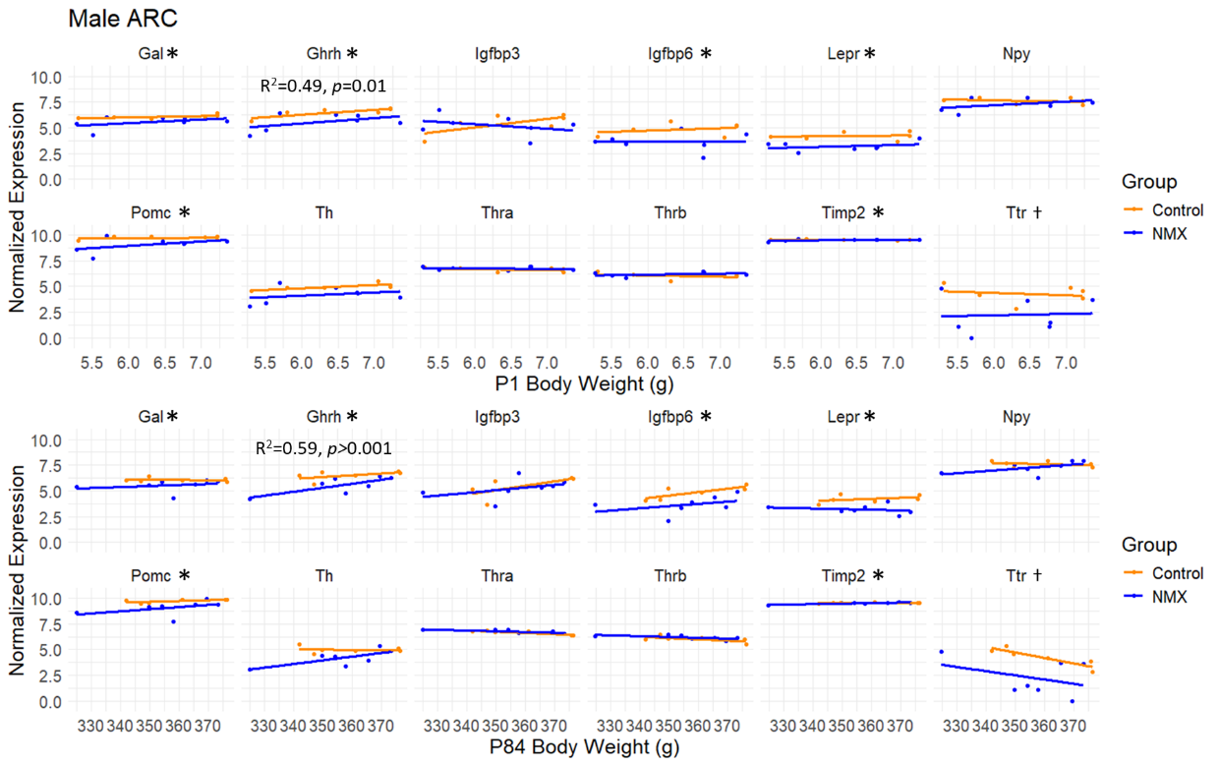

**Supplemental Figure 4:** Log-normalized expression levels of metabolic signaling genes plotted against body weight in grams (g) at P1 (infancy; top panels) and P84 (adulthood; bottom panels) in the arcuate nucleus (ARC) of control (orange) and NMX-exposed (blue) male rats. Dots represents an individual animal, and lines indicate the best-fit linear regression for each group. Asterisks next to gene names indicate genes that were significantly differentially expressed between groups.

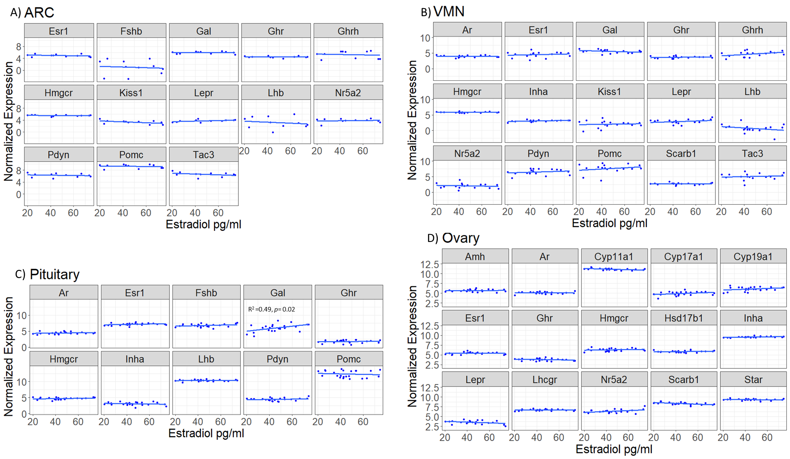

**Supplemental Figure 5****:** Log normalized counts of *a priori* selected genes related to estrogen signaling plotted against serum estradiol pg/ml for all female tissues: (A) arcuate nucleus (ARC) and (B) ventromedial nucleus (VMN) of the hypothalamus, (C) anterior pituitary (Pituitary), and (D) ovary. Dots represent individuals with a line of best fit.

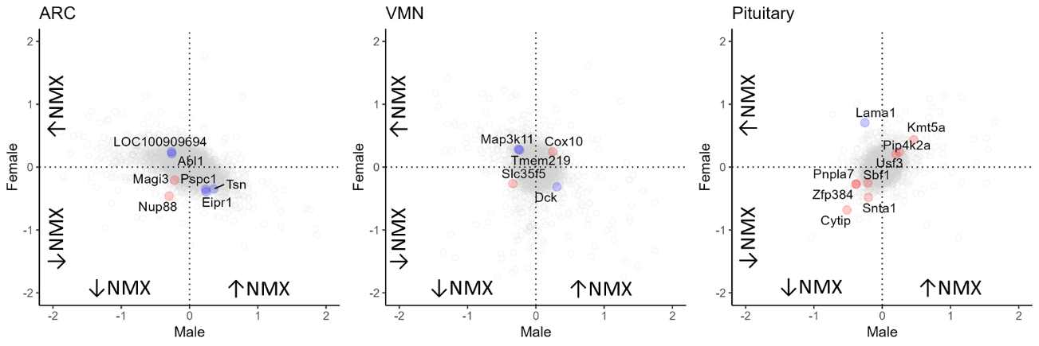

**Supplemental Figure 6:** Overlapping gene expression between male and female samples across the A) ARC, B) VMN, and C) pituitary. Y-axis represent female log2fold change and X axis represents male log2fold change. Gray points are significant DEGs in only one sex. Red points are significant DEGs in the same direction in both sexes and blue points are significant DEGs in the opposite direction in both sexes.

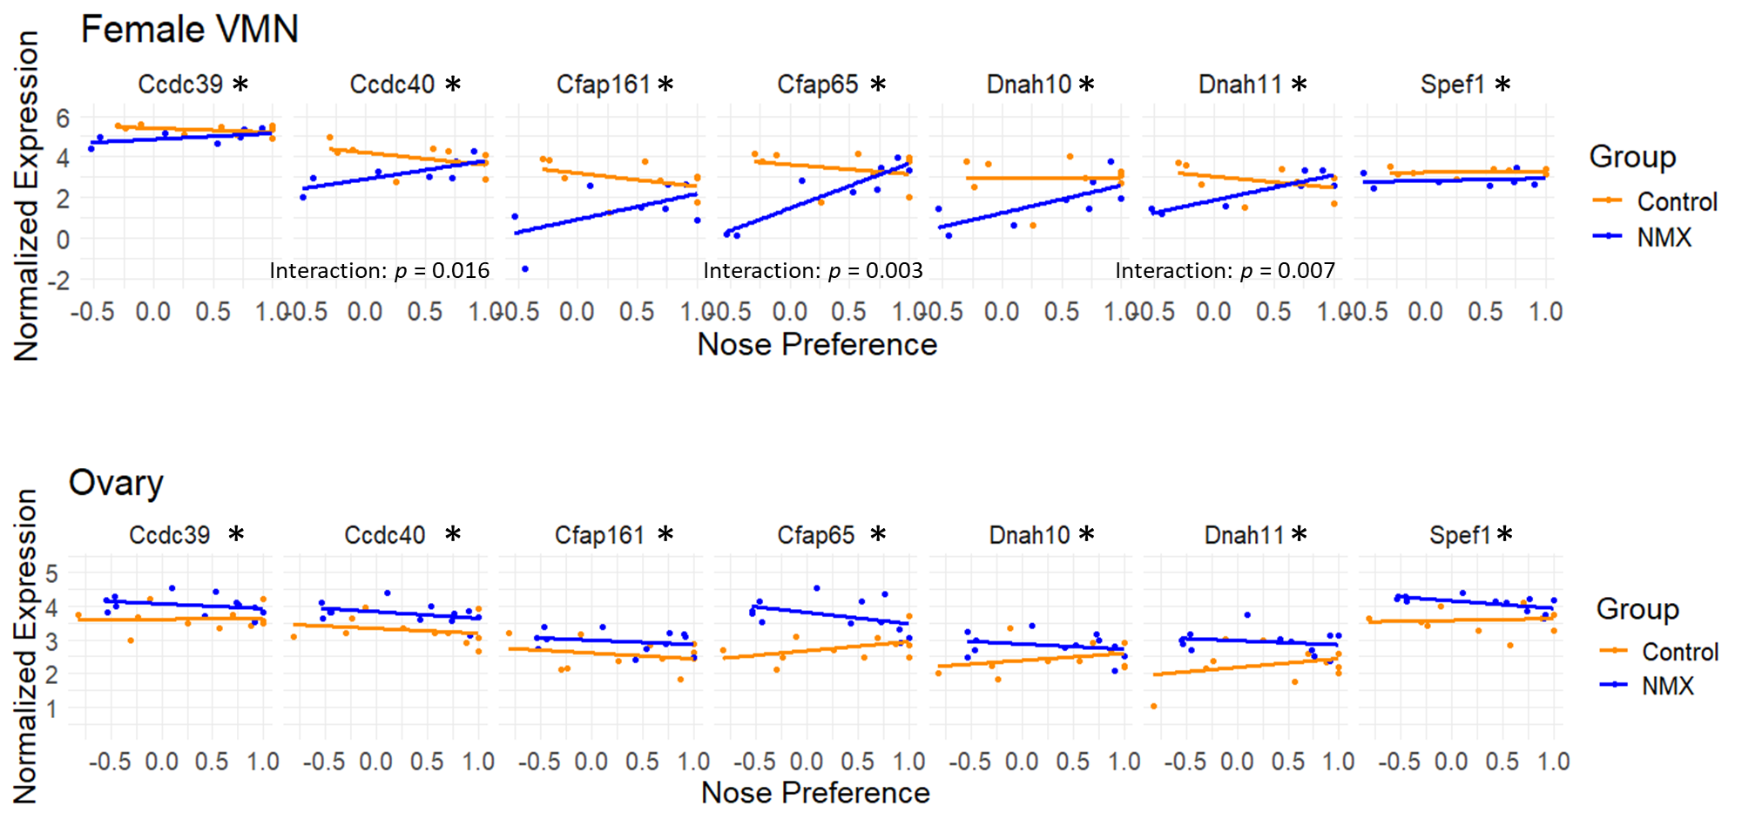

**Supplemental Figure 7:** Log-normalized expression levels of cilia-related genes plotted against hormone preference, measured as time spent nose-touching the hormone stimulus during the mate preference test (data from Gore et al., 2022). Gene expression in the ventromedial nucleus (VMN) is shown in the top panels, and expression in the ovary is shown in the bottom panels, for control (orange) and NMX-exposed (blue) male rats. Each point represents an individual animal, and lines represent the best-fit linear regression for each group. Asterisks next to gene names indicate significant differential expression between groups.