* Check the circle for ***Installer disc image file (iso):*** then click **Browse…** to access the appropriate CentOS iso file from the computer:

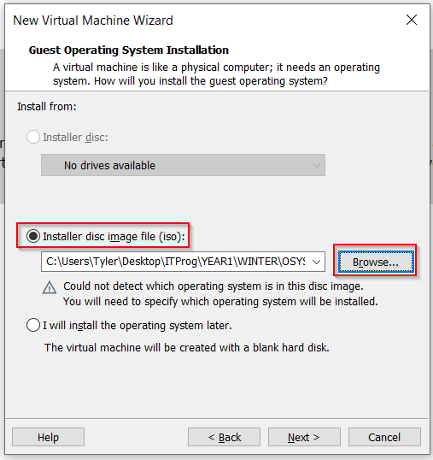

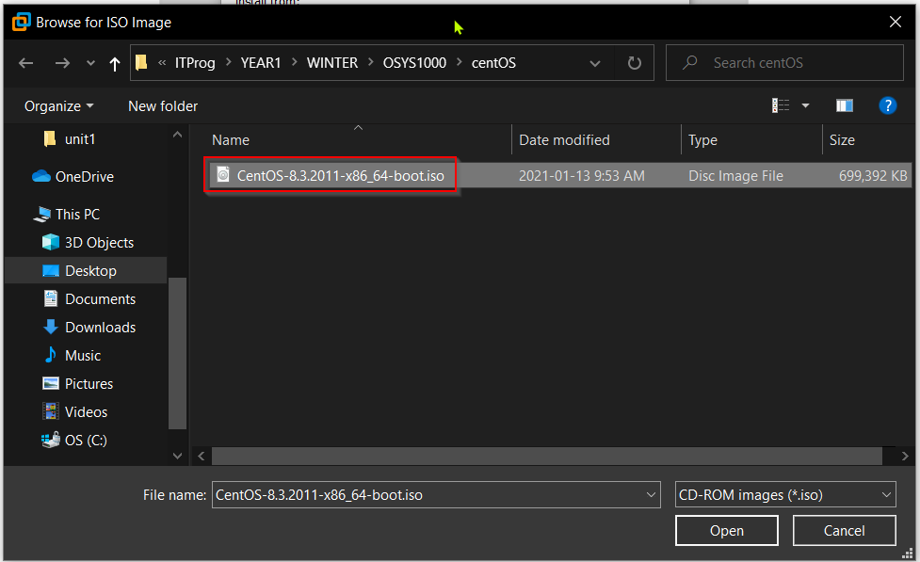

* Check the circle for **Linux** operating system. Select **CentOS 8 64-bit** from the *Version* drop-down menu:

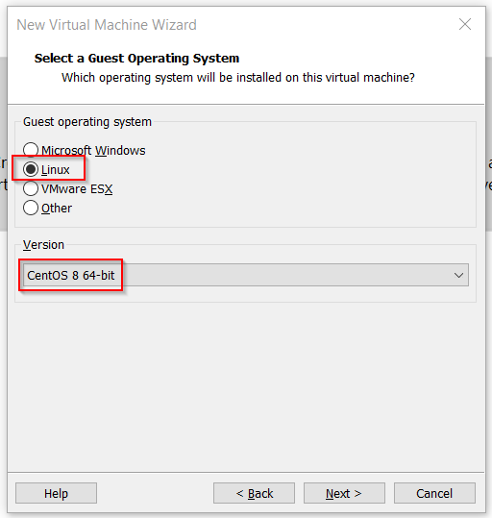

* Select **Root Password:**

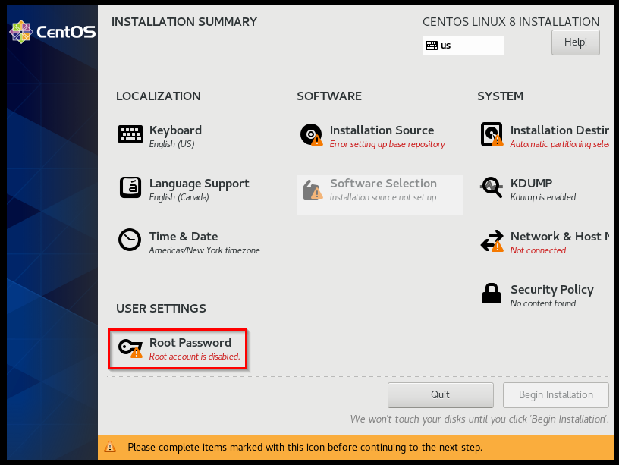

* Enter **student#1** as the password for both the *Root Password:* and *Confirm:* boxes. Because this is a *Weak* password, click **Done** twice to confirm:

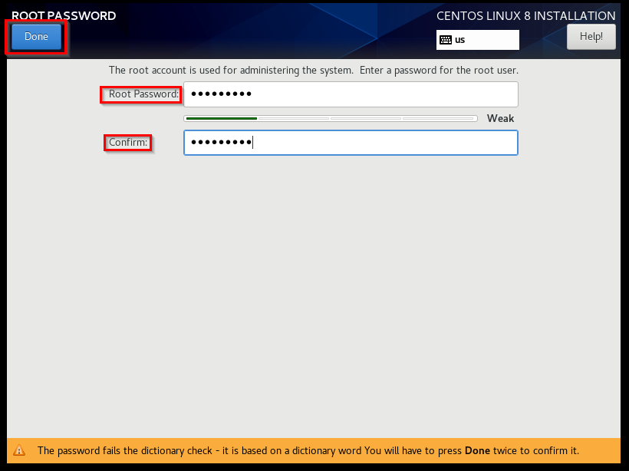

* Select **Network & Host:**

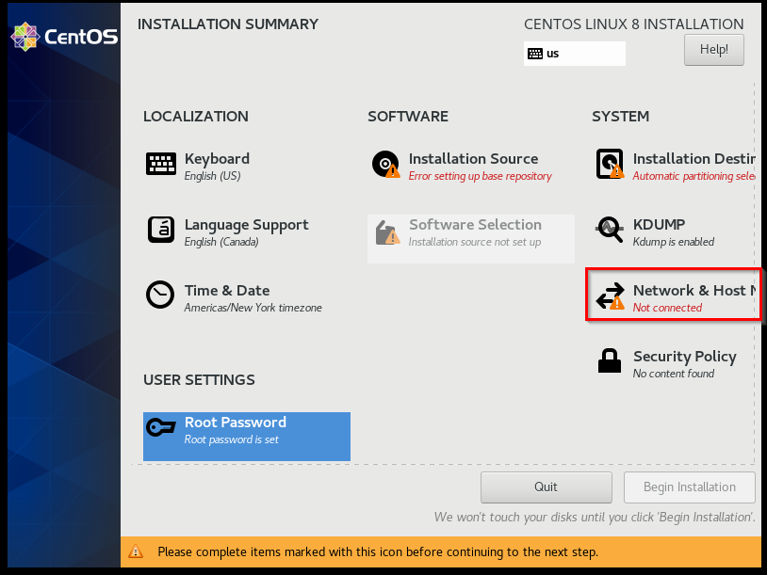

* Click button to the right of *Ethernet (ens33)* to switch it to **ON**. Click **Done**:

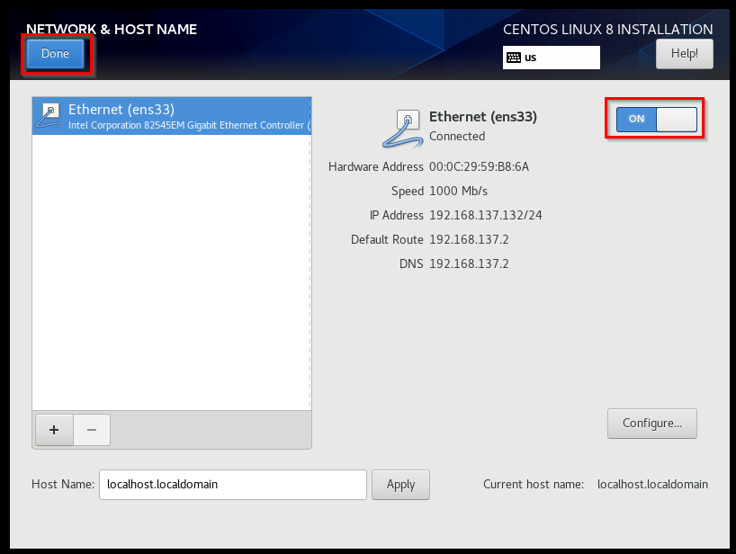

* Select **Installation Destination**:

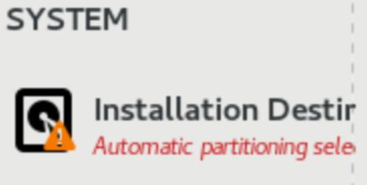

* Ensure the correct drive is checked off. Click **Done**:

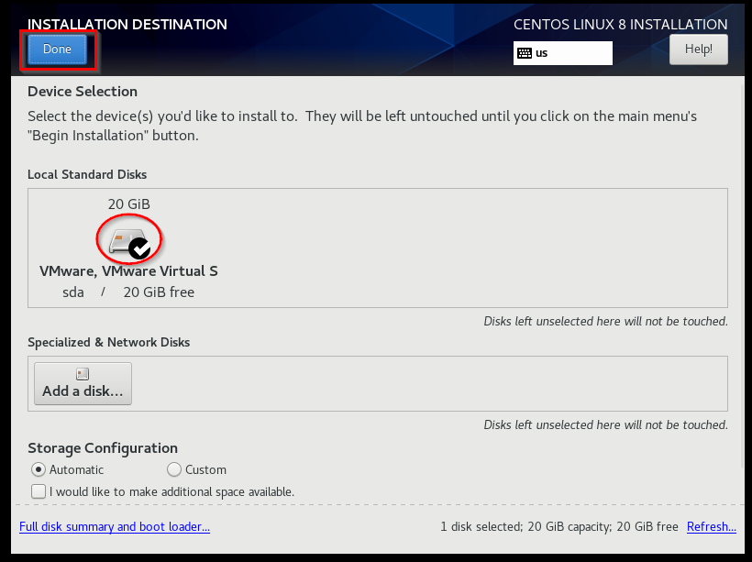

* Select **Installation Source**:

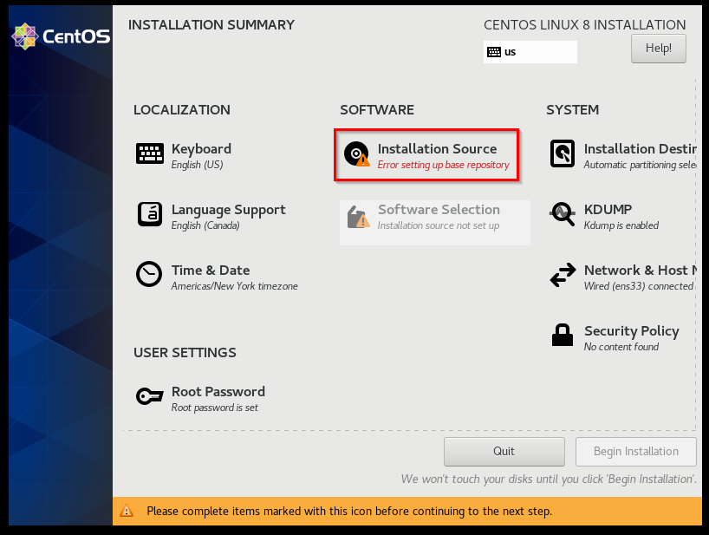

* Enter **mirror.centos.org/centos/8/BaseOS/x86_64/os/** as the destination source. Click **Done**:

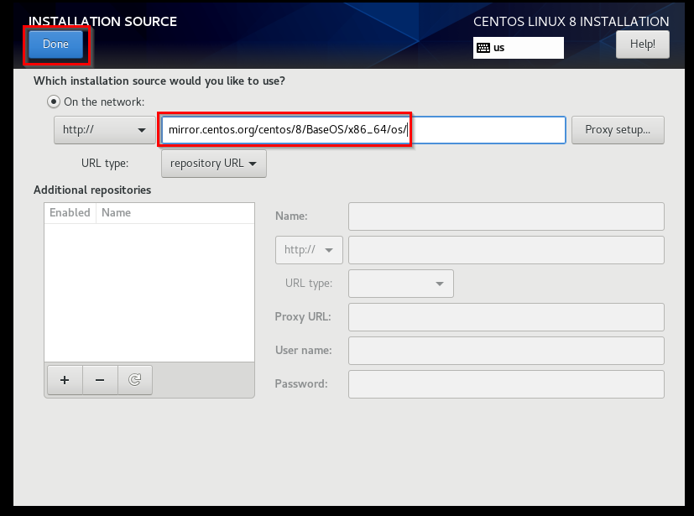

* Select **Software Selection**:

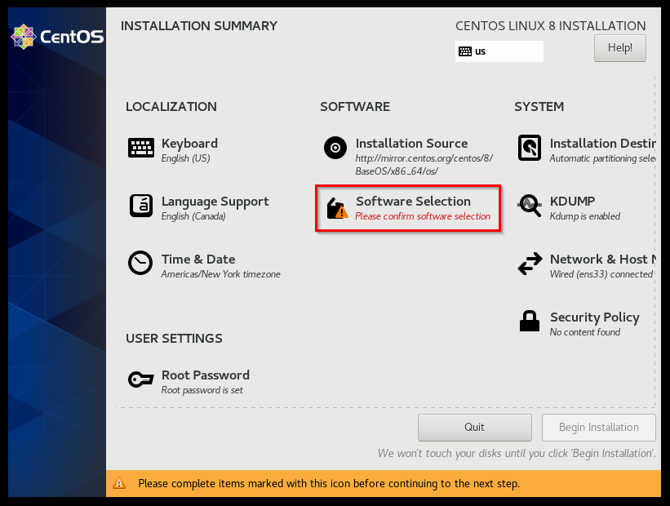

* Check the circle for **Workstation** in the left-hand pane. Check the boxes for any software to include in the right-hand pane. Click **Done**:

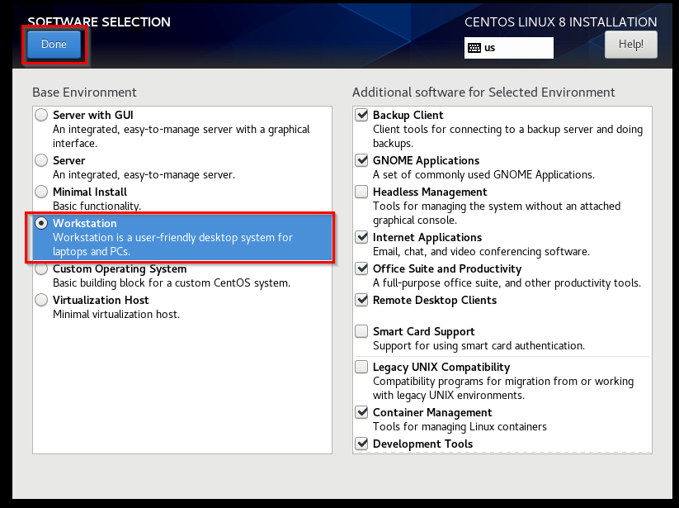

* Select **User Creation**:

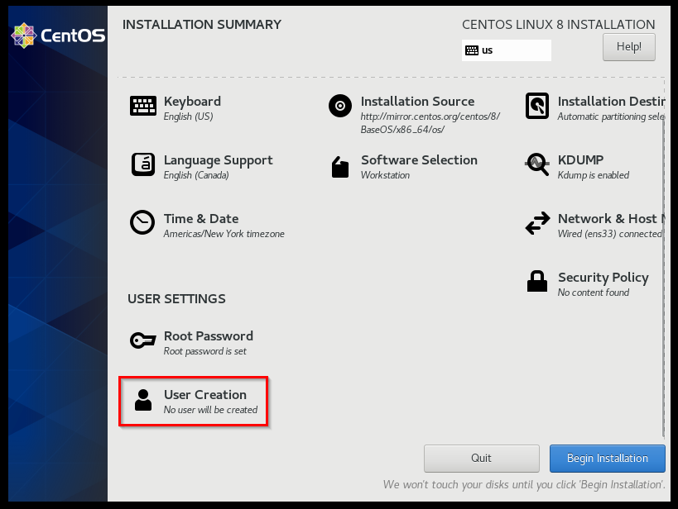

* Enter *Full name* (Ty Green), *User name* (tgreen), *Password* (student#1), and *Confirm password* (student#1). Most importantly, check the box for **Make this user administrator** to grant this user administrator privileges:

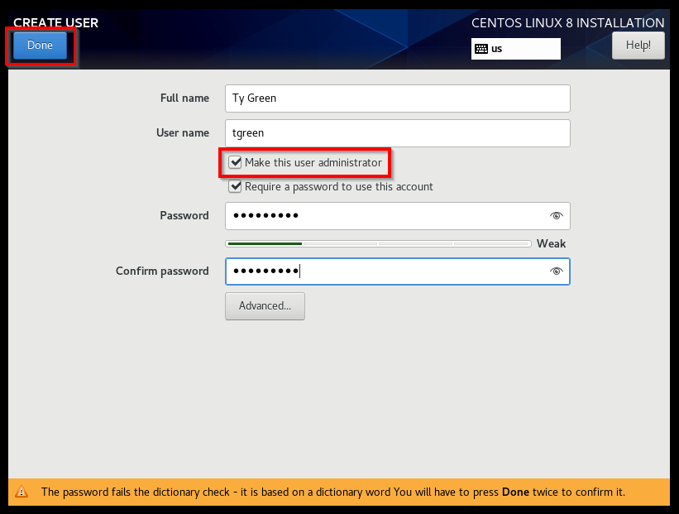

* Select **Begin Installation**:

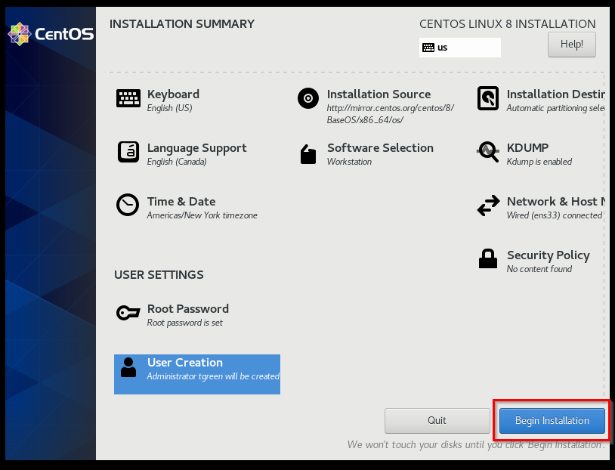

* Once installation is complete, click **Reboot System**:

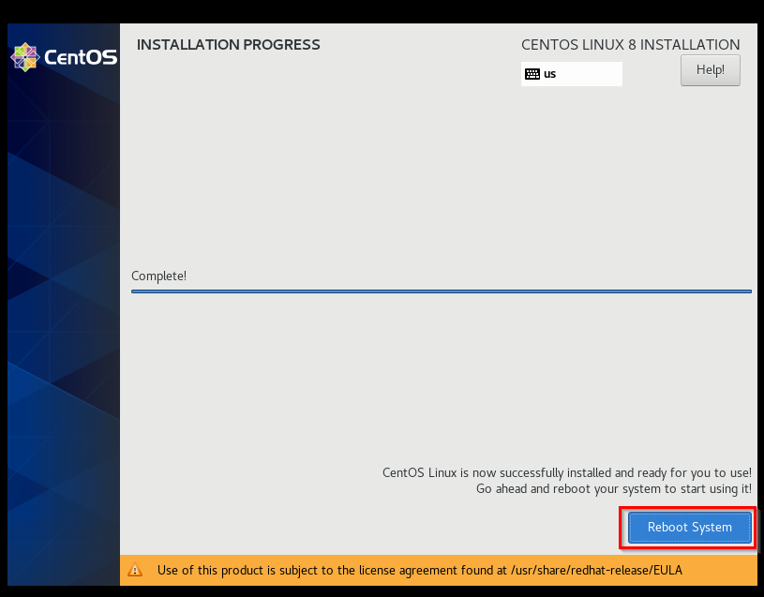

* Select **License Information**:

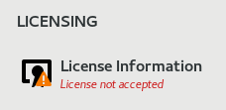

* Check the box for **I accept the license agreement**:

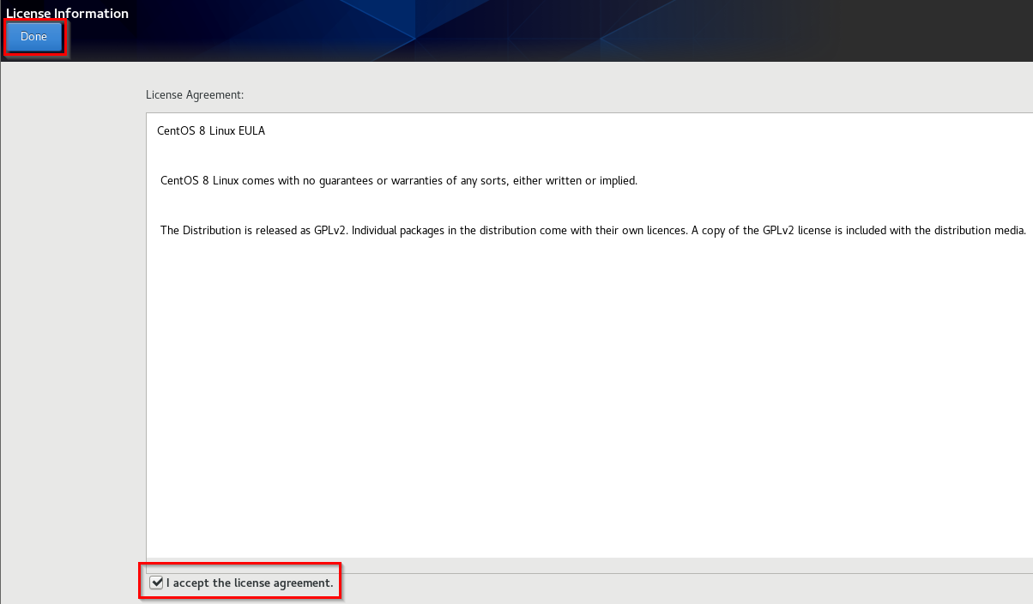

* Click **FINISH CONFIGURATION**:

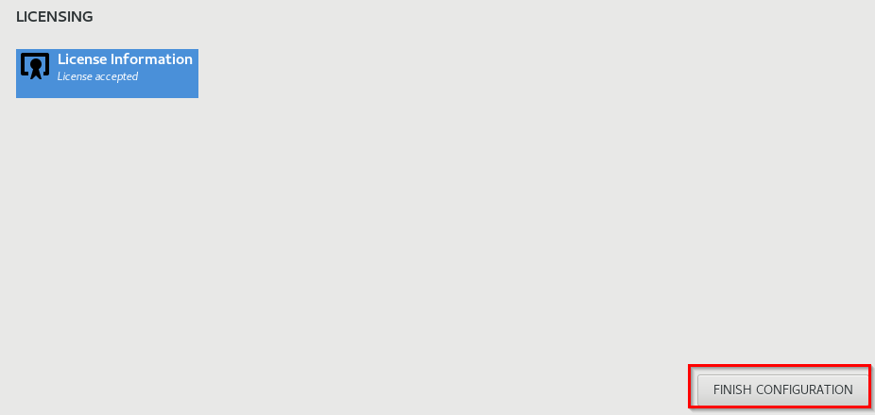

* Enter the user password (student#1). Click **Sign In**:

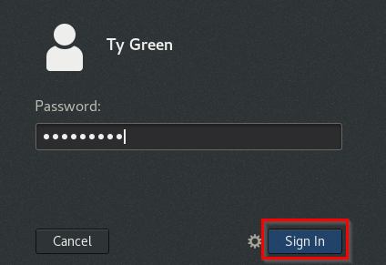

* Success! CentOS has been installed successfully:

