**How To: Write a Script to Back Up One**

**Directory to Another**

* Open **Text Editor**:

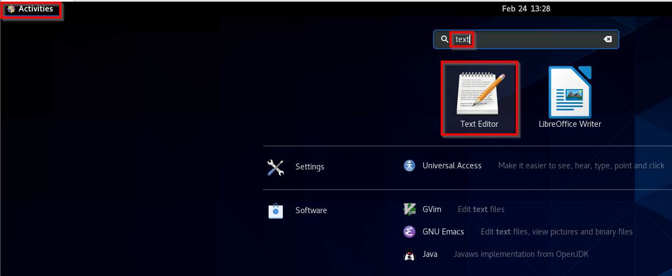

* Optional: Change text editor language from Plain Text to **sh** for extra syntax support

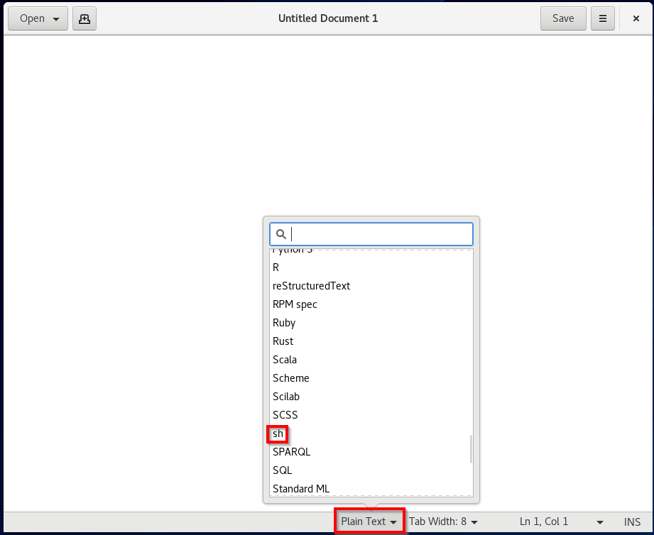

* The first line of the script should be: **#!/bin/bash**

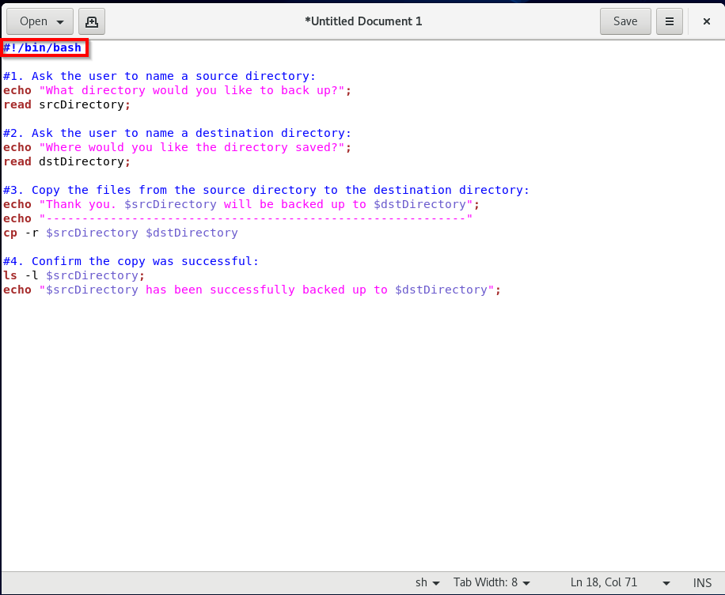

* Prompt the user for the name of the directory they wish to backup. Store their input in a variable:

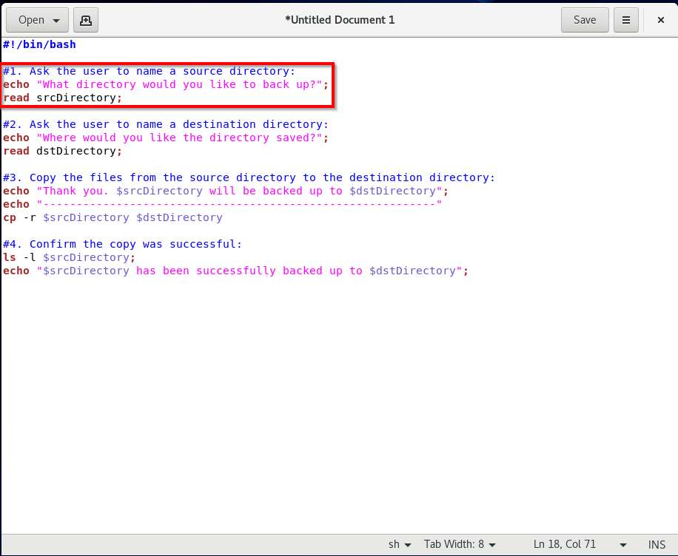

* Prompt the user for the name of the backup directory. Store their input in a variable:

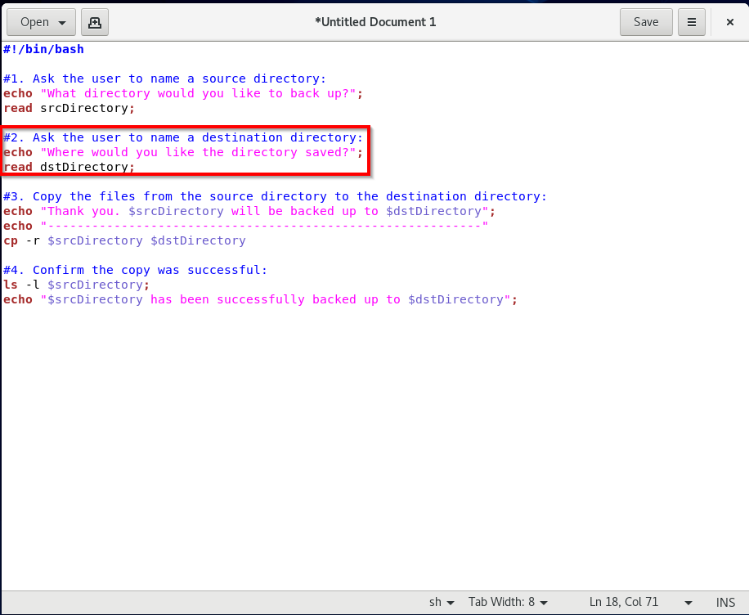

* Copy the directory stored in the first variable to the directory stored in the second variable:

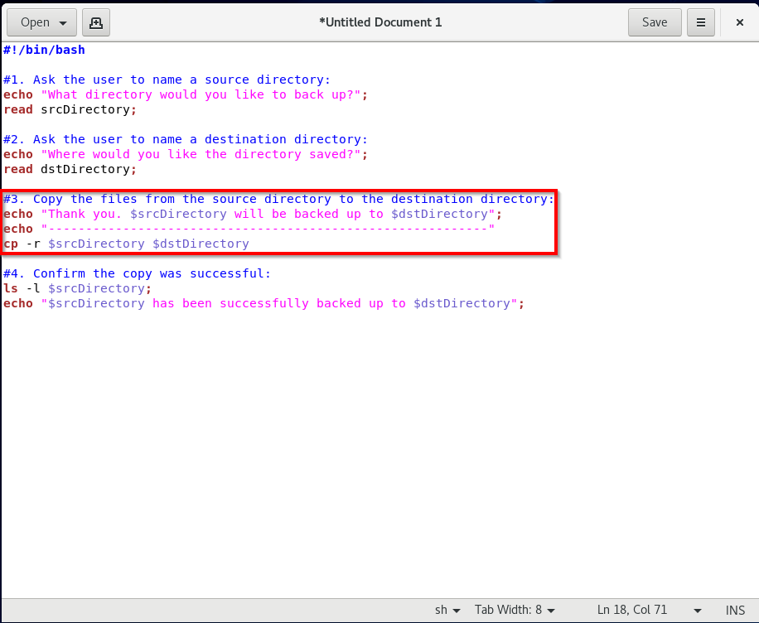

* Output the content of the newly backed up directory to the user:

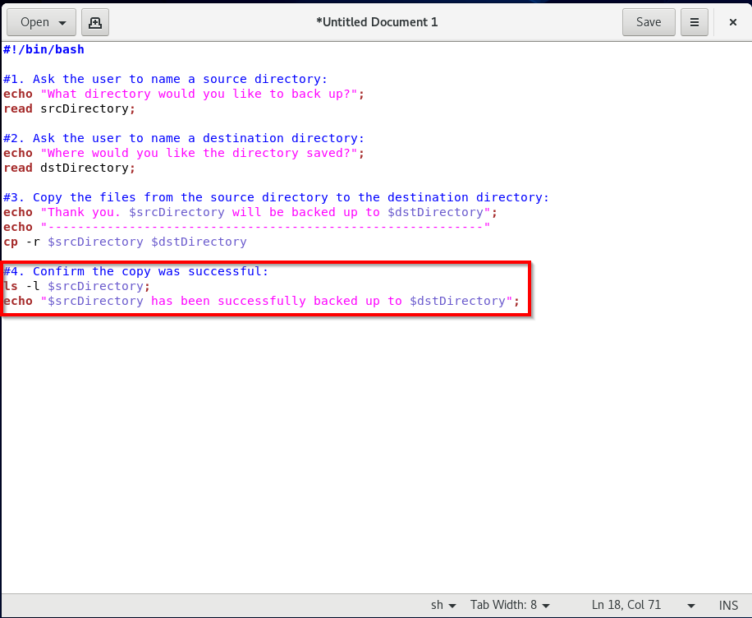

* Choose an appropriate location (e.g. “Scripts” directory) and name for the script file. The script’s name should describe its function and ends with .**sh**

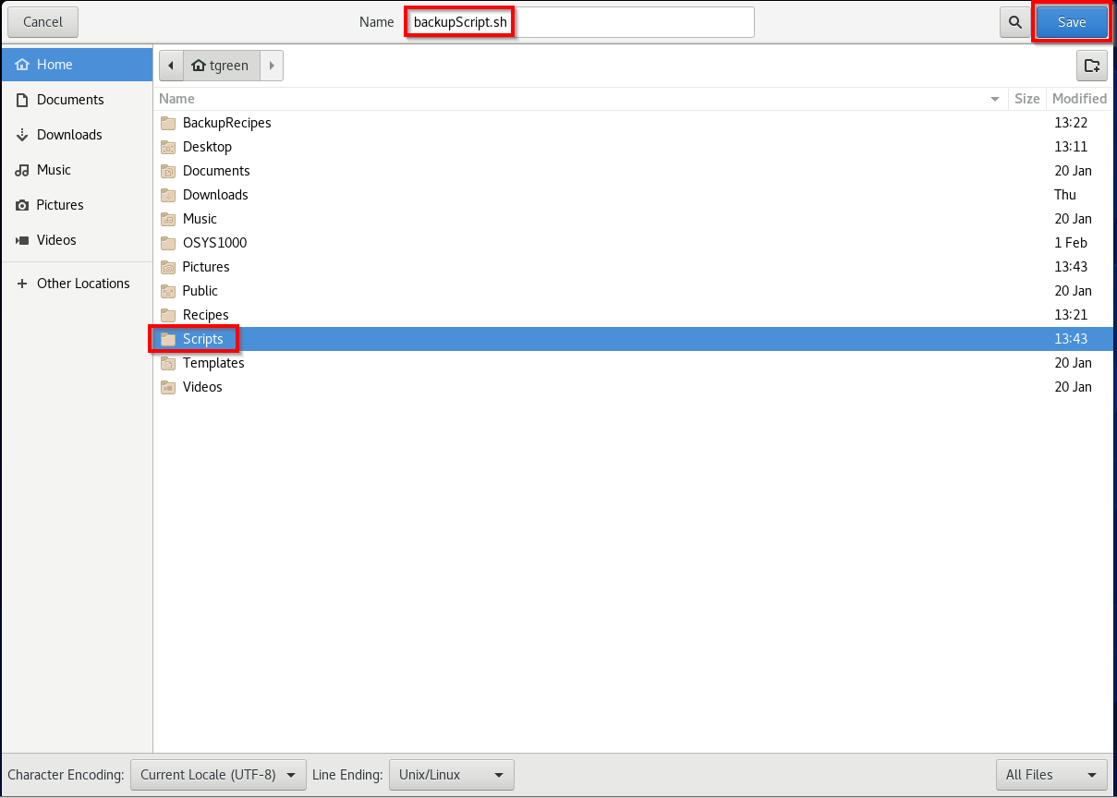

* Open the directory to which the script was saved. Right-click the script and click **Properties**:

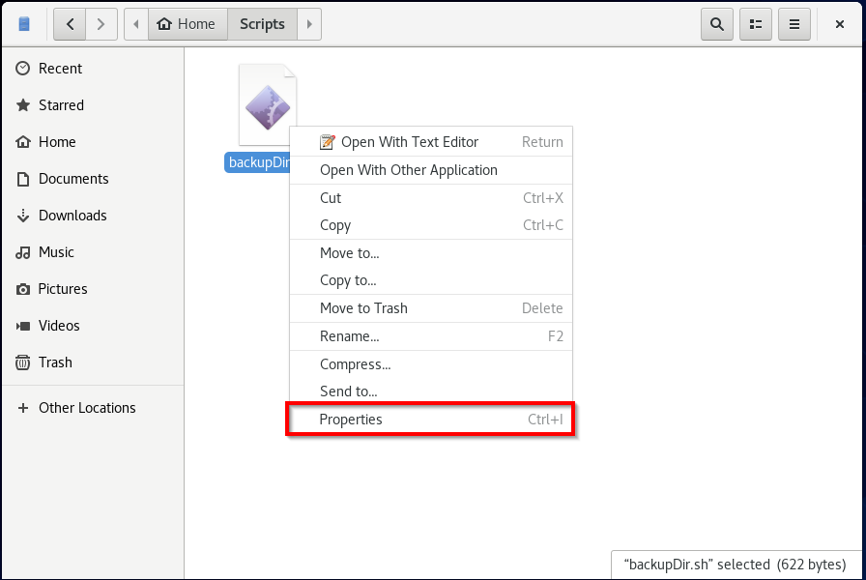

* Click **Permissions**:

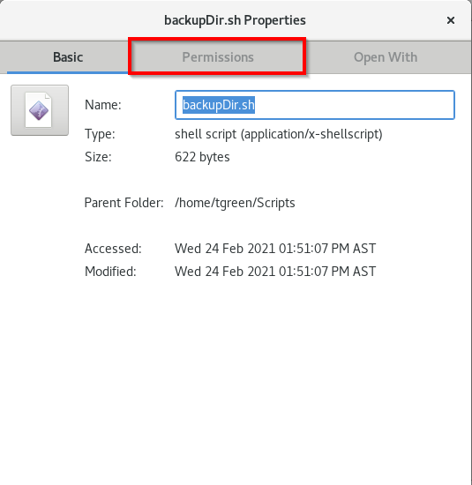

* Check the box for **Allow executing file as program** to ensure the script can be run:

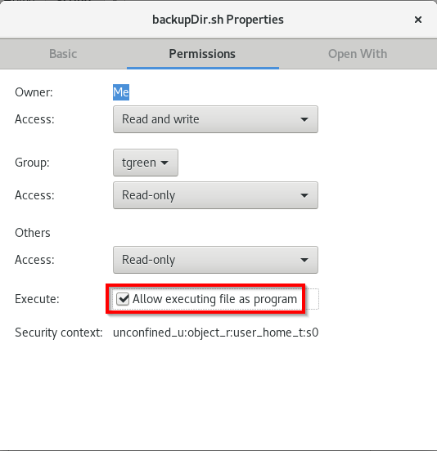

* Test the script in the Command Terminal to confirm it outputs the list of copied contents:

