**How To: Create a Cron Job to Backup Files at the Same Time Every Day**

Open a text editor in the command terminal using **nano**:

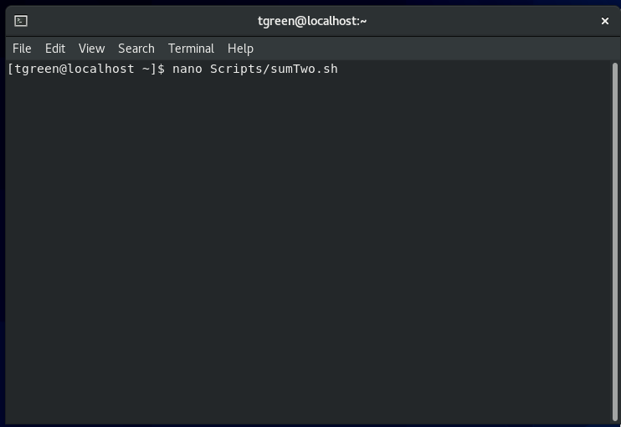

Write a script to Copy files from /home/tgreen/Documents to /home/tgreen/Backup:

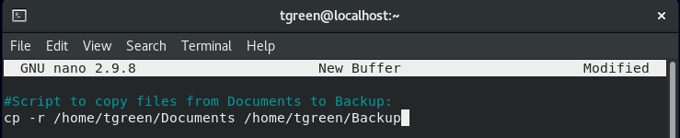

Open the directory in which the script was saved (e.g. **Scripts**). Right-click the script file and select **Properties**:

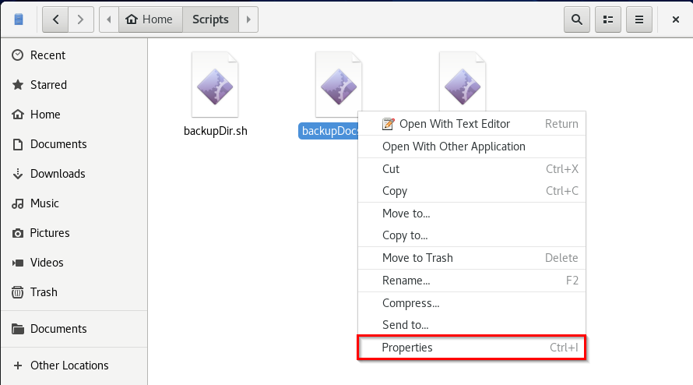

Click the **Permissions** tab:

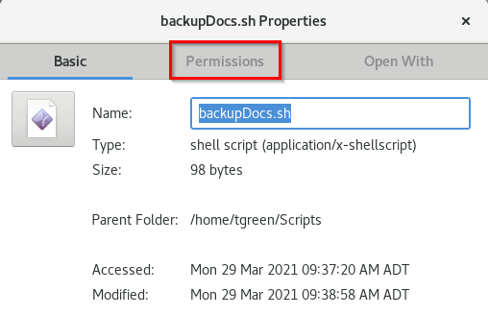

Check the box for **Allow executing file as program** to make the script file executable:

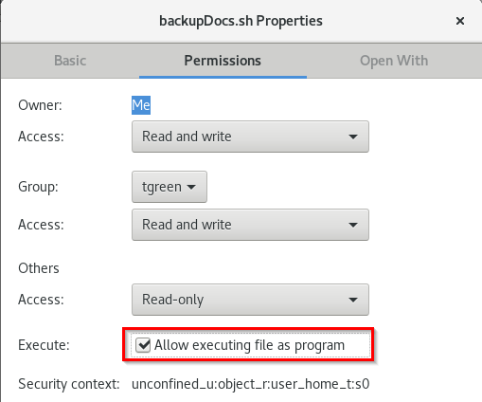

Return to the command terminal to test-run the script. Verify that the Documents directory was indeed copied to the Backup directory when the script was run:

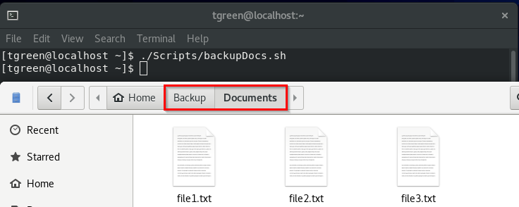

Return to the command terminal and enter **crontab -e**:

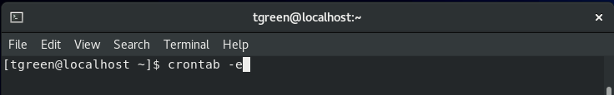

Once crontab opens, hit “**i**” to start editing the crontab ( **– INSERT –** should appear at the bottom of the crontab):

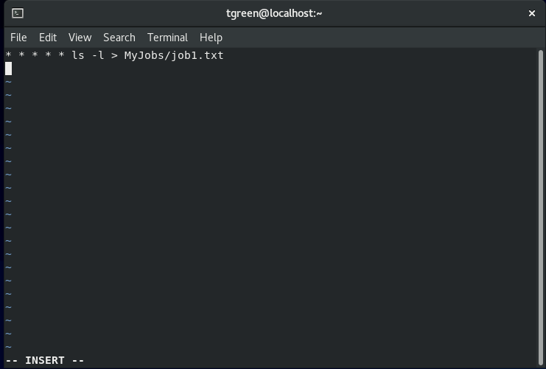

Enter the cron job to be run in the crontab. Enter * * * * * for the date/time fields so that the job can be tested immediately. To exit, hit **esc**, enter **:wq,** then hit **enter**.

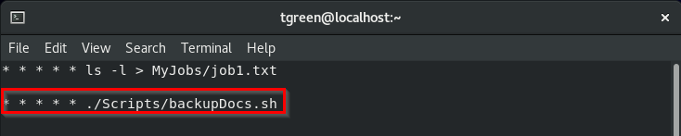

Open the Backup directory. Within one minute, the job (and thus the script) should run. Verify the job has run by confirming that the Documents directory has been copied to the Backup directory:

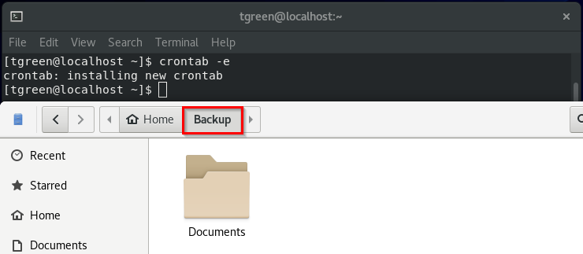

Return to the crontab and edit the original job to now run at 2:10 AM:

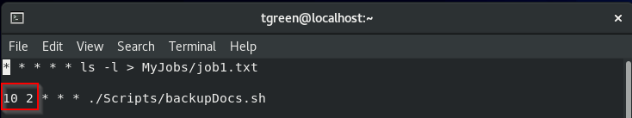

Verify job runs at the expected time by changing the system’s time to 2:09 AM. Enter “time” in the system search bar. Click **Date & Time**:

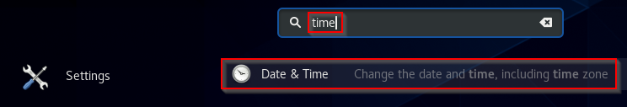

Toggle **Automatic Date & Time** to **OFF**. Double-click **Date & Time**:

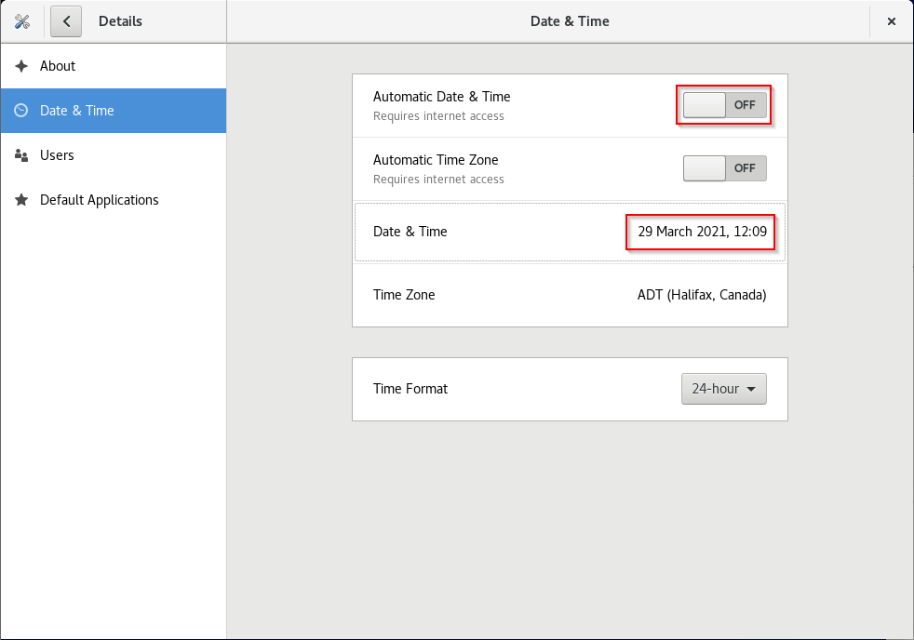

Set time to **2:09** AM:

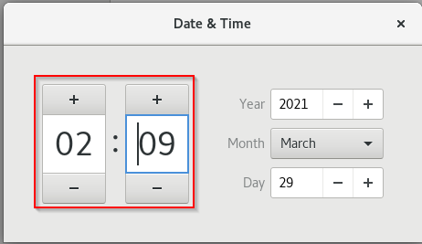

Open the **Backup** directory and ensure its contents are blank:

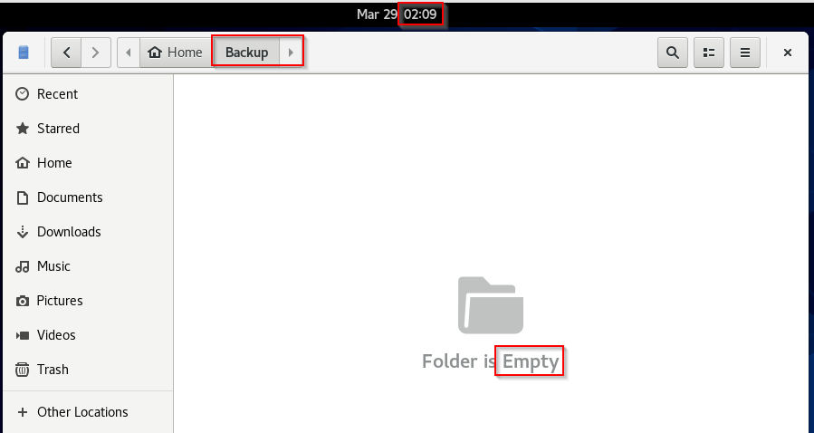

When system clock changed to 2:10 AM, verify the job has run by confirming the Documents directory copies to the Backup directory:

