**How to: Create a Permanent Alias that Runs a Custom Script**

Open a text editor in the command terminal using **nano**:

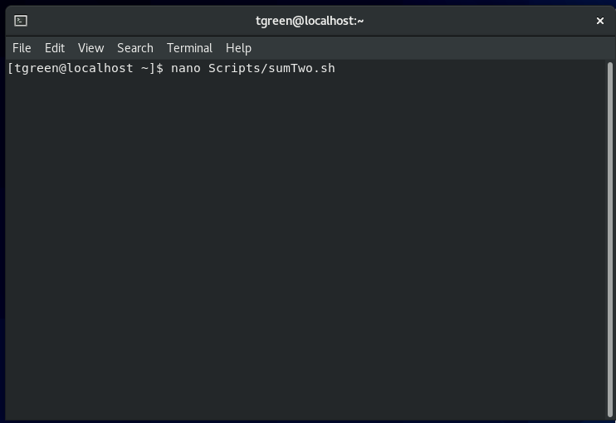

Write the script that adds two numbers input by the user:

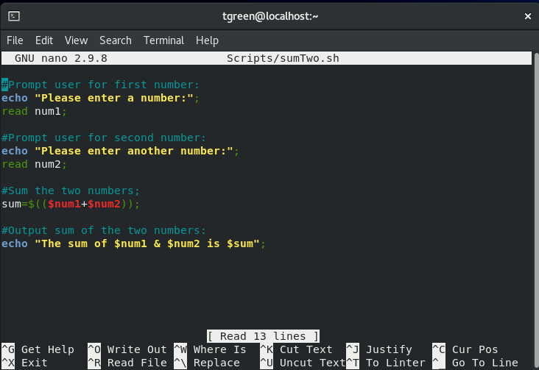

Use the **chmod** command to enable the script file to be executable:

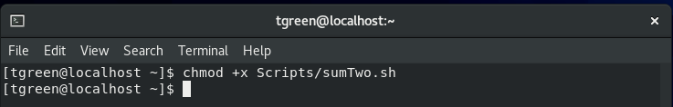

Execute the script to ensure it runs as expected:

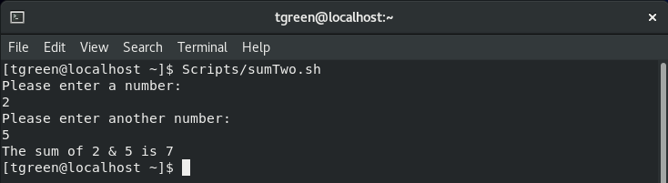

Backup the **.bashrc** file:

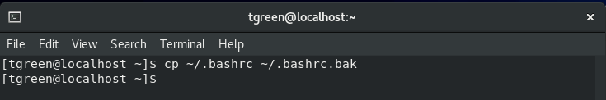

Move down to **# User specific aliases and functions**:

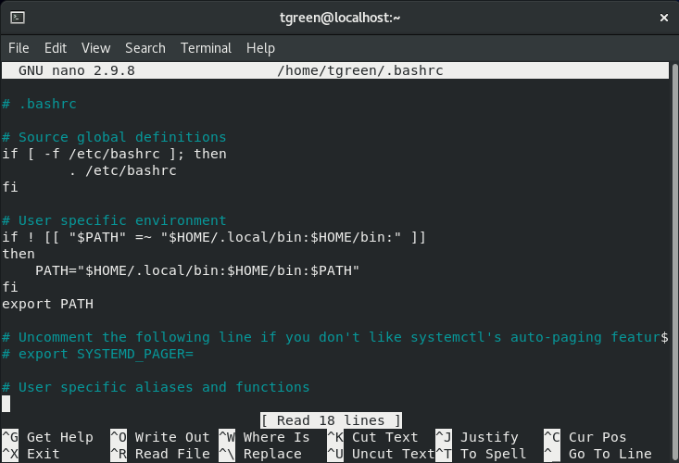

Use the **alias** command to create a (permanent) alias to run the script:

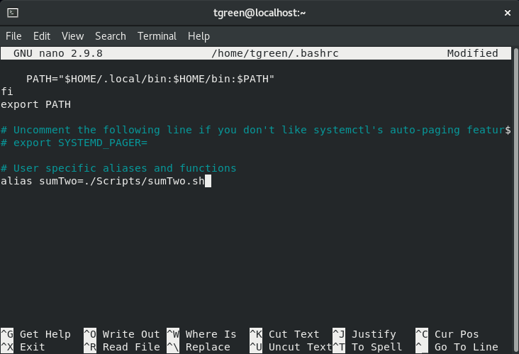

Confirm that entering the alias runs the script:

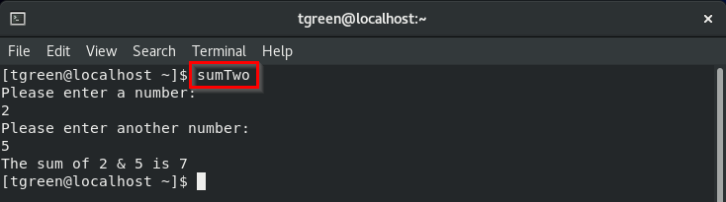

Confirm that the alias is permanent by closing the current terminal and entering the **alias** command in a new terminal:

