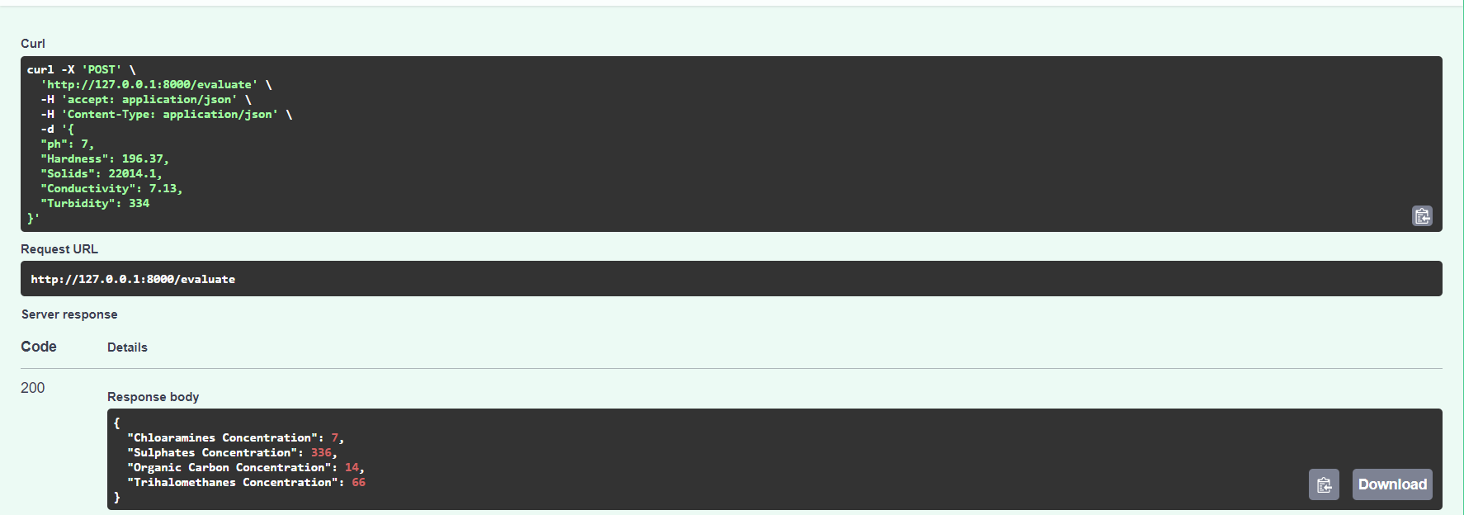

The above figure shows the machine learning models being used within an API. The API input and output format being JSON. For the above input body, each of the input components are being passed through all the machine learning pipelines for the prediction of respective chemical parameters. The API also supports a Swagger UI, utilizing an open-source framework.

API evaluation End-point: http://127.0.0.1:8000/evaluate

**Ex. Input:**

curl -X 'POST' \

'http://127.0.0.1:8000/evaluate' \

-H 'accept: application/json' \

-H 'Content-Type: application/json' \

-d '{

"ph": 7,

"Hardness": 196.37,

"Solids": 22014.1,

"Conductivity": 7.13,

"Turbidity": 334

}'

**Ex. API Output:**

{

"Chloramines Concentration": 7,

"Sulphates Concentration": 336,

"Organic Carbon Concentration": 14,

"Trihalomethanes Concentration": 66

}