Experiment No. – 1

Objective: - (i) Implement a Local Area Network (LAN) using HUB.

(ii) Implement a Local Area Network (LAN) using Switch.

Software Required: - Cisco Packet Tracer

Theory: -

LAN - It is a collection of devices that are connected together in one physical location such as building, office or home. It comprises cables, access point, hub, switches that enable devices to connect servers or other LAN. The main advantage of LAN is higher security.

HUB - It is a physical layer networking device which is used to connect multiple devices in a N/W. They are generally used to connect computers in LAN. HUB has many parts in it. A computer which intends to be connected is plugged in one of those parts. When frame arrives at port, it broadcast to every other part.

Switch - It is a device that operates at the Data Link layer of the OSI model. It takes in packets being sent by devices thar are connected to its physical ports and sends them out again, but only through the ports that lead to the devices that packets are intended to reach. They can also operate at the network layer (Layer 3 where routing occurs).

Procedure: -

(i) Implement a Local Area Network (LAN) using HUB.

Step1: - Take a PC by clicking on, End Devices>PC and add PC in working space/blank space in Cisco Packet Tracer

Step2: - Click on the PC in working space and Go to Desktop>IP configuration where we assign the IPv4 address and Subnet Mask to the PC.

Step3: - Repeat above steps and add 3 more PC’s in working Space and also provide them the unique IP address of same Class as first PC and Subnet Mask.

Step4: - Now take a HUB by clicking on, Network Devices>Hubs>PT-Hub and add PT-Hub in working space.

Step5: - Connect each PC to PT-Hub through a Straight-Through cable, to take Straight-Through cable click on Connections>Copper Straight-Through and then Click on first PC>FastEthernet0 and then Click on PT-Hub>FastEthernet0.

Step5: - Follow above step and connect all PC’s to PT-Hub.

Step6: - Go to Simulation mode and take a packet by simply clicking on Add Simple PDU.

Step7: - Finally first click on the PC from where you want to send the data and secondly click on the PC where you want to send the packet and start the Simulation mode and you can see the packet going from sender PC to receiver PC.

(ii) Implement a Local Area Network (LAN) using Switch.

Step1: - Take a PC by clicking on, End Devices>PC and add PC in working space/blank space in Cisco Packet Tracer

Step2: - Click on the PC in working space and Go to Desktop>IP configuration where we assign the IPv4 address and Subnet Mask to the PC.

Step3: - Repeat above steps and add 3 more PC’s in working Space and also provide them the unique IP address of same Class as first PC and Subnet Mask.

Step4: - Now take a HUB by clicking on, Network Devices>Hubs>2960 or and add 2960 switch in working space.

Step5: - Connect each PC to 2960 through a Straight-Through cable, to take Straight-Through cable click on Connections>Copper Straight-Through and then Click on first PC>FastEthernet0/1 and then Click on PT-Hub>FastEthernet0/1.

Step5: - Follow above step and connect all PC’s to 2960 switch.

Step6: - Go to Simulation mode and take a packet by simply clicking on Add Simple PDU.

Step7: - Finally first click on the PC from where you want to send the data and secondly click on the PC where you want to send the packet and start the Simulation mode and you can see the packet going from sender PC to receiver PC.

Screenshot: -

1. Implement a Local Area Network (LAN) using HUB.

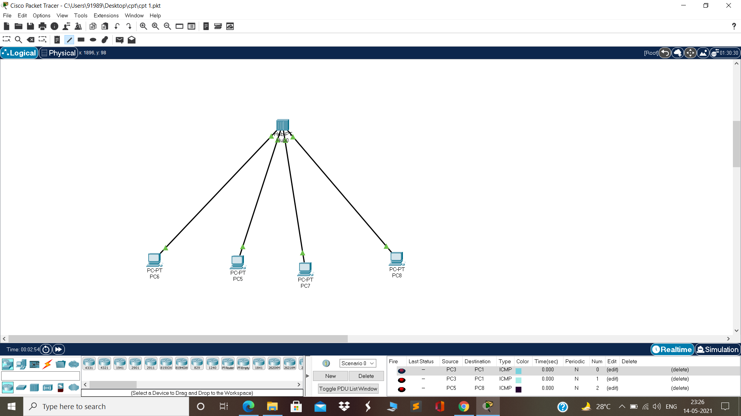

(ii) Implement a Local Area Network (LAN) using Switch.

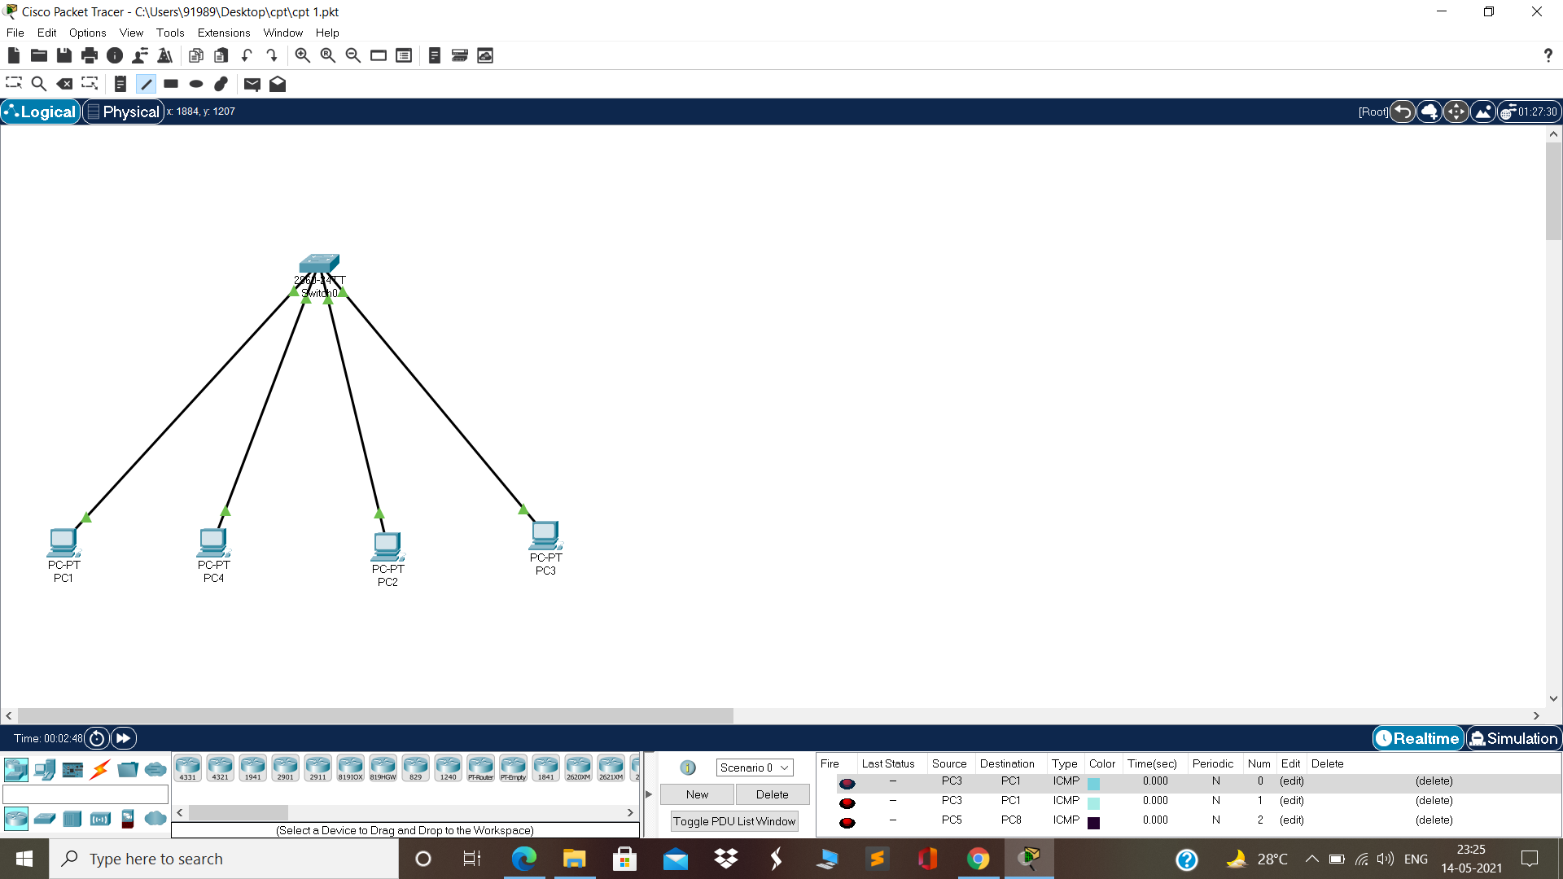

Output: -

(i) We can communicate and share resources with devices connected with the HUB.

(ii) We can communicate and share resources with devices connected with the Switch.