# Top Digital Marketing Trends in 2025

Digital marketing continues to evolve rapidly. Businesses that adapt to new trends are more likely to stay ahead of the competition. Below are some of the top trends shaping 2025:

## 1. AI-Powered Personalization

With tools like OpenAI's ChatGPT, marketers can deliver highly personalized experiences. Companies like Amazon and Netflix are already leveraging AI to recommend content and products.



## 2. Personalized Content Delivery

Using machine learning and data analytics, companies can tailor content to each user’s interests. Netflix is leading the way in personalized viewing experiences.

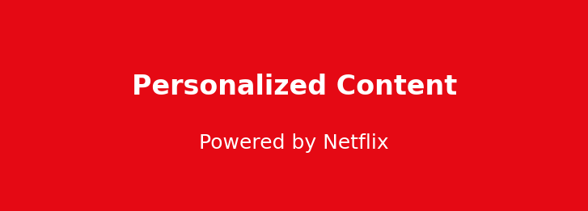

## 3. Short-Form Video Dominance

Platforms like TikTok are transforming how users engage with brands, making short-form video a must-have.

