**Features:🡪**

1. Schedule a mail on particular date, hours and minutes.
2. Send a mail on daily basis.
3. Able to send mails repeatedly.
4. Can scan whole drive and send all data files if we are giving just drive name.

**Limitations:🡪**

1. Can’t attach files those have below given extension.

1 ADE

2 ADP

3 BAT

4 CHM

5 CMD

6 COM

7 CPL

8 EXE

9 HTA

10 INS

11 ISP

12 JAR

13 JSE

14 LIB

15 LNK

16 MDE

17 MSC

1. MSP

19 MST

20 PIF

21 SCR

1. SCT

23 SHB

1. SYS

25 VB

26 VBE

27 VBS

28 VXD

29 WSC

30 WSF

1. WSH
2. Can’t attach data files those size excide 25 MB.

**Where we can use:🡪**

Where we are generating some auto reports and need to send generated reports to some other sites without human intervention.

**What required to run:🡪**

Java 1.7 version is required.

**Step1**:🡪

How to configure account and send mails.

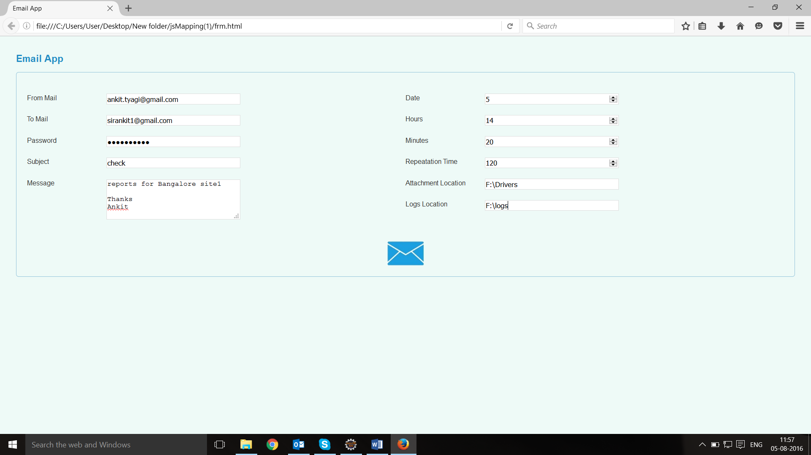

**Explanation of fields given above:🡪**

|  |  |
| --- | --- |
| **Fields** | **Explanation** |
| A form mail | Mail id of sender. |
| B to mail | Mail id of person to whom we are sending. |
| C password | Password of the sender. |
| Subject | For heading. |
| Message | For description. |
| Date | Set date on which you want to send your mail. If you want to send a mail everyday then set “everyday” in the date section. |
| Hours | Change accordingly. |
| Minutes | Change accordingly. |
| Repetition time | This is the time in which app will go to search for the attachment. |
| Logs location | A. logs location is the location of our log files.  B. logs files include following information.  1. Total no of data files: --> [10]  2. Invalid no of data files: --> [4]  3. No of files have size greater than 20 MB: --> [0]  4. Attachable data files: --> [6] |
|  |  |

**Final step:🡪**

After filling all the information click on envelope icon- which is shown below to start the mail application

