Bhawna Tyagi

November 16, 2021

Foundations of Programming: Python

Assignment 05

<https://github.com/tyagib123/IntroToProg-Python>

How do I use collections in order to create menu in Python?

# Introduction:

This document will walk you through the steps that I have taken to create a menu using collections i.e., list and dictionary. In this assignment, I have created dictionary first to load the item/items and price of an item/items into two columns: Task and priority by reading a text file. Once the data is added into dictionary, I have created a menu by asking user to provide an input if they want to add /remove one or more items and their prices from the list. In addition to this, user can also choose option to save the data to the file or exit the program. The latter two options have been performed by using write () method and break statement. Please note that in order to finish this assignment, I had given with the code template and I added some code for each task i.e., to create menu for the users. In addition to this, I have learned how to use GitHub and load my data into my repository.

# How did I create menu in python script?

Below are the steps that I have taken to create little menu for our users:

**Step 1:** I started by looking at the provided variables in the code as shown in the Figure 1. This is known as variable declaration. There is an objFile which contains the name of the file “ToDoList.txt” with existing data into it. Apart from this, there are other variables such as strData which will be used to hold each row of the data in a file and bunch of other variables for empty dictionary and list.

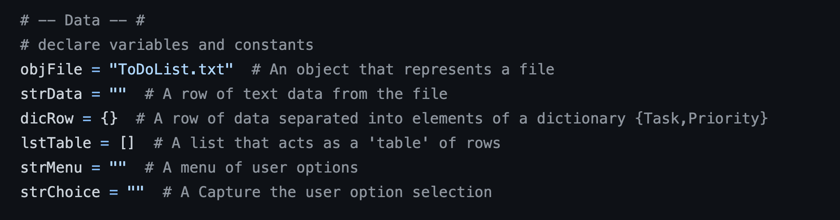

***Figure 1: Variables declaration***

**Step 2:** Oncethevariables have been declared, the next step was to read the two columns from the file and load it into a dictionary called dictRow. In order to do this, I opened a file using objFile variable and began reading from the file row by row. I looped through the file row by row using strData variable. Once I have one row of data, I splitted the row into key and value on separator ‘,’ using split(). Finally, added the key and value in the dictionary. I have used Task and Priority as column names and assigned the value as key/value. Once the dictionary is created, I added the dictionary to the list called lstRow using append (). At the end, closed the file using close (). This all is shown in Figure 2.

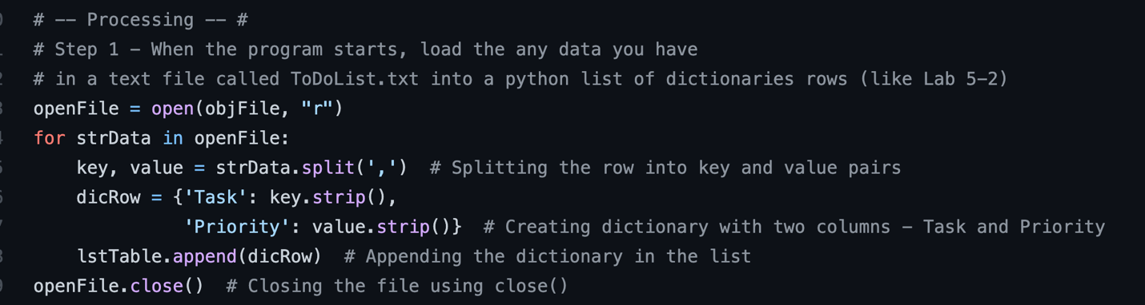

***Figure 2: Loading of the data from text file using list and dictionary***

**Step 3:** Now here comes the fun part! In the following figure 3, there is menu of options shown to the user and asked user to choose their option which they would like to perform among 1-5.

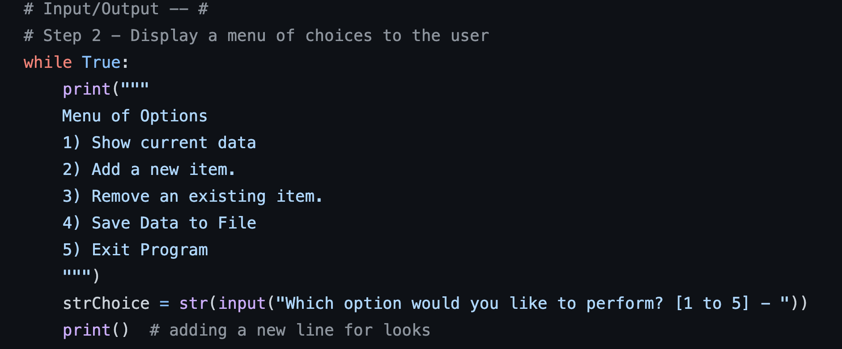

***Figure 3: Menu of options shown to the user***

**Step 4:** Depending on the user’s choice, if the user chooses option 1, the task is to print the data in the list as shown in Figure 4.

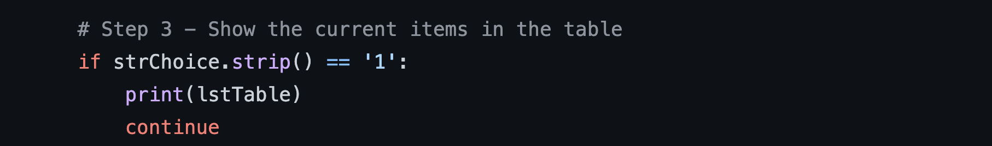

***Figure 4: Print the content in the list***

**Step 5:** If the user chooses option 2, the task is to ask them to provide the name of an item and its price and finally add the item and price in the list. In order to ask the user inputs for an item and its price, I have used two variables task and priority and used input (). Then, created new row using lstRow variable and used Task and Priority as column names. Finally, added the new item and its price in the list i.e., lstTable. This is shown in Figure 5.

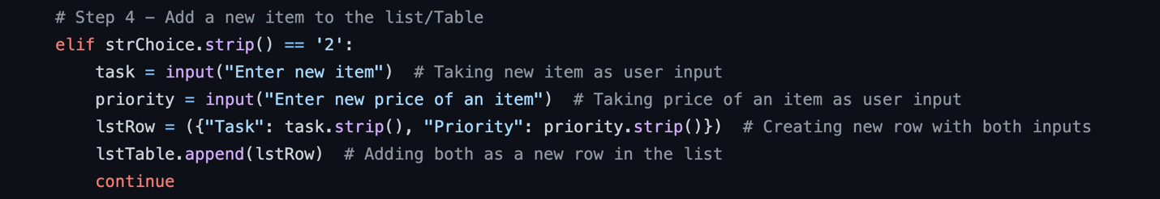

***Figure 5: Adding new item/price in the list***

**Step 6:** If the user chooses option 3, the task is to ask user which item user wants to remove from the list. In order to perform this task, I have used input () to store the user input. Then, looped through the lstTable list using row variable and compared if the item name coming in the row variable is equal to the item chosen by the user in their input. I have used row [Task] to grab the item from the dictionary present as an object in the list. If the items are equal, I have used remove () to remove the row. If not, then continue and grab the next item in the list and repeat the same process. For code, please refer to figure 6.

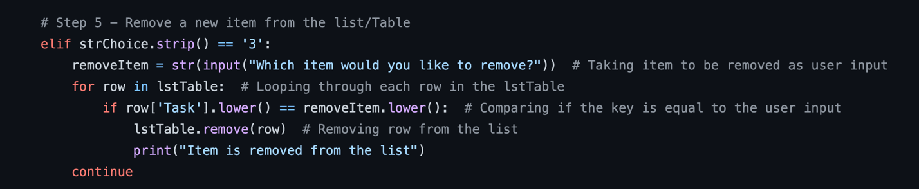

***Figure 6: Removing row from the list***

**Step 7:** If the user chooses option 4, the task is to save the data into a text file. For this purpose, I opened the file again used open () in write mode. Looping through the list row by row and write the row in the file using write (). Finally, closed the file using close () once the entire data has been written into the file as shown in Figure 7.

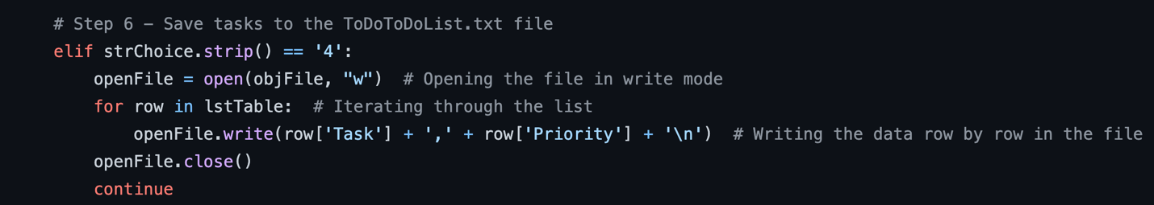

***Figure 7: Save the data to a text file***

**Step 8:** If the user chooses option 5, the task is to exit from the program. I have printed one line to confirm that the user is exiting from the program and used break statement to come out of the while loop as shown in Figure 8.

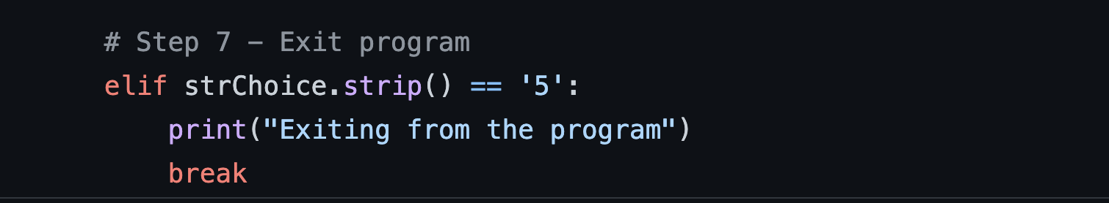

***Figure 8: Exit from the program using break***

# Complete menu script:

Below is the complete python script that I have written in PyCharm:

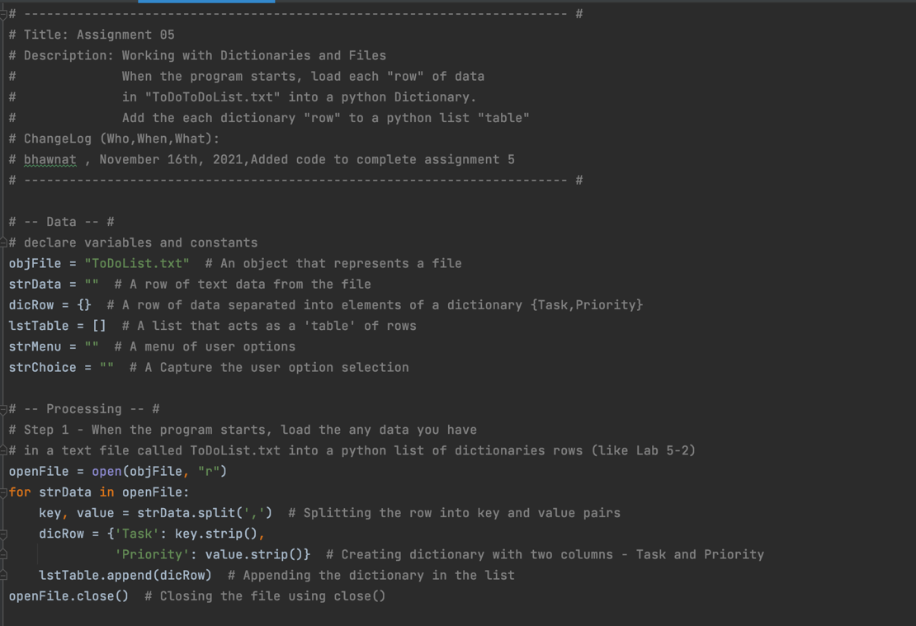

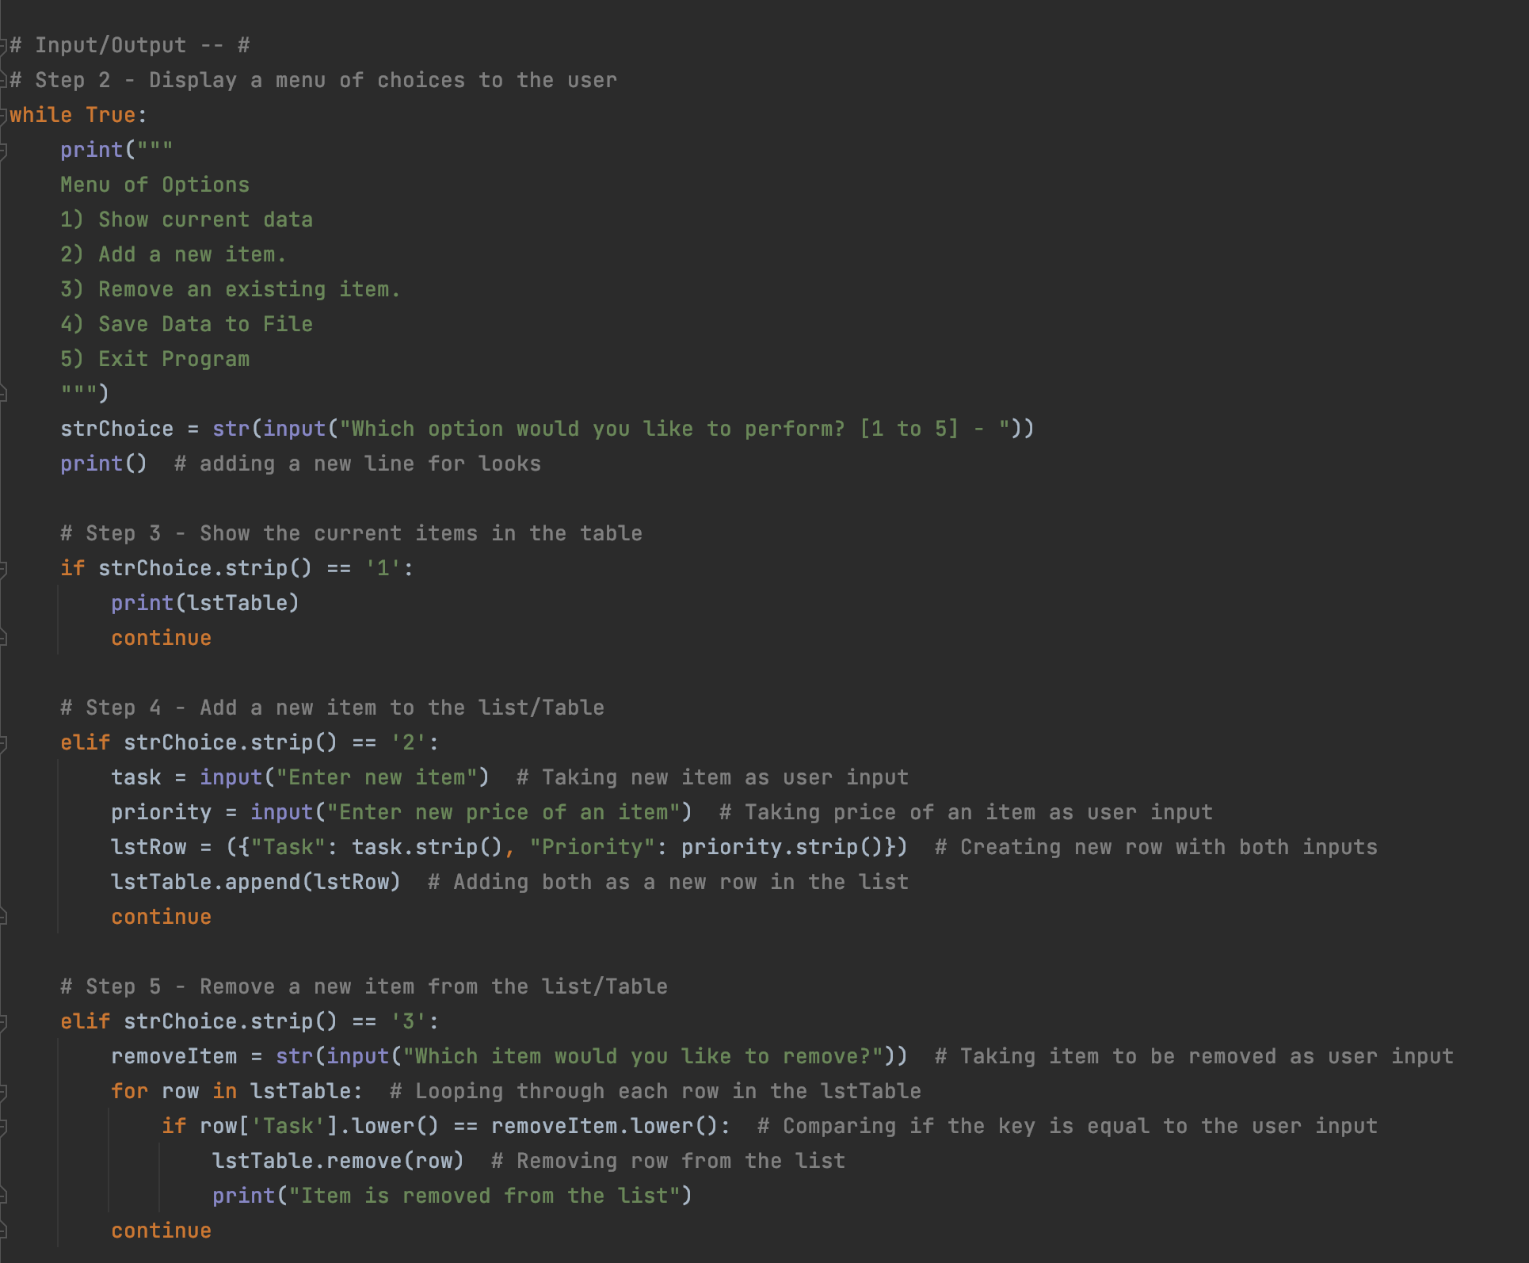

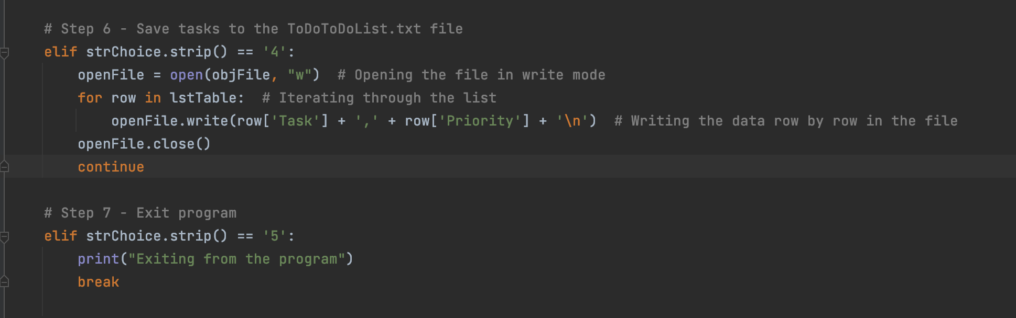

***Figure 9: Complete python script written in PyCharm***

# Result displayed in PyCharm/terminal:

Below is the result of the script executed in PyCharm as well as in Mac OS terminal shown in Figure 10a, 10b, 10c and 10d:

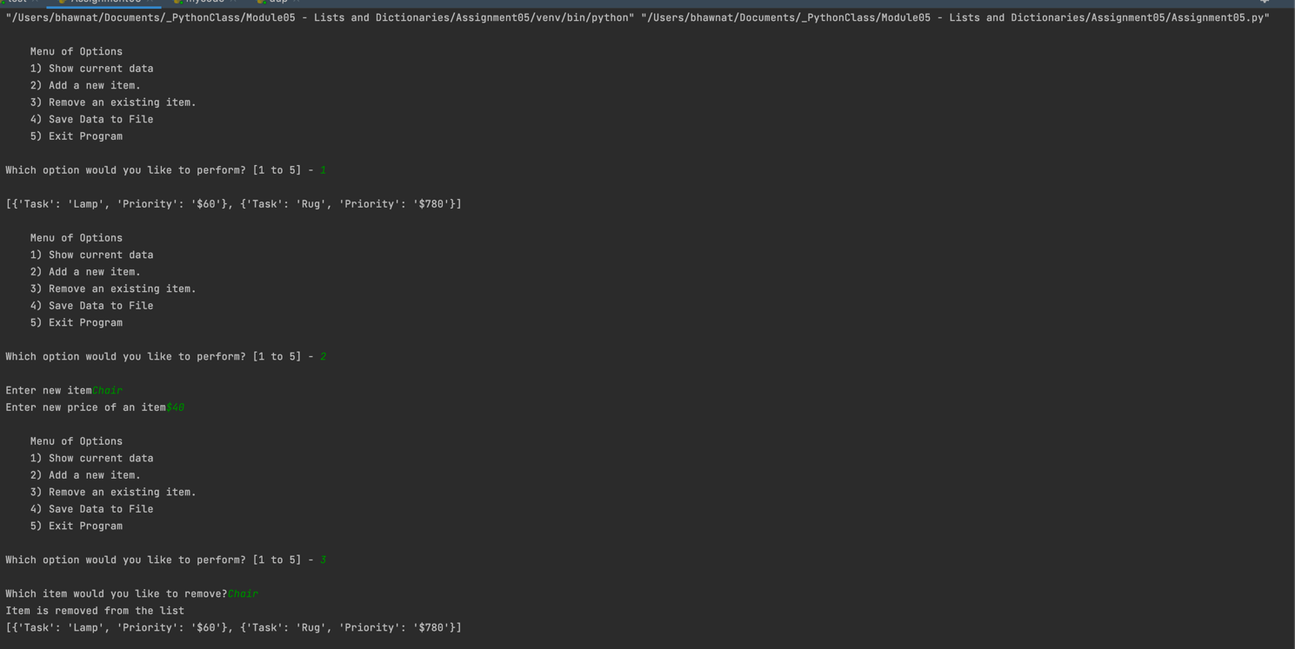

***Figure 10a: Result of the script execution in PyCharm***

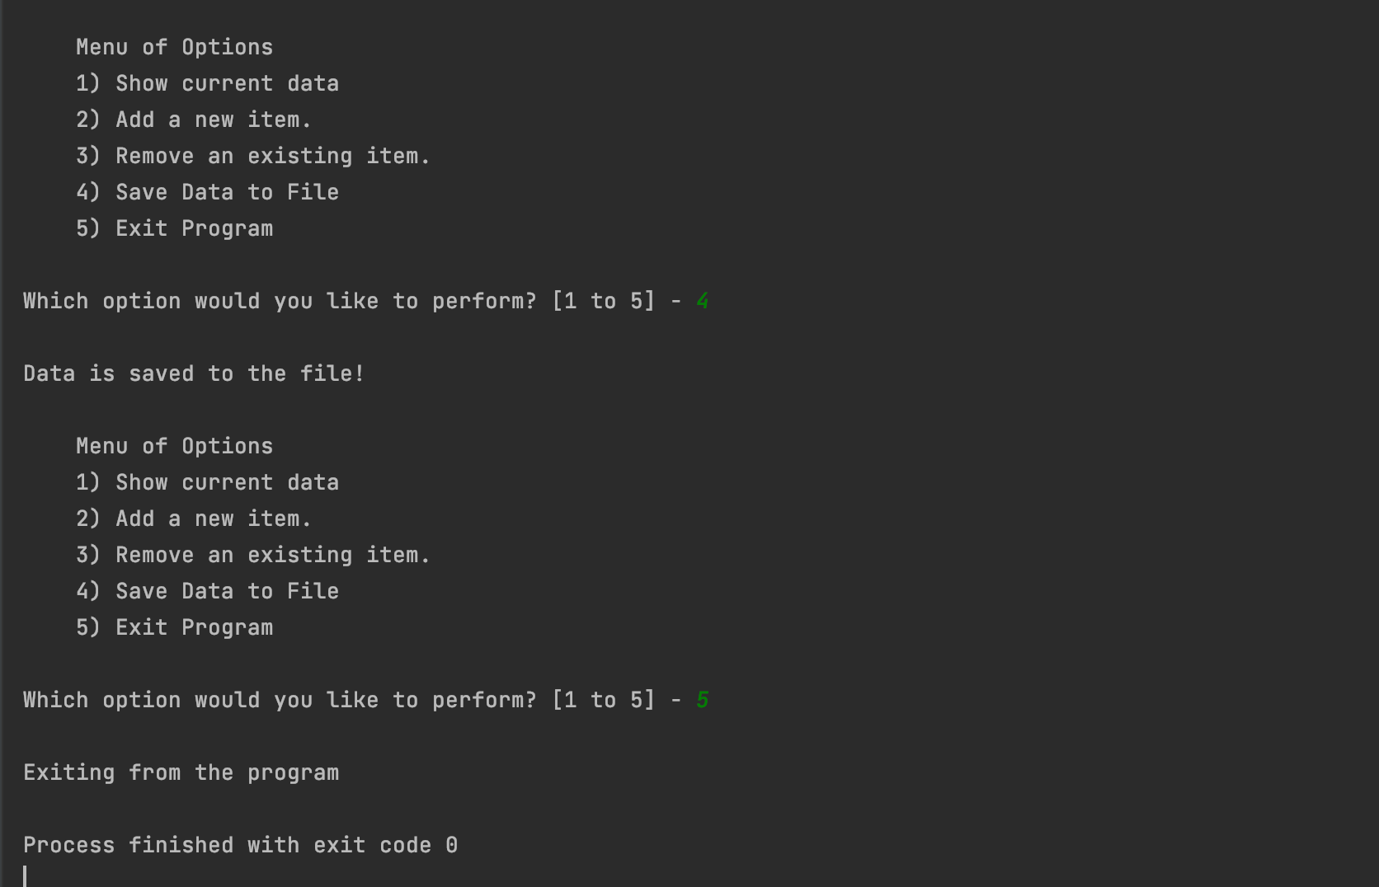

***Figure 10b: Continuation of the remaining python script execution in PyCharm***

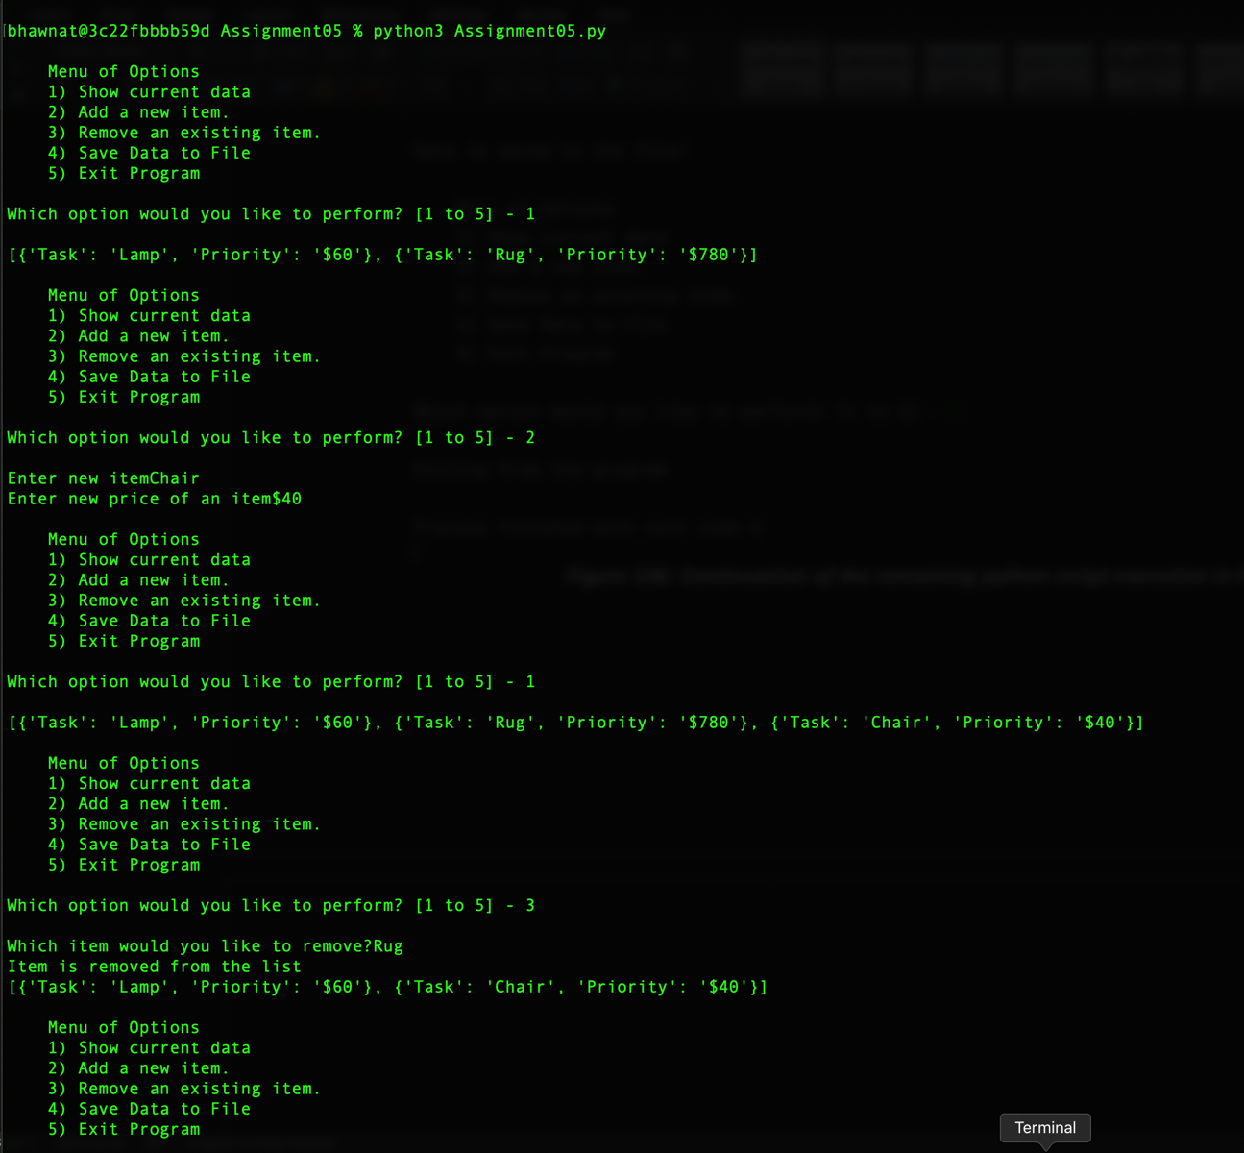

***Figure 10c: Result of the script execution in MacOS Terminal***

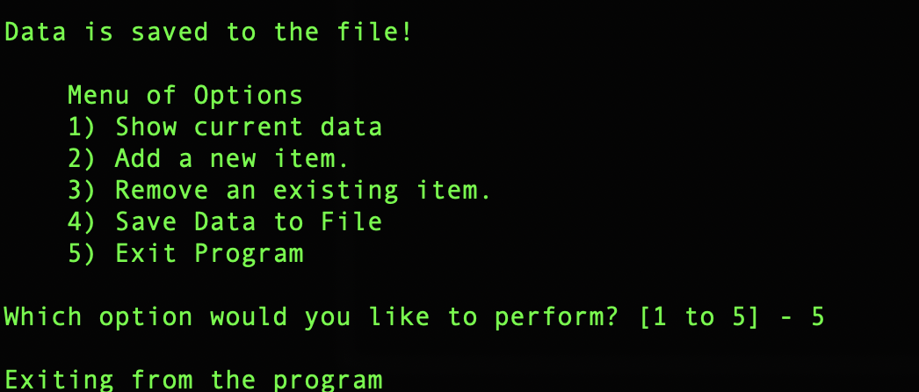

***Figure 10d: Continuation of the script execution in MacOS Terminal***

# Verify the created text file:

Below is the text file content shown in Figure 11:

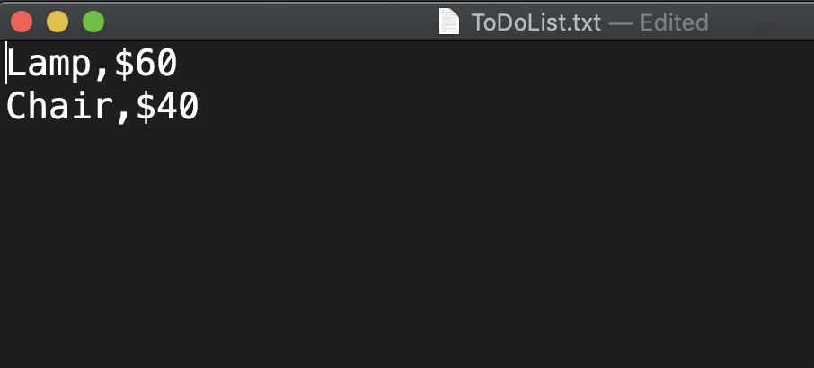

***Figure 11: Content of text file***

# Summary:

This was a great assignment and learning for me. I learned how to use collections and manipulate those collections based on different use cases. Here, I have displayed menu of options to the user and added certain tasks to performed based on the options chosen by the user. In addition to this, I learned how to use Github and got an opportunity to get my work reviewed with my peers. I had very good learning experience from this exercise.