ASSIGNMENT NUMBER-: 02

ASDM

Rishabh Tyagi

Form Number-: 220703202

Q-: Create the project for any web application example using agile methodology (SCRUM TEMPLATE).

(6 ISSUES)>>>> 4 STORY , 1 TASK, BUG

Solution-:

Creation of product backlog (6 Stories, 1 Task, 1Bug)

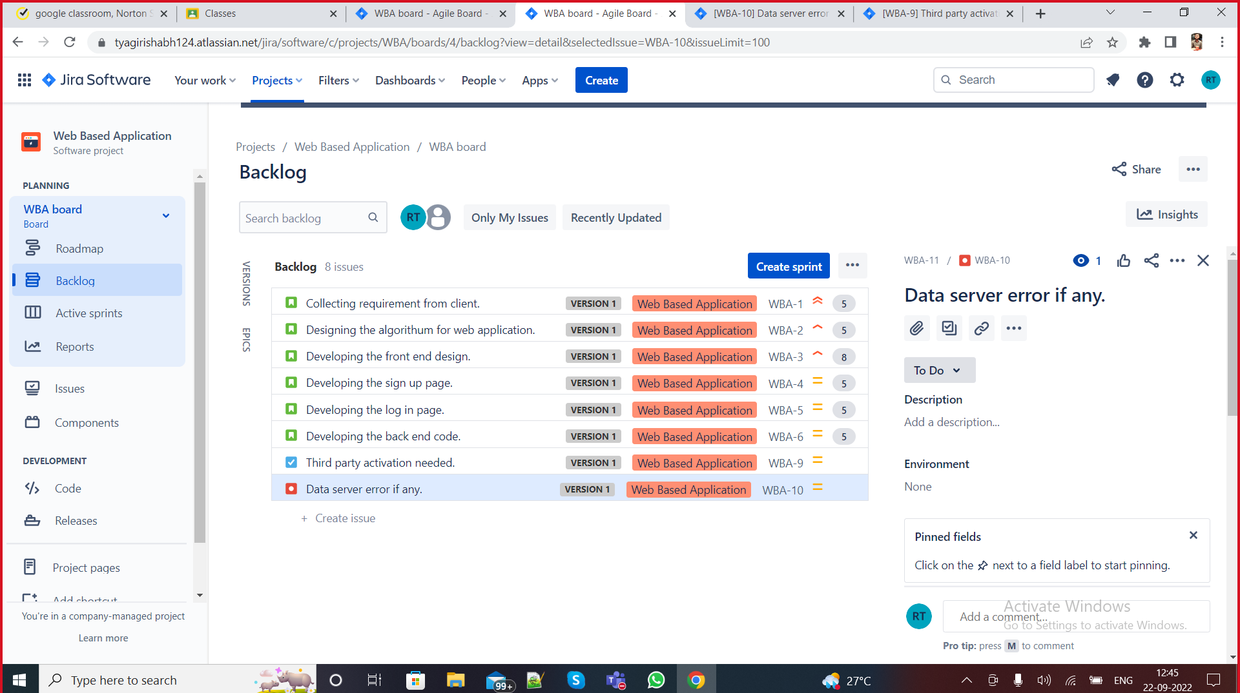

Q1. Create components

Solution-:

Creation of Components-:

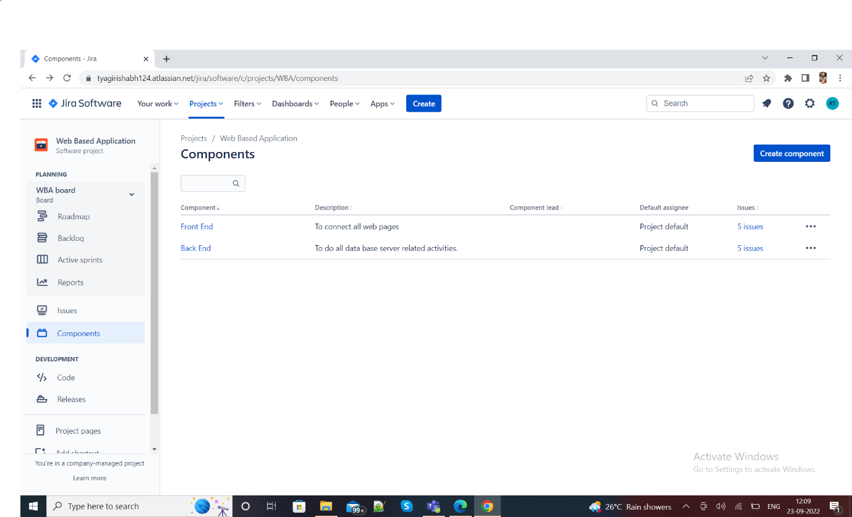

Q2. Plan the version with release dates

Solution-:

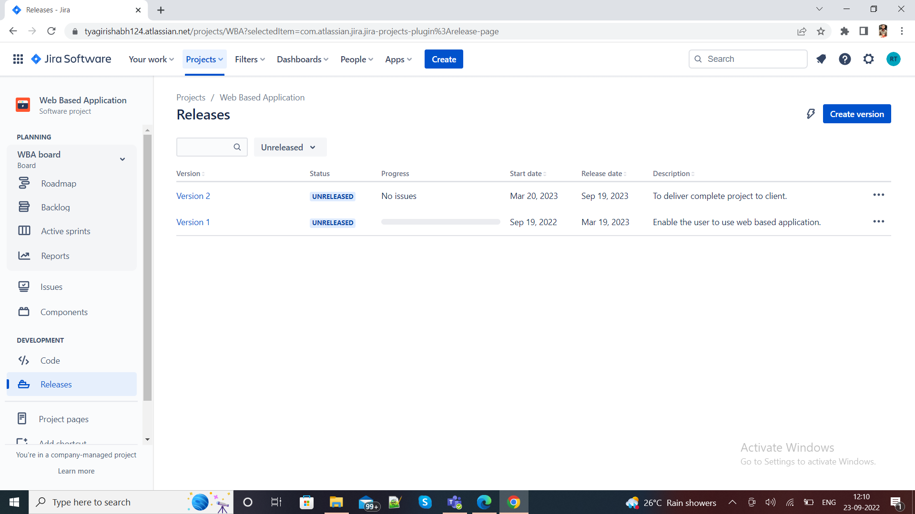

Q4-: Create different types of issues in the backlog

Solution-:

Issues/Stories created.



-Epic –provide epic link also

Solution-:

Epic Creation

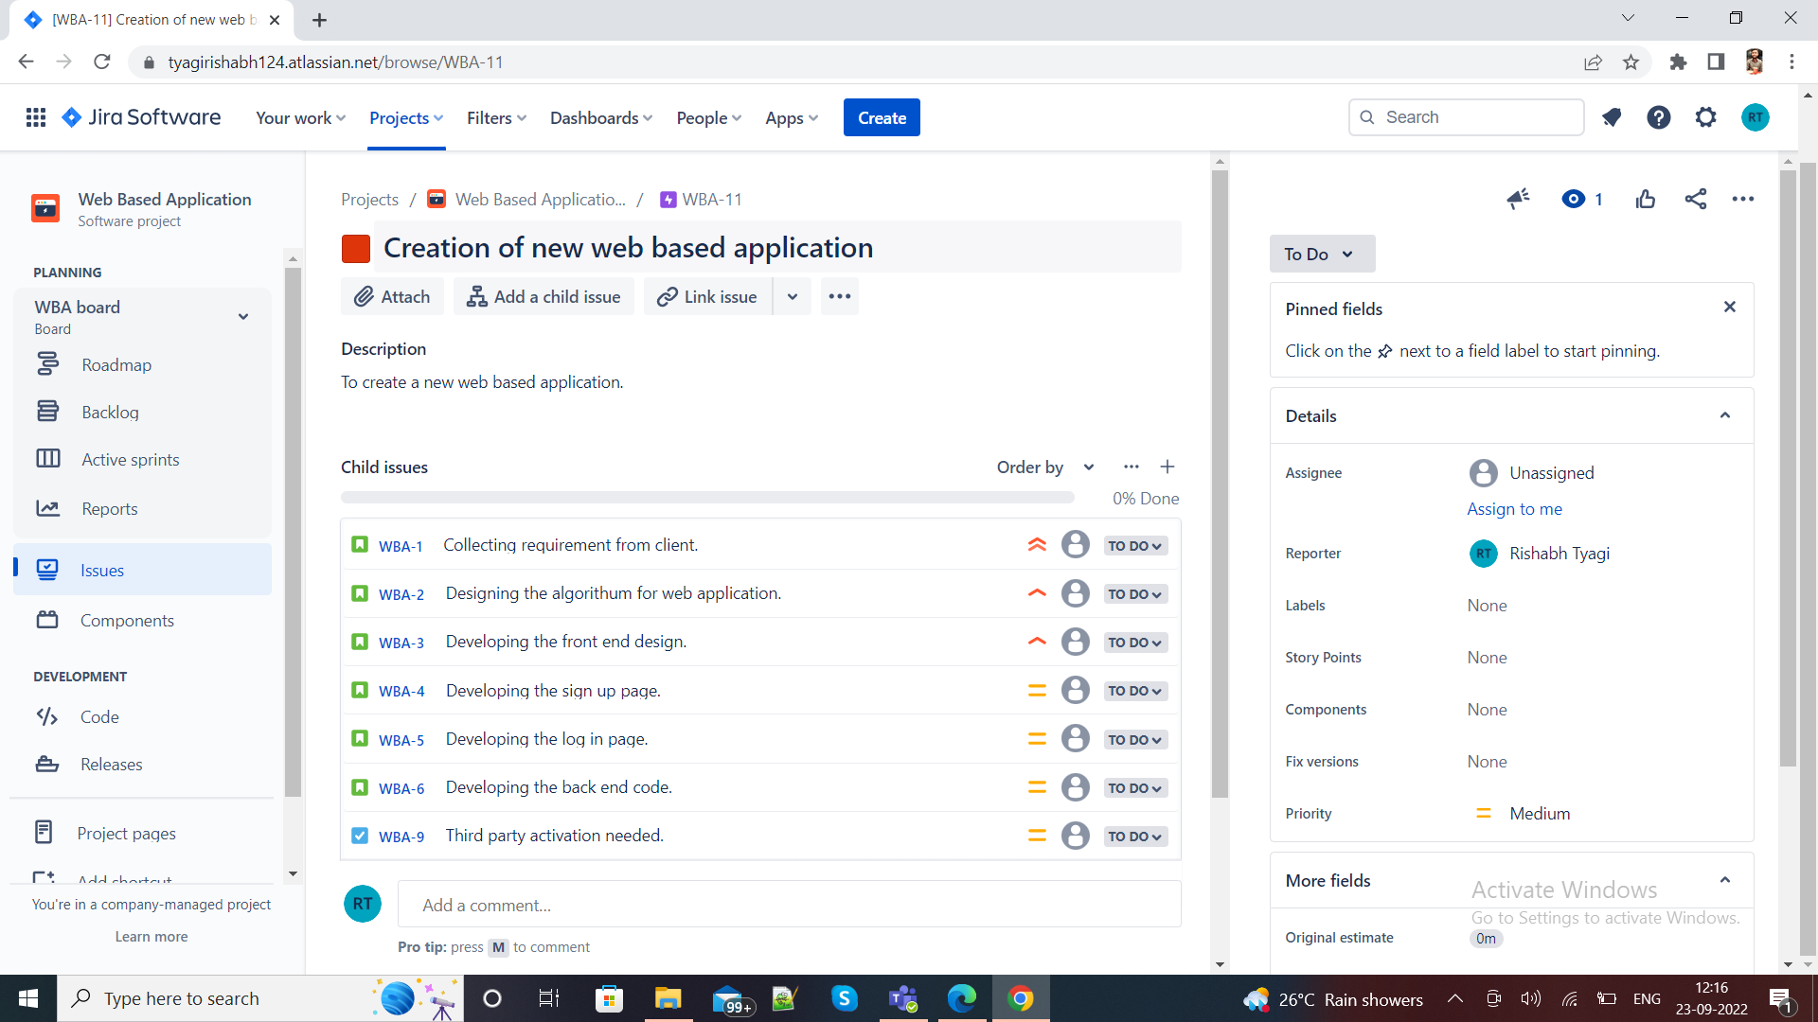

Initialize story point, Associate with Version, component

Solution-:

Initialization of story point, Associate with version, components

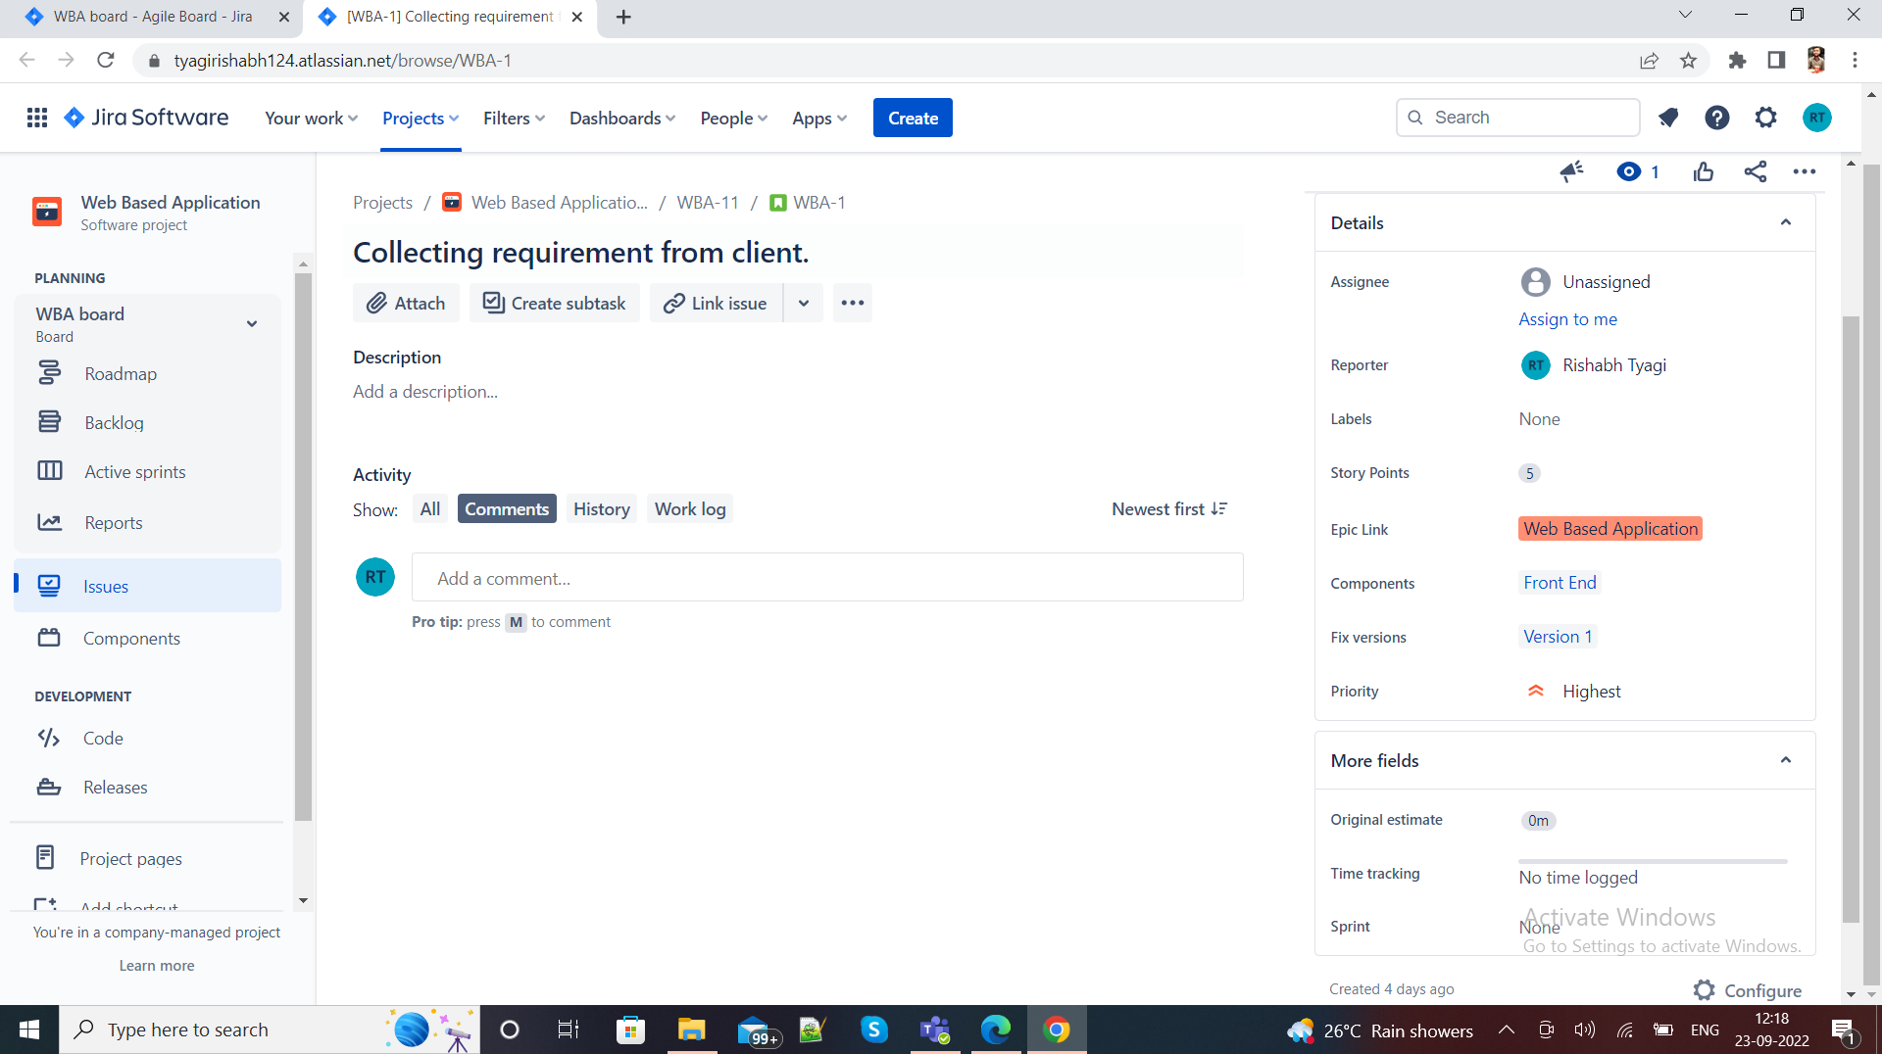

Q-: Divide into sub-tasks::::: Give estimate time

Solutions-:

Creation of sub-tasks, estimation time givn.

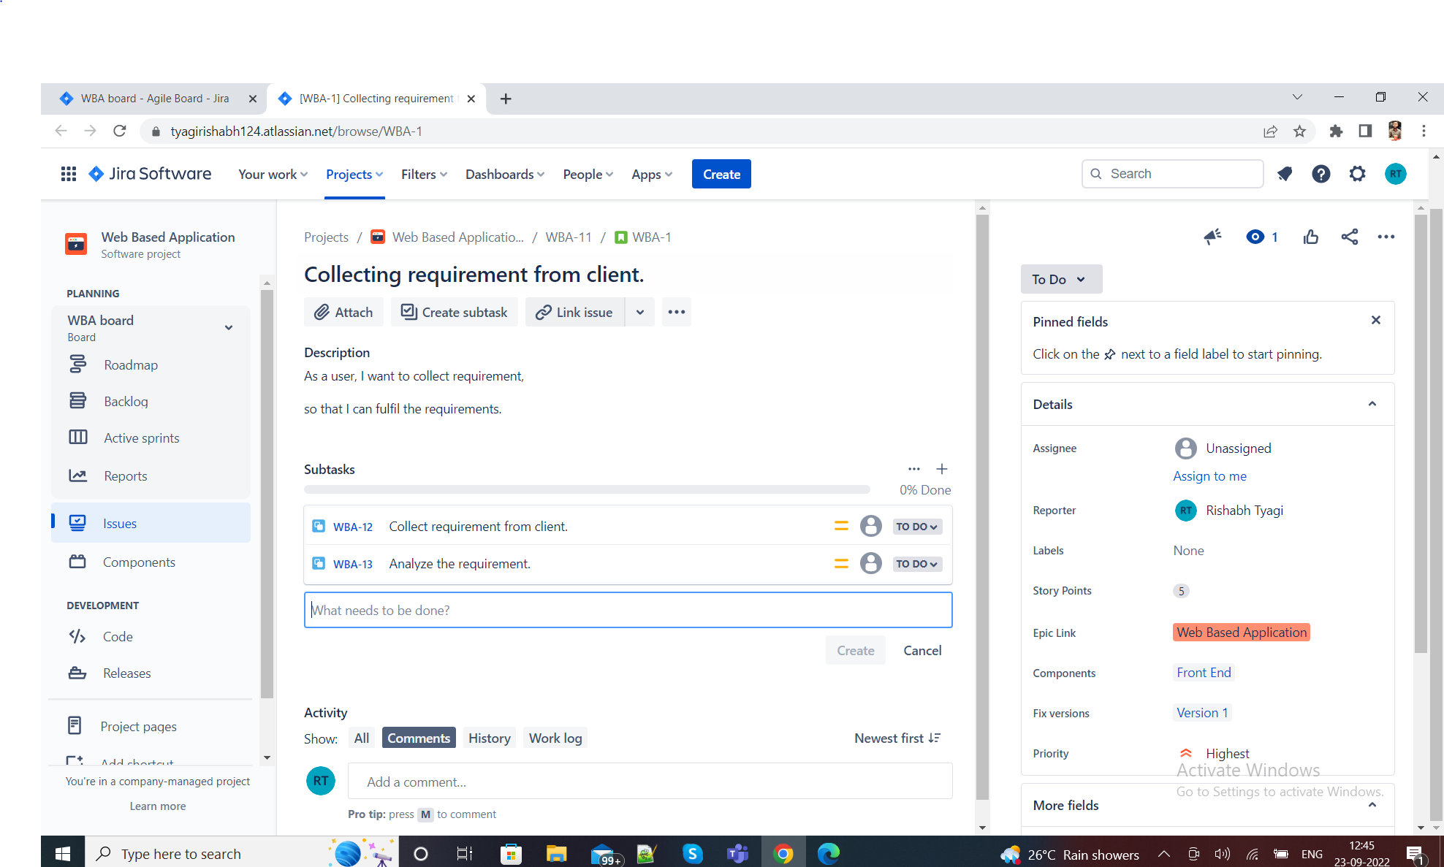

Q-: Task

Solutions-:

Creation of Task and original estimate time.

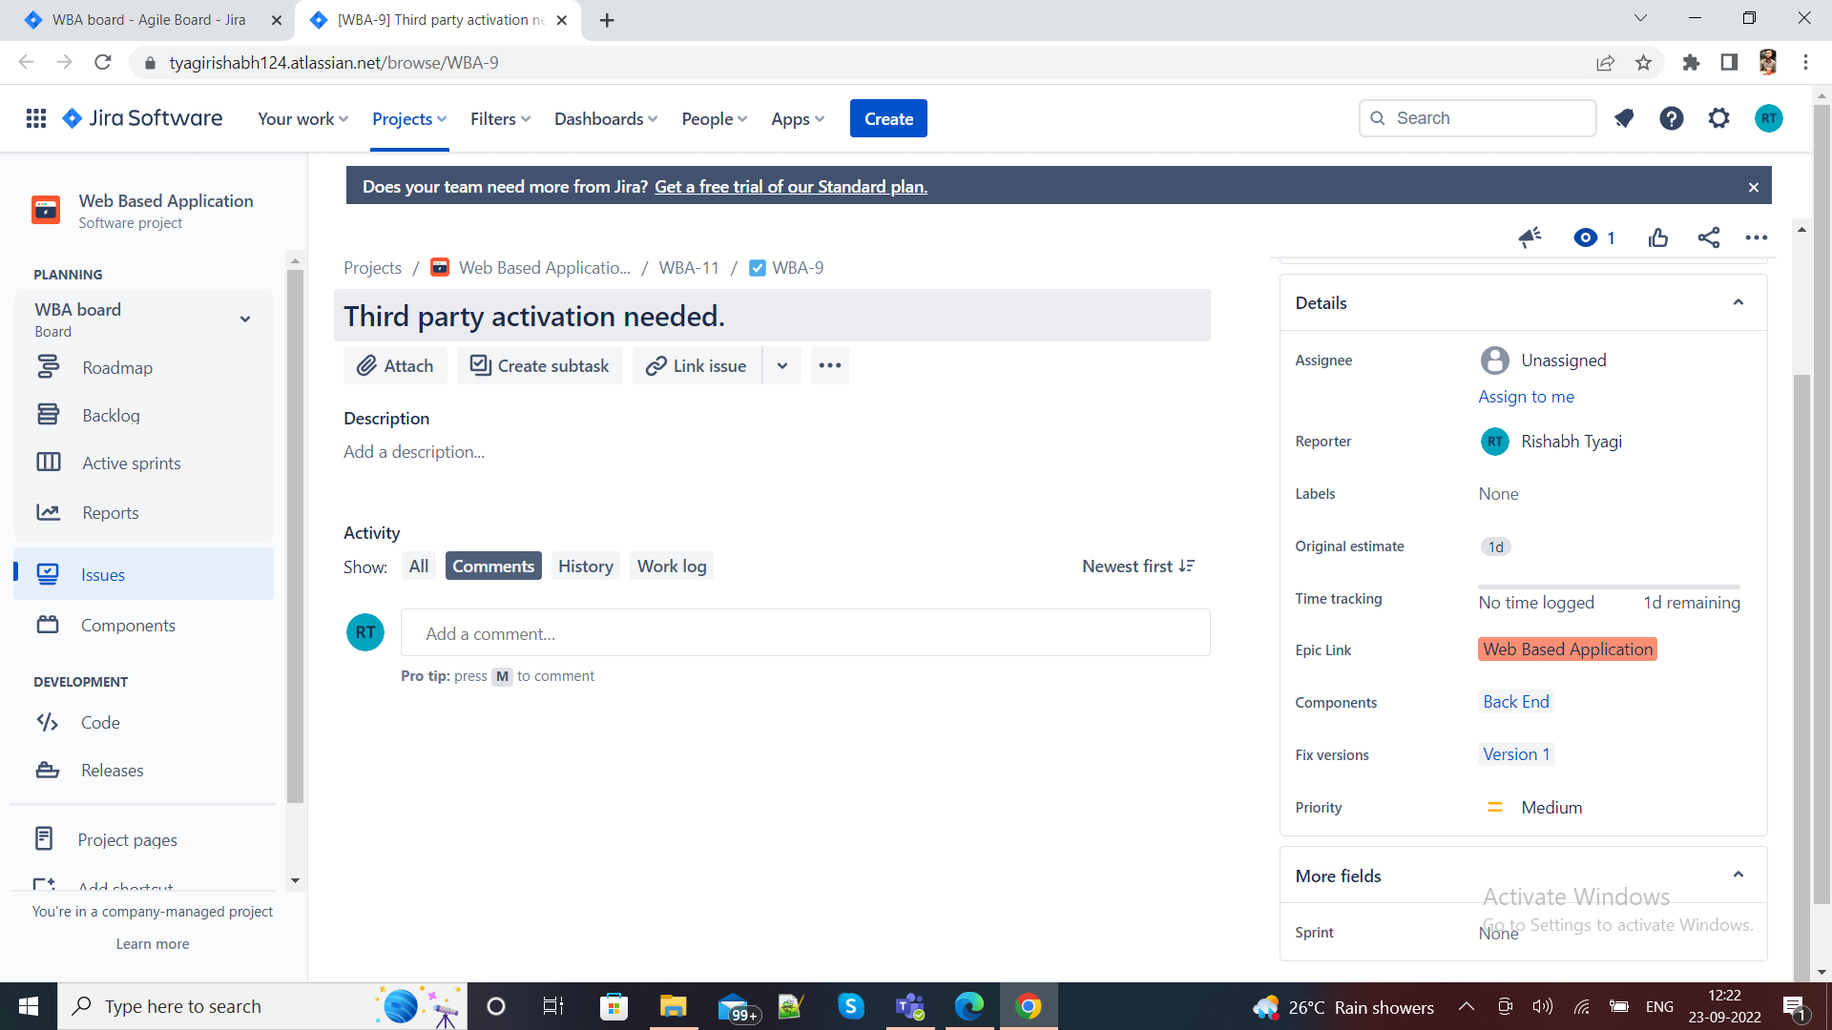

Q-: Bug - Link with issues story

Solutions-:

Creation of bug and linking with story.

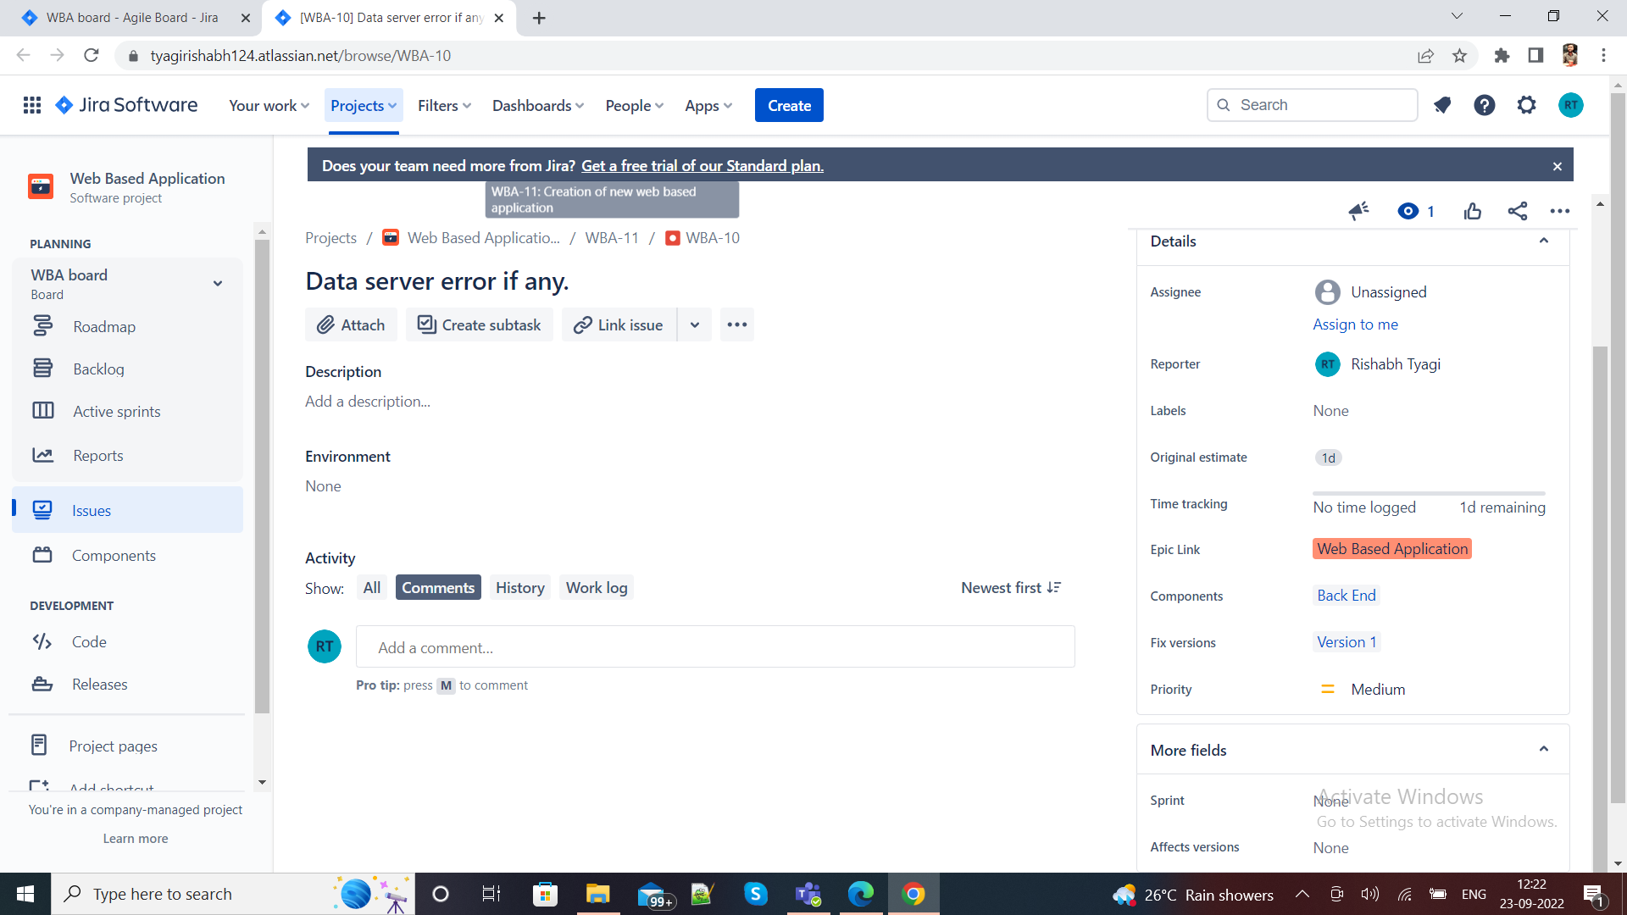

Q3-: Create sprint backlog, start sprint and complete sprint

Solution-:

Creation of Sprints backlog-:

I have created two sprints named WBA Sprint 1 and WBA Sprint 2 as shown below

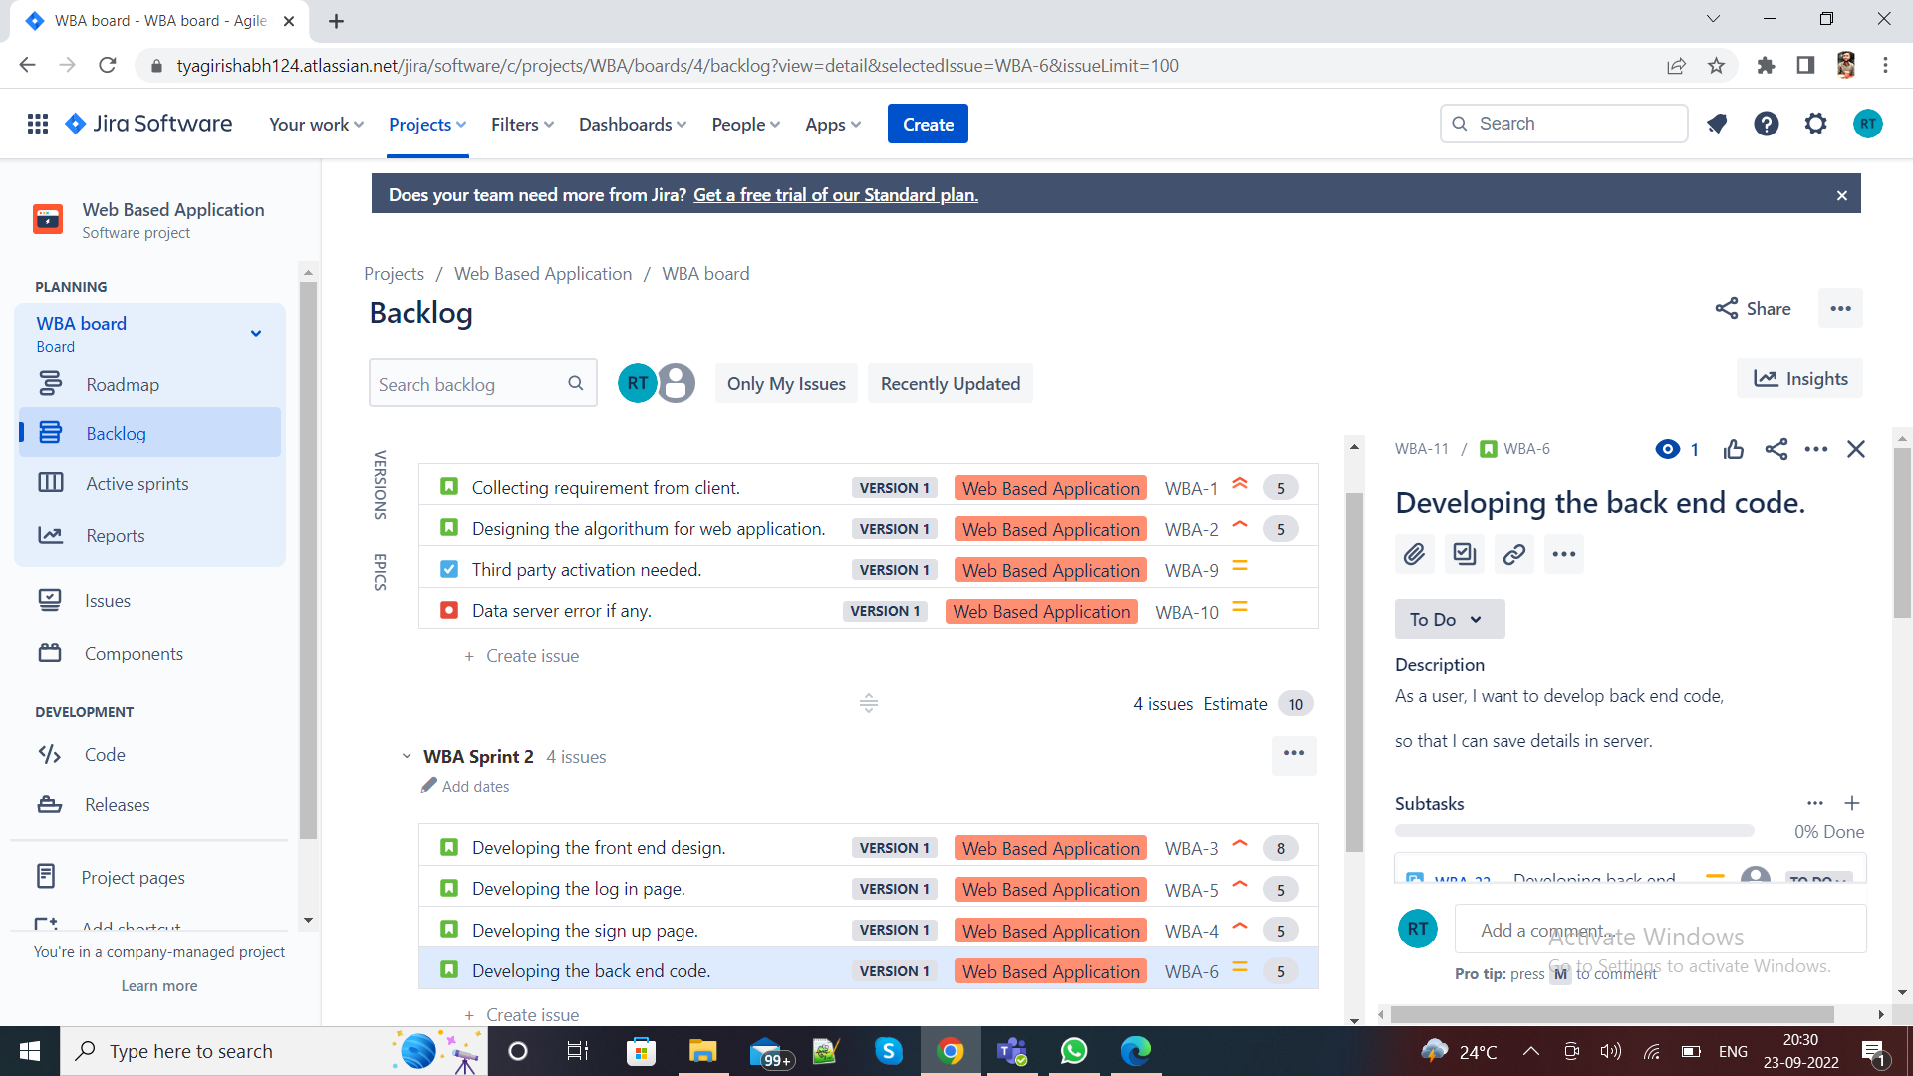

Start Sprint-:

I started sprint and then moved it from to do state to In Progress state as shown below.

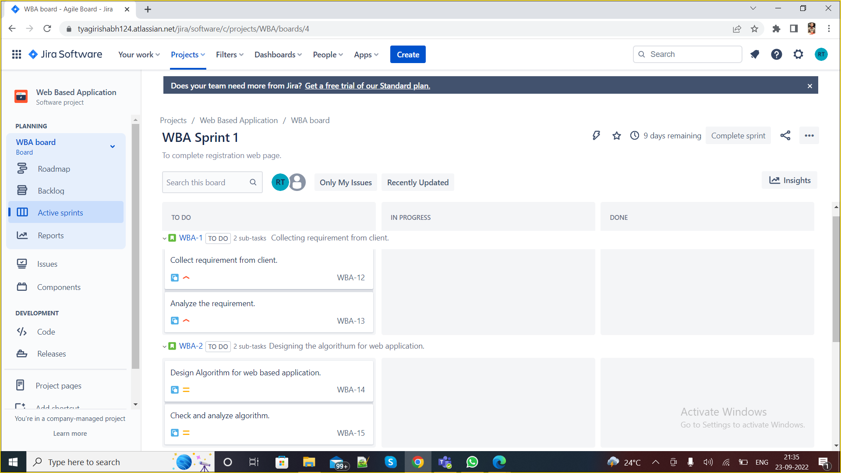

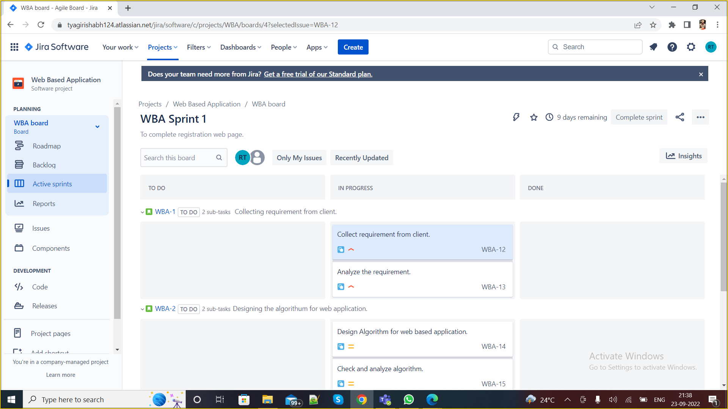

Complete Sprints-:

Solution-:

Sprint 1 finally moved to done state after completion of whole process and finally completed.

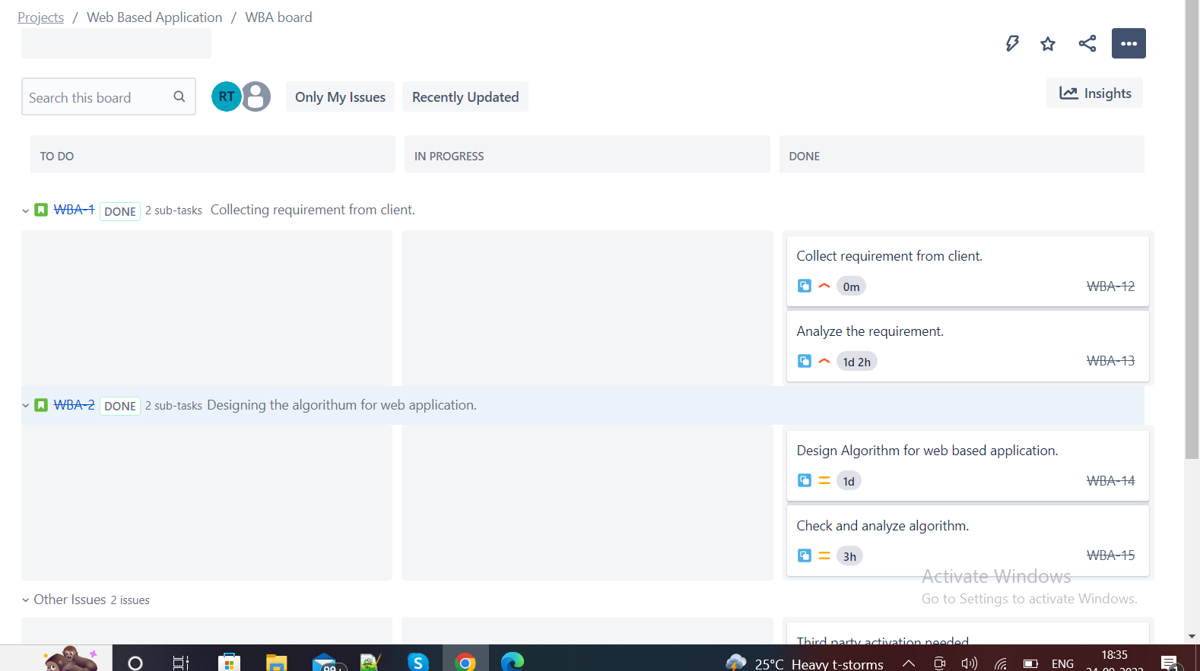

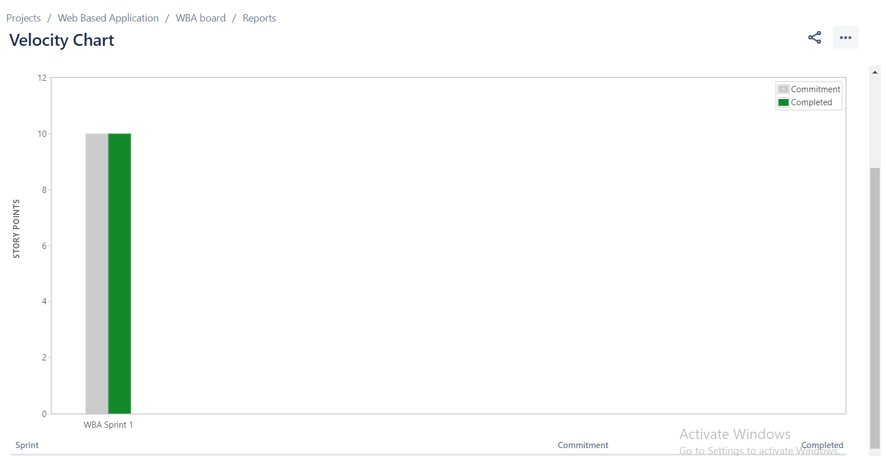

Q5-: Evaluate burn down, burn up, analyse the sprint report and velocity charts.

Solutions-:

Burn Down Charts created after completion of sprint 1 “WBA Sprint 1”

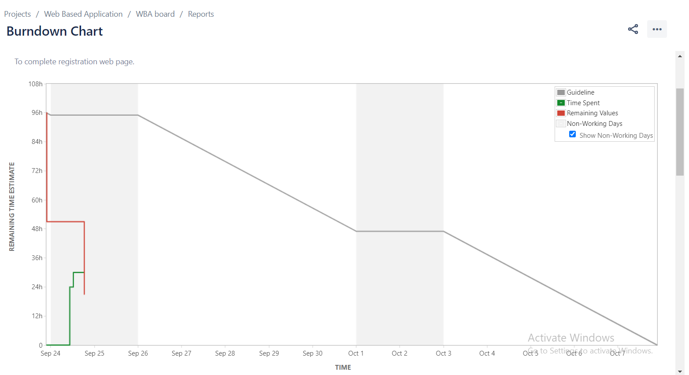

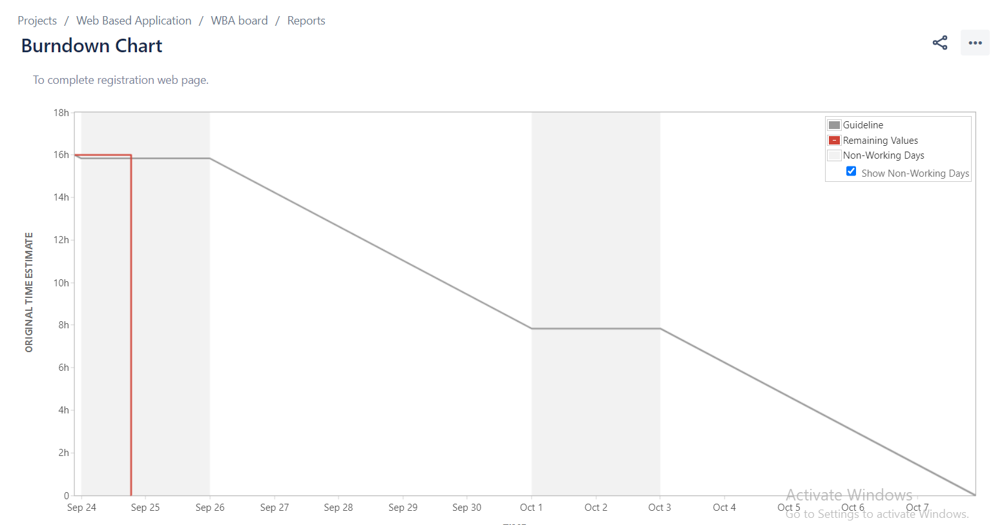

Burn UP Charts created after completion of sprint 1 “WBA Sprint 1”

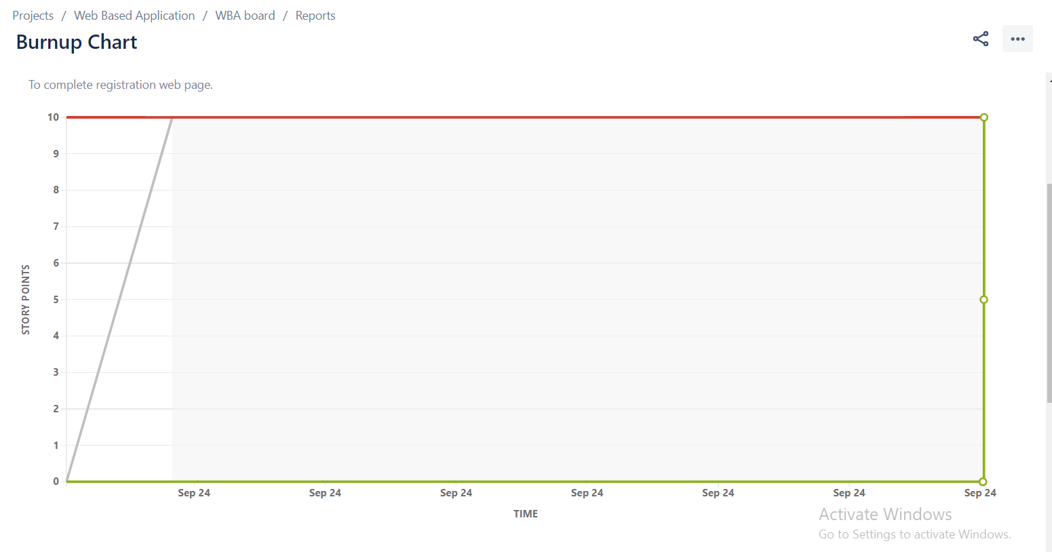

Velocity Chart created after completion of sprint 1 “WBA Sprint 1”



Burn Down Chart created after completion of sprint 2 “WBA Sprint 2”

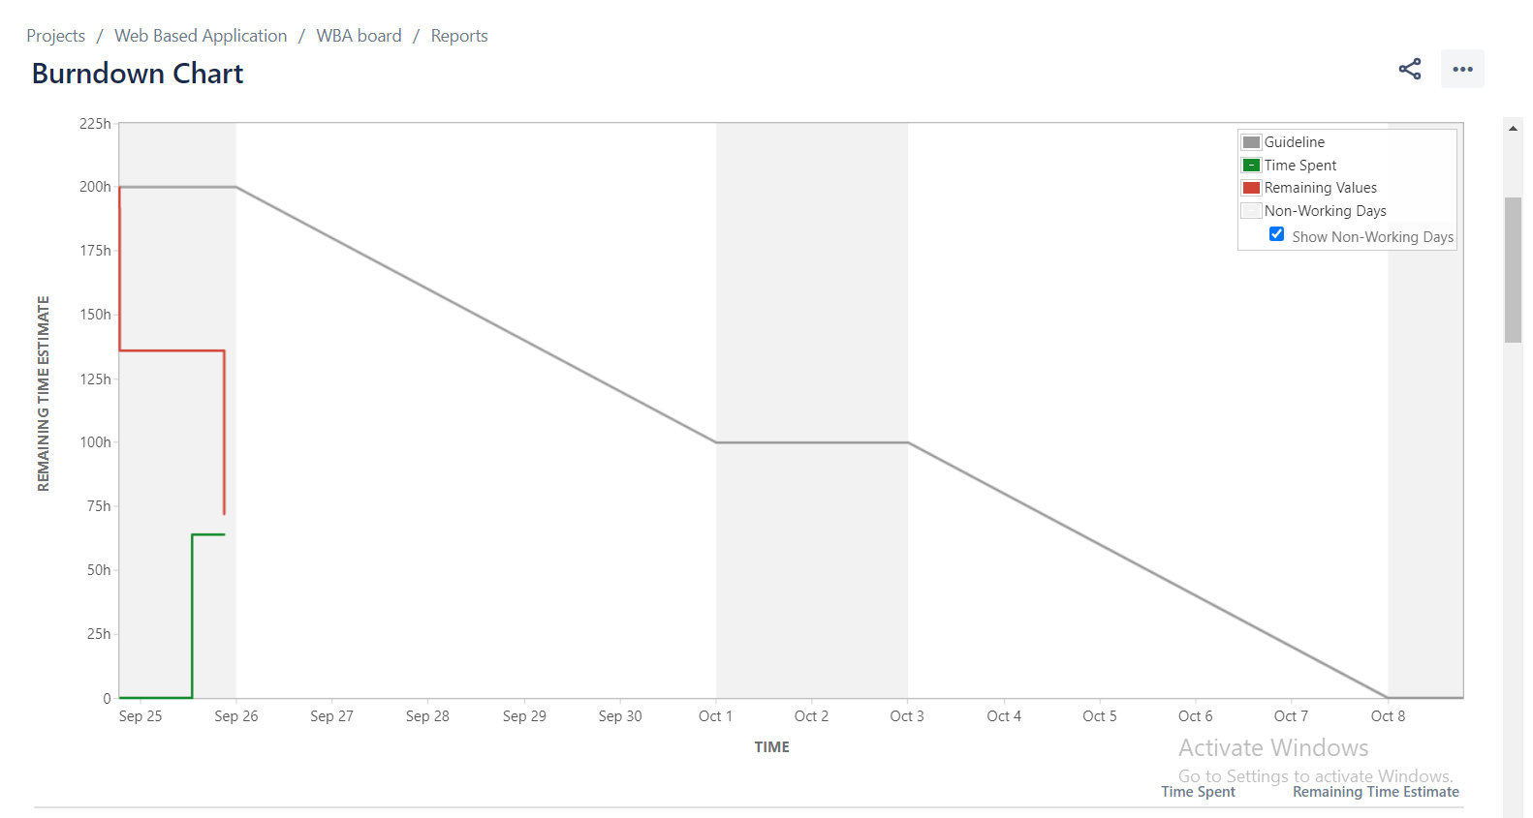

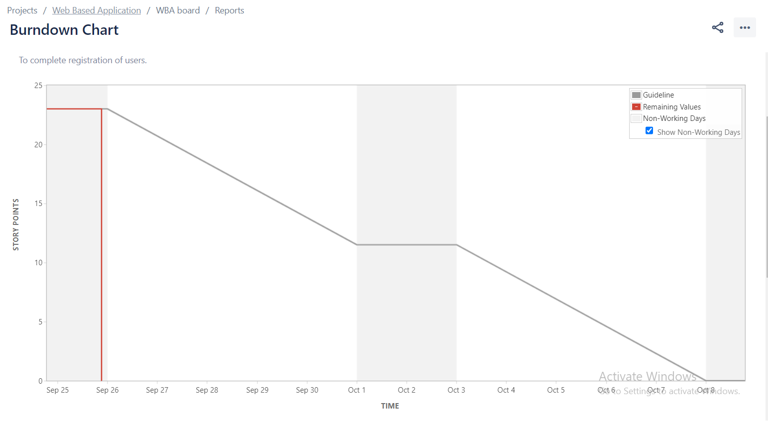

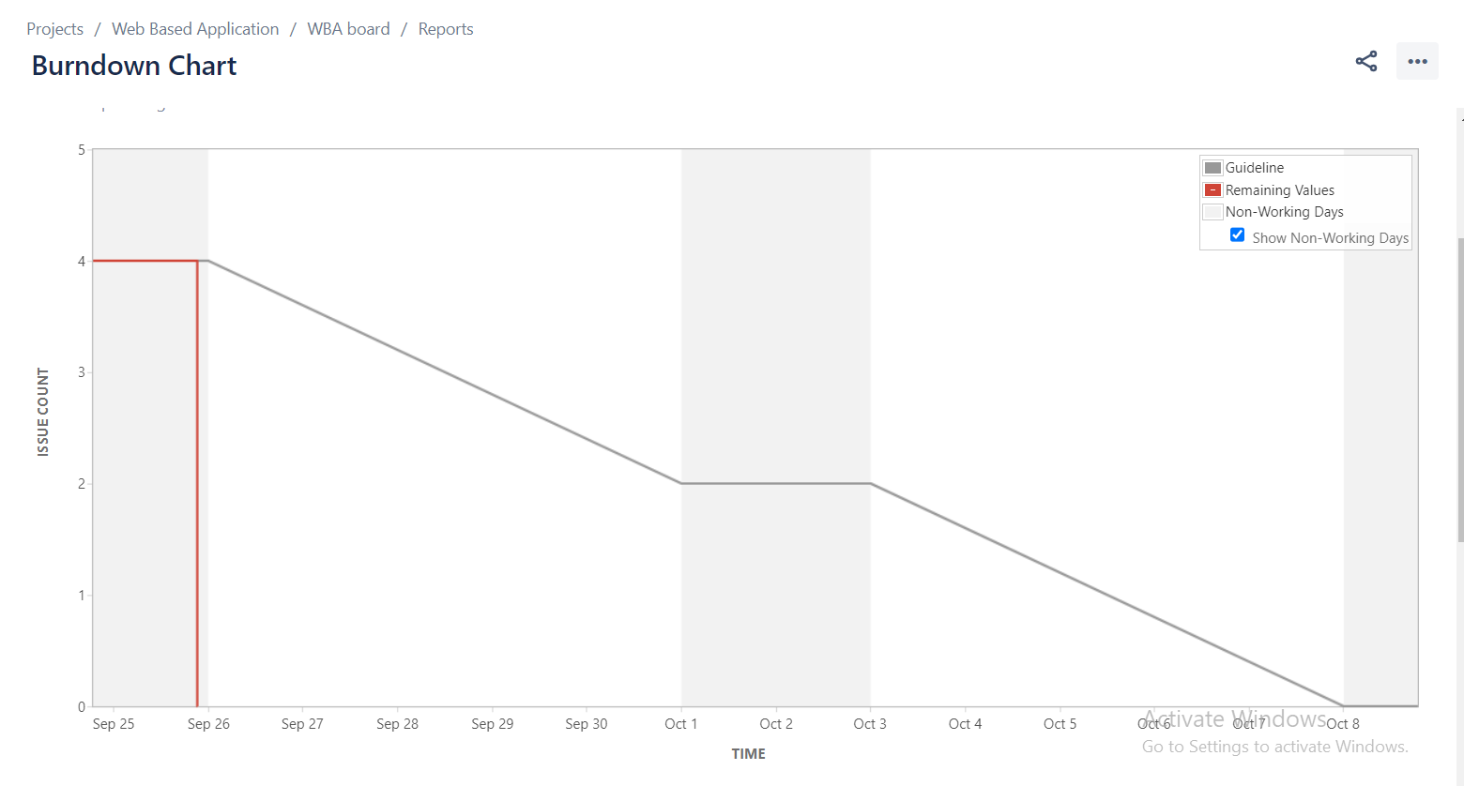

Burn UP Chart created after completion of sprint 2 “WBA Sprint 2”

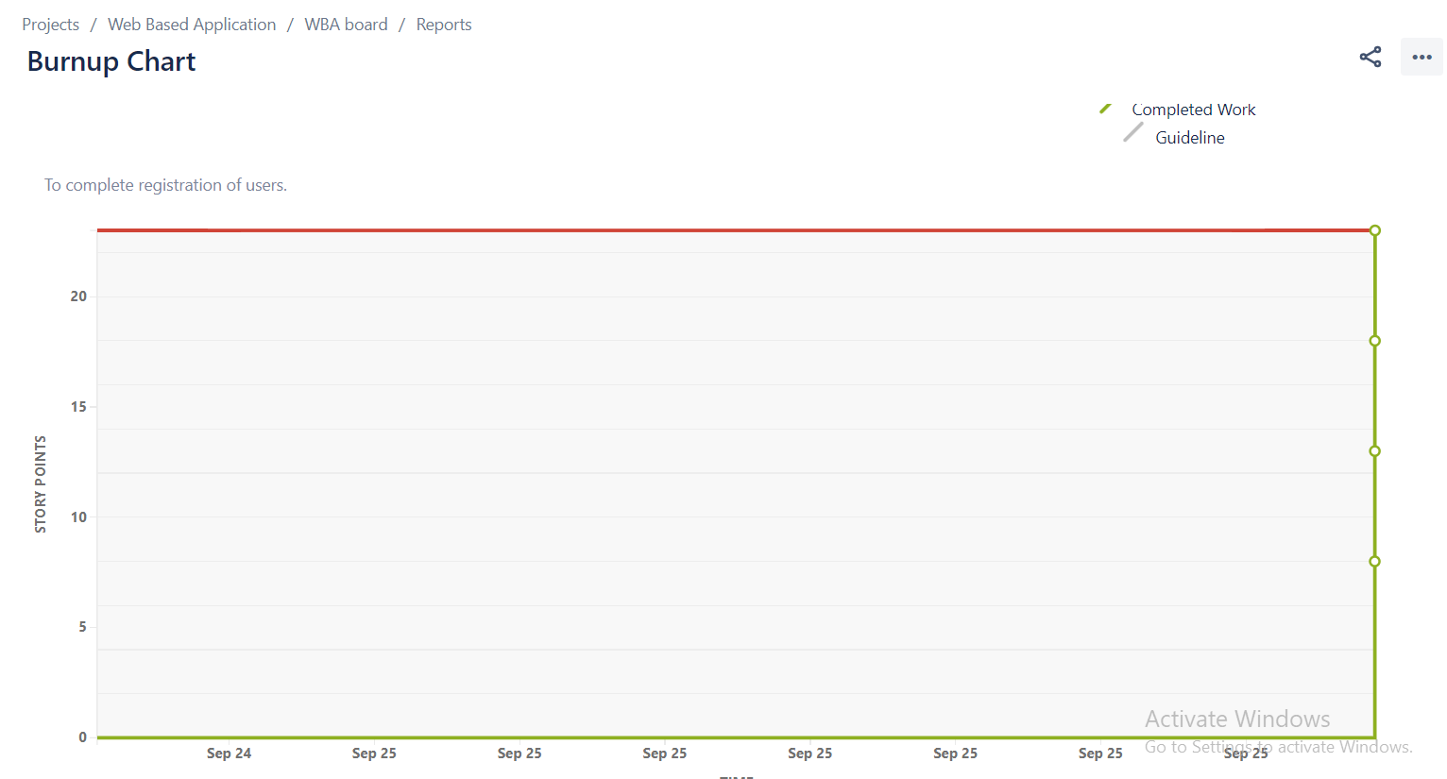

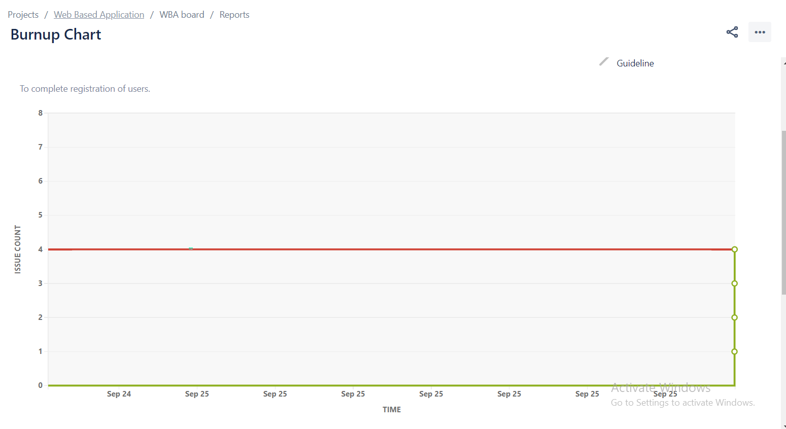

Sprint Report After completion of 2nd Sprint

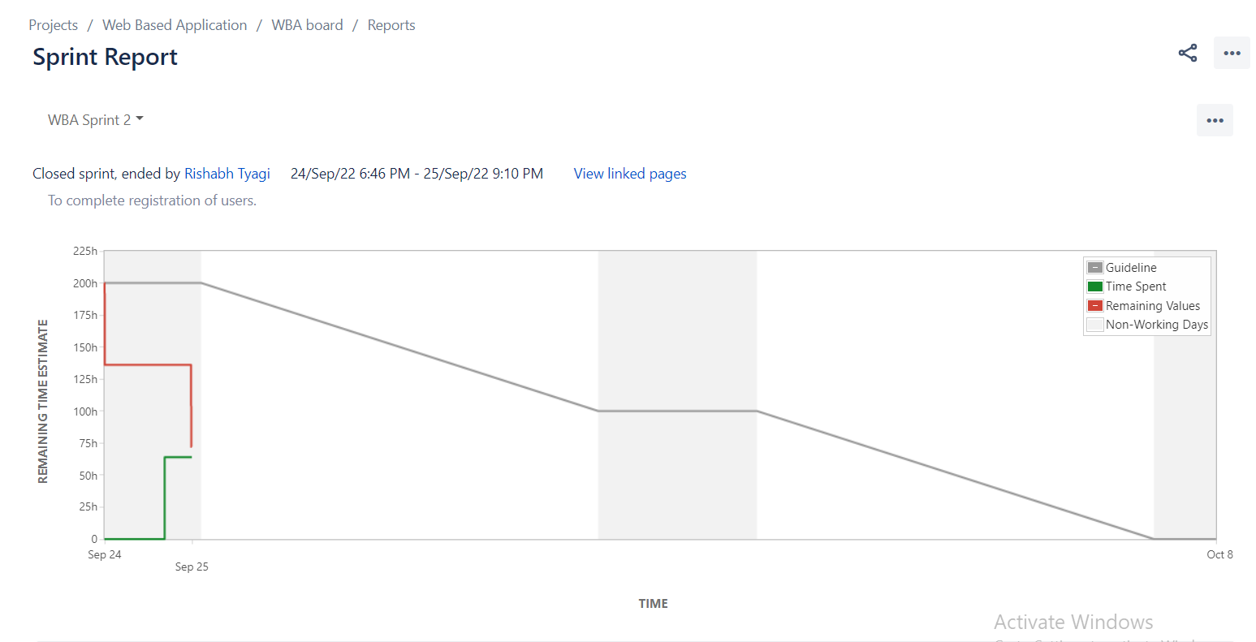

Velocity report after completion of 2nd Sprint

