**1.Create Database**

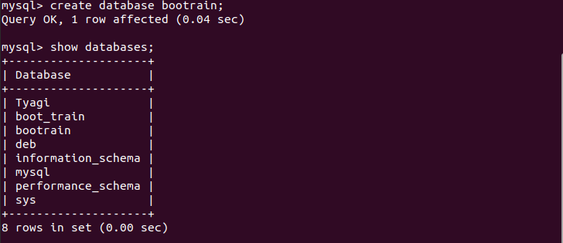

**2.Design Schema**

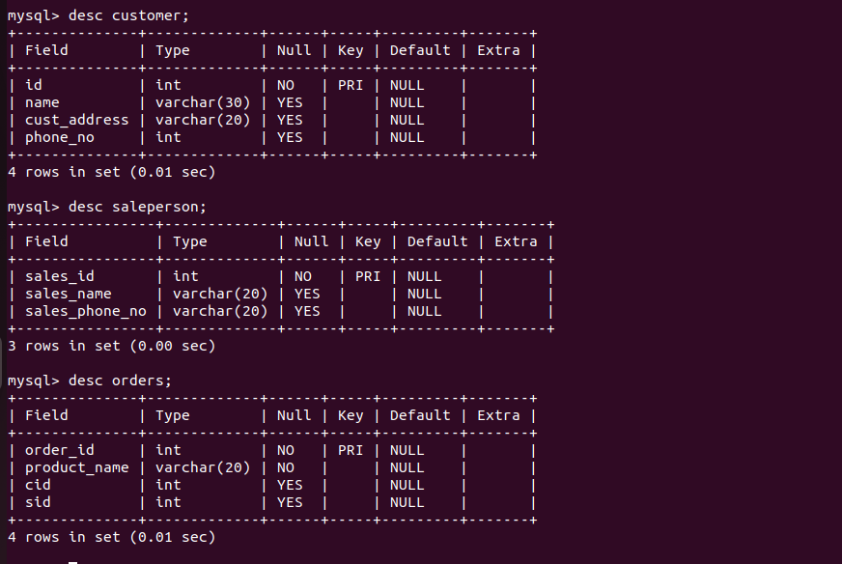

**3.Create tables**

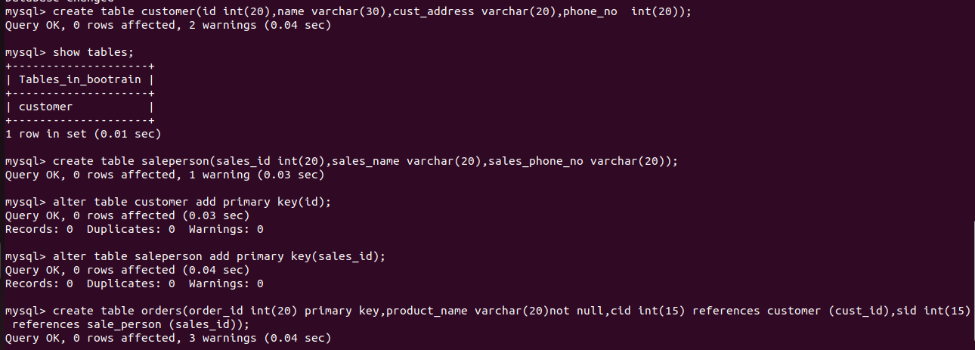

**4.Insert sample data**

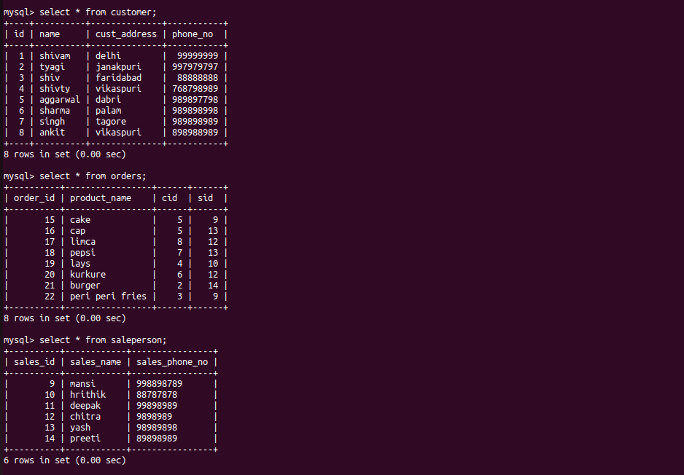

**5.Find the sales person have multiple orders**

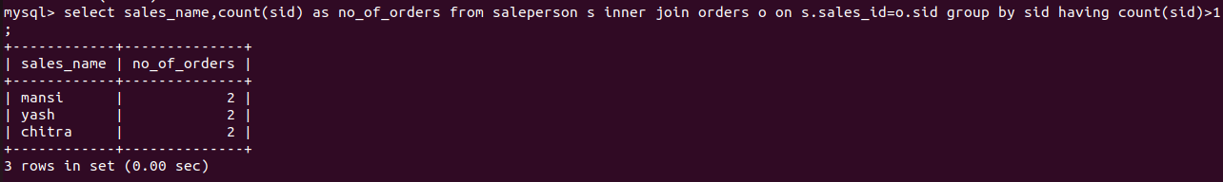

**6.Find the all sales person details along with order details**

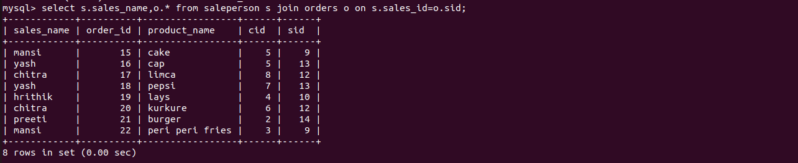

**7.Create Index**



**8.How to show index on a table**

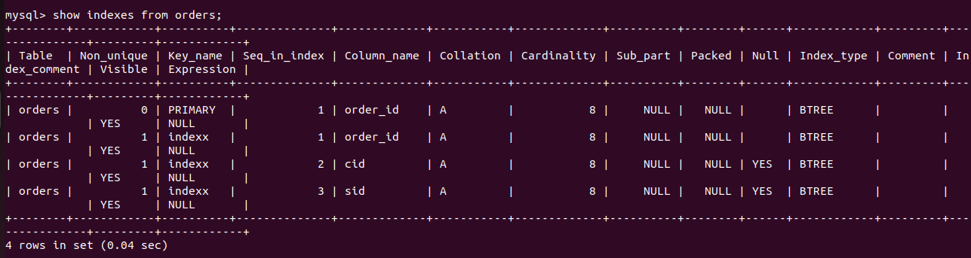

**9.Find the order number, sale person name, along with the customer to whom that order belongs to**

