**SpringAssignment-1**

Ques1.) Write a program to demonstrate Tightly Coupled code.

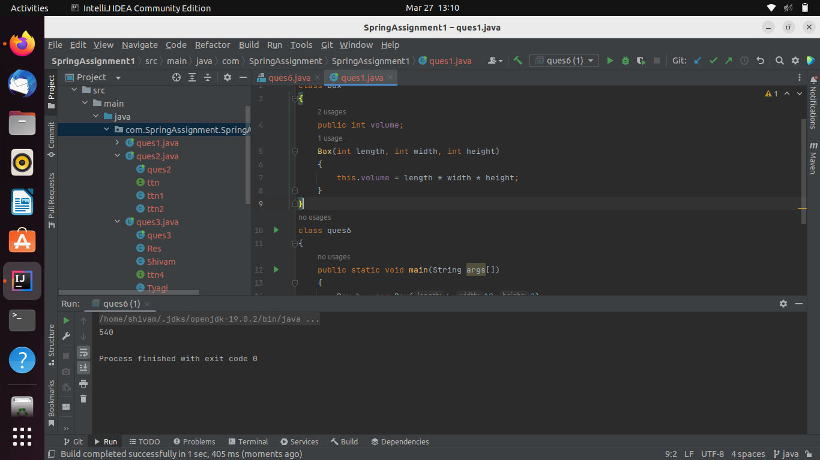

Ques2.) Write a program to demonstrate Loosely Coupled code.

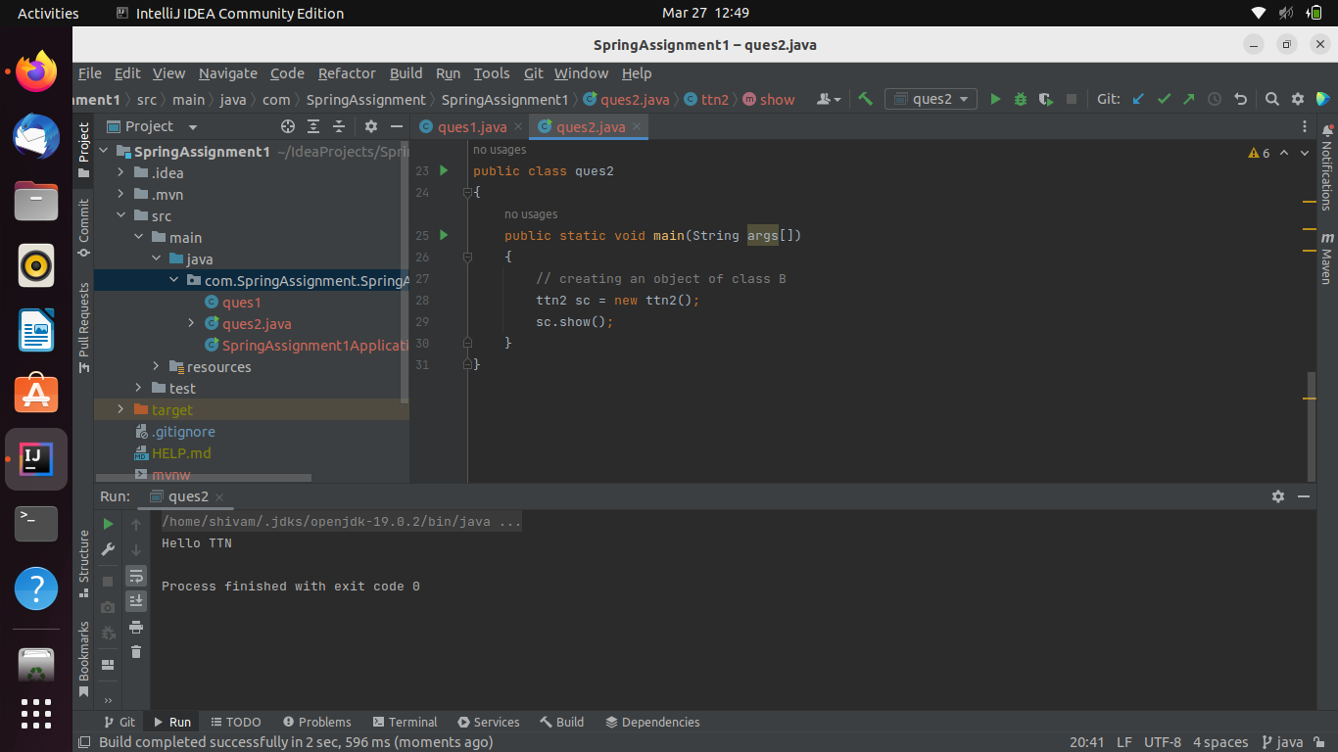

Ques3.) Use @Compenent and @Autowired annotations to in Loosely Coupled code for dependency management.

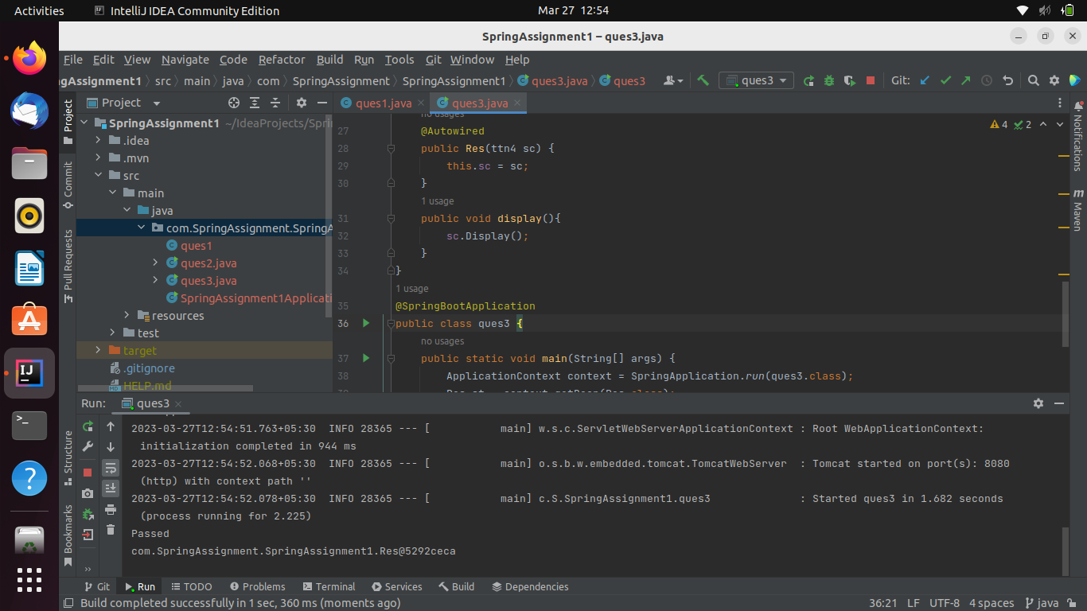

Ques4.) Get a Spring Bean from application context and display its properties.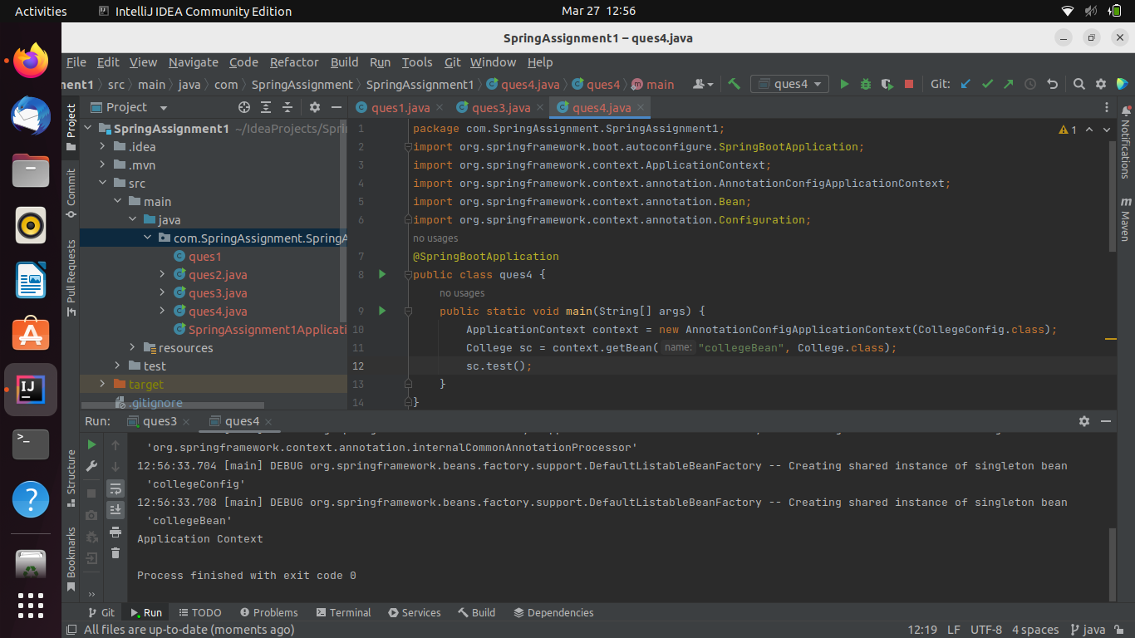Ques5.) Demonstrate how you will resolve ambiguity while autowiring bean (Hint : @Primary).

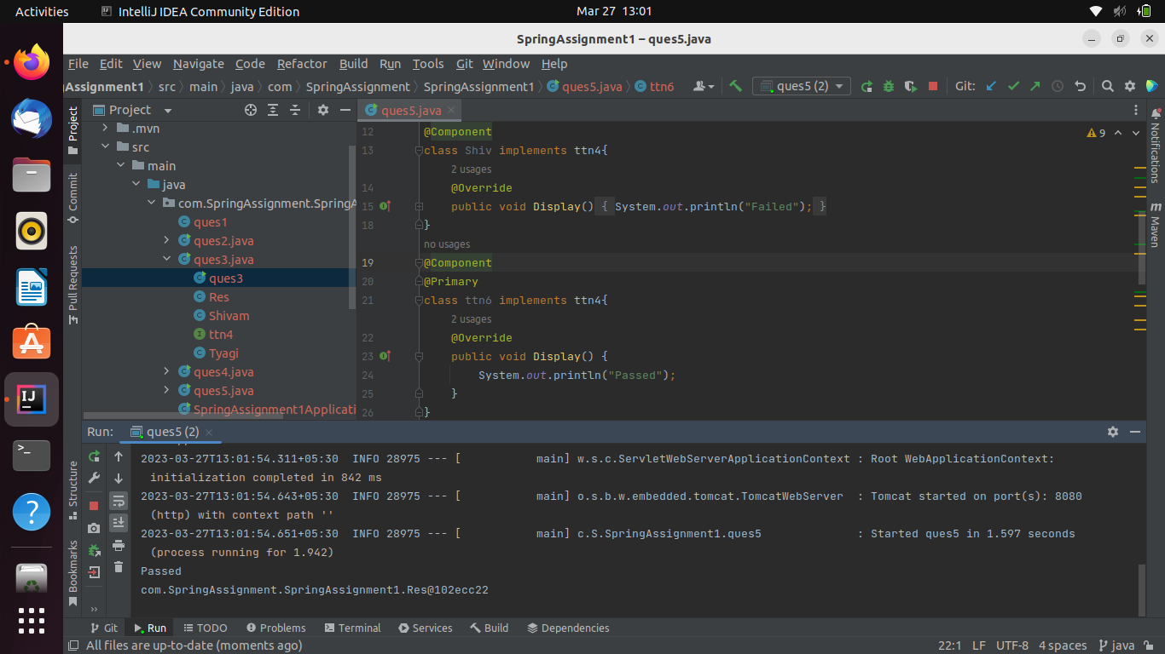

Ques6.) Perform Constructor Injection in a Spring Bean

