**JavaAssignment-7**

1. Demonstrate the use of private methods in interfaces.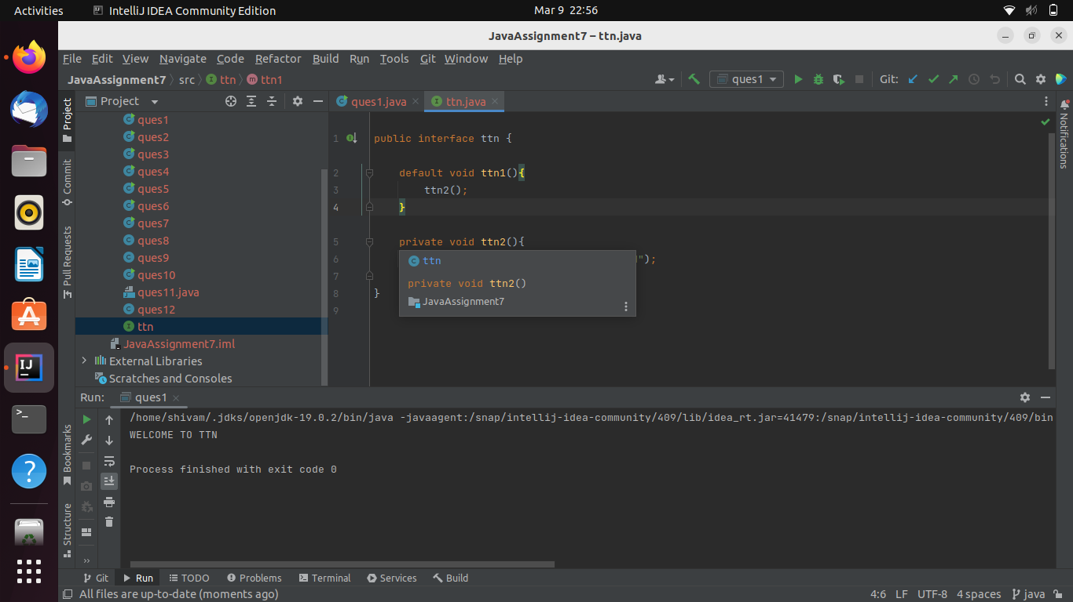
2. Perform takeWhile and dropWhile operations on stream

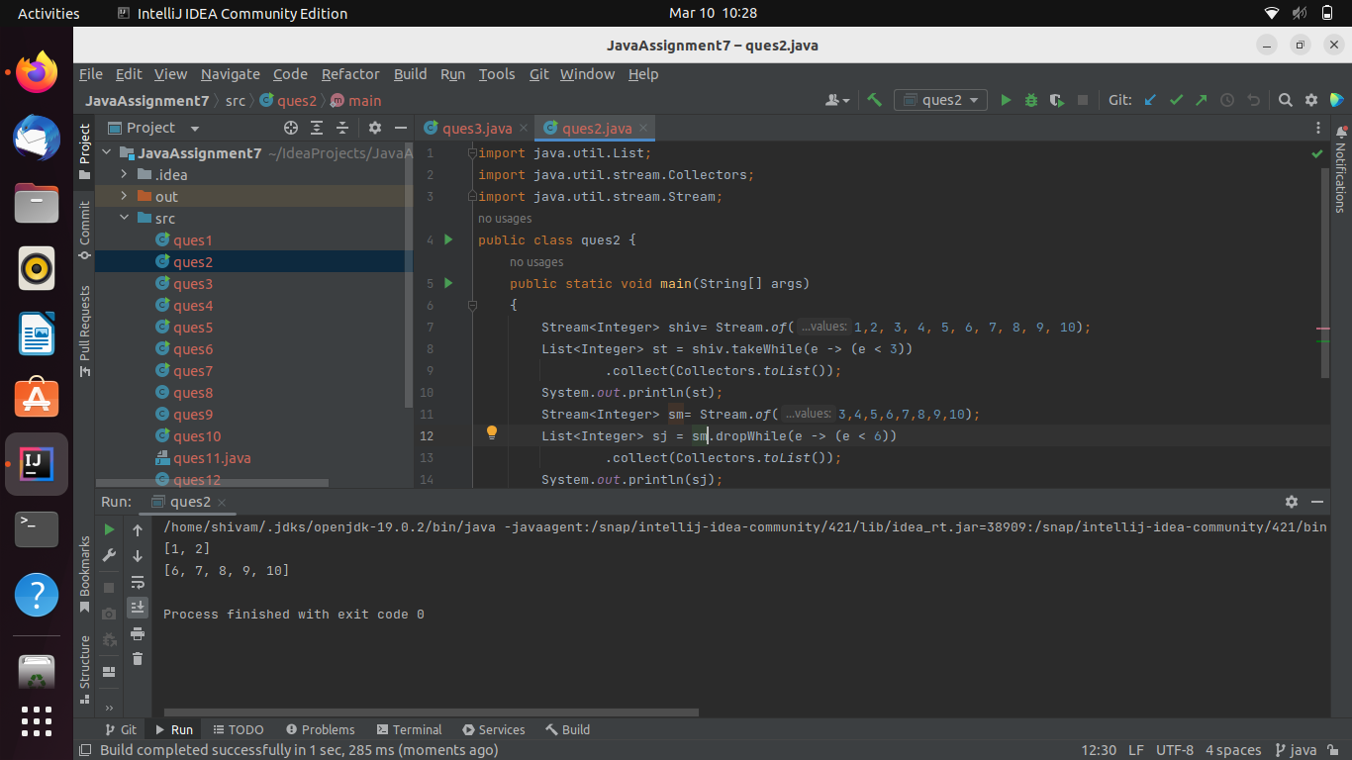

1. Use rangeClosed to create a Stream

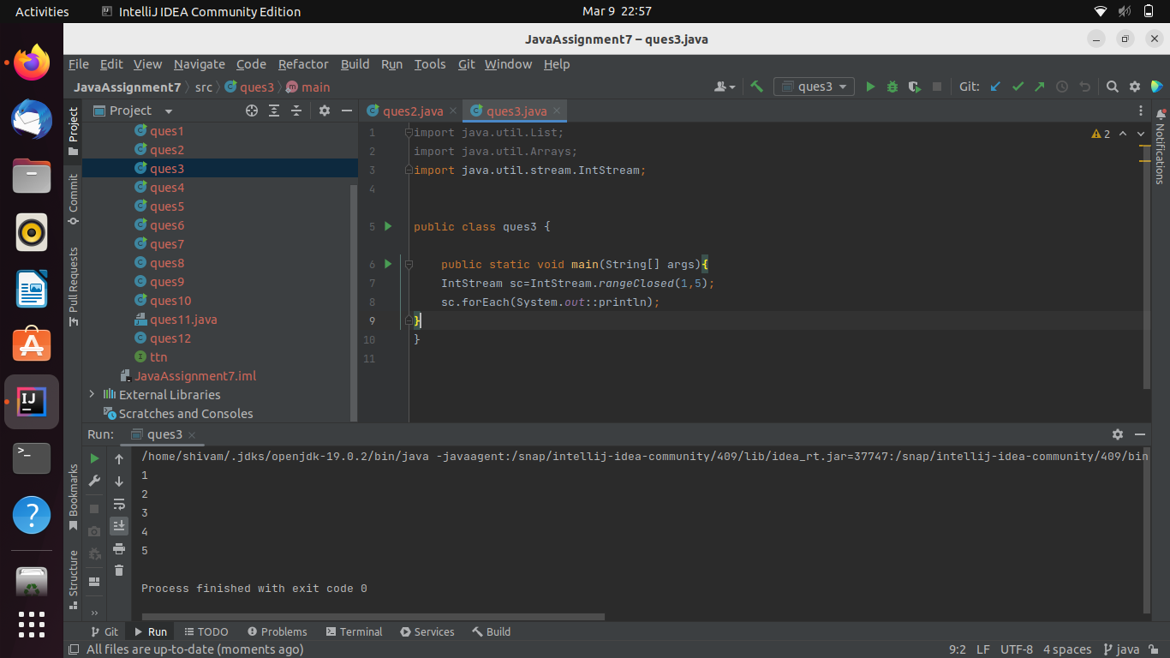

1. Use iterator stream method to generate a stream

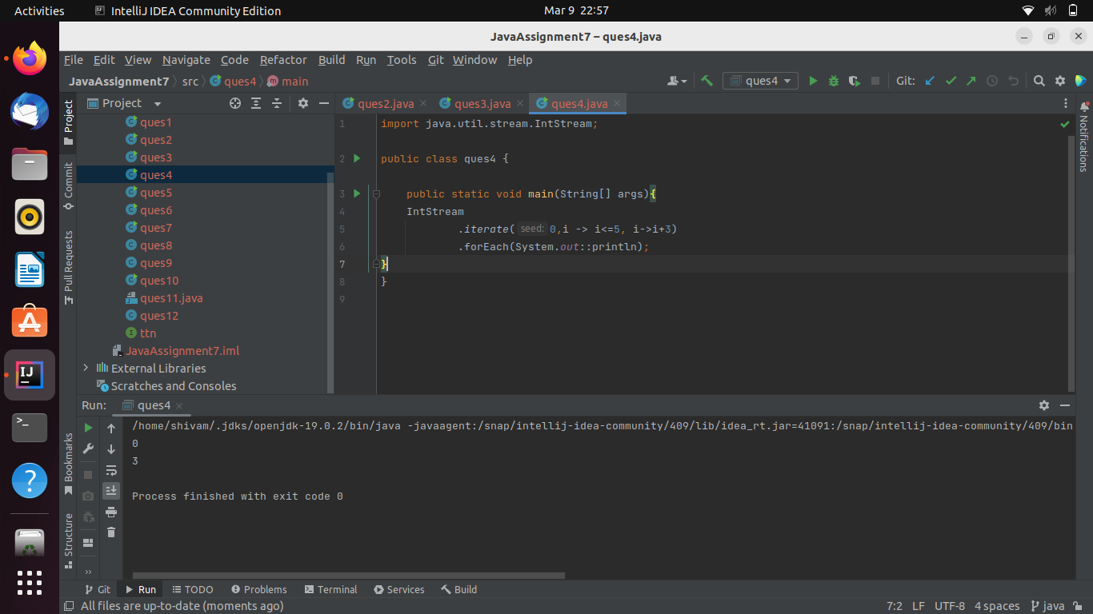

1. Use ifPresentOrElse, or, orElseThrow Operations with Optional.

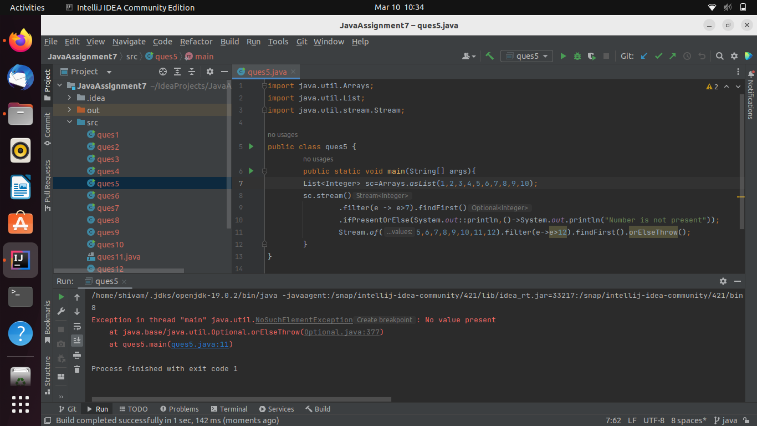

1. Convert an Optional type into Stream

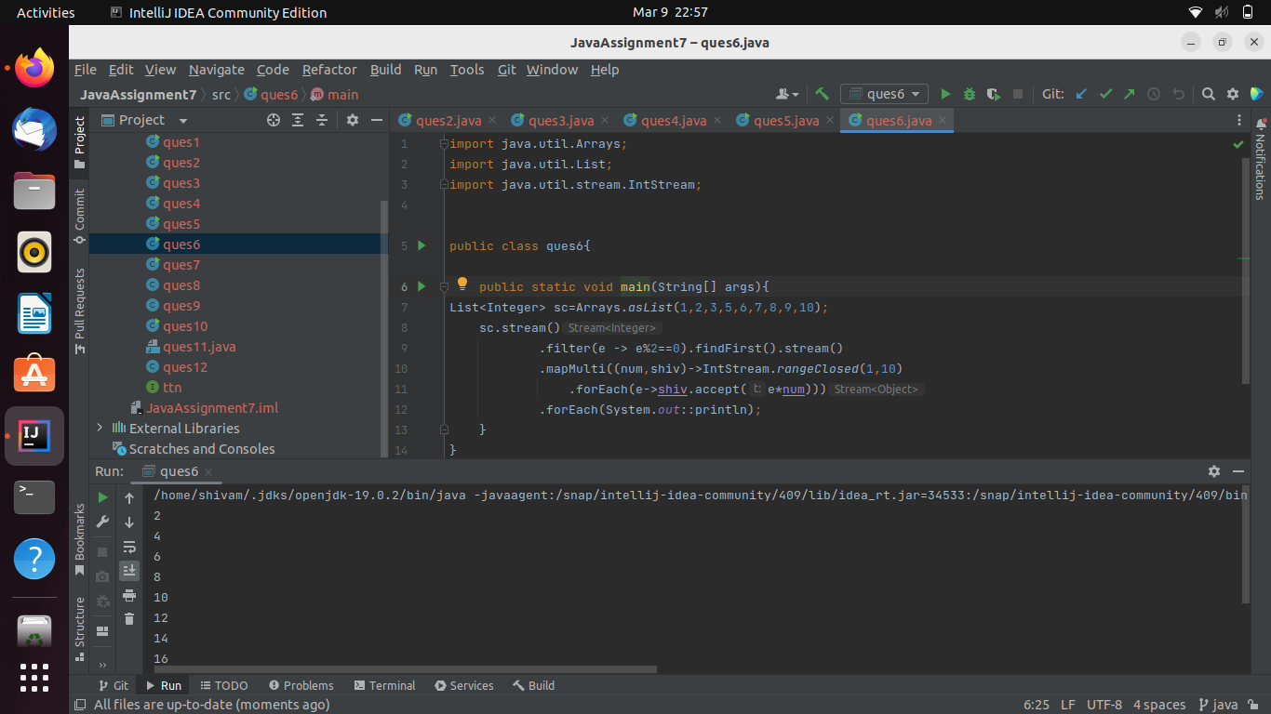

1. Use Of method to create List, Set and Map.

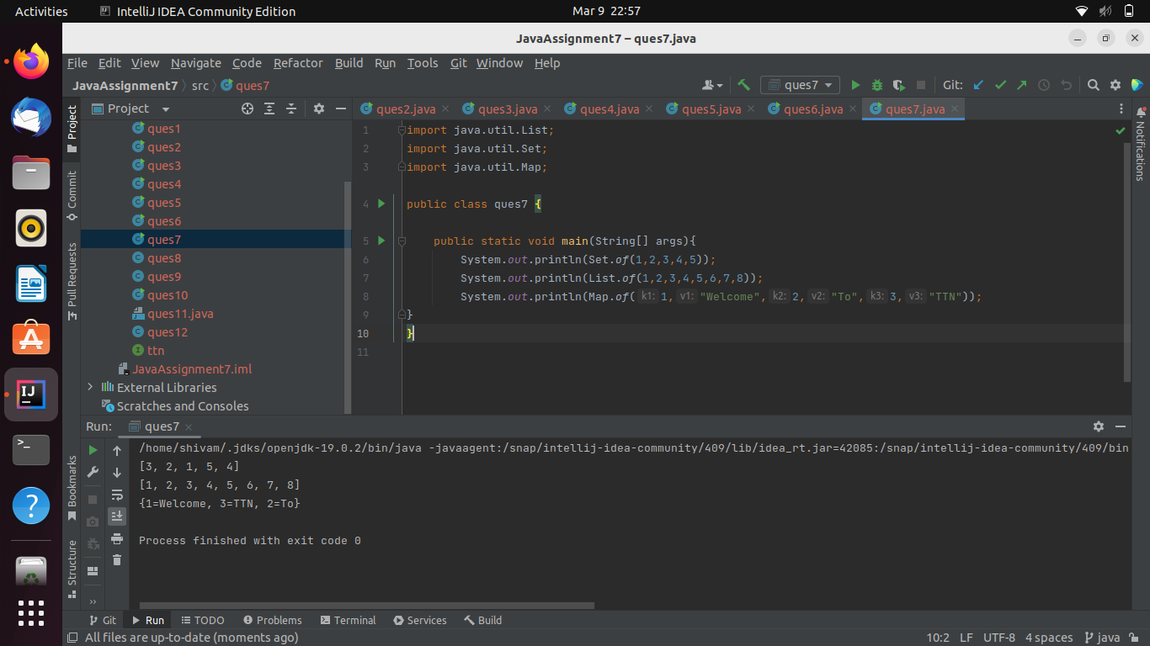

1. Demonstrate the use AutoCloseable

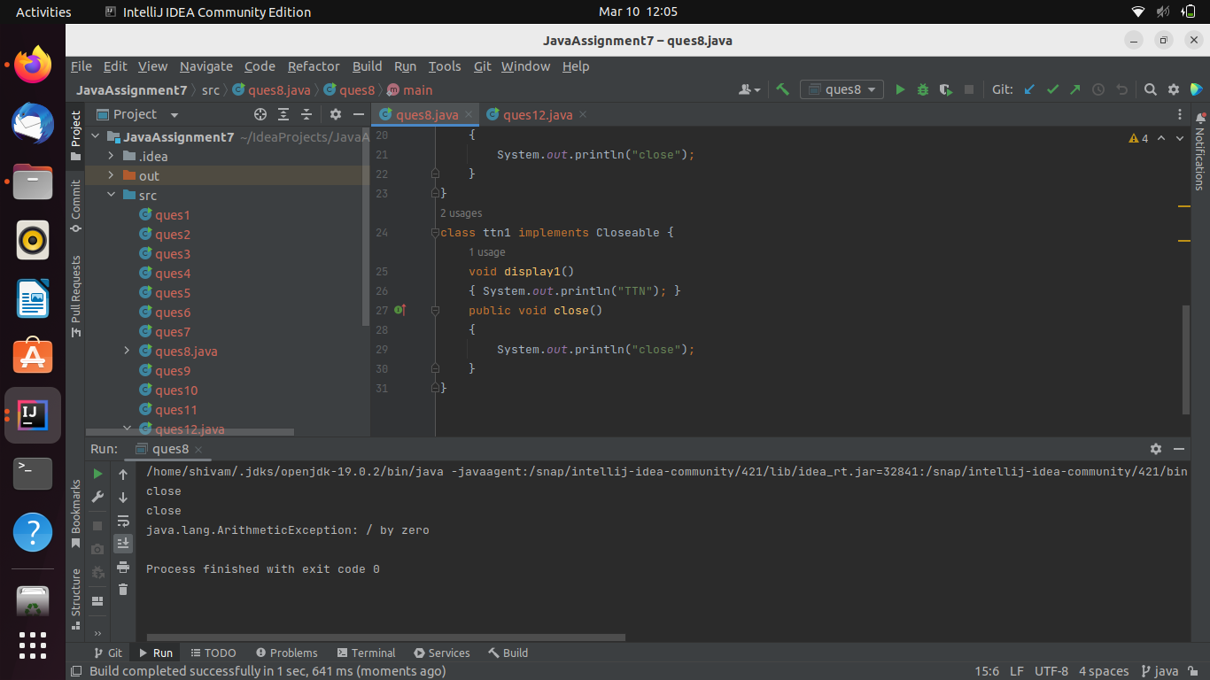

1. Create Unmodifiable List from a Steam

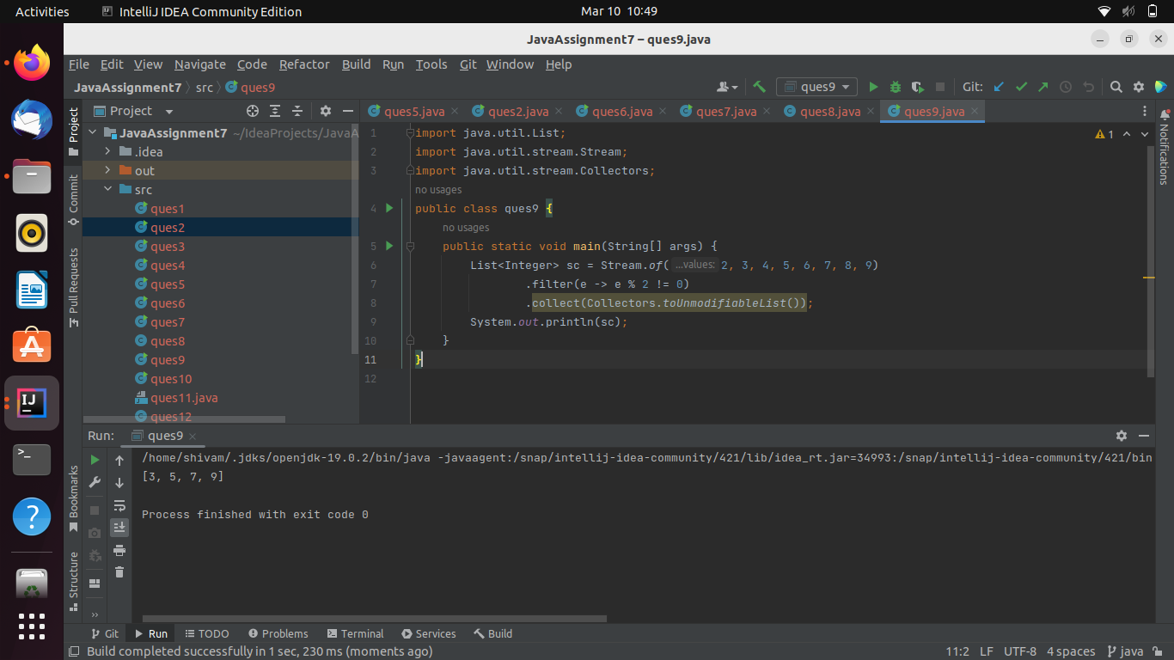

1. Demonstrate the use of repeat, strip, isBlank, indent, transform, stripIndent, translateEscapes, formatted String methods.

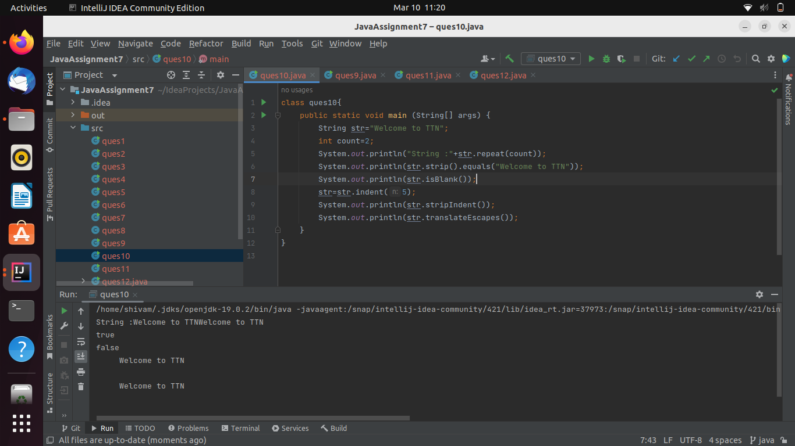

1. use record to create an immutable represent of student(name, id, age) and use its constructor for initialization, equals to compare 2 students methods. Also keep a static counter to keep the count of objects created.

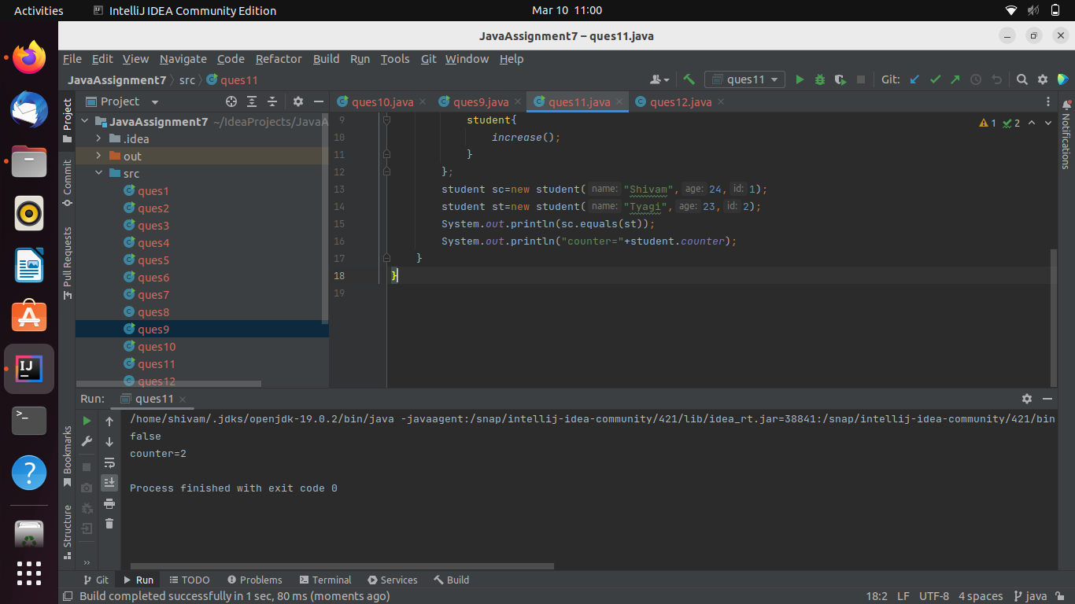

1. Demonstrate the use of Sealed Classes.

