**JavaAssignment-9**

Ques1.)WAP to show usage of Callable and demonstrate how it is different from Runnable.

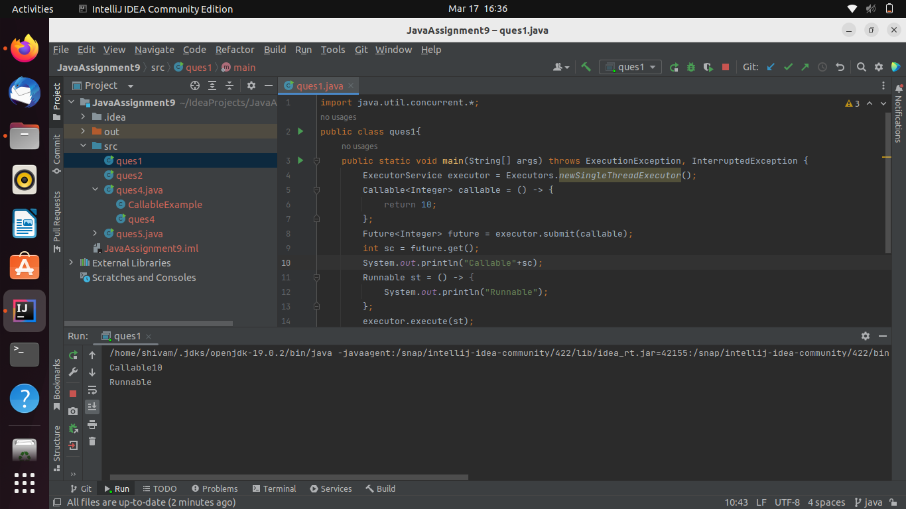

Ques2.)Improve the code written in Basics of Multi Threading Part 1 exercise question 4 to handle the deadlock using reentract lock.

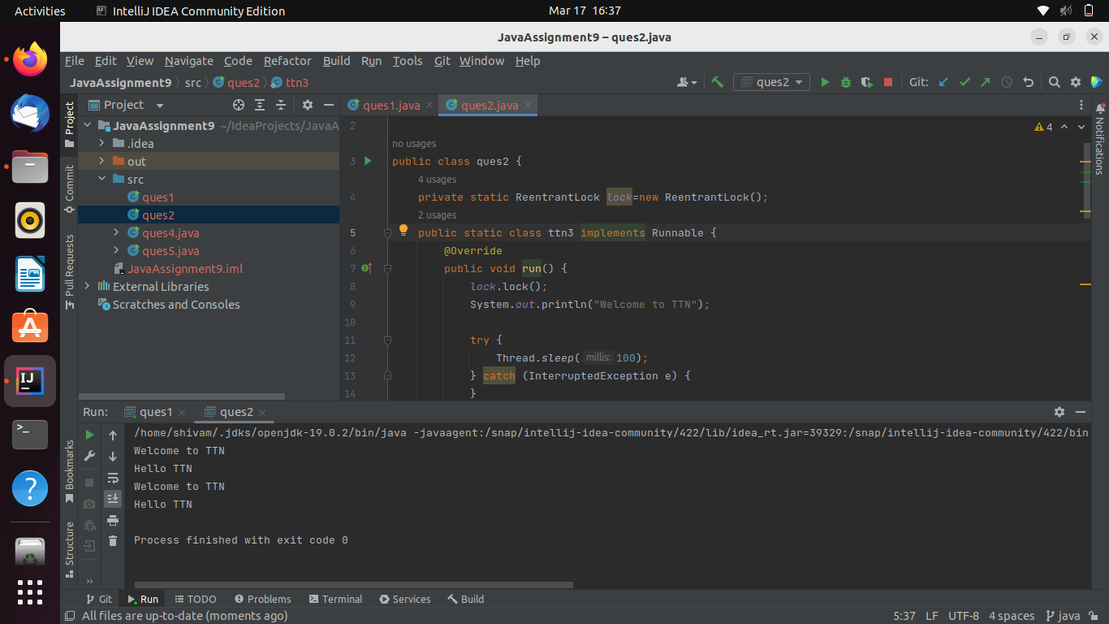

Ques3.)Use a singleThreadExecutor, newCachedThreadPool() and newFixedThreadPool() to submit a list of tasks and wait for completion of all tasks.

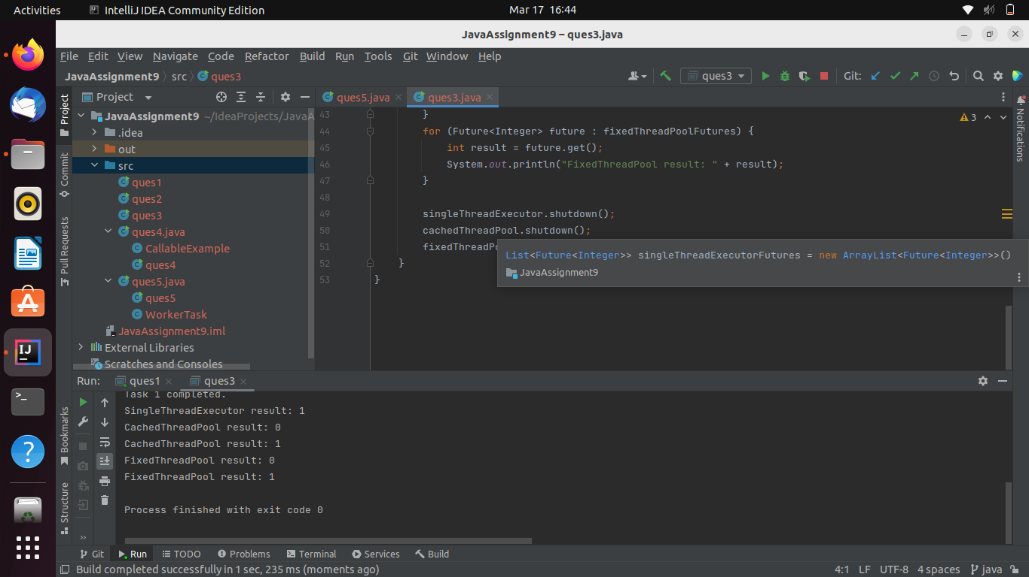

Ques4.)WAP to return a random integert value from a thread execution using Future.

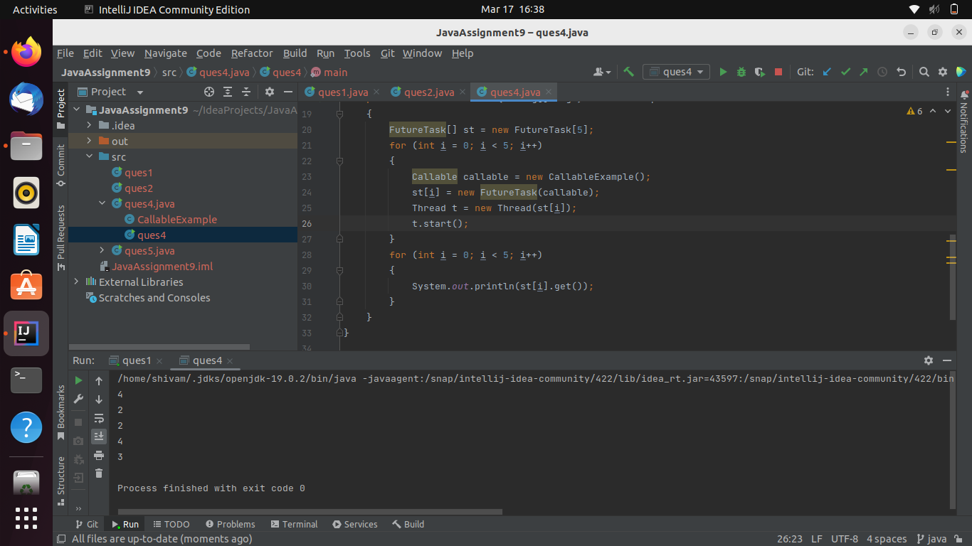

Ques5.)WAP to showcase the difference between shutdown() and shutdownNow().

