Q1) Write a class with FirstName, LastName & age field. Print Firstname, LastName & age using static block, static method & static variable respectively.

Q2) Write a program to read user input until user writes XDONE and then show the entered text by the user on commandline.

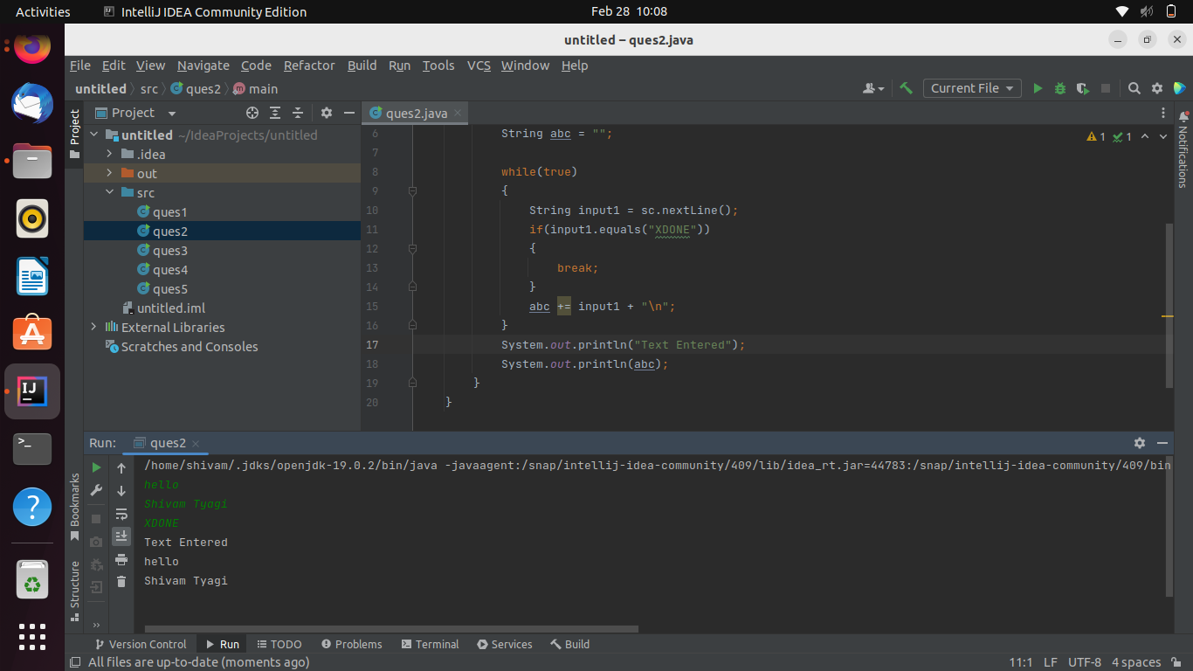

Q3) Write a java program to show following menu to the user:

\*\*\*\*\*\*\*Menu\*\*\*\*\*\*\*

1. Calculate Area of Circle

2. Calculate Circumference of a Circle

3. Exit.

Choose an option (1-3):

Take radius as user input.

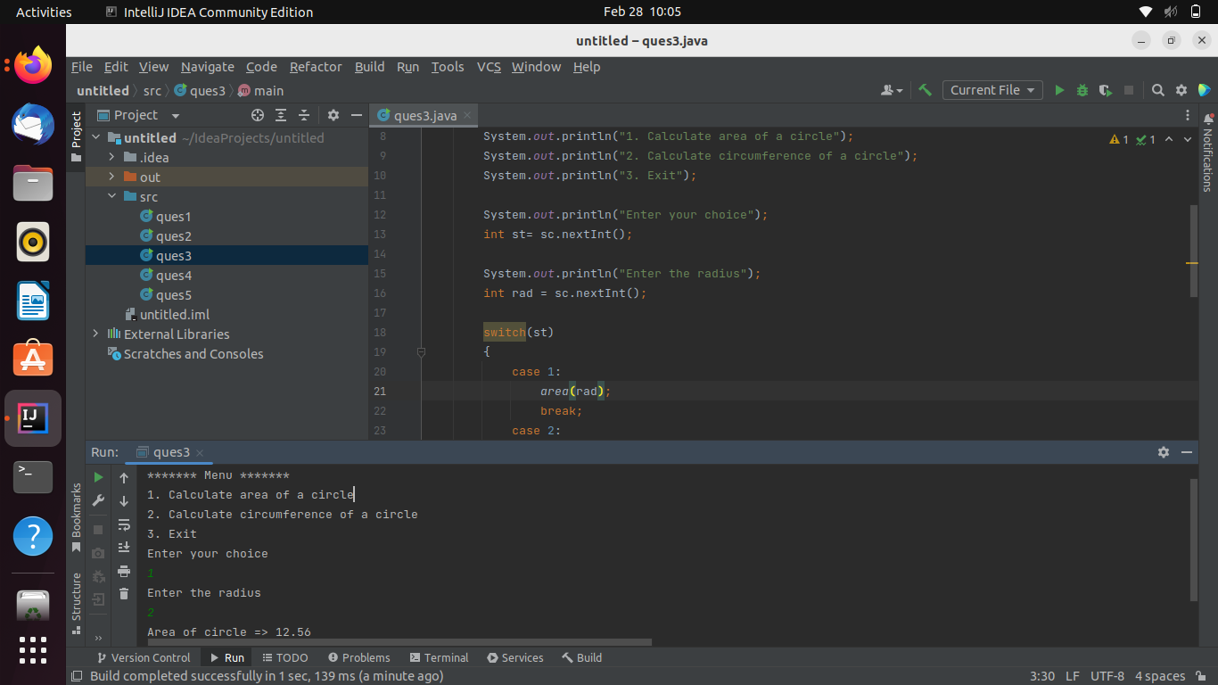

Q4) Create a two dimensional array of integers and display:

* sum of all elements of each column
* sum of all elements of each row

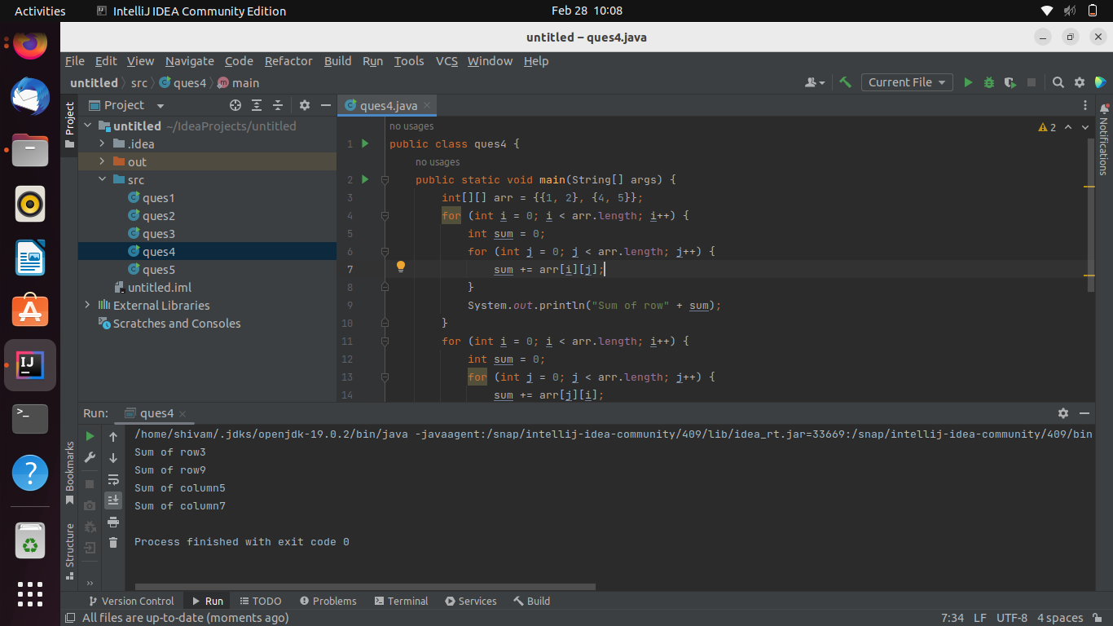

Q5) Create a class named Employee with fields firstname,lastname,age and designation.

The class should:

* have all types of constructors to initialize the object
* class should also have setter methods to update a particular field
* Override its toString method to display a meaningful message using all these fields.

