* Solution Name : - **Atomus**

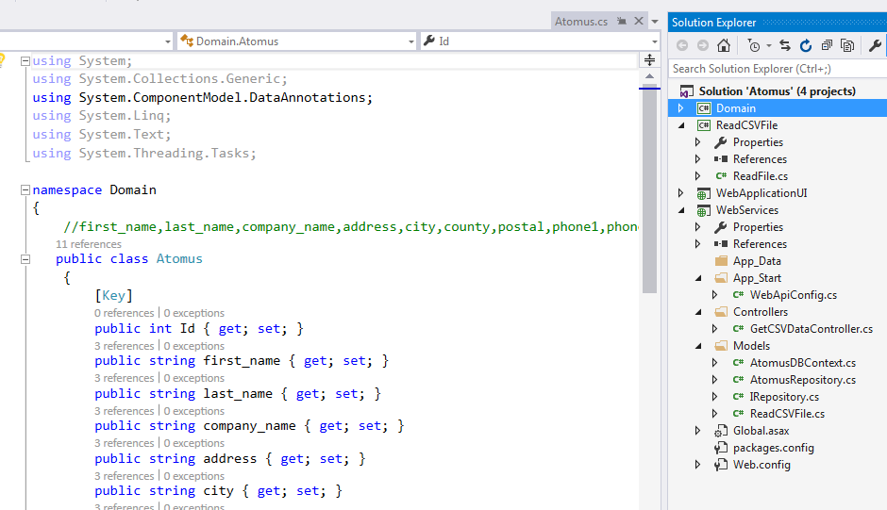

**Sub Projects:-**

1. Domain :- Domain is use for Atomus Class.
2. ReadCSVFile :- Library used for read the csv file
3. WebServices : - WebServices used for communicate with UI application.
4. WebApplicationUI:- UI application used for display the csv file data from csv file as well as from database.

**File Location:-**

Example:- E:/Test.csv

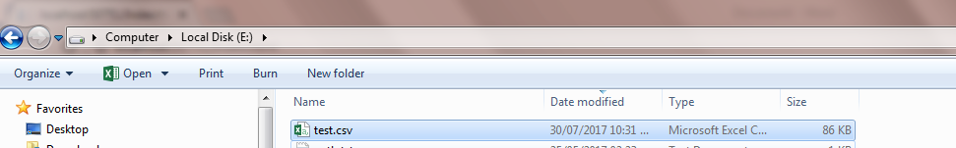

Test.csv file contents.

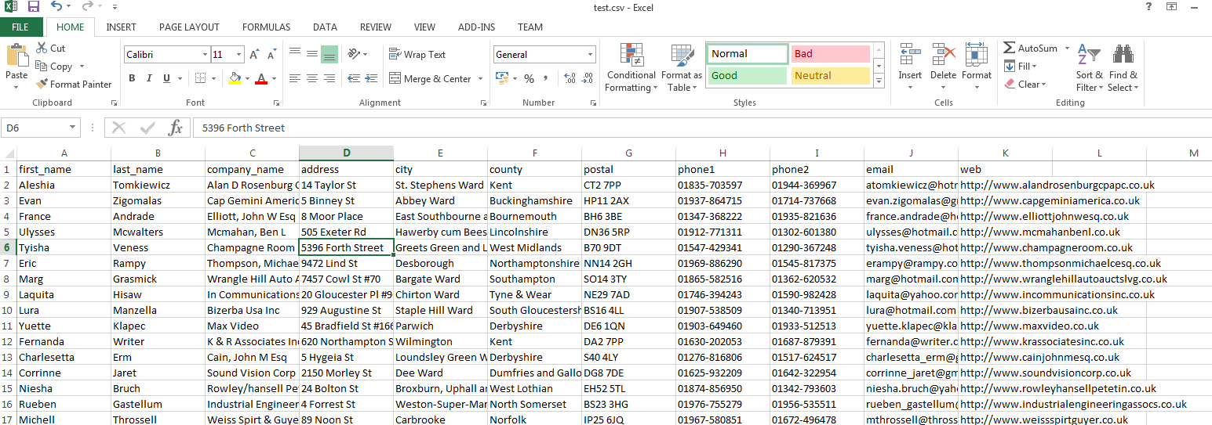

Database Details defined in Web.config under **WebServices** project. I have used the code first for database creation and access.

<connectionStrings>

<add name="AtomusDBContext" connectionString="Data Source=ADVIKA-PC\SQLEXPRESS;Initial Catalog=AtomusDB;Integrated Security=True;Connect Timeout=15;Encrypt=False;TrustServerCertificate=True;ApplicationIntent=ReadWrite;MultiSubnetFailover=False" providerName="System.Data.SqlClient" />

</connectionStrings>

Logic for access the csv file parser and database from UI application by Angular JS class with below file location path.

* var getCSVDataUrl = "**http://localhost:51381/api/GetCSVData?filepath=**" + encodeURI($scope.fileName);
* var getAllRecordUrl = "**http://localhost:51381/api/GetCSVData/GetAllRecord**";

Note:- Url should be path of web api on local machine

**Atomus\WebApplication1\Scripts\MyScript.js**

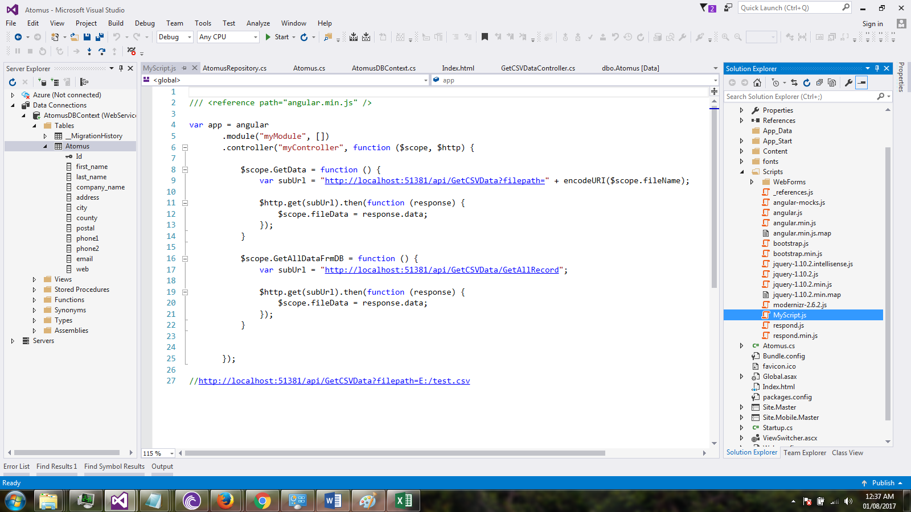

**UI Application:-**

* Please type the file location in Text box
* CSV to Database Button used for process the file for Read the data from csv file and Store in the database by REST based web API and Display on the Screen by Angular JS

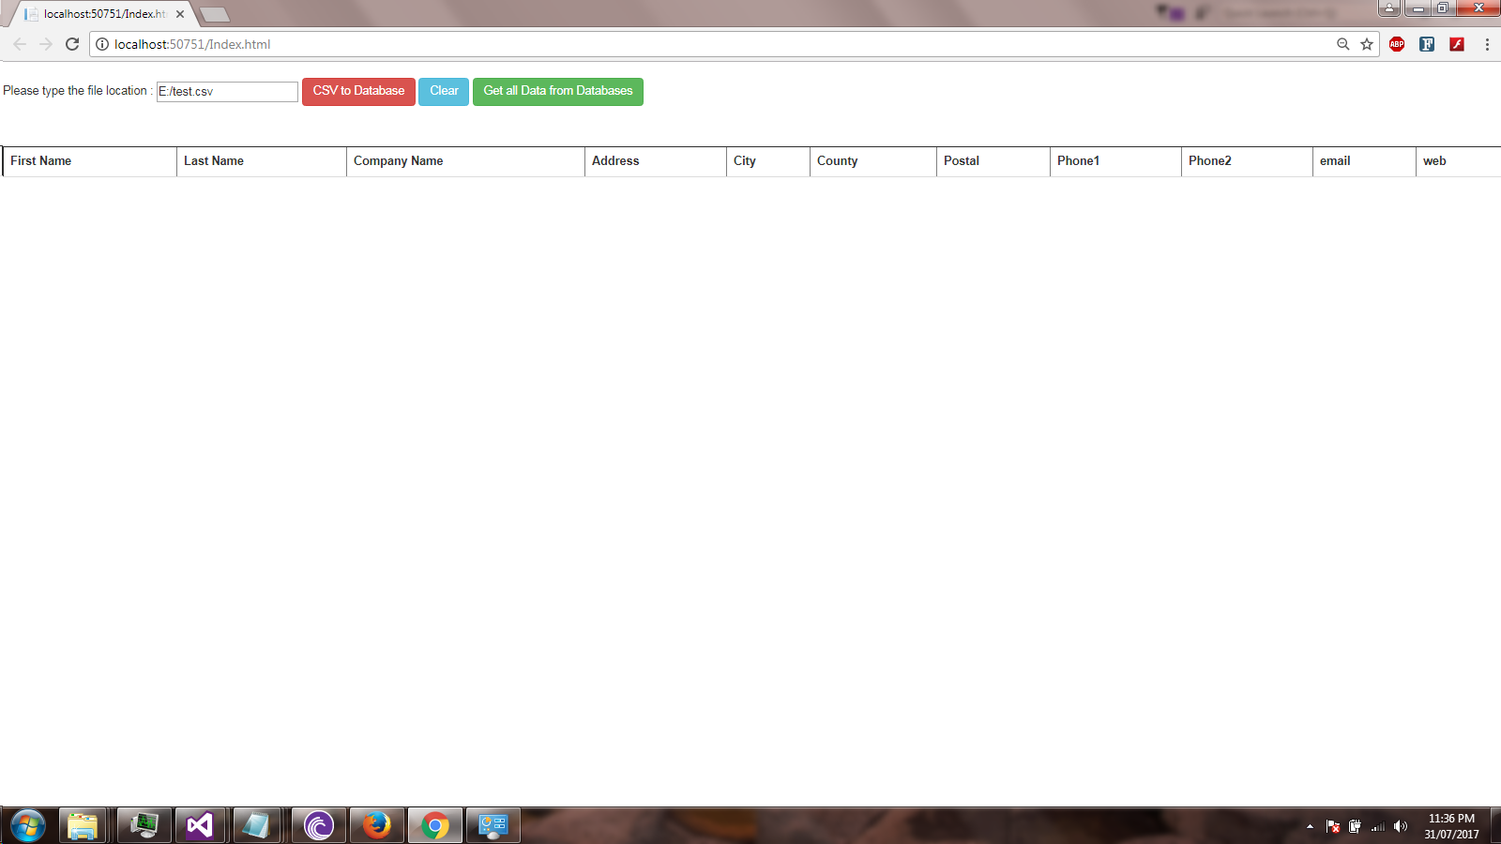

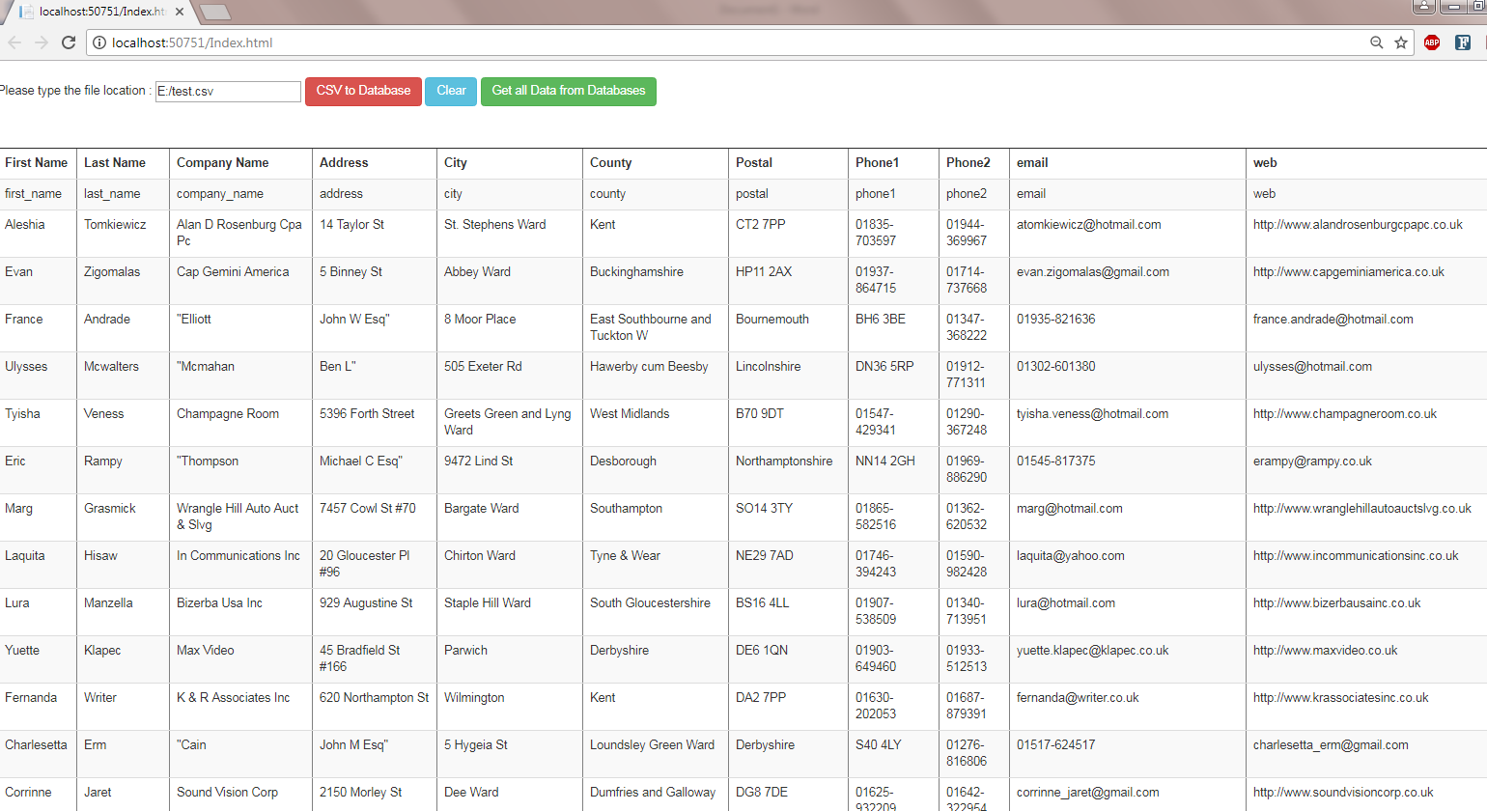

**Data in the database:-**

