CPS 3310 Prog. Languages – Homework #5 Worked Examples Name: Thomas Yamakaitis

Fall 2017 CFL; Chapter 4

Dr. Morreale

Assigned: Tuesday, October 10, 2017, in class.

Due: Thursday, October 12, 2017, submitted on Blackboard, before class begins.

1. Answer each part for the following context-free grammar *G*:

R 🡪 X R X | S

S 🡪 aTb | bTa

T 🡪 XTX | X | ε

X 🡪 a | b

1. What are the variables of G?

R,S,T,X

1. What are the terminals of G?

a, b, ε

1. Which is the start variable of G?

R

1. Give three strings in L(G).

ab, ba, aabbb

1. Give three strings not in L(G).

abbabb, bab, aba

1. True or false: T 🡪 aba

False; cannot reach T alone.

1. Give context free grammars that generate the following languages. In all cases, the alphabet Σ is { 0,1}.
2. {w | w contains at least three 1s }

S -> R1R1R1R

R -> 0R | 1R | ⍺

1. {w | the lengths of w is odd and its middle symbol is a 0 }

S → 0S0 | 1S1 | 0

4.1. Perform the pairwise disjointness test for the following grammar rules.

a. A 🡪 aB | b | cBB First: {a}, {b}, {c}, Yes

b. B 🡪 aB | bA | aBb First: {a}, {b}, {a} No

c. C 🡪 aaA | b | caB First: {a}, {b}, {c}

4.5. (30) Given the following grammar and the right sentential form, draw a parse tree and show the phrases and simple phrases, as well as the handle.

S 🡪 aAb | bBA

A 🡪 ab | aAB

B 🡪 bB | b 🡨 *Please note: this is the correct grammar rule. There is a typo in the book.*

1. aaAbb

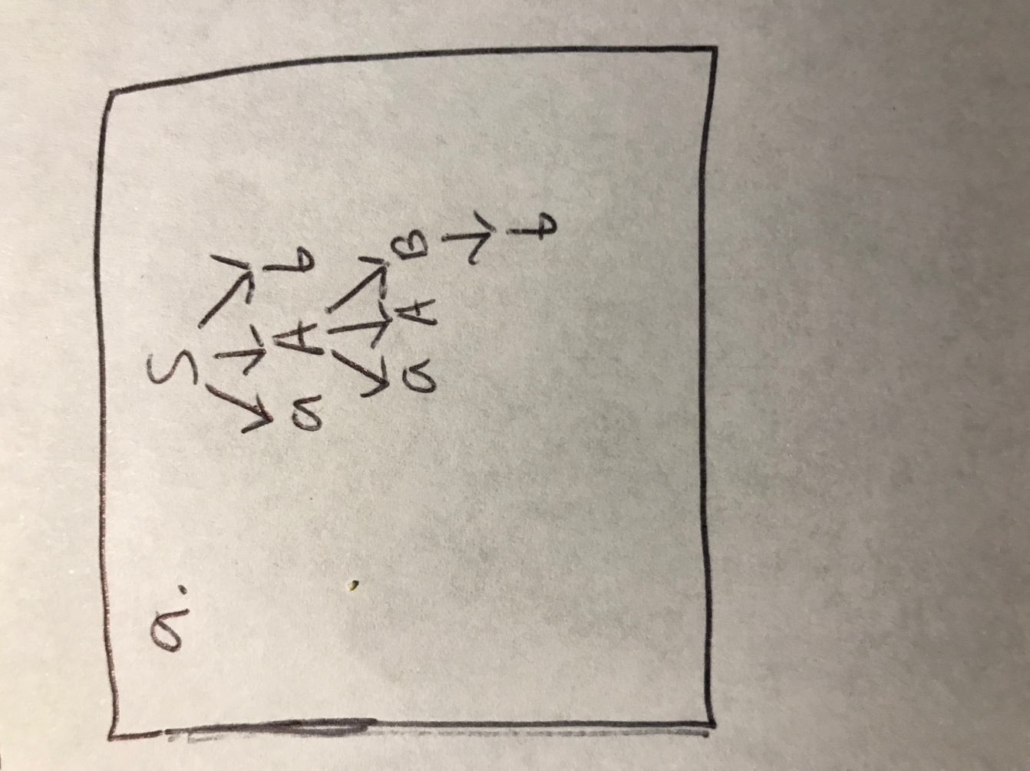

Phrases: aaAbb, aAb, b

Simple: b

Handle: b

1. bBab

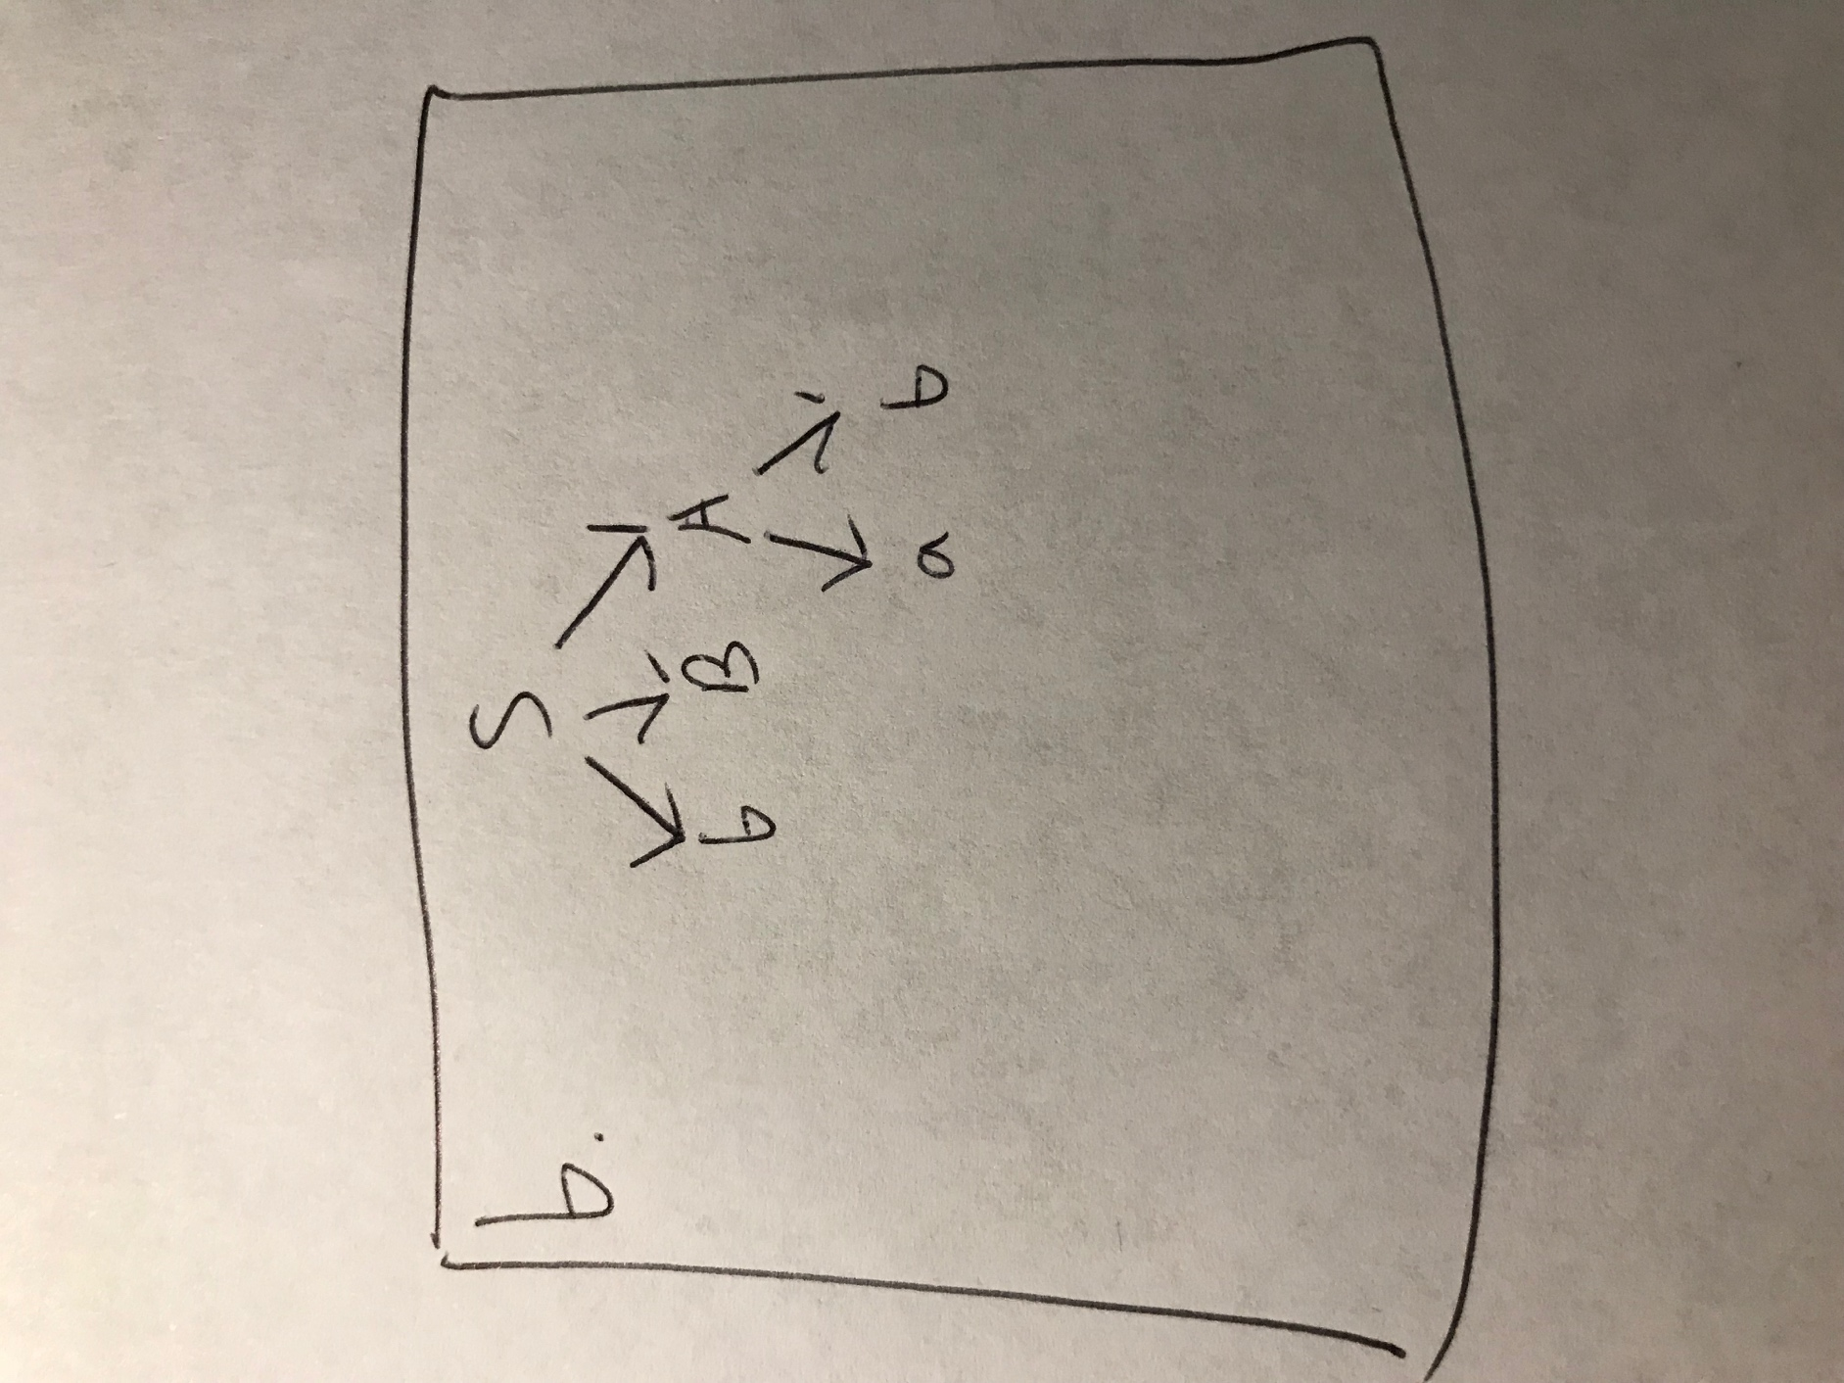

Phrases: bBab, bBa

Simple: ab

Handle: ab

1. aaAbBb

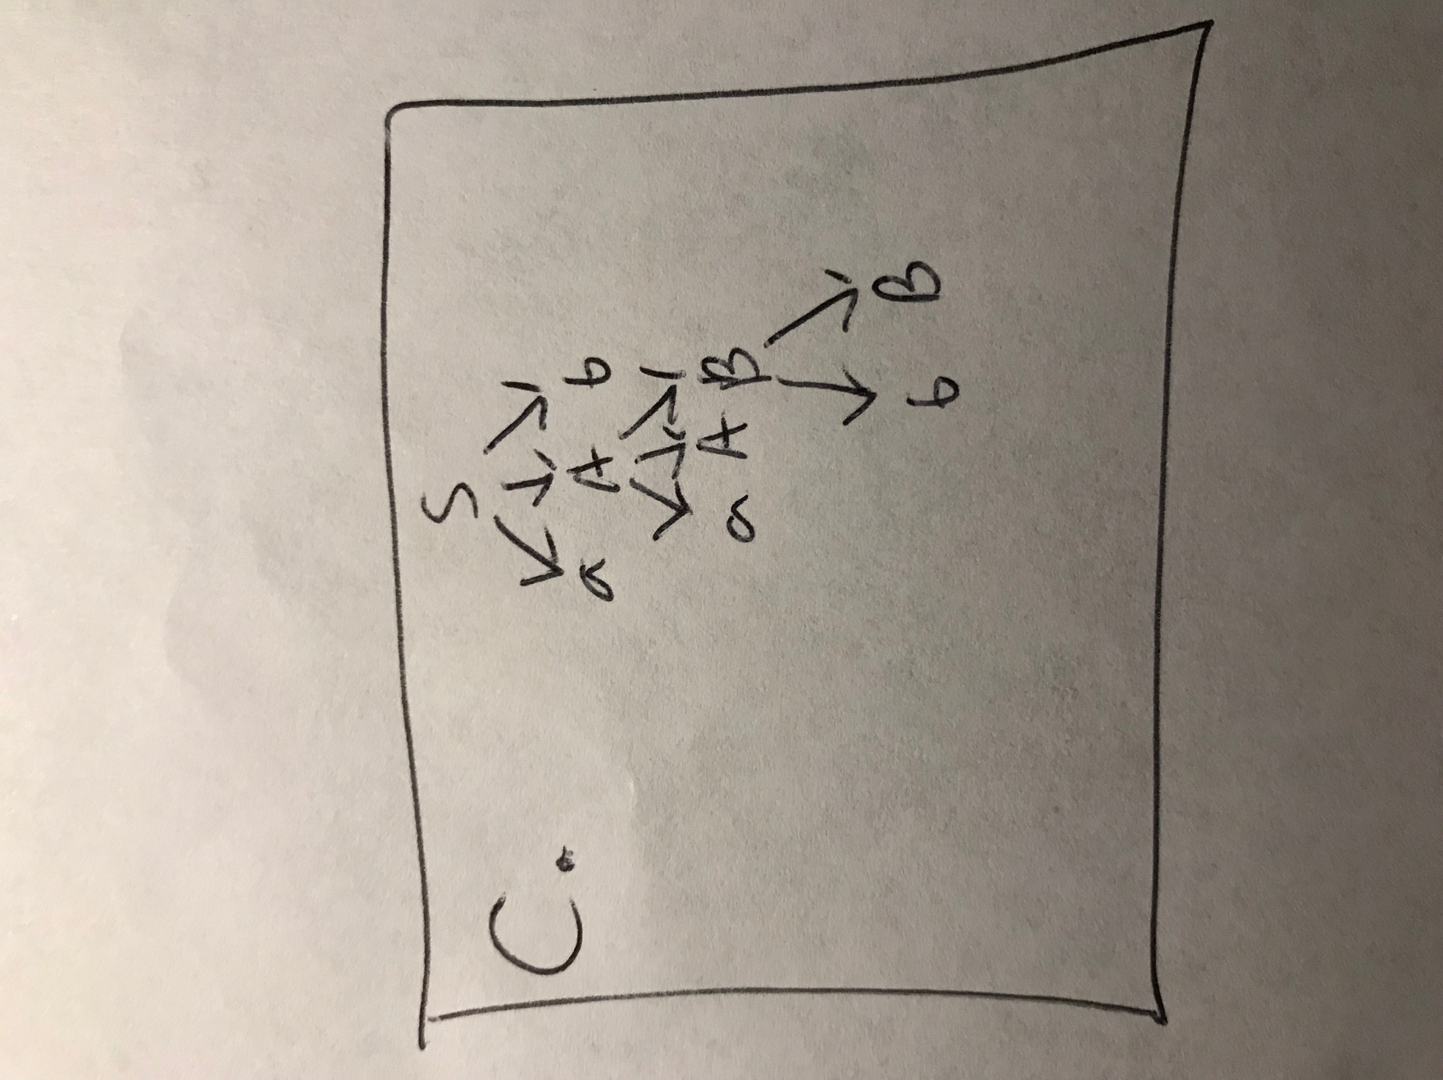

Phrases: aaAbBb, aAb

Simple: bB

Handle: bB