CPS 3310 Project #3- Programming Languages Name: Thomas Yamakaitis

Fall 2017 Python – List Manipulation

Assigned: Thursday, November 1, 2017 Due: Tuesday, November 7, 2017\*

*Submit on Blackboard before 9;30 AM*

*No Class Nov. 7 – State holiday*

Provide answers to the questions given and complete the programming function requested.

1. (2) What is []? [] is an empty list in Python.
2. (2) How would you assign the value ‘hello’ as the third value in a list stored in a variable named spam? (Assume spam contains [2, 4, 6, 8, 10].)

spam.insert(2, ‘hello’)

*For the following three questions*, consider spam to contain the list [‘a’, ‘b’, ‘c’, ‘d’]

1. (2) What does spam[int(‘3’)] evaluate to? d
2. (2) What does spam [-1] evaluate to? d
3. (2) What does spam [:2] evaluate to? [‘a’,’b’]

*For the following three questions*, bacon contains the list [3.14, ‘cat’, 11, ‘cat’, True].

1. (2) What does bacon.index(‘cat’) evaluate to? 1
2. (2) What does bacon.append(99) make the list value in bacon look like?

[3.14, ‘cat’, 11, ‘cat’, True, 99]

1. (2) What does bacon.remove(‘cat’) make the list value in bacon look like?

[3.14, 11, ‘cat’, True, 99]

1. (2) What are the operators for list concatenation and list replication?

+ is the concatenation operator for a list. \* is the replication operator for a list.

1. (2) What is the difference between the append() and insert() list methods?

Append adds to the end of a list, insert adds an element at a particular index.

1. (2) What are two way to remove values from lists?

The remove method, pop method and del can be used to remove values from lists.

1. (2) Name a few ways that list values are similar to string values.

* Both sequence types
* Similar functions like len()
* Similar indexing []
* The in operator

1. (2) What is the difference between lists and tuples?

* Lists are mutable
* Tuples are immutable

1. (2) How do you type the tuple value that has just the integer value 42 in it?

* (42,)

1. (2) How can you get the tuple form of a list value? How can you get the list form of a tuple value?

* li = list(tu)
* tu = tuple(li)

1. (5) Variables that “contain” list values don’t actually contain lists directly. What do they contain instead?

* The address of the value (pointer)

1. (5) What is the difference between copy.copy() and copy.deepcopy()?

* Shallow copy creates a new object and contains references to objects in the original
* Deep copy creates a new object and creates completely new objects replicating the original, no references.

Write a Program:

(60) Given a list value: spam = [‘apples’, ‘bananas’, ‘tofu’, ‘cats’]

Write a function that takes a list value as an argument and returns a string with all the items separated by a comma and a space, with *and* inserted before the last item. For example, passing the previous spam list to the function would return

‘apples, bananas, tofu, and cats’

Your function should be able to work with any list value passed to it.

Provide your code, and

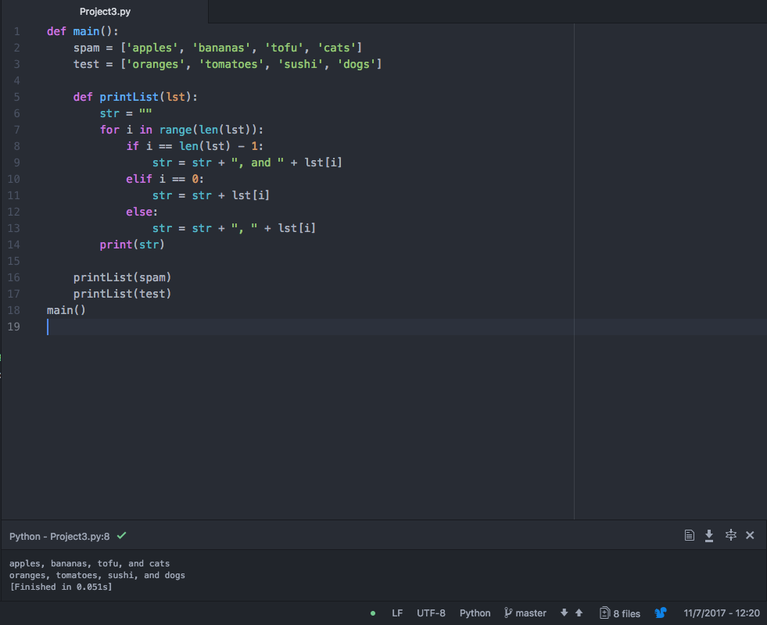

Output is at the bottom…

def main():

spam = ['apples', 'bananas', 'tofu', 'cats']

test = ['oranges', 'tomatoes', 'sushi', 'dogs']

def printList(lst):

str = ""

for i in range(len(lst)):

if i == len(lst) - 1:

str = str + ", and " + lst[i]

elif i == 0:

str = str + lst[i]

else:

str = str + ", " + lst[i]

print(str)

printList(spam)

printList(test)

main()